**Dan Millman 1946 –**

<http://en.wikipedia.org/wiki/Dan_Millman>

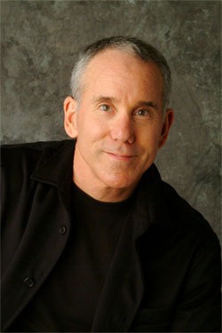 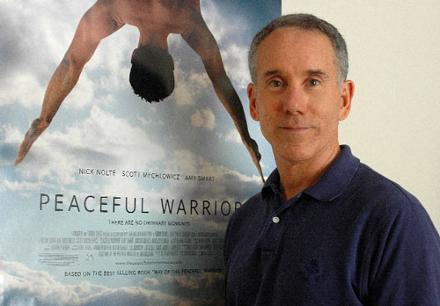 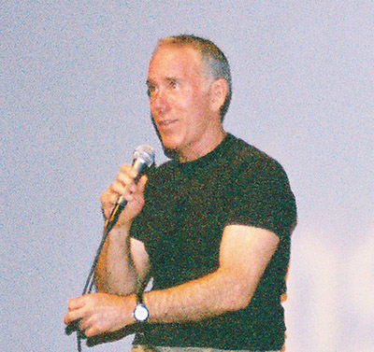

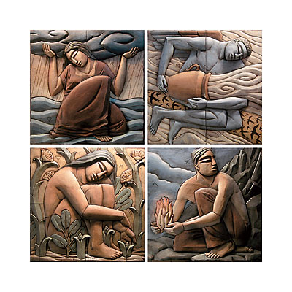

**Dan Millman** (born [Feb 22](http://en.wikipedia.org/wiki/Feb_22), [1946](http://en.wikipedia.org/wiki/1946)) is an author of thirteen [self-help](http://en.wikipedia.org/wiki/Self-help) books, the most famous of which is the semi-autobiographical novel, *Way of the Peaceful Warrior* (1980). As the winner of the 1964 [World Trampoline Championship](http://en.wikipedia.org/wiki/Trampolining) in [London](http://en.wikipedia.org/wiki/London), he co-captained the 1968 NCAA University of California gymnastics team and has also worked as a gymnastics instructor at [Stanford University](http://en.wikipedia.org/wiki/Stanford_University) and a professor of physical education at [Oberlin College](http://en.wikipedia.org/wiki/Oberlin_College). He is connected to the [human potential movement](http://en.wikipedia.org/wiki/Human_potential_movement) along with [Anthony Robbins](http://en.wikipedia.org/wiki/Anthony_Robbins). His early background includes [modern dance](http://en.wikipedia.org/wiki/Modern_dance) and [Aikido](http://en.wikipedia.org/wiki/Aikido). Later he studied various [yogas](http://en.wikipedia.org/wiki/Yoga) and martial arts while he travelled around the world, which resulted in his new calling as spiritual and motivational speaker and author.

|  |
| --- |
| Contents[1 Way of the Peaceful Warrior (1980)](http://en.wikipedia.org/wiki/Dan_Millman#Way_of_the_Peaceful_Warrior_.281980.29)  * + [1.1 Summary](http://en.wikipedia.org/wiki/Dan_Millman#Summary) * [2 Chronological list of books by Dan Millman](http://en.wikipedia.org/wiki/Dan_Millman#Chronological_list_of_books_by_Dan_Millman) * [3 Books grouped by topic](http://en.wikipedia.org/wiki/Dan_Millman#Books_grouped_by_topic) * [4 External links](http://en.wikipedia.org/wiki/Dan_Millman#External_links) |

## *Way of the Peaceful Warrior* (1980)



*Way of the Peaceful Warrior*, Millman's first book, is a work of [autobiographical](http://en.wikipedia.org/wiki/Autobiography) [fiction](http://en.wikipedia.org/wiki/Fiction) set mostly during his college years. Initially, the book had only modest sales, until Hal Kramer reportedly came out of retirement to republish the book and help make it a [best seller](http://en.wikipedia.org/wiki/Best_seller).

In the summer of 2006, [Lions Gate Films](http://en.wikipedia.org/wiki/Lions_Gate_Films) released a film version, [*Peaceful Warrior*](http://en.wikipedia.org/wiki/Peaceful_Warrior), starring [Scott Mechlowicz](http://en.wikipedia.org/wiki/Scott_Mechlowicz) and [Nick Nolte](http://en.wikipedia.org/wiki/Nick_Nolte).

### [] Summary

The story tells of a chance meeting with a gas station attendant who becomes a mentor to the young [gymnast](http://en.wikipedia.org/wiki/Gymnast), Dan Millman, who names the attendant "Socrates". When Millman's right leg is shattered in a motorcycle accident, Socrates becomes Millman's spiritual teacher and shows Millman how to become a *Peaceful Warrior*.

## [] Chronological list of books by Dan Millman

* *Whole body fitness: mind, body, and spirit* (1979). [ISBN 0-517-53853-9](http://en.wikipedia.org/wiki/Special:BookSources/0517538539)
* *Way of the Peaceful Warrior: A Book That Changes Lives* (1980). Fictionalized autobiography. [ISBN 0-915811-89-8](http://en.wikipedia.org/wiki/Special:BookSources/0915811898)
* *Sacred Journey of the Peaceful Warrior* (1991). Details the world travels of the character in the above book. [ISBN 0-915811-33-2](http://en.wikipedia.org/wiki/Special:BookSources/0915811332)
* *Secret of the Peaceful Warrior: A Story About Courage and Love* (1991). Children's book. [ISBN 0-915811-23-5](http://en.wikipedia.org/wiki/Special:BookSources/0915811235)
* *No Ordinary Moments: A Peaceful Warrior's Guide to Daily Life* [ISBN 0-915811-40-5](http://en.wikipedia.org/wiki/Special:BookSources/0915811405)
* *Quest for the Crystal Castle: A Peaceful Warrior Children's Book* (1992). [ISBN 0-915811-41-3](http://en.wikipedia.org/wiki/Special:BookSources/0915811413)
* *The Life You Were Born to Live: A Guide to Finding Your Life Purpose* (1995). ISBN-10: 0-915811-60-X
* *The Laws of Spirit: A Tale of Transformation* (1995) [ISBN 0-915811-93-6](http://en.wikipedia.org/wiki/Special:BookSources/0915811936)
* *Everyday Enlightenment: The Twelve Gateways to Personal Growth* (1998). [ISBN 0-446-67497-4](http://en.wikipedia.org/wiki/Special:BookSources/0446674974)
* *Body Mind Mastery: Creating Success in Sport and Life* (1999). [ISBN 1-57731-094-2](http://en.wikipedia.org/wiki/Special:BookSources/1577310942)

Previous versions of same book:

* *The Warrior Athlete: Body, Mind & Spirit* (1985). [ISBN 0-913299-22-7](http://en.wikipedia.org/wiki/Special:BookSources/0913299227)
* *The Inner Athlete* (1994). [ISBN 0-913229-70-9](http://en.wikipedia.org/wiki/Special:BookSources/0913229709)
* *Divine Interventions: True Stories of Mysteries and Miracles That Change Lives* (with Doug Childers, 2000) [ISBN 1-57954-338-3](http://en.wikipedia.org/wiki/Special:BookSources/1579543383)
* *Living on Purpose: Straight Answers to Life's Tough Questions* (2000) [ISBN 1-57731-132-9](http://en.wikipedia.org/wiki/Special:BookSources/1577311329)
* *Way of the Peaceful Warrior: A Book That Changes Lives*, [H J Kramer](http://en.wikipedia.org/w/index.php?title=H_J_Kramer&action=edit&redlink=1), 20th Anniversary ion, (2000) [ISBN 0-915811-89-8](http://en.wikipedia.org/wiki/Special:BookSources/0915811898)
* *The Journeys of Socrates* (April 1, 2005) [Prequel](http://en.wikipedia.org/wiki/Prequel) to first book. [ISBN 0-06-083302-5](http://en.wikipedia.org/wiki/Special:BookSources/0060833025)
* *Wisdom of the Peaceful Warrior: A Companion to the Book That Changes Lives* (January 2007)

## [] Books grouped by topic

Dan Millman groups his books into three major categories: [[1]](http://www.danmillman.com/index.php?option=com_content&task=view&id=20&Itemid=41)

1. Novels for inspiration and to provide the big picture:
   * *Way of the Peaceful Warrior*
   * *Sacred Journey*
   * *The Journeys of Socrates*
2. Non-fiction
   * Core teaching and practical guide books:
     + *Wisdom Of The Peaceful Warrior*
     + *Living on Purpose*
     + *No Ordinary Moment*
     + *The Life You Were Born to Live*
     + *Everyday Enlightenment*
     + *The Laws of Spirit*
   * Specialty and Inspiration:
     + *Body Mind Mastery*
     + *Divine Interventions*
3. Children's books:
   * *Secret of the Peaceful Warrior*
   * *Quest for the Crystal Castle*

## [] External links

* [The Peaceful Warriors Way](http://www.danmillman.com/) - Dan Millman's personal website.
* [peacefulwarrior.com](http://www.peacefulwarrior.com/) - Main promotional website
* [Interview with Spiritual Endeavors](http://www.spiritual-endeavors.org/basic/Dan_Millman.htm) discusses training philosophy, fiction in book
* [Peaceful warrior (2006)](http://www.imdb.com/title/tt0438315/) - The movie directed by [Victor Salva](http://en.wikipedia.org/wiki/Victor_Salva) and starring [Nick Nolte](http://en.wikipedia.org/wiki/Nick_Nolte), based on the book *Way of the Peaceful Warrior*
* [Dan Millman](http://www.bigspeak.com/dan-millman.html) - Brief bio and motivational speaking topics
* [iFilm.com](http://www.ifilm.com/ifilmdetail/2719426) movie preview and interviews
* [Working and Living Life Smarter Conference](http://www.aboveandbeyondlearning.com/conference.html) - keynoted by Dan Millman (November 2006)
* [West View Trampoline Community](http://www.wvtc.co.uk/history9.htm) - Trampoline History, about Dan Millman
* [U.S. Gymnastics and honored guests Hall of Fame website](http://www.usghof.org/files/bio/d_millman/d_millman.html) - Dr. Larry Banner's page on Dan Millman

Retrieved from "<http://en.wikipedia.org/wiki/Dan_Millman>"

[Categories](http://en.wikipedia.org/wiki/Special:Categories): [College gymnasts](http://en.wikipedia.org/wiki/Category:College_gymnasts) | [College gymnastics coaches](http://en.wikipedia.org/wiki/Category:College_gymnastics_coaches) | [American motivational speakers](http://en.wikipedia.org/wiki/Category:American_motivational_speakers) | [American motivational writers](http://en.wikipedia.org/wiki/Category:American_motivational_writers) | [American self-help writers](http://en.wikipedia.org/wiki/Category:American_self-help_writers) | [American spiritual writers](http://en.wikipedia.org/wiki/Category:American_spiritual_writers) | [New Age authors](http://en.wikipedia.org/wiki/Category:New_Age_authors) | [Personal development](http://en.wikipedia.org/wiki/Category:Personal_development) | [American trampolinists](http://en.wikipedia.org/wiki/Category:American_trampolinists) | [People associated with the Human Potential Movement](http://en.wikipedia.org/wiki/Category:People_associated_with_the_Human_Potential_Movement)