**Aldous Leonard Huxley 1894 – 1963**

<http://en.wikipedia.org/wiki/Aldous_Huxley>

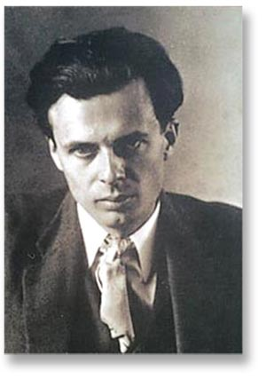 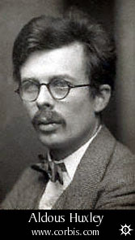 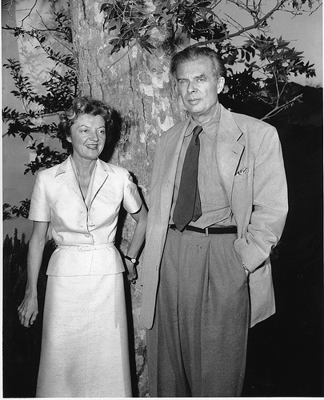 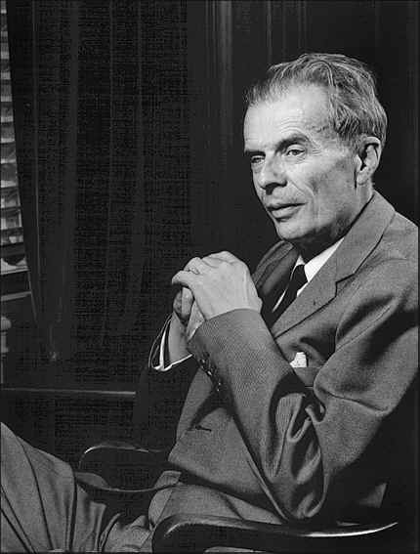 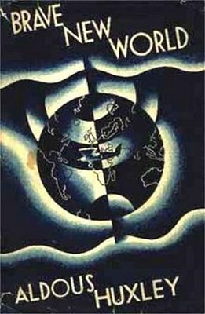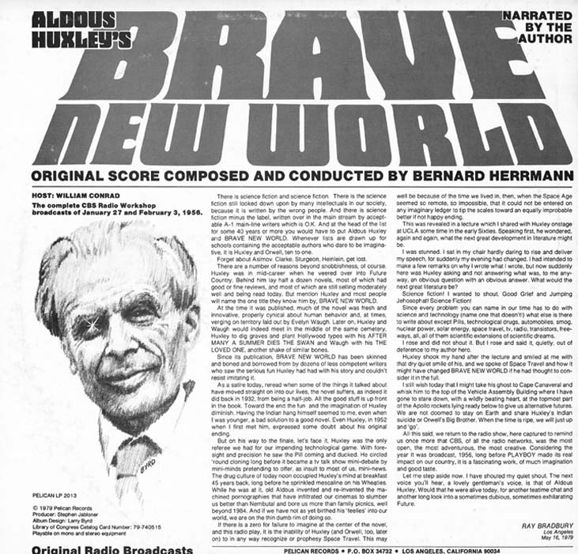 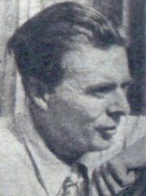 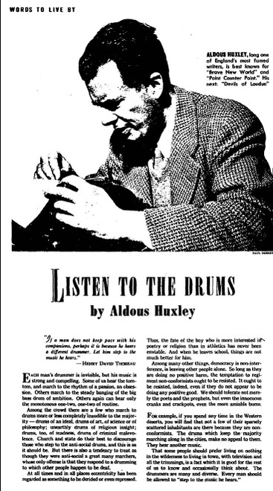 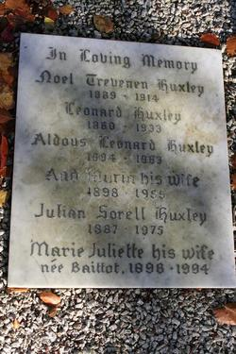

**Aldous Leonard Huxley** (26 July 1894 – 22 November 1963) was an [English](http://en.wikipedia.org/wiki/England) [writer](http://en.wikipedia.org/wiki/Writer) and one of the most prominent members of the famous [Huxley family](http://en.wikipedia.org/wiki/Huxley_family). He spent the latter part of his life in the [United States](http://en.wikipedia.org/wiki/United_States), living in [Los Angeles](http://en.wikipedia.org/wiki/Los_Angeles) from 1937 until his death in 1963. Best known for his [novels](http://en.wikipedia.org/wiki/Novel) and wide-ranging output of [essays](http://en.wikipedia.org/wiki/Essay), he also published [short stories](http://en.wikipedia.org/wiki/Short_stories), [poetry](http://en.wikipedia.org/wiki/Poetry), [travel writing](http://en.wikipedia.org/wiki/Travel_writing), and [film](http://en.wikipedia.org/wiki/Film) stories and scripts.

Huxley was a [Mystic](http://en.wikipedia.org/wiki/Mystic) and [pacifist](http://en.wikipedia.org/wiki/Pacifist), but was also latterly interested in spiritual subjects such as [parapsychology](http://en.wikipedia.org/wiki/Parapsychology) and [philosophical](http://en.wikipedia.org/wiki/Philosophy) [mysticism](http://en.wikipedia.org/wiki/Mysticism). He was also well known for advocating and taking [hallucinogens](http://en.wikipedia.org/wiki/Psychedelics,_dissociatives_and_deliriants) and is considered by many to be the "spiritual father" of the *hippie* movement.

By the end of his life Huxley was considered, in some academic circles, a leader of modern thought and an intellectual of the highest rank.[[1]](http://en.wikipedia.org/wiki/Aldous_Huxley#cite_note-0)

|  |
| --- |
| Contents    * [1 Biography](http://en.wikipedia.org/wiki/Aldous_Huxley" \l "Biography)   + [1.1 Early years](http://en.wikipedia.org/wiki/Aldous_Huxley#Early_years)   + [1.2 Middle years](http://en.wikipedia.org/wiki/Aldous_Huxley#Middle_years)   + [1.3 Post-war](http://en.wikipedia.org/wiki/Aldous_Huxley#Post-war) * [2 Literary themes](http://en.wikipedia.org/wiki/Aldous_Huxley#Literary_themes) * [3 Awards](http://en.wikipedia.org/wiki/Aldous_Huxley#Awards) * [4 Films](http://en.wikipedia.org/wiki/Aldous_Huxley#Films) * [5 Quotations](http://en.wikipedia.org/wiki/Aldous_Huxley#Quotations) * [6 Bibliography](http://en.wikipedia.org/wiki/Aldous_Huxley#Bibliography) * [7 References](http://en.wikipedia.org/wiki/Aldous_Huxley#References) * [8 External links](http://en.wikipedia.org/wiki/Aldous_Huxley#External_links) |

## [] Biography

*See also:* [*Huxley family*](http://en.wikipedia.org/wiki/Huxley_family)

### [] Early years

Aldous Huxley was born in [Godalming](http://en.wikipedia.org/wiki/Godalming), [Surrey](http://en.wikipedia.org/wiki/Surrey), [England](http://en.wikipedia.org/wiki/England) in 1894. He was the third son of the [writer](http://en.wikipedia.org/wiki/Writer) and school-master [Leonard Huxley](http://en.wikipedia.org/wiki/Leonard_Huxley_%28writer%29) and first wife, [Julia Arnold](http://en.wikipedia.org/w/index.php?title=Julia_Arnold&action=edit&redlink=1) who founded Prior's Field School. Julia was the niece of [Matthew Arnold](http://en.wikipedia.org/wiki/Matthew_Arnold) and the sister of [Mrs. Humphrey Ward](http://en.wikipedia.org/wiki/Mrs._Humphrey_Ward). Aldous was the grandson of [Thomas Henry Huxley](http://en.wikipedia.org/wiki/Thomas_Henry_Huxley), the [zoologist](http://en.wikipedia.org/wiki/Zoologist), [agnostic](http://en.wikipedia.org/wiki/Agnostic) and controversialist ("Darwin's Bulldog"). His brother [Julian Huxley](http://en.wikipedia.org/wiki/Julian_Huxley) and half-brother [Andrew Huxley](http://en.wikipedia.org/wiki/Andrew_Huxley) also became outstanding [biologists](http://en.wikipedia.org/wiki/Biology). Huxley had another brother Trevelyan (1891-1914) who committed suicide after a period of [clinical depression](http://en.wikipedia.org/wiki/Clinical_depression).

Huxley began his learning in his father's well-equipped [botanical](http://en.wikipedia.org/wiki/Botanical) [laboratory](http://en.wikipedia.org/wiki/Laboratory), then continued in a school named Hillside. His teacher was his mother who supervised him for several years until she became terminally ill. After Hillside, he was educated at [Eton College](http://en.wikipedia.org/wiki/Eton_College). Huxley's mother died in 1908, when he was fourteen. Three years later he suffered an illness ([keratitis punctata](http://en.wikipedia.org/wiki/Keratitis" \o "Keratitis)) which "left [him] practically blind for two to three years".[[2]](http://en.wikipedia.org/wiki/Aldous_Huxley#cite_note-1) Aldous's near-[blindness](http://en.wikipedia.org/wiki/Blindness) disqualified him from service in [World War I](http://en.wikipedia.org/wiki/World_War_I). Once his eyesight recovered sufficiently, he was able to study [English literature](http://en.wikipedia.org/wiki/English_literature) at [Balliol College](http://en.wikipedia.org/wiki/Balliol_College,_Oxford), [Oxford](http://en.wikipedia.org/wiki/University_of_Oxford). He graduated in 1916 with first class honours.

"I believe his blindness was a blessing in disguise. For one thing, it put paid to his idea of taking up medicine as a career...His uniqueness lay in his universalism. He was able to take all knowledge for his province." [[3]](http://en.wikipedia.org/wiki/Aldous_Huxley#cite_note-2)

Following his education at [Balliol](http://en.wikipedia.org/wiki/Balliol), Huxley was financially indebted to his father and had to earn a living. He taught French for a year at Eton, where Eric Blair (later known by the pen name [George Orwell](http://en.wikipedia.org/wiki/George_Orwell)) and [Stephen Runciman](http://en.wikipedia.org/wiki/Stephen_Runciman) were among his pupils, but was remembered by another as an incompetent and hopeless teacher who couldn’t keep discipline. Nevertheless, Blair and others were impressed by his use of words.[[4]](http://en.wikipedia.org/wiki/Aldous_Huxley#cite_note-Crick-3) For a short while in 1918, he was employed acquiring provisions at the [Air Ministry](http://en.wikipedia.org/wiki/Air_Ministry).

Significantly, Huxley also worked for a time in the 1920s at the technologically-advanced [Brunner and Mond](http://en.wikipedia.org/wiki/Brunner_Mond) chemical plant in [Billingham](http://en.wikipedia.org/wiki/Billingham), [Teesside](http://en.wikipedia.org/wiki/Teesside), and the most recent introduction to his famous [science fiction](http://en.wikipedia.org/wiki/Science_fiction) novel [*Brave New World*](http://en.wikipedia.org/wiki/Brave_New_World) (1932) states that this experience of "an ordered universe in a world of planless incoherence" was one source for the novel. Mustapha Mond is a character in the book.

Huxley completed his first (unpublished) novel at the age of seventeen and began writing seriously in his early twenties. His earlier work includes important novels on the dehumanizing aspects of scientific progress, most famously [*Brave New World*](http://en.wikipedia.org/wiki/Brave_New_World), and on [pacifist](http://en.wikipedia.org/wiki/Pacifism) themes (for example, [*Eyeless in Gaza*](http://en.wikipedia.org/wiki/Eyeless_in_Gaza)). In *Brave New World* Huxley portrays a society operating on the principles of mass production and Pavlovian conditioning. Huxley was strongly influenced by [F. Matthias Alexander](http://en.wikipedia.org/wiki/F.M._Alexander) and included him as a character in *Eyeless in Gaza*.

### [] Middle years

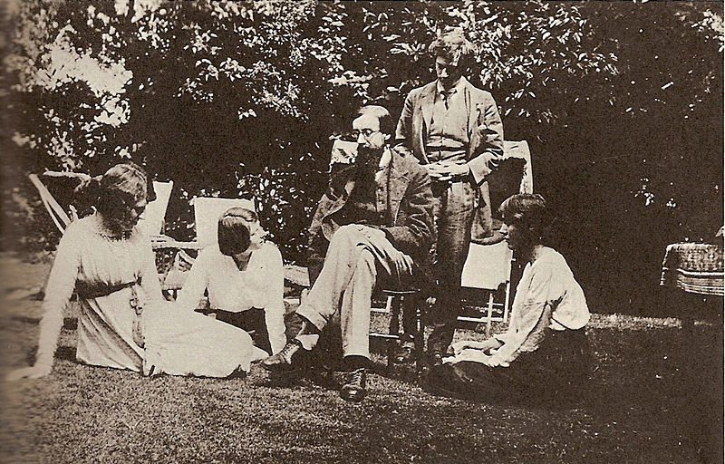

Left to right: [Lady Ottoline Morrell](http://en.wikipedia.org/wiki/Lady_Ottoline_Morrell), Maria Nys, [Lytton Strachey](http://en.wikipedia.org/wiki/Lytton_Strachey), [Duncan Grant](http://en.wikipedia.org/wiki/Duncan_Grant), and [Vanessa Bell](http://en.wikipedia.org/wiki/Vanessa_Bell).

During [World War I](http://en.wikipedia.org/wiki/World_War_I), Huxley spent much of his time at [Garsington Manor](http://en.wikipedia.org/wiki/Garsington_Manor), home of Lady [Ottoline Morrell](http://en.wikipedia.org/wiki/Ottoline_Morrell), working as a farm labourer. Here he met several [Bloomsbury](http://en.wikipedia.org/wiki/Bloomsbury_Group) figures including [D. H. Lawrence](http://en.wikipedia.org/wiki/D._H._Lawrence), [Bertrand Russell](http://en.wikipedia.org/wiki/Bertrand_Russell) and [Clive Bell](http://en.wikipedia.org/wiki/Clive_Bell). Later, in [*Crome Yellow*](http://en.wikipedia.org/wiki/Crome_Yellow) (1921) he caricatured the Garsington lifestyle. In 1919 he married Maria Nys ([10 September](http://en.wikipedia.org/wiki/September_10) [1898](http://en.wikipedia.org/wiki/1898) - [12 February](http://en.wikipedia.org/wiki/February_12) [1955](http://en.wikipedia.org/wiki/1955)), a Belgian woman he had met at Garsington. They had one child, [Matthew Huxley](http://en.wikipedia.org/w/index.php?title=Matthew_Huxley&action=edit&redlink=1) ([19 April](http://en.wikipedia.org/wiki/April_19) [1920](http://en.wikipedia.org/wiki/1920) - [10 February](http://en.wikipedia.org/wiki/February_10) [2005](http://en.wikipedia.org/wiki/2005)), who had a career as an [epidemiologist](http://en.wikipedia.org/wiki/Epidemiologist). The family lived in Italy part of the time in the 1920s, where Huxley would visit his friend D. H. Lawrence. Following Lawrence's death in 1930, he ed his letters (1933).

In 1937, Huxley moved to [Hollywood, California](http://en.wikipedia.org/wiki/Hollywood,_California) with his wife Maria, son Matthew, and friend [Gerald Heard](http://en.wikipedia.org/wiki/Gerald_Heard). He lived in the U.S., mainly in southern California, till his death, but also for a time in [Taos, New Mexico](http://en.wikipedia.org/wiki/Taos,_New_Mexico), where he wrote [*Ends and Means*](http://en.wikipedia.org/wiki/Ends_and_Means) (published in 1937). In this work he examines the fact that although most people in modern civilization agree that they want a world of "liberty, peace, justice, and brotherly love", they have not been able to agree on how to achieve it.

Heard introduced Huxley to [Vedanta](http://en.wikipedia.org/wiki/Vedanta), [mation](http://en.wikipedia.org/wiki/Meditation), and [vegetarianism](http://en.wikipedia.org/wiki/Vegetarianism) through the principle of [ahimsa](http://en.wikipedia.org/wiki/Ahimsa). In 1938 Huxley befriended [J. Krishnamurti](http://en.wikipedia.org/wiki/J._Krishnamurti), whose teachings he greatly admired. He also became a Vedantist in the circle of [Swami](http://en.wikipedia.org/wiki/Swami) [Prabhavananda](http://en.wikipedia.org/wiki/Swami_Prabhavananda), and introduced [Christopher Isherwood](http://en.wikipedia.org/wiki/Christopher_Isherwood) to this circle. Not long after, Huxley wrote his book on widely held spiritual values and ideas, [*The Perennial Philosophy*](http://en.wikipedia.org/wiki/The_Perennial_Philosophy), which discussed the teachings of renowned mystics of the world.

Huxley became a close friend of Remsen Bird, president of [Occidental College](http://en.wikipedia.org/wiki/Occidental_College). He spent much time at the college, which is in the [Eagle Rock](http://en.wikipedia.org/wiki/Eagle_Rock) neighborhood of Los Angeles. The college appears as "Tarzana College" in his satirical novel [*After Many a Summer Dies the Swan*](http://en.wikipedia.org/wiki/After_Many_a_Summer_Dies_the_Swan) (1939). The novel won Huxley that year's [James Tait Black Memorial Prize](http://en.wikipedia.org/wiki/James_Tait_Black_Memorial_Prize) for fiction. Huxley also incorporated Bird into the novel.

During this period Huxley earned some Hollywood income as a writer. In March 1938, his friend [Anita Loos](http://en.wikipedia.org/wiki/Anita_Loos), a novelist and [screenwriter](http://en.wikipedia.org/wiki/Screenwriter), put him in touch with [Metro-Goldwyn-Mayer](http://en.wikipedia.org/wiki/Metro-Goldwyn-Mayer) which hired Huxley for [*Madame Curie*](http://en.wikipedia.org/wiki/Madame_Curie_%281943_film%29) which was originally to star [Greta Garbo](http://en.wikipedia.org/wiki/Greta_Garbo) and be directed by [George Cukor](http://en.wikipedia.org/wiki/George_Cukor). (The film was eventually filmed by MGM in 1943 with a different director and stars.) Huxley got screen cr for [*Pride and Prejudice*](http://en.wikipedia.org/wiki/Pride_and_Prejudice_%281940_film%29) (1940) and was paid for his work on a number of other films, including [*Jane Eyre*](http://en.wikipedia.org/wiki/Jane_Eyre_%281944_film%29) (1944).

However, his experience in Hollywood was not a success. When he wrote a synopsis of [*Alice in Wonderland*](http://en.wikipedia.org/wiki/Alice_in_Wonderland_%281951_film%29), [Walt Disney](http://en.wikipedia.org/wiki/Walt_Disney) rejected it on the grounds that "he could only understand every third word". Huxley's leisurely development of ideas, it seemed, was not suitable for the movie moguls, who demanded fast, dynamic dialogue above all else.

For most of his life, since the illness in his teens which left Huxley nearly blind, his eyesight was poor (despite the partial recovery which had enabled him to study at Oxford). Around 1939, Huxley encountered the [Bates Method](http://en.wikipedia.org/wiki/Bates_Method) for better eyesight, and a teacher, [Margaret Corbett](http://en.wikipedia.org/wiki/Margaret_Corbett), who was able to teach him in the method. In 1940, Huxley relocated from Hollywood to a forty-acre *ranchito* in the high desert hamlet of [Llano, California](http://en.wikipedia.org/wiki/Llano,_California), in northernmost Los Angeles County. Huxley then said that his sight improved dramatically with the Bates Method and the extreme and pure natural lighting of the southwestern American desert. He reported that for the first time in over 25 years, he was able to read without [glasses](http://en.wikipedia.org/wiki/Glasses) and without strain. He even tried driving a car along the dirt road beside the ranch. He wrote a book about his successes with the Bates Method, [*The Art of Seeing*](http://en.wikipedia.org/wiki/The_Art_of_Seeing) which was published in 1942 (US), 1943 (UK).

However, while his vision had undoubtedly improved, it remained imperfect and variable. Ten years later, in 1952, [Bennett Cerf](http://en.wikipedia.org/wiki/Bennett_Cerf) was present when Huxley spoke at a Hollywood banquet, wearing no glasses and apparently reading his paper from the lectern without difficulty:

"Then suddenly he faltered—and the disturbing truth became obvious. He wasn't reading his address at all. He had learned it by heart. To refresh his memory he brought the paper closer and closer to his eyes. When it was only an inch or so away he still couldn't read it, and had to fish for a magnifying glass in his pocket to make the typing visible to him. It was an agonizing moment."[[5]](http://en.wikipedia.org/wiki/Aldous_Huxley#cite_note-Gardner-4)

This incident well exemplifies Huxley’s own words in [*The Art of Seeing*](http://en.wikipedia.org/wiki/The_Art_of_Seeing):

"The most characteristic fact about the functioning of the total organism, or any part of the organism, is that it is not constant, but highly variable. ... People with unimpaired eyes and good habits of using them possess, so to speak, a wide margin of visual safety. Even when their seeing organs are functioning badly, they still see well enough for most practical purposes. Consequently they are not so acutely conscious of variations in visual functioning as are those with bad seeing habits and impaired eyes. These last have little or no margin of safety; consequently any diminution in seeing power produces noticeable and often distressing results.”

On [21 October](http://en.wikipedia.org/wiki/October_21) [1949](http://en.wikipedia.org/wiki/1949) Huxley wrote to [George Orwell](http://en.wikipedia.org/wiki/George_Orwell), author of [*Nineteen Eighty-Four*](http://en.wikipedia.org/wiki/Nineteen_Eighty-Four), congratulating Orwell on "how fine and how profoundly important the book is." In his letter to Orwell, he predicted that "Within the next generation I believe that the world's leaders will discover that infant conditioning and narco-hypnosis are more efficient, as instruments of government, than clubs and prisons, and that the lust for power can be just as completely satisfied by suggesting people into loving their servitude as by flogging them and kicking them into obedience."[[6]](http://en.wikipedia.org/wiki/Aldous_Huxley#cite_note-Smith-5)

### [] Post-war

After [World War II](http://en.wikipedia.org/wiki/World_War_II) Huxley applied for [United States](http://en.wikipedia.org/wiki/United_States) citizenship, but his application was continuously deferred on the grounds that he would not say he would take up arms to defend the U.S., so he withdrew it. Nevertheless, he remained in the country, and in 1959 he turned down an offer of a [Knight Bachelor](http://en.wikipedia.org/wiki/Knight_Bachelor) by the [Macmillan government](http://en.wikipedia.org/wiki/Harold_Macmillan#Government). During the 1950s Huxley's interest in the field of [psychical research](http://en.wikipedia.org/wiki/Psychical_research) grew keener, and his later works are strongly influenced by both [mysticism](http://en.wikipedia.org/wiki/Mysticism) and his experiences with the [psychedelic drugs](http://en.wikipedia.org/wiki/Psychedelic_drugs).

In October 1930 the Mystic [Aleister Crowley](http://en.wikipedia.org/wiki/Aleister_Crowley) dined with Huxley in Berlin, and to this day rumours persist that Crowley introduced Huxley to [peyote](http://en.wikipedia.org/wiki/Peyote) on that occasion. He was introduced to [mescaline](http://en.wikipedia.org/wiki/Mescaline) by the psychiatrist [Humphry Osmond](http://en.wikipedia.org/wiki/Humphry_Osmond) in 1953. On [24 December](http://en.wikipedia.org/wiki/December_24) [1955](http://en.wikipedia.org/wiki/1955) Huxley took his first dose of [LSD](http://en.wikipedia.org/wiki/LSD). Indeed, Huxley was a pioneer of self-directed psychedelic drug use "in a search for enlightenment", famously taking 100 micrograms of [LSD](http://en.wikipedia.org/wiki/LSD) as he lay dying. His [psychedelic](http://en.wikipedia.org/wiki/Psychedelic) [drug](http://en.wikipedia.org/wiki/Recreational_drug_use) experiences are described in the essays [*The Doors of Perception*](http://en.wikipedia.org/wiki/The_Doors_of_Perception) (the title deriving from some lines in the book [*The Marriage of Heaven and Hell*](http://en.wikipedia.org/wiki/The_Marriage_of_Heaven_and_Hell) by [William Blake](http://en.wikipedia.org/wiki/William_Blake)), and [*Heaven and Hell*](http://en.wikipedia.org/wiki/Heaven_and_Hell_%28essay%29). Some of his writings on psychedelics became frequent reading among early [hippies](http://en.wikipedia.org/wiki/Hippies). While living in Los Angeles, Huxley was a friend of [Ray Bradbury](http://en.wikipedia.org/wiki/Ray_Bradbury). According to Sam Weller's biography of Bradbury, the latter was dissatisfied with Huxley, especially after Huxley encouraged Bradbury to take psychedelic drugs.

In 1955 Huxley's wife, Maria, died of [breast cancer](http://en.wikipedia.org/wiki/Breast_cancer). In 1956 he married [Laura Archera](http://en.wikipedia.org/wiki/Laura_Huxley) (1911-2007), also an author. She wrote a [biography](http://en.wikipedia.org/wiki/Biography) of Huxley. In 1960 Huxley himself was diagnosed with [cancer](http://en.wikipedia.org/wiki/Laryngeal_cancer), and in the years that followed, with his health deteriorating, he wrote the Utopian novel [*Island*](http://en.wikipedia.org/wiki/Island_%28novel%29), and gave lectures on "Human Potentialities" at the [Esalen](http://en.wikipedia.org/wiki/Esalen) institute, which were fundamental to the forming of the [Human Potential Movement](http://en.wikipedia.org/wiki/Human_Potential_Movement). On his deathbed, unable to speak, Huxley made a written request to his wife for "LSD, 100 µg, intramuscular.". According to her account of his death (in her book *This Timeless Moment*), she obliged with an injection at 11:45 am and another a couple of hours later. He died at 5:21 pm on [22 November](http://en.wikipedia.org/wiki/November_22) [1963](http://en.wikipedia.org/wiki/1963), aged 69. Media coverage of his death was overshadowed by the [assassination of President John F. Kennedy](http://en.wikipedia.org/wiki/John_F._Kennedy_assassination), on the same day, as was the death of the Irish author [C. S. Lewis](http://en.wikipedia.org/wiki/C._S._Lewis). Huxley's ashes were interred in the family grave at the Watts Cemetery, Compton, [Guildford](http://en.wikipedia.org/wiki/Guildford), [Surrey](http://en.wikipedia.org/wiki/Surrey), [England](http://en.wikipedia.org/wiki/England).

Huxley's only child, Matthew, was also an author, as well as an educator, [anthropologist](http://en.wikipedia.org/wiki/Anthropology), and prominent [epidemiologist](http://en.wikipedia.org/wiki/Epidemiology). His work ranged from promoting universal health care to establishing standards of care for nursing home patients and the mentally ill to investigating the question of what is a socially sanctionable drug.[[7]](http://en.wikipedia.org/wiki/Aldous_Huxley#cite_note-6) Matthew's first marriage, in [April](http://en.wikipedia.org/wiki/April) 1950, was to documentary filmmaker [Ellen Hovde](http://en.wikipedia.org/w/index.php?title=Ellen_Hovde&action=edit&redlink=1), and ended in divorce in 1961. His second wife, author and [*Washington Post*](http://en.wikipedia.org/wiki/Washington_Post) food columnist Judith Wallet Bordage, whom he married on [22 March](http://en.wikipedia.org/wiki/March_22) [1963](http://en.wikipedia.org/wiki/1963), died in 1983. He was survived by his third wife, Franziska Reed Huxley, and two children from his first marriage, Trevenen Huxley (b. [20 October](http://en.wikipedia.org/wiki/October_20) [1951](http://en.wikipedia.org/wiki/1951)) and Tessa Huxley (b. [October](http://en.wikipedia.org/wiki/October) 1953).

## [] Literary themes

*Crome Yellow* (1921) attacks Victorian and Edwardian social principles which led to World War I and its terrible aftermath. Together with Huxley's second novel, [*Antic Hay*](http://en.wikipedia.org/wiki/Antic_Hay) (1923), the book expresses much of the mood of disenchantment of the early 1920s. It was intended to reflect, as Huxley stated in a letter to his father, "the life and opinions of an age which has seen the violent disruption of almost all the standards, conventions and values current in the present epoch."

Huxley's reputation for iconoclasm and emancipation grew. He was condemned for his explicit discussion of sex and free thought in his fiction. *Antic Hay*, for example, was burned in Cairo and in the years that followed many of Huxley's books were received with disapproval or banned at one time or another. The exclusion of [*Brave New World*](http://en.wikipedia.org/wiki/Brave_New_World), [*Point Counter Point*](http://en.wikipedia.org/wiki/Point_Counter_Point) and *Island* from [*Time*](http://en.wikipedia.org/wiki/Time_%28magazine%29) magazine's all-time 100 novels list created an uproar.[[*citation needed*](http://en.wikipedia.org/wiki/Wikipedia:Citation_needed)][[*when?*](http://en.wikipedia.org/wiki/Wikipedia:Manual_of_Style_%28dates_and_numbers%29#Chronological_items)]

Huxley, however, said that a novel should be full of interesting opinions and arresting ideas, describing his aim as a novelist as being 'to arrive, technically, at a perfect fusion of the novel and the essay'; and with *Point Counter Point* (1928), Huxley wrote his first true 'novel of ideas', the type of thought-provoking fiction with which he is now associated.

One of his main ideas was pessimism about the cultural future of society, a pessimism which sprang largely from his visit to the United States between September 1925 and June 1926. He recounted his experiences in *Jesting Pilate* (1926): "The thing which is happening in America is a reevaluation of values, a radical alteration (for the worse) of established standards", and it was soon after this visit that he conceived the idea of writing a satire of what he had encountered.[[8]](http://en.wikipedia.org/wiki/Aldous_Huxley#cite_note-7)

*Brave New World* (1932) as well as *Island* (1962) form the cornerstone of Huxley's damning indictment of commercialism based upon goods generally manufactured from other countries. Indeed also, a *Brave New World* (along with Orwell's *Nineteen Eighty-Four* and [Yevgeni Zamyatin](http://en.wikipedia.org/wiki/Yevgeni_Zamyatin)'s *We*) helped form the anti-utopian or dystopian tradition in literature and has become synonymous with a future world in which the human spirit is subject to conditioning and control. *Island* acts as an antonym to *Brave New World*; it is described as "one of the truly great philosophical novels".[[9]](http://en.wikipedia.org/wiki/Aldous_Huxley#cite_note-8)

He devoted his time at his small house at Llano in the [Mojave Desert](http://en.wikipedia.org/wiki/Mojave_Desert) to a life of contemplation, mysticism, and experimentation with hallucinogenic drugs. His suggestions in *The Doors of Perception* (1954) that [mescaline](http://en.wikipedia.org/wiki/Mescaline) and [lysergic acid](http://en.wikipedia.org/wiki/Lysergic_acid) were 'drugs of unique distinction' which should be exploited for the 'supernaturally brilliant' visionary experience they offered provoked even more outrage than his passionate defense of the [Bates method](http://en.wikipedia.org/wiki/Bates_method) in *The Art of Seeing* (1942). However, the book went on to become a cult text in the psychedelic 1960s, and inspire the name of the rock band "The Doors". Huxley also appears on the sleeve of the [Beatles](http://en.wikipedia.org/wiki/Beatles)' landmark 1967 album [*Sgt. Pepper's Lonely Hearts Club Band*](http://en.wikipedia.org/wiki/Sgt._Pepper%27s_Lonely_Hearts_Club_Band).

## [] Awards

In 1959 Aldous Huxley received the [American Academy of Arts and Letters](http://en.wikipedia.org/wiki/American_Academy_of_Arts_and_Letters) Award of Merit for the novel *Brave New World*. He received the James Tait Black Memorial Prize in 1939 for *After Many a Summer Dies the Swan*.

## [] Films

Notable works include the original screenplay for [Disney's](http://en.wikipedia.org/wiki/The_Walt_Disney_Company) animated [*Alice in Wonderland*](http://en.wikipedia.org/wiki/Alice_in_Wonderland_%281951_film%29) (which was rejected because it was too literary[[10]](http://en.wikipedia.org/wiki/Aldous_Huxley#cite_note-9)), two productions of [*Brave New World*](http://en.wikipedia.org/wiki/Brave_New_World), one of [*Point Counter Point*](http://en.wikipedia.org/wiki/Point_Counter_Point), one of [*Eyeless in Gaza*](http://en.wikipedia.org/wiki/Eyeless_in_Gaza), and one of [*Ape and Essence*](http://en.wikipedia.org/wiki/Ape_and_Essence). He was a cred screenwriter for [*Pride and Prejudice*](http://en.wikipedia.org/wiki/Pride_and_Prejudice_%281940_movie%29) (1940), co-authored the screenplay for [*Jane Eyre*](http://en.wikipedia.org/wiki/Jane_Eyre_%281944_movie%29) (1944) with [John Houseman](http://en.wikipedia.org/wiki/John_Houseman), [*A Woman's Vengeance*](http://en.wikipedia.org/wiki/A_Woman%27s_Vengeance) (1947), and contributed to the screenplays of [*Madame Curie*](http://en.wikipedia.org/wiki/Madame_Curie_%28film%29) (1943) and [*Alice in Wonderland*](http://en.wikipedia.org/wiki/Alice_in_Wonderland_%281951_film%29) (1951) without cr.

Director [Ken Russell](http://en.wikipedia.org/wiki/Ken_Russell)'s 1971 film [*The Devils*](http://en.wikipedia.org/wiki/The_Devils_%28film%29), starring [Vanessa Redgrave](http://en.wikipedia.org/wiki/Vanessa_Redgrave) and [Oliver Reed](http://en.wikipedia.org/wiki/Oliver_Reed), was adapted from Huxley's [*The Devils of Loudun*](http://en.wikipedia.org/wiki/The_Devils_of_Loudun). A made-for-television adaptation of *Brave New World* was made in 1990.

## [] Quotations

* On [truth](http://www.cybernation.com/quotationcenter/quoteshow.php?type=author&id=4470): "Great is truth, but still greater, from a practical point of view, is silence about truth. By simply not mentioning certain subjects... totalitarian propagandists have influenced opinion much more effectively than they could have by the most eloquent denunciations."
* On psychological totalitarianism [[11]](http://en.wikipedia.org/wiki/Aldous_Huxley#cite_note-10) (1959): "And it seems to me perfectly in the cards that there will be within the next generation or so a pharmacological method of making people love their servitude, and producing ... a kind of painless concentration camp for entire societies, so that people will in fact have their liberties taken away from them but will rather enjoy it, because they will be distracted from any desire to rebel by propaganda, brainwashing, or brainwashing enhanced by pharmacological methods."
* On [social organizations](http://www.cybernation.com/quotationcenter/quoteshow.php?type=author&id=4470): "One of the many reasons for the bewildering and tragic character of human existence is the fact that social organization is at once necessary and fatal. Men are forever creating such organizations for their own convenience and forever finding themselves the victims of their home-made monsters."
* On [heroin](http://en.wikipedia.org/wiki/Heroin): "Who lives longer: the man who takes heroin for two years and dies, or the man who lives on roast beef, water, and potatoes till ninety-five? One passes his twenty-four months in eternity. All the years of the beef-eater are lived only in time."
* On experience: "Experience is not what happens to a man; it is what a man does with what happens to him." – *Texts and Pretexts*, 1932
* "After silence, that which comes nearest to expressing the inexpressible is music." *Music at Night*, 1931
* "Liberty? Why it doesn't exist. There is no liberty in this world, just gilded cages." *Antic Hay*, 1923
* "Democracy and freedom will be the theme of every broadcast and orial - but democracy and freedom in a strictly [Pickwickian](http://en.wikipedia.org/wiki/The_Pickwick_Papers) sense." - [*Brave New World Revisited*](http://en.wikipedia.org/wiki/Brave_New_World_Revisited)
* On religion: "You never see animals going through the absurd and often horrible fooleries of magic and religion... Dogs do not ritually urinate in the hope of persuading heaven to do the same and send down rain. Asses do not bray a liturgy to cloudless skies. Nor do cats attempt, by abstinence from cat's meat, to wheedle the feline spirits into benevolence. Only man behaves with such gratuitous folly. It is the price he has to pay for being intelligent but not, as yet, quite intelligent enough."
* "God deliver us from such criminal imbecility." [*Ends and Means*](http://en.wikipedia.org/wiki/Ends_and_Means)

## [] Bibliography

Novels

* [*Crome Yellow*](http://en.wikipedia.org/wiki/Crome_Yellow) (1921)
* [*Antic Hay*](http://en.wikipedia.org/wiki/Antic_Hay) (1923)
* [*Those Barren Leaves*](http://en.wikipedia.org/wiki/Those_Barren_Leaves) (1925)
* [*Point Counter Point*](http://en.wikipedia.org/wiki/Point_Counter_Point) (1928)
* [*Brave New World*](http://en.wikipedia.org/wiki/Brave_New_World) (1932)
* [*Eyeless in Gaza*](http://en.wikipedia.org/wiki/Eyeless_in_Gaza) (1936)
* [*After Many a Summer Dies the Swan*](http://en.wikipedia.org/wiki/After_Many_a_Summer_Dies_the_Swan) (1939)
* [*Time Must Have a Stop*](http://en.wikipedia.org/w/index.php?title=Time_Must_Have_a_Stop&action=edit&redlink=1) (1944)
* [*Ape and Essence*](http://en.wikipedia.org/wiki/Ape_and_Essence) (1948)
* [*The Genius and the Goddess*](http://en.wikipedia.org/wiki/The_Genius_and_the_Goddess) (1955)
* [*Island*](http://en.wikipedia.org/wiki/Island_%28novel%29) (1962)

Short stories

* [*Limbo*](http://en.wikipedia.org/wiki/Limbo_%28Huxley%29) (1920)
* [*Mortal Coils*](http://en.wikipedia.org/wiki/Mortal_Coils) (1922)
* [*Little Mexican*](http://en.wikipedia.org/wiki/Little_Mexican) (U.S. - *Young Archimedes*) (1924)
* [*Two or Three Graces*](http://en.wikipedia.org/wiki/Two_or_Three_Graces) (1926)
* [*Brief Candles*](http://en.wikipedia.org/wiki/Brief_Candles) (1930)
* [*Jacob's Hands; A Fable*](http://en.wikipedia.org/wiki/Jacob%27s_Hands;_A_Fable) (Late 1930s, rediscovered 1997) co-written with [Christopher Isherwood](http://en.wikipedia.org/wiki/Christopher_Isherwood)
* [*Collected Short Stories*](http://en.wikipedia.org/wiki/Collected_Short_Stories_%28Huxley%29) (1957)

Poetry

* [*The Burning Wheel*](http://en.wikipedia.org/w/index.php?title=The_Burning_Wheel_%28Huxley%29&action=edit&redlink=1) (1916)
* [*Jonah*](http://en.wikipedia.org/w/index.php?title=Jonah_%28Huxley%29&action=edit&redlink=1) (1917)
* [*The Defeat of Youth*](http://en.wikipedia.org/w/index.php?title=The_Defeat_of_Youth&action=edit&redlink=1) (1918)
* [*Leda*](http://en.wikipedia.org/wiki/Leda) (1920)
* [*Arabia Infelix*](http://en.wikipedia.org/w/index.php?title=Arabia_Infelix&action=edit&redlink=1) (1929)
* [*The Cicadas*](http://en.wikipedia.org/w/index.php?title=The_Cicadas&action=edit&redlink=1) (1931)
* [*First Philosopher's Song*](http://en.wikipedia.org/w/index.php?title=First_Philosopher%27s_Song&action=edit&redlink=1)

Travel writing

* [*Along The Road*](http://en.wikipedia.org/w/index.php?title=Along_The_Road&action=edit&redlink=1) (1925)
* [*Jesting Pilate*](http://en.wikipedia.org/w/index.php?title=Jesting_Pilate:_The_Diary_of_a_Journey_%28Huxley%29&action=edit&redlink=1) (1926) The author recounts his experiences travelling through six countries, offering his observations on their people, cultures and customs.
* [*Beyond the Mexique Bay*](http://en.wikipedia.org/wiki/Beyond_the_Mexique_Bay) (1934)

Drama

* *Now More Than Ever* ([University of Texas, Austin](http://en.wikipedia.org/wiki/University_of_Texas,_Austin), 1997)
* *The Ambassador of Captripedia* (1967)
* *The Genius and the Goddess* (stage version, co-written with Betty Wendel, 1958)
* [*Mortal Coils - A Play*](http://en.wikipedia.org/w/index.php?title=Mortal_Coils_-_A_Play&action=edit&redlink=1) (stage version of *The Gioconda Smile*, 1948)
* [*The World of Light*](http://en.wikipedia.org/w/index.php?title=The_World_of_Light&action=edit&redlink=1) (1931)
* [*The Discovery*](http://en.wikipedia.org/w/index.php?title=The_Discovery&action=edit&redlink=1) (adapted from Francis Sheridan, 1924)

Essay collections

* [*On the Margin*](http://en.wikipedia.org/w/index.php?title=On_the_Margin&action=edit&redlink=1) (1923)
* [*Along the Road*](http://en.wikipedia.org/w/index.php?title=Along_the_Road&action=edit&redlink=1) (1925)
* [*Essays New and Old*](http://en.wikipedia.org/w/index.php?title=Essays_New_and_Old&action=edit&redlink=1) (1926)
* [*Proper Studies*](http://en.wikipedia.org/w/index.php?title=Proper_Studies&action=edit&redlink=1) (1927)
* [*Do What You Will*](http://en.wikipedia.org/w/index.php?title=Do_What_You_Will&action=edit&redlink=1) (1929)
* [*Vulgarity in Literature*](http://en.wikipedia.org/w/index.php?title=Vulgarity_in_Literature&action=edit&redlink=1) (1930)
* [*Music at Night*](http://en.wikipedia.org/w/index.php?title=Music_at_Night&action=edit&redlink=1) (1931)
* [*Texts and Pretexts*](http://en.wikipedia.org/w/index.php?title=Texts_and_Pretexts&action=edit&redlink=1) (1932)
* [*The Olive Tree*](http://en.wikipedia.org/w/index.php?title=The_Olive_Tree_%28Essay%29&action=edit&redlink=1) (1936)
* [*Words and their Meanings*](http://en.wikipedia.org/w/index.php?title=Words_and_their_Meanings&action=edit&redlink=1) (1940)
* [*The Art of Seeing*](http://en.wikipedia.org/wiki/The_Art_of_Seeing) (1942)
* [*The Perennial Philosophy*](http://en.wikipedia.org/wiki/The_Perennial_Philosophy) (1945)
* [*Science, Liberty and Peace*](http://en.wikipedia.org/w/index.php?title=Science,_Liberty_and_Peace&action=edit&redlink=1) (1946)
* [*Themes and Variations*](http://en.wikipedia.org/w/index.php?title=Themes_and_Variations&action=edit&redlink=1) (1950)
* [*Tomorrow and Tomorrow and Tomorrow*](http://en.wikipedia.org/w/index.php?title=Tomorrow_and_Tomorrow_and_Tomorrow_%28Huxley%29&action=edit&redlink=1) (1952)
* [*The Doors of Perception*](http://en.wikipedia.org/wiki/The_Doors_of_Perception) (1954)
* [*Heaven and Hell*](http://en.wikipedia.org/wiki/Heaven_and_Hell_%28essay%29) (1956)
* [*Adonis and the Alphabet*](http://en.wikipedia.org/w/index.php?title=Adonis_and_the_Alphabet&action=edit&redlink=1) (1956)
* [*Collected Essays*](http://en.wikipedia.org/w/index.php?title=Collected_Essays_%28Huxley%29&action=edit&redlink=1) (1958)
* [*Brave New World Revisited*](http://en.wikipedia.org/wiki/Brave_New_World#Brave_New_World_Revisited) (1958)
* [*Literature and Science*](http://en.wikipedia.org/wiki/Literature_and_Science) (1963)

Philosophy

* [*Ends and Means*](http://en.wikipedia.org/wiki/Ends_and_Means) (1937)
* [*The Perennial Philosophy*](http://en.wikipedia.org/wiki/The_Perennial_Philosophy) (1944) ([ISBN 0-06-057058-X](http://en.wikipedia.org/wiki/Special:BookSources/006057058X))

Biography and nonfiction

* [*The Devils of Loudun*](http://en.wikipedia.org/wiki/The_Devils_of_Loudun) (1953) ([ISBN 0-78670-368-7](http://en.wikipedia.org/wiki/Special:BookSources/0786703687))
* [*Grey Eminence*](http://en.wikipedia.org/wiki/Grey_Eminence) (1941) ([ISBN 0-70110-802-9](http://en.wikipedia.org/wiki/Special:BookSources/0701108029))
* [*Selected Letters*](http://en.wikipedia.org/w/index.php?title=Selected_Letters&action=edit&redlink=1) (2007) ([ISBN 1-56663-629-9](http://en.wikipedia.org/wiki/Special:BookSources/1566636299))

Children's literature

* [*The Crows of Pearblossom*](http://en.wikipedia.org/wiki/The_Crows_of_Pearblossom) (1967)
* [*The Travails and Tribulations of Geoffrey Peacock*](http://en.wikipedia.org/w/index.php?title=The_Travails_and_Tribulations_of_Geoffrey_Peacock&action=edit&redlink=1) (1967)

Collections

* [*Texts and Pretexts*](http://en.wikipedia.org/w/index.php?title=Texts_and_Pretexts&action=edit&redlink=1) (1933)
* [*Collected Short Stories*](http://en.wikipedia.org/wiki/Collected_Short_Stories_%28Huxley%29) (1957)
* *Collected Essays* (1958)
* [*Moksha: Writings on Psychedelics and the Visionary Experience*](http://en.wikipedia.org/w/index.php?title=Moksha:_Writings_on_Psychedelics_and_the_Visionary_Experience&action=edit&redlink=1) (1977)
* [*The Human Situation: Lectures at Santa Barbara, 1959*](http://en.wikipedia.org/w/index.php?title=The_Human_Situation:_Lectures_at_Santa_Barbara,_1959&action=edit&redlink=1) (1977)

.

## [] References

1. [**^**](http://en.wikipedia.org/wiki/Aldous_Huxley#cite_ref-0) Thody, Philipe (1973). Huxley: A Biographical Introduction. Scribner.
2. [**^**](http://en.wikipedia.org/wiki/Aldous_Huxley#cite_ref-1) Huxley, Aldous (1939). "biography and bibliography (appendix)", After Many A Summer Dies The Swan (1st Perennial Classic Ed.). Harper & Row, Publishers, 243.
3. [**^**](http://en.wikipedia.org/wiki/Aldous_Huxley#cite_ref-2) Julian Huxley 1965. *Aldous Huxley 1894–1963: a memorial volume*. Chatto & Windus, London. p22
4. [**^**](http://en.wikipedia.org/wiki/Aldous_Huxley#cite_ref-Crick_3-0) Crick, Bernard (1992). George Orwell: A Life. Penguin Books.
5. [**^**](http://en.wikipedia.org/wiki/Aldous_Huxley#cite_ref-Gardner_4-0) From Bennet Cerf’s column in *The Saturday Review*, [April 12](http://en.wikipedia.org/wiki/April_12), [1952](http://en.wikipedia.org/wiki/1952), quoted in Gardner, Martin (1957). Fads and Fallacies in the Name of Science. Dover Publications.
6. [**^**](http://en.wikipedia.org/wiki/Aldous_Huxley#cite_ref-Smith_5-0) Smith, Grover (1969). Letters of Aldous Huxley. Chatto & Windus.
7. [**^**](http://en.wikipedia.org/wiki/Aldous_Huxley#cite_ref-6) [Author, NIMH Epidemiologist Matthew Huxley Dies at 84 (washingtonpost.com)](http://www.washingtonpost.com/wp-dyn/articles/A31009-2005Feb16.html)
8. [**^**](http://en.wikipedia.org/wiki/Aldous_Huxley#cite_ref-7) Huxley, Aldous (2003). "British Literature (1918-1945)", Words Words Words. La Spiga Languages, 217-218.
9. [**^**](http://en.wikipedia.org/wiki/Aldous_Huxley#cite_ref-8) The Times
10. [**^**](http://en.wikipedia.org/wiki/Aldous_Huxley#cite_ref-9) Bradshaw, David (1993). "Introduction", Aldous Huxley's "Those Barren Leaves" (Vintage Classics Edn., 2005). Vintage, Random House, 20 Vauxhall Brigade Road, London, xii.
11. [**^**](http://en.wikipedia.org/wiki/Aldous_Huxley#cite_ref-10) [More Than 54,000 Great Quotations To Inspire You!](http://www.cybernation.com/quotationcenter/quoteshow.php?type=author&id=4470)

## [] External links

* [Works by or about Aldous Huxley](http://worldcat.org/identities/lccn-n80-57246) in libraries ([WorldCat](http://en.wikipedia.org/wiki/WorldCat" \o "WorldCat) catalog)
* [Aldous Huxley](http://www.isfdb.org/cgi-bin/ea.cgi?Aldous_Huxley) at the [Internet Speculative Fiction Database](http://en.wikipedia.org/wiki/Internet_Speculative_Fiction_Database)
* [Works by Aldous Huxley](http://www.gutenberg.org/author/Aldous_Huxley) at [Project Gutenberg](http://en.wikipedia.org/wiki/Project_Gutenberg)
* [Aldous Huxley](http://www.imdb.com/name/nm0404717/) at the [Internet Movie Database](http://en.wikipedia.org/wiki/Internet_Movie_Database)
  + [*Das Genie und die Göttin (The Genius and The Goddess)*](http://www.imdb.com/title/tt0342464/) at the [Internet Movie Database](http://en.wikipedia.org/wiki/Internet_Movie_Database)
  + [*Aldous Huxley: The Gravity of Light*](http://www.imdb.com/title/tt0115497/) at the [Internet Movie Database](http://en.wikipedia.org/wiki/Internet_Movie_Database)
* [LitWeb.net: Aldous Huxley Biography](http://www.litweb.net/biography/266/Aldous_Huxley.html)
* [Video interviews of Huxley](http://www.yoism.org/?q=node/143) from the 1950s, exploring *Brave New World*, *Island*, and psychedelics
* [somaweb.org](http://somaweb.org/) Comprehensive information on Aldous Huxley and *Brave New World*. Including: biography, quotes, bibliography, discussion forum, etc..
* [The Ultimate Revolution](http://sunsite.berkeley.edu/VideoTest/hux1.ram) (talk at [UC Berkeley](http://en.wikipedia.org/wiki/University_of_California,_Berkeley), [March 20](http://en.wikipedia.org/wiki/March_20), [1962](http://en.wikipedia.org/wiki/1962))
* Interviewed by Raymond Fraser, George Wickes (Spring 1960). "[Aldous Huxley: The Art of Fiction No. 24](http://www.theparisreview.org/viewinterview.php/prmMID/4698" \o "http://www.theparisreview.org/viewinterview.php/prmMID/4698)", *The Paris Review*.
* [Huxley interviewed on *The Mike Wallace interview*](http://www.hrc.utexas.edu/multimedia/video/2008/wallace/huxley_aldous.html), [May 18](http://en.wikipedia.org/wiki/May_18), [1958](http://en.wikipedia.org/wiki/1958).
* [Select Quotes of Aldous Huxley](http://www.kevinstilley.com/aldous-huxley-select-quotes/)
* [Aldous Huxley](http://www.findagrave.com/cgi-bin/fg.cgi?page=gr&GRid=8707127) at [Find A Grave](http://en.wikipedia.org/wiki/Find_A_Grave)

<http://mural.uv.es/~mifepra/huxley_aldous2.jpg&imgrefurl>

BIOGRAPHY

Aldous Leonard Huxley was born on July 26, 1894 in Godalming, Surrey, in the SE of England. He was the third son of Dr. Leonard Huxley and Julia Arnold. Huxley belonged to a family whose members were recognised to be intellectual people. He was the grandson of Thomas Henry Huxley, who was a very important biologist who developed an interesting theory on the evolution. His aunt, Mrs. Humphrey Ward, was a famous late-Victorian novelist, and the father of his aunt, Matthew Arnold, was a poet. Aldous's mother was the granddaughter of Thomas Arnold, a famous educator. One of his brothers was a great zoologist, also the first direct of Unesco. So, observing the atmosphere in which Aldous Leonard grew up, we can tell that he was very influenced by his relatives. If we focus our attention on the book I want to analyse, we can see that there is a heritage in the book from both sides; there is the extraordinary capacity of writing, he has a determined style, and of course there is the knowledge of human evolution and his idea of a utopic future. The class structure that was so important in the England of Huxley’s childhood is also to be seen in the society which he presents in Brave New World.

Huxley had some experiences which made him stand apart from the class to which he belonged by birth. He was considered different as a child for his intelligence; we can also see that Huxley reflected this sense, this feeling of being an outsider in characters such as Bernard Marx and Hemholtz. These characters used to gather together and speak about their emotions that life produced on them. Huxley might have felt different from other people, like these two Alpha Plus men.

The death of his mother from cancer when he was only 14 , in 1908, meant also a change in his life; it gave him a sense of the transience of human happiness, and of course, it led to the break-up of the family home. You can also see the feeling that means the loss of one’s mother in Brave New World through the Savage’s reactions. In August 1914, one of his brothers, Trevenen, committed suicide; this also affected him of course, besides because Aldous was very close to him. Over twenty years later, in 1936, Huxley published Eyeless in Gaza, were the death of his mother and brother are reflected.

Huxley studied at the prestigious school Eton. At the age of 16, an eye illness made him nearly blind, and forced him to leave school. Therefore he couldn’t complete some scientific training that was so interesting for him; in the beginning, he intended to study medcine, then he turned to literature. Even though, his eyesight improved after a couple of years and he recovered enough to go to Oxford University where he graduated in English literature. He was unfit for military service and didn’t fight in World War I, which was an experience that marked a lot of his other colleges. Instead he worked as a farm labourer at Lady Ottoline Morrell's Garsington Manor. Huxley was very interested in science, and he had really good ideas related to the subject; he used some of these in Brave New World, although he never managed to work in a big scientific project.

While being at Oxford, he met writers like Lytton Strachey, D. H. Lawrence and Bertrand Russell.

Huxley started his career as a journalist, he also practised music and artistic criticism and made a few book reviews. Huxley published his first book in 1916, it was a collection of poems, "The Burning Wheel". The three books which followed this one, were also poem books, in which the influence of French symbolism is to be seen. He married in 1919 a Belgian refugee, Maria Nys, and they had a child, Matthew Huxley, the year after. By then Huxley was working for the Athenaeum magazine, after that, he became the first British editor of the magazine House and Garden; he also worked for Vogue. Huxley's family travelled a lot, especially between London and Italy, but also to places such as India and the United States. They lived first near Florence and then on the Côte d'Azur. In Along th Road, 1925, Huxley describes all the places and works of art he had taken in since his arrival in Italy.

Huxley he wrote many novels, which were more appreciated by the public than his essays and poems. He became more famous, with his reputation established, when his first novel "Crome Yellow" (1921) was published. Huxley wrote some comic novels, such as "Antic Hay" (1923) and "Those Barren Leaves" (1925); here he made clear that he had an extraordinary ability in introducing very intellectual ideas in fiction novels. In Crome Yellow and in Antic Hay he shows the expression of a mood of disenchantment in the early 1920s related to the past Victorian mores. His generation had experienced "the violent disruption of almost all the standards, conventions and values current in the previous epoch", in Huxley's words. Some people criticised the explicit discussion of sex in his novel Antic Hay, which was even burned in Cairo due to these criticisms. He published a book of essays about philosophical and social aspects in 1927, "Proper Studies".

When Huxley first visited the United States around 1926, he was amused by the extravagance of American society, but he didn’t like how American people spent their free time, spending it in useless things and not in trying to improve their mental capacity "Nowhere, perhaps, is there so little conversation... It is all movement and noise..." was what he said about this. It was his visit to the United States which made him so pesimistic about the cultural future of Europe. He said: "The thing which is happening in America is a revaluation of values, a radical alteration (for the worse) of established standards."

He could see the fascist Italy that was led by Benito Mussolini; this might have had some influence in Brave New World. Fascism and the incidents of the Soviet Union helped him when creating his distopia or bad utopia. Huxley was in each of his writings very critical with Western civilization.

Huxley wrote Brave New World, his most celebrated work, in only four months in 1931. Three years before this his best sold novel "Point Counter Point" (1928) had been published; here he tried to mix the novel and the essay. During these three years, he had written some stories, poems and some essays, but no big novel. Brief Candles, 1930,was a collection of short stories, Music at Night, 1931, volumes of essays.

In April 1937, the Huxleys arrived to the United States; he was by then a very famous novelist and the Peace Pledge Union's celebrity. By that time, Huxley was more concerned with things such as anarchism or mystical salvation than with the lamentable situation of the contemporary society. Huxley has the intention of returning to Europe, but his wife needed to live in a hot and dry climate. The year after they moved to Hollywood, Aldous worked as a screenwriter. In After Many a Summer, 1939, Huxley expresses his reaction to Hollywood and the cult to movie stars. Huxley and Hollywood were not compatible, and Aldous was unable to write a popular play during the inter-war years. He became disenchanted with the world of the film studios, and he reflects this in Ape and Essence, 1948.

In 1946 Huxley wrote a foreword to Brave New World. There he explained that he intended to find a sane society, and that he believed that it existed. Even though, he was worried about the dangers that might cause society fall into insanity.

Huxley was worried about the spirituality of the world citizens by that time; this led him towards mysticism and drugs. In the 1950’s Huxley became famous for his interest in a determined type of drugs, like LSD; he looked for drugs that would release your mind, would make you forget your problems, escape from your present but that had no negative effect. Apparently, he consumed drugs like mescaline and LSD a dozen times over ten years.

His ideas and obsessions with drugs are to be seen in a few books: Doors of Perception (1954), Heaven and Hell (1956), Island (1962)...

Huxley produced 47 books in his life. Some critics say that he was a better essayist than a novelist, because he cared more for his ideas than for the development of his characters in his books. Even though Huxley really in better at writing essays, his most read books are novels. In 1959 the American Academy of Arts and Letters gave him the Award of Merit for the novel.

During the 1960’s he became a cult figure. The famous music group "The Doors" named themselves after one of Huxley’s novels, "the Doors of Perception".

Once, there was a fire in his house and all his papers and books burned; after this incident, he called himself "a man without a past".

Huxley’s interests were very varied. He liked Greek history, Buddhist texts, philosophy, science, psychology... And he knew a lot of things about these subject so we can say he had a privileged mind.

Aldous Huxley was a pacifist. He remained blind nearly all his life. Maria, his first wife, died in 1955 and Huxley married Laura Archera a year later. He died in November 22 of 1963, the same day that President John F. Kennedy was assassinated.

Bibliography in this page:

[www.primenet.com/~matthew/huxley/huxbio.html](http://www.primenet.com/%7Ematthew/huxley/huxbio.html)

[www.gradesaver.com/ClassicNotes/Titles/BraveNewWorld.html](http://www.gradesaver.com/ClassicNotes/Titles/BraveNewWorld.html)

Introduction by David Bradshaw; Worcester College, Oxford, 1993 in Brave New World, Flamingo, 1994

© Mireia Ferrandis Pradas