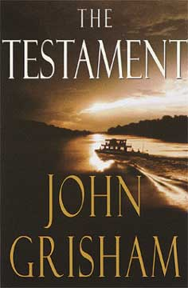 The Testament
Troy Phelan is a self-made billionaire, one of the richest men in the United States. He is also eccentric, reclusive, confined to a wheelchair, and looking for a way to die. His heirs, to no one’s surprise -- especially Troy’s -- are circling like vultures.
Nate O’Riley is a high-octane Washington litigator who’s lived too hard, too fast, for too long. He is emerging from his fourth stay in rehab with little more than fragile sobriety and good intentions.
Rachel Lane is a young woman who chose to give her life to God, who walked away from the modern world to live and work with a primitive tribe of Indians in the deepest jungles of Brazil.
Their lives are forever altered by the startling secret of The Testament.
(Taken from the cover of The Testament.).

