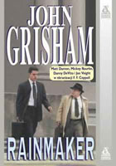 The Rainmaker
In his final semester of law school, Rudy Baylor is required to provide free legal advice to a group of senior citizens. There he meets the Dot and Buddy Black. Their son, Donny son is dying of leukemia and their insurance has refused to pay for his medical treatments.
Rudy finds himself taking on one of the most powerful, corrupt, and ruthless companies in America—and exposing a complex, multibillion dollar insurance scheme.
(Taken from the cover of The Rainmaker).

