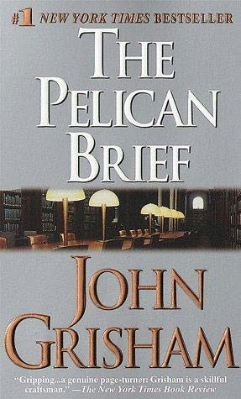 The Pelican Brief
America learns that two of its Supreme Court justices have been assassinated. And in New Orleans, a young law student prepares a legal brief . . .
To Darby Shaw it was no more than a legal shot in the dark, a brilliant guess. To the Washington establishment it was political dynamite. Suddenly Darby is witness to a murder--a murder intended for her. Going underground, she finds there is only one person she can trust--an ambitious reporter after a newsbreak hotter than Watergate--to help her piece together the deadly puzzle. Somewhere between the bayous of Louisiana and the White House's inner sanctums, a violent cover-up is being engineered. For someone has read Darby's brief –
(Taken from the cover of The Pelican Brief.)

