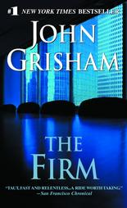 The Firm
At the top of his class at Harvard Law, he had his choice of the best in America. He made a deadly mistake.
When Mitch McDeere signed on with Bendini, Lambert & Locke of Memphis, he thought he and his beautiful wife, Abby, were on their way. The firm leased him a BMW, paid off his school loans, arranged a mortgage, and hired him a decorator. You never get nothing for nothing. Now the FBI has the lowdown on Mitch's firm and needs his help. Mitch is caught between a rock and a hard place, with no choice--if he wants to live.
(Taken from the cover of The Firm).

