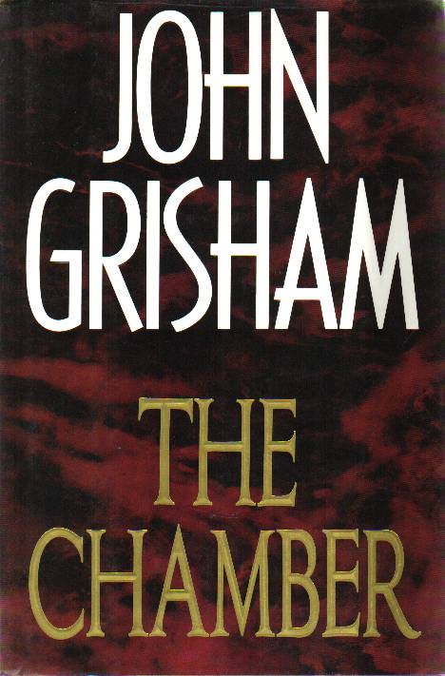 The Chambers
In the corridors of Chicago’s top law firm, twenty-six-year old Adam Hall stands on the brink of a brilliant legal career. Now he is risking it all for a death-row killer, and an impossible case.
Sam Cayhall is a former Klansman and unrepentant racist now facing the death penalty for a fatal bombing in 1967. He has run out of chances—except for one: the young Chicago lawyer who just happens to be his grandson.
(Taken from the cover of The Chamber).

