Francis Bacon 1561–1626
http://en.wikipedia.org/wiki/Francis_Bacon
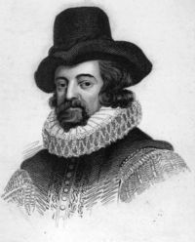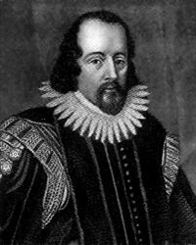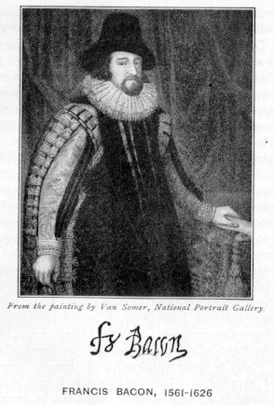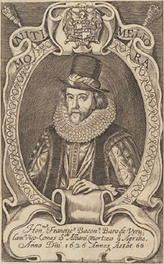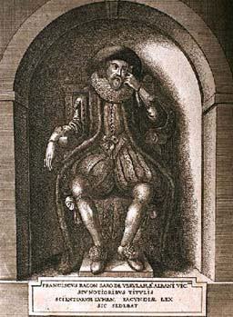
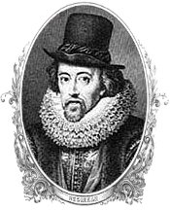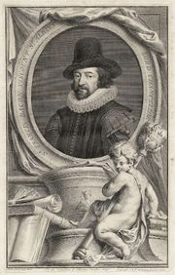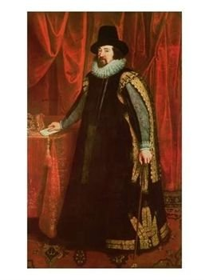

Francis Bacon, 1st Viscount St Alban, KC (22 January 1561 – 9 April 1626) was an English philosopher, statesman and essayist but is best known for leading the scientific revolution with his new 'observation and experimentation' theory which is the way science has been conducted ever since. He was knighted in 1603, created Baron Verulam in 1618, and created Viscount St Alban in 1621; both peerage titles became extinct upon his death.
He began his professional life as a lawyer, but he has become best known as a philosophical advocate and defender of the scientific revolution. His works establish and popularize an inductive methodology for scientific inquiry, often called the Baconian method. Induction implies drawing knowledge from the natural world through experimentation, observation, and testing of hypotheses. In the context of his time, such methods were connected with the occult trends of hermeticism and alchemy.

Contents
[hide]
- 1 Early life
- 2 Career
- 3 Death
- 4 Works and philosophy
- 5 Works on East Asia
- 6 Posthumous reputation
  - 6.1 Bacon and Shakespeare
- 7 Timeline
- 8 See also
- 9 Notes
- 10 References
- 11 External links

[] Early life
Bacon was born at York House Strand, London. He was the youngest of five sons of Sir Nicholas Bacon, Lord Keeper of the Great Seal under Elizabeth I. His mother, Ann Cooke Bacon was the second wife of Sir Nicholas, a member of the Reformed or Puritan Church, and a daughter of Sir Anthony Cooke, whose sister married William Cecil, Lord Burghley, the great minister of Queen Elizabeth.
Biographers believe that Bacon received an education at home in his early years, and that his health during that time, as later, was delicate. He entered Trinity College, Cambridge, in 1573 at the age of twelve, living for three years there with his older brother Anthony.
At Cambridge he first met the Queen, who was impressed by his precocious intellect, and was accustomed to call him "the young Lord Keeper."
Here also his studies of science brought him to the conclusion that the methods (and thus the results) were erroneous. His reverence for Aristotle conflicted with his dislike of Aristotelian philosophy, which seemed barren, disputatious, and wrong in its objectives.
On June 27, 1576, he and Anthony were entered de societate magistrorum at Gray's Inn, and a few months later they went abroad with Sir Amias Paulet, the English ambassador at Paris. The disturbed state of government and society in France under Henry III afforded him valuable political instruction.
The sudden death of his father in February 1579 necessitated Bacon's return to England, and seriously influenced his fortunes. Sir Nicholas had laid up a considerable sum of money to purchase an estate for his youngest son, but he died before doing so, and Francis was left with only a fifth of that money. Having started with insufficient means, he borrowed money and became habitually in debt. To support himself, he took up his residence in law at Gray's Inn in 1579.

[] Career
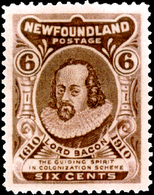
Lord Bacon Postage Stamp from Canada

In the Promus (written probably about 1603) Bacon analyses his own mental character and establishes his goals, which were threefold: discovery of truth, service to his country, and service to the church. Knowing that a prestigious post would aid him toward these ends, in 1580 he applied, through his uncle, Lord Burghley, for a post at court which might enable him to devote himself to a life of learning. His application failed, and for the next two years he worked quietly at Gray's Inn giving himself seriously to the study of law, until admitted as an outer barrister in 1582. In 1584 he took his seat in parliament for Melcombe in Dorset, and subsequently for Taunton (1586). He wrote on the condition of parties in the church, and he wrote down his thoughts on philosophical reform in the lost tract, Temporis Partus Maximus, but he failed to obtain a position of the kind he thought necessary for success.
In the Parliament of 1586 he took a prominent part in urging the execution of Mary Queen of Scots. About this time he seems again to have approached his powerful uncle, the result of which may possibly be traced in his rapid progress at the bar, and in his receiving, in 1589, the reversion to the Clerkship of the Star Chamber, a valuable appointment, the enjoyment of which, however, he did not enter into until 1608.
During this period Bacon became acquainted with Robert Devereux, 2nd Earl of Essex (1567-1601), Queen Elizabeth's favourite. By 1591 he was acting as the earl's confidential adviser. Bacon took his seat for Middlesex when in February 1593 Elizabeth called a Parliament to investigate a Roman Catholic plot against her. His opposition to a bill that would levy triple subsidies in half the usual time (he objected to the time span) offended many people; he was accused of seeking popularity, and was for a time excluded from the court. When the Attorney-Generalship fell vacant in 1594 and Bacon became a candidate for the office, Lord Essex's influence could not secure him the position; in fashion, Bacon failed to become solicitor in 1595. To console him for these disappointments Essex presented him with a property at Twickenham, which he subsequently sold for £1800, the equivalent of around £240,000 today.
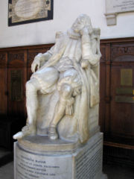
Memorial to Francis Bacon, in the chapel of Trinity College, Cambridge

In 1596 he was made a Queen's Counsel, but missed the appointment of Master of the Rolls. During the next few years, his financial situation remained bad. His friends could find no public office for him, a scheme for retrieving his position by a marriage with the wealthy widow Lady Elizabeth Hatton failed, and in 1598 he was arrested for debt. His standing in the queen's eyes, however, was beginning to improve. He gradually acquired the standing of one of the learned counsel, though he had no commission or warrant and received no salary. His relationship with the queen also improved when he severed ties with Essex, a fortunate move considering that the latter would be executed for treason in 1601; and Bacon was one of those appointed to investigate the charges against him, and examine witnesses, in connection with which he showed an ungrateful and indecent eagerness in pressing the case against his former friend and benefactor. This act Bacon endeavoured to justify in A Declaration of the Practices and Treasons, etc., of ... the Earl of Essex, etc. He received a gift of a fine of £1200 on one of Essex's accomplices.
The accession of James I brought Bacon into greater favour; he was knighted in 1603, and endeavoured to set himself right with the new powers by writing his Apologie (defence) of his proceedings in the case of Essex, who had favoured the succession of James. In 1606 during the course of the uneventful first parliament session Bacon married Alice Barnham (1592 - 1650), the fourteen year old daughter of a well-connected London alderman and M.P. Little or nothing is known of their married life. In his last will he disinherited her.
However, substantial evidence suggests that Bacon's emotional interests lay elsewhere. John Aubrey in his Brief Lives states that Bacon was "a pederast". Bacon's fellow parliamentary member Sir Simonds D'Ewes in his Autobiography and Correspondence writes of Bacon: "yet would he not relinquish the practice of his most horrible & secret sinne of sodomie, keeping still one Godrick, a verie effeminate faced youth, to bee his catamite and bedfellow". Bacon's mother Lady Ann Bacon expressed clear exasperation with what she believed was her son's behaviour. In a letter to her other son Anthony, she complains of another of Francis's companions "that bloody Percy" whom, she writes, he kept "yea as a coach companion and a bed companion" ("coach companion" in Bacon's day carried louche connotations, as the interior of a travelling coach was one of the few places affording privacy). Bacon exhibited a strong penchant for young Welsh serving-men. One such person, Francis Edney, received the enormous sum of two hundred pounds in Bacon's will. ^{[1]}
Meanwhile (in 1608), he had entered upon the Clerkship of the Star Chamber, and was in the enjoyment of a large income; but old debts and present extravagance kept him embarrassed, and he endeavoured to obtain further promotion and wealth by supporting the king in his arbitrary policy.
However, Bacon's services were rewarded in June 1607 with the office of Solicitor. In 1610 the famous fourth parliament of James met. Despite Bacon's advice to him, James and the Commons found themselves frequently at odds over royal prerogatives and the king's embarrassing extravagance, and the House was dissolved in February 1611. Through this Bacon managed in frequent debate to uphold the prerogative, while retaining the confidence of the Commons. In 1613, Bacon was finally able to become attorney general, by dint of advising the king to shuffle judicial appointments; and in this capacity he would prosecute Somerset in 1616. The parliament of April 1614 objected to Bacon's presence in the seat for Cambridge — he was allowed to stay, but a law was passed that forbade the attorney-general to sit in parliament — and to the various royal plans which Bacon had supported. His obvious influence over the king inspired resentment or apprehension in many of his peers.
Bacon continued to receive the King's favour, and in 1618 was appointed by James to the position of Lord Chancellor. In his great office Bacon showed a failure of character in striking contrast with the majesty of his intellect. He was corrupt alike politically and judicially, and now the hour of retribution arrived. His public career ended in disgrace in 1621 when, after having fallen into debt, a Parliamentary Committee on the administration of the law charged him with corruption under twenty-three counts; and so clear was the evidence that he made no attempt at defence. To the lords, who sent a committee to inquire whether the confession was really his, he replied, "My lords, it is my act, my hand, and my heart; I beseech your lordships to be merciful to a broken reed." He was sentenced to a fine of £40,000, remitted by the king, to be committed to the Tower during the king's pleasure (his imprisonment in fact lasted only a few days). More seriously, Lord St Alban was declared incapable of holding future office or sitting in parliament. He narrowly escaped being deprived of his titles. Thenceforth the disgraced viscount devoted himself to study and writing.
However substantial evidence by Nieves Mathews is demonstrated in her book, Francis Bacon: The History of a Character Assassination (1996, Yale University Press) that Bacon was completely innocent of the bribery charges and that writers from later times were themselves guilty of slandering Bacon's reputation. Bacon, commenting on his impeachment as Chancellor in which he claims to have been forced to plead guilty to bribery charges in order to save King James from a political scandal stated:
I was the justest judge, that was in England these last fifty years. When the book of all hearts is opened, I trust I shall not be found to have the troubled fountain of a corrupt heart. I know I have clean hands and a clean heart. I am as innocent of bribes as any born on St. Innocents Day.

[] Death
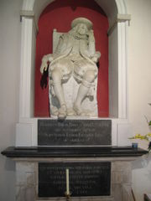
Monument to Bacon at his burial place, St Michael's church in St Albans

In March, 1626, Lord St Alban came to London. Continuing his scientific research, he was inspired by the possibility of using snow to preserve meat. He purchased a chicken (fowl) to carry out this experiment. While stuffing the chicken with snow, he contracted a fatal case of pneumonia. He died at Highgate on 9 April 1626, leaving assets of about £7,000 and debts to the amount of £22,000. It is said that the chicken still haunts Pond Square in London.

[] Works and philosophy
Bacon's works include his Essays, as well as the Colours of Good and Evil and the Mationes Sacrae, all published in 1597. His famous aphorism, "knowledge is power", is found in the Mations. He published The Proficience and Advancement of Learning in 1605. Bacon also wrote In felicem memoriam Elizabethae, a eulogy for the queen written in 1609; and various philosophical works which constitute the fragmentary and incomplete Instauratio magna, the most important part of which is the Novum Organum (published 1620). Bacon also wrote the Astrologia Sana and expressed his belief that stars had physical effects on the planet. He is also known for The New Atlantis, a utopian novel he wrote in 1626.
Bacon did not propose an actual philosophy, but rather a method of developing philosophy; he wrote that, whilst philosophy at the time used the deductive syllogism to interpret nature, the philosopher should instead proceed through inductive reasoning from fact to axiom to law. Before beginning this induction, the inquirer is to free his mind from certain false notions or tendencies which distort the truth. These are called "Idols" (idola), and are of four kinds: "Idols of the Tribe" (idola tribus), which are common to the race; "Idols of the Den" (idola specus), which are peculiar to the individual; "Idols of the Marketplace" (idola fori), coming from the misuse of language; and "Idols of the Theatre" (idola theatri), which result from an abuse of authority. The end of induction is the discovery of forms, the ways in which natural phenomena occur, the causes from which they proceed. Bacon's developments of the inductive philosophy would revolutionize the future thought of humanity.
Bacon's somewhat fragmentary ethical system, derived through use of his methods, is explicated in the seventh and eighth books of his De augmentis scientiarum (1623). He distinguishes between duty to the community, an ethical matter, and duty to God, a purely religious matter. Any moral action is the action of the human will, which is governed by reason and spurred on by the passions; habit is what aids men in directing their will toward the good. No universal rules can be made, as both situations and men's characters differ.
Bacon distinctly separated religion and philosophy, though the two can coexist. Where philosophy is based on reason, faith is based on revelation, and therefore irrational — in De augmentis he writes that "[t]he more discordant, therefore, and incredible, the divine mystery is, the more honour is shown to God in believing it, and the nobler is the victory of faith." And yet he writes in "The Essays: Of Atheism" that "a little philosophy inclineth man’s mind to atheism; but depth in philosophy bringeth men’s minds about to religion", suggesting he continued to employ inductive reasoning in all areas of his life, including his own spiritual beliefs.

[] Works on East Asia
Francis Bacon was a prominent studier of East Asia, and was one of the first European sinologists. In his work Novum Organum, he attributes three world changing inventions to China, when at the time, many thought they were invented in the West.
"Printing, gunpowder and the compass: These three have changed the whole face and state of things throughout the world; the first in literature, the second in warfare, the third in navigation; whence have followed innumerable changes, in so much that no empire, no sect, no star seems to have exerted greater power and influence in human affairs than these mechanical discoveries." -Novum Organum
"For our ordinances and rites we have two very long and fair galleries. In one of these we place patterns and samples of all manner of the more rare and excellent inventions; in the other we place the statues of all principal inventors. There we have the statue of your Columbus, that discovered the West Indies, also the inventor of ships, your monk that was the inventor of ordnance and of gunpowder, the inventor of music, the inventor of letters, the inventor of printing, the inventor of observations of astronomy, the inventor of works in metal, the inventor of glass, the inventor of silk of the worm, the inventor of wine, the inventor of corn and bread, the inventor of sugars; and all these by more certain tradition than you have. Then we have divers inventors of our own, of excellent works; which, since you have not seen) it were too long to make descriptions of them; and besides, in the right understanding of those descriptions you might easily err. For upon every invention of value we erect a statue to the inventor, and give him a liberal and honorable reward. These statues are some of brass, some of marble and touchstone, some of cedar and other special woods gilt and adorned; some of iron, some of silver, some of gold."

[] Posthumous reputation
Bacon's ideas about the improvement of the human lot were influential in the 1630s and 1650s among a number of Parliamentarian scholars. During the Restoration Bacon was commonly invoked as a guiding spirit of the new-founded Royal Society. In the nineteenth century his emphasis on induction was revived and developed by William Whewell, among others.
Bacon was ranked #90 on Michael H. Hart's list of the most influential figures in history.

[] Bacon and Shakespeare
Since the 19th century, there have been claims that Bacon was the author of the works attributed to Shakespeare (see Shakespearean authorship).
In his "Letter to a Reader," Christopher Morley said this about these claims:
"The first doubts as to Shakespeare's authorship, if I read the books correctly, were raised by a United States consul in the rum-drinking port of Santa Cruz. Like the consuls in O. Henry's Cabbages and Kings his official duties left much vacation for the mind. His idea was taken up by an eccentric lady whose name oddly enough was Delia Bacon; she inveigled Hawthorne into writing a preface for her book and the fun began." The Complete Works of William Shakespeare, Cambridge ion text (Philadelphia: Blakiston Company, 1936), p. xvii.

[] Timeline
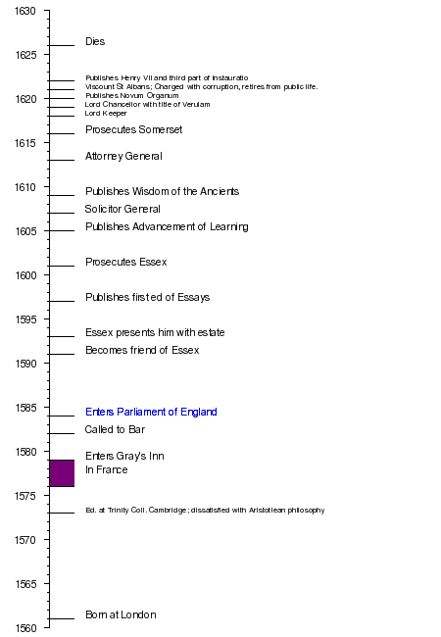

See also
- Bacon's cipher

[] Notes
- ^ Bacon's sexual orientation is discussed in detail at the website Gay History and Literature. and also in Encyclopedia of Homosexuality. Dynes, Wayne R. (ed.), Garland Publishing, 1990. p.103

[] References
- This article incorporates text from the Encyclopædia Britannica Eleventh ion, a publication now in the public domain.
- This article incorporates public domain text from: Cousin, John William (1910). A Short Biographical Dictionary of English Literature. London, J.M. Dent & sons; New York, E.P. Dutton.
- Some material originally from the 1911 Schaff-Herzog Encyclopedia of Religion.
- Some material originally from the 1912 Schaff-Herzog Encyclopedia of Religion.
- John Farrell, "The Science of Suspicion." Paranoia and Modernity: Cervantes to Rousseau (Cornell UP, 2006), chapter six.

[] External links
Works by Francis Bacon at Project Gutenberg
- Francis Bacon Books
- Online ions of Bacon's works
- Novum Organum Online
- Sir Francis Bacon's New Advancement of Learning
- Essays on the English Renaissance
- Dictionary of the History of Ideas: Baconianism
- Rictor Norton, "Sir Francis Bacon" quotes excised passages of Sir Simonds D'Ewes
- Quotations Book - Francis Bacon
- Stanford Encyclopedia of Philosophy entry
- The Twickenham Museum - Sir Francis Bacon
- Henry Wotton employed by Bacon's intelligence system
- Francis Bacon Research Trust - Studies of Bacon's connections to the Rosicrucians, Freemasonry, Shakespeare
- A more easily readable version of the New Organon
- Francis Bacon at Thoemmes Continuum
- Cryptographic Shakespeare
========================================================================================================================
END

