**The Library in Our Future**

Joseph O. Gill, BSC, GG, FGA

Email: gilljoseph1949@yahoo.com

Website: [www.worldglobetrotters.com](http://www.worldglobetrotters.com)

Also search archive.org for “Joseph O. Gill”

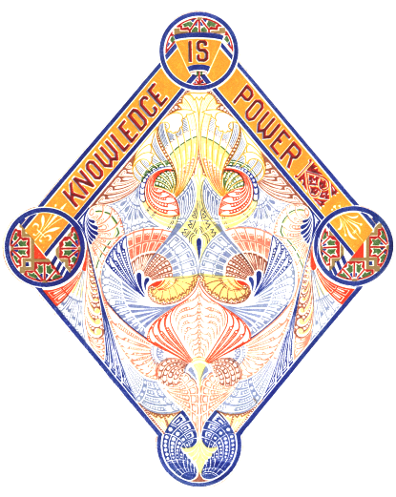

**KNOWLEDGE IS POWER** - **Bacon  
(40,000 Quotations - Charles Noel Douglas 1917, page 1058)**

The all new eco-friendly, Green, eBook is here and where is the Library in the next few years? Libraries will, and many already are, becoming museums and good students now work in the computer lab.

I have been a serious book collector since 1965, and have owned a first edition of Shakespeare’s collected works 1623 and a hand written inventory of the Crown Jewels of England 1605 and many incunabula (pre-printing 1480). Books were first written on rocks, then clay tablets then cylinder seals, then on hemp and on papyrus scrolls, then finally on printed and bound books. I am often told “I like the feel and smell of a book”. I like the feeling of the 25,000 eBooks that I can easily carry on my USB thumb drive in my breast pocket instead of 500 boxes FULL to the rim with heavy bound books.

I have seen some VERY EXPENSIVE data bases ($200,000 to $300,000 per one year) available to Universities in developing countries and after seeing them I can easily understand WHY students do not enjoy reading as in years past. I believe learning is a lifetime pleasure and not solely about getting a good job. In the USA students leave universities with a $50,000 to $300,000 debt over their head. So education is now BIG business and NOT about the joy of learning. Large research libraries are ONLY possible to the richest of universities and by copyright all information is controlled. Often the best and brightest students are strongly encouraged to stay in the USA after graduation and their own developing country of origin is deprived of their most valuable “Human Resources” often referred to as "Brain Drain". In the United States "student loans" are a huge business with fully 30 million graduated students and 20 million active students paying without possibility of default over $1,400,000,000,000 or 1.4 trillion dollars or enough to make one million four hundred thousand all new millionaire’s. So, a fair portion of the USA economy is made while enslaving our newly graduated children with a debt of $40,000 to $400,000 with no possibility of default!

Steve Jobes, the man that changed the World more than any other person in history with his Cell-Phone including also a Computer and Camera. Jobes changed the entire music world by convincing the many music companies to all sell their music for the same price one USA dollar each. I suggest that governments would save billions of dollars on education and tens of thousands of copyright infringement legal cases by monitoring eBooks download sites and every time a visitor downloads a copyrighted book or video the government pays a small fee to the author. Printed books are heavy, very expensive, so for our Earth’s sake do not print books: save trees made into paper and ink, get ecological, get modern, use searchable & easy to copy e texts, be a good example for others……eBooks are FREE to produce on the authors own computer….. You can now easily download the entire Wikipedia 77GBs at Kiwix for FREE and use Wikipedia while offline on any computer using a simple thumb drive…

**THE POWER OF ANY UNIVERSITY OR SCHOOL IS NOT THE PROFESSORS; IT IS THE QUALITY OF THEIR RESEARCH LIBRARY.**

All Universities and High Schools worldwide could have a 5TB Passport size hard drive costing them 150 $US, that would fit in your breast pocket. A massive FREE library that contains both fiction and non-fiction on all subjects, including over 625,000 books (including over 1000 encyclopedias & 500 dictionaries) and manuscripts from 600 BC through to the present, 60,000 papers, 25,000 audios, 800,000 illustrations, over 200,000 MP3 songs from all over our World or 5 years of continuous music and 12,000 videos. Learn Languages – STUDIES in over 70 languages. If this library was in hard text books it would be worth $35 million or more, take many years to collect and would fill 40,000 feet or 13,500 meters or NEAR 3 miles of very expensive bookshelves. Also a special, Primary School Library needs only a 500GB external hard drive or larger). We all started our learning in Primary School, so don’t make our children wait till University or even High School to begin learning.

I can easily do 10 years of research in one or two days in an organized digital library. Most of the work of authors such as myself is finding all relevant references to the subject being written about. With a digital library you can easily search the entire library with one click. You can also immediately search any size text without using clumsy indexes or weighty concordances.

**I have had many people offer the same comment: "Why, building your own digital library is better than the internet because everything is organized and you do not have to look all over the internet for what you want". Also we find that some 40% of the books, etc. are no longer available on the internet, while your own digital library is archived and will never lose a single item.**

Students are quickly waking up and realize that 4 or up to 8 years of education is crazy expensive. If they work in a learning type job they will earn and learn at the same time. Universities need to change drastically and immediately or students will use other options. The one option of a University education has increased too many other competitive options.

**MAKE YOUR EBOOK LIBRARY, GROW (and back it up on an external hard drive)**

**1 - For an extensive list of freely downloadable references of many thousands of books, papers and videos and many that are very rare on this subject see: E-texts, videos, pictures, etc. at** [**www.archive.org**](javascript:if(confirm('http://www.archive.org/%20%20%5Cn%5CnThis%20file%20was%20not%20retrieved%20by%20Teleport%20VLX,%20because%20it%20is%20addressed%20on%20a%20domain%20or%20path%20outside%20the%20boundaries%20set%20for%20its%20Starting%20Address.%20%20%5Cn%5CnDo%20you%20want%20to%20open%20it%20from%20the%20server?'))window.location='http://www.archive.org/') **. (Everything can be downloaded for FREE). Over 11 million items.(use search words or keywords like symbolism, religion, sun worship, swastika, cross, freemasonry, author name, exact title, etc. )**

**You should first go to** [**www.archive.org**](javascript:if(confirm('http://www.archive.org/%20%20%5Cn%5CnThis%20file%20was%20not%20retrieved%20by%20Teleport%20VLX,%20because%20it%20is%20addressed%20on%20a%20domain%20or%20path%20outside%20the%20boundaries%20set%20for%20its%20Starting%20Address.%20%20%5Cn%5CnDo%20you%20want%20to%20open%20it%20from%20the%20server?'))window.location='http://www.archive.org/') **THERE ARE MANY THOUSANDS OF RARE AND UNUSUAL BOOKS FROM OXFORD, HARVARD, LIBRARY OF CONGRESS, NYC PUBLIC LIBRARY, YALE, PRINCETON, STANFORD, UNI. OF TORONTO, UNI. OF CALIFORNIA AND MANY OTHERS ARE HERE.**

**2 - Gutenberg Project over 100,000 eBooks for free download at** [http://promo.net/pg/](javascript:if(confirm('http://promo.net/pg/%20%20%5Cn%5CnThis%20file%20was%20not%20retrieved%20by%20Teleport%20VLX,%20because%20it%20is%20addressed%20on%20a%20domain%20or%20path%20outside%20the%20boundaries%20set%20for%20its%20Starting%20Address.%20%20%5Cn%5CnDo%20you%20want%20to%20open%20it%20from%20the%20server?'))window.location='http://promo.net/pg/')

Australia - gutenberg.net.au

Canada - [www.gutenberg.ca](http://www.gutenberg.ca)

3 - Sacred Text Archive - 10,000 Books - [www.sacred-texts.com](http://www.sacred-texts.com)

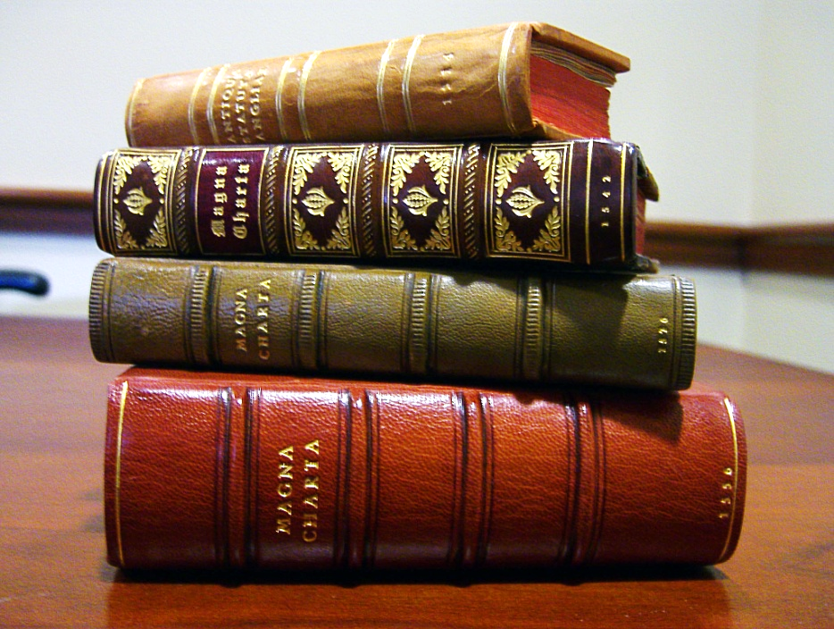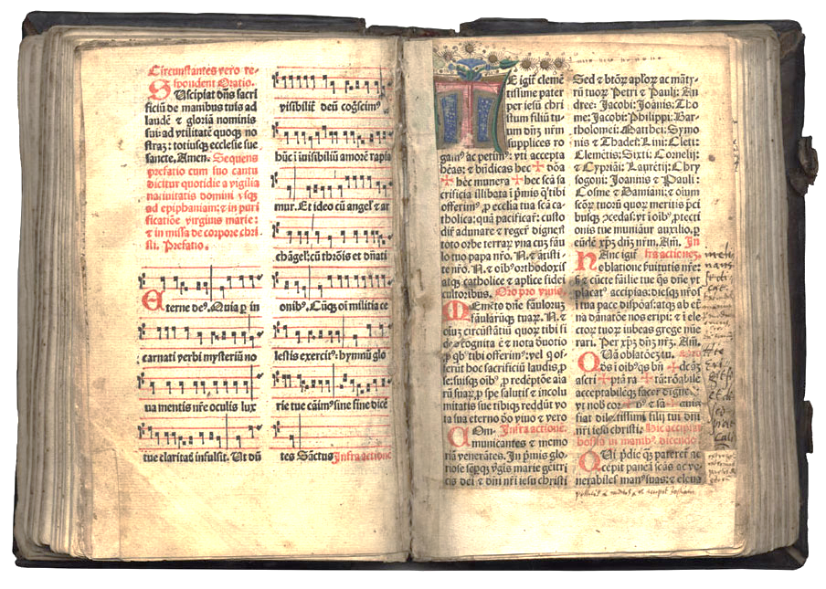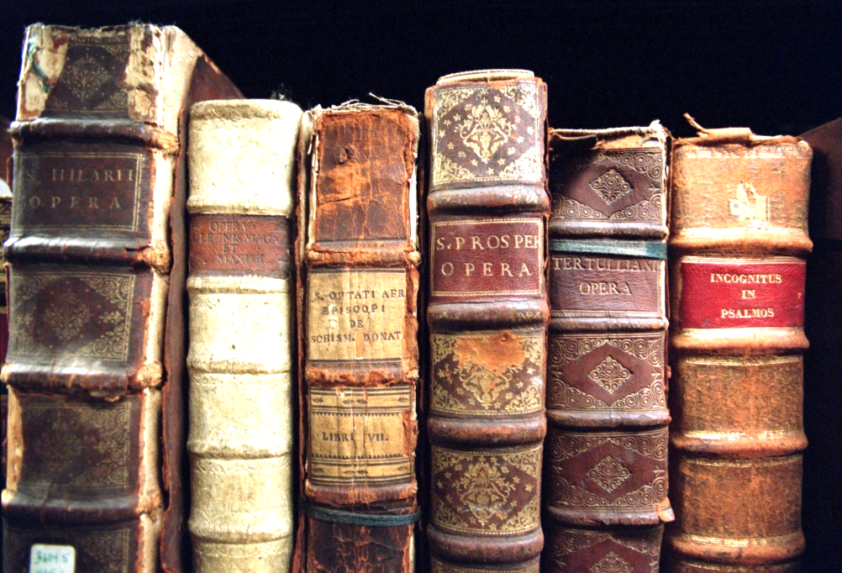

**“What are e-texts (electronic texts) & how does it help me?”**

**Make yourself laugh**

**We live in a world that is changing fast and the information age is here.**

You ask the old librarian:   "Do you have that book in your library?  No, it is checked out now for two weeks and there are three people waiting for it before you, shall I add you to the list?"  
  
**You ask the modern e-texts librarian:  "Do you have that book in your library?  Yes of course, shall I put a copy on your flash drive?"**

You ask the old librarian:   "Do you have that book in your library?  No, but I can get it from another library in a few weeks, if it is available and not checked out at that library."

**You ask the modern e-texts librarian:  "Do you have that book in your library?  Yes of course, shall I put a copy on your flash drive?"**

You ask the old librarian:   "Where will I find that book, in the section under American History or Religion or Philosophy or Psychology?   That book is rare and we only have one copy so I can check where it is now and get back to you and will tell you if it is available and not checked out."

**You ask the modern e-texts librarian:  "Where will I find that book, in the section under American History or Religion or Philosophy or Psychology?   Yes of course we put a copy in each section and you can search for it in a fraction of a second.  Shall I put a copy on your flash drive?"**

You ask the old librarian:   "Do you have that book in your library?  No, we have to consider our shelf space and that book was discarded because we had only a few people ask for it.  We also are given books that we find offensive and politically incorrect, or not acceptable to today's scientific beliefs so we decide to discard that publication."

**You ask the modern e-texts librarian:  "Do you have that book in your library?  Yes of course expensive shelf space is not an issue in this library and we do not have to review the importance of any book for the people visiting this library.  My favorite quote of Schopenhauer is: "All truth goes through three steps: First, it is ridiculed. Second, it is violently opposed. Third, it is accepted as self-evident."  Now shall I put a copy on your flash drive?"**

You call the old librarian on the phone and ask:  "Do you have that book in your library?  Yes and because of budget cuts we are only open at, such in such, limited hours and we are located across town, be on time."

**You call the modern e-texts librarian:  "Do you have that book in your library?  Yes of course as we do not have to build thousands of shelves and have acres of space we have a lot of money for all the e-texts we get.  What is your email and I will send you a copy in a couple minutes?  If you want I can also send you all the other books by that author or on your subject in the same email."**

You ask the old librarian:   "Where can I find, in this 500 page book, the information about "Atlantis" I need?  Sorry, most books have limited indexes or no indexes at all so spend a few hours and look for it".

**You ask the modern e-texts librarian:   "Where can I find in this 500 page book the information about "Atlantis" I need.  You can click CTRL + F and type in "Atlantis" and find any information instantly and can copy it instantly onto your own notes, so enjoy."**

You ask the old librarian:   "How many copies are there of that rare book and can I borrow it?  No there is only one copy and you must use it after getting permission, in our library, only.

**You ask the modern e-texts librarian:   How many copies are there of that rare book and can I borrow it?  Of course, we can make millions of copies of that rare book.  Now, shall I put a copy on your flash drive?"**

You ask the old librarian:  "I am a slow reader, my English isn't so good and I have trouble reading or my eyes are not as good as they used to be, can someone read to me?  We have a few audio books and that is all we can do for you."

**You ask the modern e-texts librarian:   "I am a slow reader, my English isn't so good and I have trouble reading or my eyes are not as good as they used to be, can someone read to me?  You can go on the net and download Balabolka or Natural Reader.  These FREE programs will read any books or papers instantly, and even your email, anything on your computers clipboard.  These programs can make the font size any size, the speed can be slow or fast so you can follow along or you can listen to some beautiful piano music at the same time while being read to.  We also have a wonderful slide show you can view with the music of your choice while you are being read to. You can even have the paper you just wrote read to you to hear how it sounds out loud."**

You ask the old librarian:  "I enjoyed that book by that author.  Do you have any speeches or talks or documentaries by him or on that subject?  Yes, but they are in another section of the library and I am not sure where they are or if we have them.  Let me check and get back in a while.  Yes, we have only a couple but they are checked out now for two weeks and there are three people waiting for it before you, shall I add you to the list?"

**You ask the modern e-texts librarian:   "I enjoyed that book by that author.  Do you have any speeches or talks or documentaries by him or on that subject?  Yes of course they are all together in our "" E-texts Library of the Future" which is here NOW.  So, shall I put a copy of all you are requesting on your flash drive?"**

You ask the old librarian:   "Do you have that book in your library?  What is the ISBN (International Standard Book Number) number?"

**You ask the modern e-texts librarian:   "Do you have that book in your library and do I need the ISBN (International Standard Book Number) number?  No, I can search for your book by authors name or any keyword or even the date in a couple seconds.  You only need ISBN numbers for hard texts for locating them or ordering them from a bookstore.  They have no need for ISBN numbers with the instant search we have on any computer today. Now, shall I put a copy on your flash drive?"**

**Do not print books: save paper and ink, get ecological, get modern, use searchable & easy to copy e texts, be a good example for others………..**

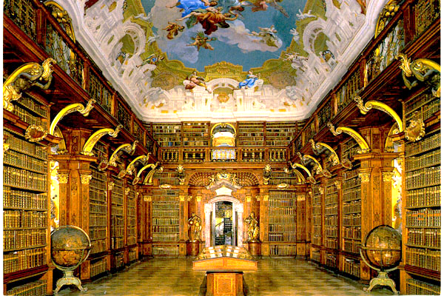

[Melk Monastery Library, Melk, Austria](http://www.thegentlemanscholar.com/Famous_Libraries.html)

**END**