Whence Come the Gods?
and related studies
by
E. L. Gardner
The main article was delivered as THE BLAVATSKY LECTURE
at the Annual Convention of The Theosophical Society in England, London
http://www.theosophical.ca/Whence%20Come%20Gods.htm

Contents
Whence come the Gods
The Rulers of Our Universe
Plenum—Monad—Devas
The Secret Doctrine: 1889
The Third Volume
The Creative Work of the Hierarchy
The Occult Laboratories
Space ----- The Divine Plenum
A Web
Humanity and Freedom
Terrestrial and Celestial Laboratories
The Earth Chain
The Planetary Chain Problem
The Earth and its Companions
Vesica Piscis
The Turning Point

The Rulers of Our Universe
The advances made by way of applied science during the last century or so have been prodigious in number and quality. The conquest of nature by mankind progresses by leaps and bounds ----- unprecedented. To travel to any part of the world takes but a few days or hours; the spoken word can be heard a thousand miles away as easily as across a lunch table. Appliances to ease labour, physically and mentally, for the home and commerce, abound. The depths of the sea and the wide open spaces above are threatened with invasion, and a new power is developing with the promise of material benefit beyond our ability to estimate. Is there any limit to man’s use of natural forces?
What of storm, tempest and flood, of lightning and earthquake? Are these in fact under any secure control and direction, or are they a display of irresponsible natural energies --- the energies of a nature which is admittedly ‘destitute of goodness or malice’ [The Mahatma Letters to A.P. Sinnett, page 56]—or do they merely await mastery? Obviously now it would be rash to predict any limit to the powers of man, active or latent.
The study of the universe, above and around us, as revealed by astronomical science, yields abundant testimony to its dynamism and also to its orderliness, [This Dynamic Universe and This Ordered Universe, by The Theosophical Research Centre, London.] Such orderliness implies control of some type, purpose, directive intelligence, which is puzzling the scientific mind of our day. The Secret Doctrine [The Secret Doctrine, by H.P.Blavatsky. The Adyar Edition of six volumes is used in the following references, unless otherwise stated.] advances a solution of the mystery by admitting a vast array of administrative posts --- from those directing island universes to those guiding solar systems and planetary chains --- all necessarily filled by highly trained and skilled officials, far beyond the level of present-day mundane humanity, yet ---- according to the Teachings --- all filled by Man, though of varied degrees of development and graded in hierarchical relationships throughout.
References to these Rulers are found in all ancient scriptures, the title given them being Lords ---- or Gods, in the plural, as it should be in the first chapter of Genesis if this were translated correctly: ‘In the beginning the Gods (Elohim) created. . . .’ The Hebrew word ‘Elohim’ is plural. This error has let to countless misunderstandings.
Where do these Great Ones come from? Where is their birthplace, their school and training ground? In short ---- Whence come the Gods?
Scriptural Evidence East and West
Many of us have found, in the study of Theosophy, that much has to be unlearned of previous teachings and concepts. I remember beginning this painful experience in my youth when a high Oxford dignitary stated publicly that the many phrases in the biblical records, which I had accepted with implicit faith, asserting “Thus saith the Lord’, ‘God spake and said’, ‘This is what the Lord hath said’, [Exodus xvi, etc.] were merely the customary idiom of tribal chiefs and leaders. However much to the point, and maybe wise, they preceded the speaker’s own views and no other. Very similar claims may often be heard from the pulpits of today: ‘God wishes you . . . desires you . . . condemns . . .’ all of which merely mean ‘ If I were God I should wish . . .desire . . .condemn . . .’ Such phrases are still frequently employed in religious exhortation.
In this connection, too, it is useful to probe the meaning of such scriptural statements as;
‘I am the lord, there is none else. There is no God beside me. I form the light and create darkness. I make peace and create evil. I the Lord do all these things.’ [Isaiah xiv ; 5, 6]
‘I am the gambling of the cheat and the splendour of splendid things.’ [Bhagavad - gitâ, X.]
Who creates evil? Who makes peace? Who gambles and cheats? The answer obviously is - Man In the Ancient Teachings it will be found that there is none else! Under many and widely varying conditions, on planets and solar systems beyond our present ken, graduates from the human school perform the function of Creative Agent. It will indeed be found as this study proceeds that Man, in one or another of his many forms, is the one Creative Agent, although his Divine activities are cloaked for many cycles under the guise of myth and symbol.
Let us here clearly consider what is meant by the term ‘man, the one creative agent’. In The Secret Doctrine and many other occult scripts of the East, the image of man that is presented is of a being possessed of a mind by means of which he can understand the world in which he lives and, eventually, can extend such understanding until it spans the universe. This concept soars far and away beyond the current limitations of biological man -- a creature of flesh and blood energised by a brain - yet it is not incompatible with modern scientific speculation. [‘Man is the agent of the evolutionary process on the planet. This is so whether he knows it or not, whether he wants it or not; but he will do the job better if he does know it and does consciously want to do it.’ The Destiny of Man, by Sir Julian Huxley, 1959.]
Matter of which a physical body may be built is not confined to that with which we are familiar.
Experimental research that has resulted in the marvels of radio, of electronic brains, of devices of automation that are self-corrective and ingenious, suggest a future that may be immeasurable. The exploration of space by rockets and artificial satellites makes some aspects of space-fiction a sober reality. It is today a plausible and popular conception that on other planets and in other conditions intelligent beings live and thrive. In occultism we find that the term ‘man’ extends to inhabitants of other solar systems - indeed covers the widest range conceivable. Moreover in myth, legend and allegory, man appears repeatedly as hero, master of his realm - a king - and often a Divine Being such as Krishna, who proclaims “There is no end of My Divine Powers’. [Bhagavad-gîtâ, X.] The vast majority of us - present-day humanity - are still in an early grade of the human ‘school’.
The distinction between an allegorical story and the teaching that lies within it corresponds to the distinction between the lower and the higher mind. A proverb, a parable, an allegory is registered by the lower mind much as a view is imprinted on the retina of the eye: if that be all, then it will be regarded quite literally. For example: a child on hearing the proverb ‘There’s many a slip ‘twixt the cup and the lip’ will be simply amused by an imagined mishap. To relate it to the hazards of everyday life needs the wider view of the probing higher mind. Familiar allegories, such as the biblical stories of Eden, of Noah’s ark, of Babel, the narratives of Ruth, Esther, Job and others, have been regarded for centuries as historical records - and still are by some of the ‘multitude’. The ‘disciplined’, with higher mental vision, interpret them at a subtler and loftier level. Preeminently wise sages and mystics, such as the authors of the Bhagavad-gîtâ, the Book of Isaiah, the Revelation of St. John, may await general understanding for a long while yet. Their very frankness is a sufficient veil. Contemplate, for instance, the following, while holding in mind that man, perfected man, Krishna the Divine Man, speaks.
‘Of letters, the letter “A” I am ... of creations the beginning and the ending . . . all-devouring death am I and the origin of all to come’ [Bhagavad-gîtâ, X.]
‘I am alpha and omega, the beginning and the ending, the first and the last.’ [Revelation of St. John.]
‘I, the Lord, do all these things.’ [Isaiah.]
The similarity is striking.
What then, it may be asked, of the Almighty God of religions? The answer is - Man is God incarnate.
We are indeed now familiar with this claim to the divinity of man as, for example, the declaration in a daily paper by the Dean of St. Paul's God is within us’. [Dr. W. R. Matthews’ column, Daily Telegraph, July 19, 1958.] This is no atheistic denial of God. A displacement, yet, from the unreal to the real, from a distant ‘aloft’ to the very core of one’s being. Nor is it tenable to conceive of an impersonal deity, for spirit and matter are inseparable at every level. It is impossible, for example, to isolate electricity or gravity; apart from their media they could not manifest. ‘The idea of pure spirit as a Being . . . is a chimera. a gigantic absurdity.’ [The Mahatma Letters to A.P. Sinnett, page 56.] It will be understood as already noted, that by ‘man’ it is the Divine Spark, the Father in Heaven, the Monad, that is meant - in the same sense that a new-born infant may be claimed to be a human being. As much indeed is implied in the words attributed to Jesus: ‘Be ye therefore perfect even as your Father’.
The imagined deity of mental projection may be, probably is, of value to a young and adolescent humanity - in much the same way as parents are ‘almighty’ to young children. But, just as a continuance of parental authority is harmful if prolonged, be it stern or merely possessive, so is the concept of a personal deity for the many who have outgrown it. A continued dependence on external assistance tends to weaken and frustrate and, moreover, it clouds and obscures a reality of far greater worth. The silent voice of the ‘God within us’ is more demanding and exacting than any influence ‘without us - transcending the limited personal vision.
When the sun rises the moon fades and, as the consciousness of man rises and knows itself to be divine in origin and being, the Personal-God - the projected substitute for man’s own latent power - fades and dissolves. In the brilliance and warmth of truth, an incubus is lifted and dispersed. The answer to whether it be wise or premature to advance this view now is forcefully given by the spectacle of the two world wars of the last fifty years - with their horror and savagery! Current religions availed very little, H.P.B sums the situation up pointedly:
‘It is not the Ever-Present God - the Divine Plenum - that is rejected, but the humanised God of religious dogma which man has shaped from his own brain-fabric and forced on his fellows as a divine revelation.’ [The Secret Doctrine. I, 73 to 81.]
In guarded language sages and mystics in all times have proclaimed the essential divinity of man - a truth so profound and all-embracing that it tends, in quiet contemplation, to overwhelm the understanding. Hence, parable and allegory are still valuable media.
Let us pass now to the testimony of The Secret Doctrine concerning the occult origin of man as the Monad and his identity with the Divine Essence of the Plenum - or Space.
The Plenum and The Monad
In the proem to The Secret Doctrine, the Senzar Occult Catechism is quoted:
‘What is that which was, is and will be, whether there is a Universe or not, whether there be Gods or none? The answer is SPACE.’ [ ibid., I: 73 to 81.]
This statement that the Eternal Parent is space, that the Divine Plenum is the One Life of the whole universe, may seem to many at first strange and somewhat disconcerting. But our everyday familiar views of space are limited to little more than one-half of a single plane, the physical. Now that the unit of physical matter itself is known to be an expression of energy, difficulty should vanish.
A synonym also used in the Stanzas is the Great Breath, then implying that manifestation is about to begin. The Breath, being of the Plenum, is also absolute, and neuter, hence in perfect equilibrium, neither conscious nor unconscious, neither benevolent nor malevolent, in absolute poise - and therefore ‘knows itself not’. [Stanzas of Dzyan, II.]
To achieve knowledge, the Breath becomes centred first in Adi and then , as ‘a spark of the Flame’, is prepared to ‘journey through the worlds’. The Monad journeys forth sharing the absoluteness of the Plenum.
“Thou art myself, my image and my shadow! I have clothed myself in thee." [ibid., VII.]
The Monad is a unit of and within the Plenum. Sheathed in a tenuous vesture of the first plane - Adi - it is still undifferentiated and hence is called ‘parentless’. The Monad therefore possesses all the attributes of the Plenum - as a drop of water may be said to possess the attributes of an ocean. As a unit of the Plenum ‘the Monad is neither spirit nor matter, it is a Breath of the Absolute’. [The Secret Doctrine, I: 292]
‘ I and my Father are one.’ [The Mystery Drama cited in St. John x., 30]
It is on the nature of the Monad, therefore, that the claim to human divinity is founded; but, as a Breath of the Absolute, the Monad can never know itself till it becomes aware of, conscious of, others besides itself. Similarly, and it is a valid correspondence, the organ of vision, the eye, can never see and know itself directly. Only as a reflection in a mirror can the eye see itself - and the Monad is, so to speak, all eye!—and there is no mirror for the Monad till forms are prepared.
A need for contrasts, opposites, arises and the consequent breaking of the perfect balance of the Plenum. This is described as a change in ‘rates of motion’ within absolute motion, which gives birth to the innumerable opposites of spirit-matter. Yet these ‘opposites’ all are of the same source, just as, for example, part of a volume of water may become violently energised as steam and part may become rigidly static as ice; yet both are of water.
The goal of the Monad is awareness of separateness, an individualized consciousness: the vast evolutionary sweep into manifestation has this as its objective. During the long early phases in which the forms essential to the awakening of the Monadic consciousness slowly mature, it is the Solar Lords who are in charge. These are drawn from the great hierarchies of earlier cycles. They pour forth streams of Power and Light and Life ‘from within’ and carry the Monads outwards into manifestation. [In The Secret Doctrine there are more than four hundred references to the Orders of Devas, the Angels or Shining Ones. Especially significant are those to be found on the following pages: Volume I: II: 160; IV: 301; V: 325, 539.]
These Solar Lords have as their design the ‘pattern in the heavens’, the extended archetypal forms of the Divine Man, the Solar Logos. They are the Elohim of Genesis, the creative Gods of myth and fable in every faith. [This subject has been treated at length by the writer in an earlier essay, The Heavenly Man.]
The great Star-Angel Lucifer appears to escort the human Monads into manifestation, sheaths them in Adi and induces them to follow the involutionary sweep into incarnation or embodiment. Rank on rank of devic workers, often termed Dhyanis in The Secret Doctrine, build the worlds of form, ensouling these with the One Life.
Devas are said to act as ‘centres of force’, and from this term and another phrase - that devas always work from within outwards - we can infer their mode of activity. Operating from a centre, a field of energy is magnetically created from centre to periphery. This method implies, in turn, a constant direction of the pattern ‘from within’, workers at lower levels depending upon their superiors for direction, rank on rank, through all the planes of the universe, from the loftiest levels to the nature spirits of the physical world. Hence, in the outermost world, the unseen agents work on predetermined lines - 'on rails’, so to speak, and a clear distinction between devic activities and those of men emerges. The devas work to rule, and from within outwards, whereas man is free to succeed or fail and for long cycles is stimulated chiefly from without.
The Skill and Limitations of the Rupa-Devas
Thus throughout the cycles of involution the devas are the form-builders. [The Secret Doctrine, II: 172.] The Web - spun by Father-Mother (Stanzas of Dzyan, III: 10) serves as the basic fabric upon which all forms are built. [ For further description of the Web, see Part II, page 26.] The fields of force within which all forms are generated are themselves the magnetically assembled vehicles - the very ‘bodies' - of the higher devas. Under their direction, impulses from the âtmic archetypes - Âtma, the One Reality’ [The Secret Doctrine, I: 317.]—excite and activate the rupa (body-building) devas and nature spirits.
“The Universe is . . . guided from within outwards.’ [ibid., I: 317.] Yet the form-building devas, though marvellously skilful, have their limitations - and the early forms of the plant and animal kingdoms on earth represent the limit of their unaided activities.
A correspondence to this type of production, with which all are nowadays familiar, is television. From a studio, radio waves are projected, which are caught and reproduced by a tuned-in receiving set and focussed on a screen as pictures. The rupa-devas are nature’s receiving sets. They pick up the impulses from the subtler regions within and project the forms of trees, shrubs, flowers and creatures as materialised pictures in the visible world. Another correspondence is that of an artist’s hand - not itself a creator but a vital creative agent, becoming ever more adept and skilful by repeated experience.
The Devic Lords direct such manifestation from within up to the level reached before in previous cycles. Their routine, though vast and elaborate, is not therefore creative in the sense of evoking a new product. It is all repetitive, amazingly skilful and exquisitely finished, but stops at the level the forms had previously attained under earlier human hierarchies. Hence the dictum of The Secret Doctrine, ‘Nature fails to create being alone’, [ibid, III: 313. The ‘divine Fashioners’ of this reference refers to the demigods (advanced men) of previous cycles.] and ‘Nature by herself fails’. Thus nature lacks initiative, is wasteful and must be content with the survival of the fit. ‘Man . . . the one free agent’ [The Mahatma Letters, p.57.] is needed as creator - at the present time and for the future.
‘Even the mineral and vegetable kingdoms develop and continue their further evolution through man!’ [The Secret Doctrine, I: 214.]
Good and Evil
The vital difference in the workings of nature and of man is especially emphasised in a Master’s Letter in two statements already quoted, ‘Nature is destitute of goodness or malice, she follows immutable laws’; and ‘Man is the one free agent’. Here lies the solution of the age-old problem of good and evil. Nature is supplied with the patterns to be followed and works at these ruthlessly, though blindly. The devic world is a-moral, because obedient, unquestioning, constantly performing a necessary function without choice. But with the attainment of self-consciousness on the part of man, and the creative activity of the ego-personality, there arises awareness of choice, of relationship, and of freedom to do or not to do within a given field of activity. This is a gift of the Monadic life. The link is by ‘the finest thread of Fohat’, yet it endows man with the power of choice, for better or for worse, between good and evil.
The Master’s further statement that ‘Evil exists only for him who is its victim’ [The Mahatma Letters, page 56.] is an obvious truism in this light, for rules, regulations, laws, governing family, tribal or national conduct, all are of human origin. The rules may be wise or cruel, ignorant or compassionate: all are man-made. There is no other source. When such laws are broken by malice, fraud or aggression, there follows - apparently - 'evil’ for the victimised and ‘good’ for the victor. But the immutable law of equilibrium, the one law of the Plenum - karma - will ensure adjustment and balance sooner or later. Human action alone is the source of such ‘evil’.
Thus the restoration of disturbed equilibrium, however slight or great the disturbance, is assured by the absoluteness of the Plenum. Only by grasping this fact and its omnipresent influence can karma be truly understood. The pressure exercised is constant, unbending, implacable and just. It is the one and only law that can be called divine - mercifully gently because infinitely patient - yet inexorable. Commandments, rules and regulations, legislation concerning morals and human relationships - all are made. It will be remembered: ‘I, the Lord, do all these things’. “There is none else.’
In one of his letters St. Paul is reported as emphasising the same truth. ‘Without the law, sin is dead’ [Romans vii, 8.]—a view so profound that it seems completely to have escaped later-day theologians, trapped apparently in allegory.
The Secret Doctrine, 1889
The transition from the Divine All of SPACE to the concentration of creative powers in an individualized man demands millennia of time and a countless succession of diminishing cycles of manifestation. This is the subject matter of The Secret Doctrine, under the titles of Cosmogenesis and Anthropogenesis, as in the 1889, edition.
In the early periods man is in tutelage to the devas, who for thousands of millions of years prepare the way, and lead the Monads through the kingdoms of nature. [The Secret Doctrine, vide Table III: 79]
‘The spark hangs from the Flame by the finest thread of Fohat. It journeys through the worlds ... a stone ... a plant...animal...Man, the Thinker ...[Stanzas of Dzyan, VII.]
The evolution of matter and of forms is slow and endlessly repetitive. During all of this phase the Monad is dependent upon his Devic Elders who direct the processes of his embodiment. From the immeasurable ‘Absolute Motion’ of the Plenum to the comparatively static state of a physical globe and a physical body, the Monad is led in successive cycles. And the object of this whole vast process of involution is given in the simple statement:
‘Only through a vehicle of matter does consciousness arise, a physical basis being necessary to focus a ray.’ [The Secret Doctrine, I: 81,]
We may conceive something of the magnitude of this task from a few current astronomical descriptions.
Cosmogenesis: From Diffusion to Stability
Astronomical science reveals that the nebulae in far space - wheeling spiral vortices of huge dimensions - consist of the subtlest visible ‘material’. Whirling clouds of glowing gas, some brilliant, some dimly luminous; multitudes of great celestial pin-wheels; vast bubbles of cool gas made to glow by stars forming near their centres; twin nebulae in double spirals - these are some of the attempted descriptions.
Distances are enormous. The great nebula in Libra, for example, is visible to us as it was over 30,000 years ago - for it is said to take that time for its light to reach us. Some are so large, as is the nebula in Orion, that light traveling from one side to the other would take twenty-five years to cross, and some are far greater even than this. These glowing, wheeling clouds seem to be the very genesis of ‘matter’. They may well be, in truth, celestial chakras transforming, converting, the Power of the Plenum into the media for manifestation - transforming energy into mass! [‘Light Condenses into Form.’ (The Secret Doctrine, I, 140) ]
Within the nebulae, minor vortices more closely knit become stars. Slowly, galaxies, constellations, and smaller groupings follow and, finally, the comparatively isolated star, a sun, with its planetary condensations. This process of slowing down may be traced step by step. From the far-flung, wide-spaced nebulae of glowing gas to the tightly woven intensity of condensation we know as physical matter, hierarchies of experts must have directed, and still direct, this dynamic and ordered achievement.
Anthropogenesis: From Circumference to Centre
Together with the condensation of matter, occult science traces concentrations of psychic energy from widespread consciousness on the largest scale to the small and separated group soul. Stage by stage the concentrations proceed to the end-on achievement, in the forms of the kingdoms of nature at our own planetary level. Group-souls are widely inclusive in the mineral kingdom; those of the plant kingdom are still extensive but much smaller. The groupings become less and less in volume in the animal kingdom, until in the domestic animals closely associated with man, there may be as few as three or four entities embraced in one group soul. Finally, an individual astral-mental soul having been achieved in the animal kingdom, the Monad is able to individualize also the creative triangle of âtma-buddhi-manas, knitting these together with a flash of power from the very Plenum Itself - and individualized man arrives. Thus Man, the true Man, is born. Using this higher triad as its conscious anchorage, a ray of the Monad can then act directly upon, become incarnate in, a ‘vehicle of matter’.
The Goal of Involution: ‘A Physical Basis to Focus a Ray’
The condensation of matter from its genesis of wide-flung violence to the close-knit stability of a physical planet and the elaboration of a physical body for man, appear to be the goal of the whole involutionary process. In-volutionary because the ‘absolute motion’ of the Plenum is still there —inturned. Thus for the Monad there is prepared on a physical planet at the extreme limit of its opposite pole, a body of the same attributes as itself.
“The atom contains in itself the creative energy of the Divine Breath.’ [The Secret Doctrine, I : 77.]
If the Monad can take possession and express itself in such a form, an imperishable body fit for immortality may be brought to birth. The head and tail of the symbolic serpent meet!
The first of the two volumes of The Secret Doctrine, published in 1889, gives an abundance of occult information concerning the origin and growth of worlds, The second volume treats similarly of the origin of man as Monad, his awakening to self-consciousness - and of a glorious and conscious immortality that he may win.
Amid the prodigal wealth of detail given there emerges a revolutionary view both of the Cosmos and of man. So far from being a humble material-bound product of stellar extrusion, a physical planet represents the very zenith of creative ingenuity. And the physical body of a human being is an amazingly well-organized and efficient mechanism, itself vitally active, and prepared to be the master or the slave of the Monad who grasps it. The physical basis thus prepared by the devic hosts enables the Monad to ‘focus a ray’ of the Plenum through the sense-organs and objectively to see and act upon the physical world around. With a mind that - potentially - can ‘embrace the universe’ [Stanzas of Dzyan, IV.] the Monad can begin to know itself.
The Third Volume
In a final passage in The Secret Doctrine, as published in 1889, another volume - the third - was promised, if among Theosophists the way was cleared for its intelligent reception. It is stated that this third volume was intended to be of a practical nature - meaning presumably that it would treat of the application of the occult teachings to the present critical cycle. This intention indeed is abundantly proved by the material contained in the many letters, articles, instructions, etc., left in somewhat scattered profusion and later assembled in a third posthumous book. Following therefore the lead given, our study will continue with an appraisal of the intended volume as indicated in the papers therein published. [Volume III of Third Edition; Volume V of current Adyar Edition.]
The Task - and the Technique
The PLENUM - 'Absolute Motion ' - is in perfect equilibrium prior to manifestation. The Monad, with self-consciousness born amid the opposites of spirit-matter, must achieve a upâdhi (a vehicle of matter, a body) of the same perfect state of balance - to win conscious, individual immortality. This is the mighty task pictured. Instruction and many hints are given.
An early difficulty is to attain harmonious relationship of the personal bodies and the higher Self - for these bodies are as tools to a craftsman. This indeed is a sound illustration. In becoming expert in the use of tools an apprentice will spend years; without them he cannot ply his trade, whatever it be. Having acquired the skill he is then free and able to use any similar tools available anywhere - the skill needed is in himself, not in them. Higher Self and lower self, causal body and personality, are in similar relationship and the goal is attained when the spiritual ego is free to use skillfully any ‘personal’ tools he may need on the outer planes. Yet to achieve this goal, as we all know, is a task that is strenuous and exacting. To reach harmony between the inner and the outer self is, however, to travel far on the road to the goal. The Bhagavad-gîtâ describes this attainment with utter clarity:
‘He...to whom a stone and gold are the same...who regards impartially friends and foes, strangers, neutrals, foreigners and relatives, also the righteous and the unrighteous - he excelleth.’
‘Everything is overcome by those whose mind remains balanced. The Eternal is balanced.’ [ Books V and VI.]
‘Whose mind remains balanced - is the comment that the student finds repeatedly in Madame Blavatsky’s instructions. Our immediate instrument is the mind, a clear, quiet mind that can mirror spiritual principles and visualize their application.
The Monad at first ‘knows itself not’. To see and know oneself, a mirror is needed. Hence the mental mirror, the important personal tool, with which the Monad is equipped:
‘The mind may be compared to a lens in the form of a sphere ... capable of giving a three-dimensional image inside itself of every external object.’ [Patanjali’s Yoga Sûtras, I: 41, Stephen’s translation.]
The physical sense-organs supply the mind with their pictures of the external world and hence the mind, as a mirror, may allow the Monad to see and know itself. The accurate reproduction of external conditions within oneself is part of the process of ‘becoming’. ‘The aspirant must become the path.’ The sense organs are expert in this. For example: I see a landscape. The scene is imprinted on the retina of the eye and conveyed to the brain and thence projected on the screen of the mind in perspective, the landscape is thus produced in my mind - and I see it there. Obviously, I have in part become the landscape. The same art of ‘becoming’ applies to emotional and purely mental experiences - and all may be repeatedly enjoyed or suffered in memory. Thus, with a physical basis, the Monadic Ray possesses a mirror by means of which it can focus and see the external world, its own creations, and itself. Such reproductions have gone on for lives and the personal self is weighted with their small, poignant patterns. We all possess in our personal vehicles mirrors that reproduce the external, and the aspirant is advised that these same mirrors can respond, intuitively, to the light within - and hence register the archetypal designs of the Ideal World. For this the will is needed to ‘inhibit the modifications of the thinking principle’.[Patanjali, I: 2.] The last and loftiest function of the ‘physical basis’ (the dense physical body) may then be envisaged - a matrix for the ‘Mind-Born Son’.
The Physical Body - An Occult Matrix
The control and mastery of the mind by the will is greatly assisted, indeed only becomes possible for man on this planet, by virtue of the stability of the physical body. Although endowed with this stable quality of inertia, the assistance given is complicated by the vigorous elemental life of the body itself. Moreover, body-building rûpa devas are active in its welfare and sustenance. Incarnation - as the descent into the physical body is called - is therefore repeatedly necessary because of the magnitude and delicacy of the monadic task. With reference to this The Secret Doctrine says:
‘The highest adept put into a new body has to struggle against it and subdue it - and finds its subjection difficult.’ [The Secret Doctrine, V: 543.]
Yet like a coat of mail it serves as a protective sheath for the subtle form. In early human periods it shields human consciousness from too close, and hence confusing, contact with the inner worlds, and in later incarnations it acts as a fulcrum to stabilize the upreaching interior life.
We are past the midpoint of our major cycle, and are living in the fifth root race of the Fourth Round. During this present era, the fifth root race period of the occupation of this globe, definite advances may be made that correspond to the later work of the Fifth Round. Preparation for the creative activity that lies ahead for our Hierarchy is invited and available. From Patanjali onwards our fifth root race has had its marching orders - for those who choose to follow a ‘discipline’. Saints and yogis have experimented with methods of clarifying the mind and presenting it as ‘a pure offering’. Madame Blavatsky has left a series of cogent instructions for the aspirant - such as the well-known Golden Stairs:
‘A clean life, an open mind, a pure heart, an eager intellect, an unveiled spiritual perception ...’
In all religions there is unanimity at least on this point: that the way of holiness, of wholeness and fitness for future service, is through purification of the personal nature.
But beyond even this attainment, beyond even the capacity to image in purity the archetypal patterns of the Divine Mind, there lies open for purified man a yet further possibility. In the last volume of The Secret Doctrine there are a few hints scattered concerning the ‘mind-born’ body of immortality. It is said that there is a body that may be built from fire and light, from the serpent-fire of the terrestrial furnace and the pure celestial light of buddhi. [See The Occult Laboratories further on- in this document ]
‘An Inward Holy Body’
It may well be a later Round before the state of the hermaphrodite Adept is reached on earth, ‘by the majority of the future mankind’ [The Secret Doctrine, III, 444.] but that future is foreshadowed during this fifth race, here and now. When the ‘acme of physical development’ has been reached, the perfected physical body is destined to serve as the matrix for an ‘alone begotten’ celestial body of immortality. This is the task of the adept in human existence, lofty beings as yet rare in our Hierarchy, but prototypes for those to follow.
All descriptions of the process of bringing to birth the ‘Mind-born son of Will and Yoga’ are veiled in the occult symbols of the Mystery Drama: the birth, testing, trials and death of the terrestrial body (the physical) and a resurrection or, rather, the birth, of the celestial body of everlasting life. Here the drama lends itself to the personal interpretation by the literal minded and fanatic, who read the dramatized story as an historical event. But such phrases as ‘I and my Father are one’, ‘No man cometh unto the Father but by me’, are readily understood as referring to the relationship of Monad and the One Life of the Plenum, for they signify both the way and the goal for all mankind.
The Kathopanishad, in which the mystery of death is deeply explored, yields enlightening phrases in regard to the nature of the ‘body’ that is born through such mystical death. It is designated the dwarf purusha, small in stature but immense in power, and is of the atomic essence, uncompounded. Elsewhere it is written of as the fivefold atomic vehicle of the high Adept, who can from his control of each of its atoms produce at will a necessary vehicle of activity on any of the five planes.
‘Out of that substance the bodies of Gods are formed.’ [The Secret Doctrine, II, 246.]
With this in mind we can contemplate the statements in The Secret Doctrine relating to the birth of
‘An inward holy body from fire and light like pure silver.’ [ibid. IV: 212. In Volume V the student will find further references on 518, 553, 561, 565, 566.] and the more intimate pronouncement of the Hermetic philosophy, ascribed to Hermes-Aphrodite:
‘Whenever I see within myself the uncompounded vision brought to birth, I know that I have passed through myself into a body that will never die. I have been born in Mind. That is the way-of-birth of the Immortal Gods.’
The creative work of our humanity thus emerges in view and it remains for us to justify our title of the Fourth Creative Hierarchy.
The Creative Work of Our Hierarchy
Our Monads, as units of the One Life, are introduced into the worlds of form under the supervision and care of the devic hosts - and clothed in vehicles of matter. The many cycles of constructive work by the devas, recapitulating on ever denser levels the workings of previous cycles, result at long last in the building of a physical planet cradled in a chain of subtler planets, with a physical body for mankind, balanced and responsive - for man to train as he will.
With that final success the devas complete their preparatory task, towards the end of the third root-race on our earth. So far do the devas take our humanity - awakening Monads - during their wonderfully skilled labours. Thence our Hierarchy takes over although still assisted by an Elder Humanity from Venus. And now in the middle of the fifth root-race, it is for us to take up the full burden, reflect the Inner Light, and bring into manifestation the Ideal World as patterned in archetypes on the plane of âtma.
Monadic consciousness can tough and respond to those archetypal plans and create, with the further help of the devas, the Grand Temple of a united Planetary Chain. [See ‘The Earth Chain’, further on in this document.] Hence the occult designation of mankind as a Creative Hierarchy. It is during the fifth, sixth and seventh Rounds that the sevenfold chain of globes blends into one globe, thus returning, with the harvests and manifestation, to the One.
‘During the last three Rounds, the Earth gradually returns to its first etherial form; it is spiritualised, so to say.’ [The Secret Doctrine, I, 213.]
The broad inclusive view that emerges from this study of The Secret Doctrine places our human Hierarchy on a veritable pinnacle of responsibility and of immeasurable promise.
This vision is of such magnitude and splendour that it will be as incredible to the ‘multitude’ as St. John’s frank declaration of man as ‘the first and the last’. Therein is its protection, hidden but effective, until the occult truths of inspired allegory are embraced. We may here perhaps remind ourselves of the warning that personal self-worship is the hazard of occult knowledge for, if indulged, it is a sure way to perdition. Yet in The Idyll of the White Lotus a Master is reported as saying that the future of man is of a glory and splendour that have no limit. And in The Secret Doctrine we find both caution and promise:
‘Each entity must have won for itself the right of becoming divine, through self-experience.’ [ibid., I: 167.]
‘In order to become a divine fully conscious God - even the highest - the spiritual primeval intelligence must pass through the human stage.’ [The Secret Doctrine, I, 167.]
‘The Mind-born Sons, the Rishis...were all men...in other worlds and preceding manvantaras.’ [ibid., I: 167.]
‘The majority of the future Mankind will be composed of Glorious Adepts.’ [ibid.,III: 444.]
The vision of the future may be thought to be too remote to be of value. I would claim that, so far from being academic, it is intensely practical for all those who can comprehend and understand. It offers the solution to a multitude of problems. It over-rides the separative bigotry of religions - a prolific cause of emotional dispute - and emphasises the divine brotherhood of man. In her last published work H.P.B charged Theosophists to clear the way of prejudice and superstition and assist with vigour the germination of truth.
To answer the enquiry of our title, ‘Whence Come the Gods?’—for our Planetary Chain they come not only from the successful humanity of previous cycles, but the Gods of the future are even now among the members of our own Creative Hierarchy and its companion Hierarchies of this Chain.
The Occult Laboratories
Space - The Divine Plenum
The Eternal Parent, awakening from the slumber of eternities, is the theme of the first Stanza of Dzyan. Another vast cycle of manifestation is here envisaged - for the awakening is of Parabrahman, the One Reality, Boundless Space, the Divine Plenum.
All life and energy, says The Secret Doctrine, is of one homogeneous absolute and omnipresent Essence...an all-inclusive Kosmos, infinite Space. In ‘Him’ indeed we live and move and have our being, though ‘He' - the Divine Plenum (neuter)—is not a God but Parabrahman - ALL. [The Secret Doctrine, I: 73-81.]
The Withins and the Without
The Secret Doctrine speaks of the Plenum as ‘an eternal within, within two other withins’ [ibid., II: 396.]—a somewhat cryptic saying. The ‘eternal within’ is the Plenum - Space, unmanifest while in slumber. For our universe, the Adi and Anupadaka planes - Sanskrit terms that mean first, and parentless - may be said to be the two other ‘withins’. The Adi plane is the highest and first of the seven planes and the Adi atom provides for the parentless Monad ‘ the most tenuous vesture compatible with objectivity’. Thus, ‘the eternal within’ is the Plenum of unmanifest Space, and the Adi plane and the Monads - units of the Breath - represent the other two ‘withins’.
In occultism, the terms within and without are often used as being more suitable than above and below, and their aptness will be clear to all who are familiar with radio broadcasting. Speech, music and pictures on the air flow around and about us nowadays continually, but are unheeded unless a radio receiving-set is tuned in. All such wave-lengths are ‘within’ and must be transformed to those ‘without’ to which our sense-organs can respond. The receiving-set is an artificial chakram that does precisely that - it links within and without.
The marvelous properties of Space are such that vast numbers of finer wave-lengths are farther, and still farther, within, constituting the varying fields of force called the subtler planes, which lie around and about us here and now. These inner extensions of matter, as H.P.B called them, must not be confused with a fourth dimension; a misnomer itself though plausibly convenient to use. There are but three dimensions and to speak of a fourth is as inaccurate as to describe the sun as rising or setting. [The Secret Doctrine, I, 295, 296.]
During ‘the slumber of eternities’, the Plenum is in equilibrium, balanced; in unison, poised. After awakening, every variation in the field of absolute motion, any change whatever, means obviously a difference in rates of motion, and therefore friction. Hence arise opposites and the distinction between spirit and matter. Opposites are a property of motion.
‘Motion is eternal in the unmanifested, and periodical in the manifest.’ [ibid., I: 160.]
The balanced equilibrium of the One Life of the Plenum can be divided and broken into many lives only by the creation of form-structures. Friction accompanies the birth of forms, and when the Breath functions through forms and is limited by these, the differing rates of motion give rise to an awareness of living. Thus consciousness is born - the offspring of friction. The Monad, a focussed unit of the Breath, thus gradually awakens amid the play of the opposites to a knowledge of itself.
A Web: ‘This Web is The Universe’
A medium for form-building, the means whereby the One may become Many, is a necessity. Thus, the third Stanza of Dzyan:
‘Father-Mother spin a Web, whose upper end is fastened to Spirit...and the lower one to its shadowy end, Matter; and this Web is the Universe, spun out of the Two Substances made in One.’
In what sense, it may be asked, can the Web be the universe? The answer seems to be that it is a necessity for the building of forms in the same sense, to name a very simple correspondence, that paper is a necessity for the writing of a letter. Strictly speaking, the letter itself is of language symbols traced in ink, but these need and must have the support of the paper. The paper carries the letter and, reasonably enough, we speak of the carrier as being the letter. Similarly, the Web, though strictly speaking not a form itself, serves to separate the One Life into many and then carries the forms.
A striking example of the use made of a web to break one into many is provided by the modern spectroscope. In this instrument, made for the analysis of light, a plate is used on which some thousands of fine lines have been cut, side by side, within the narrow spacing of one inch. A light-ray, striking this, is deflected by the web of parallels and is displayed as a long spectrum - a multitude of lines and colours. The web of straight lines, called a grating, is by way of being a two-dimensional copy of the three-dimensional Web of the Universe. Like the strings of a harp which create and sustain the sound-waves of music though not themselves sound, the Web is the medium and supporting carrier of the vibrations what we know as forms. That which we call material, therefore, is motion that is caused by the play of the Breath.
Three modes of motion may be traced. Thought moves as do electric pulses through wire; emotions are wave-like and undulatory; physical matter is shaped in rings and spirals. These latter units are probably those that are hardened by Fohat. [Stanza III, Various diagrams illustrating the structure of the Web will be found in the writer’s book, The Web of the Universe.]
All formal shapes, whether of thought pulses, astral waves, or physical spirals, play through the Web as waves through water, wind flowing over grass or corn, or as the circling lights of a pictorial advertisement - moves forward, though all appear so to do. The forms carried similarly by the Web are all built by motion and vary in an infinite complexity. The means are thereby afforded for every conceivable mode of manifestation - from the content of the humblest planet to the glories of the loftiest of stellar manifestation.
This Web, described above, that unites the globes of a Planetary Chain and cradles the physical planet, is probably local to Chains. From other hints given, also concerning trinities, two further Webs ‘within’ may be assumed centred in Sirius (and many others of the same rank), and in the Pleiades for the Galaxy. These may be surmised to extend in curved and may be spiral interlacings.
‘The Pleiades, Alcyone especially, is the centre of our Galaxy: it is the focus from and in which the Divine Breath works incessantly.’ [The Secret Doctrine, IV: 121.]
From its creation till its transcendence, the Web serves as a radio network linking all life, in the worlds of form, at the mid-mental level. In its rectangular mesh we may perceive, too, the secret of harmonic spacings and rhythms, the positional and related orbits of planets in the solar system and electrons in atoms, the cause of quanta (units) of energy, and geometric patterns in simple forms.
The Builders work on ‘a mathematical and geometrical scale of progression.’ [The Secret Doctrine, IV: 492.]
The Creations
The earliest creations are at the highest and subtlest of regions, known to us as the Adi and Anupadaka planes: these are ‘the two other withins’ as stated above and may be designated the first and second creations. In addition to being the birth-place of Monads, about to begin their journey through the forms of the Web, the Adi plane is the domain of the Architects, Designers and Builders of worlds, who have made the journey successfully in other Systems of Chains and returned to ‘the within’. It is the realm, too, of the ministers of the Solar Lord, [The Sun is the centre of our planetary universe - though far larger and more inclusive universes obviously extend beyond. In view however of the principle of correspondences, we may assume that the same interior relationships apply to all.] His shaktis - great creative centres of force, the Devic Dhyanis.
These two planes of ‘the within’ are described as of light, and the planes of ‘the without’, carried by the Web are described as of Life.
‘Above Light; below Life...the former is ever immutable, the latter manifests under countless differentiations.’ [The Secret Doctrine, V: 492.]
The undifferentiated Light of the Plenum enters the Web at all levels. Within the forms therein created, it functions as the Life side. For three vast cycles and so on to the fourth, the rupa devas skillfully build the form side, the bodies of the kingdoms of nature - mineral, plant, animal, human - under the supervision of their Superiors and the inspiration of the Dhyânis. The Monads of our hierarchy pass in succession through them, arrested for a while at some points but ever gaining experience and expanding in consciousness. At the midway point in the fourth cycle of any Chain, that is during its fourth Round and fourth globe, the human Monad of that Chain normally attains self-consciousness, and a measure of responsibility for the future of that globe. Then if he exercises his newly-won powers wisely, there is the possibility of achieving conscious immortality through the building of an atomic body, the body used by the Gods.
Humanity and Freedom
The Monad is of the Plenum and therefore of the Light, all-powerful but, as such, ‘knows itself not’. On attaining the dual-mind in man, the monadic ray at this, the very dawn of self-awareness, finds itself between the ‘above’ and the ‘below’, and insecure. This balanced, unbiased condition of consciousness still knows nothing of good and evil; such qualities are non-existent.
‘Nature is destitute of goodness or malice; she follows only immutable laws...Evil has no existence per se and is but the absence of good.’ [The Mahatma Letters, page 56.]
Thus the monadic ray, reaching self-consciousness in man, is ‘naturally’ innocent, for his absolute freedom of choice is the bequest of the Plenum. The Monad, by virtue of its origin, is also gifted with a perfect balance of attributes. Limitations in the exercise of will are due to the protective veils, the bodies, that he wears - and are well worth their limiting effect, for the will, in ignorance, can destroy as readily as it may build. The determinist, with his ‘irresistible logic of cause and effect’, fails to trace causes to their root-source in the Causeless Cause, the One Reality, the Divine Plenum. Therein and therein alone is the foundation of freewill, and freedom. With the awakening, however, of freewill, at the midway point of human evolution, and the lure of the new selfhood gained through the personal bodies with their keen taste for sensation, the incarnate monadic ray is as prone to lose itself in the shadows of matter as to find the light of wisdom and immortality.
Yet the innocence of the newly-born self can win knowledge only through experience gained amid opposites: and the clamour of the bodies for sensation forces the pace to the very borders of the without.
The training ground provided by a physical planet, and the personal vehicle through which the Monad operates, are exacting and proactive. The mind, the emotions, the physical body itself - the necessary vehicle of dense matter - are all formed of elemental essence, living and vigorous, all thrusting outwards, ‘downwards’, toward the mineral kingdom. Sensual pleasure, possessions, self-centredness are of their life - and legitimate and proper for them. Hence the lure and temptations to indulge to which the monadic ray is subjected - for it is perfectly free to pursue them if it chooses. Yet the tendencies of the personality towards self-indulgence must be controlled because, to ensure immortality, the Monad, itself perfectly balanced, must build a unique, perfectly balanced body of spirit-matter.
‘Matter...Then it became atomic ... a substance not subject to the qualities of matter, from which it is quite different...out of that substance the bodies of the Gods...are formed.’ [The Secret Doctrine, II: 240.]
It is of atomic essence that the imperishable body is built, of uncompounded atomic composition only - a task to be achieved on a physical planet and demanding the perfect co-operation of Monad and ego-personality.
Though it is essential that knowledge and experience of the without be acquired at first-hand, before such a body may be built, there is great danger in the process, for if pursued too far it leads eventually to the loss, maybe the annihilation, of the personality. Knowledge of good and evil, the pearl, is of great price only if it be lifted from the depths.
In the exercise of freewill, the risk attending an exclusive pursuit of sensation is terribly real - because it is based and founded on that very freedom of action which is the birthright of every human being. The monadic ray, though awake and self-conscious, is still of the neuter, unbiased, Breath. The risk and the dangers are emphasised in The Secret Doctrine and The Mahatma Letters:
‘The potency for evil is as great in man - aye, greater - than the potentiality for good...the origin of every evil is in human action, in man whose intelligence makes him the one free agent in Nature.’ [The Mahatma Letters, pp. 57, 130.]
‘Useless drones...who refuse to become co-workers perish by millions.’ [The Secret Doctrine, V: 501.]
In the all-embracing majestic economy of the Solar System, a safeguarding provision is made by the creation of that which may be called a celestial laboratory.
Terrestrial and Celestial Laboratories

The workings of a laboratory are by way of analysis and the production maybe of something new: the function of the two laboratories, terrestrial and celestial, at the poles of manifestation appear to have the same purpose though on a planetary scale. The reason is obvious when one contemplates the One Reality, the Plenum - Space, described in the proem to The Secret Doctrine as Absolute Motion in perfect balance, a perfection of equilibrium. Manifestation means the disturbance of that balanced state and the one immutable law of the Plenum operates in ever striving to restore that disturbed equilibrium. [The pressure towards a restoration of balance we call - karma.]
The nether pole, at mid-physical, appears to be situate at the centre of physical planets, and constitutes the terrestrial laboratory. The Secret Doctrine describes this centre as Atala, no place, [The Secret Doctrine, V: 542, 543.] but says little beyond corresponding it with âtma. This, however, is significant enough for it implies an enormous and terrific tension between the high-powered frequencies of âtma and the distorted tangled reliquae of those ‘who refuse to become co-workers’. [ibid., V: 501.] It may be inferred that the central regions of physical planets constitute a nether pole of manifestation wherein mass is transformed into energy - with a bias to strengthen the life of the elemental kingdoms. One may well deduce that this is the great Star-Angel Lucifer's province. His ‘angels of darkness’ generate and foster a driving urge in the essence of the elemental kingdoms - first, second and third - to descend towards and into the stability of the mineral-form. The powerful bias towards materiality was needed to induce, persuade, entice, tempt, the free and the balanced Monad to extend its ray and taste of the pleasures of focussed sensation - and sensuality. And the personal bodies of man are built of this very essence!
The momentum imparted downwards up to the third and fourth root-races, though still efficient, is now being gradually countered and a balance restored through the workings of a celestial laboratory said to be at the mid-âtmic level. Since the early fifth root race period on this earth, man can consciously use this source of energy. Of this, considerable more is told in the description of the third creation.
A definition of the Sanskrit terms avatma, or âtma, implies that the plane so-named serves as a bridge-like medium, a crossover. It is in this sense that âtma (lower âtma) may be regarded as the site of third creation, called the organic. Broadly speaking, it may be said that thereon the subjective forces of the within are linked to the objective field of the without, and hence to the forms of the Web.
The Third Creation
In the third creation, a special task is undertaken by very highly advanced men [Advanced Men (Nirmânakâyas), Adepts, who sacrifice their own immediate further progress by staying, often in incarnation, to help struggling humanity.] and the great Dhyânis, that of endowing a part of the Breath with a certain quality. By some process of spiritual alchemy, a specific bias is imparted; and the modified Breath then pervades the Web to the mental level, no further, and is known as buddhi. By the joyous sacrifice of those who operate the âtmic laboratory, the quality with which the neutral Breath is inspired is goodness. When responded to, buddhi makes for righteousness and its goal of immortality. Buddhi is therefore called wisdom.
‘The third creation ... termed the organic creation ... begins with buddhi ... abounding with the quality of goodness.’ [The Secret Doctrine, II: 172, 173.]
As archetypal forms are concealed in the Ideal World (âtma), [ibid., II: 95.] and buddhi is said to be the vehicle of âtma, [ ibid., I: 178, etc.] the influence of buddhi is idealistic and inspiring.
The change that is thus effected in the Breath, its modification and endowment, is of the greatest significance. As an emanation of the Plenum the Breath is in equilibrium: though all-powerful, it is neutral. The specific bias that is imparted is towards benevolence. Though we may know little or nothing of the means whereby this poignant change is made, it is obvious that no addition can be made to a Plenum: the modification must be a diversion or deletion of part.
A correspondence with that of sunlight will be familiar to all. Nothing can be added to that light but, with a screen-filter, part of the light can be diverted and the rays of a single colour are allowed to pass. The sunlight has then been modified and specialised. In some similar way, we can surmise, the Breath is modified and informed by the spirit of âtma. [ ibid., II: 291.] The enigmatic phrase that ‘buddhi is neither a discrete nor an indiscrete quantity but partakes of the nature of both’ [The Secret Doctrine, II: 172.] is clarified. The Breath, homogeneous and indiscrete, becomes modified on the plane of âtma and issues as buddhi, discrete and specialised.
Mirrored in âtma are the archetypes of the plan of the Earth-Chain. Contact with buddhi, therefore, through the higher mind, inspires a vision of the future. Buddhi illumines those who respond to its influence. Man alone, with the attainment of self-consciousness, can do this in full creative awareness. And, abounding in the quality of goodness, buddhi makes for right living, right behaviour, for righteousness - and leads to the mastery of the personal ego. [ibid.,I: 187.]
Though it may appear that we treat here of that which is transcendental and may seem academic - the broad principles of the vast Solar economy may be stated quite simply and plainly, however involved and intricately complex are their workings.
The Light of the unmanifest and the Life of the many in the manifest is of the Plenum, the One Reality. The Breath of the Plenum permeates the Web of the Life of its forms and - still homogeneous and a continuum in itself - 'destitute of goodness or malice’, functions under immutable law. Through the cycles of involution and evolution on and up to the awakening of the higher mind and self-consciousness, the human Monad is subject to this same immutable law, and is innocently unaware of any distinction between good and evil. With the awakening to self-consciousness, however, the monadic ray plays through into activity as the Breath itself, with freedom and selfhood won. Nevertheless under the veils of forms the birthright of freedom of the will may be overwhelmed amid the strains of the environment and the claims of the elemental life in the bodies worn. The temptations of personal acquisitiveness and sensual experience are severe to an extreme.
The Function of Buddhi
Hence the unique value of the third creation, which begins with buddhi, and results in considerable measure in the modification of the Breath so that it ‘abounds in goodness’. Moral and ethical behaviour arise in human consciousness by contact with buddhi - though this may be of the slightest. Every Avatar of the Gods, every sage, saint and great teacher of mankind, founding a philosophy or religious system that fosters neighbourliness and love of one’s fellows, has spread the light of buddhi. The True source, fount and origin of that which we call spiritual inspiration and illumination - all is of that reservoir of wisdom. And man, the one free agent in Nature, possessed of mind, alone can respond consciously to buddhi.
‘The function of buddhi? On this plane it has none, unless it is united with manas, the conscious Ego.’ [The Secret Doctrine, V: 494.]
‘Buddhi becomes conscious by the accretions it gets from manas.’ [ibid., I: 289.]
‘Manas is the upâdhi (vesture) of buddhi.’ [ibid., I: 163.]
The choice before every human being, in the long run, is between a self-incurred dispossession of his birthright and hardly won consciousness, on the one hand, and a self-won immortality, on the other.
Assistance in the choice is abundantly offered but the decision and acceptance of the decision by oneself is a necessity because based on the fact of freewill and the consequent freedom of human action.
At-one-ment, made vicariously by another, is a vain and cruel delusion. Advice that is given in moral admonition, in the confessions and analyses of the different branches of psychotherapy, may be of real value if voluntary sought and voluntarily accepted - but vicarious shrivings and absolutions given by another are as valueless as a life-belt to a fish. Man, by virtue of his status, is free to ignore the wisdom offered and ultimately vanish in oblivion, or to accept its guidance and inspiration and achieve immortality.

Mystics of every generation and among all people have intuitively sensed the inspiration of buddhi - compassionate love - when with open mind and aspiration this celestial reservoir of righteousness is sought. Interpretations of its nature and functions, many and various, are made depending naturally on the status of the individual thrilled with the contact. Vishnu, the Buddha, the Christ, Mahomet - it matters of course not at all who speaks, however strong the tendency is to claim the source to be one’s own ‘God’. A popular religious term for the reservoir of unlimited goodness is The Treasury of Merit, and another, The Grace of the Compassionate - and the latter is very appropriate.
The Earth Chain
The Planetary Chain Problem
The birth and growth of Planetary Chains, with their teaming life waves of nature’s kingdoms, have ever been something of a mystery. The descriptive references in the literature of occultism are fragmentary and much of it is symbolic. The first information given was in Mr. Sinnett’s Esoteric Buddhism, based on the original Mahatma Letters, [The Mahatma Letters to A.P. Sinnett, pp 93-96.] and in other early publications. These references, in their totality, reveal a glimpse of little more than a frame outlining certain principles of creative manifestation. Indeed it is clearly stated that fuller details were purposely withheld.
Among the eleven Stanzas of Dzyan omitted, there is one which gives a full description of the formation of the Planetary Chains, one after another. [The Secret Doctrine, I: 207.]
The terms - rounds, strings, rings, globes - adopted in the early days to express unfamiliar concepts, have led to confusion not because of inaccuracy so much as for their implications of separateness. In the ‘Letters’ it was pointed out several times that the terms used lacked definition.
Mistakes arising from ... confusion of terms that I had to learn from you - since it is you who are the author of ‘rounds' - 'rings'. [The Mahatma Letters, p.181.]
A serious misunderstanding of terms also led to the inclusion of the planets Mars and Mercury among the globes of our Chain. ‘A great mistake’, Madame Blavatsky called it. Their inclusion has been inferred from an answer to a somewhat ill-defined query of A.P. Sinnett’s. Both the question and the Master’s reply turn on the meaning of ‘our system of worlds’. [ibid., pp. 148, 176.] Mr. Sinnett took the affirmative answer to apply to our terrene Chain. Madame Blavatsky insisted that by the world ‘system’ a much wider view has been envisaged, and adds:
The writer, feeling sure that the speculation about Mars and Mercury was a mistake, applied to the Teachers... for an explanation ... [In the answer is the following] Both Mars and Mercury are septenary Chains ... independent of the earth’s sidereal lords and superiors. [The Secret Doctrine, I: 219.] While these very definite statements rule out Mars and Mercury as globes of our Chain, there is a possible and likely reason for the references in Man, Whence, How and Whither, pp 7, 85, 92. The relationship of the three planets Mars, Venus and Mercury to the earth has been - and still is - close, particularly that of the Regent of Venus and our human Hierarchy. The influence of Venus is in the promotion of mind, especially its higher aspect. And the influence of ‘fiery bodied Mars’ and the ‘occult and mysterious’ planet Mercury, in their relation to our humanity, is said to be concerned with the desire nature of the personality and the spiritual principle of buddhi, respectively. ‘As to Mars, Mercury and the “four other planets” they bear a relation to the earth of which no Master or high occultist will ever speak, much less explain their nature.’ (The Secret Doctrine, I: 217.) The naming, in symbolism, of a planet to indicate a phase of growth that groups of our own people have lived and worked on Mars for several lives before incarnation in the fourth race on earth. Special courses on Mercury as possible - and believed to be now actually in process. The faulty interpretation of the words ‘our systems of worlds’ is at least understandable.
In her earlier comments on the misunderstanding, Madame Blavatsky added the following: ‘If it is argued that certain expressions in the Teacher’s letters were liable to mislead, the answer comes: Amen, so they were. The author of Esoteric Buddhism understood it well when he wrote, “such are the traditional modes of teaching, by provoking perplexity”. (The Secret Doctrine, I: 218.)
In consequence, therefore, of our ignorance of the background of knowledge that lies behind many statements in The Secret Doctrine, and also of our western tendency to literalism and separate thinking, the globes of a Chain have been regarded as separate and independent, circling the sun in different orbits and each apparently on one plane only. The view serves as a useful introduction to a complicated subject, but is very incomplete. It is like learning the bass part of a choral symphony first: the part has its place but, to appreciate its contribution, the symphony must be heard in its entirety. The word Chain itself implies a close linking of parts.
The attempt here is to bring together from scattered sources, and to review, the information available regarding the Planetary Chains and the human constitution, for these are declared to be closely related and ‘to correspond curiously’. By so doing their relationship may be clarified. In occultism the significance of correspondence is repeatedly stressed and the application here has the promise of simplifying a cryptic subject.
The study has been undertaken the more willingly because the writer, long ago, put on record a brief outline of the passage of the life-waves from world to world according to all authorities. While the emphasis placed on the phases of growth and development is correct, as there stated, the mode of display suggests a separateness in structure that may mislead. Hence this further presentation is supplementary to the earlier. [Chains and Rounds, a small pamphlet.]
The Earth and Its Companions
As we have already noted, the information regarding the growth of our Planetary Chain has been obscure and often confused, giving rise to controversies regarding its composition. This is presumably because of the profound significance of its structure. Perhaps for this reason, in introducing to western students the subject of a group of interpenetrating globes, of which the earth is one, the simplest method was adopted.

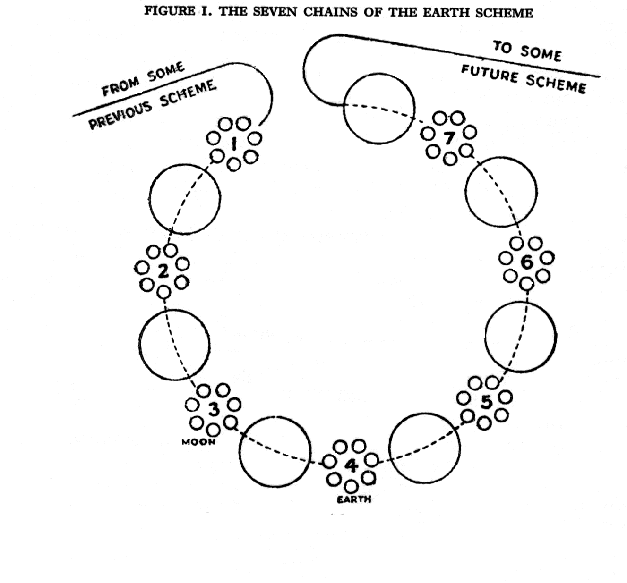
Little more was given than the naming of the four planes occupied by the seven Chains of the Earth Scheme, and the sweep of the lifewave around them, as in Figure I.
The diagram illustrates forcefully the number and vastness of the cycles needed to achieve the necessary physical basis for the Monad. The small group of seven globes marked No. 4 constitute our Earth Chain, with the earth as its densest member - and represents the goal of the whole involuntary sweep. In the Chart on page 39, seven letters - A to G - are used to distinguish these globes, the letter D representing the earth.
‘Growth and development’ of such a group implies continual and progressive change, and this is as true of Planetary Chains as it is of a human body's growth from infancy to maturity. Hence an illustration or a diagram can never depict more than a momentary phase of growth. Yet though more information was given in later works, the same general view of the group of globes has usually been presented.
However a somewhat subtler and more comprehensive view can be deduced from the explanatory commentaries of The Secret Doctrine, and the following exposition is founded upon these.
The chain of globes to which our earth belongs exists in three fields of energy. In the classic literature these are named the mental world, the astral and the physical, the mental and physical being each divided into subtler and denser levels. The seven globes of our Chain are said to exist as follows: A and G in lower-mental matter, B and F on the astral level, C and E on the etheric or subtle physical level, while the dense physical globe, D, our earth, is a single globe standing alone. ‘The earth has no sister globe.’ [The Secret Doctrine, I: 234. With reference to a diagram (page 225) it is stated that the figures are applicable mutatis mutandis to rounds, globes and races and adds ‘the fourth member of a series occupies a unique position’.]
The globes are so described, however, that it is evident on thoughtful reading that each successive globe, as it is formed, emerges in close contact with the previous manifestation. So that in our Earth Chain, while A and G are of mental material only, in the manifested world, B and F are mental and astral, C and E are mental, astral and etheric, while D is linked with all three types of matter, lower mental, astral and two types of physical. Yet the total fields of activity of each of the different types of matter differ in size as well as in quality, so that the subtler types extend beyond as well as penetrate the denser.
As the Chain becomes denser, the globes develop in sequence, all arising from a common centre, though not all, as noted, are of the same substance. [The Secret Doctrine, I: 207, 208.] The sequences of the seven globes are shown in the following arrangement.

 | CHAIN -I- |  | CHAIN -II- |  | CHAIN -III- |  | CHAIN -IV-
MENTAL LEVEL | A |  | A | G | A | G | A | G
ASTRO MENTAL |  |  | B |  | B | F | B | F
ASTRO-PHYSICAL |  |  |  |  | C |  | C | E
DENSE PHYSICAL |  |  |  |  |  |  | D

Stanza VI describes this same succession: [ibid., I: 196]
‘First one manifested, six concealed; Two manifested, five concealed; Three manifested, four concealed .... Lastly Seven Small Wheels revolving; one giving birth to the other.’
The chart above merely indicated the succession of globes, and applies to the first four Chains, and similarly to the first four Rounds of our own Earth cycle. In the sequence of Rounds the successive emphasis upon the mental, astral, etheric and physical aspects of the globes again recapitulates the earlier work of the Chains.
The mental field, or Globe A, the first to manifest, is naturally based upon the Web of the Universe, shared by all the Chains of our Solar System. It fills the entire field of the projected Chain, and has the Ring-pass-not of the Chain for its periphery. The mental globe is the foundation upon and in which all others exist. The astral field (Globe B) is at first composed of two planes only, astral and mental, but later it becomes closely involved with the denser levels. The subtle physical globe is at first interwoven with the three fields, mental, astral and etheric, and then acts as the interior matrix for the formation of dense physical matter. Finally the dense physical globe emerges, interlocked with all four levels. In these divisions or fissions and new births, the vital stimulating principle is supplied from the corresponding globe of the previous Chain. [The Ancient Wisdom, by Annie Besant, chapter XII.]
Our Earth Chain is thus a reincarnation of the preceding Chains of our Scheme of Planets, and especially of its immediate predecessor, the Moon Chain. Hence within its all-inclusive magnetic field, from its beginning, the subtle globes of that Chain, with their unabsorbed planetary skandas represented by seed vortices, were present, and were successively awakened into activity. The history of our present Earth Chain, with its globes and Rounds, may therefore be taken as dating from the very beginning of the Scheme. The proximity of the moon itself - a relic of the preceding Chain, is an indication that the area occupied by the Earth Chain in relation to the sun is approximately the same as that of its predecessor. [The Secret Doctrine, I: 225.]
It should be added that, while the recapitulations in the Rounds follow the pattern of the preceding Chains, they are naturally on a more advanced spiral.
Vesica Piscis
Fortunately, in a Master’s letter, quoted in The Secret Doctrine, and already referred to in this article, a description is given concerning the inter-relationship of the seven globes of our Chain:
‘The Globes which overshadow our Earth...are in coadunition but not in consubstantiality with our Earth.’ [ibid., I: 220.]
Coadunition is a botanical term for branchings from the same point on a shrub or tree, such as a number of leaves. The few allusions in The Mahatma Letters (see page 95) to ellipses and the epicycloid form (wheels within wheels) afford a clue to this picture of related pairs of globes as they exist in the successive Chains of a Scheme. It would appear that the group of seven planets composing our Chain branch from a common point, are closely related, and are assembled successively.
The phrase in the Stanzas ‘One giving birth to the other’, when coupled with a shloka of Stanza III - 'Father-Mother spin a Web’, reveals the method of reproduction of globes to be the same as the reproduction of cells. ‘As above so below.’ In a small publication of the Stanzas of Dzyan with brief comments, probably from notes left by H.P.B, the term ‘seven small wheels’ are said to be our Chain of seven globes and ‘the student is advised to consider the microscopic processes of cell development and the web which is spun’. [1908 Edition, page 31.] The diagram illustrates this cell division process (Figure II.
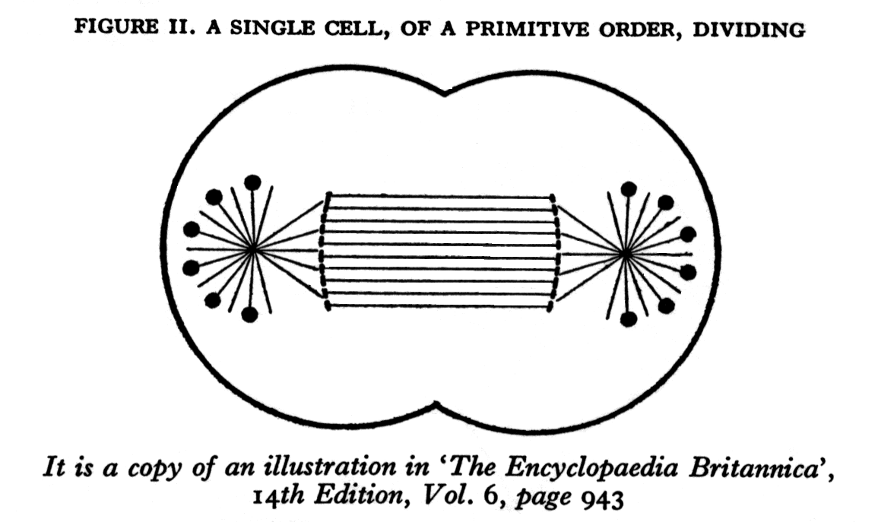
Those familiar with the processes of propagation by fission will appreciate the relevance of this suggestion. ‘Separation (of the nucleus) into two parts heralds the inception of cell division. As the two attractive spheres separate they appear to draw out the intervening cytoplasm into a spindle of fine fibrils ...The tangle of fine threads has resolved itself into a number of readily distinguishable filaments.’ [Reference as for the diagram, page 942.] As the spheres separate and the two separate nuclei assume control, the result is a double cell, which may continue to be joined or may separate completely. In unicellular plants and animalculae, cell division results in complete separation, the development of two individuals; in the case of higher forms, the cells remain attached and the multicellular form emerges.
Thus it would seem from the comments and parallels presented that the sequential appearance of the globes of a Chain may be presumed to occur very much as a cell divides. The one planet (lower mental) in the first Chain, for example, dividing like a cell, the two resulting mental globes would remain attached as in Figure II.
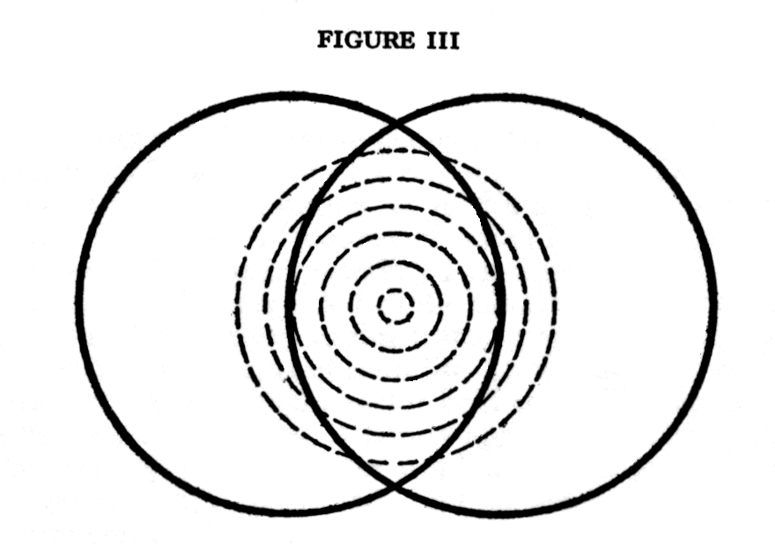
The overlapping of the two would then compose a generative centre (Vesica Piscis) [The Vesica Piscis: In Euclidean geometry the first problem is to describe an equilateral triangle upon a finite strait line. Two circles are drawn with the given line as a common radius, as in Figure III. Within the interlaced circles two more radii, all of course of equal length, form the equilateral triangle. The ovoid formed by interlaced circles of equal diameter is known as the Vesica Piscis and is regarded as the classical symbol of generation and creative life. The Vesica serves to illustrate many aspects of creation, even at the highest levels, in the terms of both life and form.
The geometric figure symbolizes this brilliantly. The circles represent the division of the One into duality. A trinity appears, the Breath and Spirit and Matter. The overlap of the circles implies interaction in the Vesica, the symbol of regeneration, of new birth, and therein the Breath is aroused into awareness, into consciousness.] for the conception and birth of a third planet, the astro-mental, as in Figure III.
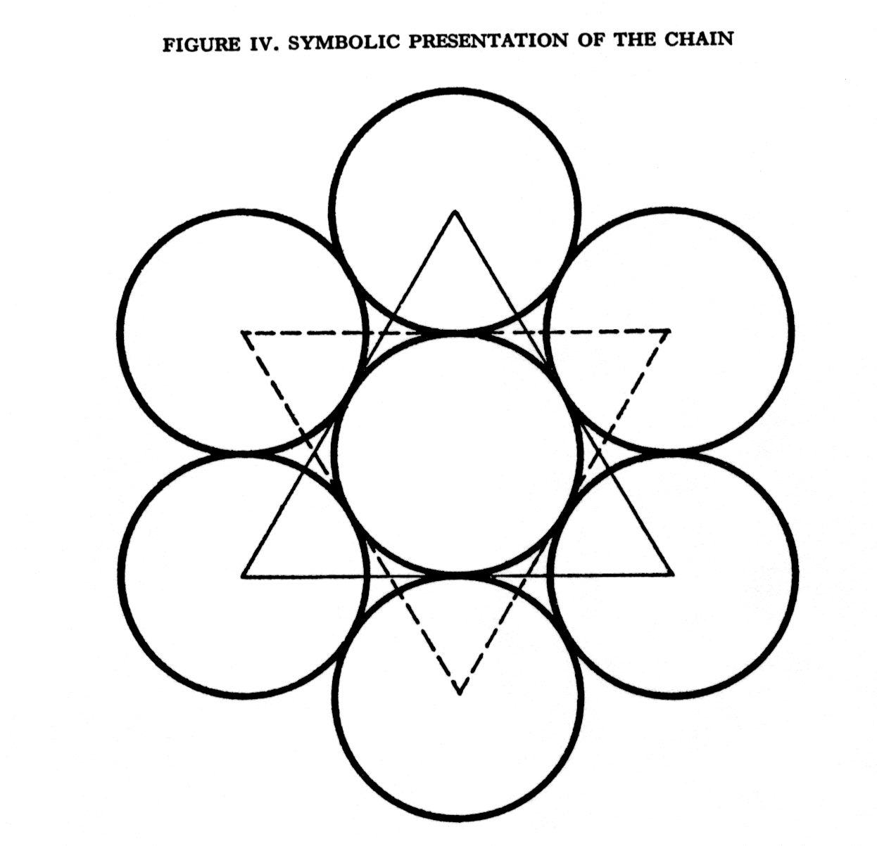
This, in its turn, divides and later gives birth to the fifth planet (astral-mental-etheric). With the division of this etheric planet, towards the end of the third Chain, there is a six-cell formation, six globes surrounding a central sphere destined to be the final, centralised planet, its core being of physical matter at its densest. The six surrounding planets ‘overshadow our earth’ and their assembly is symbolically shown in the interlaced triangles of the Theosophical Seal (Figure IV).
The following diagrammatic illustration is an attempt at the representation of the Planetary Chain of Globes with the central globe, the Earth, cradled in the three-dimensional Web within the three Vesicas.

The Seven Globes of our Planetary Chain with a Common Centre - in Coadunition
The first globe - lower-mental - divides into two, as a cell does, but these remain interlocked, forming a ‘Vesica’ between them (A and G). The second globe - astral- behaves similarly but at right-angles (B and F). The third globe - physical etheric - again divides at right-angles C and E). And finally globe D, our Earth, emerges supported within three vesicas. Imagine the Circles to be Spheres and, further, that a dual C and E are in front of and behind D.
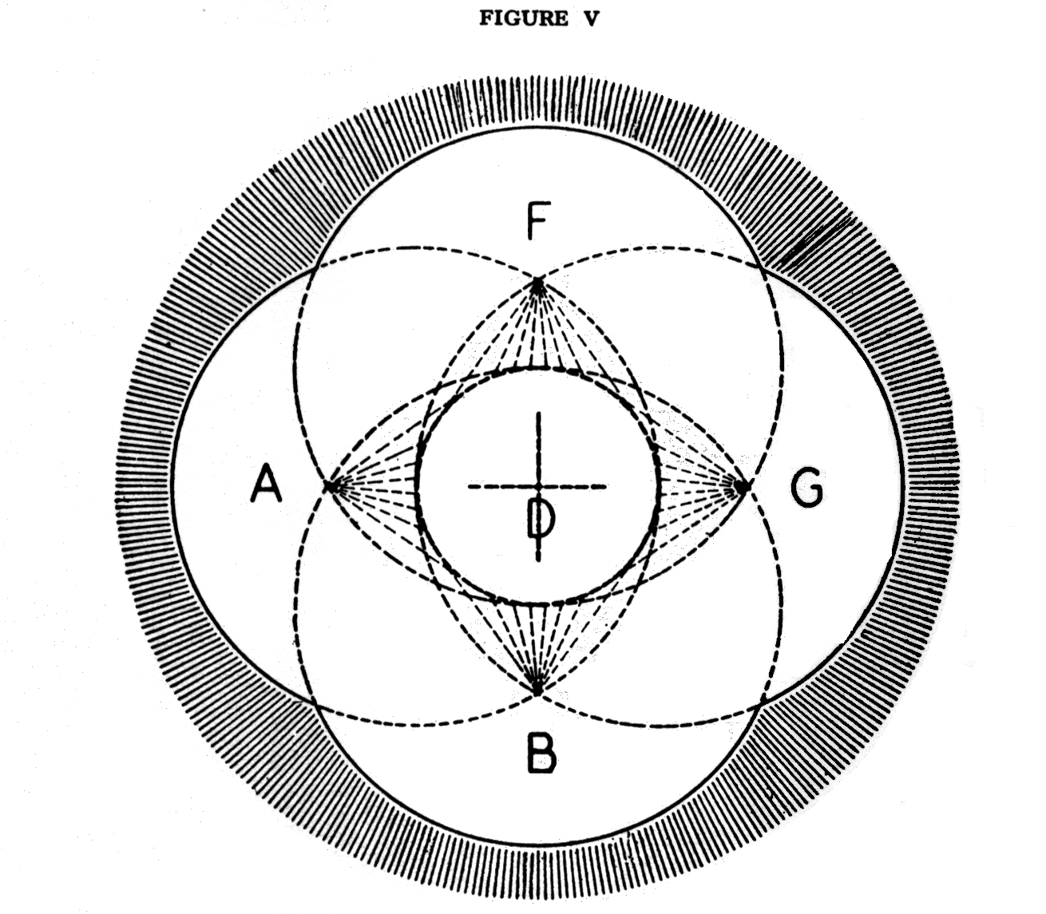
In Figure V the seven globes of the Chain are depicted as three duals and the unique fourth, in their relative positions and association in this the Fourth Round. The globes C and E must be imagined as behind and in front of the middle of the figure, in the third dimension of space.
All are now assembled and the physical globe D appears suspended within the three Vesicas of the surrounding dual-globes - the Vesicas themselves forming a perfect octahedron in form. [The central figure of the Platonic solids is the eight-sided figure, the octahedron, most easily visualised as two pyramids with their square bases joined.] Globe D thus is enabled to provide the stable foundation for the support and future growth of the Chain, even to its maturity.
‘Our Earth, as the visible representative of its invisible superior fellow-globes...has to live, as have the others, through seven Rounds. During the first three, it forms and consolidates, during the fourth it settles and hardens, during the last three, it gradually returns to its first etherial form: it is spiritualised, so to say.’ [The Secret Doctrine, I: 213,]
The paired spheres are not alike; they are not duplicates. This distinctive difference is suggested in Madame Blavatsky’s own grouping of the globes, for in one of her many diagrams [ibid., 208.] the second of each pair is placed at a higher level. The terms ‘shadowy’ for the descending arc A-B-C and ‘luminous’ for the ascending arc E-F-G, used in The Mahatma Letters, [page 95.] apply equally to the circuits of the globes in a great Round and to the minor circuits by individuals between incarnations.
The Turning Point
The fourth circuit of the globes, the fourth Round, is being made now. Within the field of our Planetary Chain, we have now reached or are just beyond the turning point not only of the present Round but also of the whole vast cycle of the Chain, and a basic radical change is occurring in the direction and course of the Life. On the broad scale of the macrocosm, the changeover from involution to evolution amounts practically to a reversal. The path of return has begun.
During the building and division of the globes on the three earlier Chains, a concentration of activity occurred on each in succession. And when the lifewave passed on, the globe vacated is said to lapse into obscuration. This, however, seems to be merely a comparatively short period of reduced activity, of quiescence.
‘ “Obscurations” are not Pralayas...they last in a proportion of one to ten.’ [The Mahatma Letters, page 177.]
From the turning point onwards and henceforth, as the globes are vivified on the remainder of this Round and later, they will all of them tend more and more to continue in activity, from the physical globe to the mental, right up to the seventh Round of consummation. Awakenings overtake obscurations. At the consummation of the seventh Round, when the whole Earth Chain becomes equilbrised, to use Madame Blavatsky’s term, the physical globe is perfected. Its subtle but still physical form is retained until the very end of the cycle. Its function might be described perhaps as the Chain’s catalyst - and it remains as the perfected Egg, containing the seeds of the future.
The retention of the physical structure of the fourth globe, our earth, till the final Round of the Chain is well founded. [The Secret Doctrine, I: 213.] Its great value is due to its comparatively stable qualities, to its prithevi tattva, its measure of vibration. It appears to contribute to the vast field of the Chain a foundation of stability. The term Round itself becomes inappropriate, as life - in terms of human consciousness, spiritually illumined, transcends many of its formal limitations and moves from an interest in analysis and structure to synthesis and living values. Consciousness can then retain the clarity of physical contacts even while its centre of direction, within its harmonised vestures, recedes to subtler levels. Correspondingly, the worlds of the etheric, astral and mental planes become successively balanced and in equilibrium.
On the forthgoing path, the worlds awaken and stimulate consciousness. On the returning path, the worlds obey. In macrocosm and microcosm the separate aspects of the One tend towards harmony and union.

END

