Katherine Augusta Westcott Tingley 1847-1929
http://en.wikipedia.org/wiki/Katherine_Tingley
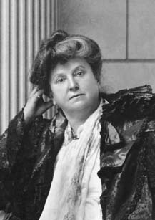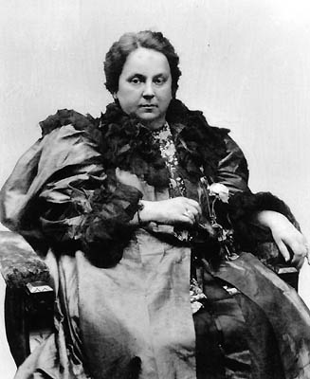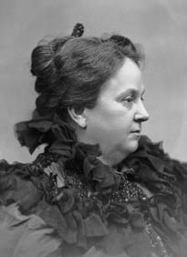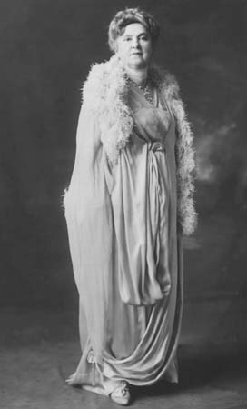

Katherine Augusta Westcott Tingley (1847, Newbury, Massachusetts - 1929) was a social worker and prominent Theosophist.
Tingley was a social worker in New York when she met William Quan Judge. She joined the Theosophical Society on October 13, 1894. In 1895, disputes between Judge and Annie Besant lead to a split, with Judge taking most of the American section with him, and leading it for one year until his death in 1896. At that point Tingley became the new head of the organization, although her identity was concealed for one year. On February 13, 1900, she transferred the Society's international headquarters from New York City to Lomaland at Point Loma, California.
Tingley founded the Raja-Yoga School and Theosophical University in Point Loma.
================================================================================================================================

Katherine Tingley and Point Loma

Theosophical Topics in Depth
Articles on Katherine Tingley and Point Loma, links to KT's books online, and to photographs of KT and the Point Loma Community.
Back of the imaginings and hopes and dreams of my childhood and womanhood, deeper than the pain caused by the contrasts I have observed in human life, there is a consciousness of the love of God and the spiritual dignity of man. And it is this consciousness that is needed now to make the world better, to bring man to his own, to give him the key to life's problems, so that he can combat difficulties understandingly, overcome injustice through knowledge, and live in the joy of life in the truest and noblest sense. -- Katherine Tingley

Articles on Katherine Tingley, her books, and Point Loma:
- "Katherine Tingley: A Biographical Sketch" by Grace F. Knoche
- "Katherine Tingley, Her Work and Aims: An Interview" by Gertrude Stevenson
- "A Few Facets of Katherine Tingley" by Raymond Rugland
- "My First Meeting with H. P. Blavatsky's Teacher" by Katherine Tingley
- "The School of Antiquity: Its Meaning, Purpose, and Scope" by J. H. Fussell
- "The S.R.L.M.A." by Alan E. Donant
- "The Raja-Yoga Schools of Point Loma" by Bernard Parsons
- "Childhood Memories of Point Loma" by Ingrid Van Mater
- "'Strong Enough to Stem the Tide': Work in Cuba" by Monica Morris
- "I Never Knew Katherine Tingley" by Eloise Hart
- "A Personal Impact" by I. M. Oderberg
- "A New Light among All: First Crusade Address" by Katherine Tingley
- "Rebirth of the Mysteries" by W. T. S. Thackara
- "Discipline Precedes the Mysteries" by Kirby Van Mater
- "The New Way" by Nancy Coker
- "A Mentor to Me" by Doreen N. Melbrod
- "Candles in the Darkness: Tingley's 'The Gods Await'" by Nancy Coker
- "A Life's Gift: Tingley's 'Wisdom of the Heart'" by Lillian Burke

Books online by Katherine Tingley:
- Theosophy: The Path of the Mystic
- The Wine of Life
- The Gods Await
- The Splendor of the Soul

Photographs of Katherine Tingley and the Point Loma Era
- Katherine Tingley 1896
- Katherine Tingley in Darjeeling, India, 1896
- Katherine Tingley, 1906
- Katherine Tingley, 1920s
- G. de Purucker's Sketch of Point Loma, drawn at Geneva, September 2, 1896
- Laying the Cornerstone of the SRLMA, Point Loma, February 23, 1897
- Raja-Yoga Academy and Temple of Peace, International Theosophical Headquarters, Point Loma, California
- Academy Building, International Theosophical Headquarters, Point Loma, California
- SRLMA Foundation Stones (staked in two columns), Point Loma
- Classroom at Point Loma, about 1900
- Cuban Raja-Yoga Students at Egyptian Gate and Peace Tree, San Juan Hill, Cuba, 1910
- Raja-Yoga Children at Point Loma, about 1928
- Raja-Yoga Symphony Orchestra, Academy Rotunda, 1912
- First Open-air Greek Theater in America, Point Loma, California, built in 1901
- "The Eumenides" Finale, Katherine Tingley's production, Greek Theater, Point Loma, 1922
- A Midsummer Night's Dream, (fairies with Bottom), Greek Theater, Point Loma, 1919
- A Midsummer Night's Dream (child dressed as cobweb), Greek Theater, Point Loma
- "The Path," painting by Reginald Machell
- Detail from R. Machell's "The Path" painting
- Author Talbot Mundy's inscription to Katherine Tingley in her copy of Om: The Secret of Ahbor Valley (1924)
- International Theosophical Peace Congress, Visingso, Sweden, June 1913
- Raja-Yoga College Band, Peace Parade, Balboa Park, September 28, 1914
- Raja-Yoga Chorus, Peace Parade, San Diego, September 28, 1914
- Parliament of Peace Committee, Temple of Peace, Point Loma, 1923 (names given)
- Katherine Tingley and party with Arizona Governor George P. Hunt, who abolished capital punishment in his state.

================================================================================================================================
www.sandiegohistory.org/bio/tingley
Katherine Augusta Westcott Tingley (1847-1929)
Born July 6, 1847, at Newbury, Massachusetts, Catharine Augusta Westcott was educated in the Newburyport schools and by private tutors. In 1888 she married Philo B. Tingley, her third husband.
In the early 1890s on New York City's East Side she set up soup kitchens and emergency relief missions, and later she established philanthropic organizations for orphaned children, unwed mothers, and destitute families.
Katherine Tingley joined the Theosophical Society on October 13, 1894, and worked closely with its president William Q. Judge, who died in 1896, just short of his 45th birthday.
Shortly after his death, she was recognized as his successor by those closest to him. She traveled worldwide, establishing schools in several countries, emphasizing practical humanitarianism, education, prison reform, and world peace. In 1900, she moved the international headquarters to Point Loma where she established the Raja-Yoga School and College, Theosophical University, and the School for the Revival of the Lost Mysteries of Antiquity. Tingley built the first open air Greek Theater in America, and formed youth and adult symphony orchestras with the headquarters staff and students.
An important feature of the Raja-Yoga School was the inclusion of music, drama, and the arts as integral parts of the regular curriculum, starting with three-year-olds -- all students, with or without talent, learned to play an instrument, sang in the choir, took drawing and painting, and participated in some form in the dramatic work, all being early exposed to the Greek and Shakespearean dramas that were performed under the personal direction of Katherine Tingley in the open-air Greek Theater erected by her in 1901.
Katherine Tingley died July 11, 1929, at the age of 82 while on a European lecture tour. After she died, the school continued for a few more years before closing in 1942. California Western University (later, U.S. International University) subsequently occupied the site, followed by Point Loma Nazarene College.
================================================================================================================================
END

=================================================================================================================================
http://www.theosociety.org/pasadena/ts/bio-kt.htm

Katherine Tingley
Katherine Tingley was born July 6, 1847, in Newbury, Massachusetts. She felt a profound sympathy for the victims of poverty, misery, and war, and worked all her life to alleviate suffering. In 1893 she met William Q. Judge who introduced her to theosophy. Soon she knew that here was a philosophy which, if practiced, could lighten the burdens of humanity. Mrs. Tingley and Judge became co-workers, and upon his death in March 1896 she succeeded him as head of The Theosophical Society. In 1900 she moved its international headquarters to Point Loma, California, where she continued her humanitarian efforts and founded the Raja-Yoga School, Academy, and College, and later, in 1919, Theosophical University. She lectured extensively in the United States and abroad until shortly before her death at Visingso, Sweden, on July 11, 1929. (Link to a Biographical Sketch.)
- Sunrise Special Issue 1998: Katherine Tingley (1847 - 1929) (Full-text online)
Books by Katherine Tingley published by Theosophical University Press:
- The Gods Await (Full-text online)
- Theosophy: The Path of the Mystic (Full-text online)
- The Wine of Life -- online edition only (Full-text online)
- The Splendor of the Soul -- online edition only (Full-text online)
Books by Katherine Tingley from other publishers available through TUP:
- The Wisdom of the Heart: Katherine Tingley Speaks, compiled and edited by W. Emmett Small
=====================================================================================================================================
END

