Ezra Pound and The Occult

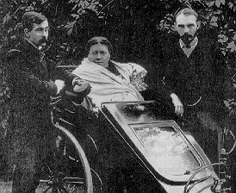
George Robert Stowe Mead is pictured on the far right. He is accompanied by James Pryse. The two men are escorting the famous Madame Helena Petrovna Blavatsky. Mead became a member of Blavatsky's Theosophical Society in 1884. He abandonded his teaching profession 1889 to be Blavatsky's private secretary. He served in this position for almost three years until Blavatsky's death in 1891. He worked as an assistant editor to Blavatsky's monthy magazine, Lucifer, which Mead renamed The Theosophical Review after taking over as its editor. Mead was appointed General Secretary of the European division of the society but resigned from the position in 1897. He was also offered the presidency following the death of the co-founder of the society. Mead turned this position down as well because he felt the need to pursue his own studies.
Mead and Pound met at one of Yeats's "Monday Evenings" and Pound immediately took an interest in Mead's work. Outside of the Monday meetings, Pound attended Mead's numerous other lectures and read his books. Eventually, Mead asked Pound to prepare a publishable lecture for his new magazine, The Quest. It was Mead's suggestion that the essay was to deal with "Troubadour Psychology."

