Leadbeater, Charles Webster 1854-1934
http://en.wikipedia.org/wiki/Charles_Webster_Leadbeater
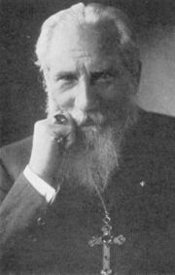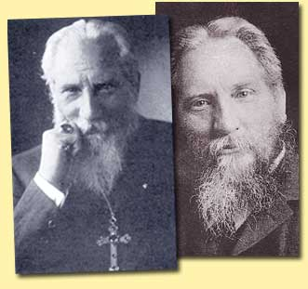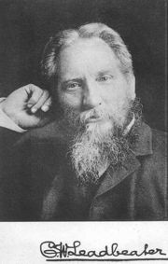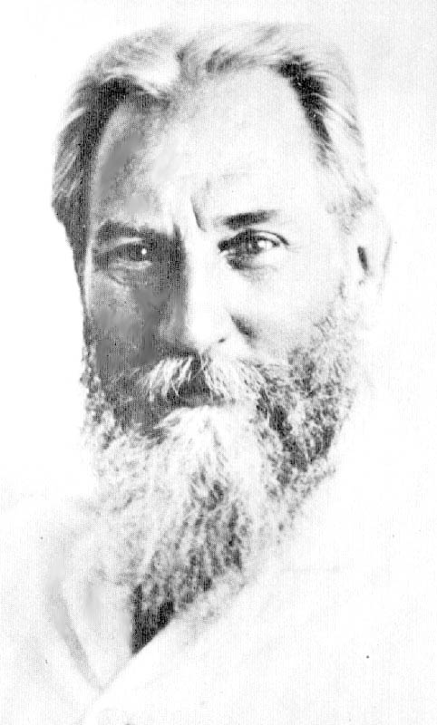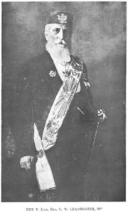
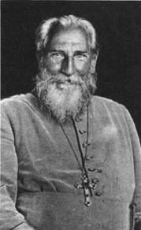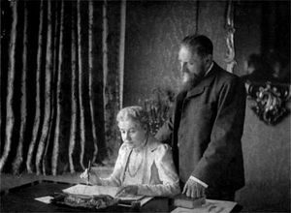
Charles Leadbeater & Annie Besant

Leadbeater, Charles Webster (Feb 16, 1854 England-1934 Perth, Western Australia), English clergyman and theosophical author, contributed to world thought mostly through his work as an alleged clairvoyant.

Contents
- 1 Early life
- 2 Joins Theosophical Society
- 3 Return to England
- 4 Occult Powers
- 5 Accused of Pederasty
- 6 Readmission to TS
- 7 Discovers Krishnamurti
- 8 To Australia
- 9 Work as a clairvoyant
- 10 Works
- 11 Notes
- 12 References
- 13 External links

Early life
Although some sources state that he was born in 1847, his biographer has uncovered sufficient documentation that he was actually born in 1854.^{[1]}
His father Charles was born in Lincoln and his mother Emma was born in Liverpool. He himself was born in Stockport, Cheshire. By 1861 the family had moved to London, where his father is listed as a "Railway Contractor's Clerk".^{[2]}
Lutyens, repeats a story that Charles and his family had gone to Brazil "...where his father was a railway contractor, and led a life of adventure in the course of which his father died and his younger brother Gerald was murdered in 1862 by bandits. After returning to England he entered Oxford University but soon had to leave when in 1866 the bank failed in which all the family money was invested."^{[3]}
His uncle, was the prominent Anglican clergyman, William Wolfe Capes. By this uncle's influence, Charles was ordained an Anglican priest in 1879 at Farnham, by the Bishop of Winchester. By 1881, he is living with his widowed mother at Bramshott, where he is listed as "Curate of Bramshott".^{[4]}

[] Joins Theosophical Society
His interest in occultism was stimulated by A.P. Sinnett's Occult World, and he joined the Theosophical Society in 1883. The next year he met Helena Petrovna Blavatsky when she came to London. "When she accepted him [as a pupil], he gave up the church, became a vegetarian, severed all ties with England, and followed her to India."^{[5]}
At this time he was the recipient of a few Mahatma letters which influenced him to go to India, where he arrived at Adyar in 1884. In India he claimed to have received visits and training from some of Blavatsky's Masters.^{[6]} This was the start of a long career in the Theosophical Society.

[] Return to England
He lived first at Adyar, and then for several years in Ceylon, where he "...taught in a school for poor boys, founded by Colonel Olcott." (Lutyens, p 13). Around 1889, Sinnett asked him to return to England to tutor his son and also George Arundale. He agreed and brought with him, one of his pupils Jinarajadasa.
Jinarajadasa relates how Leadbeater had already done some occult investigations but how in May 1894 he did his first past-life reading.
He became one of the most known speakers in the Theosophical Society for quite a number of years^{[7]} and was also Secretary of the London Lodge.^{[8]}
It is not known, when and why he added seven years to his life, but sometime in the next 20 years, he started claiming to have been born in 1847. On a ship's manifest in 1903 he lists his age as 56, occupation "Lecturer" when he went on a lecture tour to Vancouver and San Francisco. He also notes that he had previously come to Seattle in 1893.^{[9]}

[] Occult Powers
With Annie Besant, starting in 1895, they made "...occult investigations together into the cosmos, the beginnings of mankind, chemistry and the constitution of the elements, as well as frequently visiting the Masters together in their astral bodies."^{[10]}
Annie later is said-to-have allowed her occult powers to diminish, while Leadbeater's grew stronger.

[] Accused of Pederasty
Leadbeater was accused of pederasty, the first accusation coming in 1906.
Mary Lutyens in "Krishnamurti: The Years of Awakening" writes:
- "Then in 1906, after Leadbeater's return to England, the fourteen-year-old son of the Corresponding Secretary of the Estoric Section in Chicago, whom Leadbeater had taken with him to San Francisco on his first lecture tour, confessed to his parents the reason for the antipathy he had conceived for his mentor, to whom he had at first been greatly devoted -- Leadbeater had encouraged him in the habit of masturbation. Almost simultaneously the son of another Theosophical official in Chicago charged Leadbeater with the same offense without apparently there being any collusion between the two boys. Then a typewritten, unsigned, undated, cipher-letter was produced; it had been picked up by a suspicious cleaner on the floor of a flat in Toronto in which Leadbeater had stayed with the second boy and was said to have been written by Leadbeater. The code was simple and when broken revealed one passage of such obscenity, for those days, that the letter could not by law be printed in England. When decoded the offending passage read: 'Glad sensation is so pleasant. Thousand kisses darling.'" (Mary Lutyens, p 15)
A commission was appointed by the American Section, but before the meeting, Leadbetter resigned the TS, as he told Olcott, "to save the Society from embarrassment." (Mary Lutyens, p 16).
On the nature of the accusation itself, Leadbetter wrote to Annie Besant in the following words:
- "...So when boys came under my care, I mentioned this matter to them [masturbation], among other things, always trying to avoid all sorts of false shame, and to make the whole appear as natural and simple as possible...." - Letter from C W Leadbeater to Annie Besant (quoted by Mary Lutyens, p 17)
Another such accusation came later from Hubert van Hook of Chicago, who as an 11-year-old was proclaimed by Leadbeater as future World Teacher.^{[11]} On the denunciation, Mary Lutyens states: "Hubert later swore to Mrs Besant that Leadbetter had 'misused' him, but as he was extremely vindictive by that time, his testimony, though unshaken, was perhaps not altogether reliable.' (Mary Lutyens, p 45n)
Leadbetter was never charged or brought to court, though there is a body of evidence that suggests he had sexual relations with students in the United States, India and Australia. Peter Michel, in his biography of Charles W. Leadbeater, writes that these accusations are suspect as they came from those who could be considered his enemies: Alexander Fullerton, Herbert Burrows, G.R.S. Mead, Hubert van Hook, Katherine Tingley and Hilda Martyn.

[] Readmission to TS
After Olcott died in Feb 1907, Annie Besant after a political struggle became President of the Society. By the end of 1908, the International Sections voted for Leadbeater's readmission. He accepted and came to Adyar on Feb 10, 1909.

[] Discovers Krishnamurti
His most well-known activity was the discovery, in April, 1909, of Jiddu Krishnamurti, on the private beach that formed part of the Theosophical headquarters in Adyar, India. Krishnamurti and his family had been living in the headquarters for a few months before this discovery. Krishnamurti was to be the vessel for the indwelling of the coming "World Teacher" that many Theosophists were expecting. This new teacher would, in the pattern of Moses, Buddha, Zarathustra (Zoroaster), Christ, and Muhammad divulge a new dispensation, a new religious teaching. Theosophists believed that the teacher was a spiritual being who would dwell in the body vessel.
Leadbeater believed he could read past lives, and did so on Krishnamurti who he claimed was really named Alcyone, publishing 30 such past lives in The Theosophist beginning April 1910 as Lives of Alcyone. "They ranged from 20,000 BC to 624 AD... Alycone was a female in eleven of them." (Lutyens, p 25)
Charles Leadbeater stayed in India for some time overseeing the raising of Krishnamurti, but eventually felt that he was being called to go to Australia for the cause.

[] To Australia
Annie Besant had come to see Leadbeater as a liability and was relieved when, in 1915 he went to live in Sydney. While in Australia he came in closer contact with James I. Wedgwood who initiated him into Co-Masonry in 1915 and then in 1916, as a Bishop himself, consecreated Leadbeater into the Liberal Catholic Church.

[] Work as a clairvoyant
He remains well known and influential in his work through clairvoyance with for instance his books The Chakras and Man, Visible and Invisible dealing with the human aura and chakras, and writing on the function of the Sacraments in the Liberal Catholic Church, to name just a few subjects. Leadbeater's clairvoyance was not without grave errors. In his book The Inner Life he claims that there is a population of humans on the planet Mars. See Leadbeater's Observations on Mars.

[] Works
- Reincarnation (1898)
- Thought Forms (1901)
- Man Visible And Invisible (1902)
- The Inner Life (1911)
- Man: Whence, How and Whither (1913)
- Occult Chemistry (1919)
- The Inner Side Of Christian Festivals (1920)
- The Science of the Sacraments (1920)
- The Masters And The Path (1925)
- Glimpses of Masonic History (1926)
- The Hidden Life in Freemasonry (1926)
- The Chakras (1927); The Theosophical Publishing House, Wheaton, IL
- Occult Chemistry (book)
For a more complete list of his works, see A Chronological Listing of C.W. Leadbeater's Books and Pamphlets.

[] Notes
- ^ The Elder Brother, Gregory Tillet. Routledge & Kegan Paul Books. 1982
- ^ 1861 Census of England
- ^ Mary Lutyens, Krishnamurti: The Years of Awakening, Avon Books/Discus. 1983. p 12
- ^ 1881 Census of England
- ^ Lutyens,p 13
- ^ Leadbeater, C.W. How Theosophy Came to Me.
- ^ Warnon, Maurice H. Biographical Notes
- ^ A Description of the Work of Annie Besant and C W Leadbetter, by Jinarajadasa
- ^ San Francisco Passenger Lists 1893-1953
- ^ Lutyens, p 14
- ^ Mary Lutyens

[] References
- Caldwell, Daniel. Charles Webster Leadbeater: His Life, Writings & Theosophical Teachings.
- Michel, Peter. Charles W. Leadbeater:Mit den Augen des Geistes ISBN 3-89427-107-8 (In German; No English translation available)
- Tillett, Gregory. The Elder Brother: A Biography of Charles Webster Leadbeater.
- Lutyens, Mary. Krishnamurti: The Years of Awakening; Avon Books, New York. 1975

[] External links
- AnandGholap.net - Online Books by C.W. Leadbeater
- More pictures, quotes, works, etc
- bio Kingsgarden biography
- biography Singaport Lodge Biography
- bio Spirit Writings Biography
- articles by and about C.W. Leadbeater
- Occult Investigations
- Picture and short bio
- Works by Charles Webster Leadbeater at Project Gutenberg

===============================================================================================================================
END

