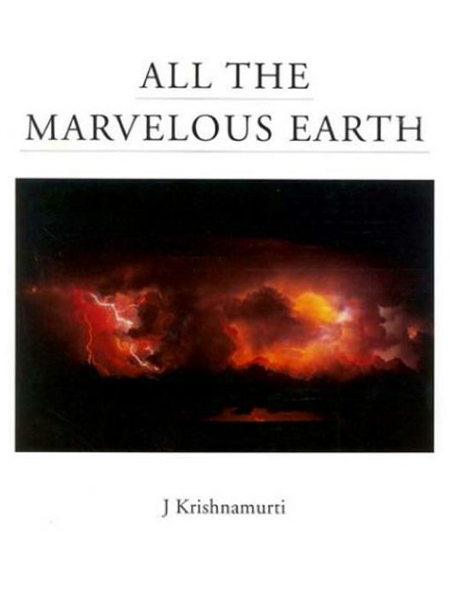
All the Marvelous Earth

By J. Krishnamurti

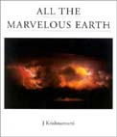

Book Description

All the Marvelous Earth is an anthology of Krishnamurti’s writings on nature and is unlike any of his previous works.

To read this book is to share a rare insight into the world of nature and human nature. Krishnamurti's finely observed descriptions were made during daily walks in city parks, the countryside, forests, and mountains. Carefully chosen photographs by noted photographers reinforce the text and bring home a fundamental truth that lies at the heart of our environmental concern: "If you hurt nature you are hurting yourself".

Through his deep appreciation of beauty and his questioning of our relationship with nature, Krishnamurti goes beyond the environmentalists' appeal for sustainable development to argue that the interaction between humankind and nature has a deeper, life-enhancing significance.
Table of Contents

About Krishnamurti
Have you any relationship with Nature?
What is Beauty?
Introduction
All The Marvelous Earth
Have you any relationship with the water of that river?
A tree by the river
A patch of blue sky
It was snowing that morning
The deep canyon
A lynx came down
A peculiar silence when it rains
Beauty is dangerous
The river that morning
Dawn was slow in coming
The Pacific has an ethereal blue
Man has killed millions of whales
There were children playing about
We are always using nature
If you hurt nature
What is nature?
The dark pines
A tree standing naked against the sky
It was cool in the wood
The whole horizon
A single tree in a green field
A rattler

ALL THE MARVELOUS EARTH

Copyright (c) 2000 Krishnamurti Foundation of America

All rights reserved.

For information about Foundations, Schools, and Study Centers, please contact:
Krishnamurti Foundation of America PO. Box 1560, Ojai, CA 93024, USA
E-mail: kfa@kfa.org
Website: http://www.kfa.org/

or

Krishnamurti Foundation Trust Ltd.
Brockwood Park
Bramdean, Hampshire, S024 OLQ, England
E-mail: kft@brockwood.org.uk
Website: http://www.brockwood.org.uk/kft/

About Krishnamurti

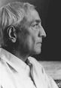

KRISHNAMURTI (1895-1986) was a modern philosopher whose influence spanned a very long life. He wrote over forty books, many of which have been translated into the world's major languages. Most are edited from talks he gave at annual gatherings in America, India, and Europe which attracted thousands of people. His books includeThe First and Last Freedom, The Awakening of Intelligence, Total Freedom and several with David Bohm including The Ending of Time .

We live in a time of growing awareness that threats to our natural environment, and very survival, demand a radically new, world-wide approach. But such an approach, Krishnamurti maintains, can come about only through the freeing of the human mind from a crippling servitude to self-centeredness, expressed collectively in a destructive adherence to nationalism and sectarian beliefs. Can sensitivity to nature therefore be seen as separable from sensitivity to the human condition as a whole? This is the fundamental issue raised throughout the book.

Have you any relationship with nature?

"If you have no relationship with nature you have no relationship with man. Nature is the meadows, the groves, the rivers, all the marvelous earth, the trees, and the beauty of the earth. If we have no relationship with that, we shall have no relationship with each other."
What is Beauty?

"... what is beauty? This is one of the most fundamental questions, it is not superficial, so don't brush it aside. To understand what beauty is to have that sense of goodness which comes when the mind and heart are in communion with something lovely without any hindrance so that one feels completely at ease -surely, this has great significance in life; and until we know this response to beauty our lives will be very shallow. One may be surrounded by great beauty, by mountains and fields and rivers, but unless one is alive to it all one might just as well be dead."
Introduction

THE last 50 years has witnessed a period of unprecedented environmental destruction. This book acknowledges our problems but focuses primarily on all the marvelous earth.

The text is drawn from a lifetime's passionate observation of nature by the 20th-century philosopher J. Krishnamurti. In his many books and talks on the human condition he would frequently preface or incorporate observations of the world of nature into the body of his work.

These exquisitely written passages are not merely an introduction to his philosophic writings, but can be seen as the very wellspring of his most profound concerns. Krishnamurti stands alone in his acute powers of perception and sensitivity to nature and human nature. His passionate insistence that we see the totality of life with clear eyes resonates through these pages.

"Our perception is not only with the eyes, with the senses, but also with the mind, and obviously the mind is heavily conditioned. So intellectual perception is only partial perception, yet perceiving with the intellect seems to satisfy most of us, and we think we understand. A fragmentary understanding is the most dangerous and destructive thing."

The pictures in this book are drawn from a large archive of photographs that illustrates both nature and our environmental problems. Krishnamurti traveled widely during the course of his annual talks in various countries. These pictures represent a diversity of his observations. They seek to illuminate rather than document the actual locations described in the text.

The editors have been deeply affected by Krishnamurti's connection to the world of nature, and hope that the juxtaposition of pictures with these writings will serve to introduce this crucial message to those who are concerned with order within ourselves, our relationship with others, and our rightful place in the world of nature.

Mark Edwards - Evelyne Blau
January 2000
ALL THE MARVELOUS EARTH

Have you any relationship with the water of that river?

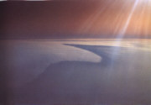

Have you any relationship with nature, with the birds, with the water of that river?

All rivers are holy, but getting more and more polluted: you may call it Ganga, or the Thames, the Nile, the Rhine, the Mississippi, or the Volga.

What is your relationship with all that, with the trees, with the birds, with all the living things that we call nature? Aren't we part of all that? So, aren't we the environment?

A tree by the river

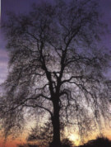

There is a tree by the river and we have been watching it day after day for several weeks when the sun is about to rise. As the sun rises slowly over the horizon, over the trees, this particular tree becomes all of a sudden golden. All the leaves are bright with life, and as you watch them as the hours pass by, that tree whose name does not matter -what matters is that beautiful tree- an extraordinary quality seems to spread all over the land, over the river. And as the sun rises a little higher the leaves begin to flutter, to dance. And each hour seems to give to that tree a different quality. Before the sun rises it has a somber feeling, quiet, far away, full of dignity. And as the day begins, the leaves with the light on them dance and give it that peculiar feeling that one has of great beauty. By midday its shadow has deepened and you can sit there protected from the sun, never feeling lonely, with the tree as your companion. As you sit there, there is a relationship of deep abiding security and a freedom that only trees can know.

Towards the evening when the western skies are lit up by the setting sun, the tree gradually becomes somber, dark, closing in on itself. The sky has become red, yellow, green, but the tree remains quiet, hidden, and is resting for the night.

If you establish a relationship with it, then you have relationship with mankind. You are responsible then for that tree and for the trees of the world. But if you have no relationship with the living things on this earth, you may lose whatever relationship you have with humanity, with human beings.

A patch of blue sky

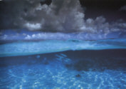

There was a patch of blue sky between two vast, endless clouds; it was a clear, startling blue, so soft and penetrating. It would be swallowed up in a few minutes and it would disappear forever. No sky of that blue would ever be seen again.

It was snowing that morning

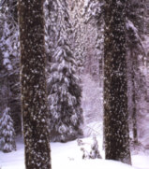

It was snowing that morning. A bitter wind was blowing, and the movement upon the trees was a cry for spring. In that light, the trunks of the large beech and the elm had that peculiar quality of grey-green that one finds in old woods where the earth is soft and covered with autumn leaves.

Walking among them you had the feeling of the wood -not of the separate individual trees with their particular shapes and forms- but rather of the entire quality of all the trees.

The deep canyon

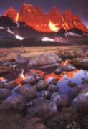

The other day, as we went up the deep canyon which lay in shadow with the arid mountains on both sides, it was full of birds, insects, and the quiet activity of small animals. You walked up and up the gentle slope to a great height, and from there you watched all the surrounding hills and mountains with the light of the setting sun upon them. It looked as though they were lit from within, never to be put out. But as you watched, the light faded, and in the west the evening star became brighter and brighter. It was a lovely evening, and somehow you felt that the whole universe was there beside you, and a strange quietness surrounded you.

A lynx came down

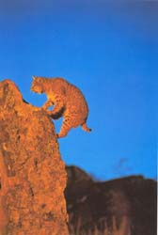

As you sat quietly without movement, a bobcat, a lynx, came down. As the wind was blowing up the valley it was not aware of the smell of that human being. It was purring, rubbing itself against a rock, its small tail up, and enjoying the marvel of the earth. Then it disappeared down the hill among the bushes. It was protecting its lair, its cave or its sleeping place. It was protecting what it needs, protecting its own kittens, and watching for danger.

It was afraid of man more than anything else, man who believes in God, man who prays, the man of wealth with his gun, with his casual killing. You could almost smell that bobcat as it passed by you. You were so motionless, so utterly still that it never even looked at you; you were part of that rock, part of the environment.

A peculiar silence when it rains

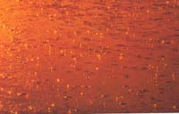

There is a peculiar silence when it rains, and that morning in the valley all the noises seemed to have stopped -the noises of the farm, the tractor, and the chopping of wood. There was only the dripping from the roof, and the gutters were gurgling.

It was quite extraordinary to feel the rain on one, to get wet to the skin, and to feel the earth and the trees receive the rain with great delight; for it hadn't rained for some time, and now the little cracks in the earth were closing up. The noises of the many birds were made still by the rain; the clouds were coming in from the east, dark, heavily laden, and were being drawn towards the west; the hills were being carried by them, and the smell of the earth was spreading into every corner. All day it rained.

Beauty is dangerous

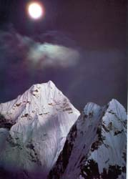

Beauty is dangerous. Standing on that hill, one saw 300 miles of Himalayas, almost from horizon to horizon, with deep, dark valleys, peak after peak with everlasting snow, not a house in sight, not a village, not a hut. The sun was touching the highest peaks, and all of a sudden the whole continuous range was afire. It was as though they were afire from within, a glow of incredible intensity. The valleys became darker and the silence was absolute. The earth was breathless in its splendor. As the sun rose from out of the far east, the immensity, the utter purity of those majestic mountains seemed so close one could almost touch them, but they were many hundreds of miles away. And the day began.

The river that morning

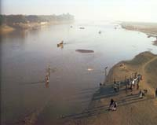

The river that morning had a strange movement of its own; it didn't seem to be ruffled by the wind, it seemed almost motionless and had that timeless quality which all waters seem to have. How beautiful it was! No wonder people have made it into a sacred river. You could sit there, on that veranda, and meditatively watch it endlessly. You weren't day-dreaming; your thoughts weren't in any direction -they were simply absent.

And as you watched the light on that river, somehow you seemed to lose yourself, and as you closed your eyes there was a penetration into a void that was full of blessing. This was bliss.

Dawn was slow in coming

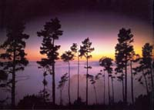

Dawn was slow in coming; the stars were still brilliant and the trees were still withdrawn; no bird was calling, not even the small owls that rattled through the night from tree to tree. It was strangely quiet except for the roar of the sea. There was that smell of many flowers, rotting leaves and damp ground; the air was very, very still and the smell was everywhere. The earth was waiting for the dawn and the coming day; there was expectation, patience, and a strange stillness.

The Pacific has an ethereal blue

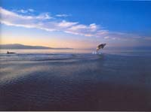

It is not that extraordinary blue of the Mediterranean; the Pacific has an ethereal blue, especially when there is a gentle breeze from the west as you drive north along the coast road. It is so tender, dazzling, clear and full of mirth. Occasionally, you would see whales blowing on their way north and, rarely, their enormous head as they threw themselves out of the water. There was a whole pod of them blowing; they must be very powerful animals. That day the sea was a lake, still and utterly quiet, without a single wave; there was not that clear dancing blue. The sea was asleep and you watched it with wonder.

Man has killed millions of whales

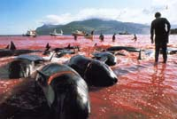

Man has killed millions of whales and is still killing them. All that we derive from their slaughter can be had through other means. But apparently man loves to kill things: the fleeting deer, the marvelous gazelle, and the great elephant. We love to kill each other. This killing of other human beings has never stopped throughout the history of man's life on this earth. If we could, and we must, establish a deep, long abiding relationship with nature -with the actual trees, the bushes, the flowers, the grass, and the fast moving clouds- then we would never slaughter another human being for any reason whatsoever.

There were children playing about

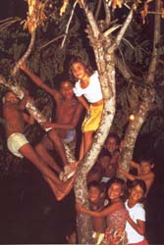

It was a lovely morning with fleeting clouds and a clear blue sky. It had rained, and the air was clean. Every leaf was new and the dreary winter was over; each leaf knew, in the sparkling sunshine, that it had no relation to last year's spring.

...There were children playing about, but they never looked at that lovely spring day. They had no need to look, for they were the spring. Their laughter and their play were part of the tree, the leaf, and the flower. You felt this, you didn't imagine it. It was as though the leaves and the flowers were taking part in the laughter, in the shouting, and in the balloon that went by. Every blade of grass, and the yellow dandelion, and the tender leaf that was so vulnerable, all were part of the children, and the children were part of the whole earth. The dividing line between man and nature disappeared, but the man on the race-course in his car and the woman returning from market were unaware of this.

Probably they never even looked at the sky, at the trembling leaf, the white lilac. They were carrying their problems in their hearts, and the heart never looked at the children or at the brightening spring day. The pity of it was that they bred these children and the children would soon become the man on the race-course and the woman returning from the market; and the world would be dark again. Therein lay the unending sorrow. The love on that leaf would be blown away with the coming autumn.

We are always using nature

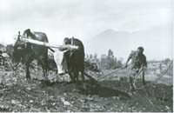

We are always using nature, either as an escape or for utilitarian ends we never actually stop and love the earth or the things of the earth. We never enjoy the rich fields, though we utilize them to feed and clothe ourselves. We never like to till the earth with our hands -we are ashamed to work with our hands. There is an extraordinary thing that takes place when you work the earth with your hands. But this work is done only by the lower castes; we upper classes are much too important, apparently, to use our own hands! So we have lost our relationship with nature.

If you hurt nature

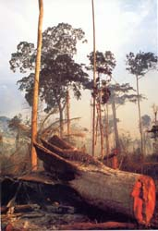

If you hurt nature you are hurting yourself.

What is nature?

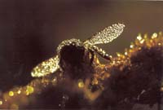

What is nature? There is a great deal of talk and endeavor to protect nature, the animals, the birds, the whales and dolphins, to clean the polluted rivers, the lakes, the green fields, and so on. Nature is not put together by thought, as religion is, as belief is. Nature is the tiger, that extraordinary animal with its energy, its great sense of power. Nature is the solitary tree in the field, the meadows, and the grove; it is that squirrel shyly hiding behind a bough. Nature is the ant and the bee and all the living things of the earth.

The dark pines

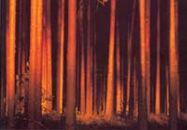

The dark pines never seemed to move, unlike those aspens which were ready to tremble at the slightest whisper. There was a strong breeze from the west, sweeping through the valley. The rocks were so alive that they seemed to run after the clouds, and the clouds clung to them, taking the shape and the curve of the rocks; they flowed around them and it was difficult to separate the rocks from the clouds. And the trees were walking with the clouds.

A tree standing naked against the sky

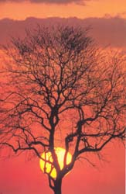

Have you ever noticed a tree standing naked against the sky, how beautiful it is? All its branches are outlined, and in its nakedness there is a poem, there is a song. Every leaf is gone and it is waiting for the spring. When the spring comes it again fills the tree with the music of many leaves, which in due season fall and are blown away. And that is the way of life.

It was cool in the wood

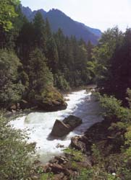

It was cool in the wood, with a shouting stream a few feet below; the pines shot up to the skies, without ever bending to look at the earth. It was splendid there with black squirrels eating tree mushrooms and chasing each other up and down the trees in narrow spirals; there was a robin that bobbed up and down, or what looked like a robin. It was cool and quiet there, except for the stream with its cold mountain waters. And there it was -love, creation, and destruction, not a symbol, not in thought and feeling, but an actual reality.

The whole horizon

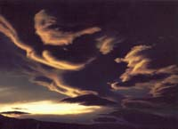

The whole horizon seemed to be filled with these clouds, range after range, piling up against the hills in the most fantastic shapes, castles such as man had never built. There were deep chasms and towering peaks. All these clouds were alight with a dark red glow and a few of them seemed to be afire, not by the sun, but within themselves.

These clouds didn't make the space; they were in the space, which seemed to stretch infinitely, from eternity to eternity.

A blackbird was singing in a bush close by, and that was the everlasting blessing.

A single tree in a green field

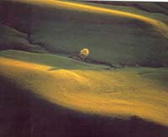

There is a single tree in a green field that occupies a whole acre; it is old and highly respected by all the other trees on the hill. In its solitude it dominates the noisy stream, the hills, and the cottage across the wooden bridge. You admire it as you pass it by but on your return you look at it in a more leisurely way; its trunk is very large, deeply embedded in the earth, solid and indestructible; its branches are long, dark, and curving; it has rich shadows. In the evening it is withdrawn into itself, unapproachable, but during the daylight hours it is open and welcoming. It is whole, untouched by an axe or saw. On a sunny day you sat under it, you felt its venerable age, and because you were alone with it you were aware of the depth and the beauty of life.

A rattler

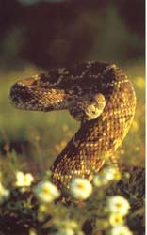

At that high altitude, suddenly, very close to you was a rattler, shrilly rattling his tail, giving a warning. You jumped. There it was, the rattler with its triangular head, all coiled up with its rattles in the center and its head pointed towards you. You were a few feet away from it and it couldn't strike you from that distance. You stared at it, and it stared back with its unblinking eyes. You watched it for some time, its fat suppleness, its danger; and there was no fear. Then, as you watched, it uncoiled its head and tail towards you and moved backwards away from you. As you moved towards it, again it coiled, with its tail in the middle, ready to strike. You played this game for some time until the snake got tired and you left it and came down to the sea.

