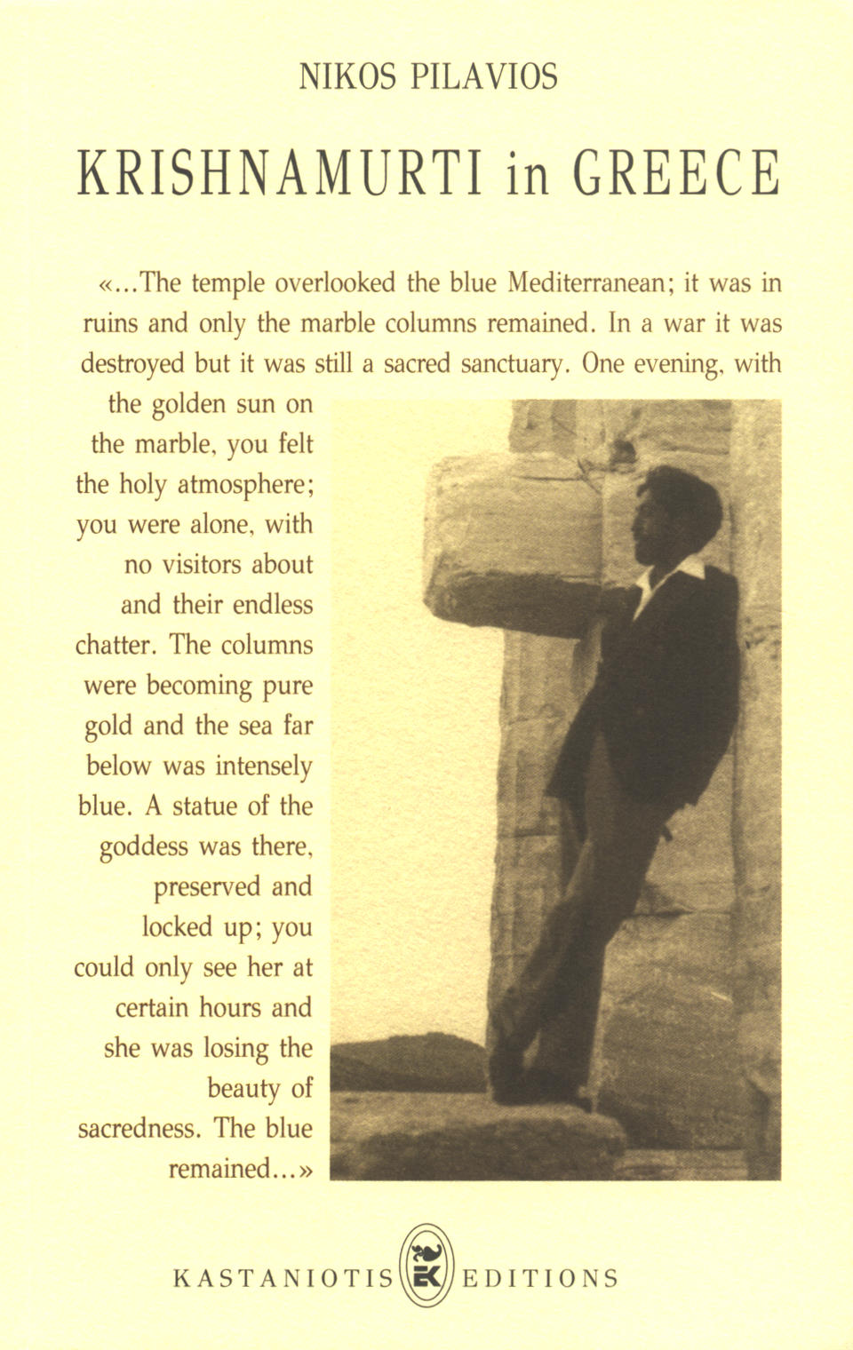

The 1930 photograph appears with the kind permission of UNITED PHOTOREPORTERS. The remaining photographs appear with the kind permission of KRISHNAMURTI LIBRARY OF ATHENS.

Krishnamurti in Greece
Copyright © Nikos Pilavios, Athens 1998
Proof Reader: Christine Cokkinos
Co-Writer: Michael Krohnen
Distribution: KRISHNAMURTI LIBRARY OF ATHENS
Published by KASTANIOTIS EDITIONS S.A.

NIKOS PILAVIOS

KRISHNAMURTI IN GREECE

KASTANIOTIS EDITIONS
ATHENS 1998

To Constantine and Marianna
TABLE OF CONTENTS

ACKNOWLEDGEMENTS
INTRODUCTION
KRISHNAMURTI’S VISITS TO GREECE
KRISHNAMURTI’S REFERENCES TO GREECE
- Greece and the Greeks
- The Parthenon
- A Story about Alexander the Great
EXTRACTS FROM KRISHNAMURTI’S TALKS IN GREECE
- Extract from his first talk in 1930
- Extract from a talk in 1933
- Extract from a talk in 1954
- Three questions posed in 1956
AN INTERVIEW AND AN ARTICLE
- The interview of 1956
- An article on his death
THE PHOTOGRAPHS
EPILOGUE
NOTES
ACKNOWLEDGEMENTS

It is impossible adequately to thank Michael Krohnen who practically rewrote the English version of this book, Spyros Tsourapas who provided me with Krishnamurti’s photos, and the unknown to me owner of their negatives.
I am deeply grateful to Mark Lee and Ingrid Porter who have so patiently helped me, and to Stephen Smith who edited the passages from K’s talks given in Greece in 1930, 1933, and 1954.
I also want to thank with all my heart Christine Cokkinos and Wendy Smith for their help.

N.P.
INTRODUCTION

This book is primarily meant for readers already acquainted with Jiddu Krishnamurti’s work. It contains thirteen photographs, never previously published. One of them dates from his first visit to Athens in 1930, and the other twelve were taken in the summer of 1933.
The book also provides details about his various visits to Greece, including his own comments about them. It contains excerpts from his talks in which he refers to Greece and Greek culture, passages from his talks given in Greece in 1930, 1933, 1954, plus his response to three questions put to him in 1956. In addition, there are an interview which he granted an Athens newspaper in 1956, and an article written shortly after his death in 1986.

KRISHNAMURTI’S
VISITS TO GREECE
Krishnamurti visited Greece four times. He was planning a fifth visit in September of 1986, but passed away in February of the same year.
During his first visit in December 1930, he stayed at the Hotel Grand Bretagne in Athens. He gave one public talk, at the Theatre Olympia. Its main theme was “Man and the Ego”.
In June 1933, a five-day gathering was organised in one of the most beautiful suburbs of Athens, Kastri. Between the 1st and 5th of June, sitting under the pine trees, in the garden of the Hotel Kastri, he gave five talks. Ten of the photographs shown at the end of this book were taken during that time. On 7th June, he also gave a public talk at a well-known Athens movie theater. This time he stayed at the Hotel Acropole in Athens.
In March 1954, he remained incognito in a villa in Ekali, one of the most picturesque suburbs of Athens. For two weeks he regularly met and discussed with a small group of friends who were keenly interested in his teachings.
In September 1956, K again visited Athens, giving three public talks on the 24th, 26th and 30th, at the Parnassos Concert Hall. An interview, given during this visit, with the morning newspaper Kathimerini can be found in the following pages.
*
Thirty years later, Krishnamurti considered visiting Greece once more at the invitation of a Greek couple. It was in 1985 during his last talks at Saanen, when the couple, after having lunch with him, sent him a short note through Raman Patel, his cook. In it they invited him to visit their country house on the island of Skiathos, whenever it might suit him. They also extended this open invitation to the other participants of the luncheon: Mrs Mary Zimbalist, Dr. Parchure and Raman Patel.
During their next encounter at Brockwood Park in September, they showed him photos of the island and of their house. Besides, they provided information about flights to the island, about suitable locations there for his daily walks, and weather conditions during the time of his prospective visit in September of the following year.
Although this visit never came to pass, it was a surprise when the couple found this incident mentioned in the third and final volume of Mary Lutyens’ biography of Krishnamurti, The Open Door:
“...A letter had just come from a Greek couple asking him and Mary to visit them on a Greek Island. K was tempted and enjoyed looking up the island in the map but wondered whether there would be enough shade in Greece.¹ (He had once had sunstroke and could not bear sitting or walking in the sun...).”²

KRISHNAMURTI’S REFERENCES
TO GREECE
In 1985 we attended the public talks at the Brockwood Park School in Hampshire, England. During the luncheon, we were sitting across the table from him in the large school dining room. He looked at me with a twinkle in his eyes, like a mischievous child and pointed at the food with a playful expression. He said, “Nothing compared to Greek food, sir... eh?” I agreed laughingly and asked him if, after so many years, he still remembered Greek food. Adopting an expression of admiration he nodded, “Yes”.
It occured to me then that only a frugal person could truly appreciate good cooking. He obviously had many good impressions of Greece and a deep and accurate understanding of ancient Greek civilization, even though he never studied it, as he himself mentioned on several occasions.
*
The KRISHNAMURTI CD-ROM TEXT COLLECTION & INDEX, contains the text of Krishnamurti’s published work from 1933-1986, and one can find many references about Greece.

A. GREECE AND GREEKS.

“...Western technology, Western outlook, Western culture, Western philosophy, Western religion, all actually derive from Greece. They are the originators of the West – right? Democracy, analysis, science, philosophy, the dialogues of Plato and so on and so on. Greece was the origin of the West – right? There is no question about it, you don’t have to doubt this.”
5th Public Dialogue, Saanen, 1979

“...if you discuss with people who know, you will see that from Greece, which exploded over Europe and from there to America and so on, you will find that the principle of their outlook was measurement, to measure.”
3rd Public Dialogue, Madras, 1978

“...You can observe that the Grecian evolution, Grecian culture from Greece, ancient Greece, has swept over the West – I am not an historian but I can see it, you can observe it...”
7th Public Talk, Saanen, 1978
*
It seems that Krishnamurti acquired a certain amount of practical and historical knowledge just through direct observation and by listening to people whenever they talked about relevant matters. Thus he probably learned about Greece: “...The Greeks, not that I am a specialist in this, I have observed, I don’t read history but just observe – the ancient Greeks said, thought is necessary because thought is measure, without measurement you can’t do anything...”. During his visits to Greece he apparently learned a great amount – from the Oracle in Delphi to the saying “Know thyself”. Every so often he masterfully employed some of this information in his talks:
“...We ask a question and then wait for somebody to answer it. If you were in ancient Greece you went to the Delphic Oracle; and if you were in India you went to some special rather unbalanced guru. If you were here, in the West, you went to the psychologist with your problems, or to the priest to confess. But here we are asking questions and trying to find an answer, but the answer is in the question itself. If we know how to put the right question we will find invariably for ourselves the right answer. And it is very difficult to put a right question...”.
1st Public Question & Answer Meeting, Saanen, 1980

“...What is self-knowledge? Let’s examine that first. What is self-knowledge? That is, the ancient Greeks, and the ancient Hindus talked about knowing yourself. It is as old as the hills – Socrates and others in Greece and in India talked about knowing yourself...”.
1st Public Question & Answer Meeting, Saanen, 1980

B. THE PARTHENON.

Lunches with Krishnamurti could go on for hours, because he stopped with his food not only when he himself spoke but also when another person addressed him. Thus during one luncheon with him in Switzerland, we discussed ancient Greece, and I said to him:
“Do you know, sir, that most of the things you say resembles what Socrates said?”
“That’s what they have told me”, he answered, “but I have never read anything about him”.
“There is no need to, sir”, I quickly responded, “you know it by yourself”.
He burst out laughing, like a child who had just heard something funny. He did not give the slightest indication that he might have been flattered by this comparison. After a while I remembered having read something in the latest book about him which had struck me as strange. I said to him, “I recently read in a book that the first time you visited the Acropolis, you actually fell to your knees. Is that true, sir?”
“Yes, yes”, he answered, laughing as if remembering something mischievous he had done.
*
Krishnamurti’s biography by Mary Lutyens mentions his first two visits to Greece (in 1930 and 1933), quoting from letters he wrote to a friend.
“...After the Ommen Camp, in 1930, K went with Rajagopal to France and then Switzerland where he became very ill with bronchitis and afterwards to Taormina, Sicily, for six weeks to recuperate. It was a happy, peaceful time. ‘Those warm sunny days and quiet have opened up many ideas and I feel a great warmth in my heart. I have written and filled my note book while I was there.’ Thus he wrote to Lady Emily on 11th December, from the Grand Bretagne Hotel, Athens, where he had arrived with Rajagopal the day before and where talks had been arranged for him. It was his first visit to Greece. The meeting on the day of his arrival had been crowded: “I believe 1.000 were turned away and there were more than 2.000 in the hall. Somebody said that if I stayed there for a fortnight I would become the Mayor of Athens!! I think I had better leave! They are very enthusiastic and I can’ t go out without a crowd, literally, coming after me.” He continued in this same letter: “...I have never seen anything more beautiful, simple, forceful than the Parthenon. The whole of the Acropolis is amazing, breath taking and everything else in nature of the expression of man is vulgar, mediocre and confused. It’s magnificent. I would come to see it a thousand miles. What people those wonderful few Greeks were. You must see it, and everything else that is not in the way of the eternal is so puny, ridiculous and stupid.” K had not been so enthusiastic about a work of art since he had seen a stone head of the Buddha in the Boston Museum, in 1924. The only other man-made object that had so far thrilled him was the Winged Victory in the Louvre.
*
“...K and Rajagopal sailed from Bombay in May [1933]. (...) They left the ship at Port Said and went to Cairo and Alexandria before going on to Athens again for another gathering. This time they stayed with friends a few miles outside the city and K was even more enthusiastic about the place that he had been to in 1930, writing to Lady Emily on 18th June:
‘It’s like California but more beautiful, more mature, more softness in the air and the people are extraordinarily friendly. It would be a pleasant land to live in. Violet hills, quantities of flowers, vineyards, cypresses, olive trees and wild thyme in purple bloom. What a country. The Acropolis is matchless and I am in love. Unfortunately the lady is in marble. It is just my luck!! She’s the goddess of Justice, Themis. She’s really superb and I’ve completely lost my heart and mind to her’.”
*
Krishnamurti would continue to mention the Acropolis and the Parthenon during public gatherings, private meetings and a few times in his journals. Here are some of the most characteristic extracts.
“...When you go to Greece and see the Parthenon for the first time, it has an extraordinary significance, you want to kneel to it, the beauty, the colour against the sky, the whole immensity of the Grecian civilization...”.
4th Public Talk, Saanen, 18.7.1982

“K: Sir, we can’t do anything in the world by ourselves. Right?
Nothing! The Parthenon was not built by one man putting stones. It was a feeling, for Athena, (I don’t want to go into that story) and putting it all together, with tremendous intelligence. Right? Can’t we do the same thing here?
JR: But isn’t there a goal there?
K: No, no, no. The feeling for the goddess. You understand? Goddess of wisdom, Athena. Right? The feeling of it, I’m talking of, not the goddess. That came later”.
3rd Dialogue with Teachers, Rishi Valley, 9.12.1985

“...If you see the Parthenon in Greece, the first time you almost go down on your knees because of the beauty of the structure...”.
4th Public Talk, Ojai, 27.5.1984

“...The temple overlooked the blue Mediterranean; it was in ruins and only the marble columns remained. In a war it was destroyed but it was still a sacred sanctuary. One evening, with the golden sun on the marble, you felt the holy atmosphere; you were alone, with no visitors about and their endless chatter. The columns were becoming pure gold and the sea far below was intensely blue. A statue of the goddess was there, preserved and locked up; you could only see her at certain hours and she was losing the beauty of sacredness. The blue sea remained...”.
Krishnamurti’s Journal, 30th September 1973

In the context of the above excerpt it is an unusual coincidence that we have both a record of Krishnamurti’s impressions and a photograph of him at that very same moment. The photograph is shown on the book cover.
It may also be worthwhile to mention Michael Krohnen’s book, THE KITCHEN CHRONICLES, in which an incident is related that occurred in April 1982. It shows Krishnamurti’s deep feelings for the Parthenon, thirty-two years after his first visit:

“...During a luncheon in midweek that was attended primarily by ‘the regulars’ and a few trustees from overseas, we began talking about ancient Greece and its prodigious success in handing down its basic ideas and institutions to our present-day world: its political, cultural and scientific influence was everywhere. (...) A few days earlier I had read a newspaper article about the destructive toll which car exhausts and other industrial pollution were exacting on the two-thousand-year-old marble relics in the congested Attic metropolis. Thinking this might be an interesting piece of information, I began by saying to Krishnamurti, who was sitting next to me, “The acid rain and sulphur oxidants are quickly eroding these marble monuments which have survived for almost three thousand years. In less than a few decades all of these irreplaceable masterpieces will be...” He turned toward me as I was talking, and a pained expression crept into his face. Suddenly he interrupted me with a tone of tremendous hurt, “No, sir, please, don’t talk about it. You don’t know... it’s too... it’s too...” He didn’t complete the sentence, but let it trail off into unspecified agony...”.

C. A STORY ABOUT ALEXANDER THE GREAT.

Chapter 22 of the book THINK ON THESE THINKS (or THIS MATTER OF CULTURE) contains a discussion that Krishnamurti had with a group of children in India. A story is related about the famous historical figure, Alexander the Great. Krishnamurti tells the story to the children in order to explain what it means to be a Brahmin. The same story, though longer, was told by K –during lunch at Rajghat, in 1985– to Dr. Krishna. He, in turn, used it in one of his talks, mentioned in an article in THE LINK, a bulletin published by Friedrich Grohe:

“...When Alexander invaded India and fought with Porus, he won. When he entered the state, he saw excellent administration, the whole of the land was tidy, clean and well maintained, people were living happily. So he asked Porus, ‘Who was responsible for your administration?’ Porus replied: ‘There was a Brahmin Prime Minister, who was responsible for all this administration’. Alexander said, ‘I would like to talk to him’. Porus answered, ‘He resigned because we lost the war, and has gone to his village’. Alexander responded, ‘Call him, nevertheless’. So they sent a messenger who came back the next day with the response, ‘Tell the king I am no longer in his service. A Brahmin does not go to anyone, therefore I am sorry that I cannot come’. When this was reported to Alexander, he said, ‘All right, I will go to his village’.
Alexander was taken to the village, where he found the Brahmin seated under a tree teaching two children. When Alexander was announced, the man looked up and said, is there something I can do for you?’ Alexander asked, ‘Are you the man who was Prime Minister?’ And the answer came, ‘Yes’; Alexander then said, ‘You ran an excellent administration’, and the man responded, ‘Thank you’. So Alexander asked him ‘Will you come with me? I will take you to Greece, give you a palace, make you head of all our armies. Come with me!’ The man considered this, looked up at Alexander, and replied, ‘Sorry, I want to teach these children’. Krishnaji then said, ‘That’s a Brahmin – somebody you can’t buy, somebody who doesn’t work for a reward. He did what was right for a Brahmin to do: he ran as good an administration as he could. When he lost the war, he took responsibility which is the right thing for Brahmins to do. When he was in the village, he did what he wanted to do, not in subservience to the king or looking for some more rewarding job to do. That is the quality of the Brahmin”.

EXTRACTS FROM KRISHNAMURTI’S
TALKS IN GREECE

The copyright of all following extracts belongs to the KRISHNAMURTI FOUNDATION OF AMERICA and they appear here by courtesy of the Foundation.
Although it is the primary intent of this book to show K’s relationship to Greece and not his work, we thought it would be interesting to include certain extracts from his talks in 1930, 1933, and 1954, and the answers he gave to three questions posed to him while he was in Athens in 1956, since we believe that they still apply today.
*
A. EXTRACT FROM HIS TALK IN 1930

The first and only talk Krishnamurti gave during his first visit to Greece was on 10th December 1930, at the Theatre Olympia. The topic of his talk was “MAN AND EGO” and it was published, along with a talk he gave the same year in Paris, in a special edition of the Greek Star Bulletin, in 1934. The talk was originally delivered in French, in Strasbourg on 16th October 1930, and again in Athens on December 10, and it is translated from French. It appears here by courtesy of the Krishnamurti Foundation of America, as do all extracts from Krishnamurti’s talks included in this book.

Whenever I am faced by a western audience, I know that there are many who say, “Oh, he represents the East; he comes from India, so what he says concerns only that country and cannot be applied to the European races with their western traditions.” When I was speaking in India – and I have traveled over a great part of that country – the people, having listened to me carefully, would shake their heads and say, “He is putting forward western philosophy”, while in Europe they similarly shake their heads and say politely with a smile, “This is Hindu philosophy.” I am happy to be judged thus differently in these two parts of the world, because it is proof positive that truth is neither of the East nor of the West...
Truth offers no consolation. It cannot be tamed, nor can it be stepped down, like electricity, to supply modern amenities. Its great light cannot be dimmed to make it softer on the eye. I would like to tell you a Hindu story:
Once upon a time, in spring, when the leaves were a tender green and the air was sweet with the scent of blossoms, all the butterflies in the valley gathered in the cool shade of a tree. They were having a conversation about light; some said it was like this, others like that, until one butterfly declared himself ready to go and find out what light really was. They all waited patiently for his return. When he came back, he said that the light was much too strong to allow anyone near it. But the butterflies weren’t satisfied with this answer and desired to know more. A second butterfly set forth and, when he got back, he told them that he had not been able to get near the light, it was so powerful and blinding. This statement was also found unsatisfactory, and a third butterfly flew off on the same quest. He returned wounded and explained to them that the light was so hot that he had been burned. At length a fourth departed, never to return; truth, which is light, had consumed him utterly.
This is about the lives of human beings, and because human beings are weak and fearful, they turn, in their suffering, toward consolations rather than truth. But in order to heal the weariness of the heart, it is useless to seek for consolations because the fulfillment of life does not lie with them. Life is fulfilled only through experiences which do not step down the truth. Every consolation is a stepping down of truth, of life; this diminishing of life leads to beliefs and dogmas which, along with religions, attempt to offer solace to the suffering human being, instead of bringing home to him the causes of his distress. Man, seeking happiness and finding it nowhere, wanders from cage to cage and goes on suffering.
It is not my intention to build new cages, even if they should be a little bigger than the old ones; nor is it my aim to storm the prison walls, but to create in human beings the strong desire to smash every cage, to awaken the will in them to discover the truth, and to find true happiness. In his blind search for happiness, man goes from prison to prison –from which the understanding of truth is necessarily excluded– and he bases his life on never-realized hope. Hope is a betrayal of truth, for, by focusing man’s attention on the future, it weakens and distracts him from the present. In the promise of a future paradise there is not even the shadow of truth; truth has no place in it. To the degree that one seeks hope and consolation, a balm to heal his wounds, one gets further and further away from the kingdom of happiness, from eternal truth. Truth needs no prayer and no adoration; it does not require the structure of a religion, nor rituals, nor priests; it is absolute and is to be discovered by each one according to his wisdom and experience; it cannot be mediated by another.
Absolute truth is the truth that is in harmony with life. Life in all its variations, with all its complications and complexities, is the only truth, and when one has solved the problem posed by life, one has found the truth.
*
B. EXTRACT FROM A TALK IN 1933

On 7th June 1933, Krishnamurti gave a public talk at a well-known Athens movie theater. The following passage is an excerpt from this talk:

To find out right values there must be an intense crisis, such as comes in suffering. Such suffering makes one intense and aware, and in that intensity alone can you face things as they are and therefore find their true significance. This, to me, is the idea of true individuality. Now, what happens in our daily life? According to me, it is quite the contrary: our whole system of existence, whether in the world of feeling or of thought, is based on the idea of security and defence. That is, when we have a great conflict, emotional or mental, we cover it with ideals, into which we retreat. Or when we are in great trouble, we seek security in consolation, and in the time of contentment, peace. So, if you examine it, you will see that our whole civilization, our whole outlook on life is based on this idea of security. To me, where there is security, where mind and heart are searching to escape from conflict, there cannot be the free flow of understanding, nor freedom. When you begin to complete any thought, any feeling, you will see how it is hindered, how it is impeded from this free flow. Thus, when you know that your thoughts and feelings are impeded, then you become conscious of what is impeding you and then you begin to question. I am not advocating instinctive action, but impetuous action is better than this notion, which is all the time conforming, which is all the time compromising. That is, if your action is incomplete because you are all the time conforming to society, because you are afraid of it, you never understand the fullness of your action but rather conform to the established standards. Your action becomes intuitive, that is, effortless when you free thought and emotion from all sense of false values. Then such action is complete, and in that action is the richness, the potential significance of life itself. Thus, you come to realize the true value for yourself without effort, and in that effortless existence there is Immortality, Reality.

Q: How can we live in this world and be free of time?

K: What creates time? What we call time is the remembrance of yesterday, today and tomorrow; it is an action that is incomplete. If yesterday has not been lived fully, completely, if it was not comprehended with all its actions, then yesterday’s memory will continue today. Thus, incomplete action which isn’t finished, either yesterday or today, creates a future and out of this is created the idea of a continuous climbing from height to height, going on and on – that gives us the idea of time. Thus, the question is not, what is timelessness, that state of mind in which there is no time, but the question is, how to complete an action. Because when there is completeness in action, when there is an intensity of living fully in the moment of experience, then you will understand completeness, what timelessness is. So, from my point of view, what prevents completeness of action is the continual conformity to standards, to these false values which clog our minds and prevent us from understanding experience fully.
*
C. EXTRACT FROM A TALK IN 1954

In March 1954, Krishnamurti met and discussed with a small group of friends for two weeks. The following passage is an excerpt from the last discussion on 27th March:

K: What is it that you are talking about? Let us state it clearly!
Q: We have seen the tricks of the mind on us.
K: The mind plays tricks upon itself. All right. Next!
Q: We say, what next? We have seen that we cannot carry on like that.
K: No, sir! I have seen the tricks the mind plays upon itself Then what happens to the mind when it realizes that it has played tricks upon itself? That is, it doesn’t play any more tricks. Is that fear? When the mind is aware that it is playing tricks upon itself then what happens? What is the next reaction? Is it one of fear, or what?
Q: Can a mind stop playing tricks?
Q: I don’t think the mind knows it is playing tricks.
K: Need I know all the tricks? I don’t know that the mind is playing tricks upon itself – not an accumulative number of tricks! Even to know that my mind is playing, is creating illusions... Do I know that? Am I aware of that? Just a minute, sir! Let’s go slowly. Is my mind aware that it has the power to create illusion? Which means what? Ideals, etc. Now, what happens to the mind when it is creating illusion? Is it fear, a sense of frustration, anxiety, not knowing what you’ll do?
Q: Maybe not, if you are really aware.
K: No, not “really aware”. Because the moment you see really the trickery, you are not aware. But am I aware of the movements of the mind and why those movements take place? What is the motive, the pressure behind that movement?
Q: It is not fear or curiosity, it is something indescribable to which we came.
K: Let us begin slowly. I have created ideals and I have followed them. And I see the emptiness of them; it has no meaning, because I am still what I am. That we discussed. Then the problem is: loneliness, dependence, frustration, and the problem of struggle, making an effort, trying, trying everlastingly. I have discussed all these things! Now, what is my mind’s relationship to all those? Has my mind stopped following – following ideals, knowing the mind plays tricks upon itself knowing all the implications involved in it: frustration, pain, the whole process of its pursuing an ideal – have I stopped?
Q: I don’t think we have understood what you mean by “stopped.”
K: Sir, what has really happened, actually? I see the inward nature of ideals, and I am no longer interested in following them myself but I am only concerned with what is with myself. My movement is no longer to try to alter what is. If I do that, is there a problem which I cannot understand?
Q: Are you at this point?
K: I want to know the state of my mind. We have been discussing the last few times to find out how the mind, your mind, works and what are the motives that make it work. And now I have seen it partially –I see the tendencies, the movement– and perhaps I am curious to know what is beyond, is that it? What is beyond this movement?
Q: If my mind is curious in that way, is it not the same trick in a different form – and so on, continuously?
Q: You mean that, so long as one finds oneself pursuing, when he stops pursuing, then there is no question!
K: Which means what? If I have understood all the various things we have discussed, really understood them, then what happens to the mind? I have tried to go through that window all my life, and if you come along and tell me there is no window at all, then all the attempts I have made all this time have left me in a state of complete quietness. I will not make a movement. Do I realize that, after breaking up the mind, with one part fighting the other part, there is only one state? And is my mind then really quiet?
May I put the problem this way? Life has many problems – not only the economic, but purely psychological problems. And I have analysed, fought, trying to understand all these problems, and I can only find an answer to these problems from a definite background in which I have been brought up. And I have to be free from my conditioning in order to understand these problems. Not a technique, obviously, which only creates another problem. Well, I have to be aware of the background without any condemnation, but look at it, which can happen only when the mind is free. By looking at it as a whole –and in that process of awareness– it falls away. Now, what is the state of the mind that is free from the conditioning? How can you find out? It will only be a speculation. If you are aware of it, then what happens to the mind? You see, sir, we have not come to that point; we have not been able to say, my background is Christian or Hindu. And we have to be aware of it, all the implications of it. We never do that. And, being aware of it, how are you aware of it? It is only when you have done this –actually, not theoretically– then only you are able to see what this state is. We don’t know actually, what freedom is, because all that I know is my conditioning, and my inquiry is not what is freedom, but can there be a total unconditioning of the mind? What God is, etc. is merely imaginary. If there is freedom from the background, then I can see.
So my concern is: Can I be aware, not only of the conditioning of the conscious mind, but also of the unconscious mind, all the experiences of my childhood, my forefathers, the whole human imprint? Then maybe I can find out what love is, then I can know what it is to have no fear. While I have all these, I can have no understanding of those; till then it is merely speculation. So can I, can my mind, which has its roots in the past, cut all these roots and have no anchorage? When I say, can it have no anchorage, the immediate response is fear for you because you don’t understand what I am talking about; you see a mind without roots as something lost. So our question is: The mind has roots. Can we examine, be aware of these roots and see what happens? By being aware, how do we approach those roots? If I am a Hindu, the implications of such a background must have left on my mind an extraordinary imprint – not only the social and economic environment of the society, but also the imprint of the unconscious, the tradition, the hopes, the fear. Can I be aware of all that? Can the conscious mind be aware of the unconscious, or is it too difficult to approach it? Can my mind, being aware, knowing how it has been imprinted, shaped –the whole business– can that mind, which is already shaped, free itself? It cannot, obviously! Do you understand the question? Then what is the mind to do? Please let us follow it up. Take my conscious and unconscious mind, which are both shaped. I don’t know a state beyond, and I am not going to speculate about it. I know the unconscious and conscious mind are both conditioned. My inquiry is: Can the mind which is so conditioned free itself or must there always be a better conditioning? Is there a better conditioning – or only a modification of the present conditioning, making it fit into different patterns? So, what is my mind to do when it sees this pattern of things? Will my thought resolve this problem? Thought, which is the outcome of my memory, memory being the result of innumerable conditionings, conditioning being the outcome of the response to the past as well as the present. Can such a mind free itself from its conditioning? Obviously not! Do I see the truth of that, that it cannot free itself? Then what is one to do? If all the doors are closed and all my life my mind has been trying this door and that, and now I see there is no door, what am I to do? Why is my mind not in that position? When you say there is no way out of any door, what am I to do? And what are the doors you see? Are they real doors, or doors which the mind has created for various reasons?
Q: But to find these doors do not exist at all, I must actually look now. I cannot see actually that there is no door at all –I try to follow anyway– but I fear I am not at this point.
K: Sir, after all, if I cease to be part of my background, and the mind foresees all the implications, then there is fear. If I cease to be a Hindu –I mean, the society that is traditionally Hindu– then I have a problem: that problem means fear, doesn’t it? And as fear arises I can deal with it. But, by being aware of my conditioning I invite fear, don’t I? I don’t consciously invite it, but by doing certain things it comes. Then, what matters is how I deal with fear, but thinking what I will do when fear arises has no meaning. I must try to find out if I am dependent on people, on an experience. If I am lonely, not to run away from it, but look and find out, really experience it. But unfortunately, my mind has already gone ahead; it does not actually look at it. It is very difficult for a mind which has been conditioned to some form of religion, ideals, experience, to break out of it and see what happens. If one had no reliance, what would happen?
*
D. THREE QUESTIONS POSED IN 1956

1ST QUESTION: Psychoanalysts offer the panacea of analysis, asserting that by just knowing what it is all about, one is cured but this does not always hold true. What is one to do when in spite of knowing the cause of one’s trouble, one is still unable to get rid of it?

Krishnamurti: You see, here we have the problem of the involvement of the analyser and the analysed. You may not go to a psychoanalyst, you may analyse yourself, but in either case there is always the analyser and the analysed. When you try to examine the unconscious, or interpret a dream, there is the examiner and the examined; and the examiner, the interpreter, analyses what he sees in terms of his own background, according to his pleasure. So there is always a division between the analyser and the analysed, with the analyser trying to reshape or control that which he has analysed. And the question is not only whether the analyser is capable of analysing, but more fundamentally whether there is actually any division between the analyser and the analysed. We have assumed that there is such a division; but is there in actuality? The analyser, surely, is also the result of our thinking. So in reality there is no division at all, we have artificially created one. If we see the truth of this, if we realize the fact that the thinker is not separate from his thought, that there is only thinking and no thinker – and it is very difficult to come to that realization – then our whole approach to the problem of inner conflict changes. After all, when you do not think, where is the thinker? The qualities of thinking, the memory of various experiences together with the desire to be secure, to be permanent, have created the thinker as something separate from thought. We say that thought is fleeting, but that the thinker is permanent. You may call the thinker permanent, enduring, divine, or anything else you like, but in reality there is no thinker, but only the process of thinking. And if there is only thinking, and not a thinker who thinks, then, without a thinker, an analyser, how shall we solve our problems?
Am I explaining the matter clearly, or only complicating it? Perhaps it is not very clear because you are merely listening to my words, you are not directly experiencing the thing. There is a great difference between having a toothache and listening to the description of a toothache, is there not? And I am afraid something of that sort is what is happening now. You are merely listening to the description, hoping to find a way to solve your problems. Briefly, what I am saying is this: if you once fully understand that there is only thinking and no thinker, then there is a tremendous revolution in your whole approach to life; because in experiencing for yourself that there is only thinking, and not a thinker who must control thought, you have at one stroke removed the very source of conflict. It is the division between the thinker and the thought that creates conflict; and if one is capable of removing that division, there is no problem.

2ND QUESTION: Is it possible to live without any attachment?

Krishnamurti: Instead of asking this question, why don’t you find out? And to ask “How am I to become detached?” is another false question. Find out to what you are attached and why. You are attached to your family, to your property, to your name, to your beliefs and ideas, to your business – to a dozen things. To be free from this attachment, you must first be aware that you are attached, and not merely ask if it is possible to live without attachment; you must experience the fact that you are attached, and understand why. You are attached, for instance, to the idea of God, of truth, or to some belief or ideal, because without that concept and the feeling it evokes, your life would be empty, miserable; you would have nothing to rely on. So your attachment is a form of drug; and knowing the fundamental reason for attachment, you then try to cultivate detachment, which is still another escape. That is why it is very important to study the process of one’s whole being, and not merely try to clarify what to believe and what not to believe, which is all so superficial. The key to freedom lies within ourselves, but we refuse to use it. We are always asking someone else to open the door and let the light in.
Athens, September 26 1956*

3RD QUESTION: What is the real meaning of brotherhood?

Krishnamurti: It is fairly obvious, is it not? A man who is nationalistic, is not brotherly. Nor is he brotherly who is a communist, a socialist, a capitalist, or who belongs to a particular religion; because anyone devoted to an ideology, to a system, to a belief obviously separates himself from other men. After all, this is our world, it is yours and mine – not to live in as Greeks, or Americans, or Indians, or Russians, but as human beings. But unfortunately we have national, economic and religious barriers, and living behind these barriers we talk about brotherhood, we talk about love, peace, God. To really know what love is we must abolish all these barriers, and each one of us must begin with himself.
Athens, September 30 1956

AN INTERVIEW AND AN ARTICLE
A. THE INTERVIEW OF 1956

On 21st September 1956, an exclusive interview given by K, together with an article about him, were published on the front page of the morning newspaper, “Kathimerini”, one of the oldest and largest newspapers in Greece. Thirty years later, on 26th February 1986, a week after his death, the same article and interview, plus a brief comment, were published again in the same newspaper, as a tribute to him under the title, “KRISHNAMURTI, THE HERALD OF SPIRITUAL LIBERTY”
Here is the interview of 1956.

What do you think about the present situation of various societies?
K: It is one of conflict. The world around us is real, but for the man who lives in ignorance this reality means gratification of his desires; achievements or failures. To these he responds, thinking that he is acting freely, but what really happens is that his actions are conditioned by the facts. Out of these responses the various civilizations are created, but we must remove all illusions. Today, nations as well as human beings are in constant conflict.

What do you mean when you talk of the total liberation of human beings?
K: Human beings should get rid of fear, which is the factor that forces them to run after so-called spiritual organizations. For practical matters of everyday life, organizations are necessary, but in the case of spiritual matters, they constitute another form of bondage for human beings. So-called “positive thought” is based on suppositions that don’t allow man to find the truth. We have to start with negation, overcome the impediments of thought, so as to reach that which rules everything.
When man is liberated from social conditions, when he stops being a prisoner of superstitions and is not attached to any possession; when man stops the pursuit of acquiring riches; when there are no religious divisions, and when he knows himself then man will be absolutely free, released from his self-centredness and able to be part of an ideal society.

Do you think that love can also become a form of bondage for man?
K: Unfortunately, in present societies so-called love is based on one’s attachment to another, and so it is really a form of dependence. True love exists when there is no such dependence. Then man is like a fragrant flower sending its perfume everywhere. When this kind of love exists, then there will also exist the ideal society that will bring about a real revolution.

Do you believe in the power of revolutions?
K: Social revolutions, no matter what shape they take, do not succeed in reforming anything or they bring about a temporary improvement. World unhappiness and misery will be reformed only by an inner revolution, inside every single human being.

Under the present circumstances, if we rely on education, do you think that there could be hope for a better tomorrow?
K: Certainly. A few friends of mine have founded some special schools, one in California – where my permanent residence is – and another one in India. At these schools, from time to time, I myself give talks. Children there, are not only educated by what is generally acceptable as knowledge, they also learn to look for the truth in their inner world. Self-knowledge is not something that can be taught by books. We don’t come upon the truth by studying a certain theory and then applying it to ourselves, but by studying ourselves. Society and one’s relationship to other human beings is the mirror of one’s self.

Yourself being a herald of freedom, how do you regard today’s incident of young Cypriots murdered by the British?³ Upon hearing this question, Krishnamurti’s serene face is filled with pain as he answers:
K: I am appalled by this incident. Such an attitude of a nation is against all sense of civility. Various social systems talk about peace, but nations are constantly creating wars; various religions preach that human beings must be free, but, unfortunately, they themselves recruit people to their organisations; all regimes, whether communistic or whatever else, tend to constantly control the human mind. Today’s question is not which is the best, probable way to limit human thought, but how we can collaborate for the sake of true freedom for all countries, without submitting to any authority. Cyprus’s tragedy, India’s tragedy, as well as the tragedy of so many other peoples, is the result of the illusory life we live.
When self-knowledge is a reality, when we abolish authorities, only then shall we be in a state to work for the creation of a real society.

One last question: You have repeatedly visited our country. What do you think of Greece?
K: I adore it!
*
B. AN ARTICLE ON HIS DEATH.

On 23rd February 1986, a few days after Krishnamurti’s death, a well known Greek journalist and writer, Nikos Demou, wrote an article which was published in one of the largest morning newspapers, To Vima. The following is the main part of the above mentioned article:

THE MAN WHO RESIGNED FROM BEING GOD!

There is a decisive moment in JIDDU KRISHNAMURTI’s life: In 1929, he formally declared that he was not the Messiah worshipped by thousands of Theosophists, but simply a mortal man searching for the truth (...)
The fact that he was mortal was proved by his death, only a few days ago in California. He died of old age – he was born in May 1895. The fact that he was searching for the truth, (...) he proved during his post-divine career. He spent his entire life teaching love and self-knowledge.
But how had he become God in the first place? Let us go back 65 years or so. At that time, the president of the international Theosophical Society – which was then at the peak of its glory – was an ingenious and very intelligent English lady, ANNIE BESANT (1847-1933). (...) Annie Besant offered the Theosophical Society a purpose: the preparation of humanity for the coming of a new Messiah, the World Teacher. Thus she added thousands of new followers from all over the world to the Society. At that time, Besant felt the need for a more visible and concrete symbol of faith. In 1911 she discovered an exquisite Indian young man and proclaimed him World Teacher and Messiah, reincarnation of the Buddha, God.
For nineteen years Krishnamurti traveled round the world (...) provoking worship as well as rousing opposition. At some point he rebelled. And came down from his pedestal. (...) The ex-god rejected every kind of religious revelations, every dogma, every form of religious group worship and ecclesiastical organization. He believed that human beings must find the path to liberation by themselves. (...)
From then on, Krishnamurti became a teacher who questioned even his own capacity. He was against gurus. “Surely”, he says, “I am not acting as your guru, because, first of all, I am not giving you any gratification, I am not telling you what you should do from moment to moment or from day to day; but I am just pointing something out to you; whether you accept it or not, depends on you, not on me. I do not demand a thing from you, neither your worship, nor your flattery, nor your insults, nor your gods. I say this is a fact, take it or leave it. But most of you will leave it for the obvious reason that you will not find any gratification in it”.⁴
His teaching, stripped of any kind of ornament, is an education in freedom. He wrote that, “First of all I do not believe in leadership. I think the very idea of leading somebody is antisocial, anti-spiritual...”.⁵ Human beings must reject everything – faith, dogma, knowledge – in order to find themselves. Krishnamurti asks for absolute clarity: “This clarity comes about through right thinking. This clarity is not to be organized for it cannot be exchanged. Organized group thought becomes dangerous, however good it may appear; organized group thought can be used, exploited; group thought ceases to be right thinking, it is merely repetitive. Clarity is essential, for without it, change and reform merely lead to further confusion. Clarity is not the result of verbal assertion but of intense self-awareness and right thinking. Right thinking is not the outcome of the mere cultivation of the intellect, nor is it conformity to pattern, however worthy and noble. Right thinking comes with self-knowledge. Without understanding yourself, you have no basis for thought; without self-knowledge what you think is not true”.⁶
The corner-stone of his thought was the ancient, “Know thyself”. Truth is something new for each human being – created inside him or her self. One cannot get it ready-made from anywhere outside one’s self. (...) Sacred books have no meaning. “When you quote the Bhagavad Gita or the Bible or some Chinese Sacred Book”, Krishnamurti points out, “surely you are merely repeating. Are you not? And what you are repeating is not the truth. It is a lie, for truth cannot be repeated”.⁷
(...) Krishnamurti talks about a complete alertness, about a non-selective awareness that leads to inner freedom. A freedom that is not the false intoxication of “traditional” salvation but a more illuminated consciousness.
The prerequisite and final objective of everything is love. A mind that comes upon peaceful wisdom, “shall know what it is to love. Love is neither personal nor impersonal. Love is love, not to be defined or described by the mind as exclusive or inclusive. Love is its own eternity; it is the real, the supreme, the immeasurable”.⁸
All these ideas are neither original nor particularly impressive. You will not find Krishnamurti’s name in any philosophical dictionary nor in any book on the history of philosophy. Besides, because of his integrity, he himself would not have wanted such a thing. By not wanting to become a philosopher, he became something better: wise.

THE PHOTOGRAPHS
PHOTOGRAPHS OF KRISHNAMURTI
IN GREECE

Krishnamurti’s first photograph was taken in the Hotel Grand Bretagne in 1930.
The photographs which show him with a beard were taken during his second visit in 1933. The first and, to our knowledge, only time that two of them have ever been published was in a Greek book, entitled, A SELECTION OF KRISHNAMURTI’S TEXTS in 1971. When I first saw the book, I was startled, since I had never seen him with a beard before. While having lunch with him in Saanen in July 1985, we were talking about Greece, and I suddenly remembered the two photos, so I asked him about them. He answered laughingly that it was the only time in his entire life that he had grown a beard. He had gone for a walk without taking into consideration how hot the Greek sun could be at that time of year (his first visit to Greece had been in winter, while the second was in summer). Apart from suffering a sunstroke, his sensitive skin was burnt, and he could not shave for days.⁹
Nobody had known a thing about these photos, and there was little hope of finding their negatives, since they were in none of the Krishnamurti Foundations’ archives.
In July of 1997, twelve years after that discussion with Krishnamurti in Saanen, I talked with a visitor at the Krishnamurti Library of Athens. He was a Greek who permanently resided in the U.S.A. but spent his vacations in Greece. By chance he mentioned that a friend of his had several negatives of photos showing Krishnamurti. A month later these negatives were in my hands and turned out to show a bearded Krishnamurti!
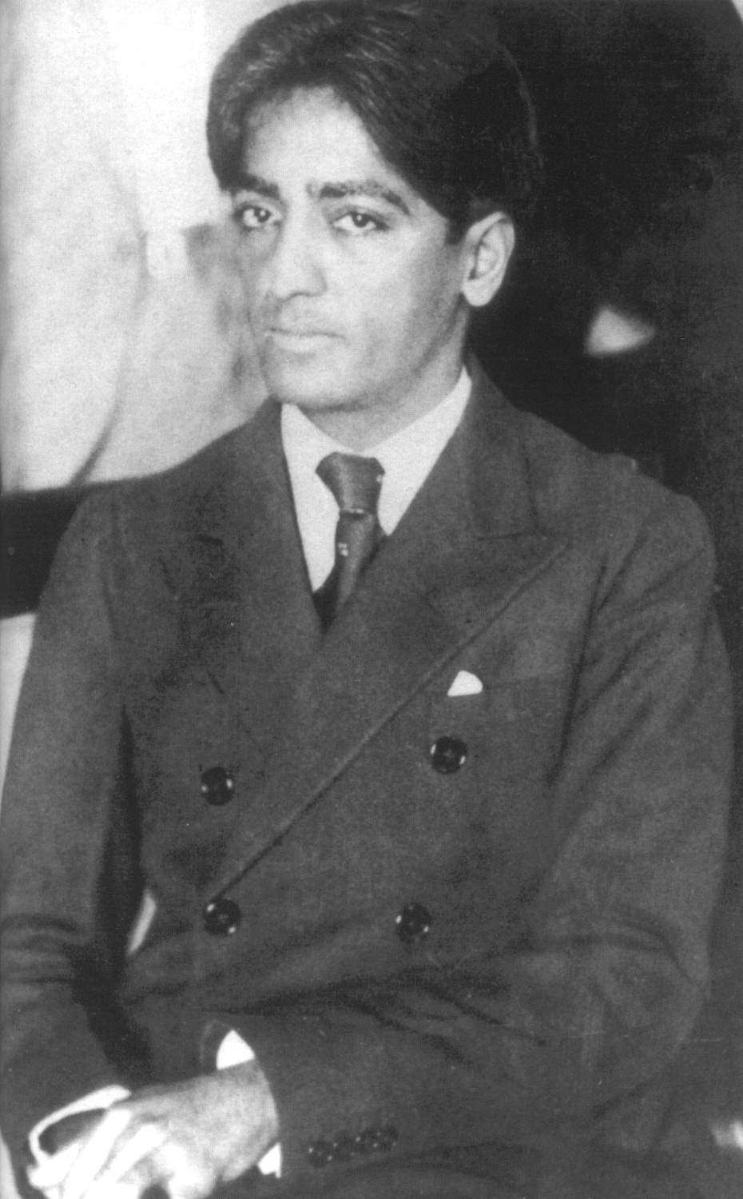
Hotel Grand Bretagne, 1930
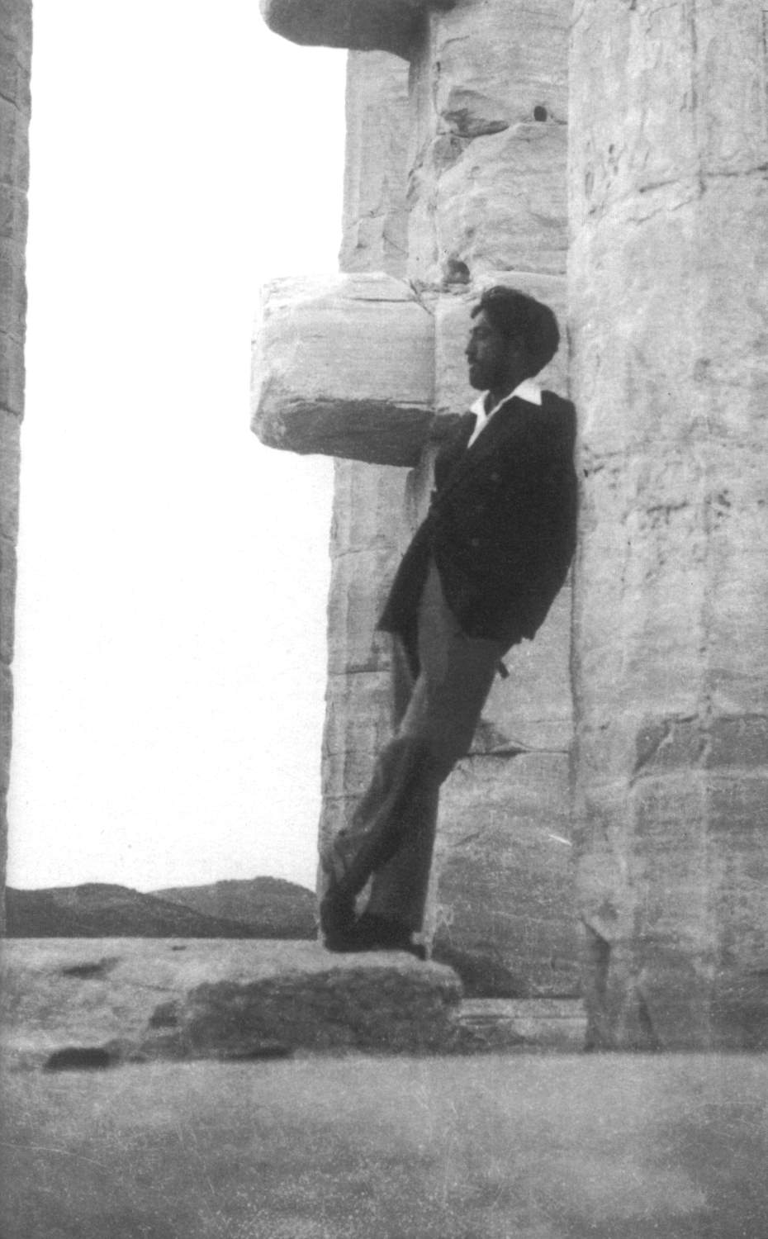
Acropolis, 1933
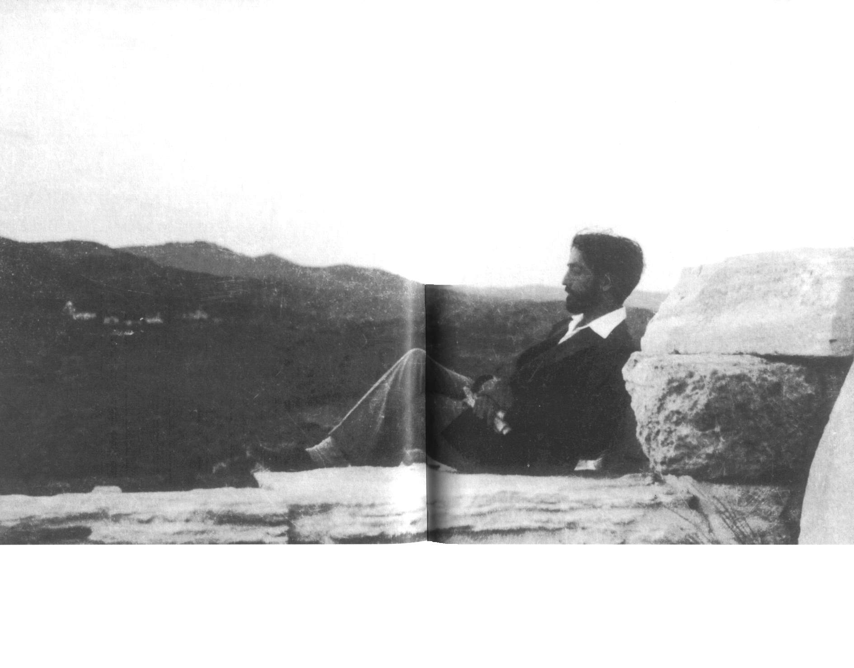
Acropolis
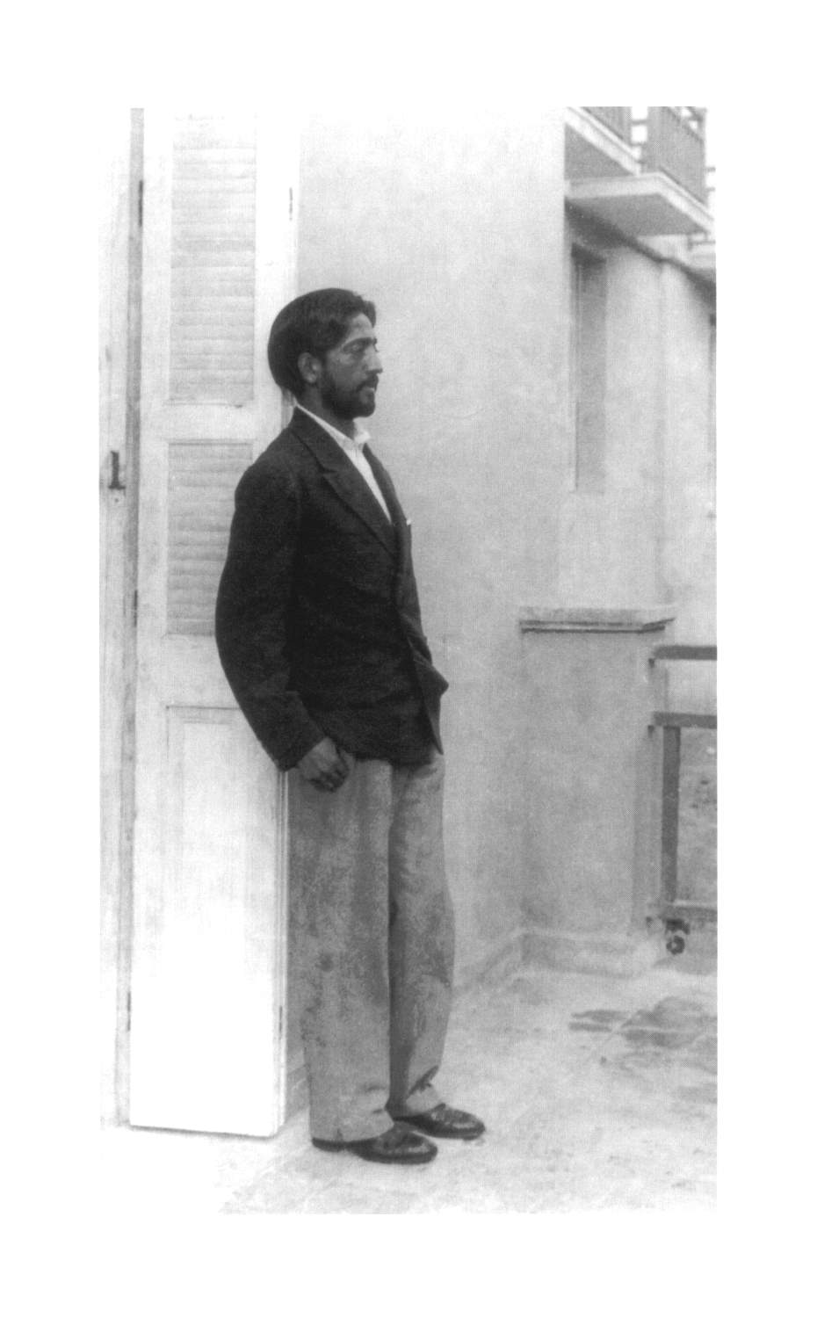
Just before his talk
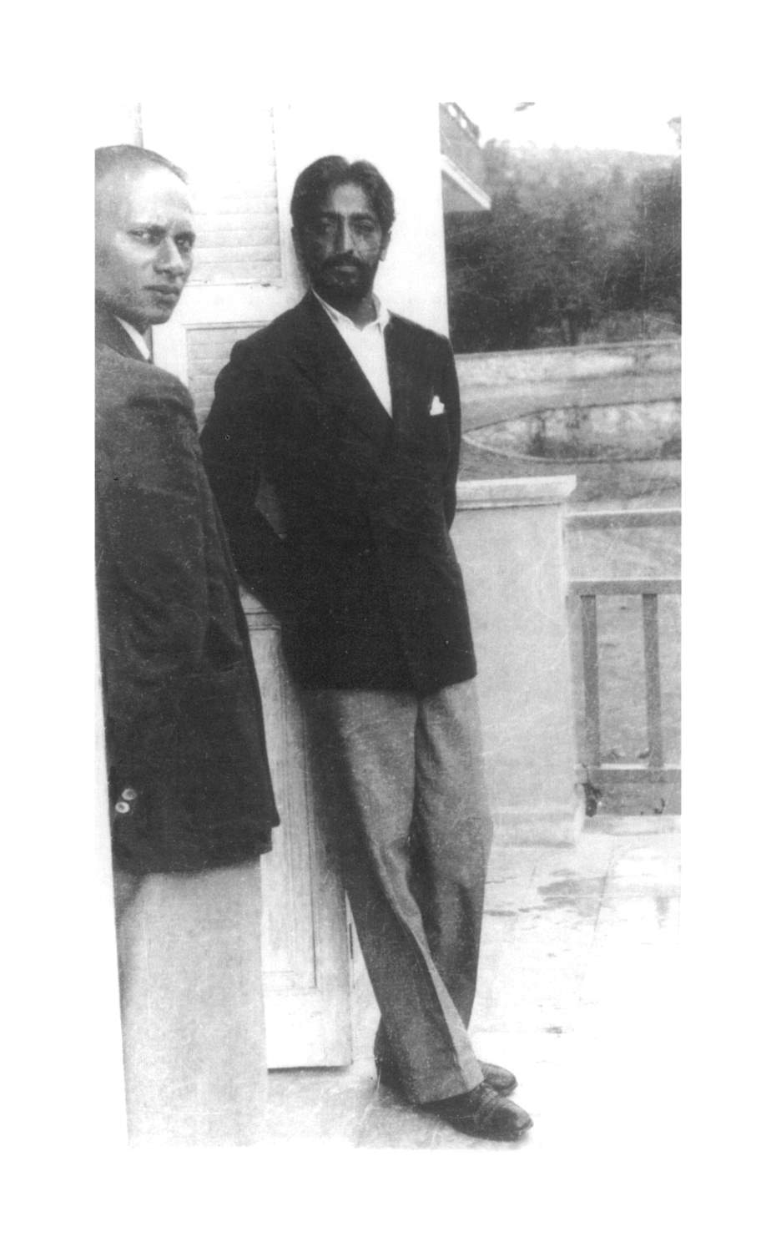
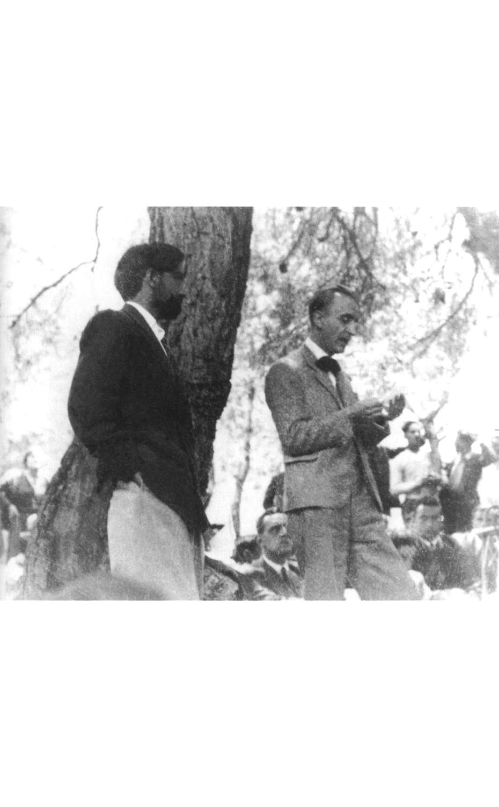
K is being presented to the audience
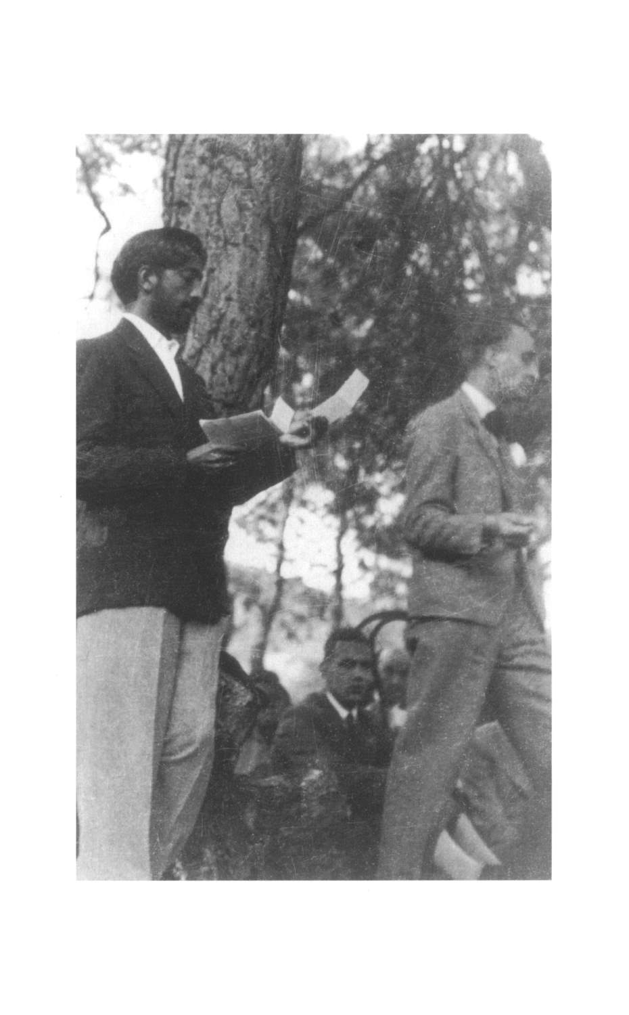
The talk starts
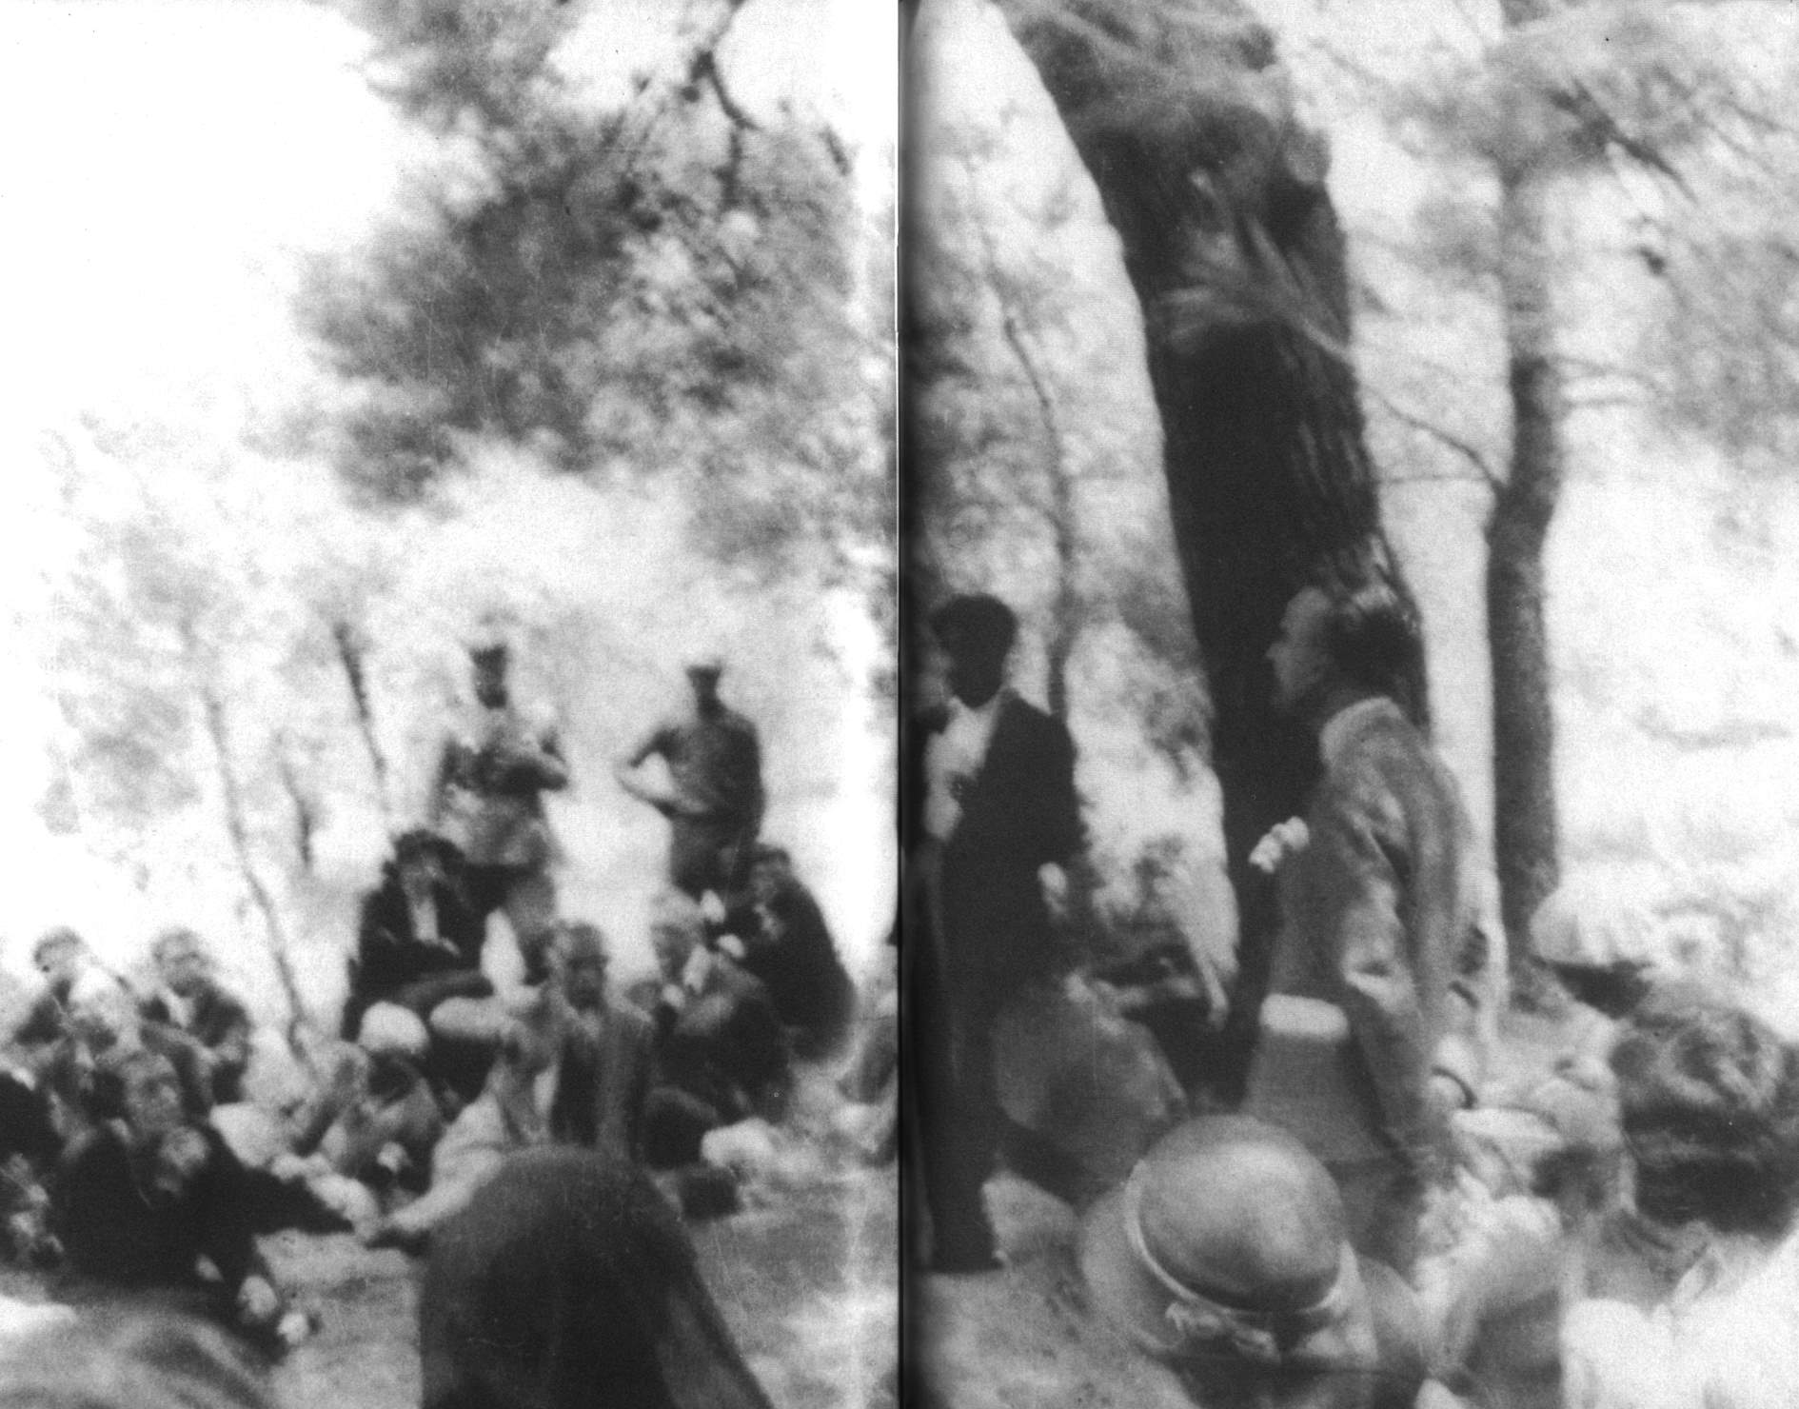
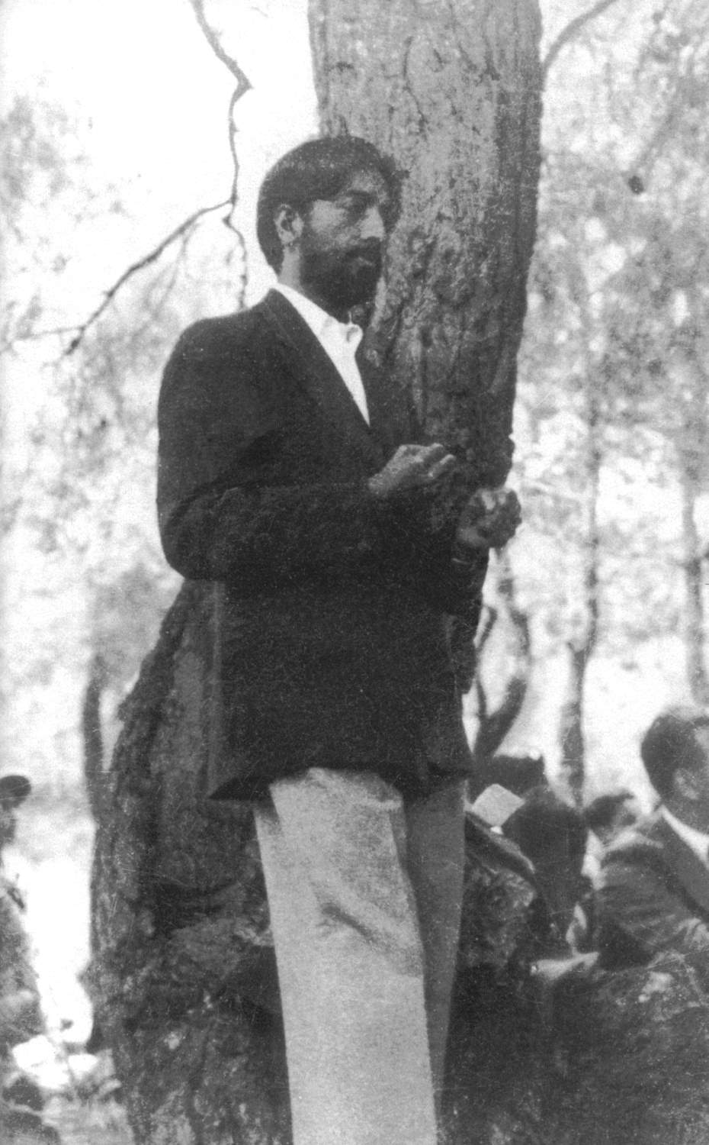
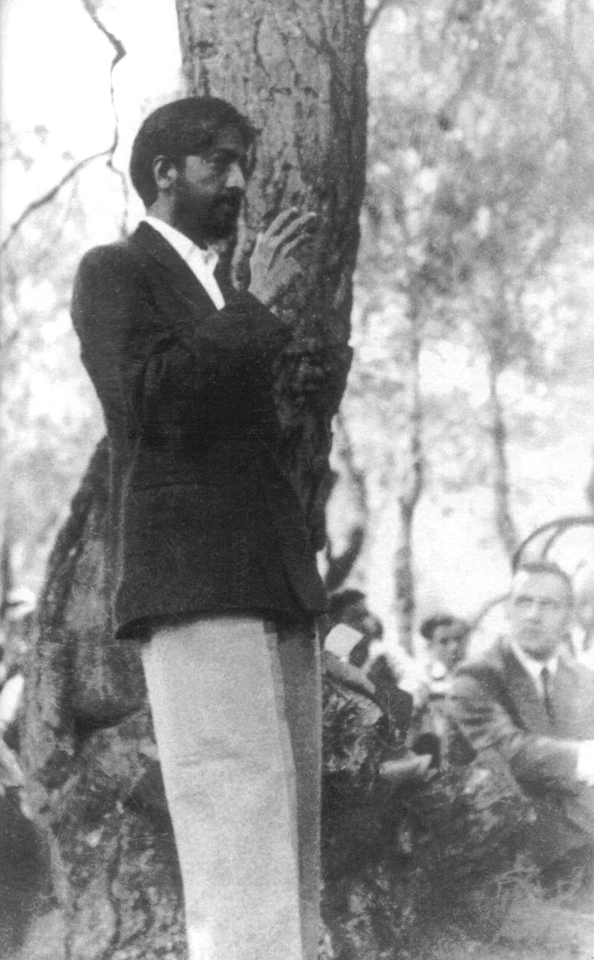
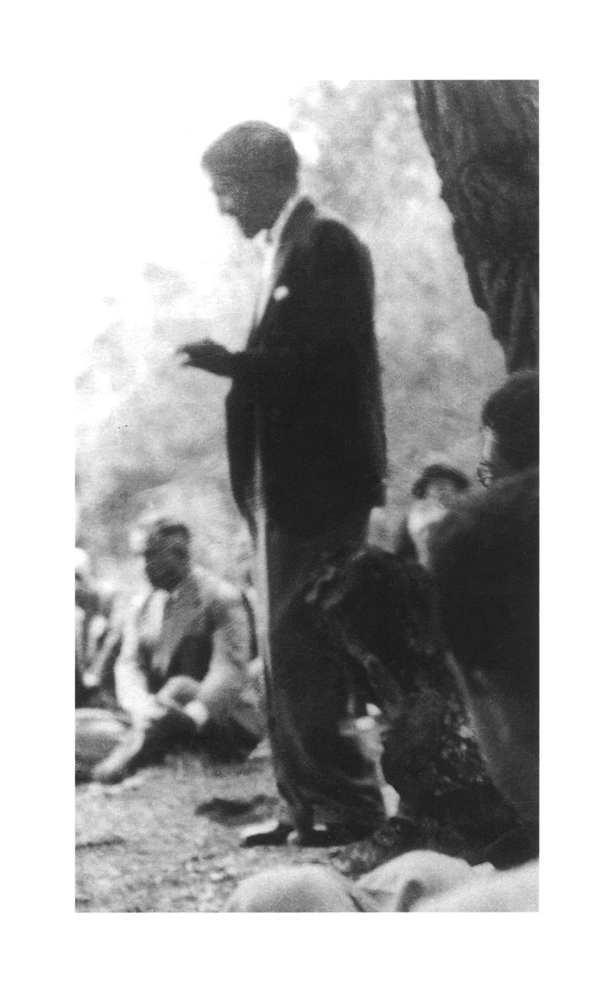
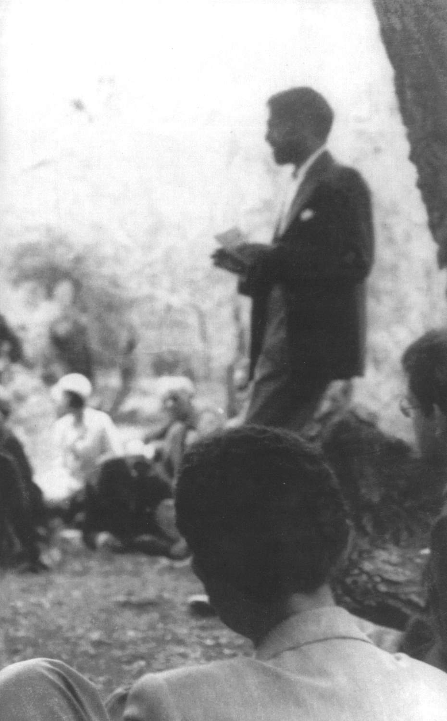
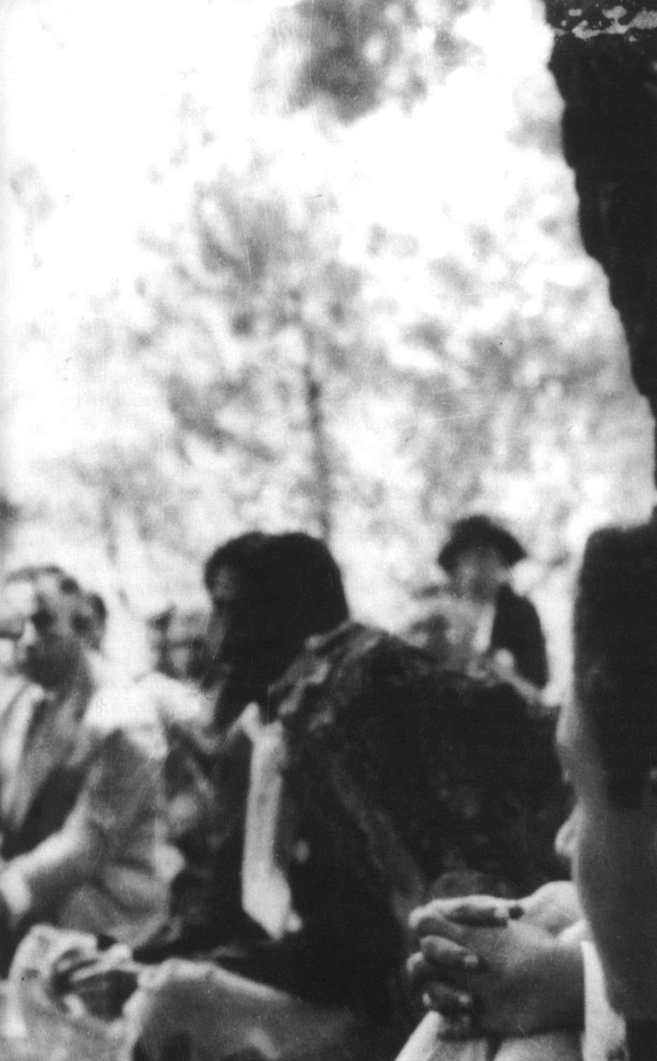
Answering questions
EPILOGUE

Krishnamurti’s work was known in Greece before he dissociated himself from the Theosophical Society. To this day there exists a Greek branch, which issues the STAR BULLETINS in Greek. When Krishnamurti dissolved the ORDER OF THE STAR in August 1929, the Greek Theosophical Society did not adopt a hostile attitude towards Krishnamurti, but extended its “hospitality” to a group of people in Athens who continued to have a keen interest in Krishnamurti and his solitary journey. It was this group that invited him to Athens to talk for the first time in December 1930.
In the years that followed – even during the Second World War and the German occupation of Greece until 1945, there was a number of people interested in K’s work who met regularly to study and discuss the talks he gave.
In 1946, his books once again were translated and published. In most cases it was the translators themselves who paid for the printing and distribution of the books. This was the case till the end of the seventies, when KASTANIOTIS EDITIONS were created and took over the publishing and distribution of K’s books. From 1970 till 1985, the continued presence of K’s work in Greece was made possible through the contributions of a few people who edited the translations of books, provided information about the dates and places of K’s talks, and offered their homes as meeting places for the showing of videos, or for listening to audio tapes of K’s talks.
After consultations with representatives of the Krishnamurti Foundation of England, had been started in December 1985 at the Rishi Valley School, India, an official, non-profit association was founded on 29th October 1986, eight months after Krishnamurti’s death: the Krishnamurti Library. Its purpose is to make Krishnamurti’s teachings available to anyone interested in studying them and to help preserve them without distortions.
The Krishnamurti Library of Athens functions with a minimum of organization. It is located in a small apartment in Athens, where one can find all of Krishnamurti’s books in Greek and English, all of the video-tapes – some of them dubbed or subtitled in Greek – a few audio cassettes and a computer with THE CD-ROM KRISHNAMURTI TEXT COLLECTION AND INDEX SOFTWARE. A simple phone call sufficies to fix an appointment. One can obtain the key from an office around the corner, and may stay there as long as one wishes to study in privacy. There is no fee. The only thing is to remember to return the key upon leaving.
The Krishnamurti Library attends to the translations and publications of books, as well as to the dubbing and subtitling of his video-tapes in Greek. It does not sell or rent out anything, it does not receive contributions of any kind and in general is not involved in financial transactions of any sort. The Krishnamurti Library’s expenses are covered by money donated by the five persons who have taken on responsibility.
People interested in K’s work from other parts of Greece –Corinth, Corfu, Northern Greece, etc.– meet to have discussions or watch video-tapes of Krishnamurti talks. Occasionally, they contact the Krishnamurti Library of Athens to ask for information or printed material related to K’s work. However, they never have been part of an organized network.
Everyone follows their own heart, especially when talking with others about Krishnamurti’s work, and making the teachings available to those interested in them. No person, group, or organization acts as an authority, offering guidance, criticism or exerts control of any kind. Since Krishnamurti refused to exert authority all those truly touched by his teaching should do similarly. He frequently stressed: “The teachings are important in themselves and interpreters or commentators only distort them. It is advisable to go directly to the source – the teachings themselves. And not through any authority”.
Krishnamurti and his work in Greece today continue to be made available through the Krishnamurti Library. One hopes it will move along the same lines which he indicated in one of his earliest talks after he dissolved the ORDER OF THE STAR: “If you are really a body of people who are discovering, not who have found, if you are a body of people who are giving information, not giving spiritual distinctions, if you are a body of people that have a really open platform, not for me or for someone special, if you are a body of people among whom there are neither leaders nor followers, then there is some hope for it in the world. (...) In true spirituality there is no distinction of the teacher and the pupil, of the man who has knowledge and the man who has not”.¹⁰
NOTES

1. In Athens, 1933.
2. THE OPEN DOOR p. 107, and THE LIFE AND DEATH OF KRISHNAMURTI p. 188. (The “Greek couple” mentioned there was the writer of this book and his wife).
3. She refers to the Cypriots Karaolis and Demetriou. At that time, Cyprus was still under British occupation and they, like many others, had fought for their country’s independence. Having been captured at some point by the British, they were executed on the day of K’s interview.
4. 2nd Public Talk, Banaras, 23rd January 1949. Verbatim Report.
5. 1st Public Talk, Madras, 22nd October, 1947. Verbatim Report. “The Collected Works of J. Krishnamurti”, Vol IV.
6. 1st Public Talk in the Oak Grove, Ojai, 1945. Authentic Report. “The Collected Works of J. Krishnamurti”, Vol IV.
7. 5th Public Talk, Madras, 16th November 1947. Verbatim Report. “The Collected Works of J. Krishnamurti”, Vol IV.
8. 4th Public Talk, Banaras, 13th February 1949. Verbatim Report.
9. Mary Lutyens in the second volume of her Krishnamurti biography, The Years of Fulfilment, says that a little before his second visit to Greece, “Still unable to shave owing to the chicken-pox spots, he had grown a full black beard”. Chicken-pox spots were, perhaps, the real reason that Krishnamurti had grown a beard, though he himself possibly did not remember this when asked 52 years later. It should also be noted that in Pupul Jayakar’s Krishnamurti: a Biography, a photo of K taken in Ootacamund, India, in 1926, also shows him with a beard. Even so, he did have a sunstroke during his second visit to Greece. I remember his explanation because it was accompanied by a funny –and very interesting– remark. Having just told me the story of his sunstroke, he looked at me with a playful sparkle in his eye and asked, “Do you know the Apostle Paul, sir?” “Of course, sir,” I responded. He continued, “That man had a sunstroke and he thought he was illuminated”. We all burst out laughing. Later on, when I remembered his remark, I felt that on a deeper level it was a vivid example of how he would subtly help one look into the right direction. I had always thought of this religious figure as a person who had changed from being the fanatic antichristian Saoul to the devoted Christian Paul. It had never occurred to me that there really was no change at all in him, since Saoul was a fanatic antichristian and after his so-called illumination he became a fanatic Christian. For the first time I saw clearly that what really mattered was that he had been and remained a fanatic.
10. Auckland, New Zealand. Talk to Theosophists. 31st March 1934.
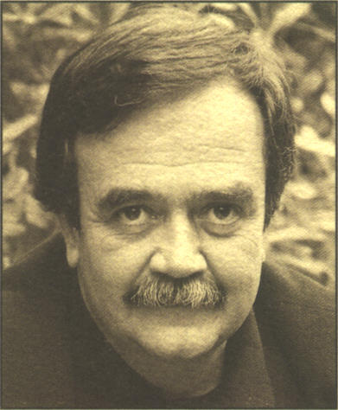

Born in Athens in 1943, Nikos Pilavios –a well known TV producer, director and writer in Greece– studied drama at the Greek National Theatre School and at the Royal Academy of Dramatic Art in London. He worked as a theatre actor until 1974. Subsequently, he was employed by the Greek State Television and Radio Company, as Head of Children’s Programmes Department, to produce and direct programs for both radio and television, and to translate, edit and write scripts while, at the same time, started to teach drama to children and Kindergarten teachers.
Discovering Krishnamurti and his work in July 1984 dramatically changed his life. He attended all of Krishnamurti’s public talks and question-and-answer meetings in England, Switzerland and India from then on until December 1985. In addition, he had several personal encounters with Krishnamurti. Soon after the latter’s death in February 1986, he and a group of friends joined together to found the Krishnamurti Library of Athens. In 1987 he resigned from Greek State Television and founded his own production company. He expanded his educational activities by founding the Centre of Creative Expression in 1988, an institute for post-graduate studies in the performing arts for teachers of all educational levels.
He wrote three children’s books: The Flying Storyteller, The Wizard of the Blue Mountain, The Great Adventure. Apart from translating various works from English to Greek, he also composed a book for adults, entitled When the Children are asleep.
He translated into Greek the following books by Krishnamurti: Last Talks at Saanen, Letters to a Young Friend, The Ending of Time, Krishnamurti’s Notebook, Krishnamurti’s Journal, Krishnamurti to Himself.
Nikos is married and has a daughter and a son.
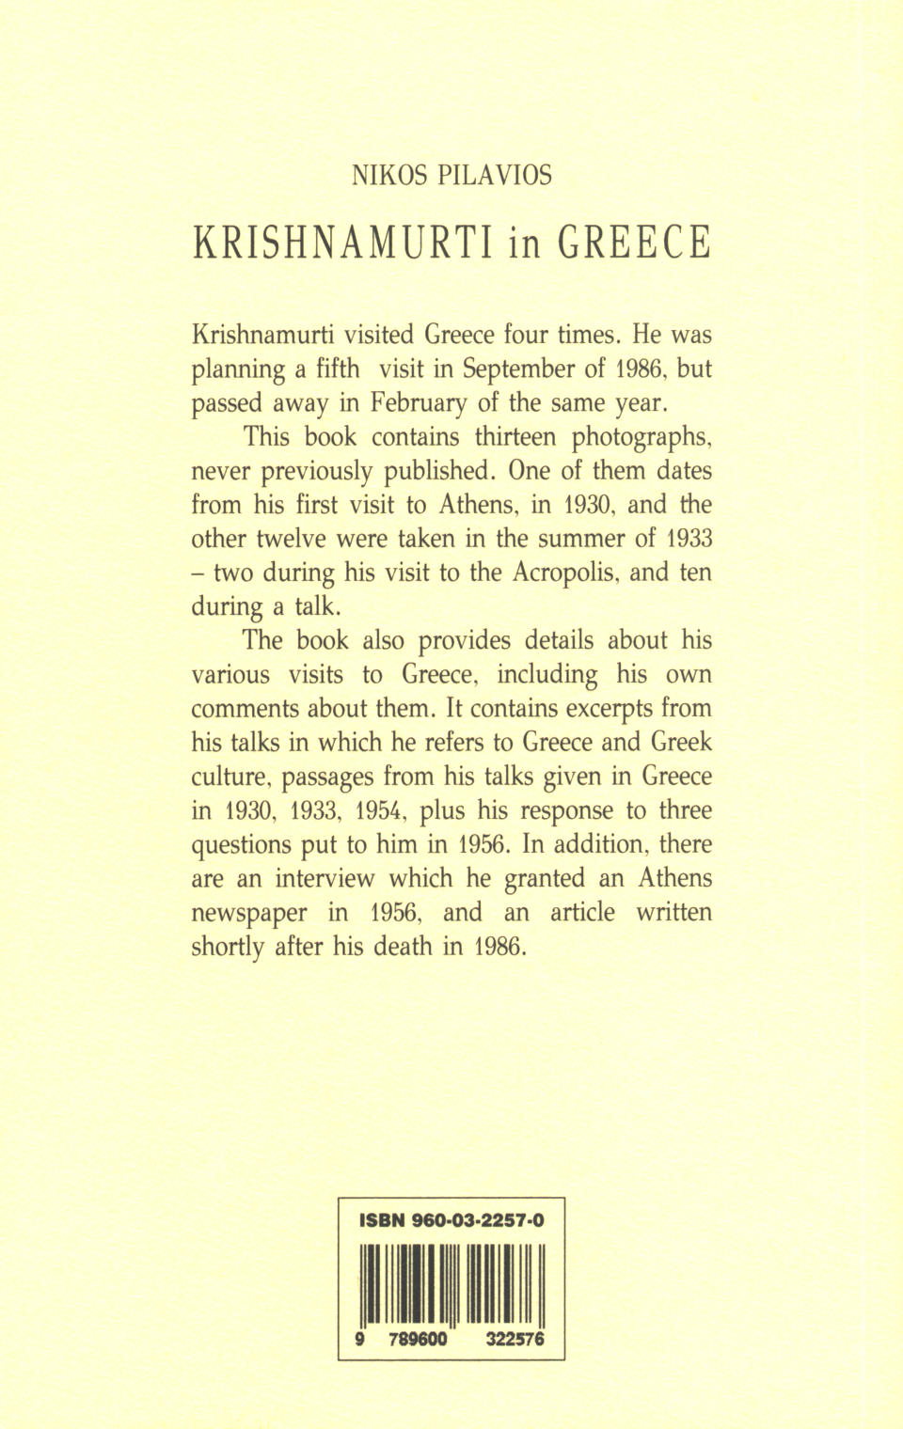

If one is interested in finding more such references, one should search under the terms: GREEK, GREEKS, GREECE, GRECIAN, ATHENA, ATHENS, PARTHENON, ACROPOLIS, SOCRATES, PLATO, ARISTOTLE, ALEXANDER.
1st Public Dialogue, Saanen, 1974.
Asit Chandmal: One Thousand Moons, page 18: “Do you know”, he (K) said, “when I first saw the Parthenon, I fell to my knees... thank God nobody else was there”.
The Years of Fulfilment and The Life and Death of Krishnamurti.
A Greek statue, moved from Greece to France.
Michael Krohnen, The Kitchen Chronicles - 1001 Lunches with J. Krishnamurti, p. 185.
THE COLLECTED WORKS OF J. KRISHNAMURTI, VOLUME X, 1956-1957. TALKS IN ATHENS, GREECE.
As the original English text of the interview is lost, Krishnamurti’s words have been translated from the Greek version. A text comparison from that period, based on the Krishnamurti CD-ROM Text Collection, was carried out in order to achieve the closest possible restoration of his words.
The writer here makes a pun on the Greek words for philosopher and wise, which are respectively philosophos (philos=friend, sophos=wise, philosophos=friend of wisdom, lover of wisdom) and sophos (means wise, not just a friend or lover of wisdom, but wise himself).

