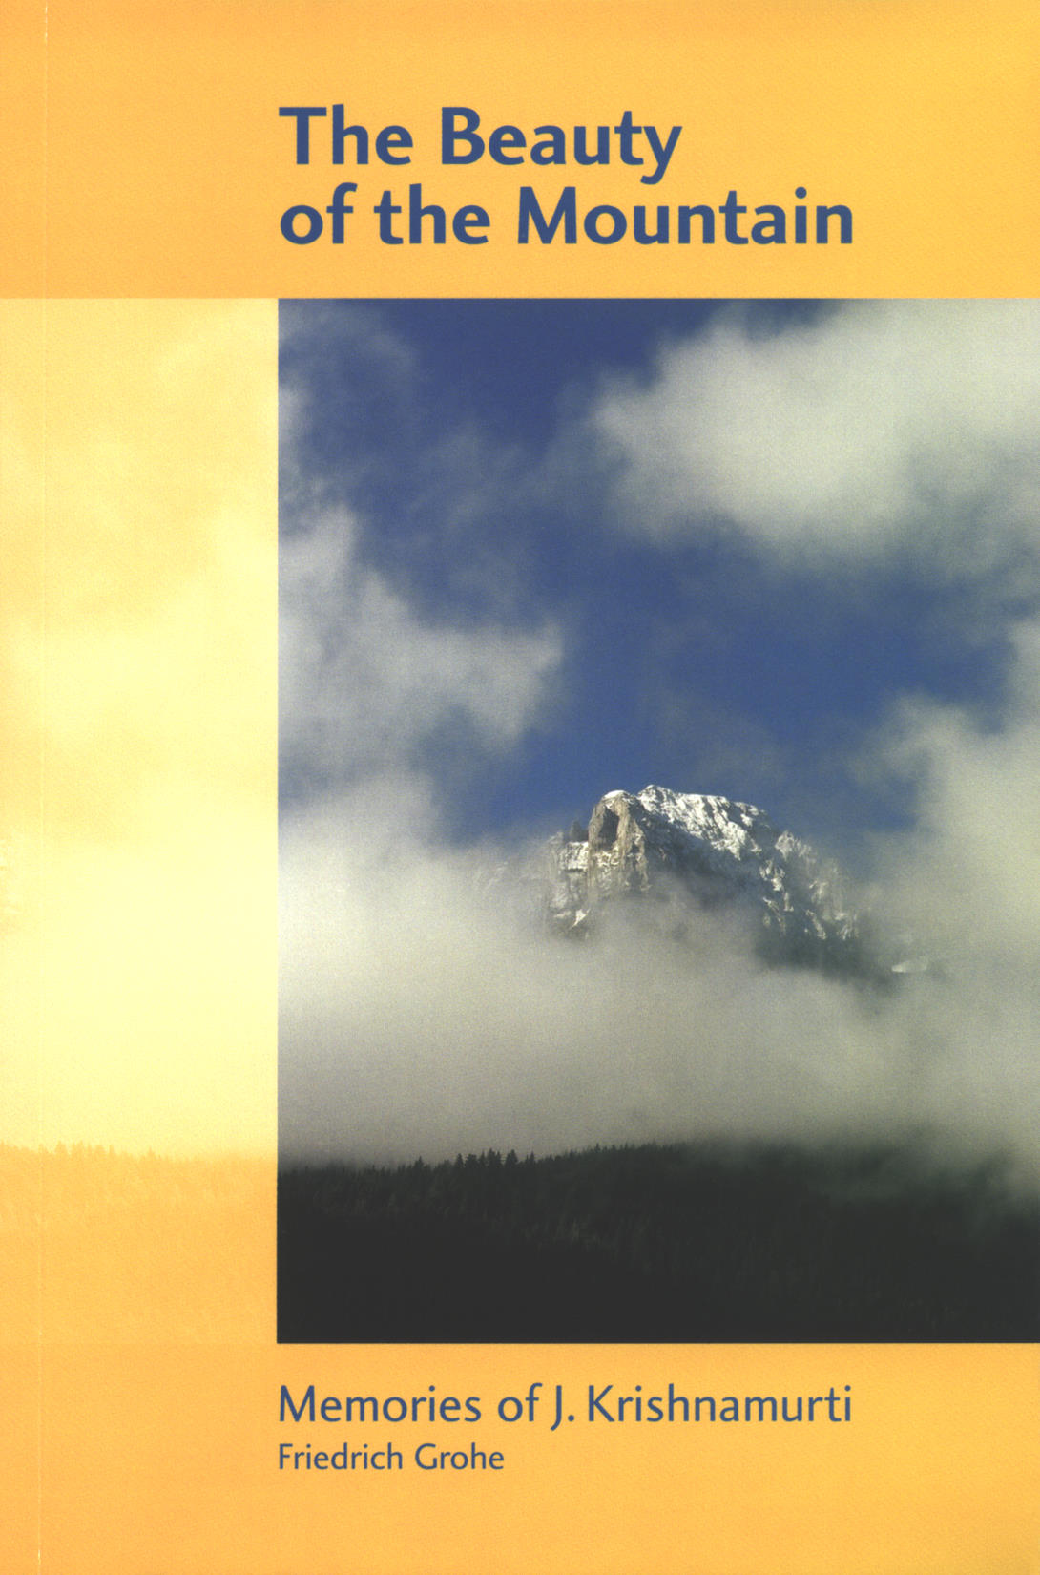

The Beauty of the Mountain: Memories of J. Krishnamurti
© 1991 Friedrich Grohe

Questions and Answers:
© 1982 Krishnamurti Foundation Trust Ltd
Brockwood Today and in the Future:
© 1983 Krishnamurti Foundation Trust Ltd
The Intent of Oak Grove School:
© 1981 Krishnamurti Foundation Trust Ltd
On Living and Dying:
© 1992 Krishnamurti Foundation Trust Ltd and
Krishnamurti Foundation of America
Letters to the Schools, Vol. 1:
© 1981 Krishnamurti Foundation Trust Ltd
Krishnamurti to Himself:
© 1987 Krishnamurti Foundation Trust Ltd

KRISHNAMURTI FOUNDATIONS
Krishnamurti Foundation Trust Ltd
Brockwood Park, Bramdean, Hampshire SO24 0LQ, England
Tel: [44] (0) 1962 771 525, Fax: [44] (0) 1962 771 159
kft@brockwood.org.uk www.kfoundation.org
Krishnamurti Foundation of America
P.O. Box 1560, Ojai, California 93024, USA
Tel: [1] (805) 646 2726, Fax: [1] (805) 646 6674
kfa@kfa.org www.kfa.org
Krishnamurti Foundation India
Vasanta Vihar, 64/65 Greenways Road, Chennai 600 028, India
Tel: [91] 44 2 493 7803/7596, Fax: [91] 44 499 1360
kfihq@md2.vsnl.net.in www.kfionline.org
Fundación Krishnamurti Latinoamericana
c/o A. Esteban, C/ Juan Pérez Almeida, 12 2º A, 28019 Madrid, Spain
Tel: [34] 91 569 3101
alfonso@fundacionkrishnamurti.org www.fundacionkrishnamurti.org

The Beauty of the Mountain
Memories of J. Krishnamurti

Friedrich Grohe

Including the following quotations from Krishnamurti:

‘Shall I talk about your teachings?’ from Questions and Answers
‘Brockwood Today and in the Future’
‘The Intent of Oak Grove School’
‘Indifference and understanding’ from On Living and Dying
‘Education for the very young’ from Letters to the Schools, Vol. 1
‘An extraordinary space in the mind’ from On Living and Dying
‘It is our earth, not yours or mine’ from Krishnamurti to Himself

Contents

Illustrations
Footnotes
Acknowledgements
Preface
K: ‘Shall I talk about your teachings?’
Introduction
K: ‘Brockwood Today and in the Future’
First Meetings with K
Visit to Buchillon
Ojai
K: ‘The Intent of Oak Grove School’
Brockwood Park
Saanen, Schönried and Rougemont
Last Journeys to India
K: ‘Indifference and understanding’
K: ‘Education for the very young’
Return to Ojai
K: ‘An extraordinary space in the mind’
Postscript
K: ‘It is our earth, not yours or mine’
Appendix
Illustrations

View of the Rubli, Videmanette, in Rougemont, Switzerland (cover)
The Grieschbach in winter; it was here, in mid-summer after the Talks at Saanen, Switzerland, that I would take a cooling dip during the hot walk home
View of the Rubli, Videmanette, in Rougemont, Switzerland
The Krishnamurti Centre at Brockwood Park, Hampshire, England
The view towards Saanen, Switzerland, with Rodomont in the background, from the bridge over the Saane that many people would have crossed while walking to the Talks
The handkerchief tree in the Grove at Brockwood Park, Hampshire, England
The famous Matterhorn, one of the many mountains I climbed, viewed from Riffelalp above Zermatt, Switzerland
Brockwood Park School, Hampshire, England
From Buchillon, Switzerland, a view over Lake Geneva
From Buchillon, Switzerland, a view over Lake Geneva towards Amphion
The Hôtel des Princes in Amphion, France, today; where K stayed in 1920
The Archives building near Pine Cottage in Ojai, California
The Pepper Tree in front of Pine Cottage, K’s home in California
The Krishnamurti Centre at Brockwood Park, springtime
The two pine trees remaining, with one ready to fall, of the several that K said we should not disturb while we walked at Brockwood Park
The main gate from the Grove at Brockwood Park, Hampshire, England
Near Brockwood Park, Hampshire, England
K with the daughter of a friend of mine before lunch in Rougemont in 1984
© Asit Chandmal
Lake Geneva “like a mirror”, Buchillon, Switzerland
Pond near Arnensee, not far from Gstaad, Switzerland
K and I at Rishi Valley, India, December 1984
© Rita Zampese
Sunrise over the Ganges, at Rajghat, India
Fishermen off Adyar Beach, where K was ‘discovered’, in Madras (Chennai), India
Rishi Valley’s percolation reservoir at sunset, looking towards Rishi Conda, India
The Nandi, a traditional Indian sculpture of a kneeling cow, near the Pepper Tree at Pine Cottage. One time, I saw it with flowers on its head and asked Mary Zimbalist if Indians had been visiting. She said K had told her to put flowers on it sometimes, so that it feels at home. A few years ago the Pepper Tree fell, but new shoots have grown out of the huge trunk that remained and it is once again vigorous and beautiful.
Near Arya Vihara, Ojai, California
One of my last walks with K at Rishi Valley, December 1984 (back)

Photographs were taken by Friedrich Grohe unless stated otherwise.
Footnotes

- Gisèle Balleys
- Mary Zimbalist
- Mary Lutyens
- Dr. T. K. Parchure
- Dorothy and Montague Simmons
- Michael Krohnen
- Alan and Helen Hooker
- Annie Besant
- Aldous Huxley
- Erna and Theo Lilliefelt
- Mark Lee
- Radha Burnier
- Scott Forbes
- Raman Patel
- Vanda Scaravelli
- Pupul Jayakar
- Rita Zampese
- Nandini Mehta
- Radhika Herzberger
- Pama, Sunanda and Achyut Patwardhan
- Vikram Parchure
- Pandit Jagannath Upadhyaya
- P. Krishna
- R. R. Upasani
- R. S. and Padma Santhanam
- Evelyne Blau
- Bill Quinn
Acknowledgements

I would like to thank the Krishnamurti Foundation Trust Ltd and the Krishnamurti Foundation of America for permission to publish material by and about Krishnamurti.
An earlier version of the chapter Last Journeys to India was written as a contribution to Mary Lutyens’s book The Open Door. It also appeared in Evelyne Blau’s Krishnamurti: 100 Years.
Many friends helped in numerous ways with this labour of love and I thank them all. I am particularly grateful to the following for their input and assistance. Michael Krohnen, who translated most of the original German manuscript into English and who, because of his long acquaintance with Krishnamurti, was very helpful in working out ideas for the book. Mary Cadogan and the late Mary Lutyens, who contributed valuable suggestions while generously going through the manuscript. Nick Short, who edited the first edition of the book. Nick Short and Claudia Herr, who edited this fourth edition. And Jürgen Brandt, who liaised with the designer and printers over successive editions.
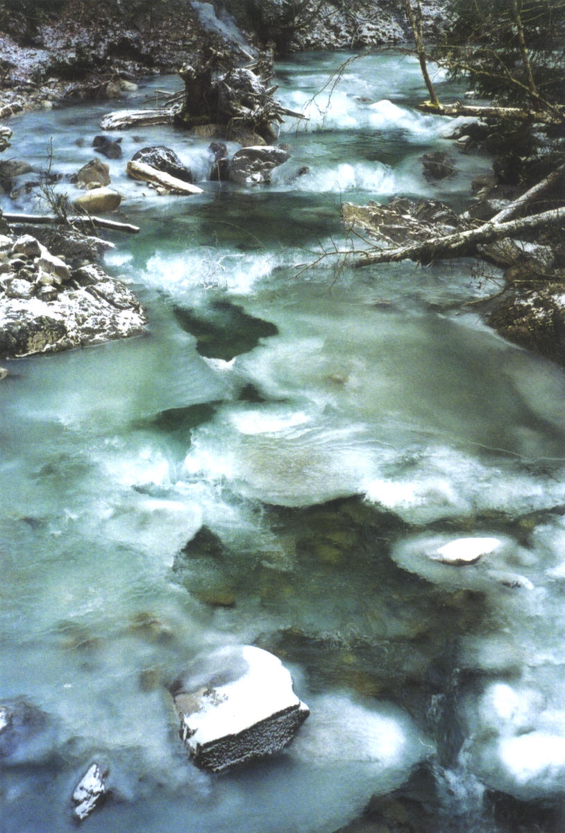
The Grieschbach in winter; it was here, in mid-summer after the Talks at Saanen, Switzerland, that I would take a cooling dip during the hot walk home
Preface

These memories of Jiddu Krishnamurti – or ‘K’, as he would often refer to himself – encompass the last three years of his life when I had regular friendly interactions with him.
Most people are familiar with K only through his books and tapes or through having attended his public talks. On several occasions, K said about himself that it is not the person that is important but rather what he says. Even so, I have encountered many people who are keen to know how he lived his everyday life. That is why I am recording here as many details as I can recall, even seemingly insignificant events, feeling that they may convey that this extraordinary human being did indeed live the ‘teachings’.
There are also comments and quotes by K included here that are not generally found elsewhere. They may be interesting and perhaps helpful for readers, and to collect them in a book was another incentive for me to write.
There is great beauty in the teachings, and beauty can come into existence only when there is no ego, as K often pointed out. This is how he was himself – without ‘I’.
Following is a passage from the book Questions and Answers, a quote that led to the title The Beauty of the Mountain.

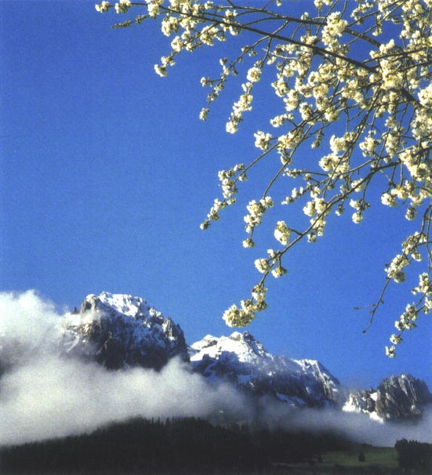
View of the Rubli, Videmanette, in Rougemont, Switzerland
Shall I talk about your teachings?

Question:
I have understood the things we have talked over during these meetings, even if only intellectually. I feel they are true in a deep sense. Now when I go back to my country shall I talk about your teachings with friends? Or since I am still a fragmented human being will I only produce more confusion and mischief by talking about them?

Krishnamurti:
All the religious preachings of the priests, the gurus, are promulgated by fragmented human beings. Though they say, “We are high up”, they are still fragmented human beings. And the questioner says: I have understood what you have said somewhat, partially, not completely; I am not a transformed human being. I understand, and I want to tell others what I have understood. I do not say I have understood the whole, I have understood a part. I know it is fragmented, I know it is not complete, I am not interpreting the teachings, I am just informing you what I have understood. Well, what is wrong with that? But if you say: “I have grasped the whole completely and I am telling you” then you become an authority, the interpreter; such a person is a danger, he corrupts other people. But if I have seen something which is true I am not deceived by it; it is true and in that there is a certain affection, love, compassion; I feel that very strongly – then naturally I cannot help but go out to others; it would be silly to say I will not. But I warn my friends, I say, “Look, be careful, do not put me on a pedestal.” The speaker is not on a pedestal. This pedestal, this platform, is only for convenience; it does not give him any authority whatsoever. But as the world is, human beings are tied to something or other – to a belief, to a person, to an idea, to an illusion, to a dogma – so they are corrupt; and the corrupt speak and we, being also somewhat corrupt, join the crowd.
Seeing the beauty of these hills, the river, the extraordinary tranquility of a fresh morning, the shape of the mountains, the valleys, the shadows, how everything is in proportion, seeing all that, will you not write to your friend, saying, “Come over here, look at this”? You are not concerned about yourself but only about the beauty of the mountain.

from Questions and Answers, pp. 63–64
© 1982 Krishnamurti Foundation Trust Ltd

In these recollections I would like to share with my friends, and whoever else may be interested, the beauty of the mountain.
Introduction

Over a period of more than seventy years Krishnamurti gave thousands of public talks and discussions in many countries, but he never spoke a word too many. His speech was precise and clear, and his appearance elegant and well cared for. He was basically reserved, or as he sometimes remarked, rather shy. Yet he would give his whole attention to whoever addressed him, taking an interest in all aspects and details. His love of people meant anybody could approach him.
Since 1983 – when I first made K’s acquaintance – I was in regular contact with him, accompanying him on some of his walks, and travelling with him on his last journey to India. We met regularly at Brockwood Park in England, Saanen in Switzerland, and Ojai in California. At Brockwood he arranged for me to have a room in the west wing, that part of the school complex where he himself used to live.
K spent about four months each year at Brockwood and had done so since its founding in 1969. In my eyes Brockwood is a central part of his legacy, and because of this – and also because K had such a deep concern to start an adult study centre there – I would like to quote his published statement about the present and future significance of the place and the role of the Foundation in caring for it; and, by implication, the role of all of the Foundations in caring for the activities in their trust.

Brockwood Today and in the Future

For fourteen years Brockwood has been a school. It began with many difficulties, lack of money and so on, and we all helped to build it up to its present condition. There have been gatherings every year, seminars and all the activities of audio and video recording. We have reached a point now not only to take stock of what we are doing, but also to make Brockwood much more than a school. It is the only centre in Europe representing the Teachings, which are essentially religious. Though we have met in Saanen for the last twenty-two years for a month or more, Brockwood is the place where K spends much more time and energy. The school has a very good reputation and Mrs. Dorothy Simmons has put her great energy, her passion, behind it. We have all helped to bring the school about in spite of great difficulties, both financial and psychological.
Now Brockwood must be much more than a school. It must be a centre for those who are deeply interested in the Teachings, a place where they can stay and study. In the very old days an ashrama – which means retreat – was a place where people came to gather their energies, to dwell and to explore deeper religious aspects of life. Modern places of this kind generally have some sort of leader, guru, abbot or patriarch who guides, interprets and dominates. Brockwood must have no such leader or guru, for the Teachings themselves are the expression of that truth which serious people must find for themselves. Personal cult has no place in this. We must emphasize this fact.

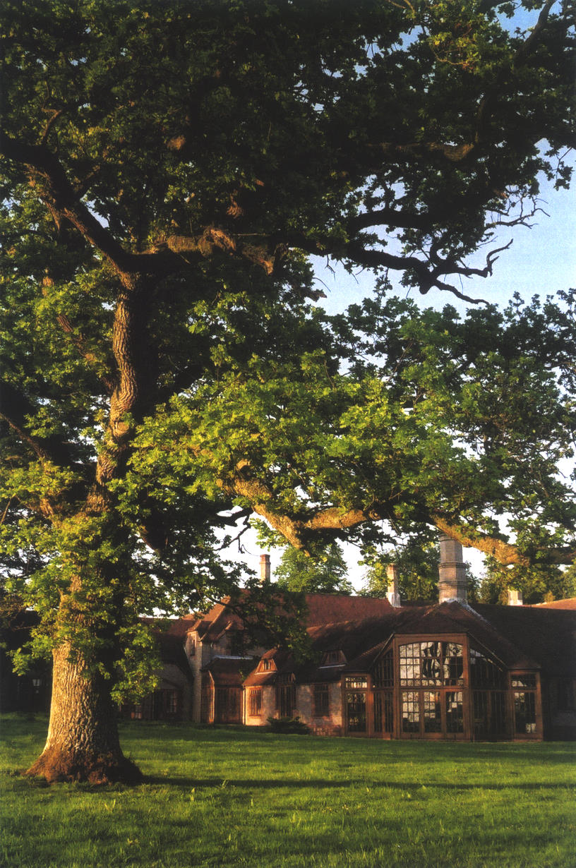
The Krishnamurti Centre at Brockwood Park, Hampshire, England
Most unfortunately our brains are so conditioned and limited by culture, tradition and education that our energies are imprisoned. We fall into comforting and accustomed grooves and so become psychologically ineffective. To counter this we expend our energies in material concerns and self-centred activities. Brockwood must not yield to this well-worn tradition. Brockwood is a place for learning, for learning the art of questioning, the art of exploring. It is a place which must demand the awakening of that intelligence which comes with compassion and love.
It must not become an exclusive community. Generally, a community implies something separate, sectarian and enclosed for idealistic and utopian purposes. Brockwood must be a place of integrity, deep honesty and the awakening of intelligence in the midst of the confusion, conflict and destruction that is taking place in the world. And this in no way depends on any person or group of people, but on the awareness, attention and affection of the people who are there. All this depends on the people who live at Brockwood and on the Trustees of the Krishnamurti Foundation. It is their responsibility to bring this about.
So each one must contribute. This applies not only to Brockwood but to all the other Krishnamurti Foundations. It seems to me that one may be losing sight of all this, becoming engrossed in various demanding activities, caught up in particular disciplines, so that one has neither time nor leisure to be deeply concerned with the Teachings. If that concern does not exist, the Foundations have no significance at all. One can talk endlessly about what the Teachings are, explain, interpret, compare and evaluate, but all this becomes very superficial and really meaningless if one is not actually living them.
It will continue to be the responsibility of the Trustees to decide what form Brockwood should take in the future, but always Brockwood must be a place where integrity can flower. Brockwood is a beautiful place with old magnificent trees surrounded by fields, meadows, groves and the quietness of countryside. It must always be kept that way, for beauty is integrity, goodness and truth.

J. Krishnamurti
© 1983 Krishnamurti Foundation Trust Ltd

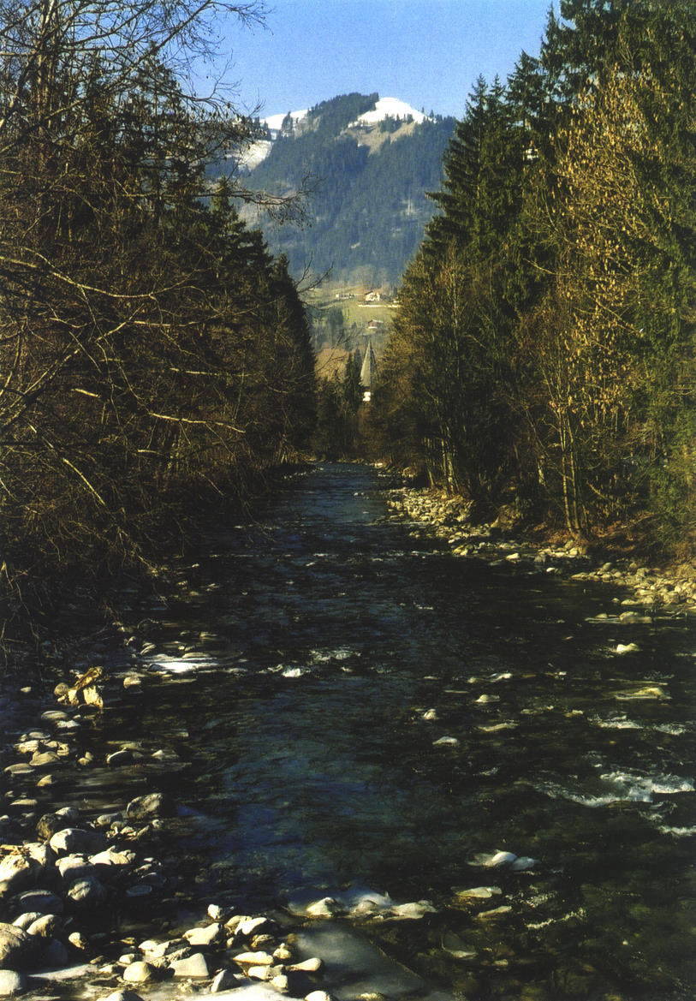
The view towards Saanen, Switzerland, with Rodomont in the background, from the bridge over the Saane that many people would have crossed while walking to the Talks
First Meetings with K

It was in 1980 that I first read a book by Krishnamurti, The Impossible Question. Even though I have found that Krishnamurti cannot be read like a novel, I could not put it down. He appeared to be saying the opposite of what one had learned and experienced, although one seemed to have vaguely felt before what he expressed there in clear, simple and overwhelming language.
Although I knew in 1981 that Krishnamurti used to give a series of public talks each year at Saanen, Switzerland, I had no desire to attend them as I was quite content just studying his books. In fact, I lost interest in philosophy, psychology, literature, art, and the like, which had once captivated me, because I suddenly felt, “This is it!” Other people’s books simply became superfluous.
This was a time of great change for me. Besides other things, I was about to retire from business life. Previously, I had not had much time to face essential questions, but now, all at once, K made it clear to me how important it was to concern oneself with central issues like death and love, pleasure and pain, freedom, desire and fear. The deeper I explored the teachings, the more fascinating they became.
I attended the Talks at Saanen for the first time in 1983, usually walking there along the high road from my apartment in Rougemont. At an hour and a half, it takes longer than the river walk, and I would arrive just in time. Others (at both Saanen and Brockwood) would queue all night in order to have first choice at the seating once the giant tent was opened – which typically meant the floor space directly in front of the platform where K would speak, where every square inch was highly valued. (In California and India, it was generally a bit more relaxed.) I was happy to listen to K while sitting on the steps just inside the side entrance to the tent, which would always be full to capacity with around 2,000 people. There, I didn’t have to sit amidst the crowd and, enjoying a fresh breeze, could be protected from the heat both inside the tent and out.
In the tent, it was possible to buy books by K translated into various languages, and I had been glad to fill my rucksack with them. Having done so, though, and with that first summer being so hot, on my hike back to Rougemont I bathed in the Grieschbach River, which would normally have been too cold.
It was overpowering to listen to him. He emanated so much energy that I felt I simply could not sit directly across from him. He spoke simply and clearly, with few gestures and no rhetoric. While listening to him, I would forget about food and drink and would not even take note of the heat.
During one Talk, I noticed an excited young man walking between the rows of people. He came along the long side of the tent where I was and proceeded to kick over a number of electric fans that were working there. As he approached me, he gestured that I should move out of his way and I ducked, expecting a kick, although nothing of the sort came about. Muttering curses, he then turned and walked up towards K, stopping disdainfully to flick up a lady’s necklace from which hung a portrait of the guru Rajneesh (‘Bhagwan’). Proceeding to the platform, he snatched the microphone from in front of K and started to address K and the crowd in German: “The followers of Rajneesh should get out, they are not wanted here.” Turning directly to K, he asked, “Am I not right, Mr. Krishnamurti? Don’t you think so too?” The man appeared extremely agitated, even dangerous. Some of the people in the front row had jumped to their feet, and one huge man, who resembled a wrestler, seemed to be on the point of throwing himself upon him. An atmosphere of extreme violence flared up in the tent and uproar ensued. But at this very moment, K intervened, saying: Don’t touch him! Apparently the intruder liked that, and repeated several times, “Don’t touch him, don’t touch him.” Krishnamurti nodded towards him, and the man finally calmed down and left the tent after mumbling a few more words. K went on talking as if nothing had happened.

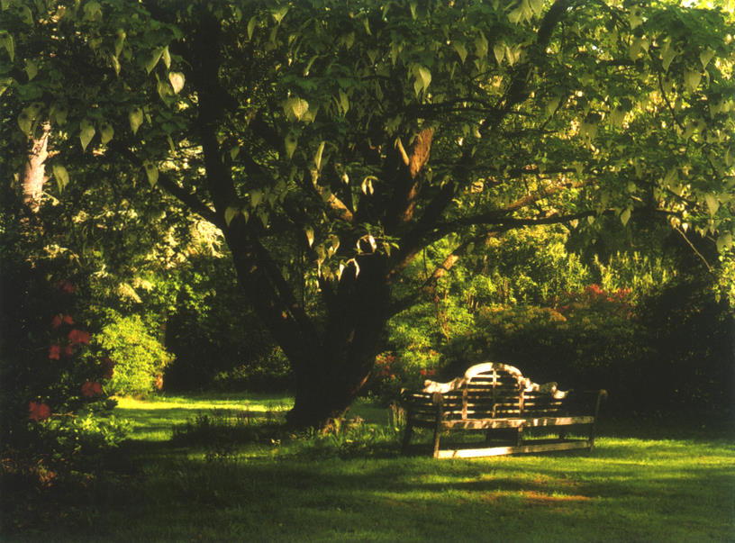
The handkerchief tree in the Grove at Brockwood Park, Hampshire, England

A similar thing happened during one of his Talks at Ojai, when a young woman suddenly jumped onto the platform where Krishnamurti was sitting. He was startled, but immediately controlled himself and told her that if she were willing to keep quiet he would not mind her sitting next to him on the platform. She did indeed remain quiet, only occasionally rolling her head around and grimacing while K continued his Talk. At the end of it, he bent down towards her and said: It is over.
When I first attended the Saanen Talks, I did not yet have any contact with the Krishnamurti Foundations or Schools. I had read a statement in another book by K, Education and the Significance of Life, which stated in essence: if you are dissatisfied with the existing schools, why don’t you start your own? This gave me the idea to start a school in Switzerland. I thought that the country where the great educators Piaget, Pestalozzi and Rousseau had been active would be the right place for this. I got in touch with the Krishnamurti Committee in Geneva and was told that a teacher from Brockwood was about to return to her native Switzerland for the summer. I contacted this person, Gisèle Balleys, and soon afterwards she and I, together with several of her friends who were also interested in the project, began looking for a suitable building for a school. We found a very charming one at Chandolin, in the Valais. It was an old, well-preserved hotel, beautifully located with a distant view of the Matterhorn, and large enough to accommodate fifty to sixty students.
During the 1983 Saanen Talks, K heard about this project and asked to meet me. After the Talks I rang Chalet Tannegg in nearby Gstaad, where he was staying, and it was agreed that we would meet there on August 1st. As I knew that K took particular care over his appearance, I went freshly shaved and well dressed. However, because the afternoons were quite hot, I had asked for a meeting in the morning, and when I arrived K was still in a simple tracksuit, for which he apologized. Even then I saw that K would enter a room quietly and gently, almost without notice. In his caring way, he asked me about my life. We laughed and talked about mountain climbing – I was an enthusiastic alpinist – and a variety of other things.
Pointing to the panorama outside, I said, “I have climbed all the peaks in sight.” He in turn pointed at the forests and hills and said: And I have been on all the paths. When I remarked that the mountains were really far more beautiful from below than from above, he responded with a hearty Yes!
He asked me if I went up a mountain vertically or in a zigzag when ski-touring. He was impressed when I told him that I sometimes went up vertically. He mentioned that he would have liked skiing when he was younger, but was not allowed to do it as it was considered too dangerous for him. He did, however, practice other kinds of sport. In his youth he played tennis, was an expert golfer, hiked, bicycled and swam. In his later life he would take brisk walks every day. And throughout his life he practiced yoga; in the last month of his life, his Indian cook, Parameswaran, would be delighted each time he saw K do his yoga exercises, as it showed that he had regained some strength.
As a young man, he had visited Davos with some Dutch friends, and at Adelboden he lived in a mountain-hut for some time. He used to break the ice in the well every morning to have a wash, until he contracted bronchitis. He told me that in California he had once stayed in a hut all by himself. There had been a gramophone player there with a single record, the Ninth Symphony by Beethoven. Every day he played it, until he knew every note by heart. He tended to be very receptive to music and was particularly fond of Beethoven, Mozart and other classical composers, as well as of Sanskrit chanting and Indian classical music. When some people came to the hut and asked for the saint who was supposed to live there, he told them that he had just left. K had a great sense of humour, as I witnessed on many occasions.
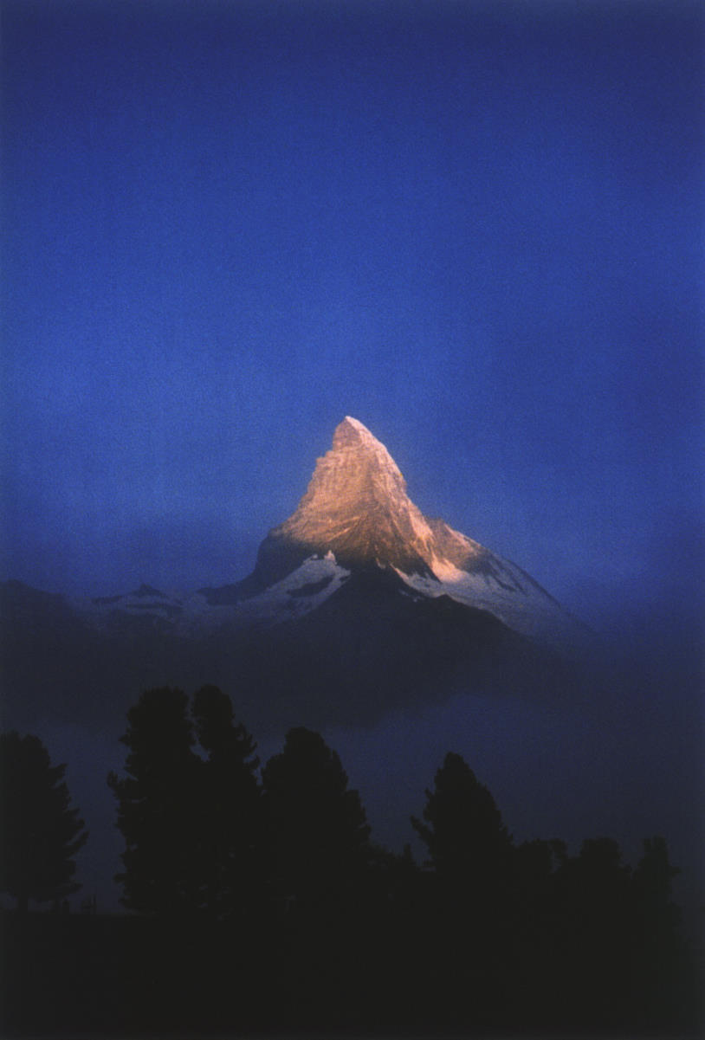
The famous Matterhorn, one of the many mountains I climbed, viewed from Riffelalp above Zermatt, Switzerland

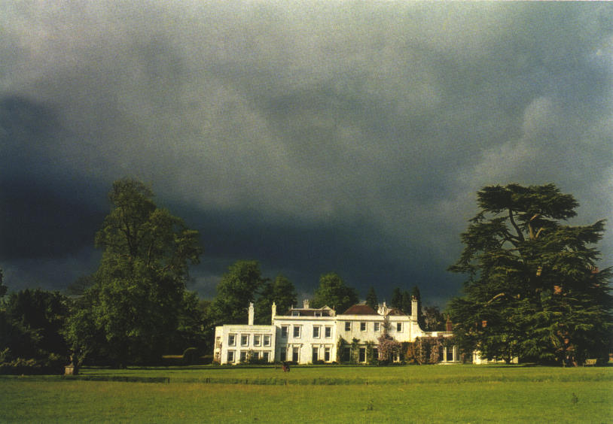
Brockwood Park School, Hampshire, England

During this first meeting, I informed him that our company produced sanitary faucets. I told him how difficult it was to get the staff to cooperate with each other, and how much I desired to have friendly relations with my colleagues in the management. K replied: Do you know how difficult it is to get people to cooperate? Soon I was to discover that even within the Foundations people found it difficult to work together, and I knew nothing as yet of the problems at the Schools in Ojai, Brockwood and India.
When we talked about the school that I wanted to start in Switzerland, K pointed out: It is very difficult to start a school. We tried it in Switzerland, Holland and France, but we were not successful until we found Brockwood. England, with her liberal school system, turned out to be the most suitable country. And schools always need money! I replied, “Well, I hope that I am not throwing my money out the window.” At this, K laughed heartily. (After K’s death, some of us tried to start a school in Germany, but were again unsuccessful.)
The question of how to accomplish something good through the right use of money had been occupying my mind for some time. After due consideration, it had become clear to me that social and ecological organizations were quite limited in their capacity to bring about any fundamental change. Even political or economic measures did not seem able to significantly prevent the destruction of the earth by mankind. The only possibility was a deep change in the human psyche, together with the right kind of education. This was the intention of the various K Schools. Therefore, when I asked K if he thought that money could do any good, his simple reply surprised me. You know, he said, someone once gave us some money, and with that money we bought Brockwood Park.
Although K had warned me about the school project, we continued with our plans. It was difficult to find teachers, and there were hardly any prospective students, but we visited Brockwood to show him what we had accomplished so far. During lunch I tried to show K some photographs of Chandolin, but he was not interested in seeing them. Then he suddenly turned to Gisèle and asked her, while pointing at me: He is the money. Would you build a school even without him? Gisèle answered, “He isn’t only the money.” And K replied: I know. I know. K then turned to me and asked: Do you have the right teachers, the right pupils and the right parents? At that moment, the scales fell from my eyes. We had nothing of the sort. It was then clear to me that it did not make sense to start a new school, as there were already Schools of the Krishnamurti Foundations in England, India and the USA. These he visited regularly, investing a lot of time and energy in them. I realized that it was far more important to help the existing Schools with their financial and other difficulties than to start new ones.
Besides giving public talks to thousands of people, K would talk regularly with the students, teachers and staff of the Schools and Foundations, both individually and in groups. He had an extraordinary ability to solve practical problems, taking great care with all the details. He knew exactly where the real cause of a problem lay. I told him once that he would have been an excellent manager, had he opted for a business career. He laughed.
This exchange occurred after I had got to know him a little better. But already during our first encounters he showed himself to be a flexible, open-minded person with a great sense of humour, a man of modesty and genuine kindness. I was very much interested in how a person with such overwhelming insight into life lived his daily life, what kind of person he was. Didn’t he have worries and longings? Wasn’t he ever angry, anxious or aggressive? One couldn’t imagine how a human being without ego – as he was – could live in this world. Mary Zimbalist once said to me that K led a very simple life. From what I knew of him, this struck me as accurate.
Mary Lutyens in her biographies of K approached the larger question of who K was. While K often emphasised that it was not important who he was – what is far more important is who you are – he also spoke powerfully about this question and I recommend Mary’s biographies, and the other books listed in the Appendix, if you would like to pursue it further.
Visit to Buchillon

In August 1983, K visited me in Buchillon, on Lake Geneva, on his way from Saanen to Geneva Airport. We met at the beautiful courtyard of nearby Chateau d’Allaman, with its magnificent trees. K got into my car, while Mary Zimbalist and Dr. Parchure, who accompanied him, followed us in their car. During the drive to Buchillon I had the strange sensation that there was no one beside me. Several people told me later that they had had similar experiences with K. Whenever he declared later I am nobody, I was reminded of this incident.
In this instance I spoke to him and asked him whether he was familiar with this area, although I somehow felt I was disturbing him. Even though he answered immediately, I had the feeling that he had returned from a remote place in order to do so.
On many occasions K remarked that he had hardly any memory of the past, and that not carrying the burden of it gave him tremendous energy. At Rishi Valley we once met an old man who insisted that he had known K for many years. K did not remember him and afterwards said to me: Tout le monde connaît le singe, mais le singe ne connaît personne. (Everyone knows the monkey, but the monkey doesn’t know anyone.)

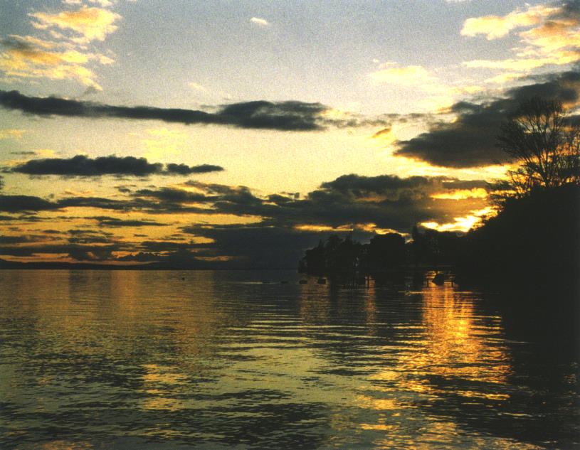
From Buchillon, Switzerland, a view over Lake Geneva

After arriving at Buchillon, we went down to the Lake. K stopped on the path under the trees, listened, and said: Silence. I felt he was referring not just to the external silence. There was a broken branch on the path and he carefully put it to one side. He had a look at the irrigation system and immediately figured out how it functioned. He also recognized the Araucaria tree in front of the house, even though it is quite exotic, and pointed out to Mary the particularly beautiful dark-violet-blue petunias that bloomed on the balcony and which I had been tending. By the lakeside he told me that many years ago he and his brother had spent a holiday at Amphion, across the lake between Thonon and Evian. The Hôtel des Princes had not been very comfortable. There was not even enough hot water for warming themselves up after they had taken a cold swim in the lake. K assumed that this was the cause of his brother’s tuberculosis, which led eventually to his early death at Ojai in 1925.
A year later, on his way to Saanen, K stopped for lunch at Buchillon. As he entered the dining room, he exclaimed Huh! and covered his eyes with one hand for a moment. There were at that time a number of paintings with rather strong colours on the wall. During lunch he carefully regarded a picture, which was hanging on the wall in front of him. Whenever K looked at something, he did so intensely and for a long time. He told me how, before the war, in Paris, he was shown Picasso’s painting Guernica. After looking at it for a long time, he had asked: What is this all about? Goya was an artist whom K appreciated, perhaps amongst other reasons because of Goya’s claim to have been still learning at the age of ninety, but he felt that modern artists only increased the general confusion and division by expressing chaos, aggressiveness and fragmentation. When I subsequently returned to Brockwood, Dorothy Simmons reported that K had spoken enthusiastically about his visit to the house at Buchillon.
While at Brockwood I was invited to attend the meetings of K with the staff and students. Most everyone would look terribly serious when K entered the room. He would then sit in front of the assembly and, to begin with, gaze at each person, one by one. As I felt so happy to be invited, I gave him a big smile when he looked at me. Radiantly, he smiled back, in a way no one had ever done towards me before. The people in front turned around to see what was going on!

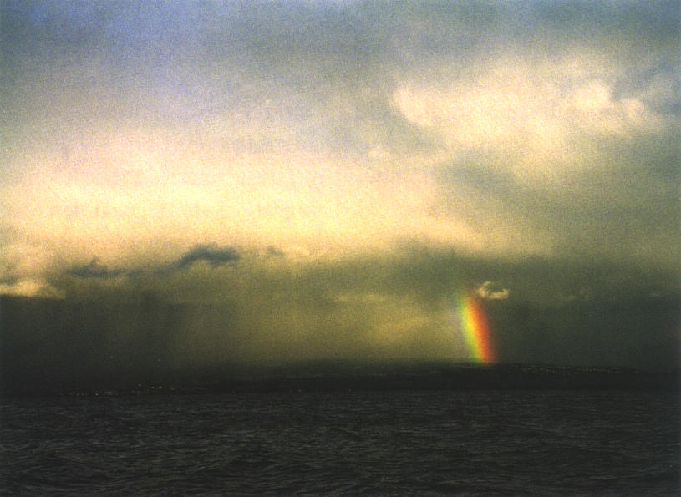
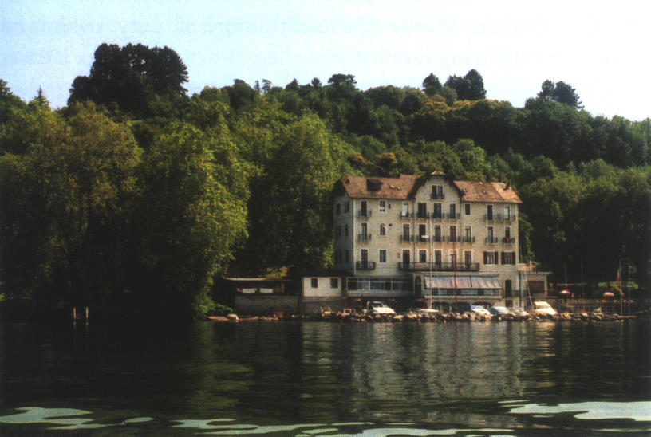
From Buchillon, Switzerland, a view over Lake Geneva towards Amphion
The Hôtel des Princes in Amphion, France, today; where K stayed in 1920
Ojai

In May 1984 I went to Ojai for the Talks. I was told that ‘Ojai’ is an American Indian word meaning ‘the nest’. A great sense of peace pervades the whole valley; one can feel it when one arrives from Ventura, particularly at dusk or during one of those magnificent moonlit nights that occur there. Returning regularly, K spent a great part of his life at Ojai, and it was there, in 1925, that death claimed his brother and in 1986, K himself.
Wherever K made his home, he would invite to lunch friends and other interesting people with whom he wanted to converse. This was the custom at Saanen, Madras, Rishi Valley, Rajghat and Ojai; but not at Brockwood, where he lunched in the dining room with students and staff. Michael Krohnen, who had been taught how to cook by Alan Hooker, was the chef at Ojai. Apart from preparing meals, it was Michael’s informal duty to inform Krishnamurti during lunch about the news of the world. He was naturally well suited to the task; also, Michael had a strong voice and K had become a bit deaf towards the end of his life. On one occasion K laughingly commented: First the teeth, then the ears, then the eyes, and then down to earth. Another time he quoted an Italian proverb: Everybody has to die; perhaps me, too.
At Ojai, when arriving for lunch, he would go to the kitchen first – peeping into the pots and exchanging a few words with Michael – and then enter the dining room from there. Michael and I once tried to figure out how many times K had stepped through that kitchen door, and figured that it must have been close to a thousand times while Michael was chef.
Michael invited me to join him when receiving K in the kitchen, and K and I, too, would exchange a few words. One day, burdened with marriage difficulties, I decided to ask K for help, but not out loud. I was simply thinking, “Please help!” But this time, K completely ignored me. This was a good lesson never to ask for help!
Sometimes, there were as many as twenty guests for the meal. K was actually a very shy person. On one occasion, when a great number of visitors had come for lunch, I heard him enquire timidly: Who are all those people? Approaching the crowd unseen, he would modestly step out from behind a screen and invite the guests with the words Madame est servie.
Lunch at Ojai was a self-service buffet, and after the meal everyone would take his or her dishes to the kitchen for cleaning. K would serve himself last and afterwards would carry not only his dishes but often some of the pots to the kitchen as well, and sometimes the biggest ones at that.
During one of these lunches, K mentioned a statement about Oak Grove School that he had written in 1975 and later revised with the school staff; he wished it to be distributed during the Talks. The Foundation lacked a good copier, however, and it looked as though it would be difficult to print the statement in time. This induced me to offer a donation to the American Foundation, a high-quality photocopier. The statement was called ‘The Intent of Oak Grove School’ (or ‘The Intent of the Krishnamurti Schools’), and as I consider it significant, I include it here:

The Intent of Oak Grove School

It is becoming more and more important in a world that is destructive and degenerating that there should be a place, an oasis, where one can learn a way of living that is whole, sane and intelligent. Education in the modern world has been concerned with the cultivation, not of intelligence, but of intellect, of memory and its skills. In this process little occurs beyond passing information from the teacher to the taught, the leader to the follower, bringing about a superficial and mechanical way of life. In this there is little human relationship.
Surely a school is a place where one learns about the totality, the wholeness of life. Academic excellence is absolutely necessary, but a school includes much more than that. It is a place where both the teacher and the taught explore not only the outer world, the world of knowledge, but also their own thinking, their behavior. From this they begin to discover their own conditioning and how it distorts their thinking. This conditioning is the self to which such tremendous and cruel importance is given. Freedom from conditioning and its misery begins with this awareness. It is only in such freedom that true learning can take place. In this school it is the responsibility of the teacher to sustain with the student a careful exploration into the implications of conditioning and thus end it.
A school is a place where one learns the importance of knowledge and its limitations. It is a place where one learns to observe the world not from any particular point of view or conclusion. One learns to look at the whole of man’s endeavor, his search for beauty, his search for truth and for a way of living without conflict. Conflict is the very essence of violence. So far education has not been concerned with this, but in this school our intent is to understand actuality and its action without any preconceived ideals, theories or belief which bring about a contradictory attitude toward existence.
The school is concerned with freedom and order. Freedom is not the expression of one’s own desire, choice or self-interest. That inevitably leads to disorder. Freedom of choice is not freedom, though it may appear so; nor is order, conformity or imitation. Order can only come with the insight that to choose is itself the denial of freedom.
In school one learns the importance of relationship which is not based on attachment and possession. It is here one can learn about the movement of thought, love and death, for all this is our life. From the ancient of times, man has sought something beyond the materialistic world, something immeasurable, something sacred. It is the intent of this school to inquire into this possibility.
This whole movement of inquiry into knowledge, into oneself, into the possibility of something beyond knowledge, brings about naturally a psychological revolution, and from this comes inevitably a totally different order in human relationship, which is society. The intelligent understanding of all this can bring about a profound change in the consciousness of mankind.

J. Krishnamurti
© 1981 Krishnamurti Foundation Trust Ltd

The following year I stayed at Arya Vihara, where the lunches were held, for almost two weeks. This is the house where Annie Besant and also Aldous Huxley had stayed, and where K’s brother Nitya had died. It is a very well kept, simple house with a wonderful atmosphere, surrounded by many flowers and splendid trees. After being the Library for many years after K’s death, it is now the Foundation’s adult study center – The Krishnamurti Retreat. The Library, where one can watch videos, listen to audio-tapes, and read or buy any of the books, has been moved to the new Archives building next door.
After I purchased a house on Country Club Drive in Ojai, K came to visit. This was in the spring of 1985; he was no longer in the best of health, but still extremely active. At one point, we were standing outside the house, and I asked him if he could do something about a guest room which did not have a pleasant atmosphere. He agreed, and asked us to wait outside while he entered the room, which we had pointed out to him. After some time he returned, and I asked him if he could exorcise another room, which he did. The following day he asked me in a modest and friendly way: Did you feel something? “Oh yes,” I answered, “It’s wonderful; such peace, such tremendous quiet. But I wonder if this is just imagination.” K grabbed my arm with his usual intensity and said: So do I. What he admired most about the house were the trees in the garden.
K liked to visit the Lilliefelts at their house on Grand Avenue. During one visit, he spoke of his body, saying that it should have been dead long ago. He claimed that they (pointing to the sky) did something.
K also held discussions at his home at Pine Cottage with trustees of the KFA and staff from Oak Grove. At one point just a few of us were there more privately, including the Lilliefelts and Mark Lee, the day after K had been to Los Angeles with Mary Zimbalist. He said: We were so tired that we went to bed at 9 o’clock. There followed a silence among the people present, after which he added: But not together.
At one of the lunch meetings with K at Arya Vihara, some of us, including Radha Burnier, were discussing pollution, the waste of paper represented by Sunday newspapers that are as big as books, and the horror of slaughterhouses. After listening to what we were talking about, K said: Yes, this is all terrible. But it’s secondary. With great emphasis he added: Why does man kill man?!
At another lunch, I showed K the programme of a psychiatrists conference that a psychiatrist friend of mine from Lausanne had sent me. K examined it with great care, as he did everything that was brought to his attention. His comment: Nothing but words. Nothing actual out of their own lives. Similarly, he would sometimes remark about modern-day philosophy that most of it amounted to more talk about talk, and more words about words and books written about books written by someone else.

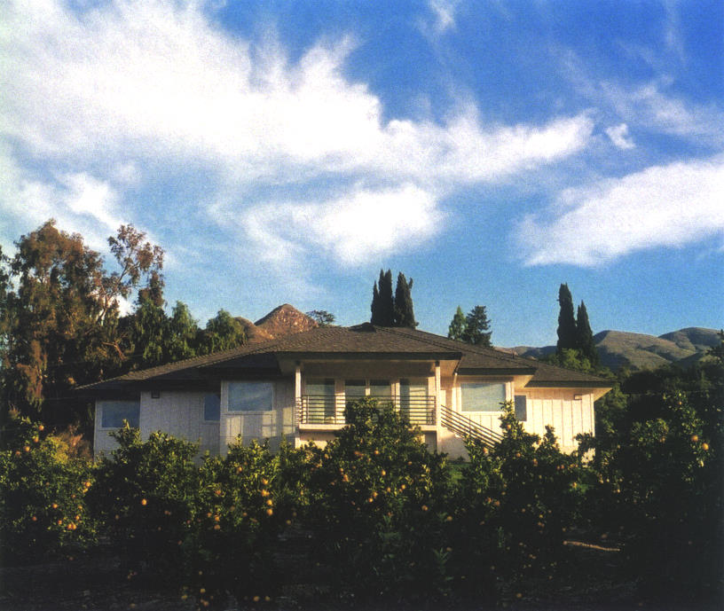
The Archives building near Pine Cottage in Ojai, California

It was with much laughter that K told the story of his encounter with the multi-millionaire. While in Washington, D.C., in 1985, giving two days of Talks at the Kennedy Center, K was asked to meet with the millionaire in the hope that he might donate money to the Foundation or to the School in California. Immediately after sitting down, the millionaire stated, “I believe in Jesus Christ.” K responded by asking him: Why do you believe? and involved him in a discussion about the deeper reasons why people look for security in a belief. K laughed as he went on to relate how the man’s face became harder and harder, like the brick wall behind him. The millionaire’s wife seemed more open-minded but even so, no donation was forthcoming.
In Washington, the superpower capital, K stated publicly: Power is ugly in any form. On another occasion, in India, he remarked to me that he did not like the atmosphere in Delhi because the city was a seat of power.
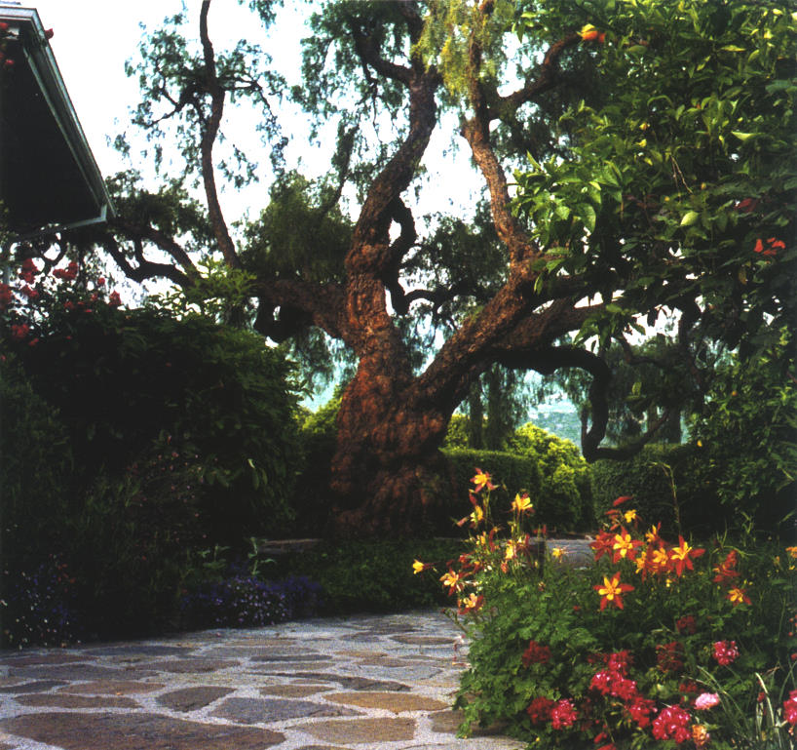
The Pepper Tree in front of Pine Cottage, K’s home in California
Brockwood Park

At the beginning of June 1984, K and Mary Zimbalist and I flew from Los Angeles to London and then went on to Brockwood. The Foundation insisted that K travel first class because of his age. On this particular flight I could not get a seat in the first class section, so I booked in business class. K heard about this and said: We shall do something about your ticket. I did not know what he meant and had forgotten all about it by the time we arrived at the airport. K and Mary went on ahead while I checked in. As I turned to follow them, a stewardess came running after me and gave me a ticket for a seat in first class, directly behind K. I did not even have to pay the price difference.
Since the late 1960s/early 1970s, once Brockwood had been set up as a school, K had the following regular schedule for his travels: after the Talks at Ojai he would go to Brockwood, around mid-May; at the end of June, just as the school year was ending, he would leave Brockwood for the Talks at Saanen; he would return to Brockwood for the Talks there in September; he would go to India early in November, visiting all the Schools and giving Talks at Madras, Bombay, and Rajghat/Varanasi; after a stopover of a few days at Brockwood – where he was always full of energy and worked intensely with the students but especially the staff regarding what to do at the School – he would return to Ojai in February. Then the cycle would begin again. The last year when he stopped briefly at Brockwood between India and Ojai, it was especially cold, with unusual ice and snow, and he still went for a walk, although he was blue with cold afterwards. I mentioned to him that most of the time he arrived at a place in springtime, so that he had an eternal spring (for example, Rishi Valley has spring in December, and in Saanen’s high mountains spring comes in June). He smiled at this.
As we flew over the California desert there was a magnificent sunset below. The mountains were glowing in all shades and colours: from the deepest purple to the most delicate pink. We could see the straight lines of the roads and railroad tracks cutting through the desert. When we arrived in England, everything was green. K enthusiastically called out: Look at it, just look! All this green!
At Brockwood I stayed in the west wing in a small room with a balcony. When K first showed me the room, he said: Here you are at home. The balcony was reached by climbing through the window. Having cleared away the dirt of generations (K agreed with this assessment), and after wrapping myself in my coat and several blankets, I practiced my yoga exercises there in the mornings. K found the whole thing quite fascinating and took a good look at the balcony. Someone once took a photograph of my feet projecting above the balustrade while I was doing a headstand.
K practiced yoga throughout his life. He emphasized that it was good for the body but that it had nothing to do with spiritual enlightenment. He also said that yoga was quite different in earlier times, being only for the few.
When K would show me some yoga exercises, I sometimes wondered what his state of mind was while doing them. It seemed as if his whole personality was absent, but at the same time one could feel an enormous presence. Later it occurred to me that he might have been in what he called meditation, a state that he said cannot be brought about by any deliberate action or exercise.
Every morning punctually at seven o’clock, we would do the yoga, going through various breathing, eye, neck and shoulder exercises, ending with jogging and jumping on the spot. (Later we wrote down the exercises so that I could do them on my own.) K was still doing all of this at the age of eighty-nine. He was so dynamic and young in his whole attitude, and his energy was that of a young person, that I was not sensitive to his age. I suggested that we also do other yoga exercises in the evening, never thinking that he might get tired.
The breathing exercises alone took about half an hour, and when K first told me that he would teach them to me, he added: Then you can walk! In fact, I was already accustomed to long hikes, as well as to mountain climbing and alpine ski-touring. During the last summer with K at Rougemont, I would set out early in the morning, partly to escape the heat of the day. When I returned for lunch, K would ask me, Combien d’heures? (How many hours?) I would answer three, four or five hours; he was always impressed and finally said: He wants to go on walking until the end of his days.

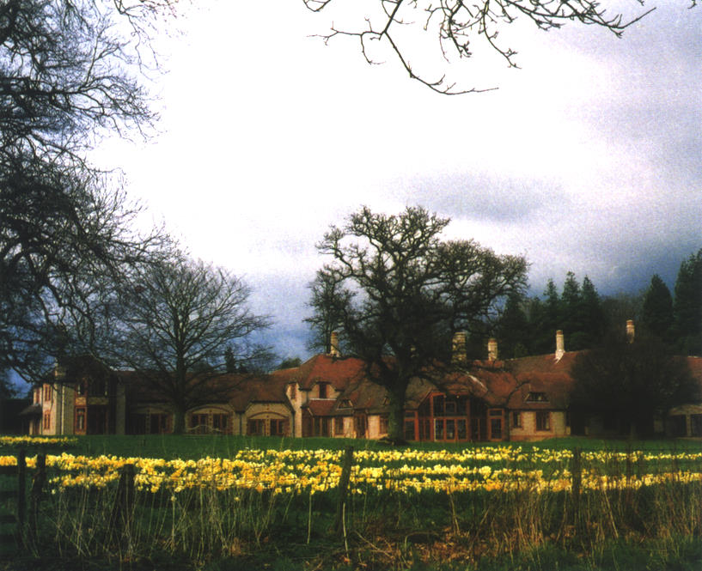
The Krishnamurti Centre at Brockwood Park, springtime

After our yoga exercises one morning, K pulled up the blinds in his room, thereby opening up a magnificent view of the vast meadows and distant hills. Pointing at this beauty, he said to me in Latin: Benedictus est qui venit in nomine domini. He asked me to translate this sentence, and I translated it as “Blessed is he who comes in the name of God.” When I pronounced the word ‘God’, he dismissed it with a gesture. K often pointed out that God, especially when given a human form, was an invention of the human mind.
Another morning, as I arrived for the yoga, K’s room was still in darkness and he was in bed. On my opening the door, he woke immediately and said: Today I shall stay in bed the whole day. I replied, “Good night,” and he laughed. He had been to London the day before and the city always exhausted him. Once after returning from London he met me on the stairs, and we both wondered why one went to such a place. He said it was a relief to get out of it again, which was exactly how I felt.
One of the things that amazed me about K was his natural joy in having physical contact with people: holding hands, hugging, just a little touch with its healing powers. For me, hugging was not a natural way of greeting somebody or bidding them farewell; I was more used to the French/Swiss way of kissing cheeks. I never saw K kissing. He hugged. As I didn’t know how to do this properly, we sometimes got entangled. Once while at Rajghat, I witnessed K meeting Michael Krohnen, who is now a close friend of mine. First K threw up his arms in surprise at seeing him there, and then he hugged Michael, who was twice as tall and three times larger than K. As can be seen in the photo on the back cover, K and I were almost the same size, only his arms and feet were longer.
I remember my astonishment when K showed me some breathing exercises while at Brockwood. He asked me to put my hands on his lower chest to feel the movement of his breathing. It felt as if his lungs would fill out the whole of his abdomen, so deep and free was his breathing.
At Brockwood K used to rinse his own dishes. When someone offered to help him with it, he would reply: It’s my job. He also insisted on cleaning his own shoes. On one occasion I saw him polishing the banister with great enthusiasm. In India they would never allow me to do that, he remarked. In India he was obliged to let the servants wait on him. At Rishi Valley, he had lived at first in a very small room, which he did not mind at all. I simply looked out the window, he joked.
There were times when I ate with K, Mary and others in the little kitchen in the west wing. On one such occasion the topic of national characteristics was raised and everyone present contributed observations. When it came to the British, I said “fair play”. K was sitting beside me and pulled me aside slightly and said: But not with the Indians.
He was a modest person, very gentle in his personal dealings and extremely courteous. Towards ladies he was most considerate, even chivalrous. There were occasions when he would be impatient with somebody, but he never wanted to hurt anyone’s feelings or tell them directly what to do. There was a sense of love about him. He would point at the deeper causes of the problem at hand and urge that person to find out for himself or herself what was the right thing to do. One could learn something from every word he uttered.
In 1984 there were great difficulties at Brockwood concerning the direction of the School. One group within the staff was in conflict with another, which eventually led to departures from the School. K devoted his whole energy to the problem. Several times he talked to the entire staff. Once he even threatened to close the door to the west wing and never set foot in the School again. Naturally, he also talked to the students and was shocked when they told him that the teachers and other staff were spending very little time with them because of being preoccupied with the divisions among themselves. Subsequently, having talked to the teachers in an unusually strict way, he told me: I have never talked like this before. In this instance, we seemed to run into each other but he must have detected me in the crowd outside the assembly hall immediately after the meeting, and he had taken my hand while we went for a short walk.
From my room in the west wing I could sometimes hear what was going on in the small kitchen there, where (other than when he had lunch with the School) K was happy to eat. At that time, in the evenings, K talked a lot with Scott Forbes, which he later described as cooking Scott for his job as Principal.
In K’s company, the perception of the natural beauty around Brockwood was more intense. On walks, he would talk very little. When crossing meadows, he insisted that one not use shortcuts. Don’t cut corners! he would say.
He had an intense relationship with the things of nature. He maintained that the roots of trees have a sound but we simply don’t hear it any more. Once, when walking across the Brockwood meadows behind the Grove, I was about to pass between a group of five tall pine trees. He caught me by the arm and said: No! Around them! We must not disturb them.
On another walk at Brockwood, returning along Morton’s farmhouse, a storm began to brew. Soon there was thunder and lightning and I was worried as we were in an exposed place. I then realized that K enjoyed the turmoil of the nature.
K used to say that when all of your senses are awake, then you are intelligent. I saw on several occasions how sensitive to nature he was. Once when walking at the lake at Buchillon, I picked a thyme flower for him to smell. He really jumped!
Something that happened in India also demonstrated his intimate relationship with living things. On the path from Rajghat to Sarnath, which the Buddha was said to have walked, there was a plantation of big mango trees that was no longer yielding fruit. Even though it was said that the Buddha had rested under these trees, there was a plan to cut them down. K recounted how one day he, K, had walked among the trees and said to them: Listen, if you do not bear any fruit, they are going to cut you down. The next year they did indeed bear fruit.
K liked working in the garden. Particularly during his earlier days at Ojai he did a lot of gardening. When I showed him my garden at Buchillon, which I had set up myself, he remarked: It’s good to feel the earth between one’s fingers.
Whenever I travelled from California to Brockwood, I would feel tired for some time due to the eight-hour time difference and the change in climate, so I would sometimes lie down and take a nap beneath a larch tree that stood in a clearing in the Grove, the sunshine warming me pleasantly. I told K about this and he responded: Oh, I couldn’t sleep out there. Too many things to see. And he rolled his large eyes from right to left as he did when doing his eye exercises. His eyesight was so good that he never required glasses for reading or anything else throughout his life.
On one of the walks that K used to take at Brockwood during his last years – usually with a few close friends (he would make sure that Dorothy Simmons was not forgotten), but sometimes it was just the two of us – one had to climb over a fence in order to continue. On this occasion I was already on the other side waiting for K, who had had some difficulties climbing the fence lately. Being a little impatient, I thought, “He really needs quite some time to get over the fence.” And as if he had read my thoughts he replied: I hope at my age you will climb over the fence this well.

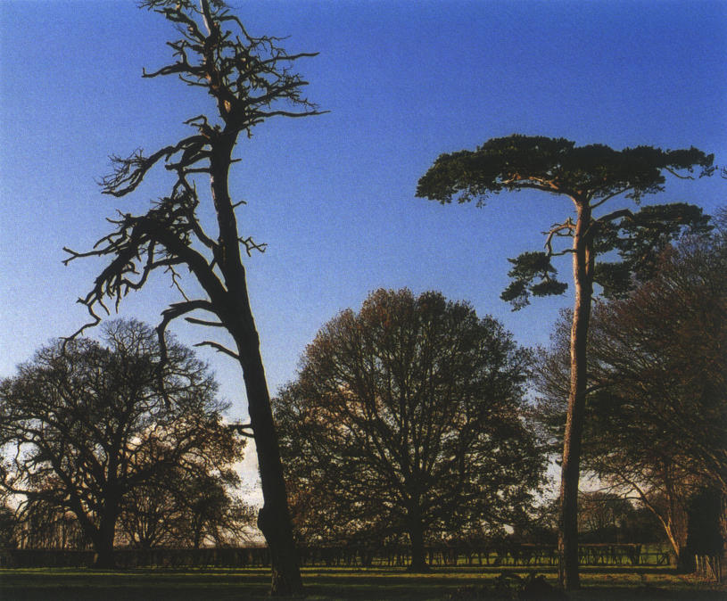
The two pine trees remaining, with one ready to fall, of the several that K said we should not disturb while we walked at Brockwood Park

Many people who came to K’s Talks would say that each time they heard him he raised the very topic they were most interested in at that time. Since K often addressed thousands of people, one has to ask oneself how such a thing was possible. Was the same problem on everybody’s mind? Was it common consciousness, which we all share? Or did K single out one person who was very intensely involved with a particular problem? In fact, each problem can be said to contain every other problem, like a hologram.
I have experienced K’s capacity to read thought, and other people have borne testimony to it themselves. Once, at Madras, K, four or five of his old friends, several of whom were Foundation trustees, and I were walking along Adyar Beach. On the way back, I was walking behind K, thinking what the others must certainly have been feeling: that K had given me, as a newcomer, a disproportionate amount of his attention. But just then he turned round to me and said: I don’t think that way.
Another incident occurred in the dining room at Brockwood. A journalist had just asked me what I did for a living. The question irked me, and I was on the point of answering him (rather provocatively) that I did nothing, when K, who was sitting next to me, nipped in before me and said: They make taps.
Another time, at Rishi Valley, an Indian lecturer from a South African university was sitting at our table. K was asking pointed questions concerning the situation in that country, trying in a variety of ways to get him to say what his personal feeling about it was, but our guest would answer only in generalities. Finally K, referring suddenly to me, said: Mr. Grohe couldn’t stand it in South Africa. I was astonished.
Admittedly, I had told him that I had worked there. I hadn’t mentioned, however, that a year into my work I couldn’t stand it any longer and returned to Europe, even though my parents were going to have a beautiful house in South Africa and were planning to live there for at least a few years. My father, fearing the Russians after the war, had relocated his family there from Germany. On one occasion I talked to K about the Germans’ fear of the Russians. He said they had been right to be worried.

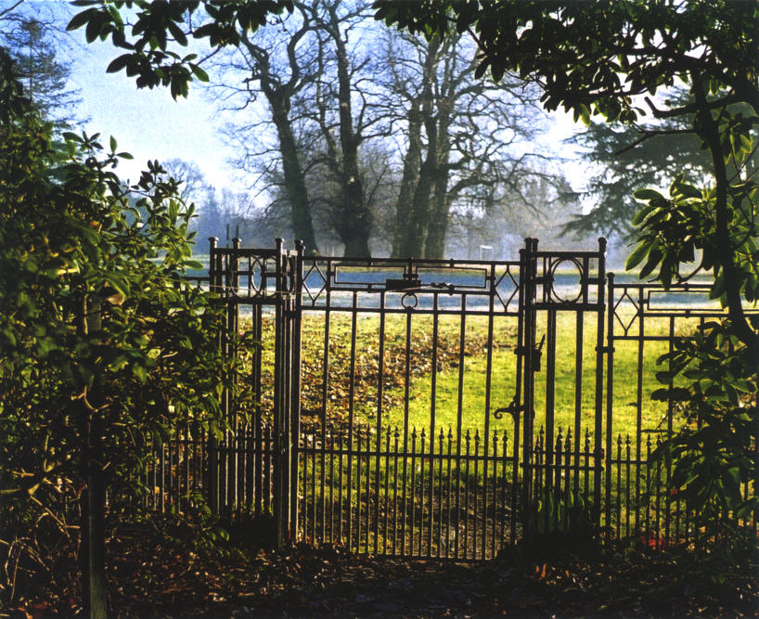
The main gate from the Grove at Brockwood Park, Hampshire, England

I once happened to be present when K was being interviewed by the Czech publisher and translator Jadry Prokorny. Prokorny asked K what he would have done had he been stuck in a communist country. K answered that he would have been able to speak only to friends like you. In conversations and public talks K repeatedly pointed to the repression and brutality of communist dictatorships. He took an interest in everything, including world politics. He liked to watch political and news programmes on television and, even on his deathbed, he enquired: What’s going on in the world?
But he did not like to talk about war. One day, K, Mary Zimbalist and I were driving from Brockwood to nearby Winchester. On the way, we passed a huge, wide hollow among the fields, which Mary pointed out was the place where Eisenhower had addressed the Allied troops before the invasion of Normandy. (The site is now famous also as a rock concert venue.) K somewhat impatiently brushed the remark aside, saying: The war has been over for a long time. He was well aware of what had happened during World War II and often pointed out that the cruelty of that and other wars continued into the present. He emphasized that nationalism is a common cause of division and conflict in the world. Often he said about himself: I am not Indian.
Another anecdote that K relayed to us concerns an event that occurred in the 1930s. He was in Rome and visiting St. Peter’s Square when the Pope was carried by in a sedan chair. The Pope stopped the sedan, leaned out and asked K, “Are you an Indian?” K replied: I am supposed to be from India. And the Pope said to him, “I like your face,” after which he leaned back into the sedan and continued on his way.

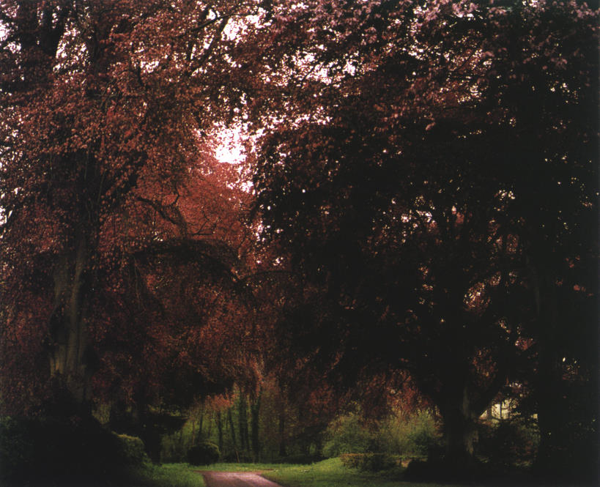
Near Brockwood Park, Hampshire, England

Although K sometimes mentioned that he had been brought up by its aristocracy, he would occasionally make reference to the stuffy English society. At one point he noticed my cuff links and told me that he and his brother had had cuff links and tie pins. They would leave them at home before going for a walk and once, at Ojai, they returned to find them gone – stolen. They were very happy they had disappeared!
But about Annie Besant, who was English and whom he had loved like a mother, he said she had done more for India than Mahatma Gandhi had done. Using the example of Gandhi, he pointed out that forcing others to do what one wanted even by the presumably peaceful means of fasting, was still violent. Fasting for political reasons was violence.
K was a tremendously serious person but he also enjoyed a good laugh and took particular delight in telling a good joke. We shared many such moments. Here are two of the many jokes that he would sometimes recount:

Three sages were sitting in the Himalayas meditating in silence. After ten years, the first one said: What a wonderful morning it is! They were silent for ten more years when the second one remarked: It might rain some time. They fell silent for another ten years, when the third one said: When will the two of you ever stop talking?

Saint Peter is showing God what is happening on Earth and the first thing they see is human beings labouring and toiling away from morning to night. God is amazed, and he asks Saint Peter: What is the matter with those people down there? Saint Peter replies: Didn’t you tell them that man should gain his bread by the sweat of his brow? God replied: But I was only joking. Then they watch another event. People in festive attire are sitting at tables lavishly loaded with food and drink. They are cardinals and bishops. To God’s question as to who these people are, Saint Peter answers: These, my Lord, are the people who understood that you were only joking.

At one time at Brockwood, K read the Old Testament. When I asked him how he liked it, he answered: I do like it. Not the fairy tales they tell you, but the language, the style. He also enjoyed reading detective stories as a pastime and appreciated a well-constructed plot.
I once heard K ask: When two egotists get married, what do you get? After a brief, expectant silence from those present, he answered his own question: Just two egotists.
This he said at Ojai in 1984 after I had risked getting married a second time, in spite of K telling me Good when I mentioned at our first meeting in Gstaad that I was divorced. He called Magda, my new wife, Madame A.G. At Brockwood he had suggested that I change my name to A.G. When I asked him what it meant, he explained: Ange Gardien (Guardian Angel). K also said: He marries the most beautiful woman and he has hell on earth.
I remember when K and I once walked side by side into the dining room. He took my hand and said with the intensity which he so frequently displayed: I don’t know why I like you so much. This has never happened to me before. It has nothing to do with the money. Je m’en fiche ([about the money] I don’t care at all). On one occasion he told me: We are brothers. Several years later I asked Sunanda Patwardhan (see footnote 19), an old friend of K’s and a trustee of the Indian Foundation, what he might have meant. She replied that K simply fell in love with people.
On 4th August 1928, at the Ommen Star Camp, K had said to his audience: I am in love, not with you, but with that which is behind you; not with your faces and your clothes, but with that which is life.
Saanen, Schönried and Rougemont

During the 1984 Saanen Talks K couldn’t stay at Chalet Tannegg, as it was being sold, so a flat was rented for him at nearby Schönried instead. He showed us a number of pictures of old ocean liners that hung in his bedroom there, on one of which he had sailed. He also watched a few of the sprint competitions that were part of the Olympic Games that summer, shown on television, and called out: Maria, look how they run! Look how they run!
He wondered why they hadn’t gone to Spiez for a boat ride the past few years. He corrected my German pronunciation, SHPEETS, to SHPEE-ets as the Swiss say it. Then he answered his own question: Too much work to do. Mary Zimbalist added, “We are getting too old.”
Twice, my old school friend Edgar Haemmerle from Austria and I were invited for lunch at K’s flat. Edgar had been living as a kind of sociable hermit in a wood cabin without electricity, telephone or running water, taking care of various animals, including an owl. When K met Edgar for the first time he immediately asked him whether he was some kind of farmer, and they went on to have a lively conversation about animals and the like.
It was well known that K had a special relationship with animals. One day for lunch we went to the Klösterli Restaurant, near Gsteig, where they serve especially good salads from their organic garden. The owner of the restaurant was very fond of dogs. While we were sitting at the table, his dog came and lay under K’s chair. The owner was amazed and said he had never before seen his dog lie down under a guest’s chair.
K enjoyed talking about his experiences with animals, but more than any other he loved telling the story of the tiger. In India some friends took him in a car to see a tiger in the wilderness. Eventually a tiger appeared and approached the car window. K moved to stroke the animal but his frightened companion sharply pulled his arm back. K was convinced that nothing detrimental would have happened to him. He was simply unafraid.
Another story, which happened at Rajghat, concerns a monkey. One day, as K was doing yoga exercises in his room, a large wild monkey jumped onto the window sill, stretching out his hand towards K. K grasped it, and so they sat there for a while, K and the monkey, holding hands. (K described this scene in the book The Only Revolution; it also appears in the Penguin Second Krishnamurti Reader, pp. 42–43.)
Once during lunch at Ojai, K told the story of how he had gone for a long walk there. On his way home he heard a barking dog. He pointed out that one could tell by the bark whether a dog was dangerous. This one evidently was. As there was no other way to get home, he had to pass by the house where the dog was barking. As he approached, the dog ran up to him and started circling him. Suddenly he grabbed K’s arm between his jaws, whereupon K admonished him: You go home! And that, indeed, is what happened: the dog let go of him and withdrew towards the house. He then explained how to handle vicious dogs according to what a French army officer had told him: hold a stick horizontally for the dog to dig his teeth into, then kick him in the belly. K did not appear to need this kind of defense, however, and he did not recommend it to us.
My friend Edgar was very fond of drinking a bit of wine. When he saw none at my house, he was quite disappointed, and naturally he did not expect that there would be any at Schönried when we went there for lunch. So he was pleasantly surprised to find a splendid bottle of red wine on the table there. K immediately told him: You can drink the whole bottle. K, as a matter of course, did not have any.

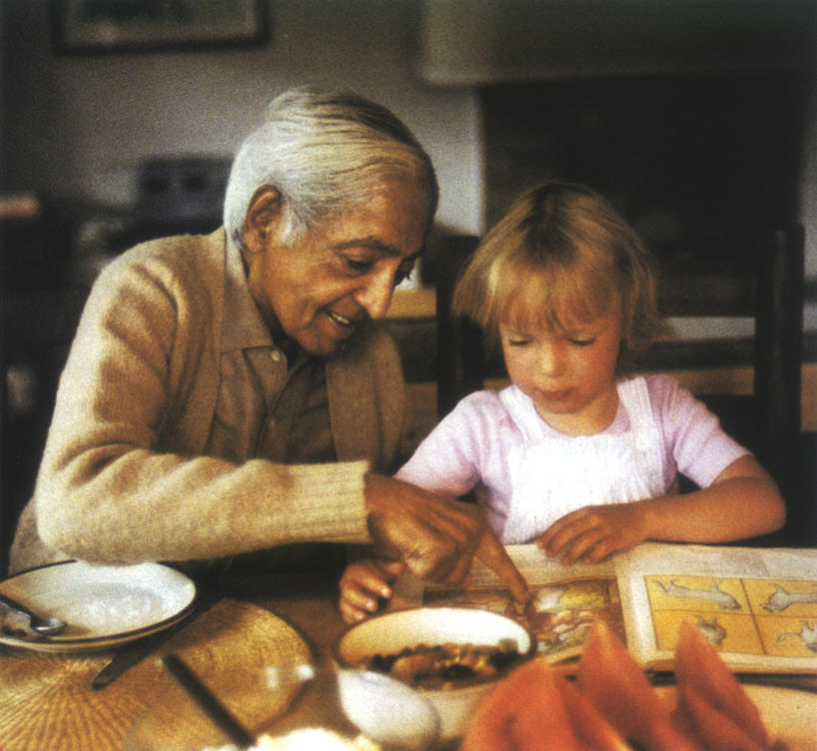
K with the daughter of a friend of mine before lunch in Rougemont in 1984
© Asit Chandmal

But the conversation was very animated on both their parts. Knowing that Edgar and I had attended the same school at Davos, K asked him if I had gone to school mainly to learn or to ski. Edgar supposed that it was mainly to ski, and K made a facial expression as if to say he had expected as much.
At one point, K mentioned to Edgar that some people in India came to his Talks even though they didn’t understand English, because they wanted to be close to a saint. Edgar then stated that K was not a saint, and K replied: Yes, but they think so.
The second time we had lunch together, Edgar had planned to return home by train from Schönried. We were having an animated conversation when I asked Edgar, with some misgiving, when his train was due to depart. It turned out that there were only five minutes to get to the station. Everyone leapt up and I said to Edgar, “We have to run.” “No, no,” interjected Mary, “I’ll drive you to the station in my car.” She went upstairs to get the car keys. K threw up his arms and shouted: You have to run! You have to run! Mary ran up the stairs even faster, while Edgar and I raced wildly downstairs, out of the house and to the station. The train was pulling in just as we arrived, panting heavily. The next time I met K, he said: I watched how you ran.
Even with regard to small things, K was very observant. Once at Ojai when I dressed to go to lunch with K, I couldn’t find the belt for my trousers and went without one. There were several other guests there, but when I returned two days later he asked me casually: Did you find your belt?
Nothing seemed to escape his notice. At one stage I had been suffering from chest pains for some time. Although the pain was considerable, I did not pay much attention to it, nor did I see a doctor. One time, however, as I was walking past K, he lightly tapped my chest with his fingers. Shortly after that the pain disappeared. It was only then I realized that he had responded to my pain. Later I heard similar stories from others.
Another time I was having difficulty understanding a bank statement for an account I had recently opened in Ojai. I asked Mary, who is from the USA, to explain it to me. As she was doing so, K approached and walked around us, repeatedly saying to Mary: Maria, be very attentive! He kept repeating it until Mary responded, “But I am attentive.” After a while, it appeared to me that nothing was more interesting than that boring bank statement.
Time and again K talked about total attention, but stressed that this was not to be confused with hypnosis. Often after a Talk the people did seem to be hypnotized. On those occasions, he would say to the audience: Ladies and gentlemen, don’t be mesmerized. Please get up!
In general, K spoke passionately but without pathos.
During the 1985 Talks, K stayed at Rougemont. I placed my rented apartment at the Chalet l’O Perrevoué at his disposal, and the Foundation rented an additional large flat at the same chalet to accommodate some helpers and companions, in this case Michael Krohnen, Raman Patel and Dr. Parchure, as well as possible guests such as Vanda Scaravelli. The previous year we had invited K for lunch there, and he had greatly admired the dining table with its heavy and well-made wooden top. He was generally well aware and highly appreciative of quality in things.
After some time, K moved from the lower apartment to the one on the upper floor as it was more spacious and had a balcony. He was also glad that, by doing so, Mary Zimbalist no longer had to share the bathroom. He remarked chivalrously: You know, she is a lady. At another time, when we were taking the car with Mary Zimbalist, I tried to help him into it although he didn’t really need help. Mary was coming from the other side and he said, pointing to her, She is a lady, which made me rush to help her.

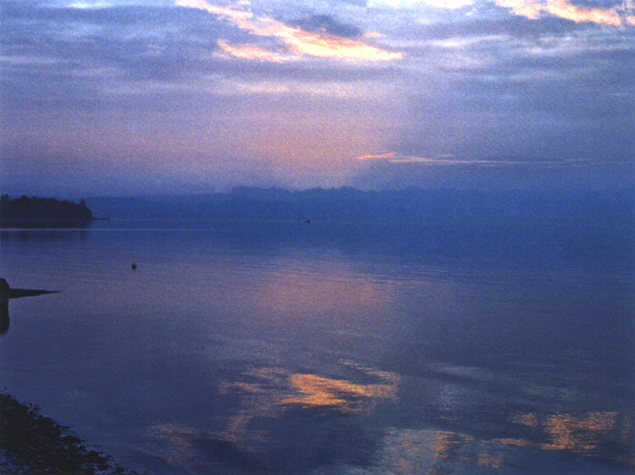
Lake Geneva “like a mirror”, Buchillon, Switzerland

Around that time K burned his finger on a brass reading lamp. I was horrified when I saw the burn, but K dismissed it, saying he could endure pain.
One day the American actor Richard Gere came for lunch. Although he had already given a Talk that day, K conversed very intensely with him for more than an hour. It was almost as though K was giving another Talk, and we left the lunch table at four o’clock. When he was on the point of leaving, Richard Gere, who appeared visibly moved, asked K if he could give him a hug. It was quite touching to see this much taller man bend down and embrace K so that K’s slight figure completely disappeared in the other’s arms.
It was also in Rougemont that my older son, Christoph, who is now a vintage-car dealer, showed K his first very carefully restored and well-kept old MG. K showed a great deal of interest and looked under the hood in his usual careful way. Christoph, tongue in cheek, proclaimed, “It’s now a holy car.”
I also wanted to bring my younger son, John, to lunch. When finally we found a date, I happily told K, who replied: But he will be bored. I immediately realized this to be true and canceled right away, to John’s great relief. But both John and Christoph had been to Ojai and met K at lunches, and both had been to Talks either at Ojai or Saanen.
On another occasion, after a particularly impressive Talk at Saanen, I went to see K in his flat. He was stretched out on his bed, his doctor having advised him to rest after each Talk. I told him that it had been wonderful. He became very serious and a great dignity emanated from him as he simply concurred: C’etait merveilleux. (It was wonderful.)
A woman from Italy who once came for lunch reported that, at a conference of healers and clairvoyants, it had been stated that spiritual healing and clairvoyance do not work when thoughts interfere. K commented simply: This is what we’ve been saying for seventy years.
It was around this time that Pupul Jayakar, in Rougemont, told K that it was too difficult to understand him. He resolutely replied: I must become simpler. And, in fact, on the following days he expressed himself even more simply and clearly.

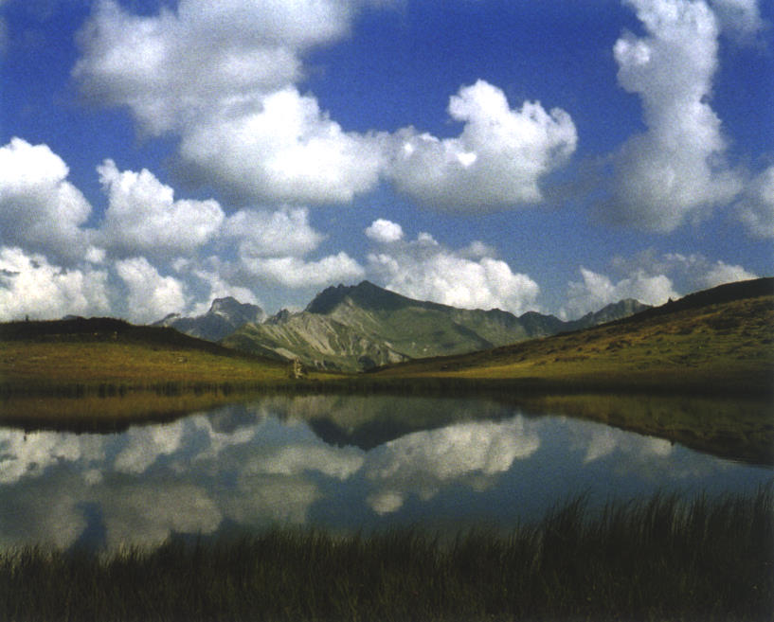
Pond near Arnensee, not far from Gstaad, Switzerland

At some point, K recounted several stories about women who kept following him around. At Madras a woman had invaded his bathroom by climbing through the window and he had had to call for help. Another woman had beseeched him to let her touch his foot. When at last he acquiesced she grabbed his ankle and wouldn’t let go. At the end of these stories he declared: We are all crazy, but they beat us! He had a wonderful gift for telling anecdotes in a humorous way and he would laugh until there were tears in his eyes. It was never dull in his company.
K enjoyed speaking French. Once during lunch he was telling us about Paris, where he had spent quite some time, particularly during the 1920s. He knew a Maharaja then who collected cars and would buy any model he did not yet own, and K accompanied him for such purchases. K told the story of the car dealers who simply refused to believe that it was not K who was the Maharaja. When I remarked that Paris was no longer what it had been, K responded: Vous savez... (You know...), which implied that it still had something.
While taking a walk at Rougemont, K commented with some admiration on the orderly way in which the Swiss stack their firewood. He speculated as to what Americans might feel about that kind of activity: Ah, we have no time for something like this; life is too short.
Once, after I had returned from a visit to Buchillon, K asked me: How was it? When I started to reply, “The lake was...,” he completed the sentence quicker than I could think: ...like a mirror.
I asked him once whether he prepared his Talks. He answered: No, for I wouldn’t know what to say.
During this last year of Saanen Talks, I started building a new chalet. K was very curious to know where it would be and why I was building it, so I described the location and told him that I had always wanted a wooden house. The next day in the Talk, he said: To build your own house is still self-centredness.
Last Journeys to India

In November 1985, at Rajghat, K told me that he still had some months to live. When I reminded him that he had promised us he would live another ten years, he only raised his arms as if to say, What can one do?!

K’s health had started to deteriorate at Brockwood. The regular walks that he took became shorter. The walk through the Grove and across the meadows, which at one point entailed climbing over a fence, he did not do anymore. Apart from that, he was as active as ever. Once he told me: Je travaille comme un fou! (I am working like hell!)

Indifference and understanding

One has to be indifferent – to health, to loneliness, to what people say or do not say, indifferent to whether one succeeds or does not succeed, indifferent to authority. If you hear somebody shooting, making a lot of noise with a gun, you can very easily get used to it, and you turn a deaf ear; that is not indifference. Indifference comes into being when you listen to that noise with no resistance, go with that noise, ride on that noise infinitely. Then that noise does not affect you, does not pervert you, does not make you indifferent. Then you listen to every noise in the world – the noise of your children, of your wife, of the birds, the noise of the chatter the politicians make. You listen to it completely with indifference and therefore with understanding.

from On Living and Dying, pg. 99
© 1992 Krishnamurti Foundation Trust Ltd
and Krishnamurti Foundation of America

I was able to experience this warm and affectionate indifference when we were sitting in a car by the west wing at Brockwood, waiting to go to the airport. We had to wait quite a long time for one of our passengers. One might have thought that K would be nervous at the prospect of such a long journey. But he sat and waited with complete composure and was even cheerful, though it was a long wait.
K had been very enthusiastic when he said to me in 1984: You come with us to India! How could one resist? He invited me to live close to where he lived and to eat the same food. You stay with us! he said when I went to Rishi Valley, Rajghat, and Madras for the first time. On the same trip, I went alone to The Valley School in Bangalore and also to the retreat in the Bhagirathi Valley near Uttar Kashi, which is now the Nachiket Study Centre and the Nachiket School.
At one point at Madras in 1984, I went to his room and he was looking at a newly published book whose cover image was a photograph of himself. Somewhat amused, he pointed to the cover and remarked: He looks a bit sad.
Now, towards the end of 1985, I was travelling with K on his last journey to India. (After that, I went many times on my own, and became a trustee of the KFI. K had made me a trustee of the KFT, and I also became an honorary trustee of the KFA.)
It was an early morning departure. The day had not yet dawned, yet all the staff and students had come to the west wing and were waiting at the bottom of the staircase to see us off. We ran the gauntlet of almost a hundred people, and K shook hands with them on his way to the door. The atmosphere was solemn. A premonition hung in the air that this had been K’s last visit to Brockwood.
Dorothy Simmons, the former Principal of the School, drove us to the airport in her car. K and I sat in the back seat. At the start there was rain, but it soon stopped, and Dorothy forgot to turn off the windscreen wipers. They began to scrape across the dry windscreen. I became tense and would have liked to say something, but instead waited for a reaction from K. And, as so often happened, his response was surprising. He simply said: It’s stopped raining, which immediately made Dorothy turn off the wipers.

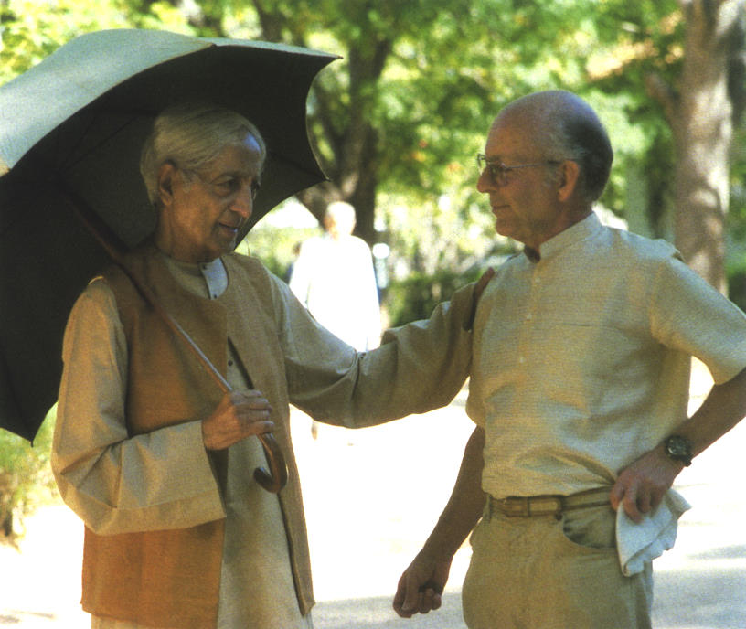
K and I at Rishi Valley, India, December 1984 © Rita Zampese

At the airport the moment of parting brought tears to the eyes of the women. Dorothy and Mary Zimbalist were staying behind, I was the only one flying with K. Rita Zampese, Manager of public relations for the United Kingdom for Lufthansa in London, led us through to the lounge. My entire luggage consisted of one rucksack, which I took with me onto the aircraft. Now I cannot imagine how I could have set off on such a journey with so few things.
We found ourselves sitting near a group of men and women, business people probably, who were very self-absorbed. They were talking, smoking and drinking alcohol. K looked at them with wide eyes, and the expression on his face was one of astonishment and mild horror, although he was not the least bit contemptuous.
We had to change at Frankfurt, and I remember with what joy K travelled on the fast electric shuttle to the terminal. Once back on the plane, he had the single seat at the front and to the right, which only Lufthansa was able to offer. By contrast, I found myself sitting by a gentleman who was reading a newspaper and listening to music at the same time. What’s more, he made hand movements like a conductor might. He, too, was self-engrossed and showed not the slightest interest in his neighbours – in this case, K and me. It was night-time when we flew over Russia and Afghanistan. On the plane K said: I’m glad we two are alone.
After arriving at Delhi, K went with Pupul Jayakar to stay at her apartment; I went to a hotel. Every day at sunset we met at Lodi Park. It was always at sunset, because K had once suffered from sunstroke and had to keep out of the strongest rays. At the entrance there was a kind of turnstile, which glistened with the sweat and the dirt of the many hands that had touched it. I would open it with my foot, and every time K would exclaim: Good! He was very concerned about cleanliness.
The park was well kept, with many trees, lawns, waterways and bridges, and old buildings from Mogul times. At dusk, innumerable birds would gather and settle down for the night. The noise they made was deafening. Occasionally Nandini Mehta or Radhika Herzberger’s daughter, Maya, joined us on our walks, as did Pama Patwardhan.
Travelling, and the frequent change of climate it entailed, exhausted K, and his health deteriorated in Delhi. He did not sleep well and he ate very little.
Occasionally other strollers recognized him. One man approached him rather aggressively, demanding, “Are you Krishnamurti? You should stay in India! Here are your roots!” K replied: I am nobody! Then he raised his open hands to me and said: You see! They have a fixed idea and stick to it. Despite such incidents, K was friendly towards everyone he met and especially so towards the underprivileged and those who were normally ignored by others, such as the ice-cream vendor at the entrance to Lodi Park.
On the plane to Varanasi, K kept the window shade down because of the bright sun. He had once suffered from sunstroke and had to be careful with direct sunlight. But time and again he would open the blind to look at the white peaks of the Himalayas. We agreed that the mountains were really something!
He told me that once, as a young man, he had been clambering around the Zugspitze, in Germany, in casual shoes. A mountain guide who passed by with a group of alpinists on a rope noticed K. After scolding him, the guide tied him to the end of the rope and led him down from the mountain. K, however, had not been afraid and said that he could have got down safely by himself.
I was overwhelmed with the atmosphere at Rajghat in Varanasi. Here one can sense the enchantment that appears to exist in all those places where K lived – it can be felt at Brockwood, Rishi Valley, Vasanta Vihar (his home in Madras and the headquarters of the Indian Foundation) and Ojai. One could also find it at Chalet Tannegg in Gstaad and both Pupulji’s rented apartment in Delhi and house in Bombay. The surroundings in all these places are of great beauty and are immaculately kept: islands of serenity amidst the turmoil of the world, full of trees, flowers, birds and butterflies; there is a certain sacredness about them.
Walking around the grounds of the School at Rajghat, one comes upon several archaeological excavation sites. The school property is situated in one of the most ancient parts of Varanasi, called Kashi, and presumably there were temples, parks and royal palaces there as long ago as 4,000 to 5,000 years. Beyond the excavation sites a canal carries sewage from the city into the Ganges. The stench was noticeable all the way to K’s house. K laughed when Pupulji assured him that a new sewage system would be built in the near future. Apparently this promise had been made many times, and when I visited the following year nothing had yet been done. It was only during my visit at the end of 1988 that I noticed construction of the huge new canal system had begun.
At Rajghat my room was underneath K’s. As soon as he arrived he began intensive dialogues with Radhika and a few colleagues. At sunset he would walk several times around the School’s large sports field, accompanied by his friends, whom he jokingly called his bodyguards. Even during these recreational walks he continued his discussions with them. His legs were becoming very weak, however, as he himself said, and after one walk he fell forward on the steps. His companions wanted to help him up but he refused to let them, saying: If I fall on the steps that is my affair!
When K could no longer walk quickly, I would go on my own, circling as briskly as I could. After such walks he would ask me how many rounds I had done and how long I had taken. When I told him that I had broken my record, he responded enthusiastically. Somebody must have complained to him, though, about this crazy guy chasing around the sports field, because he said in a meeting with friends: He just wants to keep his body fit. What’s wrong with that?

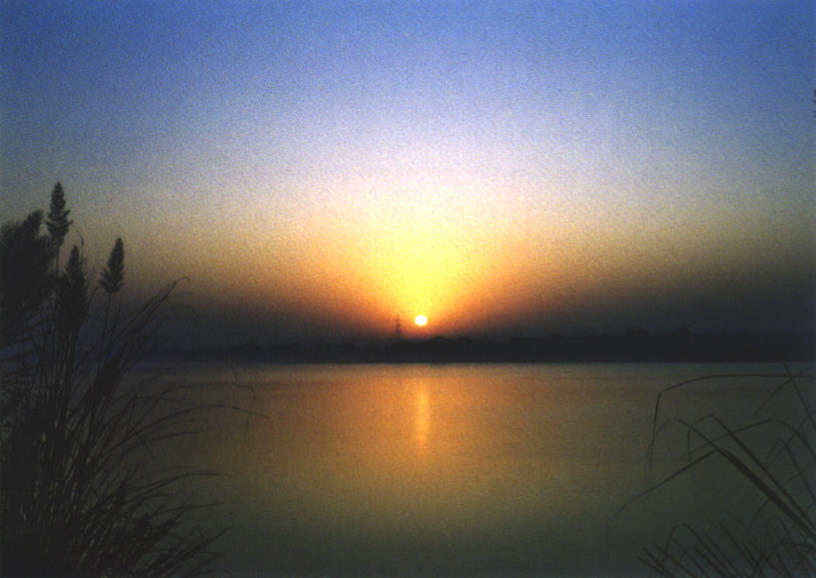
Sunrise over the Ganges, at Rajghat, India

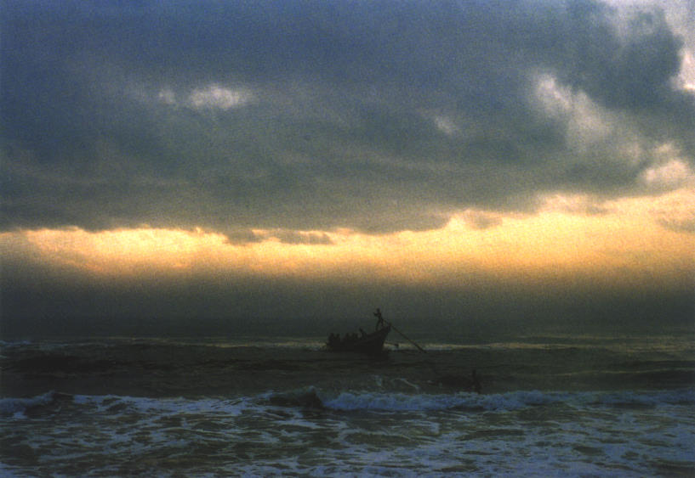
Fishermen off Adyar Beach, where K was ‘discovered’, in Madras (Chennai), India

It was customary to invite people for lunch with whom K would hold intense conversations. At Ojai and Saanen he would sometimes converse until four in the afternoon, even though he may have given a public talk that morning. He liked to question those invited about their areas of specialization. Thus he was well informed about current developments in many fields, including politics, education, medicine, science and computers. Once the vice-chancellor of a university and his wife were invited to have lunch at Rajghat. K noted sadly that the man never once smiled or even looked at his wife.
Every once in a while, Vikram Parchure’s wife, Ambika, brought along her lovely three-year-old daughter. K would say to the little girl: Don’t forget that I want to be your first boyfriend!
During the time that we were at Rajghat, a great many religious festivals were celebrated which were often very noisy. The temple next door would resound with fireworks, drums and singing late into the night. Early next morning the celebration would start up again. There was also an adjoining mosque from which we could hear the greatly amplified singsong of the muezzin during our walks. None of this seemed to disturb K. If the muezzin had not yet started his calling and noticed K approaching, he would walk up to the fence to shake K’s hands affectionately.
At this time, part of the Indian film The Seer Who Walks Alone, a documentary about K, was being shot at Rajghat. In it, K walks over the narrow bridge across the river and along the path that the Buddha had taken to go to Sarnath after his attainment of enlightenment. K told the film producer: I’ll do anything you want me to do. On one occasion, standing on a hill above the Varuna River, K was outlined against the setting sun like an ancient sculpture.
When the time for his public talks drew near, K seemed to gain new energy. He gave three Talks and held one Question & Answer meeting at Rajghat despite obvious signs of physical weakness. He also had three dialogues with Panditji in the presence of thirty or forty others in the upper story of his house, which are recorded in the book The Future Is Now.
During these Talks, one participant stood out through the clear and simple manner with which he communicated with K. At the time I did not know that this was P. Krishna, the new School Director. K, despite the poor state of his health, was concerned with every aspect of the appointment and gave all his time and energy to the matter. He invited Krishna and his family to lunch and talked affectionately with his wife and children; the grandfather came along once as well. As usual, K was interested in the practical details too, like the appropriate salary for the new Director, and that he had the use of a car. He felt enthusiastic about Krishna who, as a well-known physicist, had worked in the USA and Europe. He told me that when he had asked Krishna if he would take over the School, Krishna deliberated and then announced, “I would be delighted.” This was very fortunate, as there were then quite a few difficulties there.

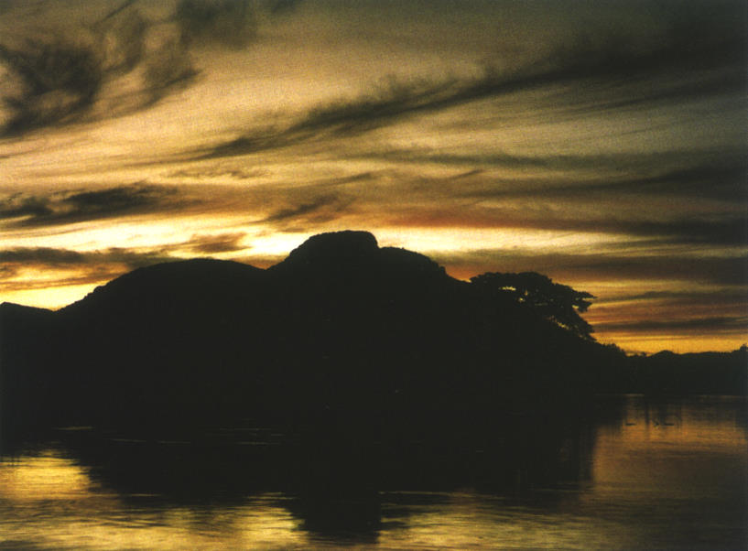
Rishi Valley’s percolation reservoir at sunset, looking towards Rishi Conda, India

Finally, it was arranged that K would take his meals in bed, as he had hardly any chance to eat during these lunchtime conversations. Actually, he had very little appetite.
After one walk K asked R. R. Upasani, who intended to retire as the Principal of the Agricultural College at Rajghat, if he would stay on to work for the Foundation. Upasani agreed to continue as long as K was there. I said to K, “Upasani should stay on even when you are not here.” K immediately asked Upasani: Sir, stay another year or more. Upasani was so moved that he wept (and, in fact, in 1987, after K’s death, he took on the position of Secretary of the Indian Foundation). It was getting dark, and suddenly K asked: Where is he? as he could not discern Upasani in the darkness. It marked the onset of a kind of night blindness.
While he was at Rajghat, K several times addressed the subject of sex. He pointed out that we would not exist if it were not for sex, which was simply a part of life. Somebody told K about a cross-cultural marriage ceremony where the guests had already gathered when it was discovered that the bridegroom had disappeared without explanation. K often referred to this event, wondering at the girl’s apparent determination to marry despite the great difficulties inherent in such circumstances. At one point he wondered aloud: Did they have sex? The innocence of this remark caused considerable laughter amongst those present.
When K sat with several Theosophists in Annie Besant’s room, he asked them: What shall we talk about? Then he went on: Oh yes, I’ll tell you a few jokes! Annie Besant’s coffee service was still in the room, but K did not have any recollection of it nor of the room itself. The coffee service must have been there for over sixty years.
After the Talks we flew via Delhi to Madras. At the time of our arrival the weather was pleasantly warm. The palm trees and flowering shrubs moved gently in the fresh breeze. As we drove from the airport to Vasanta Vihar, I suddenly felt as if I was returning home. At that very moment K remarked: It is like coming home!
Later, as we walked along the beach, we saw and heard the surf crashing thunderously onto the luminous yellow sand. There was a strong wind blowing, but delicately violet clouds hung in the sky. Against this background the full moon rose from the ocean just as the spectacular sun set opposite. All this was mirrored for us on the surface of the Adyar River.
We stayed only a few days in Madras. Having started early in the morning for Rishi Valley, we saw the sun this time rising as the moon simultaneously set in the west. We were travelling in a new car that was decidedly more comfortable than the old American one we had used on previous occasions. As usual, the car had been made available by a good friend, R. S. Santhanam. We did not stop until we had covered half the distance and the first hills were coming into view. The morning landscape was immensely peaceful. A motorcyclist who had stopped beside the road was amazed to see K there. K was no less astonished that someone should recognize him in this isolated spot.
K conversed with our pleasant chauffeur about his family and insisted that he should send his children to Rishi Valley School. Later his son did indeed attend the School.
Radhika lived on the same floor as K at Rishi Valley. She and I would have breakfast in K’s dining room. Sometimes, when K was feeling stronger, I would go to see him in his bedroom to say good morning. Because he was feeling so weak, his daily walks were often cancelled but he still had a number of meetings with students and teachers.
During our last walk together at Rishi Valley (in December 1985; the photo on the back cover, taken in 1984, is reminiscent of it), something happened. While I was looking with admiration at the lovely blue mountains east of Rishi Valley, K suddenly put his arm around my shoulder and said something like: my dear friend. Radhika was with us, and when she reminded me of the scene, I asked her to write it down, which she did:

As a party of us walked down the road, I could sense that he was straining every nerve to keep up with the small group of younger friends that walked with him that afternoon. But at one point, when we had reached the cluster of rocks under what the Rishi Valley children call Uday rock, his demeanor changed. There was an unexpected lull and I turned around to see the tension and effort go out of Krishnaji; he was his still and contemplative self. A moment later he turned around and embraced Friedrich, calling him my friend. Later that evening in his bedroom, saying goodnight to him, I said, “Something happened to you this evening, didn’t it?” Wearing the hooded look that came over him when he was approaching mystery, he said: Good for you to have noticed.

Mentioning K’s hooded look reminds me of another event, which took place while sitting in the crowded dining-room at Vasanta Vihar. K was sitting in front of me while I was looking dreamily at the sandalwood buttons on his shirt, when suddenly he caught my eye. How can I describe the flame which came from him? It was like a volcano bursting. The whole person was on fire. It was just like his description of a sunset evening at Rishi Valley where at one point he says: You were of that light, burning, furious, exploding, without shadow, without root and word. (from Krishnamurti’s Notebook, the entry of 17th November 1961) I couldn’t stand this force, so eventually looked down. None of the other guests seemed to have noticed.
The same thing happened once at a table in the west wing kitchen at Brockwood in the presence of two other people. It was unlimited energy, an immense force that he emanated. Did he want to show us something? It seemed to express Wake up or Come over. It had urgency. He used to tell us Move! Move! And sometimes, on our walks, he would push me on the shoulder, which seemed to indicate the same thing.
After the teachers from Brockwood, Ojai and the other Indian Schools arrived for the International Teachers Conference at Rishi Valley, it turned out that K was able to attend some of the meetings. His active participation had not been planned, but it raised the discussions to a higher level. These Talks, too, are included in the book The Future Is Now.
During his last two years at Rishi Valley, K spoke with the lovely younger pupils there, discussions that are available on videotape. After one of the final discussions, K asked me: Did you see these boys and girls? They will be thrown to the wolves. His relationship with students and his views on education always fascinated me. The following, from his Letters to the Schools, gives an indication of how he saw education for young children.

Education for the very young

With the very young what is most important is to help them to free themselves from psychological pressures and problems. Now the very young are being taught complicated intellectual problems; their studies are becoming more and more technical; they are given more and more abstract information; various forms of knowledge are being imposed on their brains, thus conditioning them right from childhood. Whereas what we are concerned with is to help the very young to have no psychological problems, to be free of fear, anxiety, cruelty, to have care, generosity and affection. This is far more important than the imposition of knowledge on their young minds. This does not mean the child should not learn to read, write and so on, but the emphasis is on psychological freedom instead of the acquisition of knowledge, though that is necessary.

from Letters to the Schools, Vol. 1, pp. 103–04
© 1981 Krishnamurti Foundation Trust Ltd

On one occasion we were talking with him about setting up an adult study centre at Rishi Valley. Suddenly a bird came to the window and vigorously pecked at the windowpane, obviously wanting to come in. It was a hoopoe bird, and it seemed agitated because of the many strangers in the room. K calmed it down by talking to it: All right, all right, I’m here, I’m here! Radhika told me that K often talked with the bird. Once when she entered his room she thought initially that he had a visitor with him. He was telling the bird: You are welcome to bring your children, but they probably would not like it here because when I am gone they will shut the windows and you will not be able to find a way out.
Another thing I remember about that visit to Rishi Valley is the time a farmer driving a bullock cart invited me to jump up onto the back of it. It was a hard ride without shock absorbers and I was gripping the side tenaciously. I was afraid that if the bullock took off I would go flying. We rode by K’s room in the old guest house, and I looked for him at his window. He didn’t seem to be there but later he said: You were really holding tightly to the bullock cart. I imagined him seeing me with a sixth sense.
After K returned to Madras, I travelled with a few teachers from Brockwood and Ojai to visit The Valley School in Bangalore.
The state of K’s health made it difficult for me to fathom how he could give a scheduled series of talks to thousands of people in Bombay. I felt great relief when he had them cancelled. I returned to Madras for another week and joined him on some of his walks along Adyar Beach.
On one of my last walks with K, on the beach, we had just reached the house of Radha Burnier when suddenly he took my arm firmly under his and we walked at high speed past the house, which seemed to suggest: Come on, come on, don’t sleep, don’t be dead. Just as he used to say in his Talks sometimes. This reminds me of a walk at Brockwood when we were rising after fixing our shoes and I told him that my grandmother used to say at the end of a break, “Debout les Morts!” (“Get up the dead!”) This he enjoyed very much.
Soon K decided to go to Ojai. It would be easier to obtain medical treatment while staying at Pine Cottage, and he would have more tranquillity there. Scott Forbes, who had travelled with him from Rishi Valley to Madras, accompanied him on this journey across the Pacific.
After returning to Europe, I spent three weeks in the Swiss mountains and then flew directly to California, for Ojai.
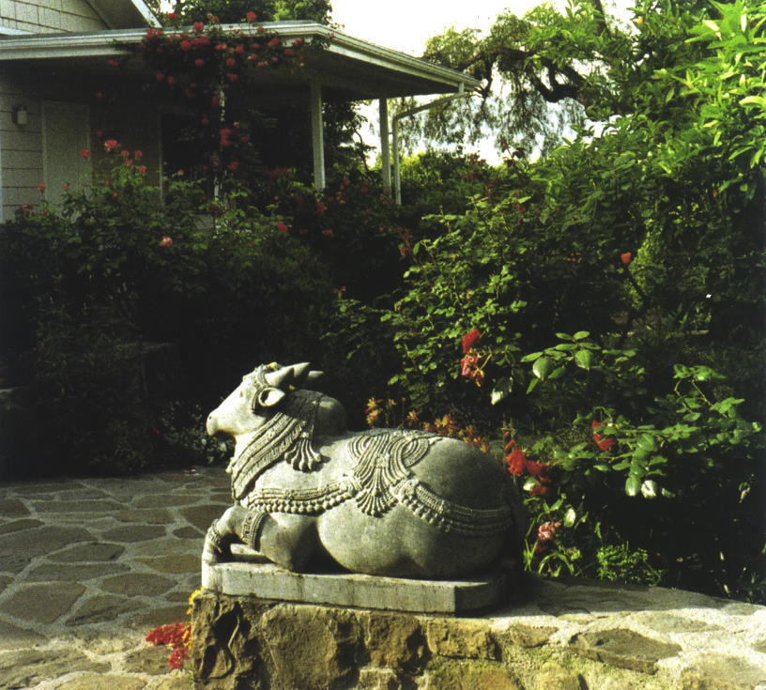
The Nandi, a traditional Indian sculpture of a kneeling cow, near the Pepper Tree at Pine Cottage. One time, I saw it with flowers on its head and asked Mary Zimbalist if Indians had been visiting. She said K had told her to put flowers on it sometimes, so that it feels at home.
A few years ago the Pepper Tree fell, but new shoots have grown out of the huge trunk that remained and it is once again vigorous and beautiful.
Return to Ojai

...Someone comes along and is extraordinarily curious to know how a person like K lives.

Although K did not address these words to me I was sure it was me he had in mind. It was not so much his life story that interested me (how Theosophists discovered a neglected boy who then developed into the World Teacher) but rather how this extraordinary person who inspired such respect actually lived his daily life. As it turned out, my curiosity was more than satisfied.
*
In February 1986, at the age of 90, Krishnamurti, at the end of an extraordinary life, came back to Ojai to die.
While on his deathbed, mail came to him from around the world and he had it read to him. I was amazed at the banal and trivial things with which the dying man was presented.
Some months earlier K had told me he would soon die, and he had said the same thing to Erna Lilliefelt. Everyone was hoping for a recovery. Indeed, forty years before, at Ojai, he had once been so mortally ill that his doctors had all but given up on him, but a homeopathic doctor named Keller looked after him, devotedly, for a whole year, and of course he did recover. (This information was given to me in Ojai by Mrs. Keller.)
A very moving account of K’s death is given by Dr. Deutsch, his doctor at the time, in Evelyne Blau’s book Krishnamurti: 100 Years. Right till the end he was concerned about humanity and those who had come close to him – about others, above all.
While K was on his deathbed, a student from Oak Grove School wrote him a letter. K had it read to him and then wished to express his thanks to the student. Despite being in great pain and feeling very weak physically, he did not forget the matter and later asked twice whether his thanks had been conveyed.
And he could still laugh. When he enquired about my house in Ojai and heard that it was still being rebuilt, he laughed so heartily I was afraid the feeding tubes that passed through his nose might injure him.
But by now K was very ill, and he had asked for some of the trustees to come and be with him so that they could talk over urgent Foundation matters. In spite of terrible weakness and pain he spoke in his usual simple, clear way to these friends who had gathered from around the world. (An account of K’s last days can be found in the third volume, The Open Door, of Mary Lutyens’s biography of K.) He laid the responsibility of cooperation on them. He said that the president and Secretary of the Foundations should not take on any other work. He talked about the possibility of bringing together a group of people whose main task would be to travel and hold the whole thing together.
He once told me at Brockwood while we were coming back from a walk: This place should always stay like this; and when he was asked what we ought to do after his death, he answered: Care for the land and keep the teachings pure.
Until the final moment, his mind was clear. I saw him for the last time three days before his death. He said to me: Je suis en train de partir, vous comprenez? (I am on the point of leaving, you understand?) These were his last words to me.
On the night of K’s death, I felt an enveloping wave of peace flood gently through the valley with the brilliant moonlight.

To complete this brief account of my ‘time with K’, I would like to quote from On Living and Dying, from a Talk that K gave in Bombay on 7th March 1962:

An extraordinary space in the mind

You see, death is destruction. It is final; you can’t argue with it. You can’t say, “No, wait a few days more.” You can’t discuss; you can’t plead; it is final; it is absolute. We never face anything final, absolute. We always go around it, and that is why we dread death. We can invent ideas, hopes, fears, and have beliefs such as “we are going to be resurrected, be born again” – those are all the cunning ways of the mind, hoping for a continuity, which is of time, which is not a fact, which is merely of thought. You know, when I talk about death, I am not talking about your death or my death – I am talking about death, that extraordinary phenomenon.
So when we talk about death, we are not talking about your death or my death. It does not really very much matter if you die or I die; we are going to die, happily or in misery – die happily, having lived fully, completely, with every sense, with all our being, fully alive, in full health, or die like miserable people crippled with age, frustrated, in sorrow, never knowing a day, happy, rich, never having a moment in which we have seen the sublime. So I am talking about Death, not about the death of a particular person.
If you have cut everything around you – every psychological root, hope, despair, guilt, anxiety, success, attachment – then out of this operation, this denial of this whole structure of society, not knowing what will happen to you when you are operating completely, out of this total denial there is the energy to face that which you call death.
You see, we do not love. Love comes only when there is nothing, when you have denied the whole world – not an enormous thing called “the world” but just your world, the little world in which you live – the family, the attachment, the quarrels, the domination, your success, your hopes, your guilts, your obediences, your gods, and your myths. When you deny all that world, when there is absolutely nothing left, no gods, no hopes, no despairs, when there is no seeking, then out of that great emptiness comes love, which is an extraordinary reality, which is an extraordinary fact not conjured up by the mind, which has a continuity with the family through sex, through desire.
And if you have no love – which is really the unknown – do what you will, the world will be in chaos. Only when you deny totally the known – what you know, your experiences, your knowledge, not the technological knowledge but the knowledge of your ambitions, your experiences, your family – when you deny the known completely, when you wipe it away, when you die to all that, you will see that there is an extraordinary emptiness, an extraordinary space in the mind. And it is only that space that knows what it is to love. And it is only in that space that there is creation – not the creation of children or putting a painting on canvas, but that creation that is the total energy, the unknowable. But to come to that, you must die to everything that you have known. And in that dying, there is great beauty, there is inexhaustible life energy.

from On Living and Dying, pp. 100–02
© 1992 Krishnamurti Foundation Trust Ltd
and Krishnamurti Foundation of America
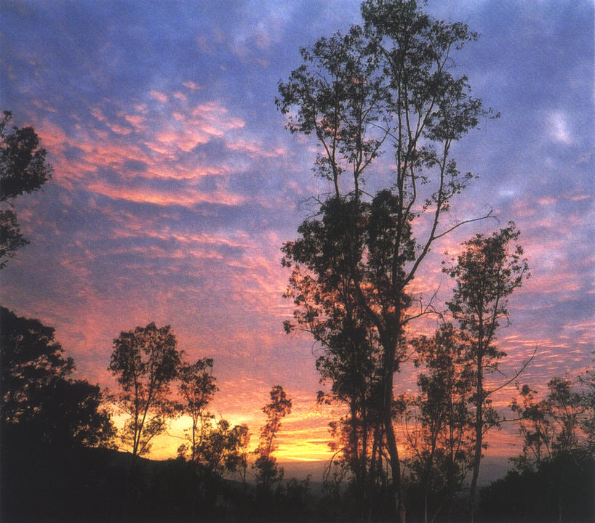
Near Arya Vihara, Ojai, California
Postscript

Eighteen years have passed since Krishnamurti’s death. The hundredth anniversary of his birth was celebrated in 1995 by the Foundations, an opportunity to give his work a wider public platform.
At Vasanta Vihar in Madras (Chennai), the headquarters of the Indian Foundation, there was a gathering attended by several thousand people and inaugurated by the Dalai Lama. Speakers included Pupul Jayakar and the former President of India, R. Venkataraman.
A large gathering was also held at Ojai in California, headquarters of the American Foundation and Oak Grove School. Universities in Mexico, the USA and France held conferences on Krishnamurti. New books were published, among them the comprehensive work by Evelyne Blau Krishnamurti: 100 Years.

Some years after K’s death, I heard from Bill Quinn about his concerns regarding a soon-to-be published book on K. After some interesting conversations with him about the matter, I asked him to comment on the personal reflections put forward in the book, as he was a witness to much that happened during that time. Bill’s letter addresses the issue very well.

April 20th 1993

Dear Friedrich,

Through the years Radha sent her manuscript to various publishers, and by chance the readers of two publishers to whom the book was assigned for evaluation were friends of mine. I deliberately read it once in one continuous effort so as to get an overall impression. I have not read the version published in England, and it’s likely that changes have been made and editing done. What follows is based on my recollection of my first and only reading.
I suspect that Radha is merely the spokesman for her parents. It has always seemed to me most unfortunate she was put in this position. She was not a direct witness to the alleged intimacy between K and R, but was told about it when she was a young woman by her mother. It is understandable that Radha, having been brought up in a seemingly magical world, should have been traumatised and embittered by Rosalind’s claims. It’s notable that early in the story it was K that Radha adored, like a father; yet she later is so condemnatory.
Having lived with the family during the period the affair was supposed to be taking place, I can attest there was a great intimacy between K and Rosalind, and I felt very much a part of a family which included them and Radha, and in which I was in daily close contact. It was an extraordinarily warm and simple life we had, extremely open so far as I could see, and so unconflicted I felt an absolute absence of self-consciousness. Rosalind appeared to me to be utterly generous and loving, and I count her among the dearest friends of my life. I felt less at ease with Raja, somewhat intimidated by his force and brilliance, but he too was warm and outgoing to me. However, he was seldom at Arya Vihara in those years, spending most of his time in Hollywood as he did. With Radha and David, her cousin, children then, I had a simple affectionate rapport. I must point out that I was a very young man at the time.
Since I felt part of this family, its breakup and the alienation of Raja from Rosalind and both from K, and the mystery surrounding it through the years, had disturbed me greatly. I was deeply affected by the book, and among my responses was a grief for everybody involved – so much pain!
It seems to me, however, that one cannot form an opinion on the basis of the book about the allegations of an affair between K and Rosalind. The letters that are said to support this claim are unavailable. It’s hard to see how one can presume to know what goes on between any two people. When a relationship is conflicted, a third person can know only the statements of the two parties, which are inevitably biased.
I feel strongly that it is important to establish the truth about K’s life, and to affirm his humanity. I deplore the widespread efforts to mythologize and deify him, because doing so makes it impossible for people to recognise their kinship with him, and puts him in an abstract sphere, as a sort of icon.
When I read the book it seemed to me possible that there had been such a relationship. Given the un-worldliness of both K and R, their innocence, such a thing could have come about through simple proximity and affection, as such things often do. Honoring the Rosalind I had known in earlier days, I even felt glad for K that he might have had such a relationship. And if there were an affair, the secrecy is understandable, given the social climate of those days. It would not have been K’s concern alone to be either open or discreet: the lives of others were involved: Rosalind, Raja and Radha, Also, they might have felt that it was no one else’s business.
What is lamentable to me about the book is that its motivation seems to be vindictiveness. To me, unfortunately, the book makes Rosalind, not K, to appear shabby and small. In part this is the effect of objectifying and blaming K and not going into Rosalind’s character in depth. I think she was a much larger person, and for a long time I wanted to talk to Radha and try and dissuade her from publication for this reason. But I had not the courage; my old affection for her and her mother made the prospect of such an encounter too painful.
The book seems to me naive in many ways, and to reflect little self-knowledge on the part of the Rajagopals. If there was such an affair in which Rosalind suffered so much, she was certainly also responsible. She was an adult. She was moreover a strong person and rather dominated K, to my mind, when I lived with them. The tone suggests a jilted lover. And through the years after their breakup, I had many hours-long conversations with Rosalind in which she poured out her hurt and rage. She was simply obsessed.
I also talked to K about the breakup, and offered to be an intermediary. He said, however, “No! It is finished.”
It seems to me that Rosalind’s story, whether the allegations about K are true or not, is a common and doleful human tragedy, and my response is more compassionate than anything else. It’s a story of how possessiveness, jealousy, suspicion and self-righteousness can destroy affection and lead to life long bitterness and a desire for revenge. It not only destroys affection, but the person.
So many people wanted to possess K! I knew well another woman who was remarkably close to K, and I happened to be with her during a time when she simply went to pieces and became bedridden for days, raging and torn. She later came to literally hate him for some years, and did some real mischief.
I think that when K went to India in 1947 a new life for him began when he met some wonderful minds, soon to include Pupul Jayakar and her family. Rosalind at that time stayed in California and was fully occupied with the newly formed Happy Valley School. At this time, I suspect, the Rajagopals began to lose control of K.
As for the allegations about Nandini, I don’t take them seriously. It’s well known that she and K had an extraordinary affinity, but to assume that this was sexually based seems unwarranted. K moved many people and was capable of a great intimacy with those who were open to him. I’m afraid Rosalind was overcome by suspicion.

Bill Quinn

During his lifetime, K frequently asked those around him: What are you going to do when K is gone? At times he pointed out that groups formed around a leader tended to break apart within forty years of the leader’s death. He also often emphasized the dangers and shortcomings of organizations that follow a particular leader and maintain a hierarchical structure or order.
When the trustees would answer K’s question with, We will protect and disseminate the teachings, K would say: You have to live the teachings, then they will affect the world. The teachings have their own protection.
There are four Krishnamurti Foundations and over forty Committees in various countries around the world, all engaged in preserving and making known the beauty and urgency of Krishnamurti’s teachings. For many years I used to liaise as closely as I could with the people involved in these groups and visited many of them, some of them often. In 1992 I began to work with former Brockwood staff members, initially so that my interactions with the School and the Foundation there might be more effective, then increasingly so that the same could be true for my interactions with the Schools and Foundations elsewhere. There are now seven of us working in this way. We call ourselves Krishnamurti Link International (KLI), named after our publication, The Link.
Meanwhile the Foundations continue to maintain the Schools, Study Centres and Archives. They produce Bulletins, books, audiotapes and videotapes, CDs and DVDs, websites, and arrange for the translation of all of this material into numerous languages. The Committees help the Foundations with their work, assisting with translations and distribution of the many publications in various media.
A major new endeavour of the Foundations is the editing and publication of The Complete Teachings of J. Krishnamurti – a long-term project to produce seventy-five volumes of K’s public talks, question-and-answer meetings, dialogues with invited participants, small- and large-group conversations, radio and television interviews, writings and talks on education, seminars, statements, notes and poems.
K intended that the Foundations and Schools should feel as one and that they should work together in that spirit. It was one of his deep concerns to communicate this to those who worked with him during his long life.
In the years since his death we have all been working together throughout the world to continue the work he began.

It is our earth, not yours or mine

Why is there, one must ask, this division – the Russian, the American, the British, the French, the German and so on – why is there this division between man and man, between race and race, culture and culture, one series of ideologies against another? Why? Why is there this separation? Man has divided the earth as yours and mine – why? Is it that we try to find security, self-protection, in a particular group, or in a particular belief, faith? For religions also have divided man, put man against man – the Hindus, the Muslims, the Christians, the Jews and so on. Nationalism, with its unfortunate patriotism, is really a glorified form, an ennobled form, of tribalism. In a small tribe or in a very large tribe there is a sense of being together, having the same language, the same superstitions, the same kind of political, religious system. And one feels safe, protected, happy, comforted. And for that safety, comfort, we are willing to kill others who have the same kind of desire to be safe, to feel protected, to belong to something. This terrible desire to identify oneself with a group, with a flag, with a religious ritual and so on, gives us the feeling that we have roots, that we are not homeless wanderers. There is the desire, the urge, to find one’s roots.
And also we have divided the world into economic spheres, with all their problems. Perhaps one of the major causes of war is heavy industry. When industry and economics go hand in hand with politics they must inevitably sustain a separative activity to maintain their economic stature. All countries are doing this, the great and the small. The small are being armed by the big nations – some quietly, surreptitiously, others openly. Is the cause of all this misery, suffering, and the enormous waste of money on armaments, the visible sustenance of pride, of wanting to be superior to others?
It is our earth, not yours or mine or his. We are meant to live on it, helping each other, not destroying each other. This is not some romantic nonsense but the actual fact. But man has divided the earth, hoping thereby that in the particular he is going to find happiness, security, a sense of abiding comfort. Until a radical change takes place and we wipe out all nationalities, all ideologies, all religious divisions, and establish a global relationship – psychologically first, inwardly before organizing the outer – we shall go on with wars. If you harm others, if you kill others, whether in anger or by organized murder which is called war, you, who are the rest of humanity, not a separate human being fighting the rest of humanity, are destroying yourself.

from Krishnamurti to Himself, pp. 59–60
© 1987 Krishnamurti Foundation Trust Ltd
Appendix

Some other ‘memories of Krishnamurti’

Blau, Evelyne
Krishnamurti: 100 Years
(a compilation of many people’s recollections)
Stewart, Tabori & Chang, New York, 1995
Field, Sidney
Krishnamurti: The Reluctant Messiah
Paragon House, New York, 1989
Jayakar, Pupul
Krishnamurti: A Biography
Harper & Row, New York, 1986
Krohnen, Michael
The Kitchen Chronicles: 1001 Lunches with J. Krishnamurti
Edwin House, Ojai, 1997
Lutyens, Mary
Krishnamurti: The Years of Awakening
John Murray, London, 1975
Lutyens, Mary
Krishnamurti: The Years of Fulfilment
John Murray, London, 1983
Lutyens, Mary
Krishnamurti: The Open Door
John Murray, London, 1988
Lutyens, Mary
The Life and Death of Krishnamurti
John Murray, London, 1990
Narayan, G.
As the River Joins the Ocean – Reflections about J. Krishnamurti
Edwin House, Ojai, 1998
Patwardhan, Sunanda
A Vision of the Sacred – My Personal Journey with Krishnamurti
Edwin House, Ojai, 1999
Smith, Ingram
The Transparent Mind – A Journey with Krishnamurti
Edwin House, Ojai, 1999
Comments regarding previous editions:

There emerges from it an engaging and intimate portrait of Krishnaji which will be very helpful and interesting to those who did not have the privilege of knowing him. And for those who did, it gives little cameos that serve to remind one of the human characteristics of the extraordinary man who gave us those invaluable teachings.
Stuart Holroyd, author of Krishnamurti –
The Man, the Mystery and the Message

I liked your memoir immensely and feel you really conveyed something of the intimate and loving feeling for life and for the art of living that made up being with K.
Dr. David Shainberg, whose discussions with
Krishnamurti and David Bohm are available on tape,
DVD and in the book The Transformation of Man

I was much taken with your beautiful photography – so sensitively and meditatively composed. I, too, found Krishnamurti, as you put it, “actually a very
shy person.” Perhaps there is an operational link between that trait and freedom from self-bondage.
Dr. Allan W. Anderson, whose dialogues with
Krishnamurti are available on tape, DVD and
in the book A Wholly Different Way of Living

I appreciate the interesting and simple clear descriptions, in which you convey some touching and more personal aspects of Krishnamurti’s life: his humour, his timidness with strangers, his willingness to wash the dishes, his enjoyment of sports, his intense interest that encompassed every aspect of life – the speed and mechanism of an airport shuttle as well as the immensity of the mountains – and most of all his constant declaration that he was “nobody”. And of course you convey that he actually lived the Teachings. ... In fact his life is not as remote and inaccessible to the lay person as one would imagine. Your memoirs shine a little light on a part of Krishnamurti that I did not know before.
Mary-Ann Ridgway, a former student and
now teacher at Brockwood

...when I lived with him I noted keenly that his intellect was like a tool which he would use intensively and then put aside in the midst of normal daily life; and that his normal presence was like that of an extremely alert child, responsive, full of wonder and affection. For this reason I think a book like yours is extremely important, since it stands as a witness to K’s extraordinary humanity, which few people were privileged to see, and which indeed exemplifies what he talked about. It always seemed unfortunate to me that his public persona was so austere.
Bill Quinn, who lived in Ojai and knew K
from the 1940s onwards

During his lifetime Krishnamurti would often ask people who worked with him, “How will you convey the perfume of the teachings when K has gone?” ... One of the values of The Beauty of the Mountain is its simple conveyance of that perfume or flavour. It is an unpretentious account ... by turns touching and humorous, and the author manages, despite his deep appreciation of Krishnamurti’s rare qualities, to avoid the excesses of hero-worship or cult creation.
Mary Cadogan, Trustee of the
Krishnamurti Foundation Trust Ltd.

Cover: View of the Rubli, Videmanette, in Rougemont, Switzerland.
Back: One of my last walks with K at Rishi Valley, December 1984. © Rita Zampese
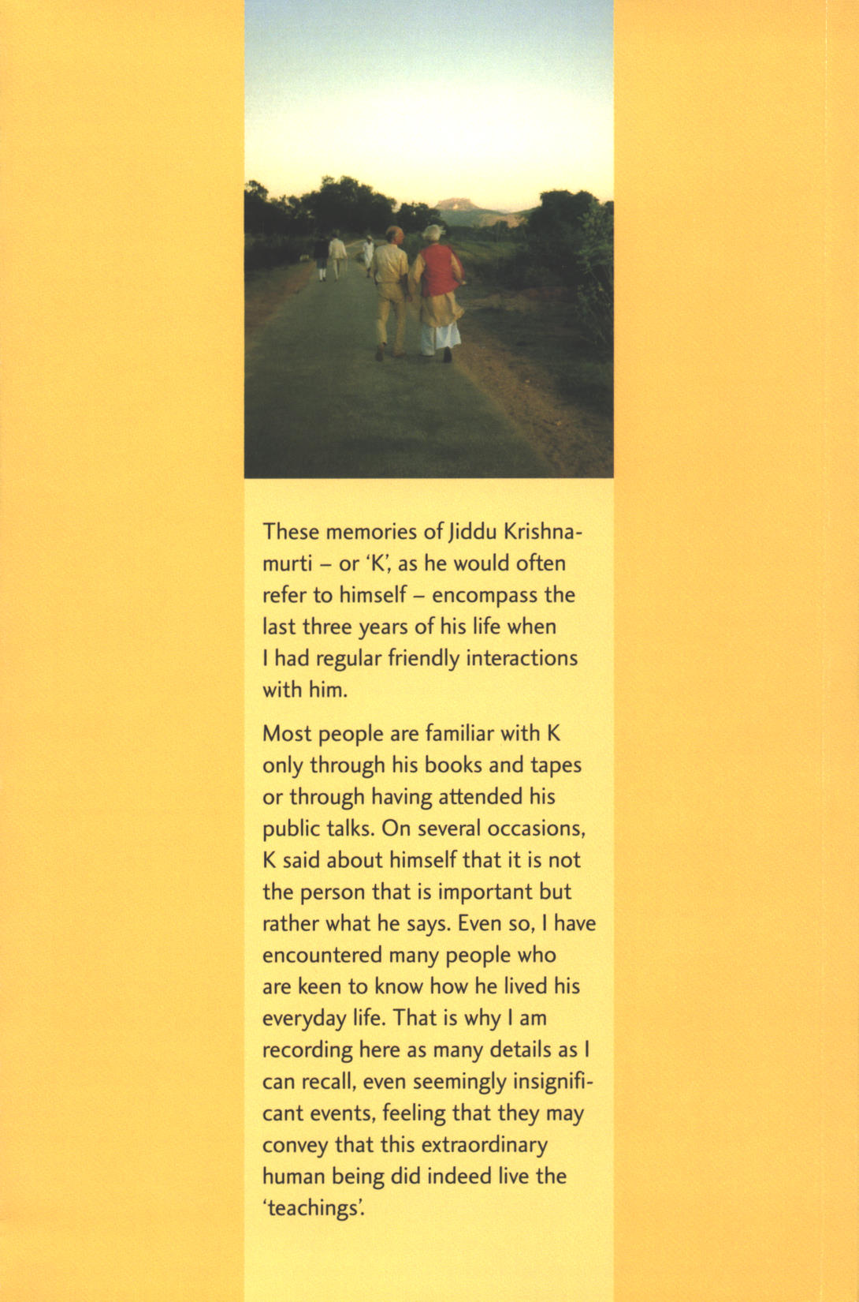

Gisèle Balleys taught French for many years at Brockwood Park School. After K’s death, she began organizing gatherings in Saanen, which continue annually. She oversees the French activities of the Krishnamurti Committee in Switzerland, and she is a trustee of the Krishnamurti Foundation Trust Ltd (established in England in 1969).
Mary Zimbalist had been associated with K since 1965 and for 21 years was his personal secretary and travelling companion. She is a founding trustee of the KFT and of the Krishnamurti Foundation of America (established in California in 1973).
Mary Lutyens was a young child when she first met K soon after his arrival in England. Her mother, Lady Emily Lutyens (wife of the architect Sir Edwin Lutyens) was very close to K for many years. K asked Mary to write his biography, which led to The Years of Awakening, The Years of Fulfilment, The Open Door and The Life and Death of Krishnamurti. She died in 1999.
Dr. T. K. Parchure accompanied K on his travels in India from 1973 onwards in order to look after K’s health. In the later years he also attended to K in Europe and the USA, and was present at K’s death at Ojai in 1986.
Dorothy Simmons was a recognized sculptress and educator before helping to set up Brockwood Park School in 1969, along with her husband, Montague. She was the School’s first Principal and a trustee until her death in 1989.
Michael Krohnen, originally from Germany, worked as the chef at Oak Grove School and for the KFA from 1975 to 1988. He is the author of The Kitchen Chronicles: 1001 Lunches with J. Krishnamurti. He now works for the KFA verifying transcripts of K’s Talks.
Alan Hooker wrote several cookbooks and was the founding owner of the famous Ranch House Restaurant in Ojai. His association with K began in 1949 and he was a trustee of the KFA until 1989. He died in 1993. His wife, Helen Hooker, was also a trustee of the KFA. She died in 2000 at the age of 97.
Annie Besant (1847–1933) was President of the Theosophical Society from 1907 to 1933. She adopted K and his brother Nityananda in 1909. A famous and outstanding public speaker, she was active in the early women’s movements and also in the movement for Indian independence. She remained closely associated with K until her death and was always greatly respected by him.
Aldous Huxley, the well-known English author – Brave New World, Island, Eyeless in Gaza, Crome Yellow, among others – met K in California in 1938. He encouraged K in his writing and wrote the Introduction to K’s The First and Last Freedom. They remained close friends until Huxley’s death in 1963.
Erna and Theo Lilliefelt had known K since the early 1950s and were founding trustees of the KFA. Erna played a crucial role in the recovery of assets for the KFA. Theo died in 1998, and Erna in 2002.
Mark Lee had been Head of the junior school at Rishi Valley and was the first Director of Oak Grove School. He is currently Executive Director of the KFA and also has his own publishing company in Ojai, Edwin House.
Radha Burnier knew K from her earliest years and has been President of the Theosophical Society since 1980. She is also a trustee of the Krishnamurti Foundation India (established in 1928).
Scott Forbes joined Brockwood Park in 1974 and established its video department. He was Principal of Brockwood Park School from 1985 to 1994 and was a trustee of the KFT.
Raman Patel was a staff member at Brockwood Park for 15 years. He now works with Krishnamurti Link International – among much else, travelling throughout the world to help maintain contact among those interested in K’s teachings.
Vanda Scaravelli met K in 1937. K became close friends with her and her husband and often stayed at their large villa, Il Leccio, near Florence. She rented Chalet Tannegg in Gstaad for K during the Saanen Gatherings. She died in 2001.
Pupul Jayakar (Pupulji) spent a lifetime in social work and was prominent in the Indian handicrafts industry. She was a close associate and confidante of Indira Gandhi, the Indian Prime Minister from 1966–84, and was her adviser on cultural matters. She met K in 1948 and was closely associated with him thereafter, becoming a trustee of the KFI and authoring Krishnamurti, A Biography. A fine selection from the intense dialogues she had with K can be found in the book Fire in the Mind.
Rita Zampese is a long-time friend of Brockwood Park. She took the photographs of K and me at Rishi Valley on this chapter and the back page. She continues to visit India every year.
Nandini Mehta was Pupul Jayakar’s sister. She met K in 1947 and became a close friend. It was she to whom K wrote the letters that can be found in the chapter Happy Is the Man Who Is Nothing in Pupul Jayakar’s biography of K, which the KFT has recently republished as Letters to a Young Friend. She founded the Bal Anand School for underprivileged children in Bombay and was a trustee of the KFI. She died in 2002.
Radhika Herzberger, Pupul Jayakar’s daughter, knew K since childhood. She is Director of Rishi Valley School and a trustee of the KFI.
Pama Patwardhan (Pamaji), along with his wife, Sunanda (author of A Vision of the Sacred – My Personal Journey with Krishnamurti), and his brother Achyut (formerly a famous freedom fighter in India), became close associates of K in 1947. All three were trustees of the KFI. Only Pamaji is still living. Achyut remained a bachelor all his life, and I once asked him how he had ‘escaped’. He replied that he had not escaped; rather, his affair of the heart had not ended as he had wished and he had not been moved in the same way again.
Vikram Parchure, one of Dr. Parchure’s sons, was a teacher at Rishi Valley School and helped to develop their rural women’s programme. He assisted the KFI with their publication programme and he now helps the Quest Foundation in Thailand with their efforts to promote K’s work.
Panditji, actually Pandit Jagannath Upadhyaya. Pandit (also pundit), a Sanskrit word meaning ‘learned man’, is the title of a person learned in Sanskrit and Hindu law, religion and philosophy, sometimes other subjects. Panditji was an eminent Buddhist and Hindu scholar who had several dialogues with K. He died shortly after K.
P. Krishna, a cousin of Radha Burnier, had met K in 1958. He was Professor of Physics at Benares Hindu University when K made him head of Rajghat Education Centre. He retired in 2002 but continues to be a trustee of the KFI.
R. R. Upasani had worked for K for over thirty years. He has since retired as Secretary of the KFI but continues to be a trustee. He is also Secretary of the Sahyadri Executive Committee (Sahyadri School was begun after K’s death).
R. S. Santhanam was a businessman from Madras. His wife, Padma, is a trustee of the KFI and very active at The School-KFI-Chennai.
Evelyne Blau is a trustee of the KFA. In addition to Krishnamurti: 100 Years she has edited, along with Mark Edwards, All the Marvelous Earth and has made several theme videos, as well as the films on K’s life and teachings With a Silent Mind and The Challenge of Change.
In the 1940s, Bill Quinn spent a year at Arya Vihara in Ojai, working in the garden. K was living there at that time and they often tended the garden – including cow, chickens and bees – together. Bill knew Alan Watts, was one of the founders of the Esalen Institute in Big Sur, California in the 1960s, and worked on the first Krishnamurti Index of subjects that later became the KFT’s three-volume Index of all of the audio and videotapes. He died in Ojai in the mid-1990s.

