William Quan Judge 1851-1896
http://en.wikipedia.org/wiki/William_Quan_Judge
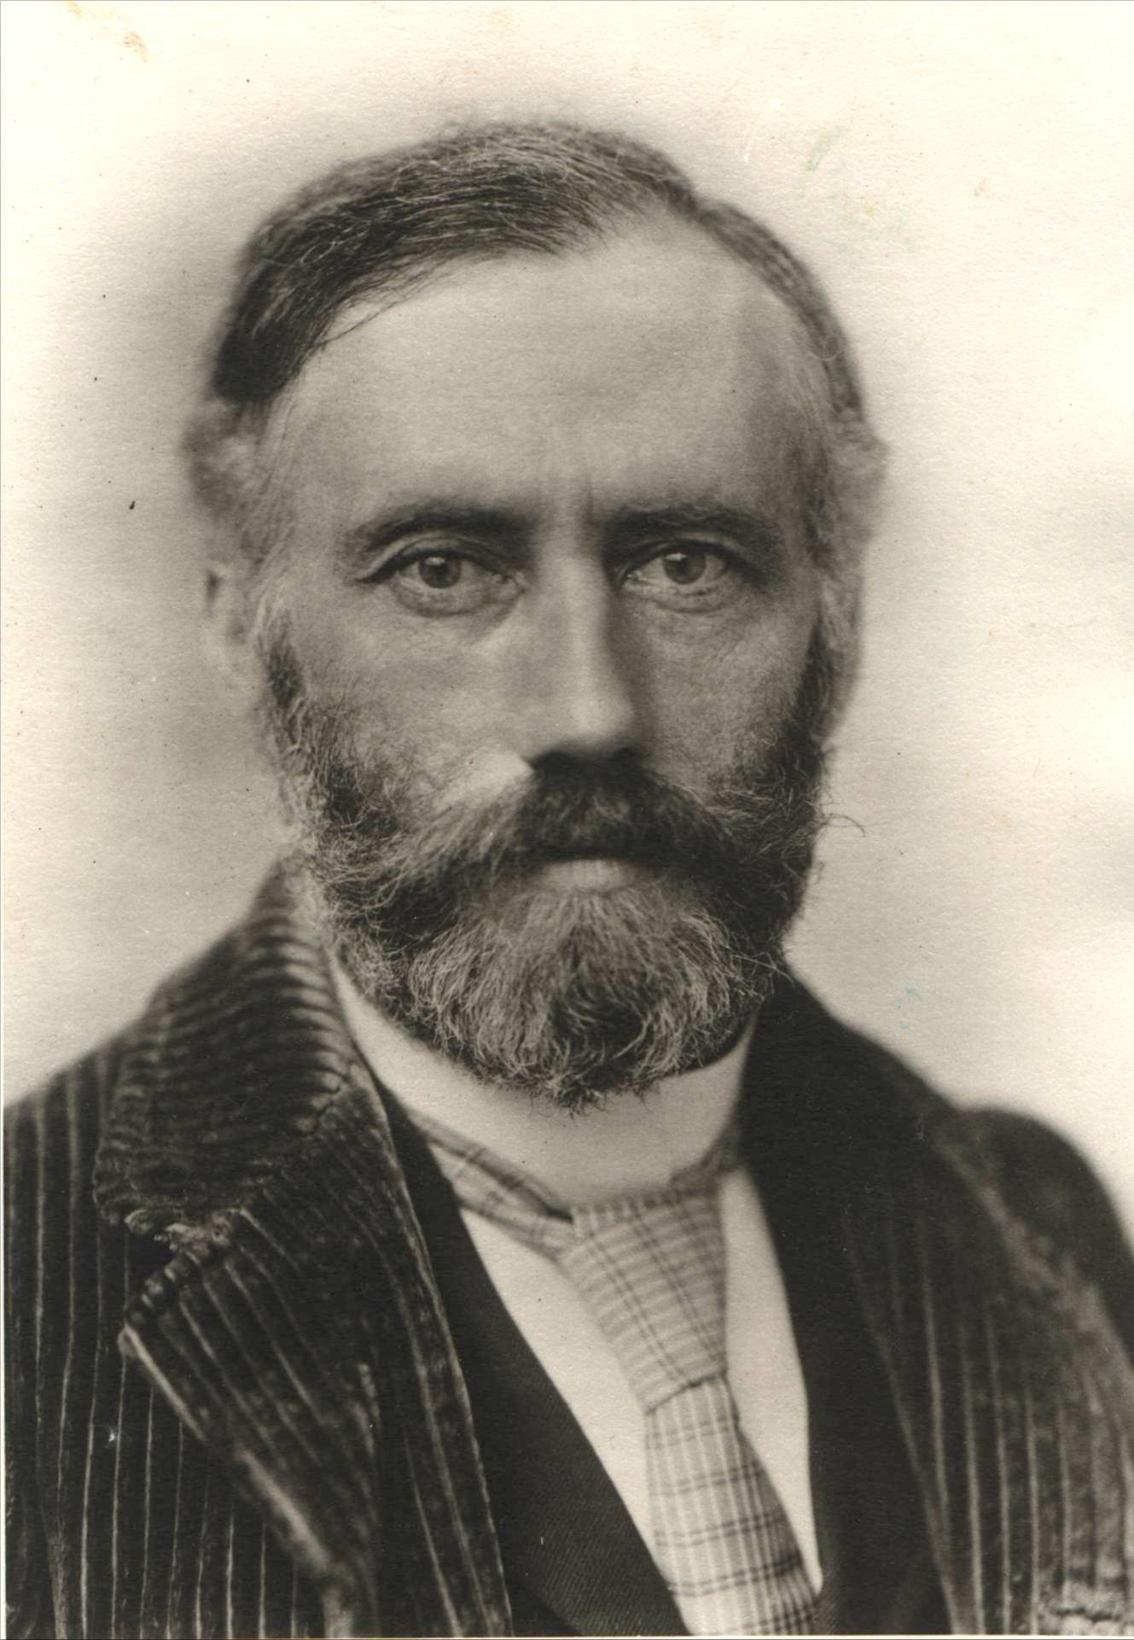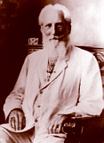

William Quan Judge (1851-March 22, 1896 New York) was a mystic, esotericist, and occultist, and one of the founders of the original Theosophical Society. He was born in Dublin, Ireland. When he was 13 years old, his family emigrated to the United States. He became a naturalized citizen at 21 and passed the New York state bar exam, specializing in commercial law.
Although merely a young man, he was among the seventeen who first put the Theosophical Society together. Like H.P. Blavatsky and Henry Steel Olcott, he stayed in the organization when others left. When Olcott and Blavatsky left the United States for India, Judge stayed behind to keep the Society's work alive, all the while working as a lawyer.
Judge wrote theosophical articles for various theosophical magazines, and also the introductory volume, The Ocean of Theosophy in 1893. He became the General Secretary of the American Section of the Theosophical Society in 1884, with Abner Doubleday as President.
After Blavatsky died in 1891, Judge became involved in a dispute with Olcott and Annie Besant over his allegedly forging letters from the Mahatmas. As a result, he ended his association with Olcott and Besant in 1895 and took most of the Society's American Section with him. He led his new organization for about a year until his death, when its leadership passed to Katherine Tingley. The organization arising from the faction led by Olcott and Besant is today based in India and known as the Theosophical Society - Adyar, while the organization led by Judge is today known simply as the Theosophical Society, but often with the clarifying statement, "international headquarters, Pasadena, California."
After his death, other organizations split off from his, including the Temple of the People (whose library bears his name) in 1898 and the United Lodge of Theosophists or ULT in 1909.

External links
- Books by Judge
- Articles by Judge
- Theosophy Library Online
- Articles by William Quan Judge and his biography
====================================================================================================================================
END

