Mabel Collins 1851-1927
http://en.wikipedia.org/wiki/Mabel_Collins
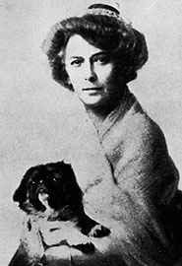

Mabel Collins (9 September 1851 - 31 March 1927) was a theosophist and author of over 46 books.
She was born in St Peter Port, Guernsey.

Works
- Light on the Path
- The Blossom and the Fruit
- Through the Gates of Gold

External links
- Works by Mabel Collins at Project Gutenberg
- Mabel Collins biography
- Mabel Collins' theosophical works
- Mabel Collins on the Mystical Site www.mysticism.nl
====================================================================================================================
END

