Boris de Zirkoff 1902-1981

http://en.wikipedia.org/wiki/Boris_de_Zirkoff

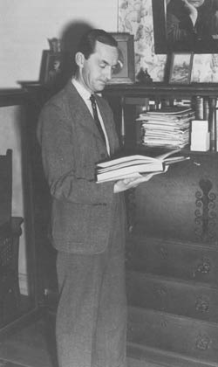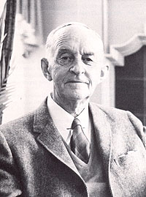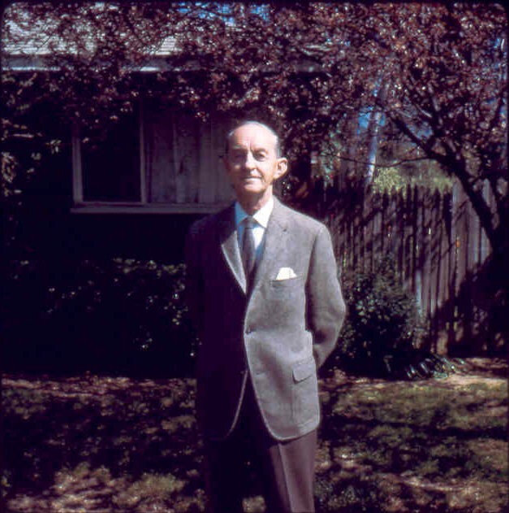
Boris de Zirkoff
Here is the explanation of his relationship to H.P.B.
Dmitriy Karlovich von Hahn, who was the first cousin of Peter Alexeyevich von Hahn (H.P.B.'s father), married Olga Vassilyevna de Dmitriyev. One of their daughters, Lydiq Dmitryevna von Hahn married Mihail Vassileyevich de Zirkoff. Their son is Boris de Zirkoff - who collected the volumes known as 'H.P. Blavatsky's Collected Writings.' With 'From the Caves and Jungles of Hindostan' it makes 15 books in the series of Collected Writings plus Index.

Boris de Zirkoff was the editor of the Blavatsky Collected writings. He was a grand-nephew of H.P. Blavatsky and a student of her work. He moved to Point Loma, California in the early 1920s when Katherine Tingley was the leading Theosophist. Before the death of the next leader Gottfried de Purucker he moved to Los Angeles. He always supported the original teachings of Blavatsky and her gurus.
This category comprises articles pertaining to "modern Theosophy" and the Theosophical Society that was founded in New York City in 1875 by Helena Blavatsky, Henry Steel Olcott, William Quan Judge, and others.
For a definition of the word "Theosophy" see [1] and [2].
============================================================================================================
http://www.questbooks.net/author.cfm?authornum=169
Boris de Zirkoff was born in Russia in 1902 where he received his early education. After the revolution, he studied in various European universities, where he specialized in languages and the classics. Emigrating to the United States, he began working for eighteen years in literary, scholastic, and secretarial capacities. In 1925 he began compiling a uniform edition of H. P. Blavatsky’s Collected Writings which is published in 12 volumes. For many years he was editor of Theosophia, an independent quarterly published in Los Angeles. In 1981, the year of his death, he was awarded the T. Subba Row medal by Radha Burnier, President of the Theosophical Society, for his outstanding contributions to Theosophical literature.
======================================================================================================================================

http://www.seekerbooks.com/book/9780913004456.htm

Boris de Zirkoff

Born in Russia in 1902, De Zirkoff's mother belonged, as did Madame Blavatsky, to the family line von Hahn. Her brother Sergei was, at the beginning of the century, director of the Imperial Bank. Grandfather Dmitri Karlovich von Hahn, participated in the creation of the frontier guard corps and at one time he was Inspector General of the special frontier guard corps. Great grandfather along the father's line, was Admiral Michail Dmitrievich Tebenkov, who in the 1850's served as Inspector General of the Russian possessions in North America, from Alaska down to Fort Ross. Under his leadership the first complete atlas of the Pacific Coast of North America was created.
His grandmother insisted that Boris be trained in foreign languages, as if she knew that Boris would be spending a large part of his life beyond the borders, speaking in English. After the revolution, the family succeeded in fleeing to Finland and it was there, in the house of acquaintances of his stepfather, that he first saw the book of his auntie Blavatsky, The Secret Doctrine. It attracted the youth's attention. But study of this great book needed to be in the English language. For at that time, it had not yet been translated into Russian.
It was in this way that Boris de Zirkoff, at the age of 15, found out about the works, famous throughout the world, of his relative. In 1923, the de Zirkoff family went to live in southern Germany in Baden-Baden. A meeting with a Russian American Nikolai Romanoff suddenly changed Boris's life. From him, he found out about the existence of the Theosophical Society at Point Loma, in America. He wrote a letter to distant California, directed to the head of this American Theosophical Society – Katherine Tingley. He specially went to Finland to meet her, because he had found out that she was traveling there to read a lecture. He succeeded in arranging a meeting with her. After discovering that 21-year old Boris was a relative of Madame Blavatsky, Miss Tingley promised to assist with his passage to Point Loma. At the very end of 1923, Boris succeeded in traveling through London to New York. Not a month had gone by, before he reached California. He stayed at Point Loma until his death in 1981, writing, lecturing and editing. He is best known as Editor of the comprehensive "Collected Writings of Helena P. Blavatsky
==================================================================================================================================

