GEORGE S. ARUNDALE 1933-1945

International President of the Theosophical Society
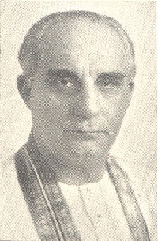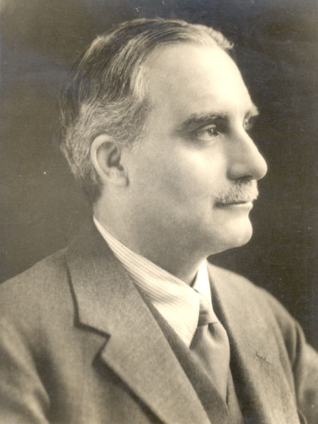

GEORGE S. ARUNDALE was born on 1st December 1878. At the death in child-birth of his mother he was adopted by his aunt, Miss Francesca Arundale, who joined the Society in 1881 and often welcomed H. P. B. as her guest, whom the small George himself knew. He was educated partly in Germany and England, and in 1900 graduated from St. John's College, Cambridge.

Two years later, at Dr. Besant's invitation, he went to India - with his aunt - to become Professor of History at the Central Hindu College, Benares. In 1907 he
was appointed Headmaster of the C. H. College School and later Principal of the College. He was very popular with both boys and teachers. He had a great understanding of youth, with whose welfare he concerned himself all his life.

In 1910 Mr. Arundale gave his first Annual Convention lectures, and frequently addressed these Conventions throughout his life. In the same year he made public the already privately formed Order of the Star in the East, which was intended to help the future work of J. Krishnamurti. As this Order was started among the boys of the C. H. College it caused a commotion among some of the College authorities. Mr. Arundale and the teachers who stood by him resigned.

After a brief period as General Secretary in England Mr. Arundale went back to India to assist Dr. Besant in her urgent political activities. Under Theosophical auspices a National University was established in Madras, of which Rabindranath Tagore became the Chancellor. Mr. Arundale became Principal of the Training College for Teacher. He stimulated education and was outstanding for the manner in which he inspired teachers and gave them the conception of teaching as a sacred profession.

He went to Indore as Minister of Education. The National University bestowed upon him the degree of D. Litt. Mr. Arundale married in 1920 Srimati Rukmini Devi, a member of a very well-known Theosophical Brahmin family, and a gifted artist, whose genius Dr. Arundale fostered in every way. She accompanied him on all his travels.

He became General Secretary in Australia, 1926, where, in addition to his Theosophical duties, he engaged in humanitarian and political work. He helped to set up the 2GB Broadcasting Station and became its first Chairman of Directors. He lived at The Manor and assisted Bishop Leadbeater in preparing it for its important future.

In 1928, Dr. Arundale was General Secretary in India, but he did not ask for re-election as he desired to help Dr. Besant in her political and other work. He undertook many tours about the world with Srimati Rukmini Devi who began to give her own interpretation of Theosophy through Beauty.

In 1934 Dr. Arundale was elected President and began at once to develop a Seven Year Plan, which included development of Adyar, and stimulus to the Society. The next year he launched a "Straight Theosophy" Campaign, with well-prepared publicity material, which culminated in the brilliant Diamond Jubilee Convention at Adyar.

The next Campaign was entitled "There Is a Plan". In 1936 he presided over a World Congress at Geneva, when he decided the third Campaign should be for "Understanding", which, proving successful, was extended into 1938. After that "Theosophy Is the Next Step" was the subject, but in 1939 war broke out and not much could be done. He then issued "Letters" to Sections which were widely used and helpful.

In 1940 Dr. Arundale set up a Peace and Reconstruction Department so as to have ready a Charter for World Peace when the War had ceased. Each year he stressed that members should be ardent in "spreading the mighty Truths of Theosophy". Though suffering from ill-health, yet he undertook tours in India, and backed with personal attention and enthusiasm the institutions and activities undertaken by Srimati Rukmini Devi. Dr. Arundale died in 1945.

As Dr. Arundale had always been so interested in Youth, he gave much assistance in the formation of the "World Federation of Young Theosophists", 1935, with Srimati Rukmini Devi as President and himself as ex officio Hon. President. Dr. Besant had cherished a longing that there should be a school near at hand in memory of her love for Youth. The beginnings of such an institution Dr. Arundale started in 1954 at Besant Gardens as the Besant Memorial School. It has flourished.

As a Co-Freemason, joining in 1902, he became, 1935, the Most Puissant Grand Commander, Eastern Federation, and Representative of the Supreme Council. In addition he was deeply interested in internationalism, Indian politics and Indian Boy Scouts, and became the Commissioner for Madras Presidency of the Hindustan Scout Movement.Dr. Arundale wrote many books, the most liked being You, Mount Everest, Nirvana, Kundalini and The Lotus Fire.

Theosophical Society Cardiff Lodge
206 Newport Road, Cardiff CF24 – 1DL
===================================================================================================================================
END

