Tarot for Beginners

Course Overview
Course Creator(s): Joan Bunning

Description
Have you ever wondered how the tarot works? How a deck of cards might reveal hidden truths? The tarot is a tool to help you access your inner wisdom. As you explore the patterns in the cards, you uncover the deeper patterns in your own life. In this course, you will learn everything you need to know to read the tarot cards successfully for yourself. You'll learn the features of the deck and a simple, step-by-step procedure for laying out the cards and interpreting them. In the end, you'll come away with a new skill to draw on whenever you want insight into your life and its direction.
Prerequisites
- Curiosity and an open mind
Objectives
- Understand how the tarot enhances intuition and self-understanding
- Learn the features of a standard tarot deck
- Explore patterns for laying out the cards
- Learn how to do a basic tarot reading about a personal question
- Discover ways to uncover the meaning in a reading
- Find out how to continue your tarot practice once the course is over
- Enjoy learning a new skill for personal growth
Faculty
Course Creator and Instructor: Joan Bunning
 |  | Joan Bunning is the author of Learning the Tarot: A Tarot Book for Beginners. Since 1995, she has managed the Learning the Tarot Web site, which has helped thousands

Lesson 1: Making Sense of the Tarot
A discussion of how the tarot cards work and why using them makes sense in the modern world.

Getting Started  In years past, whenever I mentioned the tarot, the usual response was a puzzled look or frown. Now I'm more likely to hear "Oh, will you do a reading for me?" These days the tarot seems to be everywhere -- in malls, on TV, even at company picnics. More and more people are becoming curious about these unusual cards. What are they exactly, and how do they work?  The tarot is a deck of 78 picture cards that have been used for centuries as a way to divine hidden truths. The traditional reading involves two people -- the reader and a seeker, often called the querent. The seeker is looking for insights into his life, and the reader provides these insights by interpreting cards chosen by the seeker.  You can read the tarot cards for yourself as well. In this case you are both the reader and the seeker. We will focus on this kind of tarot reading in these lessons because it is the way most people learn. You may never read for others (although I guarantee you will be asked), but you will always find it useful to know how to interpret your own cards.  In this first lesson, I would like to talk a little about the philosophy of the tarot. Learning to read the cards is not the same as learning to drive a car or set a broken arm. It's a skill that depends upon your inner state. The tarot cards are mirrors reflecting back your own awareness. They are a tool to help you access truths that you know, but perhaps don't realize you know.  To work with the cards successfully, you need to feel comfortable with them. If the tarot doesn't make sense to you, your doubts will hold you back. If you have concerns, they can limit your free responses. Before we go further, I'd like to clear up some of these potential blocks, so you can feel free to dive into the rest of the course with enthusiasm. | Welcome to Tarot for Beginners!  If you have ever wondered about the tarot cards and what they have to offer, you will have a chance to find out in these eight lessons. I know you will come away with a deeper appreciation of this fascinating subject and the tools you need to explore further on your own. Please visit the course Message Board. Tell us a little about yourself and what brings you to the Tarot.

Getting Past Fear  Many people have told me they feel somewhat nervous about the tarot. They're curious, but afraid at the same time. Why might this be so? One reason is people are concerned a tarot reading will reveal a horrifying, but unavoidable future. They say, "I don't want to know what lies ahead. I'd rather just live from day to day in blissful ignorance." But, in truth, this fear is based on a misconception about what the tarot cards can reveal. The future is not a fixed inevitability. It is created dynamically from within the present.  When you do a tarot reading, you are opening yourself to perceive the many influences in and around you at that moment. You ready yourself to sense the energies on both the outer level of events and the inner level of beliefs, desires and fears. Knowing these, you can then "predict" an outcome, but it is only a probable one, not a given. It is the result most likely to occur if all the forces of the moment continue unchanged.  This is exactly why a tarot reading is so helpful. Simply by doing a reading, you inject change into your situation. By taking the time to think about your life and your choices, you give yourself the opportunity to set in motion a new path for yourself. By understanding your situation better, you come closer to creating the future you want. Fears about the future are reduced and you can move forward with greater awareness and confidence. | Watch Out for These Tricks  In the hands of a dedicated reader, the tarot can be a wonderful tool for personal guidance. Sadly, the cards can also be abused by the unscrupulous. Be very careful if a reader tells you that he or she has detected a "curse" that can only be removed if you agree to pay for more services. Be suspicious if a reader is needlessly prolonging a timed session to run up costs.

Opening to Mystery
The tarot can also be unsettling because it challenges comfortable assumptions. For most of us, life is fairly secure and predictable. There aren't too many surprises in an average day, and the few that do occur are easy to accommodate within our normal reality. A tarot reading can puncture this aura of safe familiarity because it opens a door into the unknown.
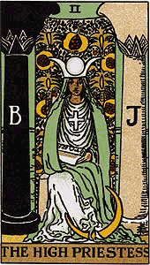
We are so much more than we appear. Each of us has incredible depths of feeling, knowledge and experience, but too often these remain hidden behind this veil. To the conscious mind, Mystery is threatening. It's easier and safer to stay on the surface and ignore the wild underside of life. The tarot reminds us of our depths and offers a way to plumb them. Exploring the unknown can be scary sometimes, but it is also exhilarating. Each time we go deeper, we come away a richer, more aware being.
In the next few weeks, try to stay in a mood of excited anticipation as you work with your cards. Be open to the fact that you have unsuspected talents and potentials. If you begin to feel doubt or concern, remember this is your conscious mind trying to stay in charge. With the tarot, it is not your mind that is primary, but your intuitive heart. Feelings and impressions lead the way . . . for a change!
This possibility may seem more vivid to you if you pause for a moment to reflect on who and what you really are. You are a lively and amazing whirl of energy! A universe of trillions of molecules interacting with each other and the environment in incredible ways. I hold out to you the thought that in a world such as this, just about anything is possible -- even the idea that a few cards could mirror life patterns.
Thankfully, there is still room for the unknown and "magical" in everyday reality. Science has not yet ruled out the possibility that there are ways to perceive and understand other than the senses. If you are open to this possibility, you will find the tarot can lead you in surprising new directions.

Moving Forward
The text for this course is my book Learning the Tarot: A Tarot Book for Beginners. It's also organized into a series of lessons that will supplement what you're absorbing online. I'll refer you to the corresponding text pages when appropriate as we go through the lessons.
There are exercises for each lesson in the text. I'll be assigning some of these, but I encourage you to try the others as well. The art of tarot reading is a practical skill that can only be developed through experience. Learning the Tarot also contains a section with detailed information about each tarot card. These pages will be a valuable reference for you as you work with your deck.
Finally, I urge you to visit the Message Board often and take part in the discussions. I know many of the questions that occur to you will also occur to others. You will speed up your progress tremendously by comparing notes with your fellow students. I hope that you are now eager to begin this adventure.
In the next lesson, we will get take a good look at the most important tool of the reader's trade -- the tarot deck itself.
Here are some wonderful books that will help your knowledge and understanding of Tarot grow:
The Tao of Physics by Fritjof Capra; Shambhala Pubns; ISBN: 1570625190
The Dancing Wu Li Masters by Gary Zukov; Bantam Books; ISBN: 055326382X
Synchronicity, Science and Soul-Making by Victor Mansfield; Open Court Publishing Company; ISBN: 0812693043

Lesson 2: The Tarot Deck
A detailed look at the features of the standard, 78-card tarot deck.

History and Background  In the 1400s, card playing was all the rage in Italy. Games were played with decks much like our modern playing cards. At some point, a new kind of deck was introduced that had 22 extra cards called triumphs. These cards had the power to take or "trump" the suited cards. Most scholars now believe this larger deck was the original tarot deck.  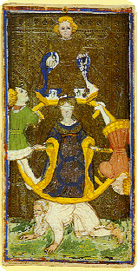  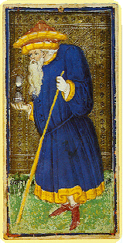  From Italy, the game of tarot spread quickly throughout Europe. Many different tarot decks were printed. Although there were variations among decks, a general pattern developed early on. This pattern became known as the Tarot of Marseilles. Decks of this style are still popular to this day.  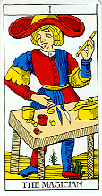  It wasn't until the 1700s that the tarot became more than just a card game. People began using the tarot for divination. Occultists speculated about the "true" origin of the cards. They believed the cards contained secret symbols conveying mystical knowledge. Some drew correspondences between the tarot and other esoteric subjects.  In 1910, Rider & Co. in England published the Rider Tarot. This influential deck was the result of a collaboration between artist Pamela Colman Smith and mystic Arthur Edward Waite. It is often called the Rider-Waite Tarot, or sometimes the Smith-Waite. | Why the Rider-Waite?  The Rider-Waite is arguably the most popular tarot deck in use today. Readers appreciate its story pictures and evocative symbols. It is suitable for beginners, but also has lasting appeal for all skill levels. I will be referring to the Rider-Waite throughout this course. You don't have to learn with this deck, but it's useful to be familiar with it since it is the model for so many other tarot decks.

Major Arcana
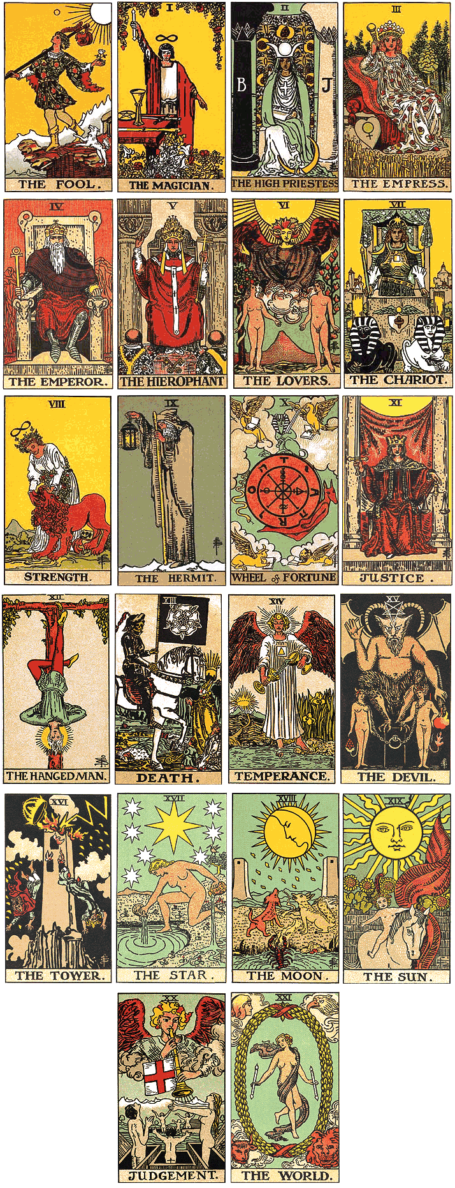

Take a moment to remove the major arcana cards from your deck. You can recognize them by the names printed at the bottom. (The court cards and the aces also have names, but do not remove these now.) Arrange the 22 cards as shown in the illustration.  Spend a few minutes looking over your cards. What impressions do you get? Does one card catch your eye? Do some seem more positive to you than others? Notice the different colors, symbols, and figures -- celestial, human, and animal.  In the tarot, every card has a unique "energy" -- a mood or feeling tone it conveys. You probably sensed some of these energies as you scanned the cards. The Emperor is firm, strong, and authoritative. The Sun feels bright, expansive, and confident.  The major arcana cards have energies that are deep and strong. You will find yourself coming back to these special cards over and over, perceiving ever more rich and subtle meanings within them.  Beginning students often wonder how you can read the tarot correctly if card meanings aren't fixed. The answer is you open to the energy of a card anew each time you see it. In this way, you receive the message the card is communicating in the moment. Usually the message is a familiar one, but sometimes it's unexpected.  Knowing how to sense a card comes with learning and experience. You begin by using meanings you learn from others, but over time, you adapt those teachings to fit your own vision and experience. As you work through these lessons, don't be concerned about "getting it right." Just be aware of your responses to your cards. You are in the process of creating your own set of tarot meanings. | The Energy of a Card  A card's energy comes from many sources -- its history, image and the thoughts of those who have worked with it. This energy is rather like the meaning of a card, but more dynamic. It's not a fixed set of ideas, but a quality that resonates.

Minor Arcana
Gather the major arcana cards and set them to one side. Spread the remaining 56 cards face down in front of you. Move them around so they are well shuffled. Next, pick up a card you feel drawn toward. You'll be making a rectangle of four rows, one for each suit. Follow the model for the cups suit as shown in Figure 2. Place the card you picked up in the proper location in its suit row. Do you feel attracted to the card, or do you recoil a little? Do you notice any specific details? Continue choosing and placing cards one at a time. Give yourself a moment or two with each one.
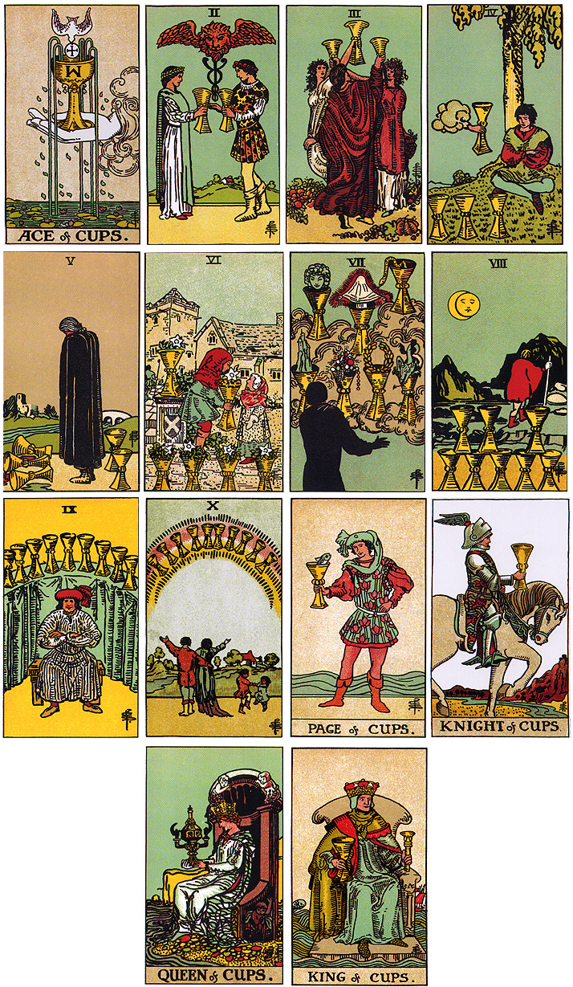

The Four Suits of the Minor Arcana  The most obvious feature of the minor arcana is its division into four suits. In the Rider-Waite, the suit names are:  - Wands  - Cups  - Swords  - Pentacles  Other tarot decks may use different names, but these are the most common.  In the tarot, each suit has its own unique focus. This chart shows the special focus of each suit and the element associated with it:  Suits and Elements  The element associated with a suit can help you remember its focus. Fire is bright and active. Earth is solid and grounded.  Each card in a suit reflects the orientation of that suit in a different way. The ten of cups shows the emotion of joy. The three of cups shows the connection that is friendship. Joy and friendship are aspects of the cups suit. The wands suit has a completely different focus. The five of wands shows competition -- an aggressive action.  In most readings, you will see a balance of suits. If one suit predominates, you know that suit's style is important in some way. Many swords can show a stressful situation. Extra cups can point out a moody atmosphere. | The "Wrong" Suit!  The suits that show up in a reading are not always the obvious ones. You may gravitate toward one suit style over another in your personality or in the circumstances of your life. When you were picking up your cards, did you choose an unusual number of one suit at first? Imagine this act was not random, but a sign that you are drawn right now toward that suit's style for some reason. See where that thought leads you.
  Top of Form  Suit | Element | Suit Focus
  Wands | Fire | Passion, action, confidence, creativity, aggression, excitement, brightness
  Cups | Water | Emotions, moods, spirituality, compassion, connection, fluidity, inner experiences,
  Swords | Air | Mind, intellect, reason, ego-states, disharmony, tension, lightning strikes
  Pentacles | Earth | Material matters, practicality, money, nature, survival, security, groundedness  Bottom of Form

Court Cards  The 16 court cards are a subgroup within the tarot deck. Each one represents a personality type that reflects the card's suit and rank. The easiest way to remember court card personalities is to imagine the cards of each suit as members of a stereotypical family:  Court Cards and Family Positions  From this scheme, you can guess that the knight of cups is excessively (knight) emotional and sensitive (cups). The king of swords acts (king) with reason using his intellect (swords). Of course, this chart is overly simple, but it does give you an idea of the nature of each court card.  In readings, a court card usually represents someone who is demonstrating a certain personality style. This could be you or another person. Students often find court cards difficult to interpret because of this ambiguity. When is a court card you, and when someone else? Usually the circumstances and other cards give you clues. It's also helpful to remember in tarot work that the line between inner and outer is blurred. A court card can represent a quality in you and in another person at the same time. You draw to yourself certain personality types and see in others reflections of yourself.  Confused?  At this point, you're probably feeling somewhat overwhelmed by all this new material. Don't be discouraged. It does take some effort to get to know your deck well, but this is a hurdle every tarot student faces. You've made a good start, and many of these ideas will become clearer as you continue. Be sure to do the assigned readings in Learning the Tarot as these concepts are explained there in more detail.  In future lessons, I will help you get more comfortable with your deck in ways that are fun and insightful. In time, you will find your tarot cards have become familiar friends. In the next lesson, we will explore the extra dimension of meaning introduced by the tarot spread. | Making a "Tarot" Deck from Playing Cards  You can turn a regular deck of playing cards into a partial tarot deck. Clubs = wands, hearts = cups, spades = swords, and diamonds = pentacles. Ace through10 and the queen and king remain the same. Jack = knight (historically the jack is the page, but it's more interesting to make him the knight) and joker = fool. (No other major arcana cards are included.)
  Top of Form  Court Card | Family Position | Focus
  King | Father | Action, outer events
  Queen | Mother | Being, inner states
  Knight | Teenager | Excess, extremes
  Page | Child | Play, enjoyment  Bottom of Form

Lesson 3: Tarot Spreads
A look at tarot spreads, or patterns for laying out the cards.

Definition of a Spread  You're now more familiar with your tarot deck. Your next step is to learn how to put that deck to use. You could simply shuffle your cards, lay out a few on the table, and interpret them. Some tarot readers do prefer this straightforward method, but it is much more common to use a tarot spread.  A spread is a pattern or template for laying out the cards. Spreads give readings structure and a deeper layer of meaning. There are hundreds of spreads for different purposes. Tarot lovers pick them up from teachers, books, and each other. You can create spreads for yourself as well.  Organization of a Spread  A spread organizes a reading in five ways. It tells you:  - The theme  There are spreads about work, relationships, health, past issues and many other topics. Some spreads are more general and do not have a specific theme.  - The number of cards to lay out  A spread tells you how many cards to use in your reading. A spread can be small, with just a few cards, or quite large. The larger the spread, the more complicated and detailed the reading.  - Where to place each card  Every spread has a shape outlining the places for the cards. I call these places the card positions. Figure 1 shows a spread shaped like the five on a die. For this spread, you would need five cards -- one for each position.  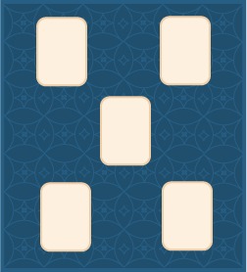  The shape of a spread often reflects its theme to help you perceive the relationships between the cards. Figure 2 shows a spread shaped like an arrow pointing to a single card. The meanings of cards in the arrow "point" to the result in the outcome card.  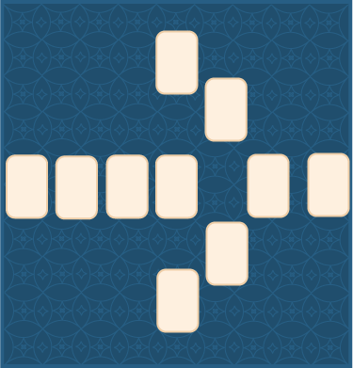  - The order of placement  The order of placement is important because it determines each card's position. Cards are usually taken in order from the top of the deck after the shuffle and cut. The top card goes in Position One, the second in Position Two, and so on.  - The context in which to interpret the card  Each position in a spread has a certain meaning associated with it. This meaning influences how the card is interpreted.  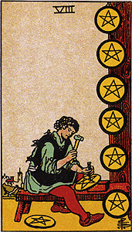  Let's say you are doing a reading about a problem in your office. You have chosen a work-related spread to use. The Eight of Pentacles happens to fall in the position that means "what someone expects of you." This card often stands for diligence -- working long and hard. In this case, you could interpret the Eight of Pentacles as "someone expects me (position meaning) to work long and hard (card meaning)."  The position gives a context or framework within which to evaluate the card.  Another position in the same spread might mean "what is most satisfying about my job." Here, the Eight of Pentacles would tell you "what is most satisfying about my job (position meaning) is the hard work (card meaning)." | Same Card, Different Meaning  The same card implies totally different understandings depending on where it lands. This extra layer of meaning is what makes spreads so powerful and useful in tarot work.

Quick Spread  Now that you understand the purpose of a tarot spread, let's take a look at a useful example. There will be many times in your life when you need guidance about a problem, but don't want to do an elaborate reading. The Quick Spread is ideal for these occasions. It is a simple three-card spread shaped like a triangle.  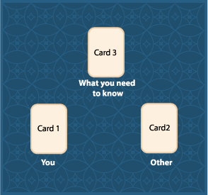  Figure 3 shows the layout. Position One is on the bottom left, Position Two on the bottom right and Position Three in the middle on the top. Here are the meanings:  - Position One = Key Factor: You  Position One represents a key factor about you in the situation, perhaps your attitude, actions or needs in relation to Position Two.  - Position Two = Key Factor: the Other  Position Two represents a key factor about what is "not-you" in the situation. It might be a person, group, idea or tendency - something you consider to be other than yourself.  - Position Three = What I Need to Know  Position Three offers guidance and commentary. It tells you what you need to know to make well-considered choices in the situation.  A Quick Spread Example  Let's say you are concerned about arguments you've been having with your strong-willed child. She refuses to cooperate, even when cooperation would be to her advantage. You want to understand why there is so much conflict in your relationship, so you do a Quick Reading and draw the following cards:  Sample Quick Spread  How Do You Read This?  What can these cards tell you about your dilemma? By combining the position and card meanings, you learn:  Sample Quick Spread Interpretation  Normally, you would not use this fill-in-the-blank formula to interpret your cards. I've used it here so you can see how the card and position meanings interact. On your own, try going deeper into this reading. Look up these three cards in the Individual Card Description section in Learning the Tarot (page 107). Read over the material for each one, and see what occurs to you. Consider sharing your ideas with others on the Message Board. Remember: there are no wrong impressions. | Power of the Unconscious  In these lessons and in Learning the Tarot, the cards in the examples are always "authentic." They come either from actual or simulated readings. At first, I tried picking cards consciously to fit my examples, but the results always seemed forced and artificial. The unconscious selects with much more subtlety and awareness!
  Top of Form  Position | Card | Meaning
  One | 7 of Pentacles | Assess, consider a direction change
  Two | Chariot | Assert yourself, use your will
  Three | Magician | Act consciously, experience power  Bottom of Form
  Top of Form  Position | Card | Interpretation
  One | 7 of Pentacles | A key factor about me is my need to assess and consider a direction change
  Two | Chariot | A key factor about my daughter is her need to assert herself and use her will
  Three | Magician | What I need to do is act consciously and experience power  Bottom of Form

Celtic Cross Spread  The most popular spread in the tarot community is the Celtic Cross. This ten-card spread is useful in any situation. It is divided into two parts: a six-card circular section on the left and a four-card staff section on the right. The circular section describes the situation at the time of the reading, and the staff section offers insight and guidance (See Figure 4).  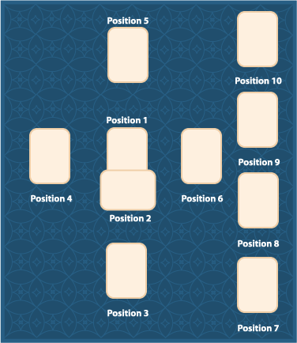  In Learning the Tarot, I describe the Celtic Cross in detail (page 275). I concentrate on this single spread in my book because it is easier for students to focus on just one layout in the beginning. Becoming familiar with 78 cards is challenging enough without having to learn many spread definitions as well. Later, you will want to explore the nuances of meaning offered by a variety of spreads.  Experience and familiarity are very important in tarot work. The more you use a spread, the more deeply its structure and meaning becomes embedded in your consciousness. After continually practicing a piano piece, your hands seem to know exactly where to go without conscious thought. When a tarot spread is that familiar, you will be able to "play" it beautifully as well. | Spread Variations  There are several versions of the Celtic Cross. The differences are usually in the order of placement of cards three through six. It is OK to try out spread variations, but once you have learned a particular version well, it is probably best to stay with that one. You don't want to disrupt the clarity you have built up about a spread over time.

Creating Your Own Spreads
It is easy to create or customize a spread for your own purposes. All you need do is specify the five elements of the spread beforehand:
- Theme
- Number of cards
- Shape (positions)
- Order of placement
- Meanings of the positions
Make the order of placement as logical as possible. Outcome or result cards work better at the end. Also, simple, all-purpose meanings are best. "What I'm hoping for" is better than "what I hope Peter will do after I talk to him."
The most important point to remember about creating a spread is to be sure you define all five elements before using it the first time. If you are uncertain about any elements, your reading will be confusing to you. Once you have tried out your spread, you can refine or change it, but be sure you are clear before trying again. Intuitive impressions can be subtle and fleeting. To capture them, you need a familiar, unambiguous framework. This is the support the tarot spread provides.

Lesson 4: Doing a Tarot Reading: Step-by-Step
How to do a tarot reading for yourself based on a personal question.

Getting Ready
Wouldn't it be wonderful to have a wise, compassionate counselor at your side day and night? Someone to consult whenever you needed advice? You do have such a counselor -- your own Inner Guide. Your Inner Guide is that part of you that knows what you need to do to meet your challenges and follow your destiny. A tarot reading offers a way to communicate with your Guide so you can receive its wisdom.
In this lesson, I describe a simple, step-by-step procedure for doing a reading about a personal issue. You write a question about your situation and then receive an answer through the medium of the tarot. Question Readings are a powerful way to tap into your inner guide.
A tarot reading has two aspects: the acts to be performed and the inner process that goes with those acts. In this lesson, I concentrate on just the actual steps. In the next lesson, I'll talk about the inner events.
First, read over this lesson to get an idea of what is involved. Then, read the corresponding material in Learning the Tarot (pages 22-26). There are many details to absorb when you are first learning, and these are explained more fully in the text. You will find a summary of the whole procedure in Appendix F (pages 311-312).
This procedure is meant to be a foundation you can build on as you work with your cards. Follow the steps closely at first, but know that they are flexible. As you practice, look for ways to adapt the steps to suit your experience. This is how you create a personal relationship with your cards.

The Shuffle, Cut, and Layout  1. Writing Your Question  Naturally enough, the first step for a Question Reading is writing a question. You think carefully about your situation and then craft a question that covers what it is you most want to know. This step is not as simple as it sounds. The words you choose have important implications. I've summarized some suggestions in the sidebar, but please read over pages 19-21 in the text so you know the rationale behind each one.  2. Gathering Your Materials  Before you start the reading, you will need:  - Your written question  - Your tarot cards  - The layout for the spread you have chosen  - A reference book with card and spread meanings (optional)  3. Setting the Mood  You want to do your reading in a quiet, private place where you feel comfortable and secure. Seat yourself on the floor or at a table with some clear space in front of you. Take a few moments to relax and breathe deeply. Switch your focus from the outer world to the inner. In the text are some suggestions for creating the ideal inner and outer environments for a reading (pages 17-18).  4. Asking Your Question  Hold your cards in one hand, and place your other hand on top. Close your eyes, and imagine you are in the presence of an all-wise, all-loving being. Share out loud what is most in your heart at the moment. If you feel awkward, don't let that hold you back. Simply express all that you are feeling. When you ask for help in this humble, sincere way, the universe always responds.  Your final statement should be your question. Say it from memory or read it exactly as written. The unconscious is quite literal and will respond to your specific words.  5. Shuffling the Cards  During the shuffle, your unconscious mind sifts through the cards to find those that are most appropriate for you at the moment. Choose a shuffling method that is comfortable for you (page 310). Focus on your question while you shuffle, but in an easy way. Continue until you feel an urge to stop. Then, gather the cards into a stack, and place them in front of you as shown in figure 1 (page 23 in your text).  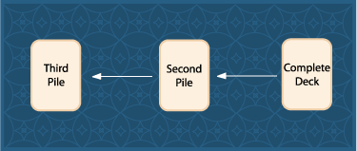  6. Cutting the Cards  Cut the cards as follows:  - Grab some number of cards from the complete deck  - Drop this pile to the left  - Grab some part of this second pile and drop it further to the left  - Regroup the cards back into one pile in any fashion  I like to cut slowly by feeling my way down the stack with my fingers until I've reached just the "right" spot. Then, I restack quickly. Feel free to experiment with the shuffle and cut, but you should eventually settle on one technique so that it becomes second nature to you.  7. Laying Out the Cards  Pick up your cards and hold them cupped in one hand. With your free hand, turn over the top card as if you are turning the page of a book.  Look at the card immediately so you know whether or not it is reversed. Then, place it in its proper location following the order of the spread you have chosen. Continue until all cards have been placed, then put the rest of the deck to one side.  You will begin receiving impressions from the moment you turn over the first card (and sometimes even before). These impressions are the answer to your question. I'll talk about this in the next lesson, but for now, know that every reaction you have during a reading is noteworthy. | Hints for Writing a Question  Ask for insights, not solutions. Keep your options open. Find the best level of detail.  Focus on yourself, not other people. Stay neutral about your situation. Be positive.  Dealing With Reversed Cards  A tarot card can be upright or reversed (upside-down). Reversed cards are usually interpreted differently, so it's best to ignore them until you know your deck well. You can discourage reversed cards by starting your shuffle with all cards facing in the same direction. Then, every time you divide the deck, make sure all the cards stay facing the same way.

Uncovering the Message  This page will continue to explain the process of doing a tarot reading.  8. Analyzing the Reading  In this step, you try to uncover the message of the cards by bringing to bear all the understandings you have about the tarot. Every reader's approach is unique, but there are certain principles of interpretation that are useful to know. I'll mention these in the next lesson.  9. Creating the Story  "Creating the story" is the phrase I use to describe the process of organizing your impressions into a coherent picture. As you examine your cards, you will have many different reactions. They will make more sense to you once you have discerned the underlying pattern and vocalized it. I'll offer hints about this step in the next lesson.  10. Writing the Summary Statement  A summary statement is a sentence or two that captures the essential message of your reading. Writing a summary statement helps you recognize the answer to your question and leaves you with a handy way to remember it.  11. Finishing Up  Write down the cards in your reading so you don't forget them. Then, return your cards to the rest of the deck. Once again, hold the deck in one hand with your other hand on top. Say out loud what you learned from your reading. Express your gratitude for the guidance you received and what you intend to do as a result. Finally, do a few quick shuffles to remove all traces of the reading. You can now put away your deck and return to everyday life. | Reading for Others  When you read the tarot for someone else, you want to involve that person as much as possible. Let her shuffle and cut the cards. When the cut is over, pick up the cards yourself, but be careful to maintain the same orientation of the deck. Arrange the cards so they face the other person. Sit side-by-side, if you can, so you can view the cards together.

Putting Your Insights to Use
You can approach the tarot from many different levels. Readings can be a source of light amusement, or they can be profoundly revealing. Either way is fine, but I have found that the value of a reading exactly corresponds to the level of trust and openness you bring to it. When you play with the tarot, insights are superficial. When you honor your cards, you discover through them the depths of understanding you hold within yourself.
Every step of this reading procedure is designed to help you become more aware and confident about your choices in life. The tarot cards cannot tell you what to do, but they can offer you a way to gain more clarity about your situation so you know what to do. The secret is to act on the insights you discover in a reading. This is the final, validating step that demonstrates your trust and seriousness of purpose.
At first these actions will be small and tentative. You need time to gain confidence in this new way of operating, but the acts you take bring results that then feed into your next reading. Each reading will become more meaningful as you train your unconscious to open up to you. If you are willing to put your insights on the line, you set in motion a cycle that keeps getting stronger and stronger.
In the next lesson, we will go beyond the mechanics of a tarot reading to explore why these enigmatic cards can have such a major impact. In the meantime, have fun taking the quiz, and be sure to log on to the Message Board and let the rest of us know how your first reading went.
Lesson 5: The Art of Interpretation
An exploration of ways to uncover the meaning of cards in a reading.

The Nature of Meaning  Imagine for a moment you are trying to discover the "meaning" of a tree. A tree has leaves, roots and a trunk, but these don't exactly define it. A lumberjack might say a tree means profits. A poet would tell you it's a source of inspiration. A hot traveler says it's a shady place to rest. Which one is right? It depends on your point of view. The meaning of a tree is all these and more.  The art of tarot interpretation is the art of discovering the meaning of a reading. Just as with a tree, there is no one interpretation that is correct. In tarot groups, members often ask each other for ideas about a reading, and the variety of responses can be startling. Each respondent sees a different truth in the same set of cards, and each is valid in its own way. Responses may be similar due to tradition and human nature, but each one bears the mark of its creator.  What is the point of a reading if it can mean anything? A reading mirrors for you the meaning of your own life. Just as a lumberjack's view of a tree says a lot about his concerns and values, your responses to your readings say much about you. A tarot reading is a game you play with yourself - a game that takes place within your own mind, and at different levels.  In this lesson, we'll take a look at some of the techniques you can use to "play" this fascinating game. I'll describe typical responses you might have during a reading and show you how to deepen those responses over time. | Deeply Rooted Answers  You ask a question consciously and receive your answer from the deepest part of you, where the answer lies. One part sends a message, another part responds. The cards are the triggers that allow this process to unfold.

Responses  Your responses during a reading are the key to its meaning for you. A response is any feeling, thought or physical reaction you have as a result of the reading process.  Take a moment now to watch your own thinking. Notice how thoughts and feelings "pop" into awareness as if from an outside source. They may be triggered by something you see or do, but they still arise fully formed. You don't decide to craft a thought, it's suddenly just there. This phenomenon corresponds to the send-and-receive process I described earlier. For tarot purposes, we assume the outside source is our Inner Guide, and our thoughts and feelings are its messages.  At first, your responses will come mainly from looking at the card images. The scenes on the Rider-Waite cards are mini-stories. They have the power to evoke complex reactions. I have watched people who are totally new to the tarot come up with detailed interpretations simply by considering the feelings they have when looking at the cards.  Most students also consult tarot authorities to enrich their responses. Teachers, books, and fellow readers are all sources of information about meanings and techniques. When you start investigating these sources, you'll find out how varied tarot opinions can be.  Evolution of Your Responses  Personal reaction and outside opinion will be the mainstays of your tarot work in the beginning, but over time, you'll rely more and more on experience. When you know your cards well, you will have familiar reactions to draw on from each one - impressions you can trust. Your responses will get easier and more assured.  In movies, tarot readers always receive messages dramatically -- as a whispered voice or vivid mental scene. Such responses are possible, but unusual. At first, you are more likely to experience a mixture of thoughts and feelings jumbled together. Your long-term goal is to smooth out this response pattern. If you can make your background mental state as blank as possible, what pops in will stand out with great clarity. Meditation and other relaxing practices are ideal supplements to tarot work.  With practice, you will gradually develop the ability to clear your mind and capture impressions as they come. You will have a working symbolic vocabulary your Inner Guide can draw on to aid and advise you. There may even come a time when you are no longer reacting, but simply receiving. Meaning comes to you without effort as direct knowing. | Recommended Reading  The Tarot: History, Mystery and Lore by Cynthia Giles  Tarot for Yourself by Mary K. Greer  Seventy-Eight Degrees of Wisdom: A Book of Tarot by Rachel Pollack  Tarot Plain and Simple by Anthony Louis  Encyclopedia of Tarot: Volumes I, II and III by Stuart Kaplan  Jung and Tarot: An Archetypal Journey by Sallie Nichols  Classic Tarot Spreads by Sandor Konraad

Individual Cards and Combinations  Let's look at some of the techniques you can use to encourage meaningful responses. There are three areas of interpretation: individual cards, card combinations, and the overall pattern. Each one offers its own challenges and rewards.  Generally you consider each card individually first (see pages 34-35). There are four sources of meaning for each one:  - The card's image  - The card's traditional meanings  - The card's position meanings  - Your question  Your interpretation of each card will be a combination of these four factors. Be systematic at first about considering each one. Start with the card in position one. Look carefully at the picture. Note the details and the overall mood it conveys to you. Then, look up the card and position meanings in your text, and add these to the mix. Finally, bring in your question.  As you progress through these steps, you'll be forming some sense of what the card means. Sometimes the meaning will strike you like a lightning bolt. Other times, it will stay hazy even until the end. Accept whatever you receive for the moment, and move on to the next card.  When you have completed each one, begin relating the cards to each other. There is a wealth of meaning to be discovered in this way. In the text, I talk about card pairs (pages 43-55). You could compare all the cards in a reading, but that's really not practical. It's better to focus on pairs that have one or more of these features:  - Opposite meanings  - Similar meanings  - Both are court cards  - Both are in linked positions  Some cards have meanings that are polar opposites. The Six of Cups and Nine of Swords are an example. These cards sometimes identify an innocence/guilt issue in a reading. Cards with similar meanings can show a doubling of some influence. By comparing two court cards, you can tell what kind of sparks will fly when two personality types meet.  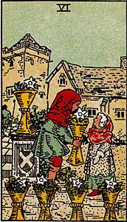  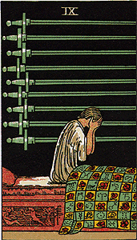  In most spreads, certain positions are linked by design. Positions one and two in the Celtic Cross are an example. The cards physically overlap to reinforce the idea that they are connected. It makes sense to interpret such cards jointly. | A Little Math  What course would be complete without a little math? You can calculate the total number of card pair combinations in any reading by using the following formula:  N * (N-1)/2  N is the number of cards (positions) in the spread you are using. In the Celtic Cross of 10 cards, there are 45 possible pairs you could analyze

Creating the Story
A half-tone image is made up of hundreds of little dots. You can see the dots when you look at the image up close, but when you pull back they blend together to reveal a face or object. A tarot reading works the same way. At some point, you move from card-by-card analysis (the dots) to the overall picture (the face). In the text, I call this "creating the story," but this phrase is a little misleading.
A tarot story is not usually an elaborate plot full of characters. It is a coherent description joining all the cards in a meaningful way. Until you arrive at this description, your understanding of a reading may not feel complete. The process is different for each reader and reading, so there is really no way to explain exactly how to go about it.
I can offer two techniques that may help. One is to allow a story to arise spontaneously from within you without conscious thought. I describe this technique on pages 59-60 of the text.
A second method is to focus on your question. Imagine a friend has asked you the exact question you wrote originally for your reading. The elements of the answer he needs are in your cards, but it's your responsibility to piece them together. Go through the cards one by one, and tell your friend how each one answers his question. This method forces you to make each card fit in some way, and connections will occur to you as you go. This technique works best when you actually address someone, either real or imaginary. Talking is a skill we all know well, and it requires being able to organize thoughts on the fly.
There are many layers of meaning to be uncovered in a reading, but no matter how deeply you go, you will never reach the bottom. With the tarot (and life), uncertainty is built in, and that is the wonder and the mystery.
In the next lesson, we will work through one complete reading so you can see how some of these ideas are put into practice.

Lesson 6: Mary's Dilemma: A Sample Reading
A detailed look at a sample tarot reading about a personal question.

The Context  In this lesson, I'll go through an interpretation so you can see how the process works. We'll analyze a reading Mary did to gain insight into a personal question. Read the lesson through once then look up each card in the text. Read that material, and also review the Celtic Cross (pages 275-287). Finally, read the lesson again. The interpretation will make more sense to you the second time around.  "Mary" and "Al" have been married almost 20 years. They have two teenage children, and both work outside the home. Mary began working part-time when her first child was born, and her career leveled out at that time. Al works long hours, but is an involved and caring husband and father when he's home.  Mary and Al get along well. There are few fights and no financial or health problems. Mary knows she should feel blessed, but instead she feels restless and lonely. She longs for more excitement in her marriage and life in general. Over the past year, she has felt a growing impulse to leave Al and strike out on her own.  Al suggested they go to counseling, and she agreed, but there was little progress. Mary kept wavering. She wanted to separate, but the thought of breaking up the family held her back. Finally the therapist said, "You must decide by our next meeting. Either commit to working on the marriage or else let it go."  It was at this time that Mary sought a reading. We decided to do a Celtic Cross reading to get guidance on this question:  "Can you give me insight into my marriage and my desire to separate at this time?"  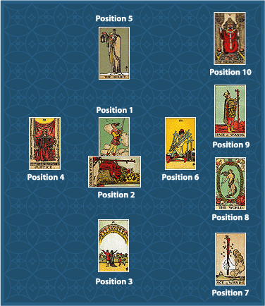  Let's go through the interpretation process described in Lesson 5. First we'll look at individual cards, then card combinations and finally the overall story. Figure 1 shows the cards Mary drew. | Using action phrases  In the text, there are certain action phrases for each card that highlight different meanings. A useful technique when interpreting a card is to scan these actions looking for ones that "jump" out at you. You may feel an inner recognition telling you that particular meaning is important.

Individual Cards  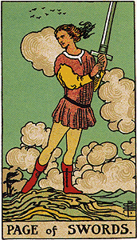  The Page of Swords often signifies a challenging situation. Mary's need to resolve her ambivalent feelings about her marriage is the heart of this matter for her (Position One). It's a tough life lesson, but one full of meaning and opportunity for growth. A page also represents a call to action -- the challenge posed to Mary by her counselor.  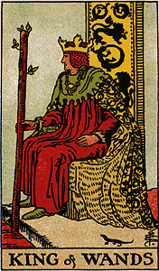  The King of Wands represents qualities Mary feels are lacking in her life right now. This king is bold, creative and forceful. Mary's desire to experience his style is a factor for change in the situation (Position Two).  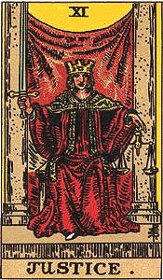  Position Three shows the deeper meaning of a situation. The Justice card often appears when a major decision needs to be made. Should Mary go or stay? What is the right and fair choice? She must weigh all the factors in the scales of Justice.  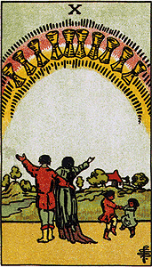  Position Four represents the past -- something fading in value. Mary smiled ruefully when she saw this card because she feels her enjoyment of her family life is receding. The young children in the picture remind her of when her children were little and she was more contented.  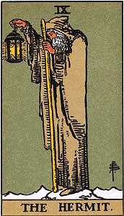  The Hermit wants to be alone. He seeks seclusion because he is searching for a more meaningful way of life. Position Five represents Mary's conscious concerns and hopes. Her desire to withdraw is much on her mind right now.  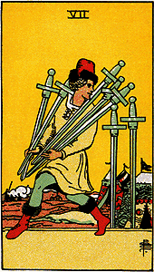  Mary was taken aback when she saw this card because she had been thinking about it before the reading. Deep inside, she knows her desire to leave is a form of running away. Position Six represents an unresolved factor in the near future. Mary will be dealing with this urge to separate for a while.  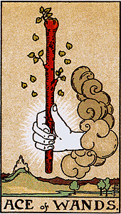  Position Seven represents an ideal Mary holds for herself. Aces show beginnings. Mary wants a new beginning characterized by the passion and freedom of the wands suit.  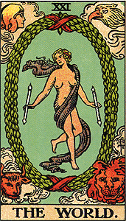  Position Eight represents how Al sees Mary. He thinks the world of her and wants the marriage to last. The World also tells Mary her environment holds many blessings and chances for fulfillment.  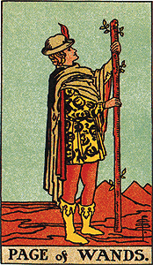  A second page, another call to action. Position Nine is a guidance card reinforcing the importance of adventure for Mary. She definitely needs to find a way to incorporate new experiences into her life.  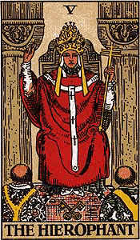  The Hierophant surprised and confused Mary. To her, it was the first card that didn't seem to fit. She associates the Hierophant with a spirit of narrow-minded conformity. She would prefer a different outcome (Position Ten). | Puns and Word Play  The tarot is a great punster. You will find the meaning of certain cards comes to you in the form of puns or other word play. Al thinks the world of Mary. You can't look for these connections; they just pop into your mind. But they are always worth a chuckle.

Card Combinations
With these initial impressions, we can now begin comparing the cards looking for meaningful configurations.

Three Wands Cards
The three wands cards make a striking combination. Mary's reading shouts out -- in triplicate! -- her deeply held need for more passion and excitement. An ace in a reading often shows the early presence of its suit's qualities. A page of the same suit tells you to grab that potential and act on it; a dynamic combination.

Reinforcing Pairs
The Hermit and the Seven of Swords are a reinforcing pair. The Hermit is the archetype of the seeker who withdraws from the company of men to seek answers within. The Seven of Swords indicates a desire to be solitary. Mary is feeling the call of this "lone wolf" energy right now.
The Ten of Cups and World are a second reinforcing pair. Together they highlight the positive, supporting atmosphere that surrounds Mary. The Ten of Cups shows a happy family, and the World is the major arcana card that most represents fulfillment.

Opposing Pairs
Justice and the Seven of Swords are an opposing pair. They tell Mary she could choose to assume responsibility, or shirk it. The Justice card is key. It reminds Mary of the serious (major arcana) nature of her decision and the need to choose with full awareness. Notice the sword on the Justice card. The Page of Sword is swinging that sword in his efforts to take fair and just action.
Putting Everything Together  Are you beginning to see the overall pattern of Mary's dilemma? Mary recognizes that her life with her husband and family holds many blessings, but she still feels an undeniable urge for adventure. In the Celtic Cross, Positions Five and Ten sometimes show alternate possible outcomes. Mary could go it alone (Hermit) or she could remain part of a group (Hierophant). Which will it be?  Mary did not breathe a sigh of relief when she saw the glowing family in Position Four (fading into the past). Instead, she felt a certain nostalgia. Her family is still important to her and a source of joy.  The Seven of Swords is significant because it flashed into Mary's thoughts before the reading started. This card has a sneaky quality. It implies that leaving will not make Mary feel better, only guilty.  Mary's surprised reaction to the Hierophant is noteworthy. It suggests the projected outcome may not be one she has considered. Her first impression was negative. To her, the Hierophant represents conforming to outside demands and expectations. I pointed out to her he also represents being devoted to a cause or group (family). Perhaps Mary will find the answer she is seeking if she changes how she looks at her situation -- how she perceives the energy of the Hierophant.  Mary's knows she must acknowledge her desire for a more vibrant life -- the wands cards tell her that in no uncertain terms. But, maybe she has been assuming she must satisfy this need by leaving. Could Mary find what she is seeking at home? Mary's reading has not given an answer, but it has clarified the issues. Mary asked for insight into her desire to separate, and this is what she has received. Now, she must weigh this information and take action.  Considerations  Before I wrote this lesson, I asked my Inner Guide to bring me a reading that would demonstrate the principles and techniques involved in tarot work. With Mary's help and permission, I received the ideal example. This reading is full of meaningful card combinations. I've only touched on the possibilities.  I encourage you to examine this reading in depth. If other insights occur to you, share them on the Message Board. You will quickly discover how rich one reading can be. In the next lesson, we will look at some ways to establish an ongoing tarot practice so your new skills can be integrated into your life. | Premonitions  Working with the tarot opens up inner perceptions. Mary had a premonition that the Seven of Swords would be meaningful. I often find a certain card will pop into my mind right before a reading. Usually it then appears among the selected cards, so I know to give it special consideration. Your Inner Guide is on call even before the reading begins.

Lesson 7: Establishing a Tarot Practice
How to make the tarot a real and valued part of everyday life.

Early Learning Phase  It's common for students to begin their tarot studies with a burst of enthusiasm, but then get discouraged and quit. Many tarot decks are lying in drawers unused because their owners weren't able to get through the early learning phase.  In this lesson, I want to share some guidelines to help you integrate the tarot successfully into your life. If I can anticipate some of your questions and concerns, then you'll have more trust in your efforts. You'll keep going until you can do readings comfortably without outside assistance. From then on, your practice will be established. Your tarot skills will be available if and when you need them.  Your biggest challenge right now is to get to know your deck well. There's no way around this key step, but once you have a working knowledge of all 78 cards, you will feel much more at ease during your readings. Begin now to become as familiar as possible with your tarot cards. | Star Trek and the Tarot  The original Star Trek series is full of characters that match court cards:  Captain James T. Kirk = King of Wands  Scotty = King of Pentacles  Mr. Spock = King/Knight of Swords  Dr. McCoy = King/Knight of Cups  Chekov = Knight of Wands  Uhura = Queen of Pentacles  Any Tribble = Page of Cups

Exploring Your Deck  - Make a tarot notebook with a page or two for each card. Enter everything you learn about a card in the appropriate section. Include useful ideas from teachers, books, fellow students and your own experience. This notebook will become your personal tarot reference manual.  - Use the charts in the text to memorize the keywords for each card (pages 111, and 158-159). These will give you some basic ideas to work with during interpretation.  - Practice daily Readings. the basic procedure is given in the sidebar, but see pages 15-16 in the text for details.  - Spend time looking at each card's picture. Allow the mood of the scene to suggest meanings to you. Look at the image intensely for one minute, then look away. See how many details you can remember before looking back. Notice which ones were easy to remember and which were difficult (ask yourself why).  - Develop your ability to call up a card's image in vivid detail in your mind's eye. Use visualization techniques to help.  - Enter into a dream-like reverie after gazing at a card for a while. Flow with the energy of the card as it presents itself to you from moment to moment.  - Find a tarot buddy. Take turns sharing your impressions of a card. Create a hypothetical situation, idea or personality, then ask the other person to choose a card that fits. (This technique works better once you've made some progress) Support each other's choices.  - After some event, look through the card descriptions (or your memory) to find a card that matches, or choose a card at random and make a connection, even if it's far-fetched.  - Tape a photocopy of a card to your computer. Glance at it from time to time for inspiration. Don't tape the card itself unless you have a spare. It might get damaged or lost, and you want to maintain the integrity of your deck by keeping your cards together.  - Do an Internet search on a card and see what comes up. Plunge into the history of the tarot to see if you can deepen your understanding that way.  - Draw your own version of a card. The tarot has inspired many artists and designers. If art isn't your specialty, capture the energy of a card with free-flowing lines and color.  - Choose cards that match people you know, famous figures and fictional characters. Notice how different traits manifest in the tarot, especially in the court cards. | The Daily Reading  1. Shuffle the deck once or twice.  2. Ask for guidance covering the next 24 hours.  3. Place the deck in front of you and cut once to the left.  4. Turn over the top card as your card of the day.  5. Return the card to the deck and shuffle again.

Common Questions and Concerns  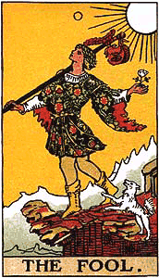  First tarot readings are often powerful and striking. Perhaps it's because we are more open and receptive the first time (the Fool). Maybe our Inner Guide wants to grab our attention. Whatever the reason, this early success is often followed by a period of slow progress and doubt. This slump tends to begin right after the last tarot class is over, and you're on your own. I encourage you to push through this low period. The learning pattern for any new skill involves cycles of little progress followed by leaps forward. Don't give up when a leap is overdue.  Here are a few common reactions people have in the early phase of tarot study. If you know the kinds of experiences you can expect, you can work your way through them.  Environment  In lesson two I talked about the energy of a card -- its dynamic feeling tone. Environments have energies as well. We've all felt the chill of emotional tension in a room or the up mood of a party. If you can do your readings in a place of beauty and calm, your experiences will be more positive and you will be more likely to continue. In the text, I offer suggestions for ways to establish a pleasing environment for readings in your home (pages 17-18).  Second Readings  You may be tempted to do many readings about the same situation, especially if the first is discouraging. Resist this temptation. Extra readings will just confuse you, and they tend to be flat and unrevealing as well. It's like telling your Inner Guide you want advice, but then not listening to the response. Make it a rule to accept your first reading no matter what. Only do a second when your situation has changed substantially, or when some time has passed. How long to wait depends on how fast your situation is developing, but on average, a few weeks is minimum.  Being Objective  You may wonder sometimes if you're being objective when you read your cards or if you're just seeing what you want to see. Objectivity is not possible or desirable in tarot work. Your goal is to become more aware, and this will happen naturally over time. However, you can learn much by watching your reactions carefully.  - Did you feel a little jolt of disappointment when certain cards appeared?  - Did you try to twist and turn your interpretation to get a good one?  - Did you suddenly get bored with your reading and decide to put it away?  - Did you want to do a second reading just to see what else the cards would say?  These reactions are signs that you are avoiding some truth about your situation. Switch your focus to this matter, and you'll be on the right track.  Trouble Creating a Story  Many tarot students have trouble creating a story. They become discouraged when they can't sew all the material together seamlessly. Indeed, this step is easier for some people than others. It helps to be able to think holistically -- to see the big picture. If you have trouble with this step, make an extra effort to review your readings.  You receive a ready-made story from the way a situation plays out in reality. By working backward, you can improve your story awareness. Also, practice reading for others. The pressure of having to present a good case to a listener can make a real difference. Keep working with the procedure described in Lesson 6, and know that sometimes partial understandings are all we can expect from our tarot readings. | Validation  At first, you will probably have a strong desire to validate your interpretations by seeking an outside opinion. Interpreting a reading is not like shooting a basketball where you get immediate feedback on whether you've missed. Seek insight from others, but remember that validation is never possible from the outside. Ultimately, you are the only one who can tell if an interpretation is meaningful, and it is if it has brought you greater awareness.

Perseverance
Your moments of doubt and hesitation will lessen over time if you persevere. In fact, you may eventually have such great success that pride becomes an issue. Take note if you find yourself thinking, "Hey, I'm getting pretty good at this. I really know what I'm doing. I guess I'm a natural."
This level of confidence is exciting, but risky. With the tarot, it's important to remember the source of your impressions is not your ego-self, but your Higher Self. Your pesky ego is going to try to take credit for your accomplishments, but don't let it get away with this little maneuver. Pat it kindly on the head, but tell it gently to "Go lie down." Keep your beginner's mind of openness and humility, and your tarot work will continue to deepen. You'll discover how much this new skill enriches your life.

Lesson 8: Expanding Your Tarot Horizons
Different ways to continue exploring and learning more about the tarot.

Hundreds of Decks  There are many ways you can expand your tarot horizons. A major area of exploration is the deck itself. The tarot has inspired artists and thinkers for centuries. Each works with the same basic pattern, but infuses it with a personal vision. There are hundreds of decks, both common and rare. Tarot lovers enjoy assessing the different ones for their reading potential and inherent beauty. Once you own one deck, you won't be able to resist getting another, and soon you'll be a collector.  The typical tarot deck comes packaged with a small booklet of instructions. In the tarot community, these booklets are jokingly called the "LWBs" for Little White Booklets. They offer some information, but not much. Larger books are sometimes available that cover a deck's purpose and design in more detail. These are usually offered with the deck as a set.  Sometimes extra cards are included. The usual print run has space for 80 cards -- two more than required. Publishers occasionally leave these cards blank. You can add one or two to your deck as a "wild" card or personal message card.  Variations in Rider-Waite  There are variations of the Rider-Waite itself:  - Universal Waite Tarot  - Albano-Waite Tarot  - Golden Rider  - Original Rider-Waite Tarot Pack  - Diamond Tarot  - Quick and Easy Tarot | Artists Take Note!  A special deck is available to use when designing your own tarot cards. This deck has the uniformity and stiffness of regular cards, but without the preprinted images. One side is blank, the other side has the backing used on the Rider-Waite.

Themes and Variations  Most tarot decks fit the pattern described in lesson two: 78 cards with a major arcana and minor arcana of four suits. The Rider-Waite is the model for this type, but variations are common. They usually fall into one or more of the following categories:  Themes  Many decks have a definite theme that colors every aspect of the deck. There are cultural decks such as the Chinese, Egyptian and Celtic. Other popular choices include historical, novelty, esoteric, animal, and fantasy themes. The Rider-Waite is an all-purpose deck with no particular theme. The Aquarian, Morgan-Greer, and Hanson-Roberts are other decks of this type.  Name Changes  There are certain common variations for the traditional suit names:  Many deck designers make suit names fit the theme of their deck. The Wonderland Tarot is based on Lewis Carroll's famous story about Alice. The suits of this deck are the Peppermills, Hats, Flamingos, and Oysters.  Court card names are often changed as well. A common variation is calling the knight a prince, and the page, a princess. This change is made to follow the example of the influential Crowley Thoth deck or to adjust the gender balance in the court cards.  Major arcana names can vary too. The High Priestess is also known as the Papess or Popess and the Hierophant, the Priest or Pope. The World card is often called the Universe. Major arcana names can also match a deck's theme. In the Vision Quest Tarot, the Magician is the Medicine Man and the Wheel of Fortune is called the Small Medicine Wheel from the Native American way of life.  Extra Cards  Most decks have 78 cards, but occasionally extras are added. The smaller version of the Crowley Thoth includes three versions of the Magus (Crowley couldn't make up his mind). The beautiful Osho Zen deck has an extra Master card showing Osho, the guru who inspired the deck.  Pip Card Differences  An important difference among tarot decks is the style of the numbered suit cards. Some pip cards have scenes, others just have suit symbols (as in playing cards). Most historical decks do not have scenes, most modern decks do. The Sola Busca deck is believed to be the first deck to introduce this feature in the late 15th century. We know this deck influenced Pamela Colman Smith, the artist for the Rider-Waite.  Size  Tarot decks vary in size from the tiny Smallest Tarot of the World to the large Visconti-Sforza. There are several versions of the Rider-Waite: miniature, pocket, regular and giant. Decks cannot be too large because they must fit comfortably in the hand.  Esoteric Features  Some decks have symbols and phrases showing correspondences between the tarot and other esoteric sciences. The Zolar Astrological deck, and the Tarot of Ceremonial Magick are two examples.  Keywords  Many decks have key words or phrases printed on them to act as cues for each card's meaning. The Quick and Easy Tarot offers detailed upright and reversed interpretations on each card. This feature can be useful for learning, but has two potential drawbacks: the printed meanings may not match your understandings, and they can be distracting later when you know your cards well.  Non-Tarot Decks  There are many decks for divination and personal growth that are not considered tarot decks. The line between tarot and non-tarot is blurry sometimes, but the best indicator is whether or not the word "tarot" is included in the deck name.  Non-tarot decks do not follow the 78-card standard. They can be any size or adopt any structure. A popular little divination deck that been around for years is the Gypsy Witch Fortune-Telling Playing Cards. These cards are similar to regular playing cards, but have tiny scenes and interpretations on them. Another example is Jamie Sams' Medicine Cards deck, which is based on animal traits and tendencies. | Justice and Strength  Historically Justice was card #8 and Strength, card #11. When designing his deck, Arthur Edward Waite exchanged these two cards without really giving a reason why. Tarot decks based on Waite's deck follow his numbering. Other decks follow the older order.  Sample Deck Styles  If you would like to sample some deck choices, please visit my Web site at learntarot.com. I have a description page with sample cards for every deck I carry so you can browse and compare.
  Top of Form  Suit | Suit Variations
  Wands | Rods, batons, staves, scepters, spears, staffs, clubs
  Cups | Chalices, cauldrons, hearts
  Swords | Spades
  Pentacles | Disks, coins, stones, shields, diamonds  Bottom of Form

Some Tarot Organizations

Tarot Publishers
There are two main tarot deck publishers in the United States:

U. S. Games Systems, Inc.
U. S. Games has been publishing card decks for over 30 years. They offer scores of tarot decks of all kinds for collectors and users. Each year in late spring, their new catalog comes out, and it is always fun to see the decks being introduced. You can request a free copy of their Tarot and Cartomancy catalog by calling 800-544-2637 or 203-353-8431.
Stuart Kaplan, the president of U. S. Games, is an avid deck collector and enthusiast. He wrote the Encyclopedia of Tarot: Volumes I, II, and III to share his knowledge with the tarot community. These books are a wonderful archive of information with reproductions of over 1,000 decks from the 15th century to the present. Some card images are in color, but most are in black and white.

Llewellyn Worldwide
Llewellyn offers many popular tarot decks, books and products. The Robin Wood and Sacred Circle are two of the best known. Each year Llewellyn publishes the Tarot Calendar with information on decks, spreads and more. Llewellyn is the North American distributor for the quality decks from Lo Scarabeo in Italy. Lo Scarabeo specializes in historical and art decks, such as the Ancient Tarot series and the Bosch Tarot. Llewellyn is located in St. Paul, Minnesota. The numbers are 1-800-THE MOON or 651-291-1908.

Tarot Organizations
There are many excellent organizations dedicated to the tarot. Here are two examples:

American Tarot Association
The American Tarot Association is devoted to establishing high ethical standards for tarot readers and promoting the idea that the tarot is a useful tool for personal and spiritual development. The ATA offers correspondence courses, seminars, conferences, a newsletter and certification information. The Web site is www.ata-tarot.com.

International Tarot Society
The International Tarot Society promotes communication between tarot enthusiasts and professionals. The ITS hosts the World Tarot Congress every two years -- three days of tarot presentations, products and a Saturday night costume ball.

Tarot-L Discussion Group
Learning the tarot with others is an ideal way to pick up fresh ideas and techniques. The Tarot-l on-line discussion group is popular with beginners and experienced readers alike. Subscription information is on this site: fortunecity.

Tarot Books
If you check the tarot section of your local bookstore, you'll be amazed at the volumes people have written about the cards. Here are some recommendations:
- The Tarot: History, Mystery and Lore by Cynthia Giles
This book is a great introduction to the non-interpretation aspects of the tarot, such as its history, occult traditions, and theoretical underpinnings.
- Tarot for Your Self by Mary K. Greer
This book truly launched the read-for-yourself tarot concept. It's full of ideas and techniques for exactly the kind of tarot I've been describing in this course.
- Seventy-Eight Degrees of Wisdom: A Book of Tarot by Rachel Pollack
This book will deepen your understanding of the meaning and symbols on the cards of the Rider-Waite. Pollack's insights will change how you see your deck.
- Tarot Plain and Simple by Anthony Louis
Tarot Plain and Simple lives up to its title. Louis presents the tarot in a simple, but thorough manner with valuable information for readers at all levels.

A Few Final Words
When you learned to walk, you first mastered the art of standing up. Then you found the courage to take a few steps while holding on to objects around you. Finally, one day, you launched yourself into the open on your own. At each point you stumbled and fell many times, but you always got up to try again. Now, walking is second nature to you. You accomplish this amazing feat every day without a thought.
Learning to read the tarot follows the same pattern. Most of us are not accustomed to using our intuitive muscles, so our steps are still hesitant. If you keep trying, you will eventually be cruising around your inner rooms like a trooper.
You know you are making progress when you begin to sense your environment in a new way. As we go about our lives, we can accept outside reality at face value, or we can recognize that underneath every object, person and place is a deeper level of meaning and purpose. This invisible layer is what you tap into when you work with the tarot. You become more self-aware as you discover the deeper layers within and around you.
The tarot is certainly not the only tool or method for plumbing this Mystery, but it is one that holds great promise. The secret is trust. You must trust this kind of work is worthwhile, and you must trust in your own wisdom and goodness.
I hope you have enjoyed this course and are taking away some new ways to look at your life and your destiny. I wish you all the best in your explorations of your tarot deck and yourself.

