Paul Foster Case 1884 - 1954

http://en.wikipedia.org/wiki/Paul_Foster_Case

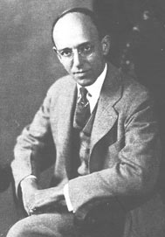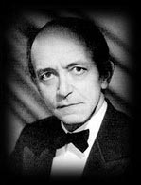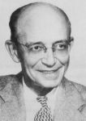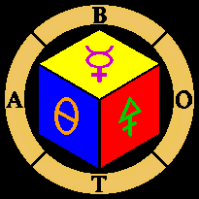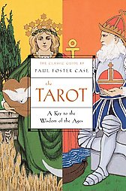
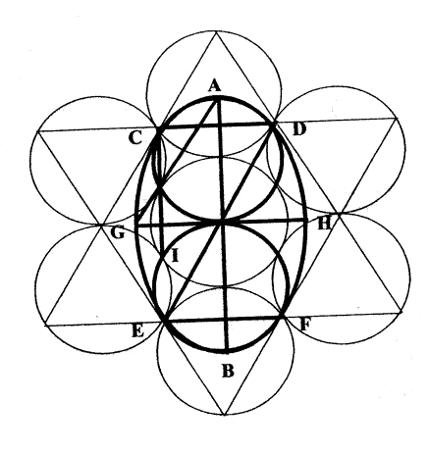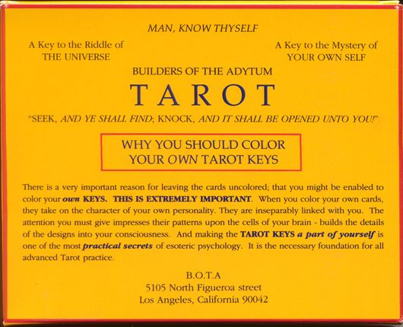

Paul Foster Case (October 3, 1884 – March 2, 1954) was an American occultist of the early 20th Century and author of numerous books on Tarot and Qabalah. Perhaps his greatest contributions to the field of occultism were the lessons he wrote for associate members of Builders of the Adytum. The Knowledge Lectures given to initiated members of the Chapters of the B.O.T.A. were equally profound, although the limited distribution has made them less well known.

Contents
- 1 Case's early life
- 2 Case's dilemma: music or the mysteries
- 3 Whitty and Alpha et Omega
- 4 The controversy with Mathers
- 5 Builders of the Adytum
- 6 Case's Views on Enochian
- 7 Case's death
- 8 Significant influences in Case's life
- 9 Case's writings
- 10 His legacy
- 11 See also
- 12 Bibliography
  - 12.1 External History Sites
- 13 External links
  - 13.1 Original texts
  - 13.2 Online resources

Case's early life
A modern scholar of the Tarot and Qabalah, Paul Foster Case was born at 5:28 p.m., October 3, 1884 in Fairport, New York.
His father was the town librarian and a Deacon at the local Congregational church. When he was five years old, his mother began teaching him to play the piano and organ, and later in his youth, Case performed as organist in his family's church. A talented musician, he embarked on a successful career as a violinist, and orchestra conductor.
Case was early on attracted to the occult. While still a child he reported experiences that today are called lucid dreaming. He corresponded about these experiences with Rudyard Kipling who encouraged him as to the validity of his paranormal pursuits.
In the year 1900, Case met the occultist Claude Bragdon while both were performing at a charity performance. Bragdon asked Case what he thought the origin of playing cards was. After pursuing the question in his father's library, Case discovered a link to Tarot, called 'The Game of Man,' thus began what would become Case's lifelong study of the Tarot.
Between 1905 and 1908 (aged 20-24), Case began practicing yoga, and in particular pranayama, from what published sources were available. His early experiences appear to have caused him some mental and emotional difficulties and left him with a lifelong concern that so called "occult" practice be done with proper guidance and training.
In the summer of 1907, Case read The Secret of Mental Magic, by William W. Atkinson (aka Ramacharacka) which led him to correspond with the then popular new thought author. Many people have speculated that Case and Atkinson were two of the three anonymous authors of The Kybalion, an influential philosophical text.

Case's dilemma: music or the mysteries
Case reported a meeting on the streets of Chicago, in 1909 or 1910, that was to change the course of his life. A "Dr. Fludd," a prominent Chicago physician approached the young Case and greeting him by name, claimed to have a message from a "Master of Wisdom" who, the Doctor said, "is my teacher as well as yours."
The stranger said that Case was being offered a choice. He could continue with his successful musical career and live comfortably, or he could dedicate himself to "serve humanity" and thereby play a role in the coming age.
From that time on, Case began to study and formulate the lessons that served as the core curricula of the Builders of the Adytum, the school of Tarot and Qabalah that Case founded and that continues in operation.
In 1916 Case published a groundbreaking series of articles on the Tarot Keys, titled "The Secret Doctrine of the Tarot," in the popular occult magazine The Word. The articles attracted wide notice in the occult community as organizing and clarifying what had been confusing and scattered threads of occult knowledge as illustrated and illuminated by the Tarot.

Whitty and Alpha et Omega
In 1918, Case met Michael Whitty, who was the editor of the magazine Azoth (and would become a close friend). Whitty was serving as the Cancellarius (Treasurer/Office Manager) for the Thoth-Hermes Lodge of the Alpha et Omega. Alpha et Omega was S. L. MacGregor Mathers' group that formed after the demise of the original Hermetic Order of the Golden Dawn. Whitty invited Case to join Thoth-Hermes, which Case did. Case's aspiration name in A.'.O.'. was Perserverantia (perseverance).
Whitty republished Case's attribution of the Tarot keys (with corrections) in Azoth. That same year, Case became Sub-Praemonstrator (Assistant Chief-Instructor) at the Thoth-Hermes Lodge. The following year, he began to correspond with Dr. John William Brodie-Innes (Fr. Sub Spe).
Between 1919 and 1920, Case and Michael Whitty collaborated in the development of the text which would later be published as The Book of Tokens. This book was written as a received text, whether through meditation, automatic writing, or some other means. It later surfaced that Master R. was the source. On May 16, 1920 Case was initiated into Alpha et Omega's Second Order. Three weeks later, according to the Hermetic Order of the Golden Dawn's bio-page on Case, he was named Third Adept.
In December of 1920, Michael Whitty died. Case believed Whitty's health problems were attributable to the dangers that arise or may arise in the handling of Enochian magic. He later corresponded with Israel Regardie about those concerns.

The controversy with Mathers
Some have alleged that it was "because of his quick advancement through the Grades of the Order [that] sparked some jealousy among the other Adepts" or that some of his teachings seemed unsuitable. Whatever the real facts, on July 18, 1921, Moina Mathers wrote to Case about concerns that had been voiced to her about some of his teachings.
In her July 18th letter, she told Case, "You evidently have reached a point in your mystical Way where there would appear to exist certain cross-roads. The artist in you, which I recognize, and with whom I deeply sympathize, would probably choose to learn the Truth through the joy and beauty of physical life."
"You who have studied the Pantheons, do you know of that enchanting God, the Celtic Angus, the Ever Young? He who is sometimes called Lord of the Land of Heart's Desire? The artist in us may have lingered in that land for a moment. But you and I who would be teachers and pioneers in this Purgatorial World must be prepared before all the Gods to be the servants of the greatest of them all... the Osiris, the Christ, the God of the Sacrifice of the Self."
And so Moina Mathers asked Case to resign as Praemonstrator which he did. Apparently Case had already begun work on establishing a Mystery School of his own.

Builders of the Adytum
After Case left Alpha et Omega, he vigorously pursued the organization of his own Mystery School. In the summer of 1922, Case put his first efforts together preparing a comprehensive correspondence course. In one year it covered what the B.O.T.A. presently cover in over five years. He called the course The Ageless Wisdom, and it covered just about the whole of Hermeticism. By 1923 Case formed The School of Ageless Wisdom, probably in Boston.
Within a few years he moved to Los Angeles, abandoning, once and for all, his career as a musician, and established the Builders of the Adytum (B.O.T.A.). Still in existence today, B.O.T.A. is an authentic Mystery School. Over the next three decades, Case organized the curriculum of correspondence lessons covering practically the whole corpus of what is called the Western Mystery Tradition; Tarot, Qabalah, and Alchemy.

Case's Views on Enochian
In the "Wheel of Life" Magazine, in March 1937, Case described B.O.T.A.'s relationship to the Golden Dawn, and his views on the Golden Dawn's use of Enochian material.
"B.O.T.A. is a direct off-shoot of the Golden Dawn, but its work has been purged of all the dangerous and dubious magic incorporated into the Golden Dawn's curriculum by the late S.L. MacGregor Mathers, who was responsible for the inclusion of the ceremonials based on the skrying of Sir Edward Kelly.
"There is much in these Golden Dawn rituals and ceremonies that is of the greatest value; but from the first grade to the last it is all vitiated by these dangerous elements taken from Dee and Kelly. Furthermore, in many places, the practical working is not provided with adequate safeguards, so that, to the present writer's personal knowledge, an operator working with the Golden Dawn rituals runs very grave risks of breaking down his physical organism, or of obsession by evil entities."

Case's death
Case died easily while vacationing in Mexico with his second wife, Harriet. His ashes lie in Forest Lawn Memorial Park in Glendale, California.

Significant influences in Case's life
Master R.
In the summer of 1921, Case received a phone call from The Master Rococzy. Case later met The Master R. in person at the Hotel Roosevelt in NYC (Madison and Lexington Avenues at 43rd Street).
The Adytum News described it this way: "One day the phone rang, and much to his surprise the same voice which had been inwardly instructing him in his researches for many years spoke to him on the phone. It was the Master R. who had come personally to New York for the purpose of preparing Paul Case to begin the next incarnation of the Qabalistic Way of Return. ... After three weeks of personal instruction with the Master R., Builders of the Adytum was formed."
Lilli Geise
Case's first wife was Lilli Geise, a soror of the Golden Dawn, but the marriage was short lived when she died a few years later (May 9, 1924).
Harriet B. Case (1893-1972)
In 1943 Case married Harriet.
Ann Davies (1912-1975)
In 1943 Case was introduced to Ann Davies. She walked into one of his classes with her sister. Later, Ann and her small daughter Bonnie moved into the Cases' house where they helped by fixing meals, mimeographing lessons, etc.
Liberal Catholic Church
The Liberal Catholic Church was established in England in 1916 out of the failing Old Catholic missionary effort there. The erratic Old Catholic bishop, Arnold Harris Matthew, had filled his clergy ranks with a number of English Theosophists and Golden Dawn Qabalists, all dedicated students of the Ageless Wisdom, which underlies all the world's great religions including Christianity. When Matthew left the movement, he left a valid apostolic succession in the hands of men prepared to teach the Ageless Wisdom and mystical Christianity, and to offer valid Catholic sacraments to all and sundry, but especially to religious non-conformists. Case was ordained a priest by Bishop Charles Hampton in the Liberal Catholic Church in Ojai, California, in 1937, and served parishes throughout the southern California area.
Masonic Affiliations
According to the membership archives of the Grand Lodge, F. & A.M. of California and an unpublished biography of Case written by the archivist of the Builders of the Adytum.
Fairport Lodge No. 476, Fairport, New York.
- Initiated: March 22, 1926
- Passed: April 12, 1926
- Raised, June 28, 1926
Hollenbeck Lodge No. 319, Los Angeles
- Affiliated: September 5, 1944
- Demitted: June 2, 1953
Eagle Rock Lodge No. 422, Los Angeles
- Affiliated: June 2, 1953

Case's writings
Articles:
- Article on Tarot in "The Word" (1916)
- Article on Tarot (revised) in "Azoth Magazine" (1918)
Books:
- The Kybalion (1912) [with William A. Atkinson]
- An Introduction to the Study of the Tarot (1920)
- A Brief Analysis of the Tarot (1927)
- The True and Invisible Rosicrucian Order (1927)
- Correlations of Sound & Color (1931)
- The Highlights of Tarot (1931)
- The Book of Tokens (1934)
- The Great Seal of the United States (1935)
- Progressive Ratoscope (1936)
- The Open Door (1938)
- The Tarot: A Key to the Wisdom of the Ages (1947)
- Daniel, Master of Magicians
- The Masonic Letter G
- The Name of Names

His legacy
Case left behind extensive published writings on Tarot and Qabalah and even more unpublished writings that are circulated today through the Mystery School he founded.
Some of the wording from "The Book of Tokens" was used in the Tarot-inspired musical episode of Xena: Warrior Princess entitled The Bitter Suite.

See also
- Western mystery tradition
- Kabbalah
- Tarot
- Mysticism
- Esotericism
- List of spirituality-related topics

Bibliography
- Research by Lee Moffitt

External History Sites
- From the Golden Dawn
- From a Tarot enthusiast
- From the Esoteric Golden Dawn
- From the Masons
- A Case Enthusiast

External links

Original texts
Writings of Case and his contemporaries
- Fraternity of the Hidden Light PFC Archives
- An Introduction to the Study of Tarot, HTML

Online resources
Online information on Case and his work
- Builders of the Adytum (B.O.T.A.)
- Fraternity of the Hidden Light (F.L.O.)
Online fora discussing Case and his work
- The Paul Foster Case Discussion Forum
- The PFC Book Discussion Forum
- The Achad Discussion Forum for students of B.O.T.A., B.O.T.A. Europe, F.L.O, & Artisans of Light
Online resources reflecting the work of Case or his students
- Divine Paradox The Ageless Wisdom in Action
- Joyous World Examples of the Qabalah and Tarot
- Joseph Nolen Essays The complete set of the Inner Journey Newsletters written by Joseph Nolen, past President of BOTA, 40 year student of Ann Davies and Paul Case, some say a master of Ageless Wisdom.
- The Paul Foster Case Resource Page PFC Resources and materials
============================================================================================================

Paul Foster Case
October 3, 1884 - March 2, 1954

http://golden-dawn.org/biocase.html

Paul Foster Case was born in Fairport, New York. His mother was a teacher and his father was the head librarian of the town library, in which Paul Case was literally born. For a man whose thirst for hidden knowledge was unquenchable, he could not have been born into more fortunate circumstances.
Paul learned to read at a very young age. By the age of four he was found pouring over "forbidden books" in the attic of his father's library. He was also found to have extraordinary musical talent at an early age, and at the age of three began training in piano and organ. At the age of nine, he was the organist at the Congregational Church in which his father was deacon.
At the age of seven, Case began correspondence with Rudyard Kipling, who verified the "fourth-dimensional" experiences Case was having as being not merely imaginary, but actual states of being. At this early age, Case found that he had the ability to consciously manipulate his dreams.
At sixteen, Case met the occultist Claude Bragdon, as they had both donated their talents to a charity performance. It was in this meeting that Paul Case got his first "directive". Bragdon asked Case, "Where do you think the playing cards come from?" This simple question sparked an immediate search for the origins and uses of Tarot. Within a very short period of time, Case had collected every book and every set of Tarot Keys available. He spent years researching, studying, and meditating on these archetypal images.
Case described his experience at the time as definitely "guided" by an inner voice. In his view, the experience with Tarot had stimulated an "inner hearing", through which he was guided to the many attributes of Tarot which were published before he was 21 years old. Perhaps Eliphas Levi's statement on Tarot best summarized its influence on the young Paul Case: "As an erudite Kabalistic book... A prisoner devoid of books, had he only a Tarot of which he knew how to make use, could in a few years acquire a universal science, and converse with unequaled doctrine and inexhaustible eloquence."
While in New York, Case was approached by Michael Whitty, the Praemonstrator of the Thoth-Hermes Temple of the Golden Dawn (Alpha et Omega). Whitty, having heard of Case's extensive knowledge of the Western Mystery Tradition and having read some of his published works, invited Case into the Order. Case naturally accepted the offer, and moved through the Outer Grades quickly. He was initiated into the Second Order on May 16, 1920, with the magical motto, Perseverantia. Just three weeks later, he was the Third Adept in the annual Corpus Christi ceremony.
He soon became known as the most knowledgeable occultist in the New York temple, and succeeded Michael Whitty as Praemonstrator within a year of his acceptance into the Second Order. Despite Case's attainments, he did have considerable difficulty with the system of Enochian Magic. Ultimately, he concluded that the Enochian system was demonic rather than angelic. His Order, the B.O.T.A., excludes all mention of Enochian from its curriculum.
Because of his quick advancement through the Grades of the Order, Case may have sparked some jealousy among the other Adepts. Moreover, others may have thought some of his teachings inappropriate. On July 18, 1921, Moina Mathers wrote Case regarding complaints she had received regarding some of his teachings. Apparently, Case had begun discussing the topic of sex magic, which at the time had no official place in the Order curriculum. Since no knowledge lectures exist on the subject, whether sex practices were ever taught in the Golden Dawn has been a long standing question. In her correspondence with Case, Moina wrote, "...I have seen the results of this superficial sex teaching in several Occult Societies as well as in individual cases. I have never met with one happy result."
But to Case, sexuality became an increasingly important subject. In his Book of Tokens, a collection of inspired meditations on the 22 Tarot Keys of the Major Arcana, Case comments on the sex function, "You must wholly alter your conception of sex in order to comprehend the Ancient Wisdom... It is the interior nervous organism, not the external organs, that is always meant in phallic symbolism, and the force that works through these interior centers is the Great Magical Agent, the divine serpent fire." In his works, The True and Invisible Rosicrucian Order and The Masonic Letter G, he writes of certain practices involving the redirection of the sexual force to the higher centers of the brain where experience of supersensory states of consciousness becomes possible.
Some members also complained about a personal relationship between Case and a soror, Lilli Geise. Case confessed the matter to Moina: "The Hierophantria and I were observed to exchange significant glances over the altar during the Mystic Repast... My conscience acquits me... Our relation to each other we submit to no other Judge than that Lord of Love and Justice whom we all adore." In time, Case married Geise, who died a few years later.
Perhaps Moina's correspondence also touched a sensitive area for Case. In her July 18th letter, she tells Case, "You evidently have reached a point in your mystical Way where there would appear to exist certain cross-roads. The artist in you, which I recognize, and with whom I deeply sympathize, would probably choose to learn the Truth through the joy and beauty of physical life." She continued, "You who have studied the Pantheons, do you know of that enchanting God, the Celtic Angus, the Ever Young? He who is sometimes called Lord of the Land of Heart's Desire?" Angus rescued Etain, the Moon, who had been turned into a golden fly. But Etain had to choose between bodily existence in the land of mortals and everlasting life. She continued still, "The artist in us may have lingered in that land for a moment. But you and I who would be teachers and pioneers in this Purgatorial World must be prepared before all the Gods to be the servants of the greatest of them all... the Osiris, the Christ, the God of the Sacrifice of the Self." Moina then asked Case to resign from his position as Praemonstrator.
Case resigned as Praemonstrator, responding to Moina, "...I have no desire to be a 'teacher and pioneer in this Purgatorial World.' Guidance seems to have removed me from the high place to which I have never really aspired. The relief is great." This seems odd coming from a man who would, in a few years, abandon his artistic endeavors to start his own occult school, the Builders of the Adytum (B.O.T.A.). Perhaps this struggle between his artistic soul and his mystical soul pre-existed his involvement with the Order, and maybe Moina knew this. Archives at the B.O.T.A. state that on one occasion years before he joined the Order, Case was approached by a stranger on the streets of Chicago who called him by name and told him many things about himself. "Your teacher is my teacher," the man told him. He told Case that he must choose between a life of material comfort as a musician and a life of suffering and renunciation as a vitally needed teacher of the Mysteries. The former would offer him "more of this world's goods than most"; the latter, important service to mankind and eternal life, and that, "In the end, you will not starve to death."
After Case was expelled from the Order, he pursued the creation of his own occult school, the School of Ageless Wisdom. This organization failed within a few years. However, he soon moved to Los Angeles, abandoning his lucrative career as a musician, and established the Builders of the Adytum (B.O.T.A.). Still in existence today, it has proven to be a successful correspondence course on Tarot.
Geise wrote to Moina that students from other temples were flocking to hear Case speak prior to his being expelled. Mrs. Elma Dame, The Imperatrix of the Philadelphia Temple, who resigned due to the numerous problems in the Order at the time, pointed to the need for a knowledgeable teacher in America. She wrote to Moina: "When you got rid of Mr. Case, you 'killed the goose that laid the golden egg.'" Dr. Pullen Burry, a former Order member, concluded that Case was the one to bring "the light of the old R.C. [Rosicrucian] teachings" into the light of Aquarian consciousness. Case's book, The True and Invisible Rosicrucian Order, stands as a classic Qabalistic interpretation of the Rosicrucian Fama Fraternitatis and Confessio.
Case died easily while vacationing in Mexico with his second wife, Harriet. Fortunately, he left behind extensive writings on Tarot and Qabalah, and is considered by many to be a true "teacher and pioneer in this Purgatorial World."

=====================================================================================================
http://freemasonry.bcy.ca/biography/esoterica/case_p/case_p.html

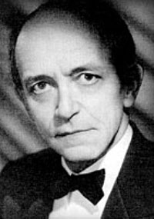

October 3, 1884 - March 2, 1954
Founder of the Los Angeles occult school, the Builders of the Adytum (B.O.T.A.), Paul Foster Case also wrote such books as The Book of Tokens, a collection of meditations on the 22 Tarot Keys of the Major Arcana.
He was initiated into the Second Order of the Thoth-Hermes Temple of the Golden Dawn (Alpha et Omega) on May 16, 1920, while in New York.
Initiated: March 22, 1926
Passed: April 12, 1926
Raised, June 28, 1926
Fairport Lodge No. 476, Fairport, New York.
Affiliated: September 5, 1944
Demitted: June 2, 1953
Hollenbeck Lodge No. 319, Los Angeles
Affiliated: June 2, 1953
Eagle Rock Lodge No. 422, Los Angeles
Source: membership archives of the Grand Lodge, F. & A.M. of California; and an unpublished biography of Case written by the archivist of the Builders of the Adytum.

=======================================================================================================================

