Old Gypsy Fortune Telling Cards
The review that started it all! The seed that sprouted and became my first published book Gypsy Fortunes
© 1940 by Whitman Publishing Co.
deck review and request by Lady Lorelei, CTR
© 2004 by Lady Lorelei CTM
Somewhat unexpectedly, Mom surrendered all her tarot-related decks to me last summer. Unexpected because I thought the James Bond 007 Tarot of the Witches deck and the Eden Gray book she gave me years ago were all she had. Along with yet another Waite deck and the Duke University Parapsychology Lab ESP deck, was a funny little deck of 36 cards still in the box marked “Old Gypsy Fortune Telling Cards”. Mom played with them as a little girl and had kept them all these years.
The cards are simple drawings with water color or comic book type illustrations. There are no suits, no major or minor arcana, only the numbering from 1 to 36. Still, one recognizes tarot paradigms (or archetypes) such as 1 and 2, the Sun and Moon, and 14 and 15, the Queen and King. I have found studying the images no different from studying the images of a regular deck. And though the images seem very different, have found very similar meanings, for me. My short interpretations follow this review and request below.
For example, card number 34 The Train. To me this is about forward momentum and being on track. Also, a business journey. Keep the wheels turning. This is positive for business enterprises. Your job is going somewhere. All of these ideas tie in to the 7 of Pentacles in the Smith Waite deck, or hope, where the picture is of a man who has done his work and is now waiting for the results, or the fruits of his labor. He’s on track, he’s crossed all his t’s and is headed for something positive, yet he has to wait for the fruit to ripen, or in the case of card 34, for the train to reach its destination.
Some of the cards pictured present new ideas. Card number 19, Clasped Hands shows a Noblewoman and a Cavalier who have agreed on something and are sealing the bargain with clasped hands. This evokes the concept of a promise, of being bound to one’s word, and of being faced with a promise that one cannot keep.
Some of the cards are just plain fun like card 25 The Cloverleaf, 17 The Stork, and 23 The Mice which shows 3 mice eating cheese under a bridge while a thief runs from a ladder.
Though it seems to belong to a bygone era, I do offer readings with this deck. I wish to thank everyone who, over the years, has sent me information on card #5 and other such odd decks handed down by their grandmother. And I especially wish to thank Sarah Tomley of Quarto Publishing in London for choosing me to write the book to accompany the re-issue of this deck in 2003. I acquired a complete deck from ebay, since mine was missing card #5. So that’s taken care of. And now my request is: if anyone knows of any odd, old, rare decks, please send images or any information to:
email: lorelei@tarotgoddess.net
Lorelei’s Card Meanings
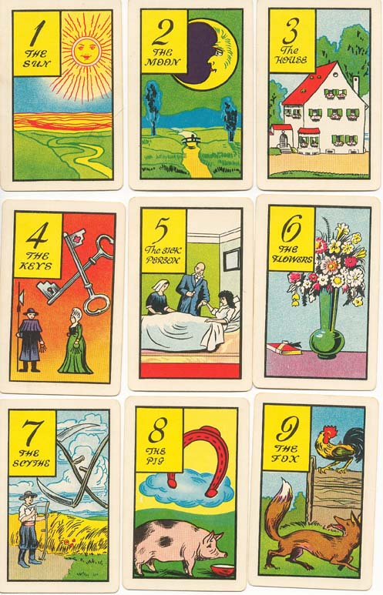
I grouped them in tens for the purposes of the exercise I was doing at the time, though I did not discern a suit as such. They seem more to be 36 Trumps or major arcana.
1-10
ACE
TITLE: The Sun
KEYWORD: blessings
Symbols: A bright yellow sun with many red rays shines above a river flowing from the mountains to the sea.
IN A READING, I AM: lucky and happy
MEANING: This is about sunshine and happiness, the joy of childhood. Seeing through the eyes of a child. Taking time to smell the roses. Appreciating, thanksgiving.
TWO
TITLE: The Moon
KEYWORD: illusion
Symbols: An eclipsed sickle moon shines squarely over a bridge crossing a river. There is a small figure, perhaps two on the bridge.
IN A READING, I AM: navigating through a maze in the dark
MEANING: things are not what they seem. Are you on the right path? Is your information good and true? Be doubtful. Get a second opinion.
THREE
TITLE: The house
KEYWORD: security, home
Symbols: white 3-story house with red shingles and green shutters. There are flower boxes in every window
IN A READING, I AM: secure
MEANING: Smell the fresh bread baking. This is home in all its comfort and familiarity. This is the place we return to at the end of a busy day, where we can let our hair down.
FOUR
TITLE: The Keys
KEYWORD: what you need
Symbols: a pair of crossed keys above a pair of Quaker-looking people who are both holding a ring of keys
IN A READING, I AM: holding what I need, now I must utilize it
MEANING: Describes the key element of a situation. Uncovers what can be used to unlock the solution to a problem. The watchman and the housewife hold the keys; they are in charge of ingredients for success.
FIVE
TITLE: The Sick Person
KEYWORD: illness, dis-ease
Symbols:
IN A READING, I AM: ill
MEANING: from the book: “If this card is near the subject’s card, there will be a great misfortune. If this card lies near the dog (card 21) it means the loss of a friend.” After seeing the card, I was struck by the presence of both a doctor and a nurse along with the Sick Person, and thus I take it to have more of a connotation of recovery, and this too shall pass. Help is at hand.
SIX
TITLE: The Flowers
KEYWORD: gift
Symbols: a vase of wild-flowers towers over a wrapped box
IN A READING, I AM: gifted
MEANING: these are presents given by the universe, the Goddess, by your friend, your parents, your teachers. Use your gifts. Give to others.
SEVEN
TITLE: The Scythe
KEYWORD: ethics
Symbols: A boy in Amish garb sharpens a scythe next to a wheat field. two scythes are crossed in the sky
IN A READING, I AM: executing my decision
MEANING: This is about the duality of cutting away the necessary bad thing, and harvesting the good thing. A surgeon’s knife can cut away a cancer to heal. Cull the rotten wheat to keep the good from spoiling. We cut wheat, a live thing, so that we can eat.
EIGHT
TITLE: The Pig
KEYWORD: the eternal soul, I am not this body
Symbols: A nude woman dances on a cloud looking astonishingly like the World in popular decks. Under the cloud and fat, sad-looking pig looks at an empty food bowl.
IN A READING, I AM: Not seeing what’s going on behind the front I’ve been given.
MEANING: When pigs fly, the ugly duckling. the silver lining and the cloud. Look behind the façade. More than meets the eye.
NINE
TITLE: The Fox
KEYWORD: trouble
Symbols: A fox has his tongue hanging out as he eyes the rooster on top of the fence.
IN A READING, I AM: in danger
MEANING: There is a fox in the chicken coop. Beware, watch out. This is the warning bark of the barn yard dog who smells the fox.
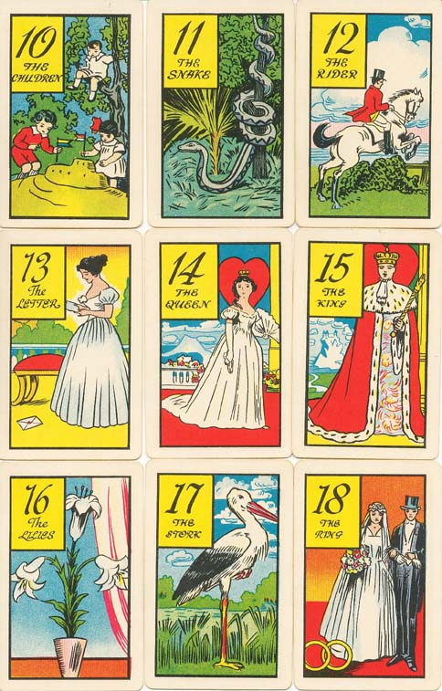
TEN
TITLE: The Children
KEYWORD: Seclusion
Symbols: 2 children plant flags in a sand castle. A third watches from a tree branch
IN A READING, I AM: surveying from the heights by my own choice
MEANING: Everyone should be included though some may be different. This is about cliques, in/out groups, belonging. Some of us are introverts and some extroverts. We won’t find a common ground if we keep ourselves up in a tree.
11-20
ACE: 11
TITLE: The Snake
KEYWORD: Temptation
Symbols: A very long snake coils down a tree. Its head and neck are free on the ground. It has a forked tongue. In a dark forest|
IN A READING, I AM: Considering a choice that I think is too good to be true.
MEANING: Ware the hidden catch, the strings attached. Don’t sell out for glitter. Examine the essense. Don’t let your weakness rule you.
TWO 12
TITLE: The Rider
KEYWORD: Control
Symbols: A rider dressed for the hunt jumps his white horse over a bush and rail fence. It’s a bright day with high clouds. There is a lake in the distance.
IN A READING, I AM: Utilizing all my resources to overcome an obstacle and reach a goal.
MEANING: The hunt/jump takes years of training and an excellent relationship between the horse and rider. The rider is in control and makes the decisions. Going forward, moving ahead, overcoming an obstacle.
THREE 13
TITLE: The Letter
KEYWORD: News
Symbols: A beautiful brunette is a white dress is so engrossed in the letter that she has let the envelope fall to the floor.
IN A READING, I AM: Learning something unexpected.
MEANING: Something unexpected has arrived. There is something to be learned. There is new information pending. You should seek new information.
FOUR 14
TITLE: The Queen
KEYWORD: Soulmate
Symbols: heart, fan, crown
IN A READING, I AM: a good spouse and parent
MEANING: Equivalent to Queen of Cups, or all Queens: widow, friend, security.
FIVE 15
TITLE: The King
KEYWORD: Authority
Symbols: heart, scepter, crown, ermine robe, castle in the distance.
IN A READING, I AM: responsible and accountable.
MEANING: King of cups = law; or all kings: ethics, adept, honest.
SIX 16
TITLE: The Lilies
KEYWORD: Life, Ankh
Symbols: A pot of three Easter Lilies blooms next to a curtain at a window.
IN A READING, I AM: properly situated.
MEANING: Easter, spring. White, purity. Happy and long life, high standards.
SEVEN 17
TITLE: The Stork
KEYWORD: Arrival
Symbols: A stork stands on one leg in a marsh
IN A READING, I AM: going to get what I want.
MEANING: The stork brings the baby. Wish. Flight of fancy.
EIGHT 18
TITLE: The Ring
KEYWORD: Marriage
Symbols: bride and groom, crossed rings
IN A READING, I AM: committed to this partnership.
MEANING: The couple look depressed. This is about the work and commitment that will make it work in the long haul. Effort is required, but the reward is security and support.
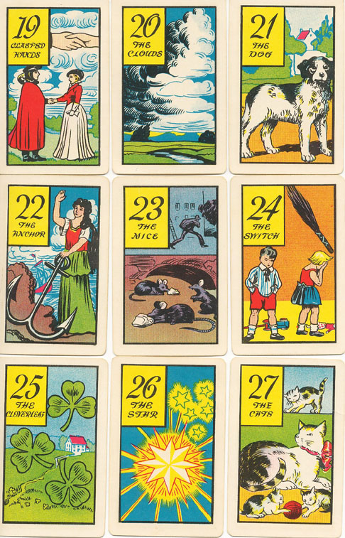
NINE 19
TITLE: Clasped Hands
KEYWORD: promise
Symbols: A Lady and A Cavalier have agreed on something.
IN A READING, I AM: bound to my word.
MEANING: Don’t make a promise you cannot keep.
TEN 20
TITLE: The Clouds
KEYWORD: Change.
Symbols: both white and dark clouds
IN A READING, I AM: influenced by external forces.
MEANING: Silver lining, storm coming or just passed.
21-30
ACE: 21
TITLE: The Dog
KEYWORD: Loyal
Symbols: Black and white, spaniel-type dog. A house and trees in the background.
IN A READING, I AM: faithful
MEANING: Dogs are loyal, obsequious, human’s best friend, needy; a responsibility. This can be someone who needs care or a good friend.
TWO 22
TITLE: The Anchor
KEYWORD: Journey’s End
Symbols: A woman with long dark hair has one hand raised and the other on a large anchor. She stands high on a cliff. There is a boat in the sea behind her.
IN A READING, I AM: finishing a phase.
MEANING: permanence, grounding, basis. Landed. Success in business.
THREE 23
TITLE: The Mice
KEYWORD: Theft
Symbols: 3 mice eat cheese under a bridge while a thief runs from a ladder.
IN A READING, I AM: being stolen from.
MEANING: Someone is sneaking around. Something is hidden. Loss is imminent.
FOUR 24
TITLE: The Switch
KEYWORD: Punishment
Symbols: A girl hides her face in shame. A boy scowls. There is a besom in the air and toys on the floor.
IN A READING, I AM: going to get punished.
MEANING: Troubles in family matters. Dispute, argument. Could be one of those meaningless, irresolvable cases where it’s better to agree to disagree.
FIVE 25
TITLE: The Cloverleaf
KEYWORD: Luck
Symbols: 3 three-leaf clovers
IN A READING, I AM: getting good luck
MEANING: Things are going my way. The universe is giving me a break. I need to make my own luck by getting out and trying.
SIX 26
TITLE: The Star
KEYWORD: Inspiration
Symbols: One big bright, many-pointed star with 2 6-pointed and 3 5-pointed stars.
IN A READING, I AM: receiving inspiration.
MEANING: Psychic visions, universal truths, great ideas.
SEVEN 27
TITLE: The Cats
KEYWORD: Nurture
Symbols: Mother cat with 3 kittens.
IN A READING, I AM: mothering mischievous persons.
MEANING: Mischievous, playful. Catty, independent. Watch out for catty people and flattery, like the cat that rubs against you when it wants fed.
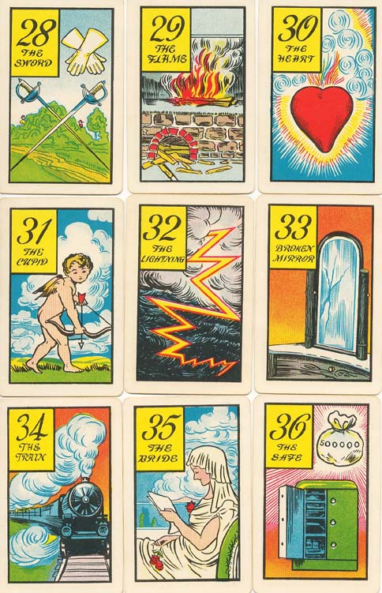
EIGHT 28
TITLE: The Sword
KEYWORD: Challenge
Symbols: Crossed rapiers, crossed gauntlets. Two men hiding in bushes by the road.
IN A READING, I AM: under attack.
MEANING: Rise to the challenge. Be careful on your journey. Don’t accept the duel if it is not worth it to you.
NINE 29
TITLE: The Flame
KEYWORD: Energy
Symbols: The is a wood pile spilling out of what looks like a stone hearth. On top of that is a fire burning brightly and smoke going up the chimney.
IN A READING, I AM: influenced by the Fire Elemental.
MEANING: This card reinforces favorable cards and weakens unfavorable cards. Fire, South, courage, passion, strength, bravery, energy. Union of Air and Earth. Burn up, burn out. Better to burn out than fade away.
TEN 30
TITLE: The Heart
KEYWORD: true heart
Symbols: red heart surrounded by a rainbow and culicues of air.
IN A READING, I AM: in touch with my center.
MEANING: This is your true heart, what you want, who you are, what you need.
31-36
ACE: 31
TITLE: The Cupid
KEYWORD: Lust
Symbols: Naked baby angel with bow and arrow.
IN A READING, I AM: greedy.
MEANING: Watch out! You think it’s love, but is it? Sense gratification. Temporary, illusory. Not satisfying in the long run.
TWO 32
TITLE: The Lightning
KEYWORD: Upheaval
Symbols: Huge lightning strike through dark clouds.
IN A READING, I AM: experiencing upheaval.
MEANING: Like the Tower, sudden huge, unexpected change. Kick in the astral. Change your paradigm.
THREE 33
TITLE: Broken Mirror
KEYWORD: Bad Luck
Symbols: A cracked dresser mirror.
IN A READING, I AM: screwed.
MEANING: This is a Mercury time period. Nothing goes right and it’s really not your fault. Bad karma. Stick it out, try to minimize it.
FOUR 34
TITLE: The Train
KEYWORD: forward momentum
Symbols: Steam engine-led train on tracks.
IN A READING, I AM: on track.
MEANING: Business journey. Keep the wheels turning. This is positive for business enterprises. Your job is going somewhere. You are on track.
FIVE 35
TITLE: The Bride
KEYWORD: Hope
Symbols: A bride reads papers and holds red roses, seated by a lake.
IN A READING, I AM: hoping.
MEANING: Great marriage. Great expectations. The future is favorable for this endeavor.
SIX 36
TITLE: The Safe
KEYWORD: Propserity
Symbols: A bag with 500,000 on it is suspended over a green safe that has one door open.
IN A READING, I AM: safe.
MEANING: Earth, pentacles, wealth. Financial, physical security.

