WHAT IS TAI CHI?

http://www.chebucto.ns.ca/Philosophy/Taichi/what.html

The Chinese characters for Tai Chi Chuan can be translated as the 'Supreme Ultimate Force'. The notion of 'supreme ultimate' is often associated with the Chinese concept of yin-yang, the notion that one can see a dynamic duality (male/female, active/passive, dark/light, forceful/yielding, etc.) in all things. 'Force' (or, more literally, 'fist') can be thought of here as the means or way of achieving this ying-yang, or 'supreme-ultimate' discipline.
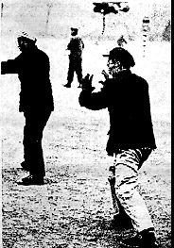
Tai Chi, as it is practiced in the west today, can perhaps best be thought of as a moving form of yoga and meditation combined. There are a number of so- called forms (sometimes also called 'sets') which consist of a sequence of movements. Many of these movements are originally derived from the martial arts (and perhaps even more ancestrally than that, from the natural movements of animals and birds) although the way they are performed in Tai Chi is slowly, softly and gracefully with smooth and even transitions between them.
For many practicioners the focus in doing them is not, first and foremost, martial, but as a meditative exercise for the body. For others the combat aspects of Tai Chi are of considerable interest. In Chinese philosophy and medicine there exists the concept of 'chi', a vital force that animates the body. One of the avowed aims of Tai Chi is to foster the circulation of this 'chi' within the body, the belief being that by doing so the health and vitality of the person are enhanced. This 'chi' circulates in patterns that are close related to the nervous and vascular system and thus the notion is closely connected with that of the practice of acupuncture and other oriental healing arts.
Another aim of Tai Chi is to foster a calm and tranquil mind, focused on the precise execution of these exercises. Learning to do them correctly provides a practical avenue for learning about such things as balance, alignment, fine-scale motor control, rhythm of movement, the genesis of movement from the body's vital center, and so on. Thus the practice of Tai Chi can in some measure contribute to being able to better stand, walk, move, run, etc. in other spheres of life as well. Many practitioners notice benefits in terms of correcting poor postural, alignment or movement patterns which can contribute to tension or injury. Furthermore the meditative nature of the exercises is calming and relaxing in and of itself.
Because the Tai Chi movements have their origins in the martial arts, practicing them does have some martial applications. In a two-person exercise called 'push-hands' Tai Chi principles are developed in terms of being sensitive to and responsive of another person's 'chi' or vital energy. It is also an opportunity to employ some of the martial aspects of Tai Chi in a kind of slow-tempo combat. Long-time practitioners of Tai Chi who are so-inclined can become very adept at martial arts. The emphasis in Tai Chi is on being able to channel potentially destructive energy (in the form of a kick or a punch) away from one in a manner that will dissipate the energy or send it in a direction where it is no longer a danger.
The practical exercises of Tai Chi are also situated in a wider philosophical context of Taoism. This is a reflective, mystical Chinese tradition first associated with the scholar and mystic Lao Tsu, an older contemporary of Confucius. He wrote and taught in the province of Honan in the 6th century B.C. and authored the seminal work of Taoism, the Tao Te Ching. As a philosophy, Taoism has many elements but fundamentally it espouses a calm, reflective and mystic view of the world steeped in the beauty and tranquillity of nature.
Tai Chi also has, particularly amongst eastern practitioners, a long connection with the I Ching a Chinese system of divination. There are associations between the 8 basic I Ching trigrams plus the five elements of Chinese alchemy (metal, wood, fire, water and earth) with the thirteen basic postures of Tai Chi created by Chang San-feng. There are also other associations with the full 64 trigrams of the I Ching and other movements in the Tai Chi form.

THE STYLES OF TAI CHI CHUAN

Over time there have evolved a variety of styles or schools of Tai Chi Chuan. These reflect both a growth and devlopment of the form in general, as well as differences of style and emphasis between different techers. Elements of other martial arts forms have made themselves felt in Tai Chi, and this has changed its character as well.
Most of the different schools or styles of Tai Chi have been given the surnames of their founders. The following are the principal schools of Tai Chi that are in existance today.
- Chen Style
- Hao (or Wu Shi) Style
- Hu Lei Style
- Sun Style
- Wu Style
- Yang Style
- Zhao Bao Style

THE CHEN STYLE OF TAI CHI

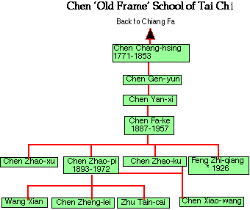
There are two principal traditions of Tai Chi in the Chen Family. In both cases the traditions were a combination of the Tai Chi that was taught to the Chen Family by Chiang Fa with the traditional Chen Family Cannon Pounding (Pao Chui) art which had derived from the Shaolin Temple tradition.
One school of Tai Chi, the so-called Old Frame of Chen Tai Chi developed from Chen Chiang-hsing (who taught Yang Lu-chan) and his student, Chen Gen-yun. His student Chen Yan-xi taught Chen Fa-ke (1887- 1957, the foremost exponent of this style whose students are responsible for its spread.
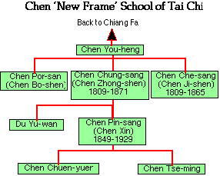
The New Frame of Chen Tai Chi developed from Chen You-heng, another student of Chiang Fa and developed via Chen Chung-sang to Chen Xin [a.k.a Chen Pin-sang] (1849-1929), the foremost latter- day exponent of this style .
The Old Frame Chen Style of Tai Chi bears a close resemblance to the New Frame Chen Style and also to the Zhao Bao and Hu Lei styles. Apparently it is not based on the classic '13 postures' which are central to the Yang and Wu Styles of Tai Chi and so it varies considerably from them.
For more detailed information on the historical development of these styles of Tai Chi see Peter Lim's fine articles:
- The Martial Arts Practiced In the Chen Village http://sunflower.singnet.com.sg/~limttk/index.htm
- The Development Of Chen Tai Ch'i Chuan

The Sun & Wu Shi (Hao) Styles of Tai Chi

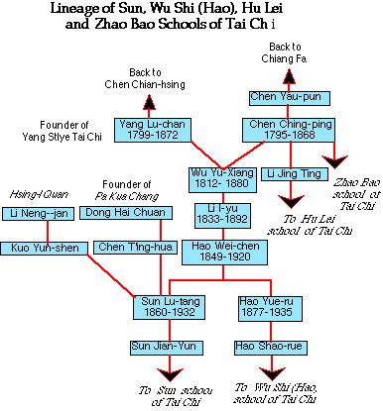
Both of these traditions have their origins with Wu Yu-xiang (1812-1880) a student of both Yang Lu-chan, the founder of the Yang Style of Tai Chi and Chen Ching-ping (or Chen Qing-ping) who taught Zhao Bao Tai Chi.
Wu Yu-xiang had only one prominent student, his nephew Li I-yu (1833- 1892) who, in turn passed his art on to Hao Wei-chen (1849-1920). One of his students was his son, Hao Yue-ru (1877-1935) who continued to teach the Wu Shi (or Hao) style of Tai Chi.
Another of Hao Wei-chen's pupils was Sun Lu-tang (1860-1932) who had already studied Hsing-I Quan with the master Kuo Yun-shen and Pa Kua with master Chen T'ing-hua. He combined elements of all three of these teachings to create the new Sun Style of Tai Chi Chuan. For more detailed information on the historical development of these styles of Tai Chi see Peter Lim's fine articles:
- The Historical Development Of Sun Taijiquan
- The Development Of Wu Yu Xiang's Tai Ch'i Chuan

THE WU STYLE OF TAI CHI

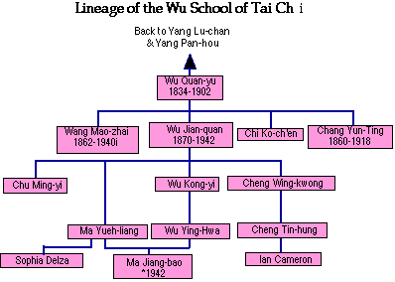
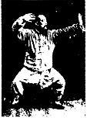
Wu Kam-chan practicing Tai Chi.
The Wu Family style of Tai Chi originates with Wu Quan-yu, a student of both Yang Lu-chan, the founder of the Yang Style of Tai Chi, and his son, Yang Pan-hou. He was Manchurian by race and worked as a bodyguard in the Imperial Court in Beijing. Because of his skill in it and his renown, he did much to popularize Tai Chi Chuan
It is said that the smaller movements and more restricted style of the Wu Form (in comparison with the Yang Style) has its origin in the elaborate and restrictive clothes of the Imperial Court. In order to be able to practice combat in this apparel the movements of the original Yang Style had to be modified somewhat.
For many years there was no differentiation between the Yang and Wu Styles. There was close contact between the two families and, for instance Wu Jian- quan and Yang Cheng-Fu would practice Push-hands together.
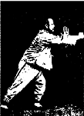
Wu Kam-chan practicing Tai Chi.
Quan-yu taught the style to a number of students, including his son Wu Jian-quan. He, in turn passed his teaching on to his son Wu Kong-yi and students Ma Jiang-bao and Cheng Wing-kwong from whom many of today's Wu Style students descend.
Currently the Wu Style of Tai Chi is second in popularity only to the Yang Style.
For more detailed information on the historical development of these styles of Tai Chi see Peter Lim's fine article:
- The Historical Development Of Wu Jian Quan Style

THE YANG STYLE OF TAI CHI

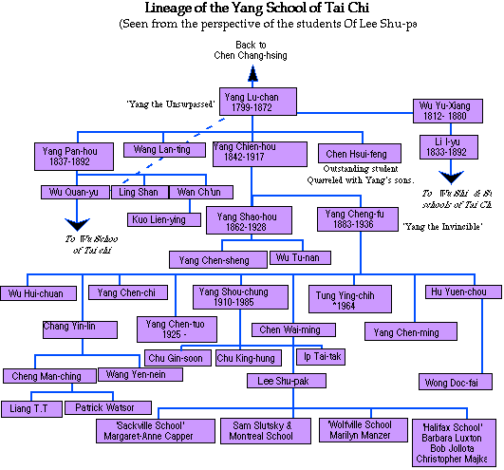
Yang Lu-chan was born in 1799 in Yung-nein in the prefecture of Kuang-p'ing in the province of Hopeh in China. There are several versions of his early life. One maintains that his family were farmers but his father soon noticed an interest in his son in martial arts. He arranged for lessons for him from a teacher named Liu. Yang Lu-chan soon mastered all his teacher could teach him and wanted to know more. Liu told him about Tai Chi Chuan, the secret of the Chen Family, but said that it was impossible for outsiders to learn the form.
Undeterred Yang Lu-chan set out for Hui-hsing in Hunan province where he managed to get employment as a servant in the household of Chen Chai-kou. At this household there was a famous teacher of Tai Chi, Chen Chang-hsing who was teaching the form to the young men there. Yang spied on them and at night practiced what he had seen.
After some time Chen Chiang-hsing happened to see him practicing one evening and realized the excellence of his technique. He decided to break with the tradition of secrecy and invited Yang into the school. Other accounts of Yang Lu-chan's early life claim that he came from very poor circumstances and was a bonded worker in a pharmacy before coming to Chen Chang-hsing's attention.
In any case, after some period of study, so great was his mastery of the form that Chen dismissed him and Yang returned to Yung-nein to teach martial arts. Later, one of his students Wu Yu-xiang, recommended that he go to Beijing to propagate the art. Yang eventually established a school of Tai Chi there, although not without some difficulties. In time he taught Tai Chi to the Imperial court and became known as 'Yang the Unsurpassed'.
Yang Lu-chan had three sons: the first Yang Ch'i died in early youth. His other two sons, Yang Pan-hou (1837-1892) and Yang Chien-hou (1842-1917) both continued to study and practice Tai Chi with their father, although perhaps not as diligently as he would have liked. One account claims that after his death an outstanding student Chen Hsui-feng, proclaimed himself the head of the Yang Family school and split with Yang's son's. In time, however, the two factions were reconciled.
Yang Cheng-fu.
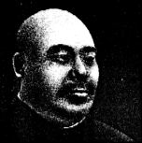
Yang Pan-hou apparently became a very adept practitioner of Tai Chi, however he found few that he could work with. He had three students Ling Shin, Wan Ch'un (or Wang Kiu-yu) and Wu Quan-yu (or Wu Chuan-yuck). The first left no students, the second taught only Kuo Lien-ying. The third Wu Quan-yu taught Wang Mou-chai and Ch'i Ko-ch'en as well as his son Wu Chien-chuan. The latter, dissatisfied with the Yang style created his own style called Wu Style which he taught to his son Wu Kung-yi and Cheng Wing-kwong who carried on the Wu Style. Consequently the Yang tradition died out on this side of the family.
Yang Chien-hou also had three children. The eldest Yang Shao- hou (1862-1928) [also known as Yang Chao-hsuing]. He had one son Yang Chen-sheng who he taught his art to. The second son Yang Chao-yuan died early in youth. The third son, Yang Cheng-fu (1883-1936) [also known as Yang Ch'eng-pu and Yang Chao-ch'ing] is in large measure responsible for the popular transmission of the Yang Family Style to many people in the east and west.
Yang Cheng-fu practicing Tai Chi.
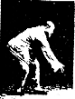
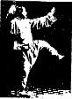
Known as 'Yang the Invincible' he had four sons; the eldest Yang Chen- Ming (also known as Yang Shou-chung); the second Yang Chen- chi; the third Yang Chen-tuo; and the fourth Yang Chen- kuo. He also had a number of outstanding students including Wu Hui-chuan, Chang Yin-lin, Tung Ying-chih, Hu Yuen-chou and Chen Wai-ming.
Chen Wai-ming taught Tai Chi in Shanghai in the 1930's and 40's before the revolution. He had four senior students to whom he passed on his innermost secrets and teachings. One of these was Lee Shiu-pak who after the revolution found himself in Hong Kong and began teaching Tai Chi there. Later on he emigrated to Canada and settled in Montreal where he established a school. His various students in Eastern Canada have gone on to carry on his and the Yang Family tradition.
For more detailed information on the historical development of these styles of Tai Chi see:
- The Historical Development Of Yang Tai Chi Chuan by Peter Lim
- Yang Style Tai Ji Quan History by Ted Knecht
- Take a look at Peter Lim's newest article on Combat Yang Taijiquan.

Part 8: The Development Of Zhao Bao Style Taijiquan
Of the popular styles of Taijiquan that have come into prominance in recent years, the Zhao Bao style Of Taijiquan is probably the most well known. Not to mention also one of the most controversial. There are two differring views on the origins of Zhao Bao Taijiquan and both have some logic to their claims.
We shall try to clarify what actually happened in the light of these two claims and present a plausible explanation to the confusion that exists today. Documentation on the Zhao Bao style is scarce and there are few published works to refer to. The Zhao Bao style is becoming increasingly popular and has spread to different countries. Perhaps in the future more primary and secondary sources will become available.
From Zhao Bao style comes a lesser known style of Hu Lei or Hu Long Jia Taijiquan. This style is just becoming known in the West and is arousing considerable interest. Works pertaining to this style are even harder to come by and investigation has been difficult because of this. But as the style is ultimately related to Zhao Bao style and its origins, more time has been devoted to the Zhao Bao style.
The Origin Theories Of Zhao Bao Taijiquan
There are two primary theories concerning Zhao Bao style Taijiquan. One comes from the Chen Villiage and the other from the Zhao Bao Villiage itself. Both, however, have the nexus on one key personage: Chen Qing Ping.
Of this noted personage we can only be certain of a few things. Chen Qing Ping had married and moved to the Zhao Bao Villiage which was his wife's home villiage. There he taught Taijiquan and had considerable influence. How he got the art is at the centre of the differences in opinion.
We shall examine the individual claims by themselves and then view them in the context of each other in an effort to determine the truth.
Claim 1: That The Chen Villiage Originated The Art
This claim was first put forth by Gu Liu Xin based on Chen Xin's seminal work on Chen style Taijiquan. In it, Chen Xin had written a family manual and that manual stated that Chen Xin had learnt his art from Chen You Ben and transmitted the art to the Zhao Bao Villiage.
Chen You Ben is widely acknowledged as the founder of the `new' style of Chen Taijiquan. We do not know for sure if he did know Taijiquan since it is disputed that the Chen Villiage did not invent Taijiquan since their claims have been proven untenable. In any case, Chen Qing Ping was supposed to have studied the Chen family arts from him and that is not what is in dispute. There is not very much material available on the `new' style and on the basis of postures there is not much variance with the `old' style.
This claim is the most widely believed due to the popularity of the works of Gu Liu Xin and Tang Hao. It was only in recent years with the liberation of China permitting more freedom that the Zhao Bao claims have been published and given air to. Beyond the recent work of Chen Xin, there is no other primary collaboration on it.
Claim 2: Zhiang Fa Transmitted The Art To Zhao Bao
In the recently published works of the Zhao Bao Taijiquan masters, there is a common belief that the art did not come from the Chen Villiage but instead was transmitted down by Jiang Fa, whose teacher was Wang Tsung Yueh, and that the art ultimately came from the Wudang mountain. This is in keeping with the early Chen references like that of Du Yu Wan.
The Zhao Bao masters hold that the art was first transmitted to the villiage by Jiang Fa who had once lived in the Zhao Bao villiage. Their placing of the date for Zhiang Fa puts him as a Ming Dynasty personage and could reflect an influence coming from the Chen Villiage on the placing of the dates. In any case, the old manuals in the Zhao Bao villiage record that the art came down from Jiang Fa.
This art passed down several generations to Zhang Yan who was supposed to have taught it to Chen Qing Ping and does not preclude the possibility that Chen Qing Ping was already skilled in the Chen family arts. The characteristics of Zhao Bao Taijiquan seem to bear this out.
Not all the Zhao Bao masters come down from Chen Qing Ping's lineage, some have come down from Chen Qing Ping's contemporaries and so it seems that the contention that Chen Qing Ping founded Zhao Bao Taijiquan may not be tenable.
The Zhao Bao Form
There are two forms of Taijiquan practiced in the Zhao Bao Villiage, one set consisting of 74 postures and another consisting of 108 postures. The postures within these routines are, however, identical so it is really just a matter of arrangement.
The postures resembles the Chen style of Taijiquan but way it is practiced, it resembles more the other major styles of Taijiquan. This makes it quite distinct from Chen style Taijiquan. There are postures in the form that are not found in Chen style Taijiquan but is evident in the other major styles and Zhao Bao style.
We need to note that the Zhao Bao Villiage and the Chen Villiage is in close proximity and so many common arts were practiced. It is entirely possible that Chen style Pao Chui was also practiced in the villiage and later softened by Jiang Fa which parallels what may have occurred in the Chen Villiage.
The form can be done in three heights and in two speeds. Each to achieve a different goal in training. There is only one type of push hands done at the Zhao Bao Villiage and that is moving step push hands. Zhao Bao Taijiquan does not have fixed step or fixed stance push hands. It also has its own weapons sets, two man sets and even its own neigong practice.
The Zhao Bao Classics
The Zhao Bao style Taijiquan lineage has the full complement of Taijiquan Classics in common with the rest of the major styles including the works of Wang Tsung Yueh. But unique to the Zhao Bao style is the 9 important treatises. No one knows who wrote them but for the Zhao Bao practitioners, these 9 treatises are very important and hold pride of place in the Classic writings as they are unique to their style.
Zhao Bao Taijiquan Today
Zhao Bao Taijiquan has now spread to many countries and is making an impact in the West. More and more publications are also becoming available for this unique style of Taijiquan and there is a growing interest in it. The style has since become acknowledged as one of the major styles of Taijiquan by the current masters of the art.
Zhao Bao Taijiquan also spawned an increasing popular style called Hu Lei or Hu Long Jia. Created by a student of Chen Qing Ping with input from another art, it is making its presence felt in the West.
Hu Lei or Hu Long Jia Taijiquan
This style of Taijiquan is becoming popular in the West in recent years. It was developed from the Zhao Bao style of Tajiquan and still retains many of its characteristics. The creator of this style was Li Jing Ting.
Li was a student of Chen Qing Ping and resided in the Zhao Bao Villiage. Hu Lei Jia Taijiquan is often classified under Chen style Taijiquan, much like Zhao Bao style is until recently when the Zhao Bao masters made it very clear that this was a misunderstanding promoted by Tang Hao and Gu Liu Xin. Hu Lei Jia Taijiquan is actually Zhao Bao Taijiquan as taught by Li Jing Ting.
Li spent most of his life around the Fu Ai area in China and there he taught his art. He also interacted with local martial artists and came into contact with styles like the Wang Bao Spear and Yun Qi Chui. All these could have had an influence on his final style.
The form itself consists of 74 postures and is almost identical to the Zhao Bao form. Due to the fact that the early practitioners of Li's lineage were illiterate, much of the information passed down was via oral transmission. This has led to some changes in the wordings handed down. For example, the style is also know as Hu Long Taijiquan. The name Hu Long comes from a name given to the jing usage in the form called `Hu Long Jing' or Sudden Dragon Jing. Hu Lei translates as Sudden Lightning.
The art has been popularised both in China and Taiwan and in recent years by Adam Hsu in North America. There has yet to be a book to be released about this style of Taijiquan and articles in the East and in the West are few and far between.

THE HISTORY OF TAI CHI

[I am deeply grateful to Peter Lim both for his excellent papers on the history of Tai Chi Chuan, and for his personal communications to me, in providing a background for this historical overview. Any errors are, however, entirely my responsibility.]
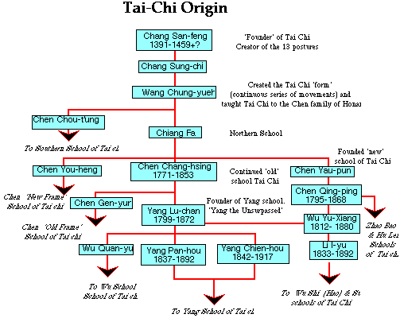
There exists a very ancient history in China of movement systems that are associated with health and philosophy. In some sense one can see all of these as contributing to the climate in which Tai Chi was born.
From the very origins of Taoism in the sixth century BC, sages like Lao Tsu wrote in the Tao Te Ching:
Yield and Overcome;
Bend and be straight.
And
He who stands of tiptoe is not steady.
He who strides cannot maintain the pace.
In this and in the entire tenor of his writings Lao Tsu reflects the central philosophical underpinnings of Tai Chi Chuan.
Later, in the period of the Three Kingdoms (220 to 265 AD) there was a physician Hua-tu'o who relied not only on medicine but also taught the 'movements of the five creatures' -- tiger, deer, bear, ape and birds -- a system he called Wu-chi chih hsi. He believed that the body needed to be regularly exercised to help with digestion and circulation and only by doing so could a long and healthy live be achieved. He advocated a system of imitating the movements of these animals to help exercise every joint in the body. His teaching, and its connection with the movements of animals, is probably the earliest pre-cursor of Tai Chi.
Painting of Bodihdharma by Feng Tien: Ch'ing Dynasty.
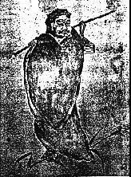
In the sixth century A.D. Bodihdharma (called Ta Mo in China) came to the Shao-Lin Monastery and seeing that the monks there were in poor physical condition from too much meditation and not enough movement, his Eighteen Form Lohan Exercise. Over time these grew to be the precursors of the Wei Chia (outer-extrinsic) school of exercise, by which is meant all the schools of kung-fu and other martial art forms which take an 'external' approach. This is in contrast to the Nei Chia (internal-intrinsic) school of which Tai Chi is a member, that take a fundamentally 'internal' approach. In the eighth century AD (the Tang dynasty) philosophers like Hsu Hsuan- p'ing developed a 'Long Kung-fu' of 37 forms. Of these certain ones such as:
- Play the Pi'pa
- Single Whip
- Step up to Seven Stars
- Jade Lady Works the Shuttles,
- High Pat on Horse; and
- White Crane (originally Phoenix) Cools Wing
Still survive in the contemporary Tai Chi form. There were several other such forms being practiced in the eighth century (Heavenly-Inborn Style, Nine Small Heavens Style and Acquired Kung-fu) from which grew the origins of Tai Chi.
Chang San-feng.
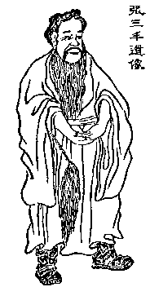
The apocryphal founder of Tai Chi was a monk of the Wu Tang Monastery, Chang San-feng to whom have been ascribed various dates and longevity's. Some scholars doubt his historical existance, viewing him as a literary construct on the lines of Lao Tzu. Other research and records from the Ming-shih (the official chronicles of the Ming dynasty) seem to indicate that he lived in the period from 1391 to 1459 (he may have been born earlier and lived later: these are simply some dates associated with him).
Linking some of the older forms with the notion of yin-yang from Taoism and stressing the 'internal' aspects of his exercises, he is credited with creating the fundamental 'Thirteen Postures' of Tai Chi corresponding to the eight basic trigrams of the I Ching and the five elements. The eight 'postures' are:
- ward-off
- rollback
- press
- push
- pull
- split
- elbow strike; and
- shoulder strike
The five 'attitudes' are:
- advance
- retreat
- look left
- gaze right; and
- central equilibrium.
His exercises stressed suppleness and elasticity and were opposed to hardness and force. They incorporated philosophy, physiology, psychology, geometry and the laws of dynamics.
His theories, writings and practices were elaborated sometime later by Wang Chung-yueh and his student Chiang Fa. Wang apparently took the thirteen postures of Chang San-feng and linked them together into continuous sequences, thus creating something which resembles the contemporary Tai Chi Chuan form. His student Chiang Fa taught Tai Chi to the villagers of a town on Honan (almost all of whom were called Chen) and thus began the first family school of Tai Chi Chuan.
Herein lies one of the most contentious and perplexing areas of Tai Chi history and scholarship. Some scholars feel that rather than bringing Tai Chi to the Chen village Chiang Fa simply discovered the Chen villagers practiciing this art. Others maintain that the Chen family's so-called 'Cannon Pounding' (Pao Chui) was a distinct martial art that undoubtedly influenced Chiang Fa's teaching but that it was not the same as Tai Chi.
Another of Wang's students was Chen Chou-t'ung who quarreled with Chiang Fa. The former then established the so-called Southern School of Tai Chi, an interesting an colourful branch of Tai Chi which subsequently disappeared. Chiang Fa continued with the mainstream 'Northern' school of Tai Chi which survives today.
Whatever their respective contributions, from Chiang-Fa and the Chen villagers in Honan emerge all of the surviving branches of Tai Chi Chuan:
- One of his students, Chen You-heng, continued what is called the New Frame Style of Chen Tai Chi.
- Chen Chang-hsing (1771-1853) studied under Chiang-Fa and combined the Cannon Pounding (Pao Chui) form of the Chen Family with the Tai Chi taught by Chiang-Fa. Chen Chang-hsing, in turn, was the teacher of Yang Lu-chan, the originator of the Yang Style of Tai Chi.
- Another Chen family member and student of Chen Chang-hsing was Chen Gen-yun whose descendants continued the Old Frame Style of Chen Tai Chi.
- Wu Quan-yu, a Manchu guard in the Imperial Palace at Beijing, was a student of both Yang Lu-chan and his son Yang Pan-hou. Wu taught it to (amongst others) his son Wu Chien-chuan (Also written as Wu Jian-quan). From this stream emerged the Wu Style of Tai Chi.
- Another Chen family member was Chen Yau-pun who veered away from Chiang Fa's tradition to create the 'new' school of Tai Chi. Apparently his student Chen Quin-ping was an originator of the Zhao Bao Style of Tai Chi.
- One of Chen Quin-ping's students was Li Jing-Ting who, in turn was the founder of the Hu Lei Style of Tai Chi.
- A student of both Yang Lu-chan and Chen Qing-ping was Wu Yu- xiang. He taught his nephew Lee I-yu who in turn taught Hao Wei-chen. This gave rise to the Wu Shi Style (or Hao Style) of Tai Chi Chuan.
- One of Hao Wei-chen's students was Sun Lu-tang who also studied Hsing-I Quan under Kuo Yun-shen and Pa Kua Chang under Cheng T'ing-hua (himself a student of Dong Hai-chuan, the founder of Pa Kua Chang). He combined these forms in the new Sun Style of Tai Chi Chuan.
These are the principal styles of Tai Chi that are in existence in the present day.
For more detailed information on the historical development of Tai Chi see:
- The Historical Development Of Tai Chi Chuan: The Origin Theories by Peter Lim
- Popular Modern Styles Of Taijiquan by Peter Lim
- History of Taijiquan (lineage diagram)

