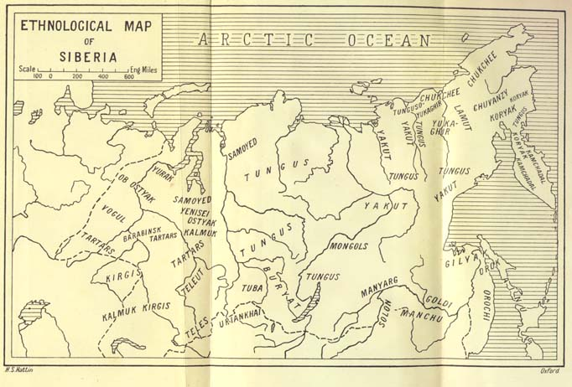

Map of Aboriginal Siberia from Czaplicka. http://www.sacred-texts.com/sha/index.htm

