William Wynn Westcott 1848-1925
http://en.wikipedia.org/wiki/William_Wynn_Westcott
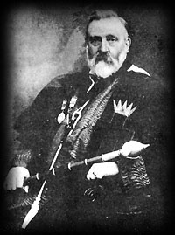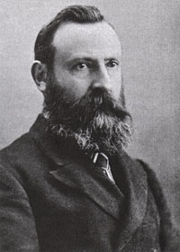

William Wynn Westcott (November 17, 1848 - July 30, 1925) was a British esotericist, coronor, ceremonial magician, and Freemason. He was born in Leamington, Warwickshire, England.

Contents
- 1 Biography
  - 1.1 The Golden Dawn
  - 1.2 Later years
- 2 Bibliography
  - 2.1 As translator
- 3 External links

Biography
A doctor of medicine by profession, he became active in Freemasonry in 1871, becoming Master of his home Lodge in 1874 and later also of the prestigious Quatuor Coronati research lodge, as well as achieving other Masonic distinctions.

[] The Golden Dawn
He studied the Kabbalah and by 1880 became active in the Societas Rosicruciana in Anglia before co-founding the Hermetic Order of the Golden Dawn with Samuel Liddell MacGregor Mathers in 1887. By then he was also active in the Theosophical Society. He devised and organized the Golden Dawn's rituals with Mathers and William Robert Woodman, who preceded him as Supreme Magus of the S.R.I.A. and like Westcott was one of the foremost exponents of Hermeticism of the time. In 1896, he abandoned public involvement with the Golden Dawn due to pressure regarding his job as a Crown Coroner, with which it was seen as an unseemly association. He continued to head the S.R.I.A. and later was involved with the Golden Dawn breakaway Stella Matutina.

[] Later years
He retired as a coroner after 1910, emigrated to South Africa in 1918, and died in Durban in 1925.

[] Bibliography
He was the author of many books on occult topics.
- The Origin of the Rosicrucians and Freemasons
- The Occult Power of Numbers
- An Introduction to the Study of the Kabalah
- A Lecture To Inquirers Into Theosophy And Practical Occultism
- History of the Rosicrucian Societies in Anglia

[] As translator
Books translated into English:
- Book of Formation
- The Chaldean Oracles of Zoroaster

[] External links
- Biography of Dr. William Wynn Westcott
===================================================================================================================================
END

