Albert Pike 1809-1891

http://en.wikipedia.org/wiki/Albert_Pike

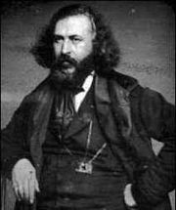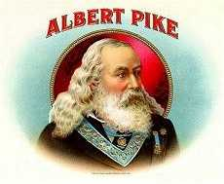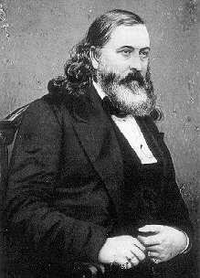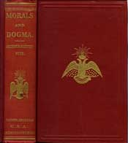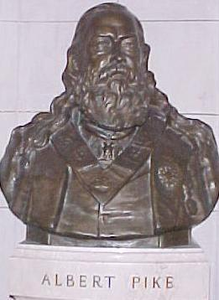

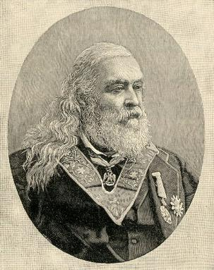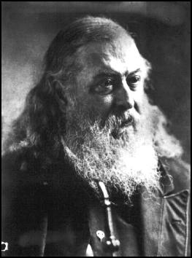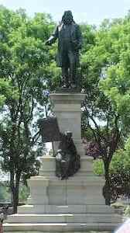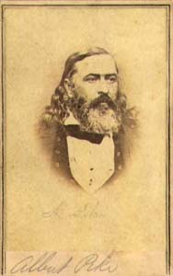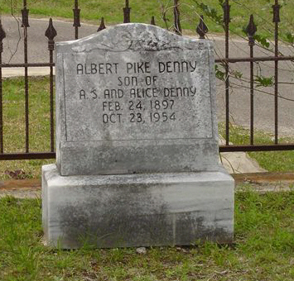

Albert Pike (b. December 29, 1809, Boston - d. April 2, 1891, Washington, D.C.) was an attorney, soldier, writer, and Freemason. Pike is the only Confederate military officer or figure to be honored with a statue in Washington, D.C. The statue sits in Judiciary Square.

Contents
- 1 Biography
- 2 Military career
- 3 After the war
- 4 In Freemasonry
- 5 Other Interests
- 6 Albert Pike and rumours regarding the Ku Klux Klan
  - 6.1 Conspiracy theories
- 7 Literature
  - 7.1 Biography
- 8 Ancestry & Family
- 9 Notes and References
- 10 External links

Biography
Pike was born in Boston, son of Benjamin and Sarah (Andrews) Pike, and spent his childhood in Byfield and Newburyport, Massachusetts. He attended school in Newburyport and Framingham until he was fifteen, at which point, having passed the Harvard entrance exam but unable to afford tuition, he began a program of self-education, later becoming a schoolteacher in Gloucester, Fairhaven and Newburyport.
In 1831 Pike left Massachusetts to travel west, first stopping in St. Louis and later moving on to Independence, Missouri. In Independence, he joined an expion to Taos, New Mexico, hunting and trading. During the excursion his horse broke and ran, forcing Pike to walk the remaining 500 miles to Taos. After this he joined a trapping expion to the Llano Estacado in New Mexico and Texas. Trapping was minimal, and after traveling about 1300 miles (650 on foot), he finally arrived at Fort Smith, Arkansas.
Settling in Arkansas in 1833, he taught school and wrote a series of articles for the Little Rock Arkansas Advocate under the pen name of "Casca." The articles were popular enough that he was asked to join the staff of the newspaper. Later, after marrying Mary Ann Hamilton, he purchased part of the newspaper with the dowry. By 1835 he was the Advocate's sole owner. Under Pike's administration the Advocate promoted the viewpoint of the Whig party in a politically volatile and divided Arkansas.
He then began to study law, and was admitted to the bar in 1837, selling the Advocate the same year. He was the first reporter for the Arkansas supreme court, and also wrote a book (published anonymously), titled The Arkansas Form Book, which was a guidebook for lawyers.

[] Military career
When the Mexican-American War started, Pike joined the cavalry and was commissioned as a troop commander, serving in the Battle of Buena Vista. He and his commander, John Selden Roane, had several differences of opinion. This situation led finally to a duel between Pike and Roane. Although several shots were fired in the duel, nobody was injured, and the two were persuaded by their seconds to discontinue it.
After the war, Pike returned to the practice of law, moving to New Orleans for a time beginning in 1853. He wrote another book, Maxims of the Roman Law and some of the Ancient French Law, as Expounded and Applied in Doctrine and Jurisprudence. Although unpublished, this book increased his reputation among his associates in law. He returned to Arkansas in 1857, gaining some amount of prominence in the legal field and becoming an advocate of slavery, although retaining his affiliation with the Whig party. When that party dissolved, he became a member of the Know-Nothing party. Before the Civil War he was firmly against secession, but when the war started he nevertheless took the side of the Confederacy.
He also made several contacts among the Native American tribes in the area, at one point negotiating an $800,000 settlement between the Creeks and other tribes and the federal government. This relationship was to influence the course of his Civil War service. At the beginning of the war, Pike was appointed as Confederate envoy to the Native Americans. In this capacity he negotiated several treaties, one of the most important being with Cherokee chief John Ross, which was concluded in 1861.
Pike was commissioned as a brigadier general on November 22, 1861, and given a command in the Indian Territory. With Gen. Ben McCullough, Pike trained three Confederate regiments of Indian cavalry, most of whom belonged to the "civilized tribes," whose loyalty to the Confederacy was variable. Although victorious at the Battle of Pea Ridge (Elkhorn Tavern) in March, Pike's unit was defeated later in a counterattack, after falling into disarray. Also, as in the previous war, Pike came into conflict with his superior officers, at one point drafting a letter to Jefferson Davis complaining about his direct superior.
After Pea Ridge, Pike was faced with charges that his troops had scalped soldiers in the field. Maj. Gen. Thomas C. Hindman also charged Pike with mishandling of money and material, ordering his arrest. Both these charges were later found to be considerably lacking in evidence; nevertheless Pike, facing arrest, escaped into the hills of Arkansas, sending his resignation from the Confederate Army on July 12. He was at length arrested on November 3 under charges of insubordination and treason, and held briefly in Warren, Texas, but his resignation was accepted on November 11 and he was allowed to return to Arkansas.

[] After the war
Pike faced the postwar years unable to earn the trust either of his former comrades or of the Union victors, and subsequently relocated to New York and later to Canada. He was however at length given a formal pardon by Andrew Johnson on August 30, 1865, and therefore enabled to continue his career in public life, becoming an associate justice of the Arkansas supreme court, later practicing law in Memphis, Tennessee from 1867-68 (where he also served as or of the Memphis Appeal), and finally moving his law office to Washington, D.C. in 1870, becoming or of the Patriot newspaper.

[] In Freemasonry
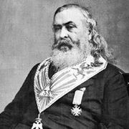
Pike in Masonic regalia

He had in the interim joined a Masonic lodge and become extremely active in the affairs of the organization, being elected Sovereign Grand Commander of the Scottish Rite's Southern Jurisdiction in 1859. He remained Sovereign Grand Commander for the remainder of his life (a total of thirty-two years), devoting a large amount of his time to developing the rituals of the order. Notably, he published a book called Morals and Dogma of the Ancient and Accepted Scottish Rite of Freemasonry in 1871, of which there were several subsequent ions.
Many claim that in Morals and Dogma of the Ancient and Accepted Scottish Rite of Freemasonry Pike proclaimed that Freemasonry is a "religion", and that its ideology is of "Lucifer". They base the assertion essentially on a single paragraph.
- "Every Masonic Lodge is a temple of religion; and its teachings are instruction in religion." Morals and Dogma of the Ancient and Accepted Scottish Rite of Freemasonry, p.213
- "The true name of Satan, the Kabalists say, is that of Yahveh reversed; for Satan is not a black god. p.102
..."Lucifer, the Light-bearer! Strange and mysterious name to give to the Spirit of Darkness! Lucifer, the Son of the Morning! Is it he who bears the Light, and with its splendors intolerable blinds feeble, sensual, or selfish Souls? Doubt it not!"... Morals and Dogma of the Ancient and Accepted Scottish Rite of Freemasonry, p.321
However, Masons and others explain that Lucifer, as used in this context, refers to the planet Venus rather than to Satan. Because Venus appears on the horizon before the rising of the sun, it symbolizes the bringing of light and the attainment of knowledge. They assert that it is incorrect to conclude from Pike's work that Masons are Satan worshippers. That said, even if Pike was referring to Venus, it could still be a Satanic reference as Venus has been long held to be a symbol of pagan gods in many world religions, including ancient Egyptian religions.
Pike is still sometimes regarded in America as an eminent^{[1]} and influential^{[2]} Freemason. His anti-Roman Catholic pronouncements were seen as representative of American freemasonry by Catholic sources.^{[3]}

[] Other Interests
Additionally, Pike wrote on several legal subjects, and continued producing poetry, a hobby he had begun in his youth in Massachusetts. His poems were highly regarded in his day, but are now mostly forgotten. Several volumes of his works were self-published posthumously by his daughter.
In 1859 he received an honorary Ph.D. from Harvard.
Pike died in Washington, D.C., aged 81, and was buried at Oak Hill Cemetery (against his wishes — he had left instructions his body be cremated).
In 1944 his remains were moved to the House of the Temple, headquarters of the Southern Jurisdiction of the Scottish Rite.

[] Albert Pike and rumours regarding the Ku Klux Klan
One of the Klan founders, Captain John C. Lester, wrote a 119 page book in 1884, in which he recalled the founding of the Klan fifteen years before. The only person that Lester mentioned was "Gen. Forrest," undoubtedly referring to Nathan Bedford Forrest. Lester does not mention Pike.
Fleming republished Lester's memoir in 1905 and added a list of names and pictures of "Klansmen". These included Pike but also Rev. D.L. Wilson, who had been Lester's co-author but not a Klansman. Thus if the inclusion of Pike on the list was a mistake, then it was not Fleming's only one.
Davis published her "Authentic History" of the Klan in 1924. She disagreed with Lester and regarded Fleming as not knowledgeable about the Klan. She also said that David L. Wilson was wrong to say that the original Klan was a failure. (This is not surprising since Davis was actively supporting a revival of the Klan at the time of her publication.)
Virtually all books or articles that claim Pike was part of the Ku Klux Klan use Fleming, Davis, other authors who cite Fleming or Davis, or else use no sources whatsoever. As one source puts it, "Research into primary source material will reveal that there isn't any primary source material" that proves or disproves Pike's association with the Klan. It is noteworthy that when the Klan was founded in Pulaski, Tennessee around Christmas 1865, Pike was living in Arkansas, and there is no record of him journeying to or being in Pulaski.
Below is a quote from one of Albert Pike's writings which supporters of the thesis that Albert Pike was, at the very least, a member of the Ku Klux Klan, sometimes cite in support of their thesis[1] (Albert Pike was the owner and publisher of the Memphis, Tennessee Daily Appeal, and the below quote is from an orial by him in that paper from April 16, 1868):
With negroes for witnesses and jurors, the administration of justice becomes a blasphemous mockery. A Loyal League of negroes can cause any white man to be arrested, and can prove any charges it chooses to have made against him.... The disenfranchised people of the South ... can find no protection for property, liberty or life, except in secret association.... We would unite every white man in the South, who is opposed to negro suffrage, into one great Order of Southern Brotherhood, with an organization complete, active, vigorous, in which a few should execute the concentrated will of all, and whose very existence should be concealed from all but its members.

[] Conspiracy theories
Pike's contributions to the Scottish Rite of Freemasonry in the Southern Jurisdiction of the United States, combined with his unique life and written works, has made him a person of note in virtually every conspiracy that mentions Freemasons.
Below are literal straight forward quotes by Albert Pike that supporters of conspiracies sometimes cite in support that Pike was indeed a Luciferian (all are from his book Morals and Dogma[2][3]):
"Every Masonic Lodge is a temple of religion; and its teachings are instruction in religion." Morals and Dogma, p.213
"LUCIFER, the Light-bearer! Strange and mysterious name to give to the Spirit of Darknesss! Lucifer, the Son of the Morning! Is it he who bears the Light, and with its splendors intolerable blinds feeble, sensual or selfish Souls? Doubt it not!" p.321
...
"Masonry, like all the Religions, all the Mysteries, Hermeticism and Alchemy, conceals its secrets from all except the Adepts and Sages, or the Elect, and uses false explanations and misinterpretations of its symbols to mislead those who deserve only to be misled, to conceal the truth, which it calls Light, from them, and to draw them away from it. Truth is not for those who are unworthy or unable to receive it, or would pervert it."
...
"The Blue Degrees are but the outer court or portico of the Temple. Part of the symbols are displayed there to the Initiate, but he is intentionally misled by false interpretations. It is not intended that he shall understand them; but it is intended that he shall imagine he understands them. Their true explication is reserved for the Adepts, the Princes of Masonry ... It is well enough for the mass of those called Masons, to imagine that all is contained in the Blue Degrees; and whose attempts to undeceive them will labor in vain."
However, if one reads the text as a whole, there are literally thousands of quotes which are irreconcilable with a belief in slavery, or with disrespect for established religions. For example:
Page 3 -- "Under Claudius and under Domitian there is a deformity of baseness corresponding to the ugliness of the tyranny. The foulness of the slaves is a direct result of the atrocious baseness of the despot... And so Humanity wages war against Humanity, in despite of Humanity... Tyrants use the force of the people to chain and subjugate -- that is, enyoke the people. Then they plough with them as men do with oxen. Then the spirit of liberty and innovation is reduced by bayonets and principles are struck dumb by cannonshot."
Page 4 -- "Therefore it is one of the fatalities of Humanity to be condemned to eternal struggle with phantoms, with superstitions, bigotries, hypocrisies, prejudices and the pleas of tyranny. Despotisms, seen in the past, become respectable, as the mountain, bristling with volcanic rock, rugged and horrid, seen through the haze of distance is blue and beautiful. The sight of a single dungeon of tyranny is worth more, to dispel illusions and create holy hatred of despotism, and to direct FORCE aright than the most eloquent volumes. The French should have preserved the Bastile as a perpetual lesson; Italy should not destroy the dungeons of the Inquisition.”
Page 6 -- “Though Masonry neither usurps the place of, nor apes religion, prayer is an essential part of our ceremonies. It is the aspiration of the soul toward the Absolute and Infinite Intelligence which is the One Supreme Deity… Thought, mation, prayer are the great mysterious pointings of the needle. It is the spiritual magnetism which connects the soul with the Deity. These majestic irradiations of the soul pierce through the shadow to the light.”
Page 17 -- “Masonry has its decalogue… These are its Ten Commandments:
II. Thy religion shall be to do good because it is a pleasure to thee, not merely because it is a duty…
Thy soul is immortal! Thou shalt not degrade it!
III. Thou shalt unceasingly war against vice!
Thou shalt not do unto others that which thou wouldst not wish them to do unto thee!
IX. … Thou shalt render good for evil!
Thou shalt not misuse either thy strength or thy superiority!
X. … Thou shalt be just!”
Page 21 -- “In the works published for the use of the Craft, we are told that the three great tenets of a Mason’s profession are Brotherly love, Relief and Truth. And it is true that a Brotherly affection and kindness should govern us in all our intercourse and relations with our brethren ; and a generous and liberal philanthropy actuate us in regard to all men. To relieve the distressed is peculiarly the duty of Masons -- a sacred duty, not to be omitted, neglected, or coldly or inefficiently complied with.”
Or:
Page 329 -- "To honor the Deity, to regard all men as our Brethren, as children equally dear to Him..."
He also cites repeatedly from texts from throughout the world, so that there can be no doubt that he regards the Negro and Oriental races as human and therefore subject to these laws of liberty, equality and justice. For example,
“The trinity of the Hindus became among the Ethiopians and Abyssinians Neph-Amon, Phtha and Neith -- the God Creator, whose emblem was a ram.”

[] Literature
- Albert Pike: Morals and Dogma. Book
- Albert Pike: Meaning of Masonry. Kessinger Publishing, May 2004. ISBN 1-4179-1101-8
- Albert Pike: Reprints of Old Rituals. Kessinger Publishing, March 1, 1997. ISBN 1-56459-983-3
- Albert Pike: Book of the Words. Supreme Council. (http://www.srmason-sj.org/acatalog/Ritual_and_Ceremonial.html)
- Albert Pike: Book of the Words. Kessinger Publishing, March 1, 1997. ISBN 1-56459-161-1
- Albert Pike: Indo-Aryan Deities and Worship as Contained in the Rig-Veda. Kessinger Publishing, March 1, 1997. ISBN 1-56459-183-2
- Albert Pike: The Point Within the Circle: Freemasonry Veiled in Allegory and Illustrated by Symbols. Holmes Pub Grou Llc, November 1, 2001. ISBN 1-55818-305-1
- Albert Pike: Morals and Dogma of the First Three Degrees of the Ancient and Accepted Scottish Rite Freemasonry. Kessinger Publishing, May 2004. ISBN 1-4179-1108-5

[] Biography
- Walter Lee Brown: A Life of Albert Pike. University of Arkansas Press, September 1, 1997. ISBN 1-55728-469-5
- Fred W. Allsopp: Albert Pike a Biography. Kessinger Publishing, March 1, 1997. ISBN 1-56459-134-4

[] Ancestry & Family
Albert's descent from his immigrant ancestor John Pike is as follows:
- John Pike (1572-1654)
  - John Pike (1613-1689/90)
    - Joseph Pike (1638-1694)
      - Thomas Pike (1682-1753/4)
        - John Pike (1710-1755)
          - Thomas Pike (1739-1836)
            - Benjamin Pike (1780-????)
              - Albert Pike (1809-1891)

[] Notes and References
- ^ "He died in the "first" House of the Temple in Washington, D.C., at eight o'clock in the evening on April 2, 1891, the fourth month of his 81st year. Thus passed from this life the all-time Goliath of Freemasonry." ALBERT PIKE AND FREEMASONRY, March-April 2002 ion, California Freemason On-Line
- ^ "Today, some Masons will diminish Pike's importance so as to deflect the charges of anti-Masons. There is no doubt, though, that he was among the most influential Masons of his time." Albert Pike, masonicinfo.com
- ^ For example "In presence of this spiritual 'Cobra di capello', this deadly, treacherous, murderous enemy, the most formidable power in the world, the unity of Italian Masonry is of absolute and supreme necessity; and to this paramount and omnipotent necessity all minor considerations ought to yield; dissensions and disunion, in presence of this enemy of the human race are criminal" Albert Pike in the Official Bulletin, September, 1887, 173, quoted as footnote [172] in Masonry (Freemasonry) from the Catholic Encyclopedia

[] External links
- Handbook of Texas Online - Albert Pike
- Pike's Masonic philosophy
- Albert Pike: Hero or Scoundrel?
- a modern analysis of his Morals and Dogma
- About room where he is entombed
- Albert Pike and World War Three (conspiracy theory—but, regarding the supposed correspondence to Giuseppe Mazzini of 1871 Aug 15, it notes that "to date, no conclusive proof exists to show that this letter was ever written.")
- His involvement with the KKK & KGC
====================================================================================================================================
END

