Mason Structures

www.heart7.net/masonstructure.html

Structrue of American Freemasonary
33° Grand Sovereign Inspector General
 | 32° Sublime Prince of the Royal Secret  31° Inspector Inquisitor  30° Knight Kodosah  29° Grand Scottish Knight of St. Andrew  28° Knight of the Sun, Adept  27° Knight Commander of the Temple  26° Prince of Mercy  25° King of the Brazen Serpent  24° Prince of the Tabernacle  23° Chief of the Tabernacle  22° Knight of the Royal Axe  21° Noachite or Prussian Knight  20° Master, Symbolic Lodge  19° Pontiff  18° Knight of Rose Croix  17° Knight of East & West  16° Prince of Jerusalmen  15° Knight of the Sword  14° Perfect Elu  13° Royal Arch of Solomon  12° Master Architect  11° Elu of Twelve  10° Elu of Fifteen  9° Elu of Nine  8° Intendent of Building  7° Provost Judge  6° Confidential Secetary  5° Perfect Master  4° Secret Master
  Orders | Auxiliary Bodies
  Order of Knights Templar  Order of the Knights of Malta  Order of the Red Cross  Super Excellent Master  Select Master  Royal Master  Royal Arch Mason  Most Excellent Master  Past Master  Mark Master | - The Shrine  (for women)  - Order of the Eastern Star  - Daughters of the Nile  - White Shrine  (for youths)  - De Molay  - Job's Daughter  - Rainbow Girls
York Rite | Scottish Rite
Master Mason 3°
Fellowcraft 2°
Entered Apprentice 1°
Blue Lodge
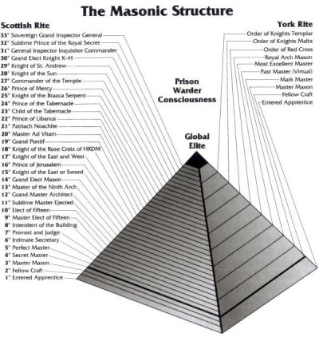
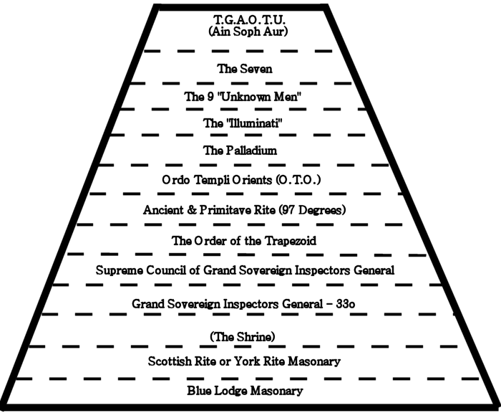
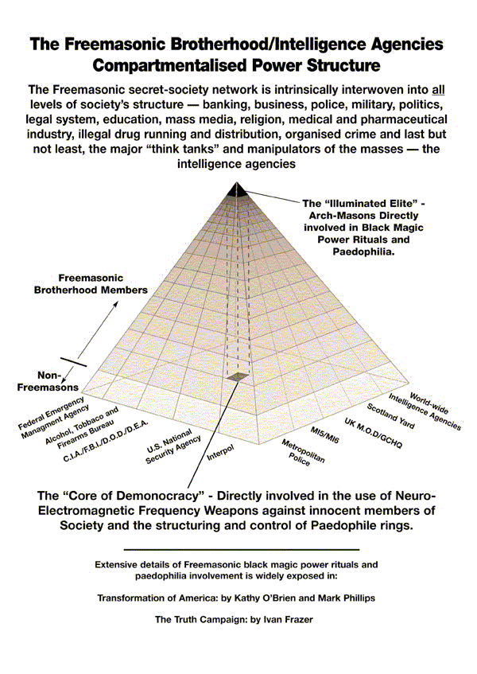
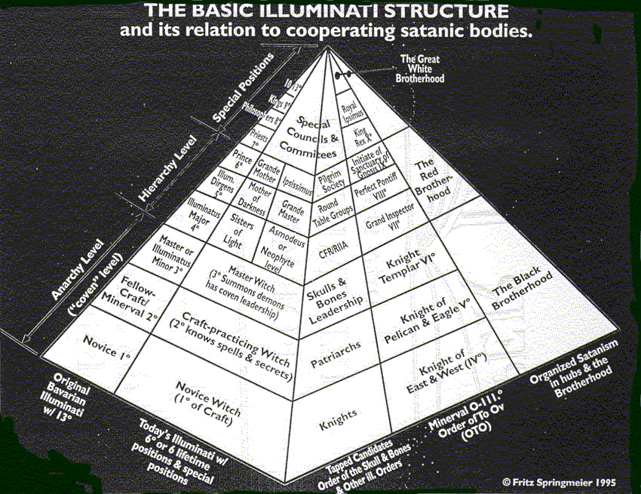

====================================================================================================================================
END

