Albert Gallatin Mackey 1807-1881
http://en.wikipedia.org/wiki/Albert_Mackey
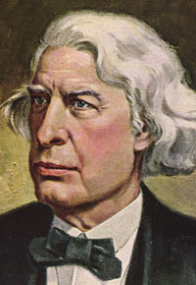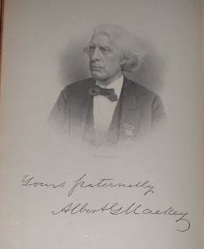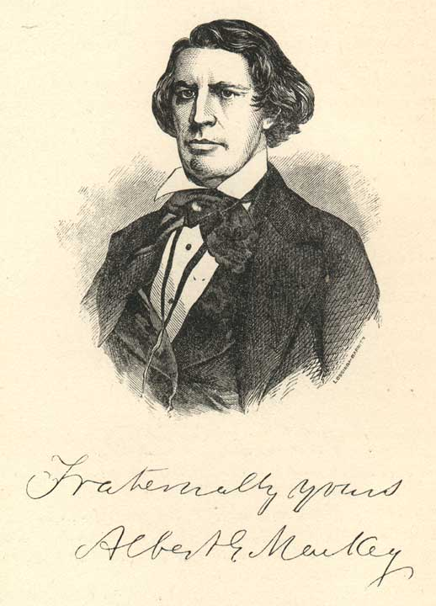

Albert Gallatin Mackey (born March 12, 1807, died June 20, 1881), was an American medical doctor, and is best known for his authorship of many books and articles about freemasonry, particularly Masonic Landmarks. He served as Grand Lecturer and Grand Secretary of The Grand Lodge of South Carolina; Secretary General of the Supreme Council of the Ancient and Accepted Rite for the Southern Jurisdiction of the United States.

Bibliography
- Albert Gallatin Mackey (1845). A Lexicon of Freemasonry.
- Albert Gallatin Mackey (?). Encyclopedia of Freemasonry.
- Albert Gallatin Mackey (?). The Mystic Tie.
- Albert Gallatin Mackey (?). Legends and Traditions of Freemasonry.
- The Principles of Masonic Law, 1856
- The Symbolism of Freemasonry, 1882

References
- Albert Gallatin Mackey. Masonic Biographies, Grand Lodge of British Columbia and Yukon. Retrieved on March 1, 2005.

External links
- Works by Albert Mackey at Project Gutenberg

================================================================================================================================
/freemasonry.bcy.ca/biography
Albert Gallatin Mackey
March 12, 1807 - June 20, 1881
Dr. Mackey practiced medicine until 1854, after which literary and masonic pursuits fully occupied his time. In July, 1865, President Johnson appointed him Collector of the Port. Later defeated in a senatorial race, he moved to Washington, D.C. in 1870.
Compiler of A Lexicon of Freemasonry in 1845, he went on to publish many books on Freemasonry, most notably his Encyclopedia of Freemasonry.
At various times he edited such publications as the Western Masonic Miscellany (1849-54), the Masonic Quarterly Review (1857-58), the American Freemason (1859-60), and Mackey's National Freemason (1871-74) and the Voice of Freemasonry (1875-79).
Initiated, Passed and Raised: 1841
Saint Andrews Lodge No. 10, South Carolina
Worshipful Master : 1842
Solomon's Lodge No. 1, Charleston
Founding member : 1851
Landmark Lodge No. 76
Grand Secretary : 1842-1867
South Carolina
Affiliated : 1870
Landmark Lodge No. 19, D.C.
Source: Albert G. Mackey, Encyclopedia of Freemasaonry.

==================================================================================================================================
END

