MASONIC SYMBOLS : The Esoteric Meaning of the Twin Pillars: Boaz and Jachin

[Araştırma](https://derinistihbarat.wordpress.com/category/arastirma/) Temmuz 19, 2012 [1 Yorum](https://derinistihbarat.wordpress.com/2012/07/19/masonic-symbols-the-esoteric-meaning-of-the-twin-pillars-boaz-and-jachin/#comments)

5 Votes

**Since the dawn of civilization, the entrance of sacred and mysterious places have been guarded by two pillars. Whether in art or in architecture, twin pillars are archetypal symbols representing an important gateway or passage towards the unknown. In Freemasonry, the pillars are named Jachin and Boaz and represent one of the Brotherhood’s most recognizable symbol, prominently featured in Masonic art, documents and buildings. This article will look at the origins of this timeless symbol and its esoteric meaning.**

[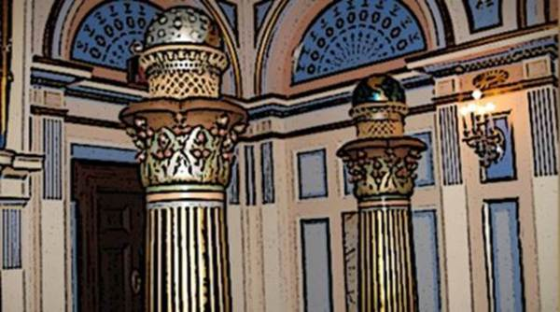](https://derinistihbarat.files.wordpress.com/2012/07/image001637.jpg)

The concept of twin pillars standing at the gates of sacred places can be traced back to ancient civilizations of Antiquity (some claim from Atlantis, the lost source of Hermetic knowledge).

**A Gateway**

The symbol of the twin pillars have, since time immemorial, guarded the gateways to holy places and mysterious realms. They mark the passage towards the unknown and the otherworldly. In ancient Greece, The Pillars of Hercules was the phrase that was applied to the promontories that flank the entrance to the Strait of Gibraltar. The northern Pillar is the Rock of Gibraltar in the British territory of Gibraltar.

[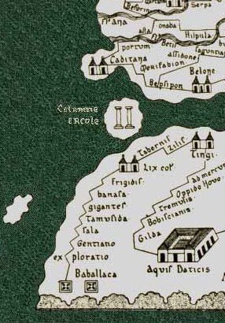](https://derinistihbarat.files.wordpress.com/2012/07/image002186.jpg)

**The Pillars of Hercules guarding the passage towards the unknown.**

According to Plato’s account, the lost realm of Atlantis was situated beyond the Pillars of Hercules, in effect placing it in the realm of the Unknown. Renaissance tradition says the pillars bore the warning Nec plus ultra (also Non plus ultra, “nothing further beyond”), serving as a warning to sailors and navigators to go no further. Symbolically, going beyond the Pillars of Hercules can mean leaving the foulness of the material world to reach a higher realm of enlightenment.

[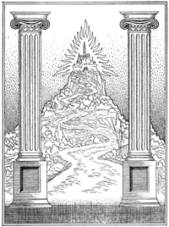](https://derinistihbarat.files.wordpress.com/2012/07/image0034.png)

**The two columns called the “Pillars of Hercules” in Ancient Greece stood at the gateway to the sphere of the enlightened**

[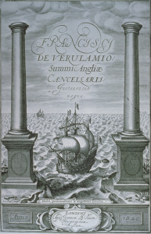](https://derinistihbarat.files.wordpress.com/2012/07/image0044.png)

**The frontispice of Francis Bacon’s “New Atlantis” featuring the Pillars of Hercules as a gateway to a new world. According to occult lore, Atlantis is the civilization from which all hermetic knowledge emerged. The rebirth of this lost kingdom has been the dream of Mystery schools for centuries.**

“The city of the philosophic elect rises from the highest mountain peak of the earth, and here the gods of the wise dwell together in everlasting felicity. In the foreground are the symbolic pillars of Hercules which appear on the title page of Bacon’s Novum Organum, and between them runs the path which leads upward from the uncertainties of earth to that perfect order which is established in the sphere of the enlightened.” [1](http://secretarcana.com/occultsymbols/the-two-pillars/#fn-37-1)

**In Freemasonry**

The Masonic usage of the terms Jachin and Boaz originates from the Biblical account of King Solomon’s Temple. The master builder of the Temple of Solomon was Hiram Abiff, a prominent figure in Masonic ritual. The verses 1 Kings 6:1-38, 1 Kings Chapter 7, and Chapter 8 describe the dimensions, the construction and the dedication of the Temple under Solomon. One passage describes more specifically the twin pillars standing in front of King Solomon’s Temple.

15 For he cast two pillars of brass, of eighteen cubits high apiece: and a line of twelve cubits did compass either of them about.

16 And he made two chapiters of molten brass, to set upon the tops of the pillars: the height of the one chapiter was five cubits, and the height of the other chapiter was five cubits:

17 And nets of checker work, and wreaths of chain work, for the chapiters which were upon the top of the pillars; seven for the one chapiter, and seven for the other chapiter.

18 And he made the pillars, and two rows round about upon the one network, to cover the chapiters that were upon the top, with pomegranates: and so did he for the other chapiter.

19 And the chapiters that were upon the top of the pillars were of lily work in the porch, four cubits.

20 And the chapiters upon the two pillars had pomegranates also above, over against the belly which was by the network: and the pomegranates were two hundred in rows round about upon the other chapiter.

21 And he set up the pillars in the porch of the temple: and he set up the right pillar, and called the name thereof Jachin: and he set up the left pillar, and called the name thereof Boaz.

22 And upon the top of the pillars was lily work: so was the work of the pillars finished.

– 1 Kings Chapter 7

**[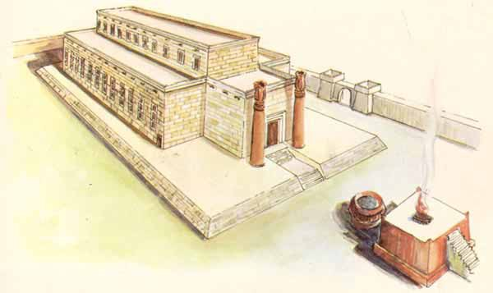](https://derinistihbarat.files.wordpress.com/2012/07/image00574.jpg)**

**An artist rendition of King Solomon’s Temple.**

The account of Solomon’s Temple is of great importance in Freemasonry as each detail of the building holds an important esoteric meaning. The Twin pillars act as a “portal to the Mysteries” by standing on each side of the entrance to a sacred place.

“According to the ancient Rabbins, Solomon was an initiate of the Mystery schools and the temple which he built was actually a house of initiation containing amass of pagan philosophic and phallic emblems. The pomegranates, the palm-headed columns, the Pillars before the door, the Babylonian cherubim, and the arrangement of the chambers and draperies all indicate the temple to have been patterned after the sanctuaries of Egypt and Atlantis.” [2](http://secretarcana.com/occultsymbols/the-two-pillars/#fn-37-2)

For this reason, Jachin and Boaz are prominently featured on Masonic buildings, monuments and documents. Here is Albert Pike’s description of the pillars in a text intended for new Masons:

“You entered the Lodge between two columns. They represent the two which stood in the porch of the Temple, on each side of the great eastern gateway. These pillars, of bronze, four fingers breadth in thickness, were, according to the most authentic account–that in the First and that in the Second Book of Kings, confirmed in Jeremiah– eighteen cubits high, with a capital five cubits high. The shaft of each was four cubits in diameter. A cubit is one foot and 707/1000. That is, the shaft of each was a little over thirty feet eight inches in height, the capital of each a little over eight feet six inches in height, and the diameter of the shaft six feet ten inches. The capitals were enriched by pomegranates of bronze, covered by bronze net-work, and ornamented with wreaths of bronze; and appear to have imitated the shape of the seed-vessel of the lotus or Egyptian lily, a sacred symbol to the Hindus and Egyptians. The pillar or column on the right, or in the south, was named, as the Hebrew word is rendered in our translation of the Bible, JACHIN: and that on the left BOAZ. Our translators say that the first word means, “He shall establish;” and the second, “In it is strength.”

These columns were imitations, by Khurum, the Tyrian artist, of the great columns consecrated to the Winds and Fire, at the entrance to the famous Temple of Malkarth, in the city of Tyre. It is customary, in Lodges of the York Rite, to see a celestial globe on one, and a terrestrial globe on the other; but these are not warranted, if the object be to imitate the original two columns of the Temple. The symbolic meaning of these columns we shall leave for the present unexplained, only adding that Entered Apprentices keep their working-tools in the column JACHIN; and giving you the etymology and literal meaning of the two names.

The word JACHIN, in Hebrew, probably pronounced Ya-kayan, and meant, as a verbal noun, He that strengthens; and thence, firm, stable, upright.

The word Boaz is Baaz which means Strong, Strength, Power, Might, Refuge, Source of Strength, a Fort. The prefix means “with” or “in,” and gives the word the force of the Latin gerund, roborando–Strengthening The former word also means he will establish, or plant in an erect position–from the verb Kun, he stood erect. It probably meant Active and Vivifying Energy and Force; and Boaz, Stability, Permanence, in the passive sense.” [3](http://secretarcana.com/occultsymbols/the-two-pillars/#fn-37-3)

**[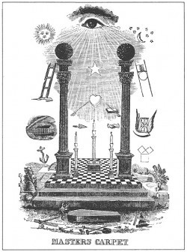](https://derinistihbarat.files.wordpress.com/2012/07/image00651.jpg)**

**The Twin Pillars on a Masonic Tracing Board**

**[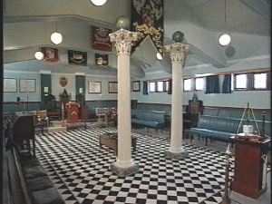](https://derinistihbarat.files.wordpress.com/2012/07/image00743.jpg)**

**Inside a Masonic Lodge**

**[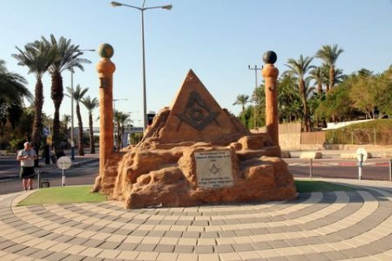](https://derinistihbarat.files.wordpress.com/2012/07/image00835.jpg)**

**Masonic monument in Israel featuring the twin pillars.**

**[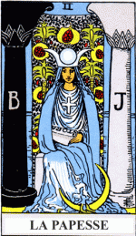](https://derinistihbarat.files.wordpress.com/2012/07/image009.png)**

**The High Priestress of the Tarot sitting between Boaz and Jachin.**

**Esoteric Meaning**

As with most occult symbols, the Masonic twin pillars conceal multiple layers of meaning, some intended for the profane and others divulged in higher degrees of Freemasonry. However, it is generally accepted that the Jachin and Boaz represent the equilibrium between two opposite forces.

“These were the names [Jachin and Boaz] of the two pillars cast from brass set up on the porch of King Solomon’s Temple. They were eighteen cubits in height and beautifully ornamented with wreaths of chainwork, nets, and pomegranates. On the top of each pillar was a large bowl – now erroneously called a ball or globe – one of the bowls probably containing fire and the other water. The celestial globe (originally the bowl of fire), surmounting the right-hand column (Jachin), symbolized the divine man; the terrestrial globe (the bowl of water), surmounting the left-hand column (Boaz), signified the earthly man. These two pillars respectively connote also the active and the passive expressions of Divine Energy, the sun and the moon, sulphur and salt, good and bad, light and darkness. Between them is the door leading into the House of God, and standing thus at the gates of Sanctuary they are a reminder that Jehovah is both an androgynous and an anthropomorphic deity. As two parallel columns they denote the zodiacal signs of Cancer and Capricorn, which were formerly placed in the chamber of initiation to represent birth and death – the extremes of physical life. They accordingly signify the summer and the winter solstices, now known to Freemasons under the comparatively modern appellation of the ‘two St. Johns.’” [4](http://secretarcana.com/occultsymbols/the-two-pillars/#fn-37-4)

“Alef is man; Bet is woman; 1 is the principle; 2 is the word; A is the active; B is the passive; the monad is BOAZ; the duad is JAKIN. In the trigrams of Fohi, unity is the YANG and the duad is the YIN.

BOAZ and JAKIN are the names of the two symbolical Pillars before the principal entrance of Solomon’s Kabalistic Temple. In the Kabalah these Pillars explain all mysteries of antagonism, whether natural, political or religious. They elucidate also the procreative struggle between man and woman, for, according to the law of Nature, the woman must resist the man, and he must entice or overcome her. The active principle seeks the passive principle, the plenum desires the void, the serpent’s jaw attracts the serpent’s tail, and in turning about upon himself, he, at the same time, flies and pursues himself. Woman is the creation of man, and universal creation is the bride of the First Principle.”

The permanent alliance of reason and faith will result not from their absolute distinction and separation, but from their mutual control arid their fraternal concurrence. Such is the significance of the two Pillars of Solomon’s Porch, one named JAKIN and the other BOAZ, one white and the other black. They are distinct and separate, they are even contrary in appearance, but if blind force sought to join them by bringing them close to one another, the roof of the temple would collapse. Separately, their power is one; joined, they are two powers which destroy one another. For precisely the same reason the spiritual power is weakened whensoever it attempts to usurp the temporal, while the temporal power becomes the victim of its encroachments on the spiritual. Gregory VII ruined the Papacy; the schismatic kings have lost and will lose the monarchy. Human equilibrium requires two feet; the worlds gravitate by means of two forces; generation needs two sexes. Such is the meaning of the arcanum of Solomon, represented by the two Pillars of the Temple, JAKIN and BOAZ.” [5](http://secretarcana.com/occultsymbols/the-two-pillars/#fn-37-5)

The union of the two pillars is said to generate a third pillar, one in the middle, which esoterically represents man and mankind.

“When the two columns find equilibrium between them it will signify the union of the Sushumna and the Kundalini. This sacred marriage will create a “Fire-Mist” to radiate throughout the human body, filling it will divine Light. It is then that humanity will become the third column of the Temple Wisdom. He/She will be a column formed by the combined forces of Strength (Jachin) and Beauty (Boaz). This act forms the Lost Word in the vibratory system of the soul’s physical embodiment.” [6](http://secretarcana.com/occultsymbols/the-two-pillars/#fn-37-6)

[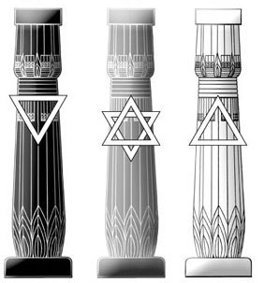](https://derinistihbarat.files.wordpress.com/2012/07/image01021.jpg)

**The combining of the two oppsite forces of the twin pillars produce the center pillar: the perfected man.**

**Qabbalistic Meaning**

In Qabbalistic teachings, Jachin and Boaz represent the two pillars of Sepiroth, the Tree of Life.

[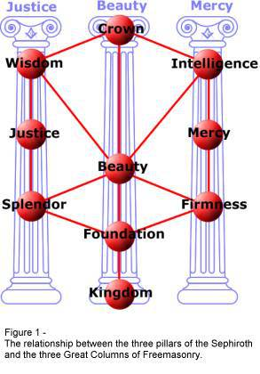](https://derinistihbarat.files.wordpress.com/2012/07/image01122.jpg)

“In the mysterious Sephirothic Tree of the Jews, these two pillars symbolize Mercy and Severity. Standing before the gate of King Solomon’s Temple, these columns had the same symbolic import as the obelisks before the sanctuaries of Egypt. When interpreted Qabbalistically, the names of the two pillars mean “In strength shall My House be established. “In the splendor of mental and spiritual illumination, the High Priest stood between the pillars as a mute witness to the perfect virtue of equilibrium – that hypothetical point equidistant from all extremes. He thus personified the divine nature of man in the midst of his compound constitution – the mysterious Pythagorean Monad in the presence of the Duad. On one side towered the stupendous column of the intellect; on the other, the brazen pillar of the flesh. Midway between these two stands the glorified wise man, but he cannot reach this high estate without first suffering upon the cross made by joining these pillars together. The early Jews occasionally represented the two pillars, Jachin and Boaz, as the legs of Jehovah, thereby signifying to the modern philosopher that Wisdom and Love, in their most exalted sense, support the whole order of creation – both mundane and supermundane.

The column on the right, which is called Jachin, has its foundation on Chochmah, the outpouring Wisdom of God; the three globes suspended from it are all masculine potencies. The column at the left is called Boaz. The three globes upon it are feminine and receptive potencies, for it is founded in Understanding, a receptive and maternal potency. Wisdom, it will be noted, is considered as radiant or outpouring, and Understanding as receptive, or something which is filled by the flowing of Wisdom. The three pillars are ultimately united in Malchuth, in which all the powers of the superior worlds are manifested.” [7](http://secretarcana.com/occultsymbols/the-two-pillars/#fn-37-7)

**In Popular Culture and Architecture**

Pillars are sometimes used in pop culture for reasons other than decorative purposes to take on an esoteric meaning. The act standing between or going through pillars, symbolically representing transformation or initiation, can be found in instances such as:

[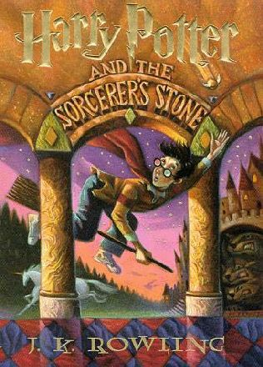](https://derinistihbarat.files.wordpress.com/2012/07/image01222.jpg)

**The cover of the first book of the Harry Potter series, where he discovers he is a wizard. His “initation” is visually protrayed as him going through two pillars. The original title of the book is*Harry Potter and the Philosopher’s Stone*, the Philosopher’s Stone an ancient alchemical concept representing Illumination.**

[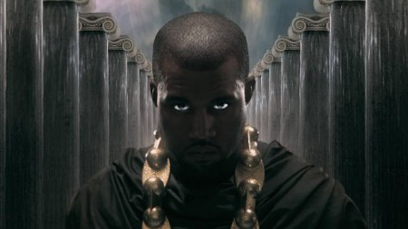](https://derinistihbarat.files.wordpress.com/2012/07/image01319.jpg)

**Rapper Kanye West standing in the middle of twin pillars in the highly symbolic video *Power*.**

[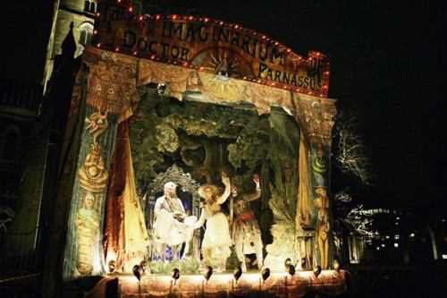](https://derinistihbarat.files.wordpress.com/2012/07/image01419.jpg)

**Amongst the plethora of esoteric symbols found in *The Imaginarium of Dr. Parnassus*, the twin pillars stand on each side of the stage.**

[](https://derinistihbarat.files.wordpress.com/2012/07/image01515.jpg)

**Two pillars standing in front of the IRS Building in Kansas. Also note the Masonic/dualistic black & white pattern and the hands pointing upwards, known as the “Hand of the Mysteries”.**

[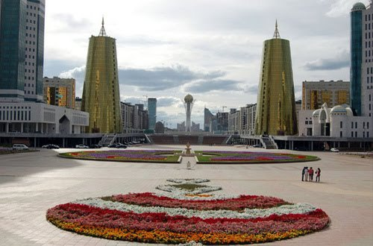](https://derinistihbarat.files.wordpress.com/2012/07/image01614.jpg)

**Two immense pillars and one in the middle in Astana, Khazakhstan, a city whose architecture and layout contain numerous occult elements.**

1. Manly P. Hall, Lectures on Ancient Philosophy

2. Manly P. Hall, The Secret Teachings of All Ages

3. Albert Pike, Morals and Dogma

4. Hall, op. cit

5. Eliphas Levi, Dogme et Rituel

6. Corinne Heline, Old Testament Bible Interpretations & The Bible and the Tarot

7. Levi, op. cit.