KU KLUX KLAN

[](https://shoptsha.com/?utm_source=leaderboard&utm_medium=TSHA&utm_campaign=holidays&utm_content=shop-our-bkstr)

[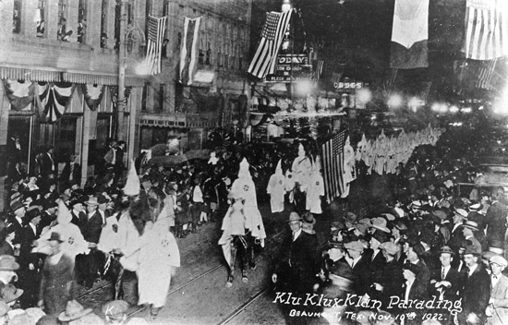](https://tshaonline.org/sites/default/files/images/handbook/KK/ku_klux_klan.jpg)

Ku Klux Klan parading, Beaumont, November 10,1922.  
Courtesy Spindletop-Gladys City Boomtown Museum,  
Beaumont.

[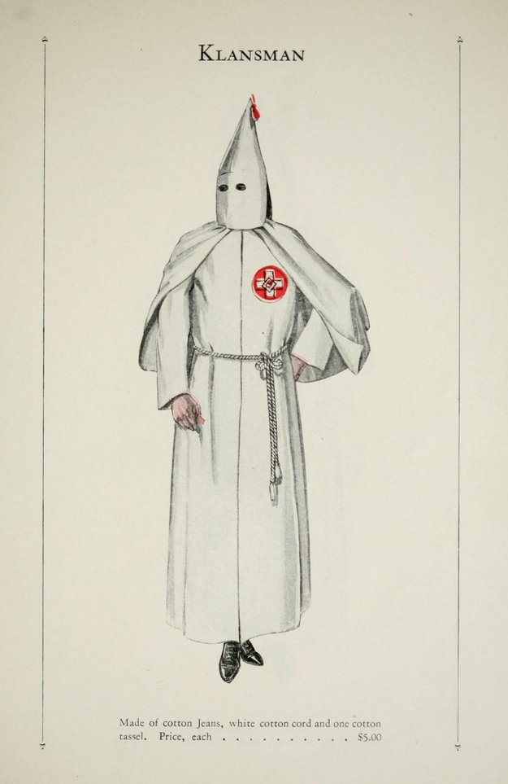](https://tshaonline.org/sites/default/files/images/handbook/KK/kkk-outfit.jpg)

Illustration, Traditional outfit of the Ku Klux Klan. Image available on the [Internet](https://www.buzzfeed.com/copyranter/your-official-ku-klux-klan-robe-catalog?utm_term=.trJeozvbX#.ipe3GrRQv)and included in accordance with [Title 17 U.S.C. Section 107](https://www.law.cornell.edu/uscode/text/17/107).

**KU KLUX KLAN**. The history of the Ku Klux Klan in Texas extends from the [**Reconstruction**](https://tshaonline.org/handbook/online/articles/mzr01) era to the present. The original organization was founded in Pulaski, Tennessee, probably in May or early June 1866, by six young Confederate veterans. Its name reportedly derived from the Greek word *kuklos*, meaning circle or band; "Klan," though redundant, was appended to the name for alliteration. The Klan's founders devised a series of elaborate secret rituals for the organization, closely patterned after the Kuklos Adelphon, a college fraternity widespread throughout the South in the antebellum period. Officers consisted of a "grand cyclops" or president, a "grand magi" (plural *sic*) or vice president, a "grand Turk" or marshal, and a "grand exchequer" (*sic*) or treasurer. Local chapters were called dens. In its early years the Klan's regalia included a white mask with holes for the eyes, a high, conical, cardboard hat, and long flowing robes. Initially the organization existed solely for amusement, but as it spread through the Southern states it became more and more associated with vigilantism and opposition to Republican rule. By the late 1860s the Klan became one of the principal forms of opposition to Reconstruction, and members were pledged to support the supremacy of the white race, to oppose the amalgamation of the races, to resist the social and political encroachment of carpetbaggers, and to restore white control of the government.

The Klan of the Reconstruction era was not a single organization or even a loose confederation of local and state groups. Several different Klan-like organizations with different relationships to each other coexisted in various parts of the South; they included the Knights of the Red Hand, the Pale Faces, the White Brotherhood, the Constitutional Union Guards, and, in Texas, the Knights of the Rising Sun and the [**Knights of the White Camellia**](https://tshaonline.org/handbook/online/articles/vek01). Evidence that the Klan had spread to Texas was first noted in March 1868. At first the group's activities consisted of parades, publications of cryptic newspaper notices, and midnight meetings at graveyards. Republican newspapers satirized these happenings, but by May, when the Klan began to resort to murder and acts of intimidation directed at freedmen and white Republicans, the light-hearted notices ended.

[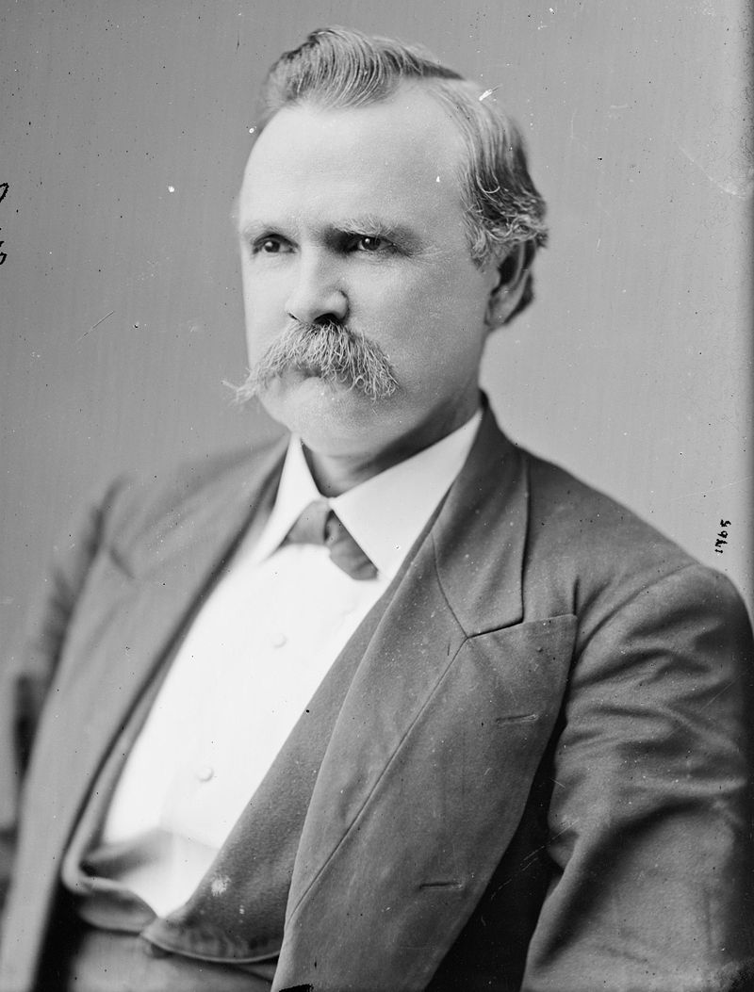](https://tshaonline.org/sites/default/files/images/handbook/MM/mills-roger.jpg)

Photograph, Portrait of Roger Quarles Mills. Image available on the [Internet](https://en.wikipedia.org/wiki/Roger_Q._Mills)and included in accordance with [Title 17 U.S.C. Section 107](https://www.law.cornell.edu/uscode/text/17/107).

Despite its outward appearance of unity, the Klan in Texas was in many ways poorly organized. [**Roger Q. Mills**](https://tshaonline.org/handbook/online/articles/fmi40), a former secessionist and later a congressman, coordinated activities in the state, but often the local groups acted autonomously with little or no central direction. Members of every social stratum belonged to the Klan, though the more respectable elite usually shied away from acts of violence. Local groups of the Klan or bands posing as Klansmen sometimes used terrorist acts such as stealing horses or burning crops merely to gain economic advantage, but most of their victims were Republicans. Generally, Klan violence closely followed politics.

Most of the Klan's activities were focused in Northeast Texas, and at least twenty counties, extending from Houston north to the Red River, experienced some form of Klan terror. In Trinity County in 1868, for example, disguised bands killed several freedmen, forced most of the black voters to register as Democrats, and intimidated federal officials. A local Republican wrote, "Anyone in this community opposed to the Grand Cyclops and his imps is in danger of his life." In Gilmer, Canton, Quitman, Boston, Marshall, and other towns of the region, civil authorities were similarly powerless to control Klan violence. Among the centers of Klan activity in the state was Jefferson and surrounding Marion County, where the small federal garrison under the command of Maj. James Curtis could do little to stem the terror. In October 1868 a band of Klan vigilantes killed George W. Smith*qv*, leader of the local Republicans, and a number of his black followers; for the next two months bands rode through the countryside burning houses and crops and beating and intimidating terrified blacks.

[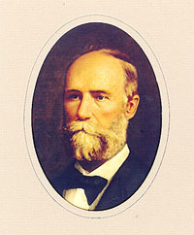](https://tshaonline.org/sites/default/files/images/handbook/DD/davis-portrait.jpg)

Portrait of Edmund Jackson Davis. Image courtesy of the [Texas State Library and Archives Commission](https://www.tsl.texas.gov/governors/war/page2.html). Image available on the Internet and included in accordance with [Title 17 U.S.C. Section 107](https://www.law.cornell.edu/uscode/text/17/107).

By late 1868, however, authorities began to gain the upper hand throughout the state. Between October 1868 and September 1869 fifty-nine cases were tried before military courts in Texas, resulting in twenty-nine convictions. In 1870, Republican governor [**Edmund J. Davis**](https://tshaonline.org/handbook/online/articles/fda37) called on the legislature to form a [**State Police**](https://tshaonline.org/handbook/online/articles/jls02) and a militia, and the measures were passed in June and July. The following year the legislature passed another law making it illegal to be armed and disguised. The Texas Klan began to wane in 1869. In March of that year, the chief executive, or "grand wizard," proclaimed a disbanding of the group. Many of the local chapters followed the lead of the statewide organization, but isolated pockets of Klan activity were still observable in the early 1870s. On June 8, 1870, the *Daily State Journal*, a Radical Republican newspaper, reported that a Klan parade had been held in McKinney, and in July 1871 the same paper reported that masked men had beaten a white teacher of a black school in Bastrop. Such incidents, however, became less common after mid-1870, and the organization in general ceased to exist after Congress passed the Ku Klux Klan Act of April 1871, which permitted the president of the United States to suspend the writ of habeas corpus in cases of secret conspiracy. Although federal efforts played a role in the dissolving the Klan, just as important was the growing reluctance of the Southern white leadership to tolerate violence.

Around the time of [**World War I**](https://tshaonline.org/handbook/online/articles/qdw01) a new Ku Klux Klan, patterned after the original one, made its appearance. The resurgent group began in Georgia, where William J. Simmons dedicated it at a cross-burning on Stone Mountain on Thanksgiving eve, 1915. The success of D. W. Griffith's epic film of the same year, *Birth of a Nation*, based on Thomas Dixon's novel *The Clansman* (1905), with its vivid portrayals of Radical Republican excesses, had helped to fan the flames of racial animosity, which had smoldered since Reconstruction. Also fueling the fire was a growing American nativist movement with its concomitant distrust of Catholics, Jews, [**African Americans**](https://tshaonline.org/handbook/online/articles/pkaan), and other "foreign" elements. At first the new Klan grew slowly, but in the aftermath of World War I, the organization spread rapidly, not only in the South and Southwest, but also through the Midwest and to both coasts. At its height in the early 1920s the new Klan boasted some two million members. As before, its members or those posing as Klansmen perpetrated acts of violence, and although atrocities were committed across the nation, they were generally concentrated in the South. Some Texans were receptive to the Klan's angry and insular message, and by the early 1920s membership in the state organization numbered in the tens of thousands. Hooded legions paraded in Texas cities and towns, and cross-burnings, intended to show the power of the "invisible empire," became all too common.

[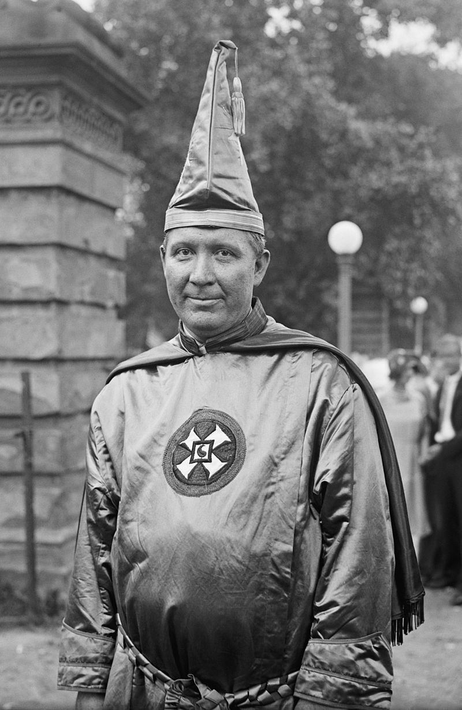](https://tshaonline.org/sites/default/files/images/handbook/EE/evans-hiram.jpg)

Photograph, Hiram Wesley Evans in his Ku Klux Klan uniform. Image available on the [Internet](https://en.wikipedia.org/wiki/Hiram_Wesley_Evans)and included in accordance with [Title 17 U.S.C. Section 107](https://www.law.cornell.edu/uscode/text/17/107).

The revived Klan's main public appeal was as a fraternal lodge, a refuge for white, Protestant America. It promised to reform politics, to enforce [**prohibition**](https://tshaonline.org/handbook/online/articles/vap01), and to champion traditional morality. The preponderance of the membership was concentrated in small towns, but the organization also spread to Dallas, Houston, San Antonio, and the other large cities. Members were drawn from all sectors of society, and many civic leaders, politicians, and law-enforcement officials either belonged or deferred to the Klan. Many officials, however, opposed it. When Waco Klan No. 33 tried to march in the small Central Texas town of Lorena, the sheriff of McLennan County tried to stop the demonstration, touching off a riot in which several people were wounded and one man stabbed to death. The growing violence attributed to the Klan caused wide resentment, and by 1922 a number of anti-Klan organizations had formed across the state. Recognizing the threat to the organization's growth, Dallas dentist [**Hiram Wesley Evans**](https://tshaonline.org/handbook/online/articles/fev17), who was elected "imperial wizard," or national leader, at the organization's first national convention in November 1922, sought to reform the Klan and to change its image. He placed strict controls on local groups, which were, for instance, no longer allowed to wear Klan regalia except at Klan-sponsored events, and sought to extend Klan power by working to have members elected to important political posts.

[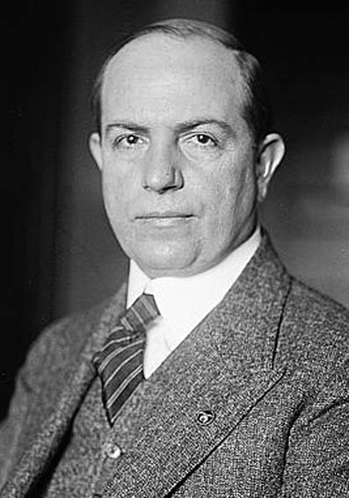](https://tshaonline.org/sites/default/files/images/handbook/MM/mayfield-earle.jpg)

Photograph, Portrait of Earle Bradford Mayfield. Image available on the [Internet](https://en.wikipedia.org/wiki/Earle_Bradford_Mayfield)and included in accordance with [Title 17 U.S.C. Section 107](https://www.law.cornell.edu/uscode/text/17/107).

[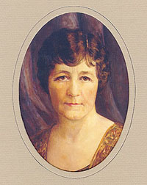](https://tshaonline.org/sites/default/files/images/handbook/FF/ferguson-ma-portrait.jpg)

Portrait of Miriam Amanda Wallace [Ma] Ferguson. Image courtesy of the [Texas State Library and Archives Commission](https://www.tsl.texas.gov/governors/personality/index.html). Image available on the Internet and included in accordance with [Title 17 U.S.C. Section 107](https://www.law.cornell.edu/uscode/text/17/107).

The strategy was especially successful in Texas. With a membership of perhaps as many as 100,000, the Klan used its united voting block to elect state legislators, sheriffs, judges, and other local and state officials. Its greatest success, however, was in securing the election of [**Earle Bradford Mayfield**](https://tshaonline.org/handbook/online/articles/fma91) to the United States Senate in 1922. The following year the Klan established firm control of city governments in Dallas, Fort Worth, and Wichita Falls, and the order probably had a majority in the House of Representatives of the Thirty-eighth Texas Legislature, which met in January. By the end of 1922 the paid membership swelled to as many as 150,000, and Kluxers looked forward to even greater triumphs. The year 1923, however, was the high-water mark for the Klan. Its candidate for governor, Felix D. Robertson, a member of the Dallas Klan, was defeated in 1924 by [**Ma (Miriam Amanda) Ferguson**](https://tshaonline.org/handbook/online/articles/ffe06), and dissension within the organization and growing anti-Klan sentiment combined to weaken its influence greatly. By 1928 the membership had declined to around 2,500, and most prominent supporters had left the fold. During the [**Great Depression**](https://tshaonline.org/handbook/online/articles/npg01), Klan strength waned even further. The fraternity continued its attack on blacks, Jews, and Catholics, but added New Deal politicians and labor organizers to its list of enemies. In 1939 Evans sold ownership of the Klan to James A. Colescott, a veterinarian from Terre Haute, Indiana, but Colescott was soon forced to dissolve the organization because of problems with back taxes and protests over the Klan's association with the German-American Bund.

After [**World War II**](https://tshaonline.org/handbook/online/articles/npwnj) the Klan became increasingly fragmented. During the civil-rights era of the late 1950s and early 1960s, Klan activity in Texas again increased, but because of new anti-Klan laws and FBI pressure, the organization remained small and politically impotent. Subsequently, the Klan fractured into numerous small cells. Among the largest of the Klan groups are the Knights of the Ku Klux Klan and the White Camellia Knights of the Ku Klux Klan, but there are also others, each with its own outlook and agenda and a hatred of competing groups. During the early 1980s the Klan gained new notoriety for its attacks on Vietnamese shrimpers along the Gulf Coast (*see* [**SHRIMPING INDUSTRY**](https://tshaonline.org/handbook/online/articles/dxs02)), and in the early 1990s it was again in the news because of assaults on black residents in Vidor. In the waning years of the twentieth century various Klan groups forged links with skinheads and other neo-Nazis and, despite numerous legal actions, continued to be an irritant in the state.

BIBLIOGRAPHY:

Charles C. Alexander, *Crusade for Conformity: The Ku Klux Klan in Texas, 1920–1930* (Houston: Texas Gulf Coast Historical Association, 1962). Charles C. Alexander, *The Ku Klux Klan in the Southwest* (Lexington: University of Kentucky Press, 1965). Linda Elaine Kilgore, The Ku Klux Klan and the Press in Texas (M.A. thesis, University of Texas, 1964). Shawn Lay, *War, Revolution, and the Ku Klux Klan: A Study of Intolerance in a Border City* (El Paso: Texas Western Press, 1985). Allen W. Trelease, *White Terror: The Ku Klux Klan Conspiracy and Southern Reconstruction* (New York: Harper and Row, 1971). Vertical Files, Dolph Briscoe Center for American History, University of Texas at Austin. "Westward," Dallas *Times Herald*, March 31, 1985.