[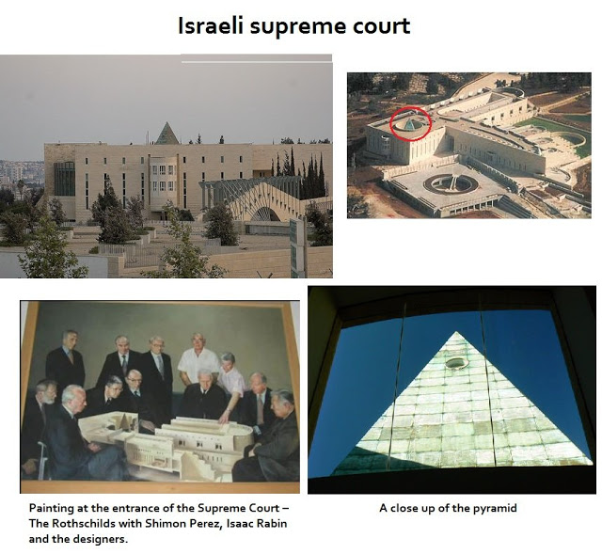](https://3.bp.blogspot.com/-2q4N68D7ogc/W2zntp7pi6I/AAAAAAAABwQ/UPZ2tePkcQk5y96WHhfXYTawPVpV3-xCACLcBGAs/s1600/45jDa5DRedvHMEutRIEU59JF2IYw1-KNEVlL9MFji6o.jpg)

Klassisk frimurer symbolik   
  
[også](https://sonsofsunnah.com/2011/04/16/the-dajjaal-the-shia-mahdi-the-opiate-of-the-masses/) i Iran:  
  
  
**Iranian Parliament, Tehran** (Pyramide med 33 vinduer  - 33 er det ypperligste tal for frimurerne)

[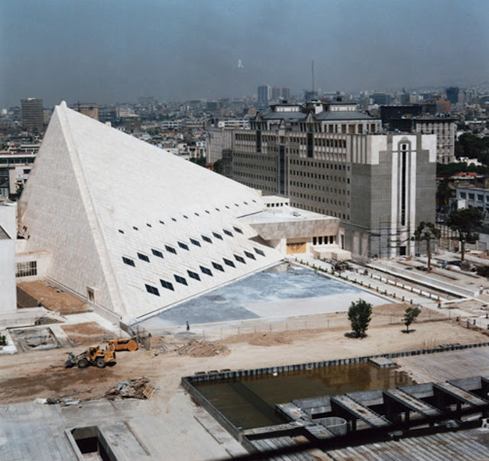](https://2.bp.blogspot.com/-frrGhx9F7jQ/W2zn-CQ_OgI/AAAAAAAABwY/AcQvzyR9uMco_UYx6kCLa_jsHAIeZDxuwCLcBGAs/s1600/1-MAJ101.jpg)  
  
Irans parlament

[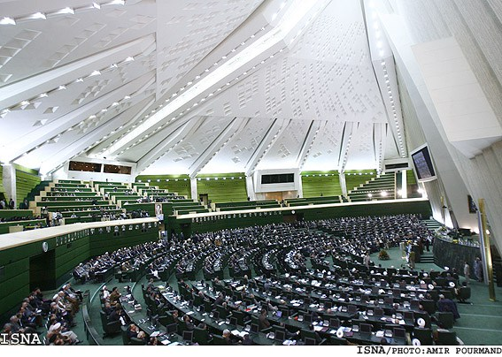](https://1.bp.blogspot.com/-SmjvHwl04dY/W2zoW1uXK_I/AAAAAAAABwg/QM_J3n1nYG4kUTWXOEyq1a69XD_rb0y_QCLcBGAs/s1600/Iran-Parliament.jpg)

[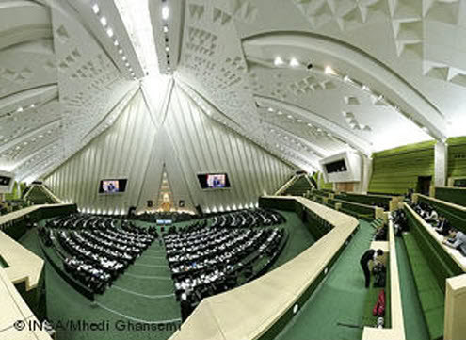](https://4.bp.blogspot.com/-mcL-fQw0OAc/W2zprpXoe1I/AAAAAAAABw0/7KURM9nt76UvtrnqoAkJq2j_dZ54QvopACLcBGAs/s1600/03258726_4001.jpg)

**Vatican City, the Pope’s Audience Hall**

[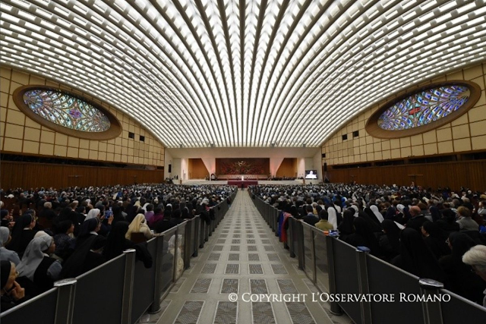](https://2.bp.blogspot.com/-TzMRvJPMRHE/W2zrsiuJdVI/AAAAAAAABxA/NIvt84Vw1901NLHD634xLTHTZvHlWBBzwCLcBGAs/s1600/image.png)

                                          Højesteret, Israel:

[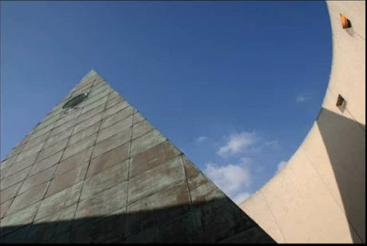](https://2.bp.blogspot.com/-DTh1_lewVJ0/WQYgame2tiI/AAAAAAAABNY/OfQlrgjQ8wwFrWjiZu0GaduvFKpN_opOgCLcB/s1600/supremecourtpyramid.jpg)

[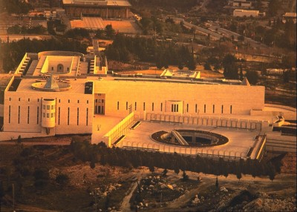](https://1.bp.blogspot.com/-xZth3CnYhkw/WQYefOwSDfI/AAAAAAAABNE/MCmNDY6GyiYiORJh_XYU6Wg5lhE3OB8YwCLcB/s1600/555dug.jpg)

|  |
| --- |
| [https://3.bp.blogspot.com/-0K9PrTsj1UA/WQYelgC2VYI/AAAAAAAABNI/6P4Z-kyZBogV69214q469NM70bq4RNjvQCLcB/s400/sacredgeometry.jpg](https://3.bp.blogspot.com/-0K9PrTsj1UA/WQYelgC2VYI/AAAAAAAABNI/6P4Z-kyZBogV69214q469NM70bq4RNjvQCLcB/s1600/sacredgeometry.jpg) |
| Sacred Geometry - but what is it? |

[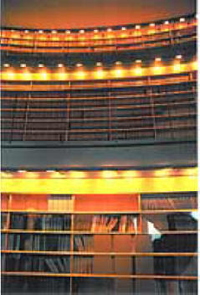](https://3.bp.blogspot.com/-3xQt2kAgNvU/WQYgF8yFTdI/AAAAAAAABNU/mpEbWGq1s146h5fJSfUtSUuxHybtIpWZACLcB/s1600/58_13library.jpg)

The library is divided in three levels, symbolically representing the last three degrees of Freemasonry (31st, 32nd and honorary 33rd) . The first level is reserved for lawyers, the second is reserved for judges and the books on the third level can only be read by retired judges. The library’s way of functioning – where some information is the exclusive privilege of a selected few – directly correlates with the functioning of occult orders, where teachings of a certain degree can only be given if the initiates have successfully cleared the previous degrees.

    “Among the ancient Mysteries the pomegranate was also considered to be a divine symbol of such peculiar significance that its true explanation could not be divulged. It was termed by the Cabiri “the forbidden secret.” Many Greek gods and goddesses are depicted holding the fruit or flower of the pomegranate in their hands, evidently to signify that they are givers of life and plenty. Pomegranate capitals were placed upon the pillars of Jachin and Boaz standing in front of King Solomon’s Temple; and by the order of Jehovah, pomegranate blossoms were embroidered upon the bottom of the High Priest’s ephod”  
    -Manly P. Hall, Secret Teachings of All Ages

[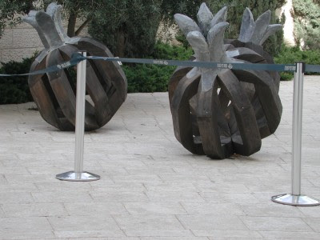](https://2.bp.blogspot.com/-PW1UTSpBzio/WQYfBbKtSiI/AAAAAAAABNM/Tfd-Qbl8G84yMxajmVg25iP5ctqqdoB4ACLcB/s1600/109095025lqEHld_fs.jpg)

As stated by Hall, pomegranates were placed on top of the two pillars standing in front of Solomon’s Temple. If you have minimal knowledge of Masonic teachings, you know that the Temple of Solomon and the pillars named Jachin and Boaz are of an utmost importance.

“The capitals were enriched by pomegranates of bronze, covered by bronze net-work, and ornamented with wreaths of bronze; and appear to have imitated the shape of the seed-vessel of the lotus or Egyptian lily, a sacred symbol to the Hindus and Egyptians.”

-Albert Pike, Morals and Dogma

- see more [**Israel Supreme Court - The Vigilant Citizen**](https://vigilantcitizen.com/sinistersites/sinister-sites-israel-supreme-court/)