**MARIE BAUER HALL**

1904-2005

<http://www.sirbacon.org/mariehall.htm>

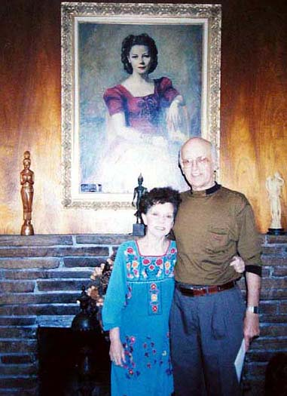   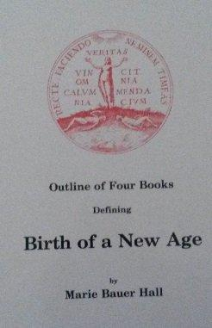 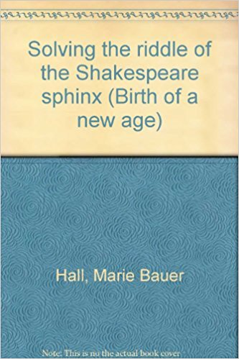

Marie with her long time friend and colleague, Fred Cole

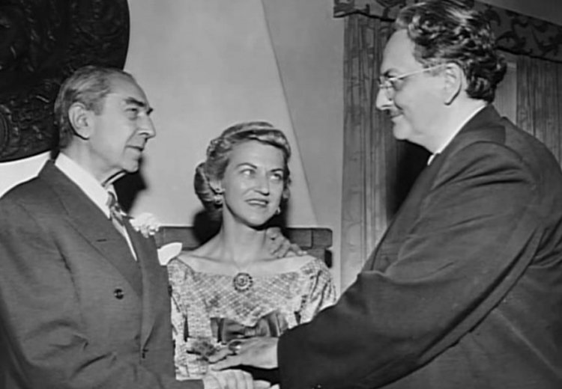 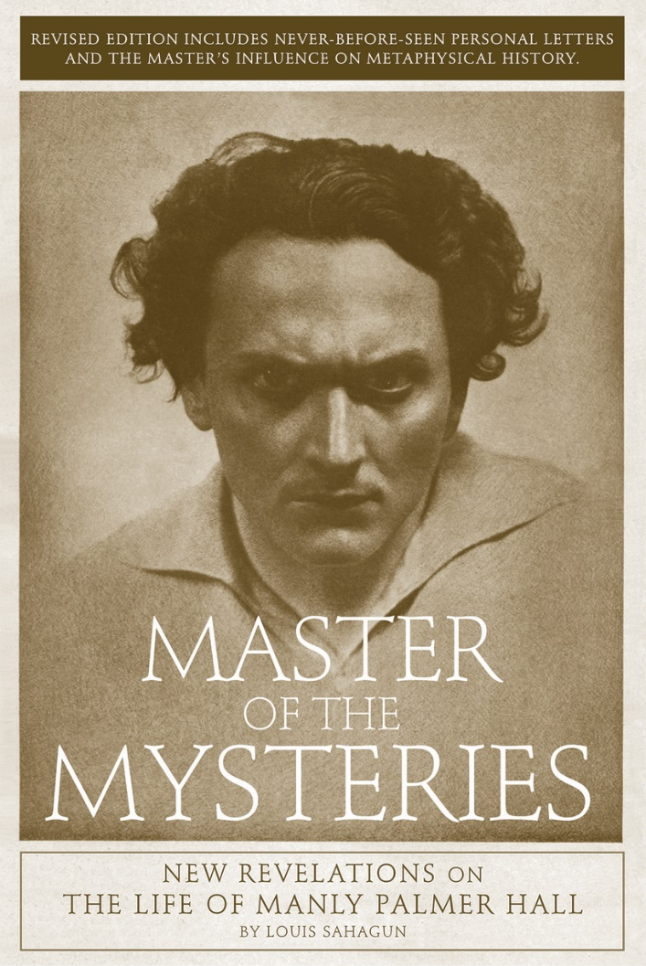 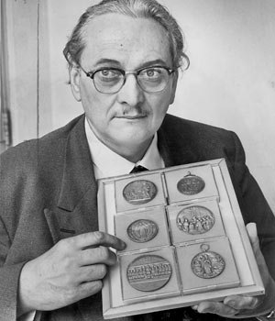 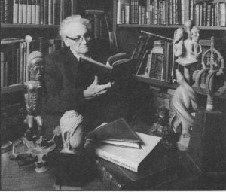

Dear Friends,

April, 20, 2005

Marie Hall, widow of Philosopher Manly Palmer Hall, died this morning at 6:33 AM, 65 days before her 101st birthday. We celebrate a life well-lived and one of service to humanity. Marie's discovery of the foundations of Bruton Parish Church in Williamsburg, Virginia, in 1938 have inspired many to seek the Truth about the Bacon/Shakespeare Mystery. Through her work, countless people have learned of America's Secret Destiny -- a destiny based on Lord Bacon's "Universal Reformation of the Whole World." She is now safe in the arms of her beloved "Divine Mother." God Bless You Marie! -Doreen Key

Marie with her long time friend and colleague, Fred Cole

 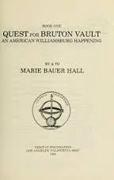

Marie Hall was author of  
  
*Foundations Unearthed*. Veritas Press, 1938.

*The Quest for Bruton Vault.* 1984.

. *Solving the Riddle of the Shakespeare Sphinx*. (The Philosophical Research Society), 1984.

*. Behold, I Come Quickly.* second edition1985

<http://articles.latimes.com/1994-12-22/local/me-11645_1_philosophical-research-society>

# A Materialistic Fate for a Philosophical Legacy

[December 22, 1994](http://articles.latimes.com/1994/dec/22)|BOB POOL | TIMES STAFF WRITER

A bitter fight over books filled with the secrets of harmony and inner peace has ended--four years after the mysterious death of a Los Angeles scholar who spent a lifetime roaming the world to collect them.

Most of Manly P. Hall's library of 18,000 books and artifacts will stay where he put them, at the nonprofit Philosophical Research Society he created and ran for 56 years.

The dispute over ownership of the unusual cache of writings on such subjects as Chinese metaphysics, Zen Buddhism and Hermetic wisdom had raged between Hall's 89-year-old widow and the man who took over the library and control of the society after Hall's death in 1990.

The court fight turned out to be a costly one for the legacy of Manly Hall.

Besides soiling the final memory of the gentlemanly, pipe-smoking scholar, Hall's supporters say the legal wrangling cost $2 million and has come close to putting an end to the Philosophical Research Society library in the Los Feliz district, where Hall spent six decades gathering the secrets of mankind's most revered thinkers.

http://articles.latimes.com/images/pixel.gif