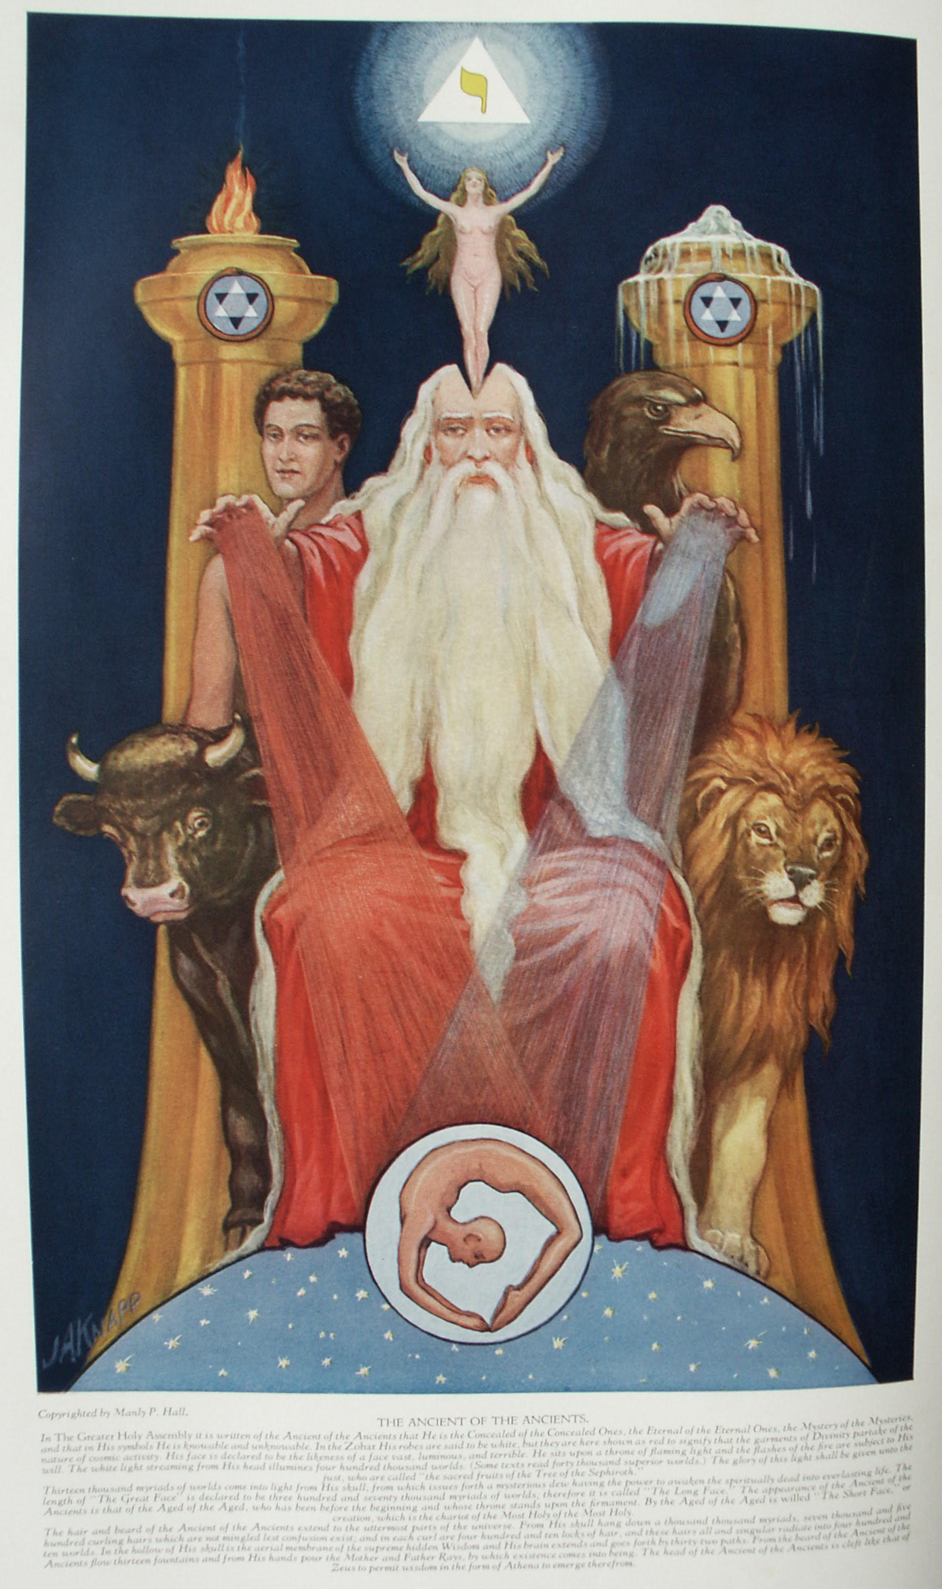

The Qabbalah
The Secret Teachings of All Ages - Manly P. Hall 1928

THE QABBALAH, THE SECRET DOCTRINE OF ISRAEL
The written and unwritten laws--The origin of the Qabbalistic writings--Rabbi Simeon ben Jochai--The great Qabbalistic books--The divisions of the Qabbalistic system--The Sepher Yetzirah.
FUNDAMENTALS OF QABBALISTIC COSMOGONY AIN SOPH
and the Cosmic Egg--The Qabbalistic system of worlds--The Qabbalistic interpretation of Ezekiel's vision--The great image of Nebuchadnezzar's dream--The Grand Man of the universe--The fifty gates of life.
THE TREE OF THE SEPHIROTH
The thirty-two paths of wisdom--The Greater and the Lesser Face--Kircher's Sephirothic Tree--The mystery of Daath--The three pillars supporting the Sephirothic Tree--The four letters of the Sacred Name.
QABBALISTIC KEYS TO THE CREATION OF MAN
Gematria, Notarikon, and Temurah--The Elohim--The four Adams--Arabian traditions concerning Adam--Adam as the archetype of mankind--The early Christian Church on the subject of marriage.
FIFTEEN ROSICRUCIAN AND QABBALISTIC DIAGRAMS
Schamayim, the Ocean of Spirit--The Seven Days of Creation--The symbolic tomb of Christian Rosencreutz--The regions of the elements--The New Jerusalem--The grand secret of Nature.

The Qabbalah, the Secret Doctrine of Israel
ALBERT PIKE, quoting from Transcendental Magic, thus sums up the importance of Qabbalism as a key to Masonic esotericism: "One is filled with admiration, on penetrating into the Sanctuary of the Kabalah, at seeing a doctrine so logical, so simple, and at the same time so absolute. The necessary union of ideas and signs, the consecration of the most fundamental realities by the primitive characters; the Trinity of Words, Letters, and Numbers; a philosophy simple as the alphabet, profound and infinite as the Word; theorems more complete and luminous than those of Pythagoras; a theology summed up by counting on one's fingers; an Infinite which can be held in the hollow of an infant's hand; ten ciphers and twenty-two letters, a triangle, a square, and a circle,--these are all the elements of the Kabalah. These are the elementary principles of the written Word, reflection of that spoken Word that created the world!" (Morals and Dogma.)
Hebrew theology was divided into three distinct parts. The first was the law, the second was the soul of the law, and the third was the soul of the soul of the law. The law was taught to all the children of Israel; the Mishna, or the soul of the law, was revealed to the Rabbins and teachers; but the Qabbalah, the soul of the soul of the law, was cunningly concealed, and only the highest initiates among the Jews were instructed in its secret principles.
According to certain Jewish mystics, Moses ascended Mount Sinai three times, remaining in the presence of God forty days each time. During the first forty days the tables of the written law were delivered to the prophet; during the second forty days he received the soul of the law; and during the last forty days God instructed him in the mysteries of the Qabbalah, the soul of the soul of the law. Moses concealed in the first four books of the Pentateuch the secret instructions that God had given him, and for centuries students of Qabbalism. have sought therein the secret doctrine of Israel. As the spiritual nature of man is concealed in his physical body, so the unwritten law--the Mishna and the Qabbalah--is concealed within the written teachings of the Mosaic code. Qabbalah means the secret or hidden tradition, the unwritten law, and according to an early Rabbi, it was delivered to man in order that through the aid of its abstruse principles he might learn to understand the mystery of both the universe about him and the universe within him.
The origin of Qabbalism is a legitimate subject for controversy. Early initiates of the Qabbalistic Mysteries believed that its principles were first taught by God to a school of His angels before the fall of man. The angels later communicated the secrets to Adam, so that through the knowledge gained from an understanding of its principles fallen humanity might regain its lost a estate. The Angel Raziel was dispatched from heaven to instruct Adam in the mysteries of the Qabbalah. Different angels were employed to initiate the succeeding patriarchs in this difficult science. Tophiel was the teacher of Shem, Raphael of Isaac, Metatron of Moses, and Michael of David. (See Faiths of the World.)
Christian D. Ginsburg has written: "From Adam it passed over to Noah, and then to Abraham, the friend of God, who emigrated with it to Egypt, where the patriarch allowed a portion of this mysterious doctrine to ooze out. It was in this way that the Egyptians obtained some knowledge of it, and the other Eastern nations could introduce it into their philosophical systems. Moses, who was learned in all the wisdom of Egypt, was first initiated into it in the land of his birth, but became most proficient in it during his wanderings in the wilderness, when he not only devoted to it the leisure hours of the whole forty years, but received lessons in it from one of the angels. * * * Moses also initiated the seventy Elders into the secrets of this doctrine and they again transmitted them from hand to hand. Of all who formed the unbroken line of tradition, David and Solomon were most initiated into the Kabbalah." (See The Kabbalah.)
According to Eliphas Levi, the three greatest books of Qabbalism are the Sepher Yetzirah, The Book of Formation; the Sepher ha Zohar, The Book of Splendor; and the Apocalypse, The Book of Revelation. The dates of the writing of these books are by no means thoroughly established. Qabbalists declare that the Sepher Yetzirah was written by Abraham. Although it is by far the oldest of the Qabbalistic books, it was probably from the pen of the Rabbi Akiba, A.D. 120.
The Sepher ha Zohar presumably was written by Simeon ben Jochai, a disciple of Akiba. Rabbi Simeon was sentenced to death about A.D. 161 by Lucius Verus, co-regent of the Emperor Marc Aurelius Antoninus. He escaped with his son and, hiding in a cave, transcribed the manuscript of the Zohar with the assistance of Elias, who appeared to them at intervals. Simeon was twelve years in the cave, during which time he evolved the complicated symbolism of the "Greater Face" and the "Lesser Face." While discoursing with disciples Rabbi Simeon expired, and the "Lamp of Israel" was extinguished. His death and burial were accompanied by many supernatural phenomena. The legend goes on to relate that the secret doctrines of Qabbalism had been in existence since the beginning of the world, but that Rabbi Simeon was the first man permitted to reduce them to writing. Twelve hundred years later the books which he had compiled were discovered and published for the benefit of humanity by Moses de León. The probability is that Moses de León himself compiled the Zohar about A.D. 1305, drawing his material from the unwritten secrets of earlier Jewish mystics. The Apocalypse, accredited to St. John the Divine, is also of uncertain date, and the identity of its author has never been satisfactorily proved.
Because of its brevity and because it is the key to Qabbalistic thought, the Sepher Yetzirah is reproduced in full in this chapter. So far as is known, the Sepher ha Zohar has never been completely translated into English, but it can be obtained in French. (S. L. MacGregor-Mathers translated three books of the Zohar into English.) The Zohar contains a vast number of philosophical tenets, and a paraphrase of its salient points is embodied in this work.

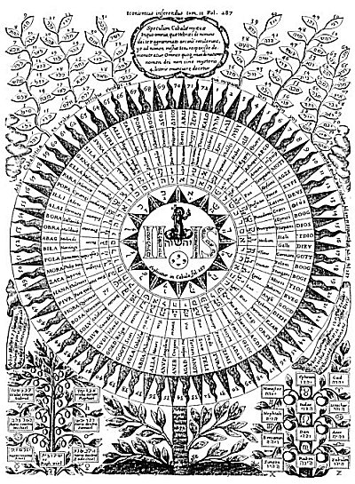
THE SEVENTY-TWO NAMES OF GOD.
From Kircher's Œdipus Ægyptiacus.
This rare cut shows the name of God in seventy-two languages inscribed upon the petals of a symbolic sunflower. Above the circle are the seventy-two powers of God according to the Hebrew Qabbalah. Below two trees, that on the left bearing the symbols of the planets and that on the right the signs of the zodiac and the names of the tribes of Israel. The esoteric doctrines of the Qabbalah are in alignment with the secret teachings of all the schools of philosophy, but the method by which its secrets are revealed to the wise and concealed from the ignorant is most unusual. As the religious world interprets its scriptures with twentieth-century educational facilities, it becomes ever more apparent that the sacred books were not historical documents, but that the kings, sages, prophets, and saviors whom Bible students ham revered for ages as once-existing personalities are in reality only personified attributes of man himself.

Few realize the influence exerted by Qabbalism over mediæval thought, both Christian and Jewish. It taught that there existed within the sacred writings a hidden doctrine which was the key to those writings. This is symbolized by the crossed keys upon the papal crest. Scores of learned minds began to search for those arcane truths by which the race should be redeemed; and that their labor was not without its reward, their subsequent writings have demonstrated.
The theories of Qabbalism are inextricably interwoven with the tenets of alchemy, Hermeticism, Rosicrucianism, and Freemasonry. The words Qabbalism and Hermeticism are now considered as synonymous terms covering all the arcana and esotericism of antiquity. The simple Qabbalism of the first centuries of the Christian Era gradually evolved into an elaborate theological system, which became so involved that it was next to impossible to comprehend its dogma.
The Qabbalists divided the uses of their sacred science into five sections. The Natural Qabbalah was used solely to assist the investigator in his study of Nature's mysteries. The Analogical Qabbalah was formulated to exhibit the relationship which exists between all things in Nature, and it revealed to the wise that all creatures and substances were one in essence, and that man--the Little Universe--was a replica in miniature of God--the Great Universe. The Contemplative Qabbalah was evolved for the purpose of revealing through the higher intellectual faculties the mysteries of the celestial spheres. By its aid the abstract reasoning faculties cognized the measureless planes of infinity and learned to know the creatures existing within them. The Astrological Qabbalah instructed those who studied its lore in the power, magnitude, and actual substance of the sidereal bodies, and also revealed the mystical constitution of the planet itself. The fifth, or Magical Qabbalah, was studied by such as desired to gain control over the demons and subhuman intelligences of the invisible worlds. It was also highly valued as a method of healing the sick by talismans, amulets, charms, and invocations.
The Sepher Yetzirah, according to Adolph Franck, differs from other sacred books in that it does not explain the world and the phenomena of which it is the stage by leaning on the idea of God or by setting itself up as the interpreter of the supreme will. This ancient work rather reveals God by estimating His manifold handiwork. In preparing the Sepher Yetzirah for the consideration of the reader, five separate English translations have been compared. The resulting form, while it embodies the salient features of each, is not a direct translation from any one Hebrew or Latin text. Although the purpose was to convey the spirit rather than the letter of the ancient document, there are no wide deviations from the original rendition. So far as known, the first translation of the Sepher Yetzirah into English was made by the Rev. Dr. Isidor Kalisch, in 1877. (See Arthur Edward Waite.) In this translation the Hebrew text accompanies the English words. The work of Dr. Kalisch has been used as the foundation of the following interpretation, but material from other authorities has been incorporated and many passages have been rewritten to simplify the general theme.
At hand also was a manuscript copy in English of the Book of the Cabalistick Art, by Doctor John Pistor. The document is undated; but judging from the general type of the writing, the copy was made during the eighteenth century. The third volume used as a reference was the Sepher Yetzirah, by the late Win. Wynn Westcott, Magus of the Rosicrucian Society of England. The fourth was the Sepher Yetzirah, or The Book of Creation, according to the translation in the Sacred Books and Early Literature of the East, edited by Prof. Charles F. Horne. The fifth was a recent publication, The Book of Formation, by Knut Stenring, containing an introduction by Arthur Edward Waite. At hand also were four other copies--two German, one Hebrew, and one Latin. Certain portions of the Sepher Yetzirah are considered older and more authentic than the rest, bur the controversy regarding them is involved and nonproductive that it is useless to add further comment. The doubtful passages are therefore included in the document at the points where they would naturally fall.

THE SEPHER YETZIRAH, THE BOOK OF FORMATION
Chapter One
1. YAH, the Lord of Hosts, the living Elohim, King of the Universe, Omnipotent, the Merciful and Gracious God, Supreme and Extolled, Dweller in the Height whose habitation is Eternity, who is Sublime and Most-Holy, engraved His name and ordained (formed) and created the Universe in thirty-two mysterious paths (stages) of wisdom (science), by three Sepharim, namely, Numbers, Letters, and Sounds, which are in Him one and the same.
2. Ten Sephiroth (ten properties from the Ineffable One) and twenty-two letters are the Foundation of all things. Of these twenty-two letters three are called "Mothers," sewn "Double," and twelve "Simple."
3. The ten numbers (Sephiroth) out of Nothing are analogous to the ten fingers and the ten toes: five over against five. In the center between them is the covenant with the Only One God. In the spiritual world it is the covenant of the voice (the Word), and in the corporeal world the circumcision of the flesh (the rite of Abraham).
4. Ten are the numbers (of the Sephiroth) out of Nothing, ten--not nine; ten--not eleven. Comprehend this great, wisdom, understand this knowledge and be wise. Inquire into the mystery and ponder it. Examine all things by means of the ten Sephiroth. Restore the Word to Its Creator and lead the Creator back to His throne again. He is the only Formator and beside Him there is no other. His attributes are ten and are without limit.
5. The ten ineffable Sephiroth have ten infinitudes, which are as follows:
The infinite beginning and the infinite end;
The infinite good and the infinite evil;
The infinite height and the infinite depth;
The infinite East and the infinite West;
The infinite North and the infinite South;
and over them is the Lord Superlatively One, the faithful King. He rules over all in all from His holy habitation for ages of ages.
6. The appearance of the ten spheres (Sephiroth) out of Nothing is as a flash of lightning or a sparkling flame, and they are without beginning or end. The Word of God is in them when they go forth and when they return. They run by His order like a whirlwind and prostrate themselves before His throne.
7. The ten Sephiroth have their end linked to their beginning and their beginning linked to their end, cojoined as the flame is wedded to the live coal, for the Lord is Superlatively One and to Him there is no second. Before One what can you count?
8. Concerning the number (10) of the spheres of existence (Sephiroth) out of Nothing, seal up your lips and guard your heart as you consider them, and if your month opens for utterance and your heart turns towards thought, control them, returning to silence. So it is written: "And the living creatures ran and returned." (Ezekiel i. 14.) And on this wise was the covenant made with us,
9. These are the ten emanations of number out of Nothing:
1st. The spirit of the living Elohim, blessed and more than blessed be the living Elohim of ages. His Voice, His Spirit, and His Word are the Holy Spirit.
2nd. He produced air from the spirit and in the air. He formed and established twenty-two sounds--the letters. Three of them were fundamental, or mothers; seven were double; and twelve were simple (single); but the spirit is the first one and above all.
3rd. Primordial water He extracted from the air. He formed therein twenty-two letters and established them out of mud and loam, making them like a border, putting them up like a wall, and surrounding them as with a rampart. He poured snow upon them and it became earth, as it reads: "He said to the snow be thou earth." (Job. xxxvii. 6.)
4th. Fire (ether) He drew forth from the water. He engraved and established by it the Throne of Glory. He fashioned the Seraphim, the Ophanim, and the Holy Living Creatures (Cherubim?), as His ministering angels; and with (of) these three He formed His habitation, as it reads: "Who made His angels spirits, His ministers a flaming fire." (Psalms civ. 4.)
5th. He selected three consonants (I, H, V) from the simple ones--a secret belonging to the three mothers, or first elements; א מ ש (A, M, Sh), air, water, fire (ether). He sealed them with His spirit and fashioned them into a Great Name and with this sealed the universe in six directions. He turned towards the above and sealed the height with י ה ו (I, H, V).
6th. He turned towards the below and sealed the depth withה י ו (H, I, V).
7th. He turned forward and sealed the East with ו י ה (V, I, H).
8th. He turned backward and sealed the West with ו ה י (V H, I).
9th. He turned to the right and sealed the South with י ו ה (I, V, H).
10th. He turned to the left and sealed the North with ה ו י (H, V, I).
NOTE. This arrangement of the letters of the Great Name is according to the Rev. Dr. Isidor Kalisch.
10. These are the ten ineffable existences out of nothing; From the spirit of the Living God emanated air; from the air, water; from the water, fire (ether); from the fire, the height and the depth, the East and the West, the North and the South.

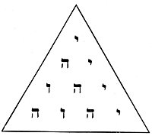
THE TETRAGRAMMATON.
By arranging the four letters of the Great Name, י ה ו ה, (I H V H), in the form of the Pythagorean Tetractys, the 72 powers of the Great Name of God are manifested. The key to the problem is as follows:
. | = | I | = | 10 | = | 10
. . | = | H I | = | 5+10 | = | 15
. . . | = | V H I | = | 6+5+10 | = | 21
. . . . | = | H V H I | = | 5+6+5+10 | = | 26
 |  |  |  | The Great Name of God | = | 72

Chapter Two
1. There are twenty-two basic (sounds and) letters. Three are the first elements (water, air, fire), fundamentals, or mothers; seven are double letters; and twelve are simple letters. The three fundamental letters א מ ש have as their basis the balance. At one end of the scale are the virtues and at the other the vices, placed in equilibrium by the tongue. Of the fundamental letters מ (M) is mute like the water, ש (Sh) hissing like fire, א (A) a reconciling breath between them. t
2. The twenty-two basic letters having been designed, appointed, and established by God, He combined, weighed, and exchanged them (each with the others), and formed by them all beings which are in existence, and all which will be formed in time to come.
3. He established twenty-two basic letters, formed by the voice and impressed upon the air by the breath. He set them to be audibly uttered in five different parts of the human mouth: namely, Gutturals, א ה ח ע; Palatals, ג י כ ק; Linguals, ד ט ל נ ת Dentals, ז ש ס ר ץ; Labials, ב ו מ ף.
4. He fixed the twenty-two basic letters in a ring (sphere) like a wall with two hundred and thirty-one gates, and turned the sphere forward and backward. Turned forward, the sphere signified good; when reversed, evil. Three letters may serve for an illustration: There is nothing better than ע נ ג (O, N, G), pleasure (joy), and nothing worse than נ ג ע (N, G, O), plague (sorrow).
5. How was it all accomplished? He combined, weighed, and changed: the א (A) with all the other letters in succession, and all the others again with א (A), and all again with ב (B); and so with the whole series of letters. Hence it follows that there are two hundred and thirty-one formations, or gates, through which the powers of the letters go forth; every creature and every language proceeded from One Name and the combinations of its letters.
6. He created a reality out of Nothing. He called the nonentity into existence and hewed colossal pillars from intangible air. This has been shown by the example of combining the letter א (A) with all the other letters, and all the other letters with א. By speaking He created every creature and every word by the power of One Name. As an illustration, consider the twenty-two elementary substances from the primitive substance of א. The production of every creature from the twenty-two letters is proof that they are in reality the twenty-two parts of one living body.

Chapter Three
1. The first three elements (the Mother letters, א מ ש) resemble a balance, in one scale virtue and in the other vice, placed in equilibrium by the tongue.
2. The three Mothers, א מ ש, enclose a great, wonderful, and unknown mystery, and are sealed by six wings (or elementary circles), namely, air, water, fire--each divided into an active and a passive power. The Mothers, א מ ש, gave birth to the Fathers (the progenitors), and these gave birth to the generations.
3. God appointed and established three Mothers, א מ ש, combined, weighed, and exchanged them, forming by them three Mothers, in the universe, in the year, and in man (male and female).
4. The three Mothers, א מ ש, in the universe are: air, water, and fire. Heaven was created from the elementary fire (or ether) ש, the earth, comprising sea and land, from the elementary water, מ, and the atmospheric air from the elementary air, or spirit, א, which establishes the balance among them. Thus were all things produced.
5. The three Mothers, א מ ש, produce in the year heat, coldness, and the temperate state. Heat was created from fire, coldness from water, and the temperate state from air, which equilibrates them.
6. The three Mothers, א מ ש, produce in man (male and female) breast, abdomen, and head. The head was formed from the fire, ש; the abdomen from the water, מ; and the breast (thorax) from air, א, which places them in equilibrium.
7. God let the letter א (A) predominate in primordial air, crowned it, combined it with the other two, and sealed the air in the universe, the temperate state in the year, and the breast in man (male and female).
8. He let the letter מ (M) predominate in primordial water, crowned it, combined it with the other two, and sealed the earth in the universe (including land and sea), coldness in the year, and the abdomen in man (male and female).
9. He let the letter ש (Sh) predominate in primordial fire, crowned it, combined it with the other two, and sealed heaven in the universe, heat in the year, and the head of man (male and female).

Chapter Four
1. The seven double letters, ב ג ד כ פ ר ת (B, G, D, K, P, R, Th), have a duplicity of pronunciation (two voices), aspirated and unaspirated, namely: פּ ת, רּ ר, פּ פ, כּ כ, דּ ד, גּ גThey serve as a model of softness and hardness, strength and weakness.
2. The seven double letters symbolize wisdom, riches, fertility life, power, peace, and grace.
3. The seven double letters also signify the antitheses to which human life is exposed. The opposite of wisdom is foolishness; of riches, poverty; of fertility, sterility; of life, death; of power, servitude; of peace, war; and of beauty, deformity.
4. The seven double letters point out the six dimensions, height, depth, East and West, North and South, and the Holy Temple in the center, which sustains them all.
5. The double letters are seven and not six, they are seven and not eight; reflect upon this fact, search into it and reveal its hidden mystery and place the Creator on His throne again.
6. The seven double letters having been designed, established, purified, weighed, and exchanged by God, He formed of them seven planets in the universe, seven days in the Year, and seven gateways of the senses in man (male and female). From these seven He also produced seven heavens, seven earths, and seven Sabbaths. Therefore He loved seven more than any other number beneath His throne.
7. The seven planets in the universe are: Saturn, Jupiter, Mars, Sun, Venus, Mercury, and Moon. The seven days in the Year are the seven days of the week (possibly the seven creative days are meant). The seven gateways in man (male and female) are two eyes, two ears, two nostrils, and the mouth.
8. NOTE. Knut Stenring differs from other authorities in his arrangement of the planets and days of the week in the following seven stanzas. Kircher has still a different order. Rev. Dr. Isidor Kalisch, Wm. Wynn Westcott, and The Sacred Books and Early Literature of the East adopt the following arrangement.
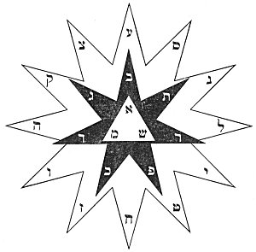
THE HEBREW LETTERS ACCORDING TO THE SEPHER YETZIRAH.
In the central triangle are the three Mother Letters from which come forth the seven Double Letters--the planets and the heavens. Surrounding the black star are the signs of the zodiac symbolized by the twelve Simple Letters. In the midst of this star is the Invisible Throne of the Most Ancient of the Ancients--the Supreme Definitionless Creator.

1st. He caused the letter. ב (B) to predominate in wisdom, crowned it, combined each with the others, and formed by them the Moon in the universe, the first day in the year, and the right eye in man (male and female).
2nd. He caused the letter ג (G) to predominate in riches, crowned it, combined each with the others, and formed by them Mars in the universe, the second day in the year, and the right ear in man (male and female).
3rd. He caused the letter ד (D) to predominate infertility, crowned it, combined each with the others, and formed by them the Sun in the universe, the third day in the year, and the right nostril in man (male and female).
4th. He caused the letterכ (K) to predominate in life, crowned it, combined each with the others, and formed by them Venus in the universe, the fourth day in the year, and the left eye in man (male and female).
5th. He caused the letter פ (P) to predominate in power, crowned it, combined each with the others, and formed by them Mercury in the universe, the fifth day in the year, and the left ear in man (male and female).
6th. He caused the letter ר (R) to predominate in peace, crowned it, combined each with the others, and formed by them Saturn in the universe, the sixth day in the year, and the left nostril in man (male and female).
7th. He caused the letter ת (Th) to predominate in grace, crowned it, combined each with the others, and formed by them Jupiter in the universe, the seventh day in the year, and the mouth of man (male and female).
9. With the seven double letters He also designed seven earths, seven heavens, seven continents, seven seas, seven rivers, seven deserts, seven days, seven weeks (from Passover to Pentecost), and in the midst of them His Holy Palace. There is a cycle of seven years and the seventh is the release year, and after seven release years is the Jubilee. For this reason God loves the number seven more than any other thing under the heavens.
10. In this manner God joined the seven double letters together. Two stones build two houses, three stones build six houses, four stones build twenty-four houses, five stones build 120 houses, six stones build 720 houses, and seven stones build 5,040 houses. Make a beginning according to this arrangement and reckon further than the mouth can express or the ear can hear.
Chapter Five
1. The twelve simple letters ה ו ז ח ט י ל נ ס ע צ ק (H, V, Z, Ch, T, I, L, N, S, O, Tz, Q) symbolize the twelve fundamental properties: speech, thought, movement, sight, hearing, work, coition, smell, sleep, anger, taste (or swallowing), and mirth.
2. The simple letters correspond to twelve directions: east height, northeast, east depth; south height, southeast, south depth; west height, southwest, west depth; north height, northwest, north depth. They diverge to all eternity and are the arms of the universe.
3. The simple letters having been designed, established, weighed, and exchanged by God, He produced by them twelve zodiacal signs in the universe, twelve months in the year, and twelve chief organs in ` human body (male and female).
4, The signs of the zodiac are: Aries, Taurus, Gemini, Cancer, Leo, Virgo, Libra, Scorpio, Sagittarius, Capricorn, Aquarius, and Pisces. The months of the year are: Nisan, liar, Sivan, Tammuz, Ab, Elul, Tisri, Marcheshvan, Kislev, Tebet, Sebat, and Adar. The organs of the human body are: two hands, two feet, two kidneys, gall, small intestine, liver, esophagus, stomach, and spleen.
5. NOTE. In the following twelve stanzas, Knut Stenring again differs, this time as to the arrangement of properties:
1st. God caused the letter ה (H) to predominate in speech, crowned it, combined it with the others, and fashioned by them Aries (the Ram) in the universe, the month Nisan in the year, and the right foot of the human body (male and female).
2nd. He caused the letter ו (V) to predominate in thought, crowned it, combined it with the others, and fashioned by them Taurus (the Bull) in the universe, the month liar in the year, and the right kidney of the human body (male and female).
3rd. He caused the letter ז (Z) to predominate in movement, crowned it, combined it with the others, and fashioned by them Gemini (the Twins) in the universe, the month Sivan in the year, and the left foot of the human body (male and female).
4th. He caused the letter ח (Ch) to predominate in sight, crowned it, combined it with the others, and fashioned by them Cancer (the Crab) in the universe, the month Tammuz in the year, and the right hand of the human body (male and female).
5th. He caused the letter ט (T) to predominate in hearing, crowned it, combined it with the others, and fashioned by them Leo (the Lion) in the universe, the month Ab in the year, and the left kidney of the human body (male and female).
6th. He caused the letter י (I) to predominate in work, crowned it, combined it with the others, and fashioned by them Virgo (the Virgin) in the universe, the month Elul in the year, and the left hand of the human body (male and female).
7th. He caused the letter ל (L) to predominate in coition, crowned it, combined it with the others, and fashioned by them Libra (the Balance) in the universe, the month Tisri in the year, and the gall of the human body (male and female).
8th. He caused the letter נ (N) to predominate in smell, crowned it, combined it with the others, and fashioned by them Scorpio (the Scorpion) in the universe, the month Marcheshvan in the year, and the small intestine in the human body (male and female).
9th. He caused the letter ס (S) to predominate in sleep, crowned it, combined it with the others, and fashioned by them Sagittarius (the Archer) in the universe, the month Kislev in the year, and the stomach in the human body (male and female).
10th. He caused the letter ע (O) to predominate in anger, crowned it, combined it with the others, and fashioned by them Capricorn (the Goat) in the universe, the month Tebet in the year, and the liver in the human body (male and female).
11th. He caused the letter צ (Tz) to predominate in taste (or swallowing), crowned it, combined it with the others, and fashioned by them Aquarius (the Water Bearer) in the universe, the month Sebat in the year, and the esophagus in the human body (male and female).
12th. He caused the letter ק (Q) to predominate in mirth, crowned it, combined it with the others, and fashioned by them Pisces (the Fishes) in the universe, the month Adar in the year, and the spleen in the human body (male and female).
6. He made them as a conflict, He arranged them as provinces and drew them up like a wall. He armed them and set one against another as in warfare. (The Elohim did likewise in the other spheres.)
Chapter Six
1. There are three Mothers or first elements, א מ ש (A, M, Sh), from which emanated three Fathers (progenitors)--primordial (spiritual) air, water, and fire--from which issued the seven planets (heavens) with their angels, and the twelve oblique points (zodiac).
2. To prove this there are three faithful witnesses: the universe, the year, and man. There are the twelve, the balance, and the seven. Above is the Dragon, below is the world, and lastly the heart of man; and in the midst is God who regulates them all.
3. The first elements are air, water, and fire; the fire is above, the water is below, and a breath of air establishes balance between them. The token is: the fire carries the water. The letterמ (M) is mute; ש (Sh) is hissing like fire; there is א (A) among them, a breath of air which reconciles the two.
4. The Dragon (Tali) is in the universe like a king upon his throne; the celestial sphere is in the year like a king in his empire; and the heart is in the body of men like a king in warfare.
5. God also set the opposites against each other: the good against the evil, and the evil against the good. Good proceeds from good, evil from evil; the good purifies the bad, the bad the good. The good is reserved for the good, and the evil for the wicked.
6. There are three of which each stands by itself: one is in the affirmative (filled with good), one is in the negative (filled with evil), and the third equilibrates them.
7. There are seven divided three against three, and one in the midst of them (balance). Twelve stand in warfare: three produce love and three hatred; three are life-givers and three are destroyers.
8. The three that cause love are the heart and the two ears; the three that produce hatred are the liver, the gall, and the tongues; the three life-givers are the two nostrils and the spleen; and the three destroyers are the mouth and the two lower openings of the body. Over all these rules God, the faithful king, from His holy habitation in all eternity. God is One above three, three are above seven, seven are above twelve, yet all are linked together.
9. There are twenty-two letters by which the I AM (YAH), the Lord of Hosts, Almighty and Eternal, designed and created by three Sepharim (Numbers, Letters, and Sounds) His universe, and formed by them all creatures and all those things that are yet to come.
10. When the Patriarch Abraham had comprehended the great truths, meditated upon them, and understood them perfectly, the Lord of the Universe (the Tetragrammaton) appeared to him, called him His friend, kissed him upon the head, and made with him a covenant. First, the covenant was between the ten fingers of his hands, which is the covenant of the tongue (spiritual); second, the covenant was between the ten toes of his feet, which is the covenant of circumcision (material); and God said of him, "Before Abraham bound the spirit of the twenty-two letters (the Thora) upon his tongue and God disclosed to him their secrets. God permitted the letters to be immersed in water, He burned them in the fire and imprinted them upon the winds. He distributed them among the seven planets and gave them to the twelve zodiacal signs.

===================================================================================================================================================

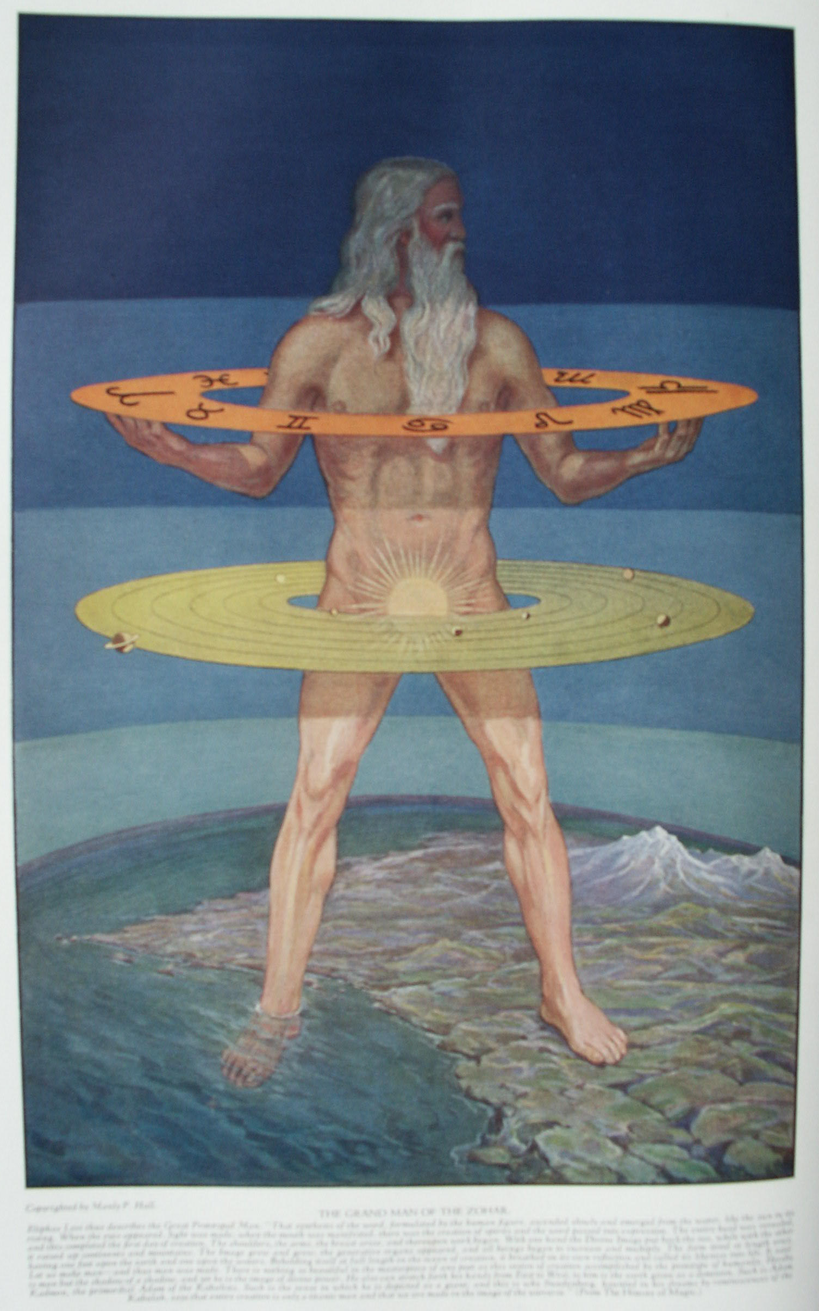

Fundamentals of Qabbalistic Cosmogony

THE Qabbalists conceive of the Supreme Deity as an Incomprehensible Principle to be discovered only through the process of eliminating, in order, all its cognizable attributes. That which remains--when every knowable thing has been removed--is AIN SOPH, the eternal state of Being. Although indefinable, the Absolute permeates all space. Abstract to the degree of inconceivability, AIN SOPH is the unconditioned state of all things. Substances, essences, and intelligences are manifested out of the inscrutability of AIN SOPH, but the Absolute itself is without substance, essence, or intelligence. AIN SOPH may be likened to a great field of rich earth out of which rises a myriad of plants, each different in color, formation, and fragrance, yet each with its roots in the same dark loam--which, however, is unlike any of the forms nurtured by it. The "plants" are universes, gods, and man, all nourished by AIN SOPH and all with their source in one definitionless essence; all with their spirits, souls, and bodies fashioned from this essence, and doomed, like the plant, to return to the black ground--AIN SOPH, the only Immortal--whence they came.
AIN SOPH was referred to by the Qabbalists as The Most Ancient of all the Ancients. It was always considered as sexless. Its symbol was a closed eye. While it may be truly said of AIN SOPH that to define It is to defile It, the Rabbis postulated certain theories regarding the manner in which AIN SOPH projected creations out of Itself, and they also assigned to this Absolute Not-Being certain symbols as being descriptive, in part at least, of Its powers. The nature of AIN SOPH they symbolize by a circle, itself emblematic of eternity. This hypothetical circle encloses a dimensionless area of incomprehensible life, and the circular boundary of this life is abstract and measureless infinity.
According to this concept, God is not only a Center but also Area. Centralization is the first step towards limitation. Therefore, centers which form in the substances of AIN SOPH are finite because they are predestined to dissolution back into the Cause of themselves, while AIN SOPH Itself is infinite because It is the ultimate condition of all things. The circular shape given to AIN SOPH signifies that space is hypothetically enclosed within a great crystal-like globe, outside of which there is nothing, not even a vacuum. Within this globe--symbolic of AIN SOPH--creation and dissolution take place. Every element and principle that will ever be used in the eternities of Kosmic birth, growth, and decay is within the transparent substances of this intangible sphere. It is the Kosmic Egg which is not broken till the great day "Be With Us," which is the end of the Cycle of Necessity, when all things return to their ultimate cause.
In the process of creation the diffused life of AIN SOPH retires from the circumference to the center of the circle and establishes a point, which is the first manifesting One--the primitive limitation of the all-pervading O. When the Divine Essence thus retires from the circular boundary to the center, It leaves behind the Abyss, or, as the Qabbalists term it, the Great Privation. Thus, in AIN SOPH is established a twofold condition where previously had existed but one. The first condition is the central point--the primitive objectified radiance of the eternal, subjectified life. About this radiance is darkness caused by the deprivation of the life which is drawn to the center to create the first point, or universal germ. The universal AIN SOPH, therefore, no longer shines through space, but rather upon space from an established first point. Isaac Myer describes this process as follows: "The Ain Soph at first was filling All and then made an absolute concentration into Itself which produced the Abyss, Deep, or Space, the Aveer Qadmon or Primitive Air, the Azoth; but this is not considered in the Qabbalah as a perfect void or vacuum, a perfectly empty Space, but is thought of as the Waters or Crystalline Chaotic Sea, in which was a certain degree of Light inferior to that by which all the created [worlds and hierarchies] were made." (See The Qabbalah.)
In the secret teachings of the Qabbalah it is taught that man's body is enveloped in an ovoid of bubble-like iridescence, which is called the Auric Egg. This is the causal sphere of man. It bears the same relationship to man's physical body that the globe of AIN SOPH bears to Its created universes. In fact, this Auric Egg is the AIN SOPH sphere of the entity called man. In reality, therefore, the supreme consciousness of man is in this aura, which extends in all directions and completely encircles his lower bodies. As the consciousness in the Kosmic Egg is withdrawn into a central point, which is then called God--the Supreme One--so the consciousness in the Auric Egg of man is concentrated, thereby causing the establishment of a point of consciousness called the Ego. As the universes in Nature are formed from powers latent in the Kosmic Egg, so everything used by man in all his incarnations throughout the kingdoms of Nature is drawn from the latent powers within his Auric Egg. Man never passes from this egg; it remains even after death. His births, deaths, and rebirths all take place within it, and it cannot be broken until the lesser day "Be With Us," when mankind--like the universe--is liberated from the Wheel of Necessity.

THE QABBALISTIC SYSTEM OF WORLDS
On the accompanying circular chart, the concentric rings represent diagrammatically the forty rates of vibration (called by the Qabbalists Spheres) which emanate from AIN SOPH. The circle X 1 is the outer boundary of space. It circumscribes the area of AIN SOPH. The nature of AIN SOPH Itself is divided into three parts, represented by the spaces respectively between X 1 and X 2, X 2 and X 3, X 3 and A 1; thus:
X 1 to X 2, | אין, | AIN, the vacuum of pure spirit.
X 2 to X 3, | אין סוף, | AIN SOPH, the Limitless and Boundless.
X 3 to A 1, | אין סוף אור, | AIN SOPH AUR, the Limitless Light.
It should be borne in mind that in the beginning the Supreme Substance, AIN, alone permeated the area of the circle; the inner rings had not yet come into manifestation. As the Divine Essence concentrated Itself, the rings X 2 and X 3 became apprehensible, for AIN SOPH is a limitation of AIN, and AIN SOPH AUR, or Light, is a still greater limitation. Thus the nature of the Supreme One is considered to be threefold, and from this threefold nature the powers and elements of creation were reflected into the Abyss left by the motion of AIN SOPH towards the center of Itself. The continual motion of AIN SOPH towards the center of Itself resulted in the establishment of the dot in the circle. The dot was called God, as being the supreme individualization of the Universal Essence. Concerning this the Zohar says:
"When the concealed of the Concealed wished to reveal Himself He first made a single point: the Infinite was entirely unknown, and diffused no light before this luminous point violently broke through into vision."
The name of this point is I AM, called by the Hebrews Eheieh. The Qabbalists gave many names to this dot. On this subject Christian D. Ginsberg writes, in substance: The dot is called the first crown, because it occupies the highest position. It is called the aged, because it is the first emanation. It is called the primordial or smooth point. It is called the white head, the Long Face--Macroprosophus--and the inscrutable height, because it controls and governs all the other emanations.
When the white shining point had appeared, it was called Kether, which means the Crown, and out of it radiated nine great globes, which arranged themselves in the form of a tree. These nine together with the first crown constituted the first system of Sephiroth. These ten were the first limitation of ten abstract points within the nature of AIN SOPH Itself. The power of AIN SOPH did not descend into these globes but rather was reflected upon them as the light of the sun is reflected upon the earth and planets. These ten globes were called the shining sapphires, and it is believed by many Rabbins that the word sapphire is the basis of the word Sephira (the singular of Sephiroth). The great area which had been privated by the withdrawal of AIN SOPH into the central point, Kether, was now filled by four concentric globes called worlds, or spheres, and the light of the ten Sephiroth was reflected down through each of these in turn. This resulted in the establishment of four symbolical trees, each hearing the reflections of the ten Sephirothic globes. The 40 spheres of creation out of AIN SOPH are divided into four great world chains, as follows:
A 1 to A 10, Atziluth, the Boundless World of Divine Names.
B 1 to B 10, Briah, the Archangelic World of Creations.
C 1 to C 10, Yetzirah, the Hierarchal World of Formations.
D 1 to D 10, Assiah, the Elemental World of Substances.

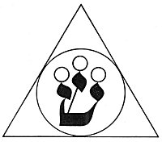
THE HEBREW TRIAD.
The Qabbalists used the letter ש, Shin, to signify the trinity of the first three Sephiroth. The central circle slightly above the other two is the first Sephira--Kether, the White Head, the Crown. The other two circles represent Chochmah, the Father, and Binah, the Mother. From the union of the Divine Father and the Divine Mother are produced the worlds and the generations of living things. The three flame-like points of the letter ש have long been used to conceal this Creative Triad of the Qabbalists.

Each of these worlds has ten powers, or spheres--a parent globe and nine others which conic out of it as emanations, each globe born out of the one preceding. On the plane of Atziluth (A 1 to A 10), the highest and most divine of all the created worlds, the unmanifested AIN SOPH established His first point or dot in the Divine Sea--the three spheres of X. This dot--A 1--contains all creation within it, but in this first divine and uncontaminated state the dot, or first manifested. God, was not considered as a personality by the Qabbalists but rather as a divine establishment or foundation. It was called the First Crown and from it issued the other circles of the Atziluthic World: A 2, A 3, A 4, A 5, A 6, A 7, A 8, A 9, and A 10. In the three lower worlds these circles are intelligences, planers, and elements, but in this first divine world they are called the Rings of the Sacred Names.
The first ten great circles (or globes) of light which were manifested out of AIN SOPH and the ten names of God assigned to them by the Qabbalists are as follows:
From AIN SOPH came A 1, the First Crown, and the name of the first power of God was Eheieh, which means I Am [That I Am].
From A 1 came A 2, the first Wisdom, and the name of the second power of God was Jehovah, which means Essence of Being.
From A 2 came A 3, the first Understanding, and the name of the third power of God was Jehovah Elohim, which means God of Gods.
From A 3 came A 4, the first Mercy, and the name of the fourth power of God was El, which means God the Creator.
From A 4 came A 5, the first Severity, and the name of the fifth power of God was Elohim Gibor, which means God the Potent.
From A 5 came A 6, the first Beauty, and the name of the sixth power of God was Eloah Vadaath, which means God the Strong.
From A 6 came A 7, the first Victory, and the name of the seventh power of God was Jehovah Tzaboath, which means God of Hosts.
From A 7 came A 8, the first Glory, and the name of the eighth power of God was Elohim Tzaboath, which means Lord God of Hosts.
From A 8 came A 9, the first Foundation, and the name of the ninth power of God was Shaddai, El Chai, which means Omnipotent.
From A 9 came A 10, the first Kingdom, and the name of the tenth power of God was Adonai Melekh, which means God.
From A 10 came B 1, the Second Crown, and the World of Briah was established.
The ten emanations from A 1 to A 10 inclusive are called the foundations of all creations. The Qabbalists designate them the ten roots of the Tree of Life. They are arranged in the form of a great human figure called Adam Qadmon--the man made from the fire mist (red dirt), the prototypic Universal Man. In the Atziluthic World, the powers of God are most purely manifested. These ten pure and perfect radiations do not descend into the lower worlds and take upon themselves forms, but are reflected upon the substances of the inferior spheres. From the first, or Atziluthic, World they are reflected into the second, or Briatic, World. As the reflection always lacks some of the brilliancy of the original image, so in the Briatic World the ten radiations lose part of their infinite power. A reflection is always like the thing reflected, but smaller and fainter.
In the second world, B 1 to B 10, the order of the spheres is the Name as in the Atziluthic World, but the ten circles of light are less brilliant and more tangible, and are here referred to as ten great Spirits--divine creatures who assist in the establishment of order and intelligence in the universe. As already noted, B 1 is born out of A 10 and is included within all the spheres superior to itself. Out of B 1 are taken nine globes--B 2, B 3, B 4, B 5, B 6, B 7, B 8, B 9, and B 10--which constitute the World of Briah. These ten subdivisions, however, are really the ten Atziluthic powers reflected into the substance of the Briatic World. B 1 is the ruler of this world, for it contains all the other rings of its own world and also the rings of the third and fourth worlds, C and D. In the World of Briah the ten spheres of light are called the Archangels of Briah. Their order and powers are as follows:
From A 10 came B 1, the Second Crown; it is called Metatron, the Angel of the Presence.
From B 1 came B 2, the second Wisdom; it is called Raziel, the Herald of Deity who revealed the mysteries of Qabbalah to Adam.
From B 2 carne B 3, the second Understanding; it is called Tsaphkiel, the Contemplation of God.
From B 3 came B 4 ' the second Mercy; it is called Tsadkiel, the justice of God.
From B 4 came B 5, the second Severity; it is called Samael, the Severity of God.
From B 5 came B 6, the second Beauty; it is called Michael, Like Unto God.
From B 6 came B 7, the second Victory; it is called Haniel, the Grace of God.
From B 7 came B 8, the second Glory; it is called Raphael, the Divine Physician.
From B 8 came B 9, the second Foundation; it is called Gabriel, the Man-God.
From B 9 came B 10, the second Kingdom; it is called Sandalphon, the Messias.
From B 10 came C 1, the Third Crown, and the World of Yetzirah was established.
The ten Archangels of Briah are conceived to be ten great spiritual beings, whose duty is to manifest the ten powers of the Great Name of God existent in the Atziluthic World, which surrounds and interpenetrates the entire world of creation. All things manifesting in the lower worlds exist first in the intangible rings of the upper spheres, so that creation is, in truth, the process of making tangible the intangible by extending the intangible into various vibratory rates. The ten globes of Briatic power, while themselves reflections, are mirrored downward into the third or Yetziratic World, where still more limited in their expression they become the spiritual and invisible zodiac which is behind the visible band of constellations. In this third world the ten globes of the original Atziluthic World are greatly limited and dimmed, but they are still infinitely powerful in comparison with the state of substance in which man dwells. In the third world, C 1 to C 10, the globes become hierarchies of celestial creatures, called the Choirs of Yetzirah. Here again, all are included within the ring C 1, the power which controls the Yetziratic World and which includes within itself and controls the entire world D. The order of the globes and the names of the hierarchies composing them are as follows:
From B 10 came C 1, the Third Crown; the Hierarchy is the Cherubim, Chaioth Ha Kadosh, the Holy Animals.
From C 1 came C 2, the third Wisdom; the Hierarchy is the Cherubim, Orphanim, the Wheels.
From C 2 came C 3, the third Understanding; the Hierarchy is the Thrones, Aralim, the Mighty Ones.
From C 3 came C 4, the third Mercy; the Hierarchy is the Dominations, Chashmalim, the Brilliant Ones.
From C 4 came C 5, the third Severity; the Hierarchy is the Powers, Seraphim, the Flaming Serpents.
From C 5 came C 6, the third Beauty; the Hierarchy is the Virtues, Melachim, the Kings.
From C 6 came C 7, the third Victory; the Hierarchy is the Principalities, Elohim, the Gods.
From C 7 came C 8, the third Glory; the Hierarchy is the Archangels, Ben Elohim, the Sons of God.
From C 8 came C 9, the third Foundation; the Hierarchy is the Angels, Cherubim, the Scat of the Sons.
From C 9 came C 10, the third Kingdom; the Hierarchy is Humanity, the Ishim, the Souls of Just Men.
From C 10 came D 1, the Fourth Crown, and the World of Assiah was established.
From the Yetziratic World the light of the ten spheres is reflected into the World of Assiah, the lowest of the four. The ten globes of the original Atziluthic World here take upon themselves forms of physical matter and the sidereal system is the result. The World of Assiah, or the elemental world of substance, is the one into which humanity descended at the time of Adam's fall. The Garden of Eden is the three upper worlds, and for his sins man was forced into the sphere of substance and assumed coats of skin (bodies). All of the spiritual forces of the upper worlds, A, B, C, when they strike against the elements of the lower world, D, are distorted and perverted, resulting in the creation of hierarchies of demons to correspond with the good spirits in each of the higher worlds. In all the ancient Mysteries, matter was regarded as the source of all evil and spirit the source of all good, for matter inhibits and limits, often so clogging the inner perceptions that man is unable to recognize his own divine potentialities. Since matter thus prevents humanity from claiming its birthright, it is called the Adversary, the power of evil. The fourth world, D, is the world of solar systems, comprising not only the one of which the earth is a part but all the solar systems in the universe.

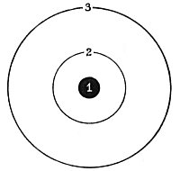
THE PLAN OF DIVINE ACTIVITY.
According to the Qabbalists, the life of the Supreme Creator permeates all substance, all space, and all time, but for diagrammatic purposes the Supreme, All-Inclusive Life is limited by Circle 3, which may be called "the boundary line of Divine existence." The Divine Life permeating the area bounded by Circle 3 is focused at Point 1, which thus becomes the personification of the impersonal life and is termed "the First Crown." The creative forces pouring through Point 1 come into manifestation as the objective universe in the intermediate space, Circle 2.

Opinions differ as to the arrangement of the globes of this last world, D 1 to D 10 inclusive. The ruler of the fourth world is D 1, called by some the Fiery Heaven; by others the Primum Mobile, or the First Motion. From this whirling fire emanates the material starry zodiac, D 2, in contradistinction to the invisible spiritual zodiac of the Yetziratic World. From the zodiac, D 2, are differentiated the spheres of the planets in concatenate order. The ten spheres of the World of Assiah are as follows:
From C 10 came D 1, the Fourth Crown; Rashith Ha-Galagalum, the Primum Mobile, the fiery mist which is the beginning of the material universe.
From D 1 came D 2, the fourth Wisdom; Masloth, the Zodiac, the Firmament of the Fixed Stars.
From D 2 came D 3, the fourth Understanding; Shabbathai, the sphere of Saturn.
From D 3 came D 4, the fourth Mercy; Tzedeg, the sphere of Jupiter.
From D 4 came D 5, the fourth Severity; Madim, the sphere of Mars.
From D 5 came D 6, the fourth Beauty; Shemesh, the sphere of the Sun.
From D 6 came D 7, the fourth Victory; Nogah, the sphere of Venus.
From D 7 came D 8, the fourth Glory; Kokab, the sphere of Mercury.
From D 8 came D 9, the fourth Foundation; Levanah, the sphere of the Moon.
From D 9 came D 10, the Fourth Kingdom; Cholom Yosodoth, the sphere of the Four Elements.
By inserting a sphere (which he calls the Empyrean) before the Primum Mobile, Kircher moves each of the other spheres down one, resulting in the elimination of the sphere of the elements and making D 10 the sphere of the Moon.
In the World of Assiah are to be found the demons and tempters. These are likewise reflections of the ten great globes of Atziluth, but because of the distortion of the images resulting from the base substances of the World of Assiah upon which they are reflected, they become evil creatures, called shells by the Qabbalists. There are ten hierarchies of these demons to correlate with the ten hierarchies of good spirits composing the Yetziratic World. There are also ten Archdemons, corresponding to the ten Archangels of Briah. The black magicians use these inverted spirits in their efforts to attain their nefarious ends, but in time the demon destroys those who bind themselves to it. The ten orders of demons and the ten Archdemons of the World of Assiah are as follows:
D 1, the evil Crown; the hierarchy is called Thaumiel, the doubles of God, the Two-headed; the Archdemons are Satan and Moloch.
From D 1 came D 2, the evil Wisdom; the hierarchy is called Chaigidiel, those who obstruct; the Archdemon is Adam Belial.
From D 2 came D 3, the evil Understanding; the hierarchy is called Satharial, the concealment of God, the Archdemon is Lucifuge.
From D 3 came D 4, the evil Mercy; the hierarchy is called Gamchicoth, the disturber of things; the Archdemon is Astaroth.
From D 4 came D 5, the evil Severity; the hierarchy is called Golab, incendiarism and burning; the Archdemon is Asmodeus.
From D 5 came D 6, the evil Beauty; the hierarchy is called Togarini, the wranglers; the Archdemon is Belphegor.
From D 6 came D 7, the evil Victory; the hierarchy is called Harab Serap, the dispensing Raven; the Archdemon is Baal Chanan.
From D 7 came D 8, the evil Glory; the hierarchy is called Samael, the embroiler; the Archdemon is Adramelek.
From D 8 came D 9, the evil Foundation; the hierarchy is called Gamaliel, the obscene; the Archdemon is Lilith.
From D 9 came D 10, the evil Kingdom; the hierarchy is called Nahemoth, the impure; the Archdemon is Nahema.

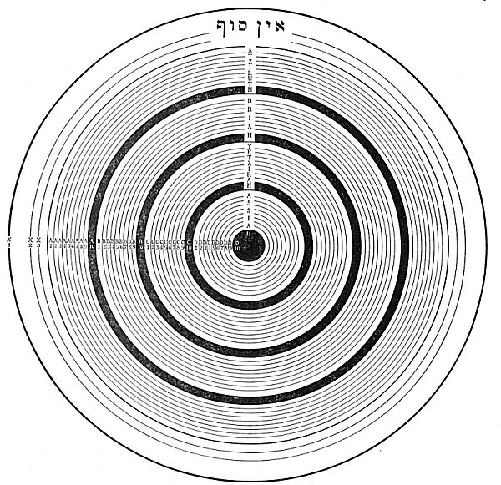
THE QABBALISTIC SCHEME OF THE FOUR WORLDS.
In the above chart the dark line between X 3 and A 1 constitutes the boundary of the original dot, while the concentric circles within this heavier line symbolize the emanations and the worlds which came forth from the dot. As this dot is contained within the outer rings X 1, X 2, and X 3, and represents the first establishment of an individualized existence, so the lower universe symbolized by the forty concentric circles within the dot represents the lower creation evolved out of and yet contained within the nature of the first Crown, which may be called God, within whom the divine powers, the celestial beings the sidereal worlds, and man, live and move and have their being. It is highly important that all the rings within A 1 be considered as being enclosed by the primitive dot, which is itself encircled by the great ring X 1, or the Auric Egg of AIN SOPH.
Each ring includes with in its own nature all the rings within itself and is included within the natures of all the rings outside of itself. Thus, A 1--the primitive dot--controls and contains the thirty-nine rings which it encloses, all of these partaking of its nature in varying degrees according to their respective dignities. Consequently, the entire area from A 1 to D 10 inclusive is the original dot, and the rings symbolize the divisions which took place with in it and the emanations which poured out from it after its establishment in the midst of the abstract nature of AIN SOPH. The powers of the rings decrease towards the center of the diagram, for Power is measured by the number of things controlled, and each ring controls the rings within it and is controlled by the rings outside of it. Thus, while A 1 controls thirty-nine rings besides itself, B 1 controls only twenty-nine rings besides its own. Therefore, A 1 is more powerful than B 1. As the greatest spiritual solidity, or permanence, is at the circumference and the greatest material density, or impermanence, is at the center of the diagram, the rings as they decrease in Power become more material and substantial until the center sphere, D 10, symbolizes the actual chemical elements of the earth. The rates of vibration are also lower as the rings approach the center. Thus, the vibration of A 2 is lower than A 1 but higher than A 3, and so on in decreasing scale towards the center, A 1 being the highest and D 10 the lowest sphere of creation. While A 1, the ruler of creation, controls the circles marked A, B, C, and D, it is less than the three rings of AIN SOPH--X 1, X2, and X3--and therefore bows before the throne of the ineffable Creator from whose substances it was individualized.

The Qabbalists declare that the worlds, intelligences, and hierarchies were established according to the vision of Ezekiel. By the man of Ezekiel's vision is symbolized the World of Atziluth; by the throne, the World of Briah; by the firmament, the World of Yetzirah; and by the living creatures the World of Assiah. These spheres are the wheels within wheels of the prophet. The Qabbalists next established a human figure in each of the four worlds: A 1 was the head and A 10 the feet of the man of Atziluth; B 1 was the head and B 10 the feet of the man of Briah; C 1 was the head and C 10 the feet of the man of Yetzirah; D 1 was the head and D 10 the feet of the man of Assiah. These four are called the World Men. They are considered androgynous and are the prototypes of humanity.
The human body, like that of the universe, is considered to be a material expression of ten globes or spheres of light. Therefore man is called the Microcosm--the little world, built in the image of the great world of which he is a part. The Qabbalists also established a mysterious universal man with his head at A 1 and his feet at D 10. This is probably the secret significance of the great figure of Nebuchadnezzar's dream, with its head in the World of Atziluth, its arms and hands in the World of Briah, its generative system in the World of Yetzirah, and its legs and feet in the World of Assiah. This is the Grand Man of the Zohar, of whom Eliphas Levi writes:
"It is not less astonishing to observe at the beginning of the Zohar the profundity of its notions and the sublime simplicity of its images. It is said as follows: 'The science of equilibrium is the key of occult science. Unbalanced forces perish in the void. So passed the kings of the elder world, the princes of the giants. They have fallen like trees without roots, and their place is found no more. Through the conflict of unbalanced forces, the devastated earth was void and formless, until the Spirit of God made for itself a place in heaven and reduced the mass of waters. All the aspirations of Nature were directed then towards unity of form, towards the living synthesis (if equilibrated forces; the face of God, crowned with light, rose over the vast sea and was reflected in the waters thereof. His two eyes were manifested, radiating with splendour, darting two beams of light which crossed with those of the reflection. The brow of God and His eyes formed a triangle in heaven, and its reflection formed a second triangle in the waters. So was revealed the number six, being that of universal creation.' The text, which would be unintelligible in a literal version, is translated here by way of interpretation. The author makes it plain that the human form which he ascribes to Deity is only an image of his meaning and that God is beyond expression by human thought or representation by any figure. Pascal said that God is a circle, of which the center is everywhere and the circumference nowhere. But how is one to imagine a circle apart from its circumference? The Zohar adopts the antithesis of this paradoxical image and in respect of the circle of Pascal would say rather that the circumference is everywhere, while that which is nowhere is the center. It is however to a balance and not to a circle that it compares the universal equilibrium of things. It affirms that equilibrium is everywhere and so also is the central point where the balance hangs in suspension. We find that the Zohar is thus more forcible and more profound than Pascal. * * * The Zohar is a genesis of light; the Sepher Yetzirah is a ladder of truth. Therein are expounded the two-and-thirty absolute symbols of speech--being numbers and letters. Each letter produces a number, an idea and a form, so that mathematics are applicable to forms and ideas, even as to numbers, in virtue of an exact proportion, and a perfect correspondence. By the science of the Sepher Yetzirah, the human mind is rooted in truth and in reason; it accounts for all progress possible to intelligence by means of the evolution of numbers. Thus does the Zohar represent absolute truth, while the Sepher Yetzirah furnishes the method of its acquisition, its discernment and application." (History of Magic.)
By placing man himself at the point D 10, his true constitution is revealed. He exists upon four worlds, only one of which is visible. It is then made evident that his parts and members upon the material plane are, by analogy, hierarchies and intelligences in the higher worlds. Here, again, the law of interpenetration is evidenced. Although within man is the entire universe (the 43 spheres interpenetrating D 10), he is ignorant of its existence because he cannot exercise control over that which is superior to or greater than himself. Nevertheless, all these higher spheres exercise control over him, as his functions and activities demonstrate. If they did not, he would be an inert mass of substance. Death is merely the result of deflecting the life impulses of the higher rings away from the lower body.
The control of the transubstantial rings over their own material reflection is called life, and the spirit of man is, in reality, a name given to this great host of intelligences, which are focused upon substance through a point called the ego, established in the midst of themselves. X 1 is the outside boundary of the human Auric Egg, and the entire diagram becomes a cross section of the constitution of man, or a cross section of the Kosmic constitution, if correlated with the universe. By the secret culture of the Qabbalistic School, man is taught how to climb the rings (unfold his consciousness) until at last he returns to AIN SOPH. The process by which this is accomplished is called the Fifty Gates of Light. Kircher, the Jesuit Qabbalist, declares that Moses passed through forty-nine of the gates, but that Christ alone passed the fiftieth gate.
To the third edition of the Sepher Yetzirah translated from the Hebrew by Wm. Wynn Westcott are appended the Fifty Gates of Intelligence emanating from Binah, the second Sephira. The source of this information is Kircher's Œdipus Ægyptiacus. The gates are divided into six orders, of which the first four have each ten subdivisions, the fifth nine, and the sixth only one.
The first order of gates is termed Elementary and its divisions areas follows: (1) Chaos, Hyle, the First Matter; (2) Formless, void, lifeless; (3) The Abyss; (4) Origin of the Elements; (5) Earth (no seed germs); (6) Water;(7) Air;(8) Fire;(9) Differentiation of qualities; (10) Mixture and combination.
The second order of gates is termed Decad of Evolution and its divisions areas follows: (11) Minerals differentiate; (12) Vegetable principles appear; (13) Seeds germinate in moisture; (14) Herbs and Trees; (15) Fructification in vegetable life; (16) Origin of low forms of animal life; (17) Insects and Reptiles appear; (18) Fishes, vertebrate life in the waters; (19) Birds, vertebrate life in the air; (20) Quadrupeds, vertebrate earth animals.
The third order of gates is termed Decad of Humanity and its divisions are as follows: (21) Appearance of Man; (22) Material human body; (23) Human Soul conferred; (24) Mystery of Adam and Eve; (25) Complete Man as the Microcosm; (26) Gift of five human faces acting exteriorly; (27) Gift of five powers to the soul; (28) Adam Kadmon, the Heavenly Man; (29) Angelic beings, (30) Man in the image of God.
The fourth order of gates is termed World of Spheres and its divisions are as follows: (31) The Heaven of the Moon; (32) The Heaven of Mercury, (33) The Heaven of Venus; (34) The Heaven of the Sun; (35) The Heaven of Mars; (36) The Heaven of Jupiter; (37) The Heaven of Saturn; (38) The Firmament; (39) The Primum Mobile; (40) The Empyrean Heaven.
The fifth order of gates is termed The Angelic World and its divisions are as follows: (41) Ishim--Sons of Fire; (42) Orphanim--Cherubim; (43) Aralim--Thrones; (44) Chashmalim--Dominions; (45) Seraphim--Virtues; (46) Melachim--Powers; (47) Elohim--Principalities; (48) Ben Elohim--Angels; (49) Cherubim--Archangels. [The order of the Angels is a matter of controversy, the arrangement above differing from that accepted in other sections of this volume. The Rabbins disagree fundamentally as to the proper sequence of the Angelic names.]
The sixth order is termed The Archetype and consists of but one gate: (50) God, AIN SOPH, He whom no mortal eye hath seen. The fiftieth gate leads from creation into the Creative Principle and he who passes through it returns into the unlimited and undifferentiated condition of ALL. The fifty gates reveal a certain evolutionary process and it was declared by the Rabbins that he who would attain to the highest degree of understanding must pass sequentially through all of these orders of life, each of which constituted a gate in that the spirit, passing from the lower to the higher, found in each more responsive organism new avenues of self-expression.

===================================================================================================================================================

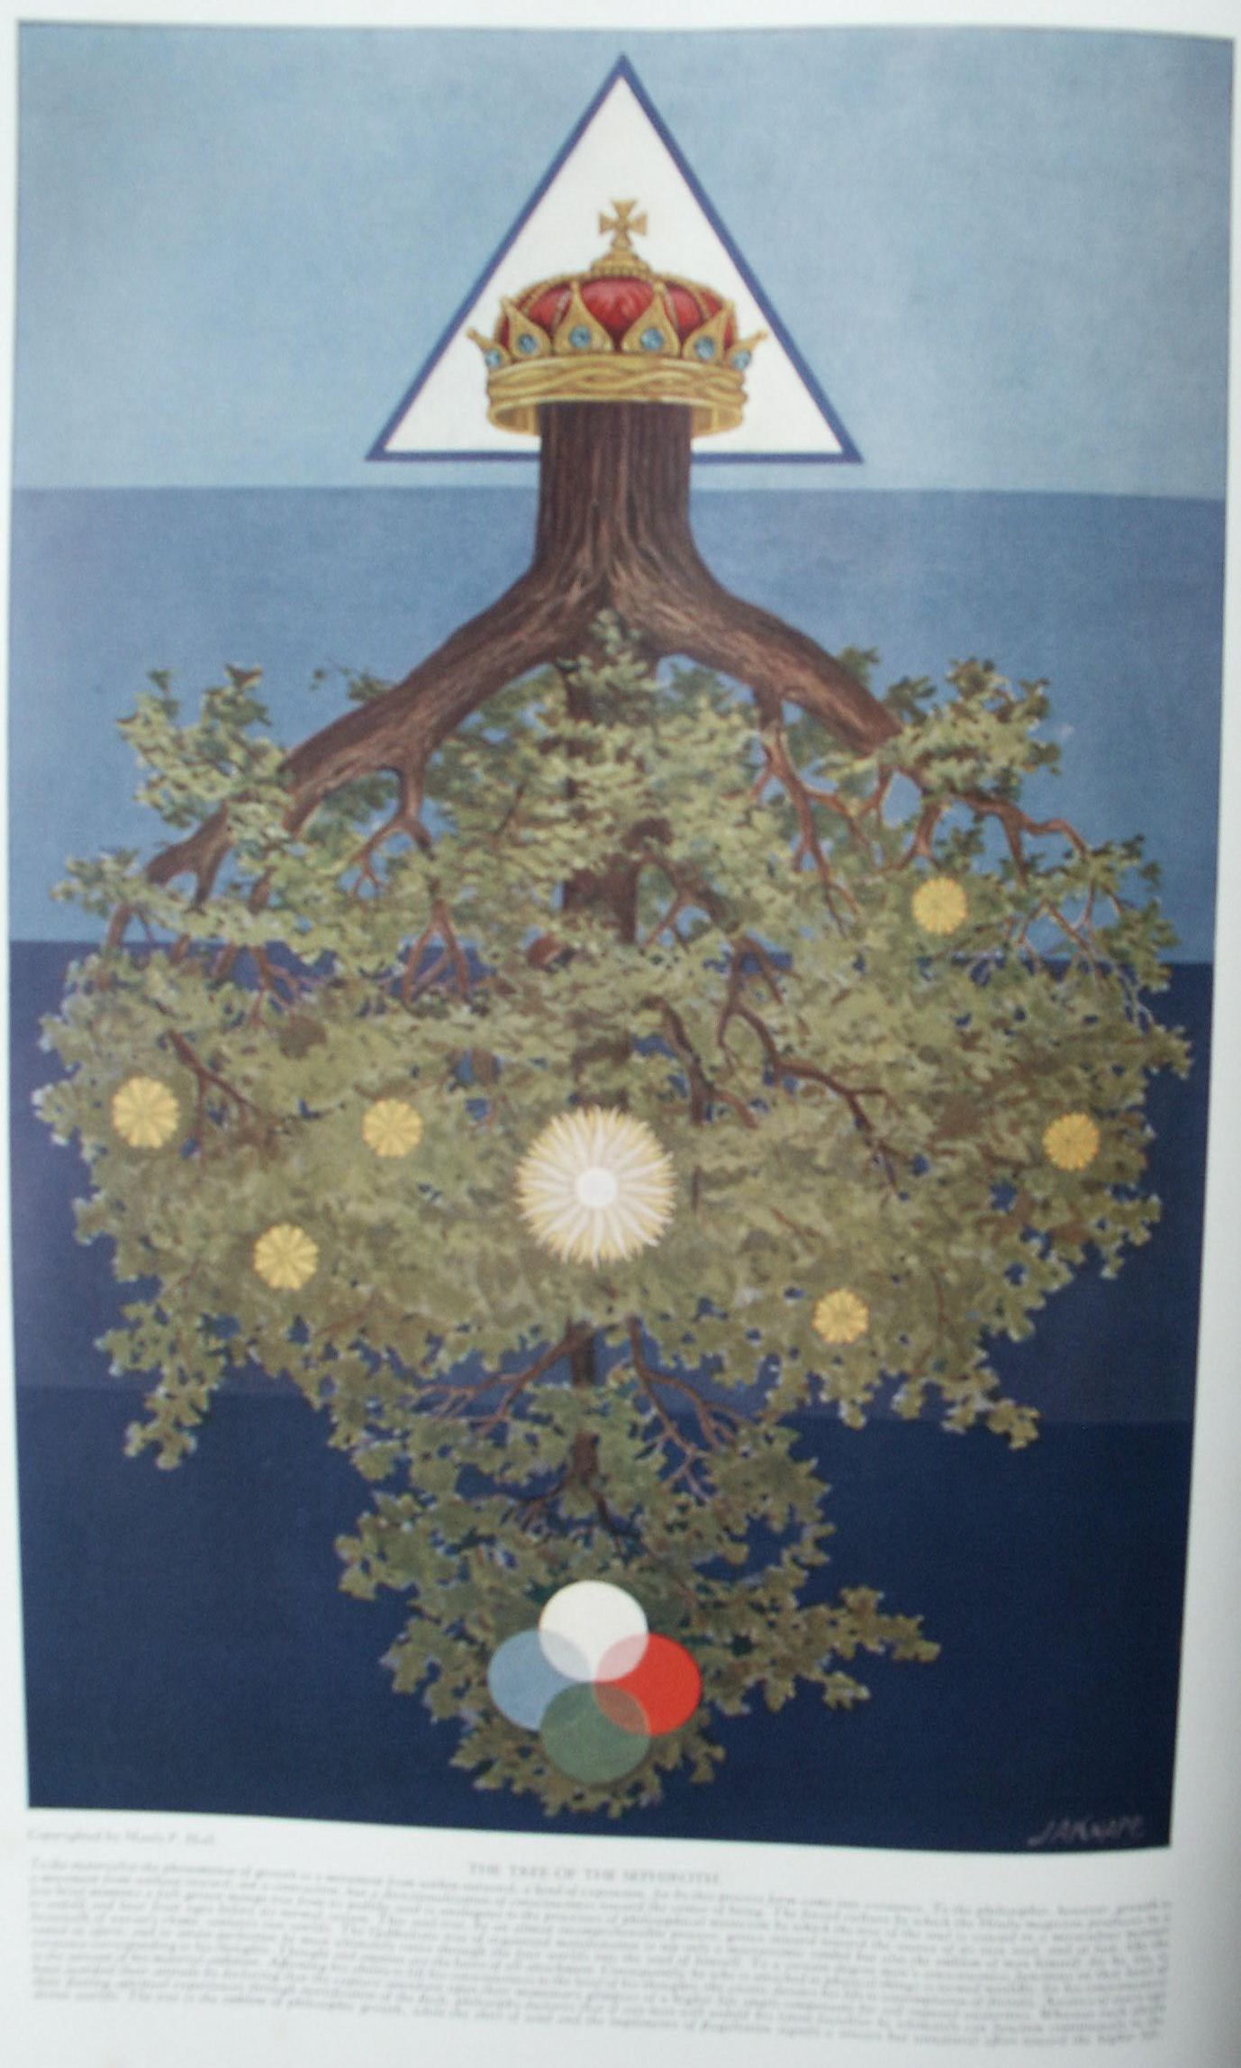

The Tree of the Sephiroth

THE Tree of the Sephiroth may be considered an invaluable compendium of the secret philosophy which originally was the spirit and soul of Chasidism. The Qabbalah is the priceless heritage of Israel, but each year those who comprehend its true principles become fewer in number. The Jew of today, if he lacks a realization of the profundity of his people's doctrines, is usually permeated with that most dangerous form of ignorance, modernism, and is prone to regard the Qabbalah either as an evil to be shunned like the plague or as a ridiculous superstition which has survived the black magic of the Dark Ages. Yet without the key which the Qabbalah supplies, the spiritual mysteries of both the Old and the New Testament must remain unsolved by Jew and Gentile alike.
The Sephirothic Tree consists of ten globes of luminous splendor arranged in three vertical columns and connected by 22 channels or paths. The ten globes are called the Sephiroth and to them are assigned the numbers i to 10. The three columns are called Mercy (on the right), Severity (on the left), and, between them, Mildness, as the reconciling power. The columns may also be said to represent Wisdom, Strength, and Beauty, which form the triune support of the universe, for it is written that the foundation of all things is the Three. The 22 channels are the letters of the Hebrew alphabet and to them are assigned the major trumps of the Tarot deck of symbolic cards.
Eliphas Levi declared that by arranging the Tarot cards according to a definite order man could discover all that is knowable concerning his God, his universe, and himself. When the ten numbers which pertain to the globes (Sephiroth) are combined with the 22 letters relating to the channels, the resultant sum is 32--the number peculiar to the Qabbalistic Paths of Wisdom. These Paths, occasionally referred to as the 32 teeth in the mouth of the Vast Countenance or as the 32 nerves that branch out from the Divine Brain, are analogous to the first 32 degrees of Freemasonry, which elevate the candidate to the dignity of a Prince of the Royal Secret. Qabbalists also consider it extremely significant that in the original Hebrew Scriptures the name of God should occur 32 times in the first chapter of Genesis. (In the English translations of the Bible the name appears 33 times.) In the mystic analysis of the human body, according to the Rabbins, 32 spinal segments lead upward to the Temple of Wisdom--the skull.
The four Qabbalistic Trees described in the preceding chapter were combined by later Jewish scholars into one all-inclusive diagram and termed by them not only the Sephirothic but also the Archetypal, or Heavenly, Adam. According to some authorities, it is this Heavenly Adam, and not a terrestrial man, whose creation is described in the opening chapters of Genesis. Out of the substances of this divine man the universe was formed; in him it remains and will continue even after dissolution shall resolve the spheres back into their own primitive substance. The Deity is never conceived of as actually contained in the Sephiroth, which are purely hypothetical vessels employed to define the limits of the Creative Essence. Adolph Franck rather likens the Sephiroth to varicolored transparent glass bowls filled with pure light, which apparently assumes the color of its containers but whose essential nature remains ever unchanged and unchangeable.
The ten Sephiroth composing the body of the prototypic Adam, the numbers related to them, and the parts of the universe to which they correspond are as follows:
No. | THE SEPHIROTH | THE UNIVERSE | ALTERNATIVE
1 | Kether--the Crown | Primum Mobile | The Fiery Heavens
2 | Chochmah--Wisdom | The Zodiac | The First Motion
3 | Binah--Understanding | Saturn | The Zodiac
4 | Chesed--Mercy | Jupiter | Saturn
5 | Geburah--Severity | Mars | Jupiter
6 | Tiphereth--Beauty | Sun | Mars
7 | Netsah--Victory | Venus | Sun
8 | Hod--Glory | Mercury | Venus
9 | Jesod--the Foundation | Moon | Mercury
10 | Malchuth--the Kingdom | Elements | Moon
It must continually be emphasized that the Sephiroth and the properties assigned to them, like the tetractys of the Pythagoreans, are merely symbols of the cosmic system with its multitude of parts. The truer and fuller meaning of these emblems may not be revealed by writing or by word of mouth, but must be divined as the result of study and meditation. In the Sepher ha Zohar it is written that there is a garment--the written doctrine-which every man may see. Those with understanding do not look upon the garment but at the body beneath it--the intellectual and philosophical code. The wisest of all, however, the servants of the Heavenly King, look at nothing save the soul--the spiritual doctrine--which is the eternal and ever-springing root of the law. Of this great truth Eliphas Levi also writes declaring that none can gain entrance to the secret House of Wisdom unless he wear the voluminous cape of Apollonius of Tyana and carry in his hand the lamp of Hermes. The cape signifies the qualities of self-possession and self-reliance which must envelope the seeker as a cloak of strength, while the ever-burning lamp of the sage represents the illumined mind and perfectly balanced intellect without which the mystery of the ages can never be solved.
The Sephirothic Tree is sometimes depicted as a human body, thus more definitely establishing the true identity of the first, or Heavenly, Man--Adam Kadmon--the Idea of the Universe. The ten divine globes (Sephiroth) are then considered as analogous to the ten sacred members and organs of the Protogonos, according to the following arrangement. Kether is the crown of the Prototypic Head and perhaps refers to the pineal gland; Chochmah and Binah are the right and left hemispheres respectively of the Great Brain; Chesed and Geburah (Pechad) are the right and left arms respectively, signifying the active creative members of the Grand Man; Tiphereth is the heart, or, according to some, the entire viscera; Netsah and Hod are the right and left legs respectively, or the supports of the world; Jesod is the generative system, or the foundation of form; and Malchuth represents the two feet, or the base of being. Occasionally Jesod is considered as the male and Malchuth as the female generative power. The Grand Man thus conceived is the gigantic image of Nebuchadnezzar's dream, with head of gold, arms and chest of silver, body of brass, legs of iron, and feet of clay. The mediæval Qabbalists also assigned one of the Ten Commandments and a tenth part of the Lord's Prayer in sequential order to each of the ten Sephiroth.
Concerning the emanations from Kether which establish themselves as three triads of Creative Powers--termed in the Sepher ha Zohar three heads each with three faces--H. P. Blavatsky writes: "This [Kether] was the first Sephiroth, containing in herself the other nine ספּירות Sephiroth, or intelligences. In their totality and unity they represent the archetypal man, Adam Kadmon, the πρωτόγονος, who in his individuality or unity is yet dual, or bisexual, the Greek Didumos, for he is the prototype of all humanity. Thus we obtain three trinities, each contained in a 'head.' In the first head, or face (the three-faced Hindu Trimurti), we find Sephira [Kether], the first androgyne, at the apex of the upper triangle, emitting Hachama [Chochmah], or Wisdom, a masculine and active potency--also called Jah, יה--and Binah, בינה, or Intelligence, a female and passive potency, also represented by the name Jehovah יהוה. These three form the first trinity or 'face' of the Sephiroth. This triad emanated Hesed, הסד, or Mercy, a masculine active potency, also called El, from which emanated Geburah גבורה, or justice, also called Eloha, a feminine passive potency; from the union of these two was produced Tiphereth טפּארת, Beauty, Clemency, the Spiritual Sun, known by the divine name Elohim; and the second triad, 'face,' or 'head,' was formed. These emanating, in their turn, the masculine potency Netzah, נצה, Firmness, or Jehovah Sabaoth, who issued the feminine passive potency Hod,הוד, Splendor, or Elohim Sabaoth; the two produced Jesod, יסוד, Foundation, who is the mighty living one El-Chai, thus yielding the third trinity or 'head.' The tenth Sephiroth is rather a duad, and is represented on the diagrams as the lowest circle. It is Malchuth or Kingdom, מלכות, and Shekinah, שכינה, also called Adonai, and Cherubim among the angelic hosts. The first 'Head' is called the Intellectual world; the second 'Head' is the Sensuous, or the world of Perception, and the third is the material or Physical world." (See Isis Unveiled.)

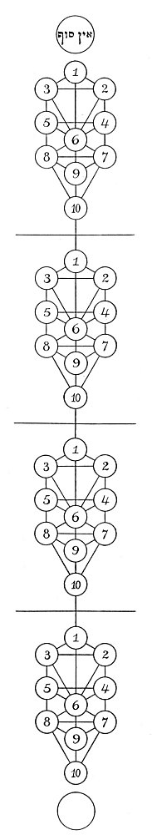
THE FOUR SEPHIROTHIC TREES.
The forty concentric circles shown in the large circular cut in the preceding chapter are here arranged as four trees, each consisting of ten circles. These trees disclose the organization of the hierarchies controlling the destinies of all creation. The trees are the same in each of the four world but the powers vested in the globes express themselves differently through the substances of each world, resulting in endless differentiation.

Among the later Qabbalists there is also a division of the Sephirothic Tree into five parts, in which the distribution of the globes is according to the following order:
(1) Macroprosophus, or the Great Face, is the term applied to Kether as the first and most exalted of the Sephiroth and includes the nine potencies or Sephiroth issuing from Kether.
(2) Abba, the Great Father, is the term generally applied to Chochmah--Universal Wisdom--the first emanation of Kether, but, according to Ibn Gebirol, Chochmah represents the Son, the Logos or the Word born from the union of Kether and Binah.
(3) Aima, the Great Mother, is the name by which Binah, or the third Sephira, is generally known. This is the Holy Ghost, from whose body the generations issue forth. Being the third person of the Creative Triad, it corresponds to Jehovah, the Demiurgus.
(4) Microprosophus, or the Lesser Face, is composed of the six Sephiroth--Chesed, Geburah, Tiphereth, Netsah, Hod, and Jesod. The Microprosophus is commonly called the Lesser Adam, or Zauir Anpin, whereas the Macroprosophus, or Superior Adam, is Arikh Anpin. The Lesser Face is properly symbolized by the six-pointed star or interlaced triangles of Zion and also by the six faces of the cube. It represents the directions north, east, south, west, up, and down, and also the first six days of Creation. In his list of the parts of the Microprosophus, MacGregor-Mathers includes Binah as the first and superior part of the Lesser Adam, thus making his constitution septenary. If Microprosophus be considered as sexpartite, then his globes (Sephiroth) are analogous to the six days of Creation, and the tenth globe, Malchuth, to the Sabbath of rest.
(5) The Bride of Microprosophus is Malchuth--the epitome of the Sephiroth, its quaternary constitution being composed of blendings of the four elements. This is the divine Eve that is taken out of the side of Microprosophus and combines the potencies of the entire Qabbalistic Tree in one sphere, which may be termed man.

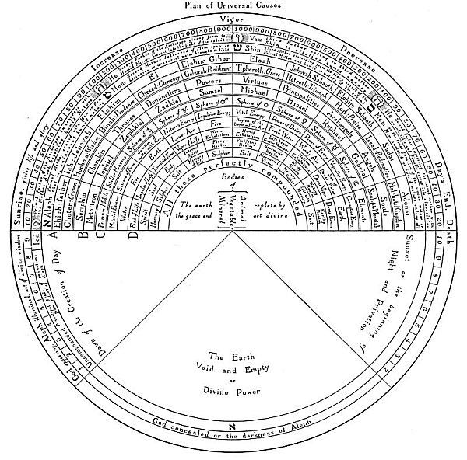
A TABLE OF SEPHIROTHIC CORRESPONDENCES.
From Fludd's Collectio Operum.
The above diagram has been specially translated from the Latin as being of unique value to students of Qabbalism and also as an example of Robert Fludd's unusual ability in assembling tables of correspondences. Robert Fludd ranks among the most eminent Rosicrucians and Freemasons; in fact, he has often been called "the first English Rosicrucian." He has written several valuable documents directly bearing upon the Rosicrucian enigma. It is significant that the most important of his works should be published at the same time as those of Bacon, Shakespeare, and the first Rosicrucian authors.

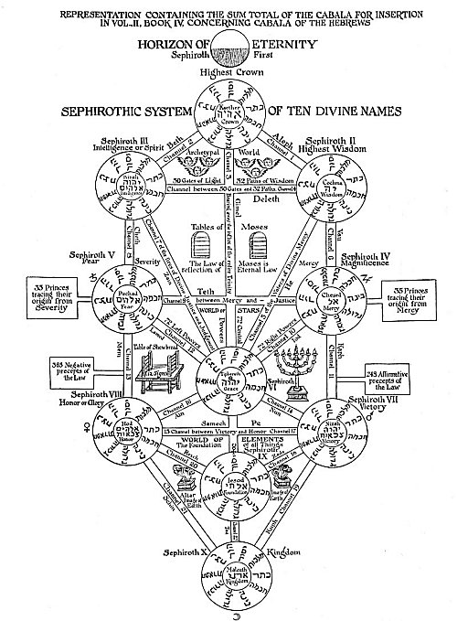
THE SEPHIROTHIC TREE OF THE LATER QABBALISTS.
Translated from Kircher's Œdipus Ægyptiacus.
Having demonstrated that the Qabbalists divided the universe into four worlds, each consisting of ten spheres, it is necessary to consider next how the ten spheres of each world were arranged into what is called the ''Sephirothic Tree." This Tree is composed of ten circles, representing the numbers 1 to 20 and connected together by twenty-two canals--the twenty-two letters of the Hebrew alphabet. The ten numbers plus the twenty-two letters result in the occult number 32, which, according to the Mishna, signifies the Thirty-two Paths of Wisdom. Letters and numbers, according to the Qabbalists, are the keys to all knowledge, for by a secret system of arranging them the mysteries of creation are revealed. For this reason they are called "the Paths of Wisdom." This occult fact is carefully concealed in the 32nd degree of Freemasonry.
There are four trees, one in each of the four worlds established in the preceding chapter. The first is in the Atziluthic World, the ten circles being the ten globes of light established in the midst of AIN SOPH. The powers and attributes of this Tree are reflected into each of the three lower worlds, the form of the Tree remaining the same but its power diminishing as it descends. To further complicate their doctrine, the Qabbalists created another tree, which was a composite of all four of the world trees but consisted of only ten globes. In this single tree were condensed all the arcana previously scattered through the voluminous archives of Qabbalistic literature.

According to the mysteries of the Sephiroth, the order of the Creation, or the Divine Lightning Flash which zigzags through the four worlds according to the order of the divine emanations, is thus described: From AIN SOPH, the Nothing and All, the Eternal and Unconditioned Potency, issues Macroprosophus, the Long Face, of whom it is written, "Within His skull exist daily thirteen thousand myriads of worlds which draw their existence from Him and by Him are upheld." (See The Greater Holy Assembly.) Macroprosophus, the directionalized will of AIN SOPH, corresponding to Kether, the Crown of the Sephiroth, gives birth out of Himself to the nine lesser spheres of which He is the sum and the overbrooding cause. The 22 letters of the Hebrew alphabet, by the various combinations of which the laws of the universe are established, constitute the scepter of Macroprosophus which He wields from His flaming throne in the Atziluthic World.
From this eternal and ancient androgyne--Kether--come forth Chochmah, the great Father, and Binah, the great Mother. These two are usually referred to as Abba and Aima respectively--the first male and the first female, the prototypes of sex. These correspond to the first two letters of the sacred name, Jehovah, יהוה, IHVH. The Father is the י, or I, and the Mother is the ה, or H. Abba and Aima symbolize the creative activities of the universe, and are established in the creative world of Briah. In the Sepher ha Zohar it is written, "And therefore are all things established in the equality of male and female; for were it not so, how could they subsist? This beginning is the Father of all things; the Father of all Fathers; and both are mutually bound together, and the one path shineth into the other--Chochmah, Wisdom, as the Father; Binah, Understanding, as the Mother."
There is a difference of opinion concerning certain of the relationships of the parts of the first triad. Some Qabbalists, including Ibn Gebirol, consider Kether as the Father, Binah as the Mother, and Chochmah as the Son. In this later arrangement, Wisdom, which is the attribute of the Son, becomes the creator of the lower spheres. The symbol of Binah is the dove, a proper emblem for the brooding maternal instinct of the Universal Mother.
Because of the close similarity of their creative triad to the Christian Trinity, the later Qabbalists rearranged the first three Sephiroth and added a mysterious point called Daath--a hypothetical eleventh Sephira. This is located where the horizontal line connecting Chochmah and Binah crosses the vertical line joining Kether and Tiphereth. While Daath is not mentioned by the first Qabbalists, it is a highly important element and its addition to the Sephirothic Tree was not made without full realization of the significance of such action. If Chochmah be considered the active, intelligent energy of Kether, and Binah the receptive capacity of Kether, then Daath becomes the thought which, created by Chochmah, flows into Binah. The postulation of Daath clarifies the problem of the Creative Trinity, for here it is diagrammatically represented as consisting of Chochmah (the Father), Binah (the Mother, or Holy Ghost), and Daath, the Word by which the worlds were established. Isaac Myer discounts the importance of Daath, declaring it a subterfuge to conceal the fact that Kether, and not Chochmah; is the true Father of the Creative Triad. He makes no attempt to give a satisfactory explanation for the symbolism of this hypothetical Sephira.
According to the original conception, from the union of the Divine Father and the Divine Mother is produced Microprosophus--the Short Face or the Lesser Countenance, which is established in the Yetziratic World of formation and corresponds to the letter ו, or V, in the Great Name. The six powers of Microprosophus flow from and are contained in their own source, which is Binah, the Mother of the Lesser Adam. These constitute the spheres of the sacred planets; their name is Elohim, and they move upon the face of the deep. The tenth Sephira--Malchuth, the Kingdom--is described as the Bride of the Lesser Adam, created back to back with her lord, and to it is assigned the final, ה, or H, the last letter of the Sacred Name. The dwelling place of Malchuth is in the fourth world--Assiah--and it is composed of all the superior powers reflected into the elements of the terrestrial sphere. Thus it will be seen that the Qabbalistic Tree extends through four worlds, with its branches in matter and its roots in the Ancient of Ancients--Macroprosophus.
Three vertical columns support the universal system as typified by the Sephirothic Tree. The central pillar has its foundation in Kether, the Eternal One. It passes downward through the hypothetical Sephira, Daath, and then through Tiphereth and Jesod, with its lower end resting upon the firm foundation of Malchuth, the last of the globes. The true import of the central pillar is equilibrium. It demonstrates how the Deity always manifests by emanating poles of expression from the midst of Itself but remaining free from the illusion of polarity. If the numbers of the four Sephiroth connected by this column be added together (1 +6 +9 + 10), the sum is 26, the number of Jehovah. (See chapter on Pythagorean Mathematics.)
The column on the right, which is called Jachin, has its foundation on Chochmah, the outpouring Wisdom of God; the three globes suspended from it are all masculine potencies. The column at the left is called Boaz. The three globes upon it are feminine and receptive potencies, for it is founded in Understanding, a receptive and maternal potency. Wisdom, it will be noted, is considered as radiant or outpouring, and Understanding as receptive, or something which is filled by the flowing of Wisdom. The three pillars are ultimately united in Malchuth, in which all the powers of the superior worlds are manifested.
The four globes upon the central column reveal the function of the creative power in the various worlds. In the first world the creative power is Will--the one Divine Cause; in the second world, the hypothetical Daath--the Word coming forth from the Divine Thought; in the third world, Tiphereth--the Sun, or focal point between God and Nature; in the fourth world it is twofold, being the positive and negative poles of the reproductive system, of which Jesod is the male and Malchuth the female.
In Kircher's Sephirothic Tree it should be especially noted that the ornaments of the Tabernacle appear in the various parts of the diagram. These indicate a direct relationship between the sacred House of God and the universe--a relationship which must always be considered as existing between the Deity through whose activity the world is produced and the world itself, which must be the house or vehicle of that Deity. Could the modern scientific world but sense the true profundity of these philosophical deductions of the ancients, it would realize that those who fabricated the structure of the Qabbalah possessed a knowledge of the celestial plan comparable in every respect with that of the modern savant.
The Tetragrammaton, or the four-lettered Name of God, written thus יהוה, is pronounce Jehovah. The first letter is י, Yod, the Germ, the Life, the Flame, the Cause, the One, and the most fundamental of the Jewish phallic emblems. Its numerical value is 10, and it is to be considered as the 1 containing the 10. In the Qabbalah it is declared that the a Yod is in reality three Yods, of which the first is the beginning, the second is the center, and the third is the end. Its throne is the Sephira Chochmah (according to Ibn Gebirol, Kether), from which it goes forth to impregnate Binah, which is the first ה, He. The result of this union is Tiphereth, which is the ו Vau, whose power is 6 and which symbolizes the six members of the Lesser Adam. The final ה, He, is Malchuth, the Inferior Mother, partaking in part of the potencies of the Divine Mother, the first He. By placing the four letters of the Tetragrammaton in a vertical column, a figure closely resembling the human body is produced, with Yod for the head, the first He for the arms and shoulders, Vau for the trunk of the body, and the final He for the hips and legs. If the Hebrew letters be exchanged for their English equivalents, the form is not materially changed or the analogy altered. It is also extremely significant that by inserting the letter ש, Shin, in the middle of the name Jehovah, the word Jehoshua, or Jesus, is formed thus:
יהשוה
In the Qabbalistic Mysteries, according to Eliphas Levi, the name Jehovah is occasionally written by connecting together 24 dots--the 24 powers before the throne--and it is believed that the name of the Power of Evil is the sign of Jehovah reversed or inverted. (See Transcendental Magic.) Of the Great Word, Albert Pike writes: "The True Word of a Mason is to be found in the concealed and profound meaning of the Ineffable Name of Deity, communicated by God to Moses; and which meaning was long lost by the very precautions taken to conceal it. The true pronunciation of that name was in truth a secret, in which, however, was involved the far more profound secret of its meaning. In that meaning is included all the truth that can be known by us, in regard to the nature of God." (See Morals and Dogma.)
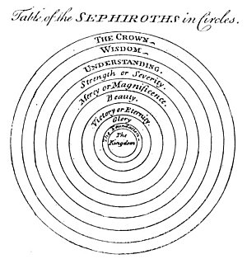
THE SEPHIROTH IN THE FORM OF THE SOLAR SYSTEM.
From Maurice's Indian Antiquities.
Thomas Maurice reproduces the above engraving, which is modification of the elaborate tree on the preceding page. The Sephiroth are here superimposed, decreasing in size as they decrease in power and dignity. Thus, the Crown is the greatest and the all-inclusive, and the Kingdom--which represents the physical universe--is the smallest and of least importance.

===================================================================================================================================================

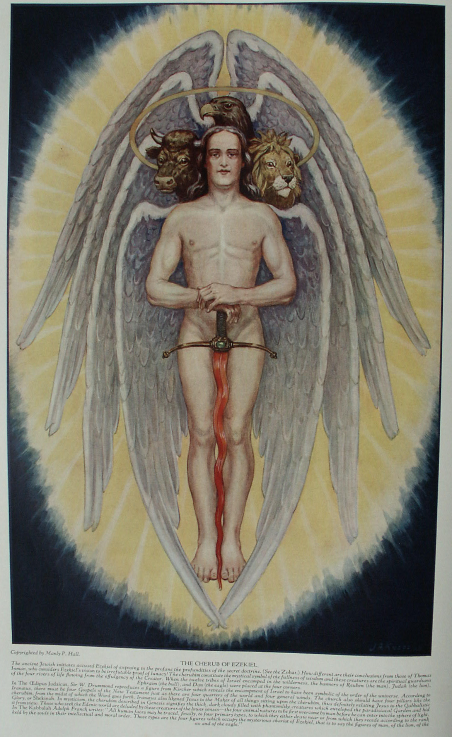

Qabbalistic Keys to the Creation of Man

HENRIE STEPHEN, in A World of Wonders, published in 1607, mentions a monk of St. Anthony who declared that while in Jerusalem the patriarch of that city had shown him not only one of the ribs of the Word made flesh and some rays from the Star of Bethlehem, but also the snout of a seraph, a finger nail of a cherub, the horns of Moses, and a casket containing the breath of Christ! To a people believing implicitly in a seraph sufficiently tangible to have its proboscis preserved, the more profound issues of Judaistic philosophy must necessarily be incomprehensible. Nor is it difficult to imagine the reaction taking place in the mind of some ancient sage should he hear that a cherub--which, according to St. Augustine, signifies the Evangelists; according to Philo Judæus, the outermost circumference of the entire heavens, and according to several of the Church Fathers, the wisdom of God--had sprouted finger nails. The hopeless confusion of divine principles with the allegorical figures created to represent them to the limited faculties of the uninitiated has resulted in the most atrocious misconceptions of spiritual truths. Concepts well-nigh as preposterous as these, however, still stand as adamantine barriers to a true understanding of Old and New Testament symbolism; for, until man disentangles his reasoning powers from the web of venerated absurdities in which his mind has lain ensnared for centuries, how can Truth ever be discovered?
The Old Testament--especially the Pentateuch--contains not only the traditional account of the creation of the world and of man, but also, locked within it, the secrets of the Egyptian initiators of the Moses concerning the genesis of the god-man (the initiate) and the mystery of his rebirth through philosophy. While the Lawgiver of Israel is known to have compiled several works other than those generally attributed to him, the writings now commonly circulated as the purported sixth and seventh books of Moses are in reality spurious treatises on black magic foisted on the credulous during the Middle Ages. Out of the hundreds of millions of pious and thoughtful students of Holy Writ, it is almost inconceivable that but a mere handful have sensed the sublimity of the esoteric teachings of Sod (the Jewish Mysteries of Adonai). Yet familiarity with the three Qabbalistical processes termed Gematria, Notarikon, and Temurah makes possible the discovery of many of the profoundest truths of ancient Jewish superphysics.
By Gematria is meant not only the exchange of letters for their numerical equivalents but also the method of determining by an analysis of its measurements the mystic purpose for which a building or other object was constructed. S. L. MacGregor-Mathers, in The Kabbalah Unveiled, gives this example of the application of Gematria: "Thus also the passage, Gen. xviii. 2 VHNH SHLSHH, Vehenna Shalisha, 'And lo, three men,' equals in numerical value 'ALV MIKAL GBRIAL VRPAL, Elo Mikhael Gabriel Ve-Raphael,' These are Mikhael, Gabriel and Raphael; 'for each phrase = 701." Assuming the sides of a scalene to be 11, 9, and 6 inches, a triangle of such dimensions would then be an appropriate symbol of Jehovah, for the sum of its three sides would be 26, the numerical value of the Hebrew word IHVH. Gematria also includes the system of discovering the arcane meaning of a word by analyzing the size and arrangement of the strokes employed in the formation of its various letters. Gematria was employed by the Greeks as well as the Jews. The books of the New Testament--particularly those attributed to St. John--contain many examples of its use. Nicephorus Callistus declared the Gospel according to St. John to have been discovered in a cavern under the Temple at Jerusalem, the volume having been secreted "long anterior to the Christian æra." The existence of interpolated material in the fourth Gospel substantiates the belief that the work was originally written without any specific reference to the man Jesus, the statements therein accredited to Him being originally mystical discourses delivered by the personification of the Universal Mind. The remaining Johannine writings--the Epistles and the Apocalypse--are enshrouded by a similar veil of mystery.
By Notarikon each letter of a word may become the initial character of a new word. Thus from BRASHITH, first word in the book of Genesis, are extracted six words which mean that "in the beginning the Elohim saw that Israel would accept the law." Mr. MacGregor-Mathers also gives six additional examples of Notarikon formed from the above word by Solomon Meir Ben Moses, a mediæval Qabbalist. From the famous acrostic ascribed to the Erythræan Sibyl, St. Augustine derived the word ΙΧΘΥΣ, which by Notarikon was expanded into the phrase, "Jesus Christ, Son of God, Savior." By another use of Notarikon, directly the reverse of the first, the initial, last, or middle letters of the words of a sentence may be joined together to form a new word or words. For example, the name Amen, ἁμήν, maybe extracted from ארנימלרנאטז, "the Lord is the faithful King." Because they had embodied these cryptic devices in their sacred writings, the ancient priests admonished their disciples never to translate, edit, or rewrite the contents of the sacred books.
Under the general heading of Temurah several systems may be grouped and explained in which various letters are substituted for other letters according to prearranged tables or certain mathematical arrangements of letters, regular or irregular. Thus the alphabet may be broken into two equal parts and written in horizontal lines so that the letters of the lower row can be exchanged for those of the upper row, or vice versa. By this procedure the letters of the word Kuzu may be exchanged for those of IHVH, the Tetragrammaton. In another form of Temurah the letters are merely rearranged., שתיה is the stone which is found in the center of the world, from which point the earth spread out on all sides. When broken in two the stone is שת יה, which means "the placing of God."(See Pekudei Rakov, 71, 72.) Again, Temurah may consist of a simple anagram, as in the English word live, which reversed becomes evil. The various systems of Temurah are among the most complicated and profound devices of the ancient Rabbins.
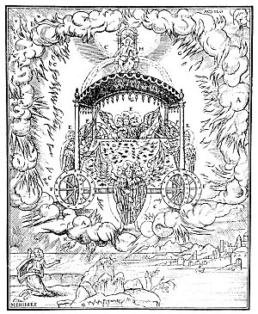
THE VISION OF EZEKIEL.
From The "Bear" Bible.
This plate, which is from the first Protestant Bible published in Spanish, shows the Mercavah, or chariot of Jehovah, which appeared to Ezekiel by the river Chebar. The prophet beheld four strange creatures (E), each having four heads, four wings, and brazen hoofs like those of a calf. And there were four wheels (F) filled with eyes. Where the cherubim went the wheels went also. The space between the cherubim and the wheels was filled with coals of fire. Upon the top of the chariot was a throne, upon which sat the likeness of a man (H). Ezekiel fell upon his knees when he beheld the Mercavah surrounded by a whirlwind of clouds and flames (A, B, C). A hand (K) reached out from the clouds and the prophet was ordered to eat of a scroll which the hand held forth.
According to the mystics, the wheels supporting the throne of God represent the orbits of the planets, and the entire solar system is properly the Mercavah, or chariot of God. One of the divisions of the Qabbalah--that dealing with the arts and sciences of those planes which are under the heavens--is called the Mercavah. In the Zohar it is written that the celestial throne or Ezekiel's vision signifies the traditional law; the appearance of a man sitting upon the throne represents the written law, Philo Judæus in describing the cherubim upon the Ark of the Covenant declares that the figures are an intimation of the revolutions of the whole heavens, one of the cherubim representing the outer circumference and the other the inner sphere. Facing each other, they represent the two hemispheres of the world. The flaming sword of the cherubim of Genesis is the central motion and agitation of the heavenly bodies. In all probability it also represents the solar ray.

Among theological scholars there is a growing conviction that the hitherto accepted translations of the Scriptural writings do not adequately express the spirit of the original documents.
"After the first copy of the Book of God," writes H. P. Blavatsky, "has been edited and launched on the world by Hilkiah, this copy disappears, and Ezra has to make a new Bible, which Judas Maccabeus finishes; * * * when it was copied from the horned letters into square letters, it was corrupted beyond recognition; * * * the Masorah completed the work of destruction; finally, we have a text, not 900 years old, abounding with omissions, interpolations, and premeditated perversions." (See Isis Unveiled.)
Prof. Crawford Howell Toy of Harvard notes: "Manuscripts were copied and recopied by scribes who not only sometimes made errors in letters and words, but permitted themselves to introduce new material into the text, or to combine in one manuscript, without mark of division, writings composed by different men; instances of these sorts of procedure are found especially in Micah and Jeremiah, and the groups of prophecies which go under the names of Isaiah and Zachariah." (See Judaism and Christianity.)
Does the mutilated condition of the Holy Bible--in part accidental--represent none the less a definite effort to confuse the uninitiated reader and thus better conceal the secrets of the Jewish Tannaim? Never has the Christian world been in possession of those hidden scrolls which contain the secret doctrine of Israel, and if the Qabbalists were correct in their assumption that the lost books of the Mosaic Mysteries have been woven into the fabric of the Torah, then the Scriptures are veritably books within books. In rabbinical circles the opinion is prevalent that Christendom never has understood the Old Testament and probably never will. In fact, the feeling exists--in some quarters, at least--that the Old Testament is the exclusive possession of the Jewish faith; also that Christianity, after its unrelenting persecution of the Jew, takes unwarranted liberties when it includes strictly Jewish writings in its sacred canon. But, as noted by one rabbi, if Christianity must use the Jewish Scriptures, it should at least strive to do so with some degree of intelligence!
In the opening chapter of Genesis it is stated that after creating light and separating it from darkness, the seven Elohim divided the waters which were under the firmament from the waters which were above the firmament. Having thus established the inferior universe in perfect accord with the esoteric teachings of the Hindu, Egyptian, and Greek Mysteries, the Elohim next turned their attention to the production of flora and fauna and lastly man. "And God said, Let us make man in our image, after our likeness. * * * So God created man in his own image, in the image of God created he him; male and female created he them. And God blessed them, and God said unto them, Be fruitful, and multiply, and replenish the earth, * * *."
Consider in thoughtful silence the startling use of pronouns in the above extract from "the most perfect example of English literature." When the plural and androgynous Hebrew word Elohim was translated into the singular and sexless word God, the opening chapters of Genesis were rendered comparatively meaningless. It may have been feared that had the word been correctly translated as "the male and female creative agencies," the Christians would have been justly accused of worshiping a plurality of gods in the face of their repeated claims to monotheism! The plural form of the pronouns us and our reveals unmistakably, however, the pantheistic nature of Divinity. Further, the androgynous constitution of the Elohim (God) is disclosed in the next verse, where he (referring to God) is said to have created man in his own image, male and female; or, more properly, as the division of the sexes had not yet taken place, male-female. This is a deathblow to the time-honored concept that God is a masculine potency as portrayed by Michelangelo on the ceiling of the Sistine Chapel. The Elohim then order these androgynous beings to be fruitful. Note that neither the masculine nor the feminine principle as yet existed in a separate state! And, lastly, note the word "replenish." The prefix re denotes "back to an original or former state or position," or "repetition or restoration." (See Webster's International Dictionary, 1926.) This definite reference to a humanity existing prior to the "creation of man" described in Genesis must be evident to the most casual reader of Scripture.
An examination of Bible dictionaries, encyclopedias, and commentaries discloses the plural form of the word Elohim to be beyond the comprehension of their respected authors and editors. The New Schaff-Herzog Encyclopedia of Religious Knowledge thus sums up the controversy over the plural form of the word Elohim: "Does it now or did it originally signify plurality of divine being?" A Dictionary of the Bible, edited by James Hastings, contains the following conclusion, which echoes the sentiments of more critical etymologists of the Bible: "The use of the plur. Elohim is also difficult to explain." Dr. Havernick considers the plural form Elohim to signify the abundance and super-richness existing in the Divine Being. His statement, which appears in The Popular and Critical Bible Encyclopædia, is representative of the efforts made to circumvent this extremely damaging word. The International Standard Bible Dictionary considers the explanations offered by modern theologians--of which Dr. Havernick's is a fair example--to be too ingenious to have been conceived by the early Hebrews and maintains that the word represents the survival of a polytheistic stage of Semitic thought. The Jewish Encyclopedia supports the latter assumption with the following concise statement: "As far as epigraphic material, traditions, and folk-lore throw light on the question, the Semites are shown to be of polytheistic leanings."
Various schools of philosophy, both Jewish and Gentile, have offered explanations erudite and otherwise of the identity of Adam. In this primordial man the Neo-Platonists recognized the Platonic Idea of humanity--the archetype or pattern of the genus homo. Philo Judæus considered Adam to represent the human mind, which could understand (and hence give names to) the creatures about it, but could not comprehend (and hence left nameless) the mystery of its own nature. Adam was also likened to the Pythagorean monad which by virtue of its state of perfect unity could dwell in the Edenic sphere. When through a process akin to fission the monad became the duad--the proper symbol of discord and delusion--the creature thus formed was exiled from its celestial home. Thus the twofold man was driven from the Paradise belonging to the undivided creation and cherubim and a flaming sword were placed on guard at the gates of the Causal World. Consequently, only after the reestablishment of unity within himself can man regain his primal spiritual state.
According to the Isarim, the secret doctrine of Israel taught the existence of four Adams, each dwelling in one of the four Qabbalistic worlds. The first, or heavenly, Adam dwelt alone in the Atziluthic sphere and within his nature existed all spiritual and material potentialities. The second Adam resided in the sphere of Briah. Like the first Adam, this being was androgynous and the tenth division of its body (its heel, Malchuth) corresponded to the church of Israel that shall bruise the serpent's head. The third Adam--likewise androgynous--was clothed in a body of light and abode in the sphere of Yetzirah. The fourth Adam was merely the third Adam after the fall into the sphere of Assiah, at which time the spiritual man took upon himself the animal shell or coat of skins. The fourth Adam was still considered as a single individual, though division had taken place within his nature and two shells or physical bodies existed, in one of which was incarnated the masculine and in the other the feminine potency. (For further details consult Isaac Myer.)
The universal nature of Adam is revealed in the various accounts concerning the substances of which he was formed. It was originally ordained that the "dirt" to be used in fashioning him was to be derived from the seven worlds. As these planes, however, refused to give of their substances, the Creator wrenched from them by force the elements to be employed in the Adamic constitution. St. Augustine discovered a Notarikon in the name of Adam. He showed that the four letters, A-D-A-M, are the first letters of the four words Anatole Dysis Arktos Mesembria, the Greek names for the four corners of the world. The same author also sees in Adam a prototype of Christ, for he writes: "Adam sleeps that Eve may be formed: Christ dies, that the Church may be formed. While Adam sleeps, Eve is formed from his side. When Christ is dead, His side is smitten with a spear, that there flow forth sacraments to form the church. * * * Adam himself was the figure of Him that was to come."
In his recent work, Judaism, George Foote Moore thus describes the proportions of the Adamic man: "He was a huge mass that filled the whole world to all the points of the compass. The dust of which his body was formed was gathered from every part of the world, or from the site of the future altar. Of greater interest is the notion that man was created androgynous, because it is probably a bit of foreign lore adapted to the first pair in Genesis. R. Samuel bar Nahman (third century), said, when God created Adam, He created him facing both ways (דיו פרעופים); then He sawed him in two and made two backs, one for each figure.
The Zohar holds the concept of two Adams: the first a divine being who, stepping forth from the highest original darkness, created the second, or earthly, Adam in His own image. The higher, or celestial, man was the Causal sphere With its divine potencies and potentialities considered as a gigantic personality; its members, according to the Gnostics, being the basic elements of existence. This Adam may have been symbolized as facing both ways to signify that with one face it looked upon the proximate Cause of itself and with the other face looked upon the vast sea of Cosmos into which it was to be immersed.
Philosophically, Adam may be regarded as representative of the full spiritual nature of man--androgynous and nor subject to decay. Of this fuller nature the mortal man has little comprehension. Just as spirit contains matter within itself and is both the source and ultimate of the state denominated matter, so Eve represents the lower, or mortal, portion that is taken out of, or has temporal existence in the greater and fuller spiritual creation. Being representative of the inferior part of the individual, Eve is the temptress who, conspiring with the serpent of mortal knowledge, caused Adam to sink into a trancelike condition in which he was unconscious of his own higher Self. When Adam seemingly awoke, he actually sank into sleep, for he no longer was in the spirit but in the body; division having taken place within him, the true Adam rested in Paradise while his lesser part incarnated in a material organism (Eve) and wandered in the darkness of mortal existence.
The followers of Mohammed apparently sensed more accurately than the uninitiated of other sects the true mystic import of Paradise, for they realized that prior to his fall the dwelling place of man was not in a physical garden in any particular part of the earth but rather in a higher sphere (the angelic world) watered by four mystical streams of life. After his banishment from Paradise, Adam alighted on the Island of Ceylon, and this spot is sacred to certain Hindu sects who recognize the old Island of Lanka--once presumably connected with the mainland by a bridge--as the actual site of the Garden of Eden from which the human race migrated. According to the Arabian Nights (Sir Richard Burton's translation), Adam's footprint may still be seen on the top of a Ceylonese mountain. In the Islamic legends, Adam was later reunited with his wife and after his death his body was brought to Jerusalem subsequent to the Flood for burial by Melchizedek. (See the Koran.)
The word ADM signifies a species or race and only for lack of proper understanding has Adam been considered as an individual. As the Macrocosm, Adam is the gigantic Androgyne, even the Demiurgus; as the Microcosm, he is the chief production of the Demiurgus and within the nature of the Microcosm the Demiurgus established all the qualities and powers which He Himself possessed. The Demiurgus, however, did not possess immortality and, therefore, could not bestow it upon Adam. According to legend, the Demiurgus strove to keep man from learning the incompleteness of his Maker. The Adamic man consequently partook of the qualities and characteristics of the angels who were the ministers of the Demiurgus. It was affirmed by the Gnostic Christians that the redemption of humanity was assured through the descent of Nous (Universal Mind), who was a great spiritual being superior to the Demiurgus and who, entering into the constitution of man, conferred conscious immortality upon the Demiurgic fabrications.
That phallic symbolism occupies an important place in early Jewish mysticism is indisputable. Hargrave Jennings sees in the figure of Adam a type of the lingam of Shiva, which was a stone representative of the creative power of the World Generator. "In Gregorie's works * * *," writes Jennings, "is a passage to the effect that 'Noah daily prayed in the Ark before the Body of Adam,' i.e., before the Phallus--Adam being the primitive Phallus, great procreator of the human race. 'It may possibly seem strange,' he says, 'that this orison should be daily said before the body of Adam,' but 'it is a most confessed tradition among the eastern men that Adam was commanded by God that his dead body should be kept above ground till a fullness of time should come to commit it פדככאלאועto the middle of the earth by a priest of the Most High God.' This means Mount Moriah, the Meru of India. 'This body of Adam was embalmed and transmitted from father to son, till at last it was delivered up by Lamech into the hands of Noah.'" (See Phallicism.)
This interpretation somewhat clarifies the Qabbalistic assertion that in the first Adam were contained all the souls of the Israelites. (See Sod.) Though according to the Aurea Legenda Adam was buried with the three seeds of the Tree of Knowledge in his mouth, it should be borne in mind that apparently conflicting myths were often woven around a single individual. One of the profound mysteries of Qabbalism is that set forth in the Notarikon based upon the letters of the name Adam (ADM). These three letters form the initials of the names Adam, David, and the Messiah, and these three personalities were said to contain one soul. As this soul represents the World Soul of humanity, Adam signifies the involving soul, the Messiah the evolving soul, and David that condition of the soul termed epigenesis.
In common with certain philosophic institutions of Asia, the Jewish Mysteries contained a strange doctrine concerning the shadows of the Gods. Gazing down into the Abyss, the Elohim beheld their own shadows and from these shadows patterned the inferior creation. "In the dramatic representation of the creation of man in the Mysteries," writes the anonymous Master of Balliol College, "the Aleim [Elohim] were represented by men who, when sculpturing the form of an Adamite being, of a man, traced the outline of it on their own shadow, or modelled it on their own shadow traced on the wall. This is how the art of drawing originated in Egypt, and the hieroglyphic figures carved on the Egyptian monuments have so little relief that they still resemble a shadow."
In the ritualism of the early Jewish Mysteries the pageantry of creation was enacted, the various actors impersonating the Creative Agencies. The red dirt from which the Adamic man was fashioned may signify fire, particularly since Adam is related to the Yod, or fire flame, which is the first letter of the sacred name Jehovah. In John ii. 20 it is written that the Temple was forty and six years in the building, a statement in which St. Augustine sees a secret and sacred Gematria; for, according to the Greek philosophy of numbers, the numerical value of the name Adam is 46. Adam thus becomes the type of the Temple, for the House of God-like primitive man--was a microcosm or epitome of the universe.
In the Mysteries, Adam is accredited with having the peculiar power of spiritual generation. Instead of reproducing his kind by the physical generative processes, he caused to issue from himself--or, more correctly, to be reflected upon substance--a shadow of himself. This shadow he then ensouled and it became a living creature. These shadows, however, remain only as long as the original figure of which they are the reflections endures, for with the removal of the original the host of likenesses vanish with it. Herein is the key to the allegorical creation of Eve out of the side of Adam; for Adam, representative of the idea or pattern, is reflected into the material universe as a multitude of ensouled images which collectively are designated Eve. According to another theory, the division of the sexes took place in the archetypal sphere; hence the shadows in the lower world were divided into two classes consistent with the orders established in the Archetype. In the apparently incomprehensible attraction of one sex for the other Plato recognized a cosmic urge toward reunion of the severed halves of this archetypal Being.

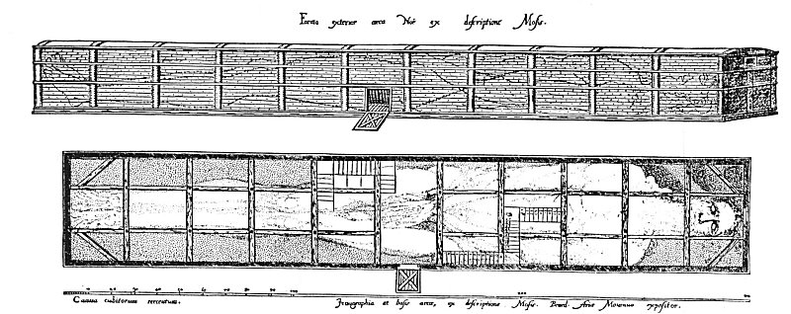
NOAH AND HIS ZODIACAL ARK.
From Myer's Qabbalah.
The early Church Father--notably Tertullian, Firmilian, St. Cyprian, St. Augustine, and St. Chrysostom--recognized in the ark a type or symbol of the Holy Catholic Church. Bede the Venerable, declared that Noah in all things typified Christ as Noah alone of his generation was just, so Christ alone was without sin. With Christ there was a sevenfold spirit of grace: with Noah seven righteous Persons. Noah by water and wood saved his own family Christ by baptism and the cross saves Christians. The ark was built of wood that did not decay. the church is composed of men who will live forever, for this ark means the church which floats upon the waves of the world.
The diagram shown above is also reproduced in The Rosicrucians, by Hargrave Jennings. This author adds to the original diagram appearing in Antiquitatum Judaicarum Libri IX the signs of the zodiac, placing Aries at the head and continuing in sequential order to Leo, which occupies the fifth cross section of the ark. Jennings assigns the panel containing the door to the undivided constellation of Virgo-Libra-Scorpio (which is continued into the first subdivision of the second section) and the remaining four cress sections to the constellations of Sagittarius to Pisces inclusive. A study of the plate discloses the ark to be divided into eleven main sections, and along the base and roof of each section are shown three subdivisions, thus making in all the sacred number 33. Occupying the position corresponding to the generative system of the human body will also be noted the cross upon the door of the central section. Two openings are shown in the ark: one--the main door representing the orifice through which the animal lives descend into physical existence; the other a small window proximate to the crown of the head through which the spirit gains liberty according to the ancient rites.
"When the androgenic Scorpio-Virgo was separated and the Balance or Harmony made from Scorpio, and placed between Scorpio, i.e., male, and Virgo, i.e., female, then appeared the 32 constellations or signs, as we now have them. The ark is three stories high (perhaps to symbolize Heaven, Man, Earth). In the figure of the Man, notice the parting of the hair in the middle of the forehead and the arrangement of the beard, whiskers, moustache and the hair, on the back of the neck and shoulders." (See The Qabbalah by Isaac Myer.)

Exactly what is to be inferred by the division of the sexes as symbolically described in Genesis is a much-debated question. That man was primarily androgynous is quite universally conceded and it is a reasonable presumption that he will ultimately regain this bisexual state. As to the manner in which this will be accomplished two opinions are advanced. One school of thought affirms that the human soul was actually divided into two parts (male and female) and that man remains an unperfected creature until these parts are reunited through the emotion which man calls love. From this concept has grown the much-abused doctrine of "soul mates" who must quest through the ages until the complementary part of each severed soul is discovered. The modern concept of marriage is to a certain degree founded upon this ideal.
According to the other school, the so-called division of the sexes resulted from suppression of one pole of the androgynous being in order that the vital energies manifesting through it might be diverted to development of the rational faculties. From this point of view man is still actually androgynous and spiritually complete, but in the material world the feminine part of man's nature and the masculine part of woman's nature are quiescent. Through spiritual unfoldment and knowledge imparted by the Mysteries, however, the latent element in each nature is gradually brought into activity and ultimately the human being thus regains sexual equilibrium. By this theory woman is elevated from the position of being man's errant part to one of complete equality. From this point of view, marriage is regarded as a companionship in which two complete individualities manifesting opposite polarities are brought into association that each may thereby awaken the qualities latent in the other and thus assist in the attainment of individual completeness. The first theory may be said to regard marriage as an end; the second as a means to an end. The deeper schools of philosophy have leaned toward the latter as more adequately acknowledging the infinite potentialities of divine completeness in both aspects of creation.
The Christian Church is fundamentally opposed to the theory of marriage, claiming that the highest degree of spirituality is achievable only by those preserving the virginal state. This concept seemingly originated among certain sects of the early Gnostic Christians, who taught that to propagate the human species was to increase and perpetuate the power of the Demiurgus; for the lower world was looked upon as an evil fabrication created to ensnare the souls of all born into it--hence it was a crime to assist in bringing souls to earth. When, therefore, the unfortunate father or mother shall stand before the Final Tribunal, all their offspring will also appear and accuse them of being the cause of those miseries attendant upon physical existence. This view is strengthened by the allegory of Adam and Eve, whose sin through which humanity has been brought low is universally admitted to have been concerned with the mystery of generation. Mankind, owing to Father Adam its physical existence, regards its progenitor as the primary cause of its misery; and in the judgment Day, rising up as a mighty progeny, will accuse its common paternal ancestor.
Those Gnostic sects maintaining a more rational attitude on the subject declared the very existence of the lower worlds to signify that the Supreme Creator had a definite purpose in their creation; to doubt his judgment was, therefore, a grievous error. The church, however, seemingly arrogated to itself the astonishing prerogative of correcting God in this respect, for wherever possible it continued to impose celibacy, a practice resulting in an alarming number of neurotics. In the Mysteries, celibacy is reserved for those who have reached a certain degree of spiritual unfoldment. When advocated for the mass of unenlightened humanity, however, it becomes a dangerous heresy, fatal alike to both religion and philosophy. As Christendom in its fanaticism has blamed every individual Jew for the crucifixion of Jesus, so with equal consistency it has maligned every member of the feminine sex. In vindication of Eve philosophy claims that the allegory signifies merely that man is tempted by his emotions to depart from the sure path of reason.
Many of the early Church Fathers sought to establish a direct relationship between Adam and Christ, thereby obviously discounting the extremely sinful nature of man's common ancestor, since it is quite certain that when St. Augustine likens Adam to Christ and Eve to the church he does not intend to brand the latter institution as the direct cause of the fall of man. For some inexplicable reason, however, religion has ever regarded intellectualism--in fact every form of knowledge--as fatal to man's spiritual growth. The Ignaratitine Friars are an outstanding example of this attitude.
In this ritualistic drama--possibly derived from the Egyptians--Adam, banished from the Garden of Eden, represents man philosophically exiled from the sphere of Truth. Through ignorance man falls; through wisdom he redeems himself. The Garden of Eden represents the House of the Mysteries (see The Vision of Enoch) in the midst of which grew both the Tree of Life and the Tree of the Knowledge of Good and Evil.
Man, the banished Adam, seeks to pass from the outer court of the Sanctuary (the exterior universe) into the sanctum sanctorum, but before him rises a vast creature armed with a flashing sword that, moving slowly but continually, sweeps clear a wide circle, and through this "Ring Pass Not" the Adamic man cannot break.
The cherubim address the seeker thus: "Man, thou art dust and to dust thou shalt return. Thou wert fashioned by the Builder of Forms; thou belongest to the sphere of form, and the breath that was breathed into thy soul was the breath of form and like a flame it shall flicker out. More than thou art thou canst not be. Thou art a denizen of the outer world and it is forbidden thee to enter this inner place."
And the Adam replies: "Many times have I stood within this courtyard and begged admission to my Father's house and thou hast refused it me and sent me back to wander in darkness. True it is that I was fashioned out of the dirt and that my Maker could not confer upon me the boon of immortality. But no more shalt thou send me away; for, wandering in the darkness, I have discovered that the Almighty hath decreed my salvation because He hath sent out of the most hidden Mystery His Only Begotten who didst take upon Himself the world fashioned by the Demiurgus. Upon the elements of that world was He crucified and from Him hath poured forth the blood of my salvation. And God, entering into His creation, hath quickened it and established therein a road that leadeth to Himself. While my Maker could not give me immortality, immortality was inherent in the very dust of which I was composed, for before the world was fabricated and before the Demiurgus became the Regent of Nature the Eternal Life had impressed itself upon the face of Cosmos. This is its sign--the Cross. Do you now deny me entrance, I who have at last learned the mystery of myself?"
And the voice replies: "He who is aware, IS! Behold!"
Gazing about him, Adam finds himself in a radiant place, in the midst of which stands a tree with flashing jewels for fruit and entwined about its trunk a flaming, winged serpent crowned with a diadem of stars. It was the voice of the serpent that had spoken.
"Who art thou?" demands the Adam.
"I," the serpent answers, "am Satan who was stoned; I am the Adversary--the Lord who is against you, the one who pleads for your destruction before the Eternal Tribunal. I was your enemy upon the day that you were formed; I have led you into temptation; I have delivered you into the hands of evil; I have maligned you; I have striven ever to achieve your undoing. I am the guardian of the Tree of Knowledge and I have sworn that none whom I can lead astray shall partake of its fruits."
The Adam replies: "For uncounted ages have I been thy servant. In my ignorance I listened to thy words and they led me into paths of sorrow. Thou hast placed in my mind dreams of power, and when I struggled to realize those dreams they brought me naught but pain. Thou hast sowed in me the seeds of desire, and when I lusted after the things of the flesh agony was my only recompense. Thou hast sent me false prophets and false reasoning, and when I strove to grasp the magnitude of Truth I found thy laws were false and only dismay rewarded my strivings. I am done with thee forever, O artful Spirit! I have tired of thy world of illusions. No longer will I labor in thy vineyards of iniquity. Get thee behind me, rempter, and the host of thy temptations. There is no happiness, no peace, no good, no future in the doctrines of selfishness, hate, and passion preached by thee. All these things do I cast aside. Renounced is thy rule forever!"
And the serpent makes answer: "Behold, O Adam, the nature of thy Adversary!" The serpent disappears in a blinding sunburst of radiance and in its place stands an angel resplendent in shining, golden garments with great scarlet wings that spread from one corner of the heavens to the other. Dismayed and awestruck, the Adam falls before the divine creature.
"I am the Lord who is against thee and thus accomplishes thy salvation, " continues the voice. "Thou hast hated me, but through the ages yet to be thou shalt bless me, for I have led thee our of the sphere of the Demiurgus; I have turned thee against the illusion of worldliness; I have weaned thee of desire; I have awakened in thy soul the immortality of which I myself partake. Follow me, O Adam, for I am the Way, the Life, and the Truth!"

===================================================================================================================================================

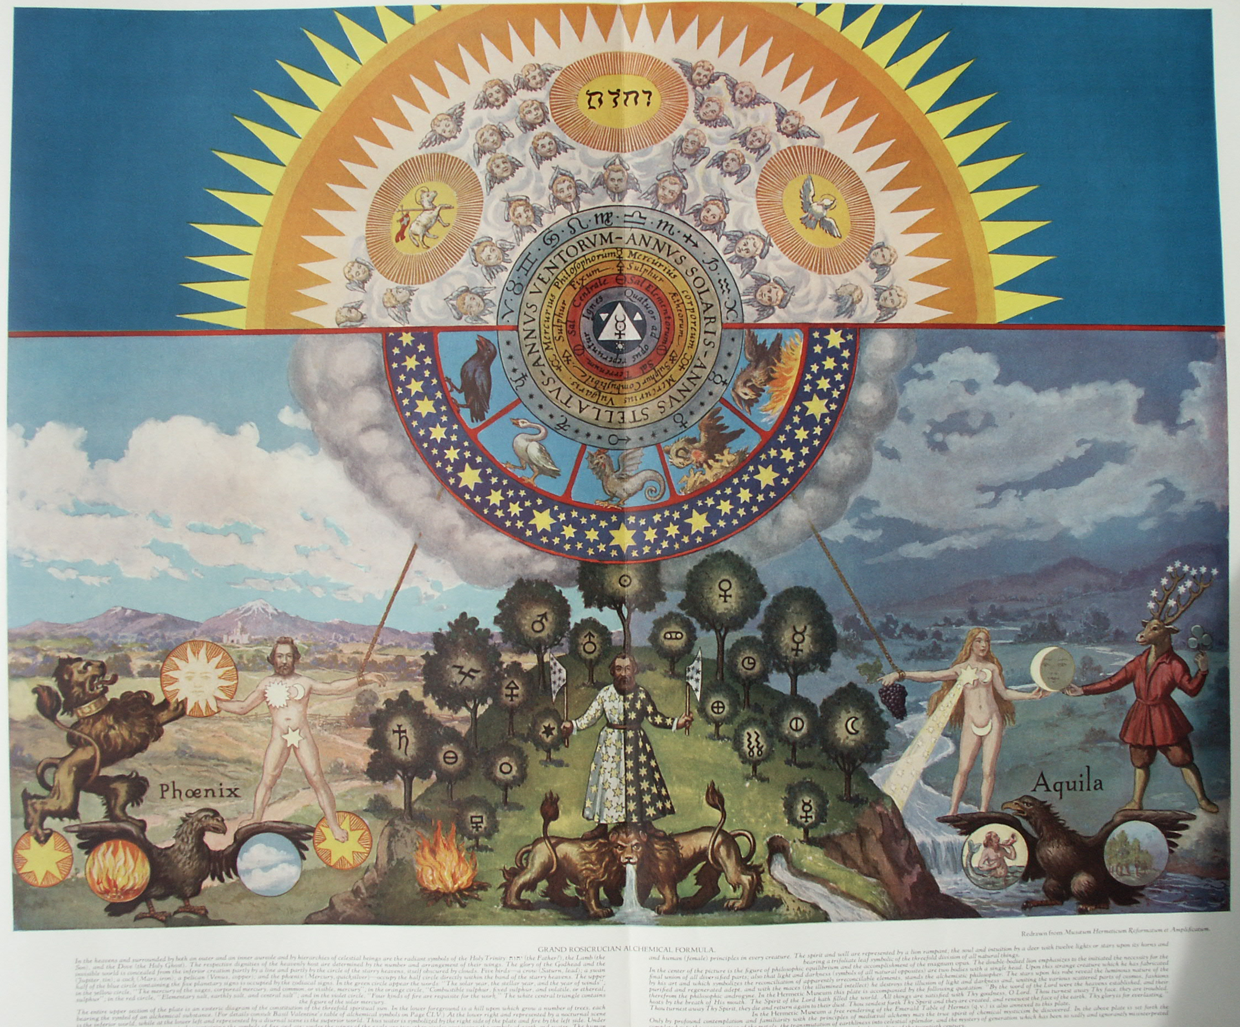

Fifteen Rosicrucian and Qabbalistic Diagrams

IN his well-known work, The Rosicrucians, Their Rites and Mysteries, Hargrave Jennings reproduces five Qabbalistic charts which he declares to be genuine Rosicrucian drawings. He gives no information concerning their origin nor does he attempt an elucidation of their symbolism. A recent writer who reproduced one of these charts correlated it to the emblematic tomb of Father C.R.C., thus exposing the true nature of Christian Rosencreutz.
The five plates reproduced in Hargrave Jennings' book are part of a series of fifteen diagrams which appear in The Magical, Qabbalistical, and Theosophical Writings of Georgius von Welling, on the Subject of Salt, Sulphur, and Mercury. This extremely rare volume was published at Frankfort and Leipzig in 1735 and 1760. The numbers and figures on the charts refer to the chapters and sections of the Writings. These fifteen charts constitute a remarkable and invaluable addition to the few other known admittedly authentic Qabbalistic and Rosicrucian diagrams.
Lucifer is the greatest mystery of symbolism. The secret knowledge of the Rosicrucians concerning Lucifer is nowhere so plainly set forth as in these plates, which virtually reveal his true identity, a carefully guarded secret about which little has been written. Lucifer is represented by the number 741.
Von Welling does not give a complete exposition of the fifteen charts; to have done so would have been contrary to the principles of Qabbalistic philosophy. The deeper significance of the symbols is revealed only by profound study and contemplation.
TABLE I, Figures 1-11. Figure 1 is a Ptolemaic chart showing the true relationship existing between the primordial elements. Its secret significance is as follows: The outer ring enclosed by the lines A and B is the region of Schamayim, a Qabbalistic name for the Supreme Deity, signifying the expanse of the heavens, or a spiritual fiery water. Schamayim is "The Ocean of Spirit, " within which all created and uncreated things exist and by the life of which they are animated. In the lower worlds Schamayim becomes the astral light.
The space between B and C marks the orbits or planes of the seven Spiritual Intelligences called the Divine Planets (not the visible planets). According to the Mysteries, the souls of men enter the lower worlds through ring B, the fixed stars. All creation reflects the glory of Schamayim, the energy that filters into the spheres of the elements through the windows of the stars and planets. Between C and D lies the region of the subtle, spiritual air, a subdivision of ether. D to E marks the surface of the earth and sea, by which are also meant grades of ether. E to F marks the lower region, called "The Gathering of the Waters and the Production of the Virgin Earth, " or "Ares. " The alchemists called this "quicksand," the true mystic foundation of the solid earth. F to G marks the circle of the subterranean air, which is more dense and coarse than that in the outer space, C to D. In this denser atmosphere the stellar influences and celestial impulses are crystallized into corporeal spirits, thus forming the multitude of forms which exist without knowledge of their own fiery source. G is the region of the central fire of the element earth, a coarse fire in contradistinction to the divine fiery Schamayim. The sphere of the starry heavens likewise has its opposite in the sphere of the subterranean air; and the sphere of the upper air (or subtle vaporous water) has its opposite in the sphere E to F. The focal point, D to E, between the three higher and the three lower spheres, is called "The Reservoir." It receives impressions from both the superior and the inferior regions and is common to both.
Figure 2 is the Qabbalistic symbol of elemental water; Figure 9 represents the spiritual invisible water. Figure 3 is the Qabbalistic symbol of elemental air; Figure 7 represents the spiritual and invisible air. Figure 4 is the Qabbalistic sign of the elemental earth; Figure 8 represents the spiritual and invisible earth. Figure 5 is the Qabbalistic sign of the elemental fire; Figure 6 represents the spiritual and invisible fire. Figures 6, 7, 8, and 9 symbolize the four elements before the descent of Lucifer. They are the four rivers spoken of in Genesis, having their source in the one river, Figure W, which represents the elements superimposed on one another. The golden ball in the center is Schamayim, the fiery source of all elements. Figure 11 is the emblem of the beginning and the end of all creatures. From it all things proceed and to it all must return again, to become one with the fiery water of divine understanding.
TABLE II, Figures 12-51. Figures 12, 13, 14 demonstrate the sphere as a symbol of motion to be emblematic of fire, water, and air; and the cube as a symbol of weight to be emblematic of earth. The sphere rests upon a point, the cube upon a surface; the sphere is therefore used to symbolize spirit, and the cube, matter. Figure 14 demonstrates that atmosphere rushing in behind a falling object increases its velocity and apparently adds to its weight. The essential nature of each element is occultly signified by the peculiar symbol and character assigned to it.
Of Figure 15, the symbol of salt, von Welling writes, in substance: The cube has six sides, corresponding to the six days of creation, with the point of rest (the seventh day) in the center of the cube. On each surface of the cube appear the signs of the four elements [triangles]. The alchemists declared that salt was the first created substance produced by the fire (Schamayim) which flowed out of God. In salt all creation is concentrated; in salt are the beginning and end of all things. The cube, furthermore, is composed of twelve bodies, each of which has six sides. These bodies are the twelve fundamental pillars of the true invisible church, and when these twelve bodies are multiplied by their six sides the magical number 72 results. The wise have said that nothing is perfect until it has been dissolved, separated, and again united so that it becomes a body composed of twelve bodies, like the cube. The cube also consists of six pyramids with the six surfaces of the cube as their bases. The points of these six pyramids meet at the center of the cube. These six pyramids, each consisting of four triangles, signify the elements, and produce the magical number 24, which refers to the Elders before the Throne. The six surfaces and the point constitute the magical number 7. If 7 be multiplied by 7 again, and so on 7 times, the answer will reveal the method used by the ancients for measuring the periods of eternity; thus: (1) 7 X 7 = 49; (2) 49 X 7 = 343; (3) 343 X 7 = 2,401; (4) 2,401 X 7 = 16,807; (5):16,807 X 7 = 117,649; (6) 117,649 X 7 = 823,543; (7) 823,543 X 7 = 5,764,801. (This is not to be taken as earth years or times.) The 5,000, 000 represents the great hall year; the 700,000 the great Sabbath year, wherein all human beings gradually gain true understanding and become heirs to their original and eternal inheritance, which was lost when they were enmeshed in the lower elements. The 64,800 is the number of the fallen angels, and the last one year signifies the liberation of Lucifer and return to his original estate.
Figure 16 is another symbol of salt, while Figure 17 (the dot) is the sign of spirit, gold, the sun, or the germ of life. If the dot be moved before itself it becomes a line, Figure 18. This motion of the dot is the first motion. The beginning and end of every line is a dot. Figure 19 is the circle. It is the second motion and the most perfect of all lines. Out of it are formed all figures and bodies imaginable. Figure 20 represents the outpouring of the upper and spiritual life into manifestation. Figure 21 represents darkness, for it is the loosening of the subterrene destructive principle. Figure 20 is also the symbol of day, and Figure 21 of night.

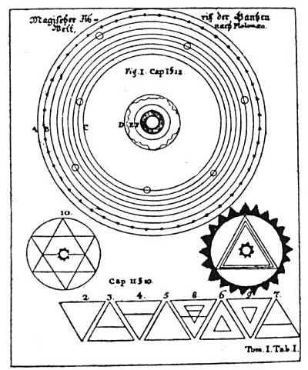
TABLE I, Figures 1-11.

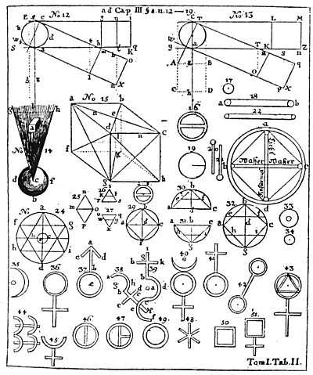
TABLE II, Figures 12-51.

Figure 22 is a symbol of water; Figure 23 is the complete universal character of light and darkness. The upright triangle represents Schamayim; the inverted triangle the dark earth which imprisons the infernal subterranean fire. It is "The First Day of Creation," or the time of the separation of Schamayim and Ares. Figure 24 represents the six days of creation and proves that the elements are an outflow of the Divine Fire which, breaking up, becomes the substances of the tangible universe, as signified in Figure 25.
Figure 26 is the character of the air, showing that air is born out of the Eternal Light and the ethereal water. Figure 27 is the character of water. It is the inversion of Figure 26, indicating that its origin is from the lower fire and not the higher. Its upper part signifies that water does not lack the Divine element, but as a universal mirror reflects the heavenly influences. Figures 28 and 29 are symbols of salt, showing that it is both fire and water in one. Figure 30 is the character of fire in all its attributes, and Figure M (the same inverted), water in all its powers. Figure 32 is the character of salt in all its attributes. Figure 33 represents both gold and the sun. Their essential natures are identical, being formed from the first fire out of Schamayim. They are perfect, as can be seen from their symbol, for no more perfect form can be produced out of the dot than the circle.
Figure 34 is the character of the greater and lesser worlds; as the dot is surrounded by its circumference, this world is surrounded by Schamayim. Man (the Little World) is included in this symbol because his inner nature is potential gold (Aphar Min Haadamah), which gold is his eternal indestructible spiritual body. Gold is the masculine principle of the universe.
Figure 35 is the character of silver and the moon. It signifies that silver (like gold) is a perfect metal, except that the red part of its nature is turned inward. Silver is the feminine principle of the universe.
Figure 36 is the character of copper and Venus; Figure 37, of iron and Mars; Figure 38, of tin and Jupiter; Figure 39, of lead and Saturn; Figure 40, of Mercury (both the planet and the element); Figure 41, of antimony, the key metal of the earth itself; Figure 42, of arsenic; Figure 43, of sulphur; Figure 44, of cinnabar; Figure 45, of quicklime; Figure 46, of nitre; and Figure 47, of vitriol. Figure 48 is the character of sal ammoniac, which element derives its name from the Temple of Jupiter Ammon in an Egyptian desert, where it was found. Figure 49 is the character of alum; Figure 50, of alkali, a name of Arabian origin; and Figure 51, of sal tartar, a substance possessing great occult virtue.
TABLE Ill, Figure 52. The eight globes and the central square represent the seven days of creation. The three worlds wherein creation occurs are symbolized by three concentric rings. The German words in the outer ring are extracts from the first chapter of Genesis. The words around the outside of the outer ring are The First Day. The four small globes inside the outer ring deal with the abstract phases of creation. The upper globe containing the triangle encloses the words Heaven and Earth. The globe to the right contains the word Light, and the one to the left, Jehovah Elohim in the upper part and Darkness in the lower part. The globe at the bottom contains the word Day in the upper half and Night in the lower.
The four globes within the second ring depict the second, third, fourth, and fifth days of creation. The white globe above divided by a dotted line is designated The Second Day; the globe to the left with the mountains, The Third Day; the globe to the right with the planetary rings, The Fourth Day; and the globe below bisected by a dotted line, The Fifth Day. The square in the central ring containing the human form is marked The Sixth Day. This chart is a diagrammatic exposition of the three layers of the macrocosmic and microcosmic auric eggs, showing the forces active within them.
TABLE IV, Figure. 53. Figure 53 has been designated the symbolic tomb of Christian Rosencreutz. The upper circle is the first world--the Divine Sphere of God. The triangle in the center is the throne of God. The small circles at the points of the star symbolize the seven great Spirits before the throne, mentioned in the Book of Revelation, in the midst of which walks the Alpha and Omega--the Son of God. The central triangle contains three flames--the Divine Trinity. From the lowest of these flames proceeds the first divine outflow, shown by two parallel lines descending through the throne of Saturn (the Spirit Orifelis, through whom God manifested Himself). Passing through the boundary of the celestial universe and the 22 spheres of the lower system, the lines end at point B, the throne of Lucifer, in whom the divine outpouring is concentrated and reflected. From him the divine light irradiates in succession to d (Capricorn), e (Gemini), f (Libra), g (Taurus), h (Pisces), i (Aquarius), k (Cancer), l (Virgo), m (Aries), n (Leo), o (Scorpio), p (Sagittarius), thence back to d. The zodiacal circles represent twelve orders of great and beneficent Spirits, and the smaller circles within the ring of fixed stars mark the orbits of the sacred planets.
TABLE V, Figure 54. Figure 54 is similar to Figure 53, but represents the universe at the time God manifested Himself through the character of Jupiter, the Spirit Sachasiel. Von Welling gives no reason for the change in the order of influx into the twelve orders of spirits, for the third world, for the adding of another circle and the interlaced triangles in the upper world, or for the letters Y and Z. In the upper triangle, A represents the Father Principle, F the divine outflow, G the point of influx into the twelve orders of spirits (probably Sagittarius). The letters H, I, J, K, L, M, N, O, P, Q, S, and T denote the sequential points of irradiations to each other; W and X, the World of the Sons of God; and B, C, D, and E, the World of Lucifer. This plate shows the universe after the descent of Lucifer into matter. According to von Welling, when Lucifer wanted to control power, the influx of the divine light instantly ceased. Lucifer's world (which later became the solar system), with all its legions of spirits (who in their essence were Schamayim) reflecting his ideas and inverting the divine light, was turned into darkness. Lucifer's Schamayim thereupon became a contracted disc, a tangible substance; and Chaos came into existence.

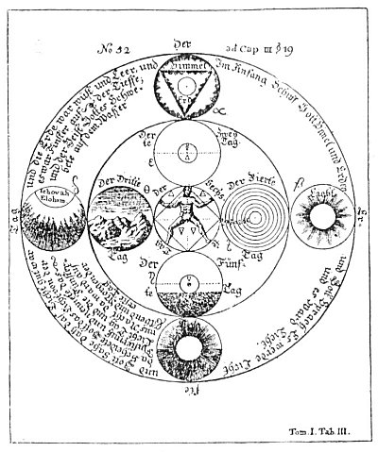
Table III, Figure 52

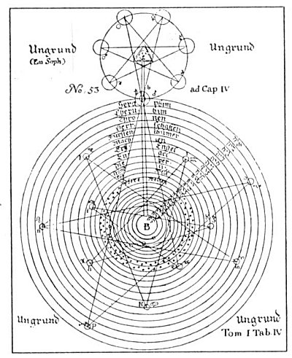
Table IV, Figure 53

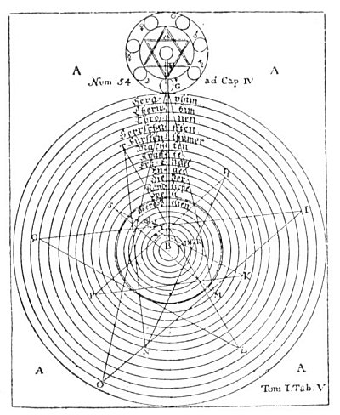
Table V, Figure 54

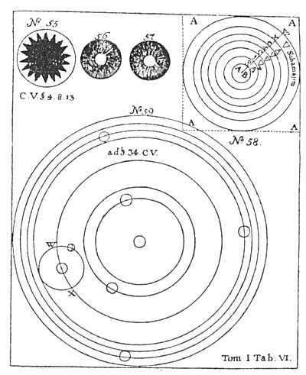
Table VII, Figures 1-5, 7 and 8

TABLE VI, Figures 55-59. Figure 55 symbolizes the Chaos of Lucifer; Figure 56, the separation of light from darkness; Figure 57, the light in the midst of the darkness; and Figure 58, the regions of the elements and their inhabitants. The four A's signify the Abyss surrounding all things. The A B is the fiery throne of Lucifer. The plane of g is the subterranean air; f, the subterranean water; c, the earth region; d, the outer water; e, the outer air, W and X the region of Schamayim. The elemental inhabitants of the planes differ in goodness according to their proximity to the center of wickedness (A B). The earth's surface (c) divides the subterranean elementals from those of the outer water, air, and fire (d, c, and X). The elementals of the upper strata (the upper half of c, and all of d, e, and X) represent an ascending scale of virtue, while those of the lower strata (the lower half of c, and all of f, g, and A B) represent a descending scale of depravity.
The region of air (e) is a partial exception to this order. While air is close to the light and filled with beautiful spirits, it is also the habitation of Beelzebub, the Evil Spirit of the air, with his legion of elemental demons. Upon the subtle element of air are impressed the influences of the stars; the thoughts, words, and deeds of man; and a myriad of mysterious influences from the various planes of Nature. Man inhales these impressions, and they produce diverse effects upon his mind. In air are suspended also the seed germs by which water is impregnated and made capable of bringing forth forms of organic and inorganic life. The grotesque figures seen in crystal caves and frost pictures upon windows are caused by these aerial impressions. While the air elementals are great and wise, they are treacherous and confused because amenable to both good and evil impressions. The mighty elemental beings who inhabit the watery light fire of the region X cannot be deceived by the spirits of darkness. They love the creatures of the waters, for the watery element (d) proceeded from the fiery water (X). Mortal man cannot endure the society of these fiery spirits, but gains wisdom from them through the creatures of the waters in which they continually mirror themselves. Figure 59 represents this solar system, with W and X as the locality of the Garden of Eden.
TABLE VII, Figures 1-5, 7, 8. (Table VIII has Figure 6.) Figure 1 is the triune divine sulphur, the All-Perfect out of the All-Perfect, the Soul of creatures. The threefold Divine One is symbolized by three interlaced circles designated alchemically salt, sulphur, and mercury. In the central triangle is the divine name Ehieh. Geist means spirit. The other words require no translation. Figure 2 is common destructive sulphur. A bar placed in the triangle makes it the character of earth. Figure 3 is true oil of vitriol, composed of a circle with two diameters and two reversed half-circles hanging below. In this are hidden the characters of all metals. Tin is symbolized by Figure 4 and iron by Figure 5. Figure 7 is the solar system according to Copernicus. Figure 8 is the last judgment. The sun is removed from the center of the solar system and replaced by the earth. This changes the respective positions of all the other planets except Mars, Jupiter, and Saturn, which retain their respective circles. The letter a signifies the circle of the sun; b, that of Mercury; c, that of Venus; d, (sic) that of the moon; and E, that of the earth. Inward from the sphere h are the great circles of damnation.
TABLE VII., Figure 6. In Figure 6 the letter a marks the center of eternity. The motion of the rays toward b, d, and c was the first divine manifestation and is symbolized by the equilateral triangle, b, d, c. The eternal world within the inner circle became manifest in the water (salt), the light (mercury), and the fire (sulphur) of the archetypal world, represented by the three circles (f, e, g) within the triangle of complete equality (h, i, k), which is in turn surrounded by the circle of the high throne. The circle f is named understanding; e, wisdom; g, reason. In circle i is the word Father; in circle h, Son; in circle k, Spirit. The seven outer circles are the seven spirits before the throne. The lower part of the figure is similar to Figures 53 and 54. The outer circles are the angelic world ending in the cognizable world of the Sons of God. Then comes the circle of the visible constellations and fixed stars; within this is the solar system with the sun as the center (l). Ungrund means the Abyss.
TABLE IX, Figure 9. Figure 9 is a synthesis of the Old and New Testaments and represents the interblending planes of being. In the right margin the seven outer circles contain the names of the planetary angels. The words in the graduated circles from the top triangle downward read: (1) Abyss of Compassion; (2) Zion; (3) The New Heaven and the New Earth; (4) The New Jerusalem; (5) Paradise; (6) The Bosom of Abraham; (7) The Outer Courts of the Lord. From below the circles of darkness reach upward, each divine principle being opposed by an infernal opposite. The small circle on the left containing a triangle and cross is named The Tree of Life, and that on the right The Tree of the Knowledge of Good and Evil. In the center of the diagram is the Trinity, joined with the superior and inferior planes by lines of activity.
TABLE X, Figures 10-15. Figure 10 shows the New Jerusalem in form of a cube, with the names of the twelve tribes of Israel written on the twelve lines of the cube. In the center is the eye of God. The words round the outer circle are from the Book of Revelation. Figures 11, 12, 13, 14, and 15 possibly are cipher symbols of the angels of the plagues, the name of the Antichrist, the signature of the beast of Babylon, and the name of the woman riding on the beast of blasphemy.

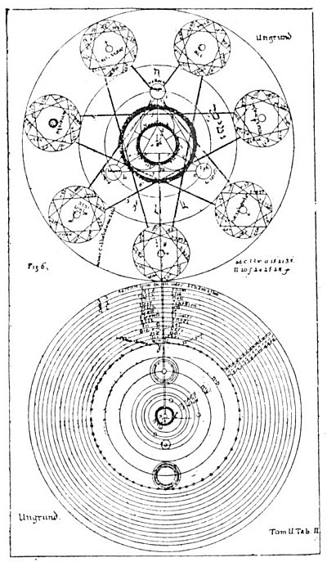
Table VIII, Figure 6.

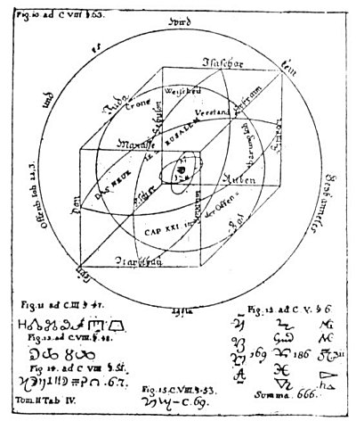
Table X, Figures 10-15.

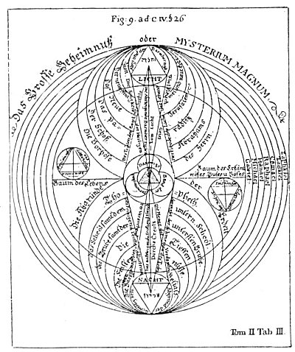
Table IX, Figure 9.

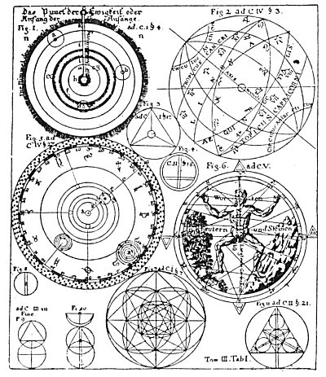
Table XI, Figures 1-11

TABLE XI, Figures 1.-11. Figure 1 is the solar system according to Genesis. The o on top of the radius of the circle is the dot of Eternity--the Beginning of Beginnings. The whole diameter is the outflow of God, manifesting first in the heaven of heavens--the Schamayim, in which region human understanding cannot function. The space from k to i contains the heavens of Saturn, Jupiter, and Mars; l to m, the heavens of Venus and Mercury; m to h, the heavens of the sun. The letter e is the moon, the circle of the earth.
Figure 2 is the globe of the earth, showing the houses and signs of the zodiac. Figure 3 is the character of the Universal Mercury (Divine Life) in its triune aspect of mercury, sulphur, and salt. Figure 4 is true saltpetre purified with quicklime and alkali. Figure 5 shows the exact degree or angle of the planets' places as well as the individual fixed stars in the zodiac. The letter a is the sun and b is the earth. From k to i are the circles of Mercury and Venus; g to h, the circles of earth and moon; f to e and e to c, of Jupiter and Saturn; c to d, the starry belt or zodiac. Figure 6 is the Microcosm, with the planets and signs of the zodiac corresponding to the different parts of its form. The words upon the figure read: Know thyself. In words, herbs, and stones lies a great power. Figure 7 is the universal character from which all characters have been taken. Figures 8, 9, and 10 are left to the solution of the reader. Figure 11 is the radiating Universal Mercury.
TABLE XII, Figures 12-19. Figure 12 is called A Mirror of Astrological Aspects. Below it is an astrologer's wheel. Figure 13 is similar to Figure 12. Figure 14 is a secret alchemical formula. The words around the circle read: Out of one in all is all. Figure 15 is an unsatisfactory attempt to show the comparative sizes of the suns and planets and their distances from each other. Figure 16 is the solar system with its internal and spiritual heavens. A B is the solar system; C is the sphere of fixed stars; D, E, F, G are the systems of the spiritual worlds; H is the throne of the living God; J, K, L, M, and N are the Great Beyond, unmeasurable.
Figure 17 shows the creation of the solar system out of the ring of the Divine Eternity. The four A's are the Abyss, B is the first revelation of God out of the Abyss, and from this revelation C, D, E, F, and G were created. C and D represent the spiritual hierarchies; D and E, the upper worlds, or constellations; E and F, the distance from Jupiter to the upper worlds; F and G, the solar system with its planets and their heavens; B and C the throne of Christ.
Figure 18 describes the division according to Genesis of the waters above the heavens (D) from the waters below (A, B, and C). Figure 19 is the mercury of the philosophers, essential to material existence.
TABLE XIII, Figures 1-4. Figure 1 is Ain Soph, the Incomprehensible Abyss of Divine Majesty, an endless welling up, limitless in time and space. Figure 2 symbolizes the three Divine Principles--Father, Son, and Holy Ghost. Around the triangle is written: I Shall Be That I Shall Be. At the apex of the triangle is the word Crown; in the left point, Wisdom; in the right point, Understanding. Figure 3 represents the Trinity with its outflow. The words above the upper sphere are Revelation of the Divine Majesty in Jehovah Elohim. The lower circles contain the names of the Hierarchies controlling the lower worlds. The words within the circle of stars read: Lucifer the Son of the Aurora of the morning. The letter C represents the Universal Mercury. The words within the circle read: The first beginning of all creatures. Figure 4 represents the abode of Lucifer and his angels, the Chaos spoken of in Genesis.
TABLE XIV, Figures 5, 7, 8. Figure 5 shows the triangle of triune Divinity in the midst of a cross. At the left is a small triangle containing the words The Secrets of Elohim, and at the right is another inscribed The Secrets of Nature. On the horizontal arms of the cross are the words The Tree of Life and The Tree of the Knowledge of Good and Evil. The plate explains the interblending of the spiritual and infernal powers in the creation of the universe. Figure 7 is called The Road to Paradise. It probably indicates the positions of the sun, moon, and planets at the moment of their genesis. Figure 8 is the earth before the flood, when it was watered by a mist or vapor. The words at the left are The Tree of Life; those at the right, The Tree of the Knowledge of good and Evil. The diagram with the symbol of Mars is devoted to a consideration of the rainbow.
TABLE XV, Figures 6, 9, 10. Figure 6 is similar to Figure 5 and is called The Secret of Nature. An interesting diagram is shown on either side of the central figure, each consisting of a triangle with circles radiating from its points. The diagram on the left is called The Secrets of the Upper World, and the one on right The Secrets of the Underworld.
Figure 9 is the solar system. Around the central part are the words The Place of the Damned. Figure 10 shows the dot, or point of rest, surrounded by a triangle enclosing a circle containing the names of the twelve tribes of Israel. It represents completion of the process of regeneration and the consummation of the Great Work.

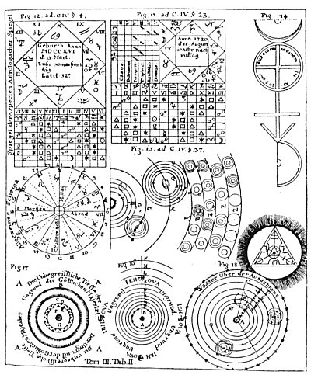
Table XII, Figures 12-19

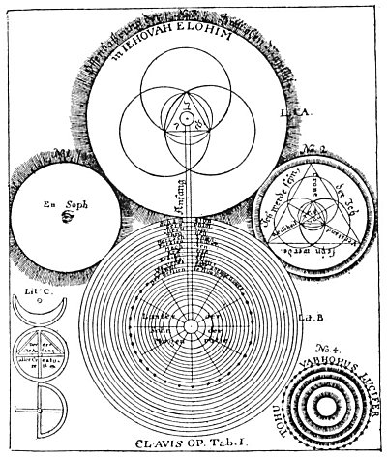
Table XIII, Figures 1-4

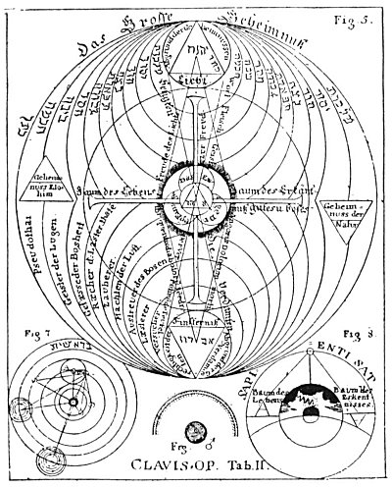
Table XIV, Figures 5, 7, and 8

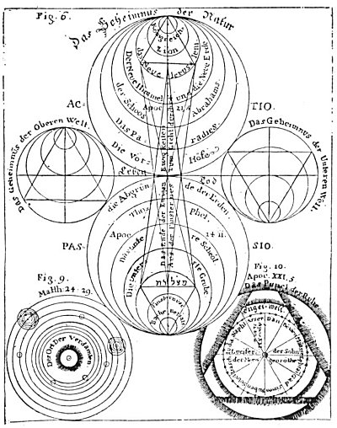
Table XV, Figures 6, 9, and 10

===================================================================================================================================================
END

