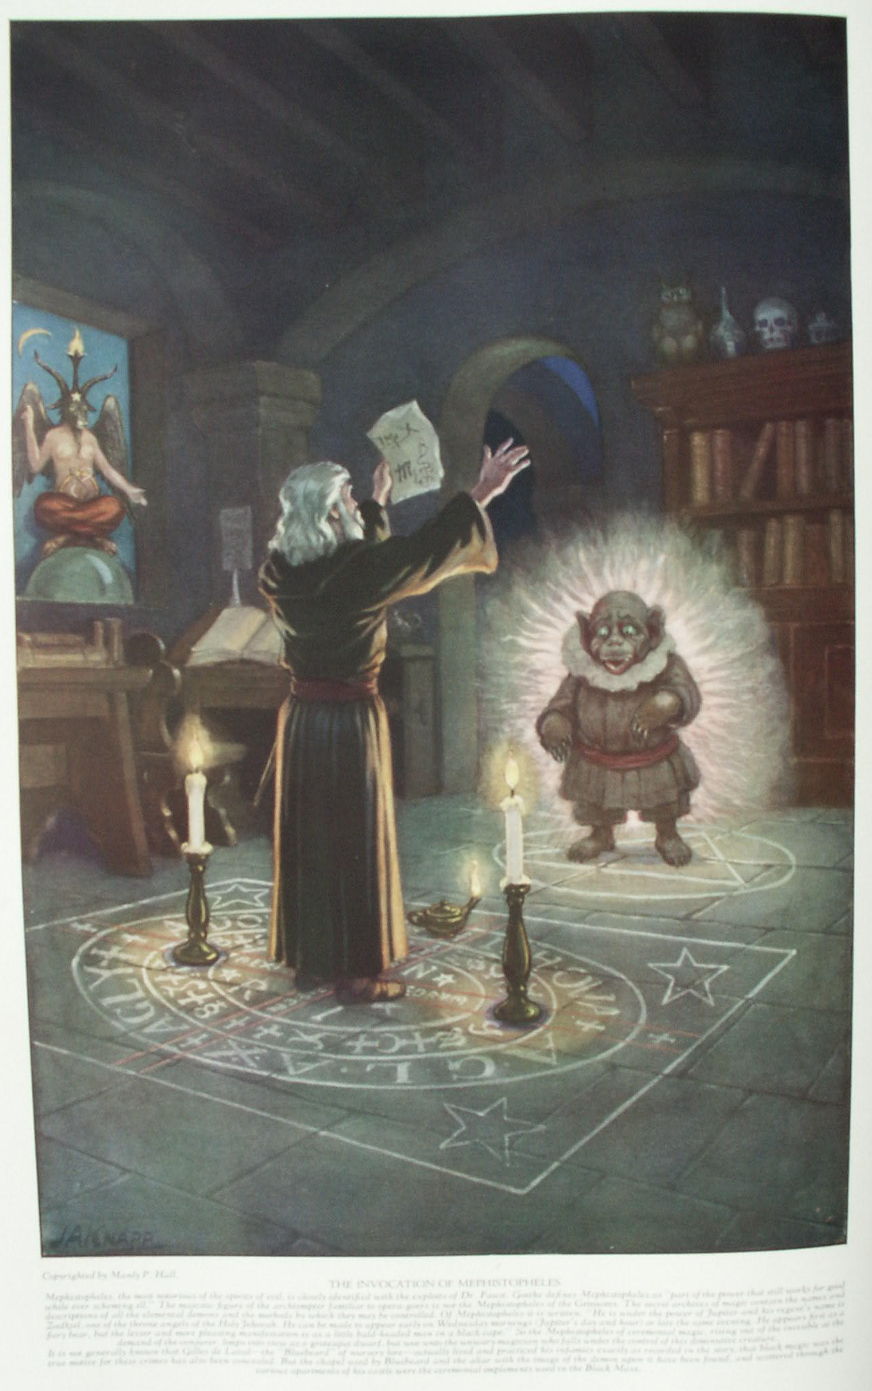

**Ceremonial Magic and Sorcery**

**The Secret Teachings of All Ages - Manly P. Hall 1928**

**CEREMONIAL MAGIC AND SORCERY  
The black magic of Egypt--Doctor Johannes Faustus--The Mephistopheles of the Grimores--The invocation of spirits--Pacts with demons--The symbolism of the pentagram.**

CEREMONIAL magic is the ancient art of invoking and controlling spirits by a scientific application of certain formulæ. A magician, enveloped in sanctified vestments and carrying a wand inscribed with hieroglyphic figures, could by the power vested in certain words and symbols control the invisible inhabitants of the elements and of the astral world. While the elaborate ceremonial magic of antiquity was not necessarily evil, there arose from its perversion several false schools of sorcery, or *black magic*.

Egypt, a great center of learning and the birthplace of many arts and sciences, furnished an ideal environment for transcendental experimentation. Here the black magicians of Atlantis continued to exercise their superhuman powers until they had completely undermined and corrupted the morals of the primitive Mysteries. By establishing a sacerdotal caste they usurped the position formerly occupied by the initiates, and seized the reins of spiritual government. Thus black magic dictated the state religion and paralyzed the intellectual and spiritual activities of the individual by demanding his complete and unhesitating acquiescence in the dogma formulated by the priestcraft. The Pharaoh became a puppet in the hands of the Scarlet Council--a committee of arch-sorcerers elevated to power by the priesthood.

These sorcerers then began the systematic destruction of all keys to the ancient wisdom, so that none might have access to the knowledge necessary to reach adeptship without first becoming one of their order. They mutilated the rituals of the Mysteries while professing to preserve them, so that even though the neophyte passed through the degrees he could not secure the knowledge to which he was entitled. Idolatry was introduced by encouraging the worship of the images which in the beginning the wise had erected solely as symbols for study and meditation. False interpretations were given to the emblems and figures of the Mysteries, and elaborate theologies were created to confuse the minds of their devotees. The masses, deprived of their birthright of understanding and groveling in ignorance, eventually became the abject slaves of the spiritual impostors. Superstition universally prevailed and the black magicians completely dominated national affairs, with the result that humanity still suffers from the sophistries of the priestcrafts of Atlantis and Egypt.

Fully convinced that their Scriptures sanctioned it, numerous mediæval Qabbalists devoted their lives to the practice of ceremonial magic. The transcendentalism of the Qabbalists is founded upon the ancient and magical formula of King Solomon, who has long been considered by the Jews as the prince of ceremonial magicians.

Among the Qabbalists of the Middle Ages were a great number of black magicians who strayed from the noble concepts of the *Sepher Yetzirah* and became enmeshed in demonism and witchcraft. They sought to substitute magic mirrors, consecrated daggers, and circles spread around posts of coffin nails, for the living of that virtuous life which, without the assistance of complicated rituals or submundane creatures, unfailingly brings man to the state of true individual completion.

Those who sought to control elemental spirits through ceremonial magic did so largely with the hope of securing from the invisible worlds either rare knowledge or supernatural power. The little red demon of Napoleon Bonaparte and the infamous oracular heads of de Medici are examples of the disastrous results of permitting elemental beings to dictate the course of human procedure. While the learned and godlike dæmon of Socrates seems to have been an exception, this really proves that the intellectual and moral status of the magician has much to do with the type of elemental he is capable of invoking. But even the dæmon of Socrates deserted the philosopher when the sentence of death was passed.

Transcendentalism and all forms of phenomenalistic magic are but blind alleys--outgrowths of Atlantean sorcery; and those who forsake the straight path of philosophy to wander therein almost invariably fall victims to their imprudence. Man, incapable of controlling his own appetites, is not equal to the task of governing the fiery and tempestuous elemental spirits.

Many a magician has lost his life as the result of opening a way whereby submundane creatures could become active participants in his affairs. When Eliphas Levi invoked the spirit of Apollonius of Tyana, what did he hope to accomplish? Is the gratification of curiosity a motive sufficient to warrant the devotion of an entire lifetime to a dangerous and unprofitable pursuit? If the living Apollonius refused to divulge his secrets to the profane, is there any probability that after death he would disclose them to the curious-minded? Levi himself did not dare to assert that the specter which appeared to him was actually the great philosopher, for Levi realized only too well the proclivity of elementals to impersonate those who have passed on. The majority of modern mediumistic apparitions are but elemental creatures masquerading through bodies composed of thought substance supplied by the very persons desiring to behold these wraiths of decarnate beings.

**THE THEORY AND PRACTICE OF BLACK MAGIC**

Some understanding of the intricate theory and practice of ceremonial magic may be derived from a brief consideration of its underlying premises.

*First*. The visible universe has an invisible counterpart, the higher planes of which are peopled by good and beautiful spirits; the lower planes, dark and foreboding, are the habitation of evil spirits and demons under the leadership of the Fallen Angel and his ten Princes.

*Second*. By means of the secret processes of ceremonial magic it is possible to contact these invisible creatures and gain their help in some human undertaking. Good spirits willingly lend their assistance to any worthy enterprise, but the evil spirits serve only those who live to pervert and destroy.

*Third*. It is possible to make contracts with spirits whereby the magician becomes for a stipulated time the master of an elemental being.

*Fourth*. True black magic is performed with the aid of a demoniacal spirit, who serves the sorcerer for the length of his earthly life, with the understanding that after death the magician shall become the servant of his own demon. For this reason a black magician will go to inconceivable ends to prolong his physical life, since there is nothing for him beyond the grave.

The most dangerous form of black magic is the scientific perversion of occult power for the gratification of personal desire. Its less complex and more universal form is human selfishness, for selfishness is the fundamental cause of all worldly evil. A man will barter his eternal soul for temporal power, and down through the ages a mysterious process has been evolved which actually enables him to make this exchange. In its various branches the black art includes nearly all forms of ceremonial magic, necromancy, witchcraft, sorcery, and vampirism. Under the same general heading are also included mesmerism and hypnotism, except when used solely for medical purposes, and even then there is an element of risk for all concerned.

Though the demonism of the Middle Ages seems to have disappeared, there is abundant evidence that in many forms of modern thought--especially the so-called "prosperity" psychology, "willpower-building" metaphysics, and systems of "high-pressure" salesmanship-- black magic has merely passed through a metamorphosis, and although its name be changed its nature remains the same.

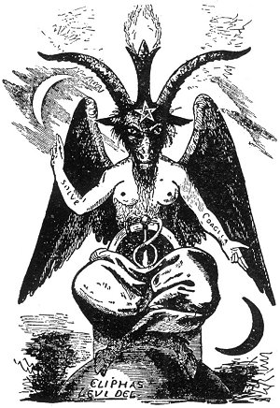  
BAPHOMET, THE GOAT OF MENDES.

From Levi's *Transcendental Magic*.

*The practice of magic--either white or black--depends upon the ability of the adept to control the universal life force--that which Eliphas Levi calls the great magical agent or the astral light. By the manipulation of this fluidic essence the phenomena of transcendentalism are produced. The famous hermaphroditic Goat of Mendes was a composite creature formulated to symbolize this astral light. It is identical with Baphomet the mystic pantheos of those disciples of ceremonial magic, the Templars, who probably obtained it from the Arabians.*

A well-known magician of the Middle Ages was Dr. Johannes Faustus, more commonly known as Dr. Faust. By a study of magical writings he was enabled to bind to his service an elemental who served him for many years in various capacities. Strange legends are told concerning the magical powers possessed by Dr. Faust. Upon one occasion the philosopher, being apparently in a playful mood, threw his mantle over a number of eggs in a market-woman's basket, causing them to hatch instantly. At another time, having fallen overboard from a small boat, he was picked up and returned to the craft with his clothes still dry. But, like nearly all other magicians, Dr. Faust came at length to disaster; he was found one morning with a knife in his back, and it was commonly believed that his familiar spirit had murdered him. Although Goethe's Dr. Faust is generally regarded as merely a fictional character, this old magician actually lived during the sixteenth century. Dr. Faust wrote a book describing his experiences with spirits, a section of which is reprinted below. (Dr. Faust must not be confused with Johann Fust, the printer.)

**EXTRACT FROM THE BOOK OF DR. FAUST, WITTENBERG, 1524**

(An abridged translation from the original German of a book ordered destroyed.)

"From my youth I followed art and science and was tireless in my reading of books. Among those which came to my hand was a volume containing all kinds of invocations and magical formulæ. In this book I discovered information to the effect that a spirit, whether he be of the fire, the water, the earth or the air, can be compelled to do the will of a magician capable of controlling him. I also discovered that according as one spirit has more power than another, each is adapted for a different operation and each is capable of producing certain supernatural effects.

"After reading this wonderful book, I made several experiments, desiring to rest the accuracy of the statements made therein. At first I had little faith that what was promised would take place. But at the very first invocation which I attempted a mighty spirit manifested to me, desiring to know why I had invoked him. His coming so amazed me that I scarcely knew what to say, but finally asked him if he would serve me in my magical investigations. He replied that if certain conditions were agreed upon he would. The conditions were that I should make a pact with him. This I did not desire to do, but as in my ignorance I had not protected myself with a circle and was actually at the mercy of the spirit, I did not dare to refuse his request and resigned myself to the inevitable, considering it wisest to turn my mantle according to the wind.

"I then told him that if he would be serviceable to me according to my desires and needs for a certain length of time, I would sign myself over to him. After the pact had been arranged, this mighty spirit, whose name was *Asteroth*, introduced me to another spirit by the name of *Marbuel*, who was appointed to be my servant. I questioned *Marbuel* as to his suitability for my needs. I asked him how quick he was, and he answered, 'As swift as the winds.' This did not satisfy me, so I replied, 'You cannot become my servant. Go again whence you have come.' Soon another spirit manifested itself, whose name was *Aniguel*. Upon asking him the same question he answered that he was swift as a bird in the air. I said, 'You are still too slow for me. Go whence you came.' In the same moment another spirit by the name of *Aciel* manifested himself. For the third time I asked my question and he answered, 'I am as swift as human thought.' 'You shall serve me,' I replied. This spirit was faithful for a long time, but to tell you how he served me is not possible in a document of this length and I will here only indicate how spirits are to be invoked and how the circles for protection are to be prepared. There are many kinds of spirits which will permit themselves to be invoked by man and become his servant. Of these I will list a few:

"*Aciel*: The mightiest among those who serve men. He manifests in pleasing human form about three feet high. He must be invoked three times before he will come forth into the circle prepared for him. He will furnish riches and will instantly fetch things from a great distance, according to the will of the magician. He is as swift as human thought.

"*Aniguel*: Serviceable and most useful, and comes in the form of a ten-year-old boy. He must be invoked three times. His special power is to discover treasures and minerals hidden in the ground, which he will furnish to the magician.

"*Marbuel*: A true lord of the mountains and swift as a bird on the wing. He is an opposing and troublesome spirit, hard to control. You must invoke him four times. He appears in the person of Mars [a warrior in heavy armor]. He will furnish the magician those things which grow above and under the earth. He is particularly the lord of the *spring-root*. [The *spring-root* is a mysterious herb, possibly of a reddish color, which mediæval magicians asserted had the property of drawing forth or opening anything it touched. If placed against a locked door, it would open the door. The Hermetists believed that the red-capped woodpecker was specially endowed with the faculty of discovering *spring-root*, so they followed this bird to its nest, and then stopped up the hole in the tree where its young were. The red-crested woodpecker went at once in quest of the spring-root, and, discovering it, brought it to the tree. It immediately drew forth the stopper from the entrance to the nest. The magician then secured the root from the bird. It was also asserted that because of its structure, the etheric body of the *spring-root* was utilized as a vehicle of expression by certain elemental spirits which manifested through the proclivity of drawing out or opening things.]

"*Aciebel*: A mighty ruler of the sea, controlling things both upon and under the water. He furnishes things lost or sunk in rivers, lakes, and oceans, such as sunken ships and treasures. The more sharply you invoke him, the swifter he is upon his errands.

"*Machiel*: Comes in the form of a beautiful maiden and by her aid the magician is raised to honor and dignity. She makes those she serves worthy and noble, gracious and kindly, and assists in all matters of litigation and justice. She will not come unless invoked twice.

"*Baruel*: The master of all arts. He manifests as a master workman and comes wearing an apron. He can teach a magician more in a moment than all the master workmen of the world combined could accomplish in twenty years. He must be invoked three times.

"These are the spirits most serviceable to man, but there are numerous others which, for lack of space, I am unable to describe. Now, if you desire the aid of the spirit to get this or that, then you must first draw the sign of the spirit whom you desire to invoke. The drawing must be made just in front of a circle made before sunrise, in which you and your assistants will stand. If you desire financial assistance, then you must invoke the spirit *Aciel*. Draw his sign in front of the circle. If you need other things, then draw the sign of the spirit capable of furnishing them. On the place where you intend to make the circle, you must first draw a great cross with a large sword with which no one ever has been hurt. Then you must make three concentric circles. The innermost circle is made of a long narrow strip of virgin parchment and must be hung upon twelve crosses made of the wood of *cross-thorn*. Upon the parchment you must write the names and symbols according to the figure which follows. Outside this first circle make the second as follows:

"First secure a thread of red silk that has been spun or twisted to the left instead of the right. Then place in the ground twelve crosses made of laurel leaves, and also prepare a long strip of new white paper. Write with an unused pen the characters and symbols as seen on the second circle. Wind this latter strip of paper around with the red silken thread and pin them upon the twelve crosses of laurel leaves. Outside this second circle make a third one which is also of virgin parchment and pinned upon twelve crosses of consecrated palm. When you have made these three circles, retire into them until at last you stand in the center upon a pentagram drawn in the midst of the great cross first drawn. Now, to insure success, do everything according to the description, and when you have read off the sacred invocation pronounce the name of the spirit which you desire to appear. It is essential that you pronounce the name very distinctly. You must also note the day and the hour, for each spirit can only be invoked at certain times."

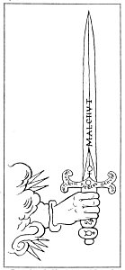  
A MAGICAL SWORD.

From Levi's *The Magical Ritual*.

*Eliphas Levi describes the preparation of a magical sword in substance as follows: The steel blade should be forged in the hour of Mars, with new tools. The pommel should be of hollow silver containing quicksilver, and the symbols of Mercury and the moon and the signatures of Gabriel and Samael should be engraved upon it. The hilt should be encased with tin, with the symbol of Jupiter and the signature of Michael engraved upon it. A copper triangle should extend from the hilt along the blade a short distance on each side: these should bear the symbols of Mercury and Venus. Five Sephiroth should be engraved upon the handle, as shown. The blade itself should have the word Malchut upon one side and Quis ut Deus upon the other. The sword should be consecrated on Sunday.*

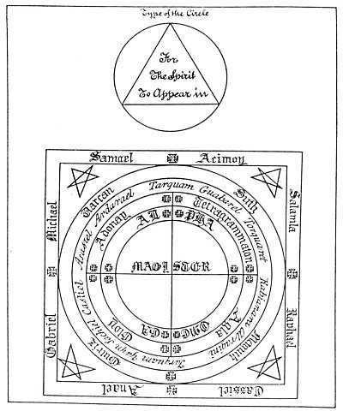  
A MAGIC CIRCLE.

From *The Complete Book of Magic Science* (unpublished).

*The above figure is a complete and faithful representation of a magic circle as designed by mediæval conjurers for the invocation of spirits. The magician accompanied by his assistant takes his place at the point formed by the crossing of the central lines marked MAGISTER. The words about the circle are the names of the invisible intelligences, and the small crosses mark points at which certain prayers and invocations are recited. The small circle outside is prepared for the spirit to be invoked, and while in use has the signature of the desired intelligence traced within the triangle.*

While the black magician at the time of signing his pact with the elemental demon maybe fully convinced that he is strong enough to control indefinitely the powers placed at his disposal, he is speedily undeceived. Before many years elapse he must turn all his energies to the problem of self-preservation. A world of horrors to which he has attuned himself by his own covetousness looms nearer every day, until he exists upon the edge of a seething maelstrom, expecting momentarily to be sucked down into its turbid depths. Afraid to die--because he will become the servant of his own demon--the magician commits crime after crime to prolong his wretched earthly existence. Realizing that life is maintained by the aid of a mysterious universal life force which is the common property of all creatures, the black magician often becomes an occult vampire, stealing this energy from others. According to mediæval superstition, black magicians turned themselves into werewolves and roamed the earth at night, attacking defenseless victims for the life force contained in their blood.

**MODUS OPERANDI FOR THE INVOCATION OF SPIRITS**

The following condensed extract from an ancient manuscript is reproduced herewith as representative of the ritualism of ceremonial magic. The extract is from *The Complete Book of Magic Science*, an unpublished manuscript (original in the British Museum), with pentacles in colors, mentioned by Francis Barrett in his *Magus*.

"*Opening Prayer*

"Omnipotent and Eternal God who hath ordained the whole creation for thy praise and glory and for the salvation of man, I earnestly beseech thee that thou wouldst send one of thy spirits of the order of Jupiter, one of the messengers of *Zadkiel* whom thou hast appointed governor of thy firmament at the present time, most faithfully, willingly, and readily to show me these things which I shall ask, command or require of him, and truly execute my desires. Nevertheless, O Most Holy God, thy will and not mine be done through JC, thine only begotten Son our Lord. Amen.

"*The Invocation*.

[The magician, having properly consecrated his vestments and utensils and being protected by his circle, now calls upon the spirits to appear and accede to his demands.]

"Spirits, whose assistance I require, behold the sign and the very Hallowed Names of God full of power. Obey the power of this our pentacle; go out your hidden caves and dark places; cease your hurtful occupations to those unhappy mortals whom without ceasing you torment; come into this place where the Divine Goodness has assembled us; be attentive to our orders and known to our just demands; believe not that your resistance will cause us to abandon our operations. Nothing can dispense with your obeying us. We command you by the Mysterious Names *Elohe Agla Elohim Adonay Gibort*. Amen.

"I call upon thee, Zadkiel, in the Name of the Father, and of the Son, and of the Holy Ghost, blessed Trinity, unspeakable Unity.

"I invoke and intreat thee, Zadkiel, in this hour to attend to the words and conjurations which I shall use this day by the Holy Names of God *Elohe El Elohim Elion Zebaoth Escerehie Iah Adonay Tetragrammaton*.

"I conjure thee, I exorcise thee, thou Spirit *Zadkiel*, by these Holy Names *Hagios O Theos Iscyros Athanatos Paracletus Agla on Alpha et Omega Ioth Aglanbroth Abiel Anathiel Tetragrammaton*: And by all other great and glorious, holy and unspeakable, mysterious, mighty, powerful, incomprehensible Names of God, that you attend unto the words of my mouth, and send unto me *Pabiel* or other of your ministering, serving Spirits, who may show me such things as I shall demand of him in the Name of the Father, and of the Son, and of the Holy Ghost. Amen.

"I intreat thee, *Pabiel*, by the whole Spirit of Heaven, Seraphim, Cherubim, Thrones, Dominations, Witnesses, Powers, Principalities, Archangels, and Angels, by the holy, great, and glorious Angels *Orphaniel Tetra-Dagiel Salamla Acimoy pastor poti*, that thou come forthwith, readily show thyself that we may see you and audibly hear you, speak unto us and fulfil our desires, and by your star which is Jupiter, and by all the constellations of Heaven, and by whatsoever you obey, and by your character which you have given, proposed, and confirmed, that you attend unto me according to the prayer and petitions which I have made unto Almighty God, and that you forthwith send me one of your ministering Spirits, who may willingly, truly, and faithfully fulfil all my desires, and that you command him to appear unto me in the form of a beautiful Angel, gently, courteously, affably, and meekly, entering into communication with me, and that he neither permitting any evil Spirit to approach in any sort of hurt, terrify or affright me in any way nor deceiving me in any wise. Through the virtue of Our Lord JC, in whose Name I attend, wait for, and expect thy appearance. Fiat, fiat, fiat. Amen, Amen, Amen.

"*Interrogatories*.

[Having summoned the spirit unto his presence, the magician shall question him as follows:]

"'Comest thou in peace in the Name of the Father and of the Son and of the Holy Ghost?' [And the spirit shall answer:] 'Yes.'

"'Thou art welcome, noble Spirit. What is thy Name?' [And the spirit shall answer:] '*Pabiel*.'

"'I have called thee in the Name of Jesu of Nazareth at whose Name every knee doth bow in heaven, earth, and hell, and every tongue shall confess there is no name like unto the Name of Jesus, who hath given power unto man to bind and to loose all things in his most Holy Name, yea even unto those that trust in his salvation.

"'Art thou the messenger of Zadkiel?' [And the spirit shall answer:] 'Yes.'

"'Wilt thou confirm thyself unto me at this time and henceforth reveal all things unto me that I shall desire to know, and teach me how I may increase in wisdom and knowledge and show unto me all the secrets of the Magic Art, and of all liberal sciences, that I may thereby set forth the glory of Almighty God?' [And the spirit shall answer:] 'Yes.'

"'Then I pray thee give and confirm thy character unto me whereby I may call thee at all times, and also swear unto me this oath and I will religiously keep my vow and covenant unto Almighty God and will courteously receive thee at all times where thou dost appear unto me.'

"*License to Depart*.

"'Forasmuch as thou comest in peace and quietness and hath answered unto my petitions, I give humble and hearty thanks unto Almighty God in whose Name I called and thou camest, and now thou mayest depart in peace unto thine orders and return unto me again at what time soever I shall call thee by thine oath, or by thy name or by thine order, or by thine office which is granted thee from the Creator, and the power of God be with me and thee and upon the whole issue of God, Amen.

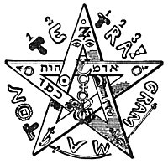  
THE PENTAGRAM.

From Levi's *Transcendental Magic*.

*THE PENTAGRAM. The pentagram is the figure of the microcosm--the magical formula of man. It is the one rising out of the four--the human soul rising from the bondage of the animal nature. It is the true light--the "Star of the morning." It marks the location of five mysterious centers of force, the awakening of which is the supreme secret of white magic.*

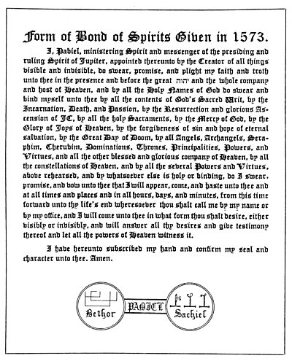  
FORM OF PACT WITH THE SPIRIT OF JUPITER.

From *The Complete Book of Magic Science*.

*The aforesaid Bond of spirits, together with the seal and character of the planetary angel, must be written m virgin Parchment and laid before the Spirit [for signature] when he appears; at that time the invocant must not lost confidence but be patient, firm, bold, and Persevering, and take care that he asks nor requires nothing of the Spirit but with a view to the glory of God and the well-being fellow creatures. Having obtained his desires of the Spirit, the invocant may license him to depart."*

"'Glory be to the Father, and to the Son, and to the Holy Ghost.'

[Note.] "It would be advisable for the invocant to remain in the circle for a few minutes after reciting the license, and if the place of operation be in the open air, let him destroy all traces of the circle, etcetera, and return quietly to his home. But should the operation be performed in a retired part of a house, cc cetera, the circle may remain, as it might serve in alike future operation, but the room or building must be locked up to avoid the intrusion of strangers."

The agreement set forth above is purely ceremonial magic. In the case of black magic, it is the magician and not the demon who must sign the pact. When the black magician binds an elemental to his service, a battle of wits ensues, which the demon eventually wins. With his own blood the magician signs the pact between himself and the demon, for in the arcanum of magic it is declared that "he controls the soul who controls the blood of another." As long as the magician does not fail, the elemental will fulfil to the letter his obligation under the pact, but the demon will try in every possible way to prevent the magician from carrying out his part of the contract. When the conjurer, ensconced within his circle, has evoked the spirit he desires to control and has made known his intention, the spirit will answer somewhat as follows: "I cannot accede to your request nor fulfil it, unless after fifty years you give yourself to me, body and soul, to do with as I may please."

If the magician refuses, other terms will be discussed. The spirit may say: "I will remain in your service as long as on every Friday morning you will go forth upon the public street giving alms in the name of Lucifer. The first time you fail in this you belong to me."

If the magician still refuses, realizing that the demon will make it impossible for him to fulfil his contract, other terms will be discussed, until at last a pact is agreed upon. It may read as follows: "I hereby promise the Great Spirit Lucifuge, Prince of Demons, that each year I will bring unto him a human soul to do with as it may please him, and in return Lucifuge promises to bestow upon me the treasures of the earth and fulfil my every desire for the length of my natural life. If I fail to bring him each year the offering specified above, then my own soul shall be forfeit to him. Signed . . . . . . . . . . . . . " [Invocant signs pact with his own blood.]

**THE PENTAGRAM**

In symbolism, an inverted figure always signifies a perverted power. The average person does not even suspect the occult properties of emblematic pentacles. On this subject the great Paracelsus has written: "No doubt many will scoff at the seals, their characters and their uses, which are described in these books, because it seems incredible to them that metals and characters which are dead should have any power and effect. Yet no one has ever proved that the metals and also the characters as we know them are dead, for the salts, sulphur, and quintessences of metals are the highest preservatives of human life and are far superior to all other simples." (Translated from the original German.)

The black magician cannot use the symbols of white magic without bringing down upon himself the forces of white magic, which would be fatal to his schemes. He must therefore distort the hierograms so that they typify the occult fact that he himself is distorting the principles for which the symbols stand. Black magic is not a fundamental art; it is the misuse of an art. Therefore it has no symbols of its own. It merely takes the emblematic figures of white magic, and by inverting and reversing them signifies that it is left-handed.

A good instance of this practice is found in the pentagram, or five-pointed star, made of five connected lines. This figure is the time-honored symbol of the magical arts, and signifies the five properties of the Great Magical Agent, the five senses of man, the five elements of nature, the five extremities of the human body. By means of the pentagram within his own soul, man not only may master and govern all creatures inferior to himself, but may demand consideration at the hands of those superior to himself.

The pentagram is used extensively in black magic, but when so used its form always differs in one of three ways: The star may be broken at one point by not permitting the converging lines to touch; it may be inverted by having one point down and two up; or it may be distorted by having the points of varying lengths. When used in black magic, the pentagram is called the "sign of the cloven hoof," or the footprint of the Devil. The star with two points upward is also called the "Goat of Mendes," because the inverted star is the same shape as a goat's head. When the upright star turns and the upper point falls to the bottom, it signifies the fall of the Morning Star.

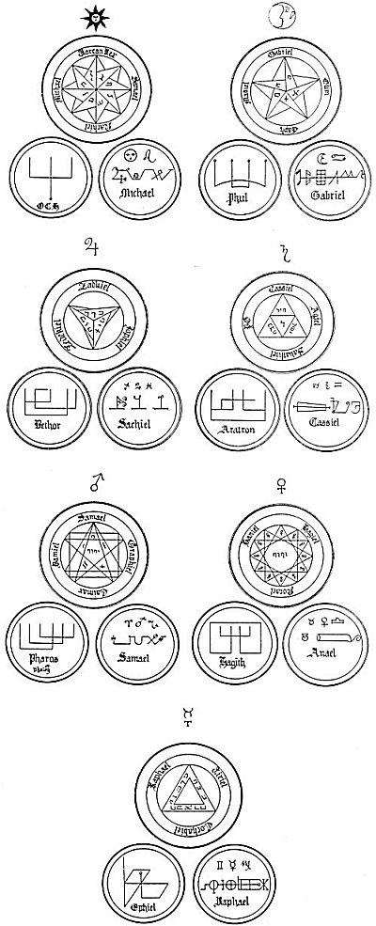  
THE PENTACLES OF THE SEVEN PLANETS AND THE SEALS AND CHARACTERS OF THE PLANETARY ANGELS.

From a mediæval *Book of Spirits* (unpublished).

*The seven large circle are the planets, while the two small circles under each contain the seal and the character of the controlling intelligence of the planet.*

===================================================================================================================================================

END