Bilderberg Group
http://en.wikipedia.org/wiki/Bilderberg_Group
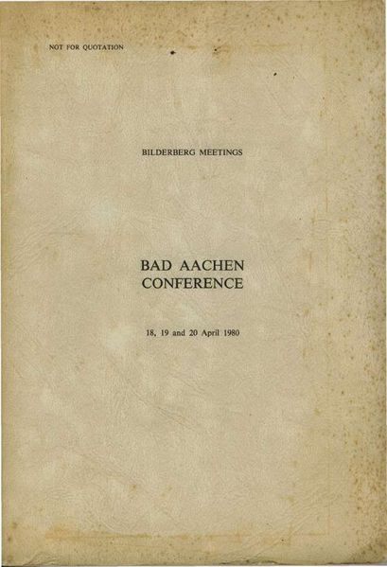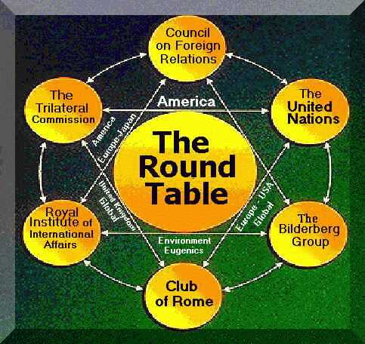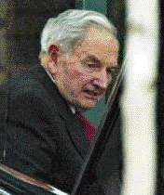
This is the front cover of the privately circulated report of the 1980 Bilderberg conferene in Bad Aachen, Germany.

The Bilderberg Group or Bilderberg conference is an unofficial annual invitation-only conference of around 130 guests, most of whom are persons of influence in the fields of business, academia, media, or politics.
Due to discussions by public officials and powerful business leaders (and others) being off the record, these annual meetings are the subject of much criticism (for circumventing the democratic process of discussing issues openly and publicly) and numerous conspiracy theories.
The elite group meets annually, in secret, at exclusive, five-star resorts throughout the world, normally in Europe, although sometimes in the United States or Canada. It has an office in Leiden, South Holland, Netherlands.

Contents
- 1 Origin of the name "Bilderberg"
- 2 Origin and purpose of the first annual conference
- 3 Declared purpose
- 4 Perspectives on the nature of the group
- 5 Attendees
- 6 Meetings
- 7 See also
- 8 References
- 9 External links

Origin of the name "Bilderberg"
The "Bilderberg" title comes from what is generally recognized to be the location of its first official meeting in 1954 — the Hotel de Bilderberg in Oosterbeek near Arnhem in the Netherlands. Although the conference is not officially regarded as a club of any sort, many members are regular attendees, and guests are often seen as belonging to a secretive Bilderberg Group.

[] Origin and purpose of the first annual conference
The original Bilderberg conference was held at the Hotel de Bilderberg, near Arnhem, from May 29 to May 30, 1954. The meeting was initiated by Polish emigre and political adviser, Joseph Retinger. Concerned about the growth of anti-Americanism in Western Europe, he proposed an international conference at which leaders from European countries and the United States would be brought together with the aim of promoting understanding between the cultures of America and Western Europe.
Retinger approached Prince Bernhard of the Netherlands, who agreed to promote the idea, together with Belgian Prime Minister Paul Van Zeeland. The guest list was to be drawn up by inviting two attendees from each nation, one each to represent conservative and liberal (both terms used in the American sense) points of view.
The success of the meeting led the organizers to arrange an annual conference. A permanent Steering Committee was established, with Retinger appointed as permanent secretary. As well as organizing the conference, the steering committee also maintained a register of attendee names and contact details, with the aim of creating an informal network of individuals who could call upon one another in a private capacity. The declared purpose of the Bilderberg Group was to make a common political line tie between the United States of America and Europe in their opposition to the USSR and the global communist danger.
Dutch economist Ernst van der Beugel took over as permanent secretary in 1960, upon the death of Retinger. Prince Bernhard continued to serve as the meeting's chairman until 1976, the year of his involvement in the Lockheed scandal. There was no conference that year, but meetings resumed in 1977 under Alec Douglas-Home, the former British Prime Minister. He was followed in turn by Walter Scheel, ex-President of Germany, Eric Roll, former head of SG Warburg and Lord Carrington, former Secretary-General of NATO.^{[1]}

[] Declared purpose
The original intention of the Bilderberg Group was to further the understanding between Western Europe and North America through informal meetings between powerful individuals. Each year, a "steering committee" devises a selected invitation list with a maximum of 100 names. Invitations are only extended to residents of Europe and North America. The location of their annual meeting is not secret, and the agenda and list of participants are openly available to the public, but the topics of the meetings are kept secret and attendees pledge not to divulge what was discussed. The official stance of the Bilderberg Group is that their secrecy prevents the members' discussions from being manipulated by the media.

[] Perspectives on the nature of the group
The group's stated justification for secrecy is that it enables people to speak freely without the need to carefully consider how every word might be interpreted by the mass media. Some, however, consider the elite and secretive nature of the meeting antithetical to the principles of inclusion in democratic societies.

[] Attendees
See List of Bilderberg attendees for a longer list of Bilderberg attendees.
Attendees of Bilderberg include central bankers, defense experts, mass media press barons, government ministers, prime ministers, royalty, international financiers and political leaders from Europe and North America.
Some of the Western world's leading financiers and foreign policy strategists attend Bilderberg. Donald Rumsfeld is an active Bilderberger, as is Peter Sutherland from Ireland, a former European Union commissioner and chairman of Goldman Sachs and of British Petroleum. Rumsfeld and Sutherland served together in 2000 on the board of the Swedish/Swiss energy company ABB. Former U.S. Deputy Defense Secretary and current World Bank head Paul Wolfowitz is also a member, as is Roger Boothe, Jr. The group's current chairman is Etienne Davignon, the Belgian businessman and politician.^{[2]}

[] Meetings
- 1954 Hotel de Bilderberg in Oosterbeek, Netherlands
- 1955 (March 18-20) in Barbizon, France and (September 23-25) in Garmisch-Partenkirchen, West Germany
- 1956 (May 11-13) in Fredensborg, Denmark
- 1959 in Yesilkoy Istanbul, Turkey
- 1975 (April 22-24) in Cesme Izmir, Turkey
- 1976 no conference
- 1977 (April 22-24) in Torquay, England
- 1978 (April 21-23) in Princeton, NJ, United States
- 1979 (April 27-29) in Baden, Austria
- 1980 (April 18-20) in Aachen, West Germany
- 1981 (May 15-17) in Bürgenstock, Switzerland
- 1982 (May 14-16) in Sandefjord, Norway
- 1983 (May 13-15 at the Château Montebello in Montebello, Quebec, Canada
- 1984 (May 11-13) in Saltsjöbaden, Sweden
- 1985 (May 10-12) in Rye Brook, NY, United States
- 1986 (April 25-27) in Gleneagles, Scotland
- 1987 (April 24-26) in Villa d'Este, Italy
- 1988 (June 3-5) in Telfs-Buchen, Austria
- 1989 (May 12-14) in La Toja, Spain
- 1990 (May 11-13) in Glen Cove, NY, United States
- 1991 (June 6-9) in Baden-Baden, Germany
- 1992 (May 21-24) in Evian-les-Bains, France
- 1993 (April 22-25) in Vouliagmeni, Greece
- 1994 (June 2-5) in Helsinki, Finland
- 1995 (June 8-11) in Zürich, Switzerland
- 1996 (May 30-June 2) at the CIBC Leadership Centre in Toronto, Canada
- 1997 (June 12-15) at the Pine Isle resort in Lake Lanier, Georgia, United States
- 1998 (May 14-17) in Turnberry, Scotland
- 1999 (June 3-6) at the Caesar Park Hotel Penha Longa in Sintra, Portugal
- 2000 (June 1-3) at the Chateau Du Lac Hotel in Brussels, Belgium
- 2001 (May 24-27) in Gothenburg, Sweden
- 2002 (May 30-June 2) at the Westfield Marriott^{[3]} ^{[4]} in Chantilly, Virginia, United States
- 2003 (May 15-18) in Versailles, France
- 2004 (June 3-6) in Stresa, Italy
- 2005 (May 5-8) at the Dorint Sofitel Seehotel in Rottach-Egern, Germany
- 2006 (June 8-11) at the Brookstreet Hotel ^{[5][6]} in Ottawa, Ontario, Canada. See picture of meeting location at time of meeting.
- 2007 (May) in Istanbul, Turkey (unconfirmed)

[] See also
- Club of Rome
- Council on Foreign Relations
- Trilateral Commission
- World Economic Forum
- Bohemian Grove
- David Rockefeller
- Influence
- Geopolitics
- Cabal
- NGOs
- Rothschilds
- Rockefellers
- Capitalism
- Internationalism

[] References
- ^ Rockefeller, David (2002). Memoirs. Random House, p.412. ISBN 0-679-40588-7.
- ^ Bill Hayton (29th September, 2005). Inside the secretive Bilderberg Group. BBC.
- ^ Westfield Marriott hotel
- ^ Gosling, Tony (2002). Bilderberg Conference 2002. Bilderberg Conferences reference page: Secret lobbying for Anti-Democratic European Superstate by Western Elite. Tony Gosling. Retrieved on 2006-06-12.
- ^ The Brookstreet Hotel, Kanata (Ottawa)
- ^ Panetta, Alexander (2006). Secretive Bilderbergers meet. www.thestar.com. Toronto Star Newspapers Limited. Retrieved on 2006-06-12.
- Hatch, Alden (1962). “The Hôtel de Bilderberg”, H.R.H.Prince Bernhard of the Netherlands: An authorized biography. London: Harrap. ISBN B0000CLLN4.
- Ronson, Jon (2001). THEM: Adventures with Extremists. London: Picador. ISBN 0-330-37546-6.

[] External links
- Scholarly article by Mike Peters on "The Bilderberg Group and the European Unification project" from Lobster: The Journal of Parapolitics
- Free Press International Extensive list of online articles on the Group
- Extract from the official Bilderberg report on the Fiuggi Conference 4-6 October 1957
- Guardian article on the group - an excerpt from Jon Ronson's book Them
- BBC Interview with Étienne Davignon, September 2005
- Elite power brokers meet in secret BBC News 15 May 2003
- BBC online article on Group
- CTV.ca - Shadowy group meets amid secrecy in Ottawa
- 2006 Bilderberg Group meeting attendance list
- The Secret Rulers of the World on Google Video
- Minutes from the 1999 Bilderberg meeting from SchNEWS website
=================================================================================================================================
END

