Johann Adam Weishaupt 1748-1830
http://en.wikipedia.org/wiki/Adam_Weishaupt
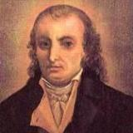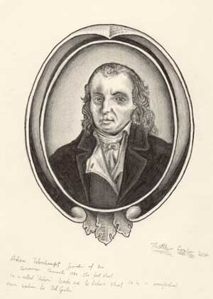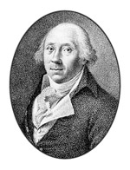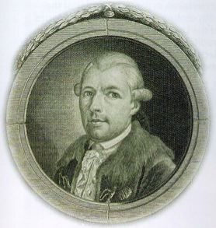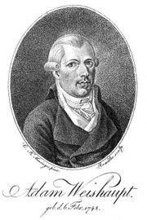
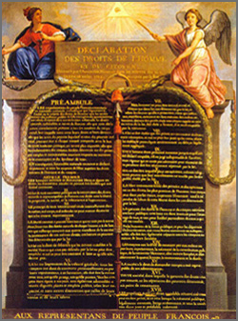

Johann Adam Weishaupt (* 6 February 1748 in Ingolstadt; † 18 November 1830 in Gotha) was a German who founded the Order of Illuminati.

Contents
[hide]
- 1 Early Activities
- 2 Founder of the Illuminati
- 3 Activities in exile
- 4 Quotes about Weishaupt
- 5 Weishaupt in Fiction
- 6 Notes
- 7 External links

[] Early Activities
He was born and raised in Ingolstadt, where he attained the rank of Professor of Canon Law in 1772. Though he was educated by Jesuits and was clearly influenced by the discretion, loyalty and the hierarchic obedience of the Society of Jesus and was for a time a member of their order, his appointment as Professor of Natural and Canon Law at the University of Ingolstadt in 1775 offended them. He broke with them, instead joining with movements of freethinkers, that were the most radical offshoot of The Enlightenment, and became increasingly liberal in his religious and political views, favoring deism and a kind of millennial natural order that swept aside states and organized religion.

[] Founder of the Illuminati
With the help of Adolph Freiherr Knigge, on May 1, 1776 Weishaupt formed the "Order of Perfectibilists", which was later known as the Illuminati. He adopted the name of "Brother Spartacus" within the order. Though the Order was not egalitarian or democratic, its mission was to establish a New World Order, which meant the abolition of all monarchical governments and religions.
Weishaupt wrote: the ends justified the means. The actual character of the society was modeled on one of its traditionalist enemies, the jesuits, and was an elaborate network of spies and counter-spies. Each isolated cell of initiates reported to a superior, whom they did not know, a party structure that was effectively adopted by some later groups, including more recently by the early Ba'ath party in Syria and Iraq.
Weishaupt was initiated into Freemasonry Lodge "Theodor zum guten Rath", at Munich in 1777 by Adolf Freiherr Knigge. His project of "illumination, enlightening the understanding by the sun of reason, which will dispel the clouds of superstition and of prejudice" was an unwelcome reform. Soon however he had developed gnostic mysteries of his own, with the goal of "perfecting human" nature through re-education to achieve a communal state with nature, freed of government and organized religion. He began working towards incorporating his system of Illuminism into that of Masonry, with the aim of creating a New World Order.
He wrote: "I did not bring Deism into Bavaria more than into Rome. I found it here, in great vigour, more abounding than in any of the neighboring Protestant States. I am proud to be known to the world as the founder of the Illuminati."
Weishaupt's radical rationalism, sweeping away nations and religions, private property and marriage, with the vocabulary used by the French Revolution, was not likely to succeed. Writings that were intercepted in 1784 were interpreted as sious, and the Society was banned by the government of Karl Theodor, Elector of Bavaria in 1784. Weishaupt lost his position at the University of Ingolstadt and fled Bavaria.

[] Activities in exile
He received the assistance of Duke Ernst II of Saxe-Gotha-Altenburg (1745-1804), and lived in Gotha writing a series of works on Illuminism, including A Complete History of the Persecutions of the Illuminati in Bavaria (1785), A Picture of Illuminism (1786), An Apology for the Illuminati (1786), and An Improved System of Illuminism (1787). He died there in 1811, though his later career was so obscure that some sources place the year of his death at 1830.
A century after his death, occultist interest in Weishaupt and the Bavarian Illuminati picked up, through the writings of Aleister Crowley.

[] Quotes about Weishaupt
A human devil.
--Augustin Barruél
An enthusiastic philanthropist.
--Thomas Jefferson^{[1]}

[] Weishaupt in Fiction
Adam Weishaupt is referred to repeatedly in The Illuminatus! Trilogy, by Robert Shea and Robert Anton Wilson, as the founder of the Bavarian Illuminati, and as an imposter who killed George Washington and took his place as the first president of the United States. Washington's portrait on the one-dollar bill is said to actually be Weishaupt's.
Another fictionalized version, Adam Weisshaupt, appears in the extensive comic book-cum-novel Cerebus the Aardvark by Dave Sim, as a combination of Weishaupt and George Washington. He appears primarily in the Cerebus and Church and State I volumes. His motives are republican confederalizing of city-states in Estarcion (a pseudo-Europe) and the accumulation of capital unencumbered by government or church.
Weishaupt is also mentioned among the mish-mash of complicated conspiracies in the PC game Deus Ex. During JC Denton's escape from Versalife labs in Hong Kong, he recovers a virus engineered with the molecular structure in multiples of 17 and 23. Tracer Tong notes "1723... the birthdate of Adam Weishaupt" Weishaupt was in fact born in 1748. This error is probably an intentional allusion to the law of fives in Principia Discordia, which ascribes mystical significance to the numbers 5, 17, and 23. This is supported by an earlier ATM password in the game: 230023. 1723 was also the year that Weishaupt's freemasonry lodge, "Theodor zum guten Rath", was founded.

[] Notes
- ^ Thomas Jefferson to Reverend James Madison, January 31, 1800, The Thomas Jefferson Papers (American Memory from the Library of Congress)

[] External links
====================================================================================================================================
end

