Science of Mind
http://en.wikipedia.org/wiki/Religious_Science

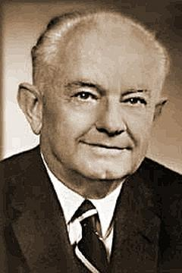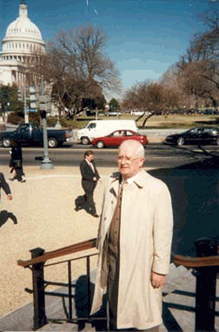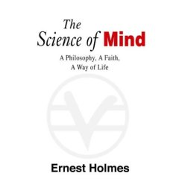

Religious Science, also known as Science of Mind, was founded in 1927 by Ernest Holmes (1887–1960) and is a religious movement within the New Thought Movement. (In general, the term "Science of Mind" applies to the teachings, while the term "Religious Science" applies to the organizations. However, adherents often tend to use the terms interchangeably.)

History
Upon publication of his seminal book in 1926, The Science of Mind, Holmes established the Institute for Religious Science in Los Angeles. This organization would later become the Church of Religious Science.
In 1953 the organization split into two organizations, known today as the United Church of Religious Science, or UCRS, and Religious Science International, or RSI. RSI cites the cause of the split as "differences in approach to corporate structure and church administration." UCRS is based in Burbank, California and currently led by Rev. Kathy Hearn. RSI is based in Spokane, Washington and currently led by Dr. Candice Becket. RSI is more decentralized. Global Religious Science Ministries, or GRSM, was founded by former RSI ministers who envisioned an expanded definition of ministry. GRSM is based in Silver Spring, Maryland and currently led by Rev. Douglas Kinney. In addition, there are some smaller branches, as well as independent Religious Science churches. The teachings of the branches are generally the same.

Teachings
The Science of Mind (SOM) teachings generally have idealistic and monist tones. SOM teaches that all beings in the universe are expressions of an Infinite Intelligence, or God, also known as Spirit, or the One Mind. SOM also teaches that people can open themselves to spiritual guidance and learn to love themselves, have more satisfying lives, and reach their potential. It teaches that thought is creative, and people can learn to more consciously create their own experience. A slogan used by some Religious Science churches is "Change Your Thinking, Change Your Life.")
People can begin to be motivated to achieve more fulfilling lives through a process called spiritual mind treatment, or affirmative prayer. Spiritual mind treatment is a step-by-step process, in which one states the desired outcome as if it is already known that it has happened. Each step flows logically from the last one. Treatment is to be stated as personal, positive, powerful, and present. The goal is to gain clarity in thinking that guides action to be consistent with the desired outcome. The treatment sets off a new chain of causation in Mind that leads to the good for which one is treating. One of the most popular treatment processes includes the following five steps:
- Recognition: There is one Spirit. Spirit is all there is. (God is).
- Unification: Spirit and I are one. I live, move, and have my being in God. (I am).
- Realization: A series of statements affirming/declaring the outcome desired. (I accept).
- Thanksgiving: Being thankful that we have received the desired outcome, or something even better. (I am thankful) or (I Give Thanks).
- Release: Giving it over to the Law and letting the Law do its work (Let go and let God) or (And So It Is).
Someone who is certified to conduct treatments during church services or to assist people through treatment is called a practitioner. A professional practitioner is available for spiritual counseling by appointment and performs some ecclesiastical functions in association with the minister, such as giving treatments during church services or making announcements. The way that each practitioner conducts treatments is very different. The training of practitioners varies a bit in each of the branches, but licensed practitioners (who carry the designation RScP) are thoroughly trained in professional courses and required to maintain an ongoing education and service to their communities. Ministers are also carefully trained, and other members are also encouraged to take Science of Mind classes. Everyone is also encouraged to do spiritual mind treatment on their own to solve various problems in their lives.
The Science of Mind also states seven main attributes (or Seven Verities) of Infinite Intelligence, or God: love, light, life, power, peace, beauty, and joy. It describes God as a "triune unity" (Holmes's phrase) of Spirit, Soul, Body. God is viewed as Omnipotent, Omniscient, and Omnipresent.
The healing work of Dr. Phineas P. Quimby gave birth to much of the New Thought movement, including Religious Science and Christian Science. Although some of the teachings are similar, Religious Science is not to be confused with Christian Science, founded by Mary Baker Eddy. Former Christian Scientist Emma Curtis Hopkins developed her own method of "Scientific Christian Mental Practice," which she taught to Holmes and founders of several other New Thought denominations (including the Fillmores, founders of Unity, and the Brooks sisters, co-founders of Divine Science). Her work was later published as a book by the same name. Ernest Holmes was strongly influenced by Ms. Hopkins and by the writings of Judge Thomas Troward and Ralph Waldo Emerson, as he developed his synthesis which became known as Religious Science.
Though UCRS and RSI have standardized Science of Mind curriculum and course materials, the approach to the teachings may vary from church to church. While some churches have ministers who bring a more Christian influence, others focus on influences from other religions, such as Buddhism, Hinduism, or Taoism. Many Religious Science churches have active youth groups.

External links
- United Centers for Spiritual Living
- Phineas Parkhurst Quimby
- Conscious Kernels Spiritual eBooks and More
================================================================================================================================
END

