**ELITE SEX CLUB**

**The most exclusive sex party ever? Go inside the elite club where members indulge their most erotic fantasies in the company of musicians, glamorous models and Hollywood actors**

* **Snctm holds monthly parties where men and women are invited to explore their 'primal urges' but creator Damon Lawner claims it has 'never been about sex'**
* **All guests are required to arrive at the parties wearing a mask. Men are required to wear tuxedos and women either evening wear or lingerie**
* **Annual membership costs between $12,000 and $75,000 while individual party tickets cost over $1,000**
* **Highest level members are said to include 11 men and one woman who are required to take part in a 'blood oath' to join**

By [Miranda Bryant For Dailymail.com](http://www.dailymail.co.uk/home/search.html?s=&authornamef=Miranda+Bryant+For+Dailymail.com)

PUBLISHED: 15:54, 3 February 2017 | UPDATED: 20:13, 3 February 2017

An exclusive club invites members to indulge their sexual fantasies in the surroundings of a Beverley Hills mansion in the company of top musicians, models and Hollywood actors.

But membership to this elite group comes at a price: interested parties must submit an application and pay an annual feel of between $12,000 and $75,000, while highest level members take part in a 'blood oath', according to the [New York Post](http://nypost.com/2017/02/01/inside-las-most-exclusive-sex-party/).

Snctm creator Damon Lawner, 45, told the newspaper that only 11 men and one woman have been bestowed with the highest level membership.

Scroll down for video

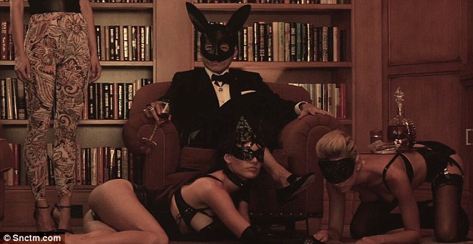

+7

A-List erotica: Exclusive LA club Snctm invites members to indulge their sexual fantasies in the company of top musicians, glamorous models and Hollywood actors



Like minds: Snctm holds monthly parties where men and women are invited to explore their 'primal urges'

This includes entry to every party - including access to private rooms - a special silver necklace and the advice of sex experts.

Alternatively, there is a lower level membership that offers discounted party tickets and networking opportunities.

Lawner claims its members include Grammy-winning artists and said Gwyneth Paltrow has attended their parties with her boyfriend, Glee producer, Brad Falchuk.

'[Gwyneth is] not a crazy-kinky person, like people think,' Lawner said. 'She’s a down-to-earth total sweetheart...They are exploratory with each other.'

A recent event featured erotically dressed waitresses, Japanese bondage demonstrations, fire-eating shows and live sex acts, according to the newspaper.

Lawner, who is a father-of-two and divorced, founded the club four years ago.



+7

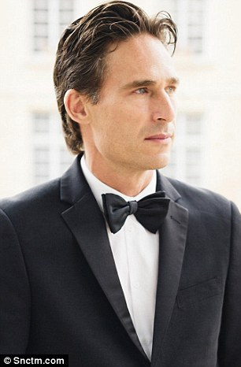

+7

Mission: Creator Damon Lawner, pictured, claims it has 'never been about sex'



+7

Dress code: All guests are required to arrive at the parties wearing a mask. Men are required to wear tuxedos and women either evening wear or lingerie



Fee: Annual membership costs between $12,000 and $75,000 while individual party tickets cost over $1,000

He said some members attend parties to learn 'how to give better [pleasure]' while others see it as a place 'for primal urges to be explored'.

Single men pay $1,850 per party or $1,500 if they attend with a woman, according to the newspaper.

Women do not pay but are required to submit an application in the form of full-body photographs.

Privacy is an important consideration for the club. Mobile phones are banned and everybody is required to wear masks on entry.

The dress code consists of tuxedos for men and either evening wear or lingerie for women.

Last year Scntm held a secret party in New York to coincide with fashion week where guests were required to collect keys engraved with the location address.

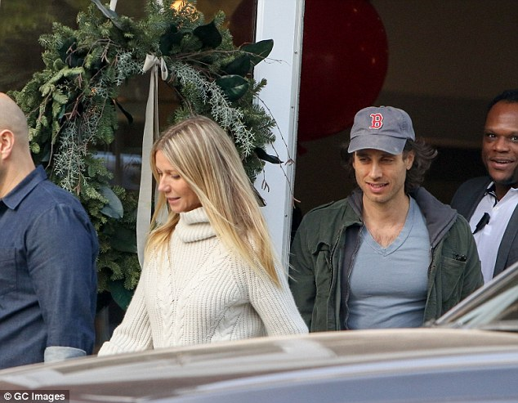

+7

Celebrity guests: Lawner claims actress Gwyneth Paltrow and her boyfriend Glee producer Brad Falchuk, pictured, have attended his parties

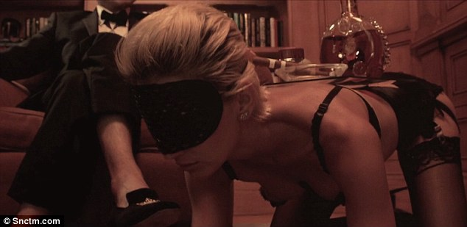

+7

Committed: Highest level members are said to include 11 men and one woman who are required to take part in a 'blood oath' to join



+7

Sexual: A promotional video, pictured, shows women in lingerie crawling around the floor and on their hands and knees serving and licking a masked man sat on a chair in a tuxedo

Inside SNCTM, Los Angeles' most exclusive sex party

Lawner claims that his 20 employees and himself are banned from engaging in sex at the parties but, according to the New York Post, he likes to watch.

A promotional [video](https://www.snctm.com/) shows women in lingerie crawling around the floor and on their hands and knees serving and licking a masked man sat on a chair in a tuxedo.

Despite the focus on eroticism of the club, Lawner claims it has 'never been about sex'.

He told Paltrow's lifestyle website [Goop](http://goop.com/inside-snctm-l-a-s-exclusive-erotic-theater/): 'There are sex parties out there and I’ve honestly never been to one, nor desire to.

'Snctm is a place to get turned on, to explore, to hold hands, to realize that sex doesn’t have to be hidden away. It can be open and celebrated, and that’s all right.'

Read more: <http://www.dailymail.co.uk/femail/article-4185980/LA-club-members-indulge-sexual-fantasies.html#ixzz4ZkSJctUc>