**A BRIEF REVIEW ON THE CABAL**

The Cabal apparently dates back to before the Roman Empire. They are vastly wealthy and believe in segregating their own "bloodlines" from everyone else's.

They once ruled openly as the Egyptian pharaohs, the Mesoamerican priesthoods, and as various royal bloodlines in Europe and Asia.

One key characteristic that many of them have is psychopathy. This means they have "fearless dominance," seek power, and have no conscience about hurting others.

This type of disorder can be intentionally inflicted upon someone through severe, prolonged abuse -- particularly if it is sexual in nature.

Torture research going back to well before the Spanish Inquisition has proven that any human being can be "broken" after enough repeated trauma.

This actually does change how their brains function in the most basic way. We make physiological modifications as a survival and coping mechanism.

Though they see their behavior as a sign that they are more highly evolved, medical research shows the frontal lobes in the brain of psychopaths are nearly deactivated.

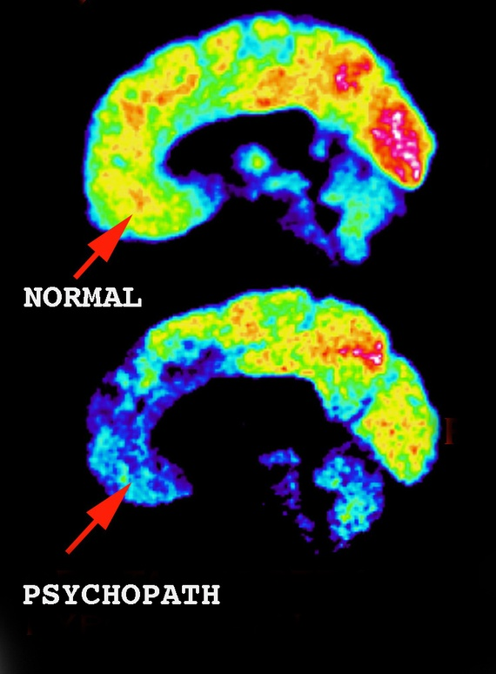

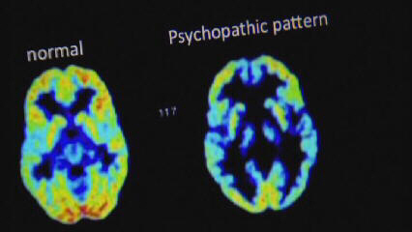

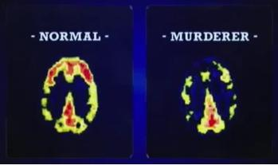

This means an entire part of their neurophysiology that is built to feel empathy, compassion and concern for others is simply not functioning.

It is also possible to have a harmful over-abundance of neurological activity in the frontal lobes.

Instead of this just manifesting as an extremely sensitive and highly caring person, it will often create [clinical OCD (Obsessive-Compulsive Disorder.)](http://www.sciencenutshell.com/ocd-brain/)

[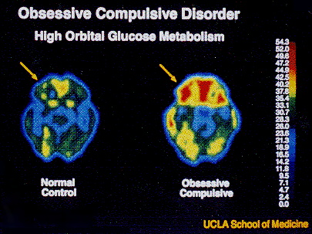](http://www.sciencenutshell.com/ocd-brain/)

[The slice here is taken at a different angle, hence the normal control does not look the same as in the previous images.]

Since the frontal lobes are the parts of the brain that process emotions, OCD leads to constant feelings of anxiety and hyper-vigilance.

These people get caught in obsessive, looping thought patterns that are emotionally-based -- tossing around the same things over and over again.

Their obsessions are often traceable to unhealed trauma from how others treated them.

They may fall into seemingly bizarre, repetitive behavioral patterns that help to provide relief against the constant sense of anxiety they feel.

There are many different types of obsessions these sufferers can fall into, including compulsive hoarding.

Psychologists can usually trace the onset of these behaviors to one or a series of very intense traumas that altered the person's neurochemistry.

[Click here to read a comprehensive list of the different types of OCD. A regular meditation practice can help calm the brain and alleviate these symptoms.](http://www.ocdtypes.com/ybocs_checklist.php)

**THIS IS A PROBLEM WE ALL MUST FACE**

The psychopath is not affected by fear, punishment, shame or the opinions of others or society as a whole, including morals and ethics.

They have an enormous sense of personal value and grandiosity, and can modify their personalities to present exactly what people will respond to the most.

They will often be master manipulators, and may go to great lengths to be as physically and socially attractive as possible.

In the beginning, you will feel as if you have never been more in love, or at least that you have found one of the most fascinating people on earth.

Once you have been suitably "groomed" and are under at least some degree of control, the whole experience changes dramatically.

These people comprise about 2 percent of women and 5 percent of men, worldwide, and most of them are not actively violent offenders.

Only a very small number of people are actually Cabal members, just a few million -- and the vast majority of psychopaths are not involved with it.

What makes the Cabal interesting from a storytelling viewpoint is what happens when psychopaths organize on such a massive level of scale.

**THERE IS A YIN-YANG COMPENSATION IN THE FRONTAL LOBES**

Psychopaths feed on power over others. They have to seek out ways to dominate and humiliate others on a daily basis or they feel horribly empty inside.

It is ironic that living with a neurologically-deadened psychopath often causes over-activity in the frontal lobes of the victim, leading to anxiety and OCD.

You begin obsessively looking for clues that they are getting better, and try to be optimistic, when in fact the same abuse just keeps happening, year after year.

Since you never know when a psychopath will strike, your frontal lobes are constantly scanning for any subtle emotional tip-offs signaling the next attack.

You never have to wait very long. A genuine psychopath will not let you "off the hook" for even one day. They can't wait that long. They need a 'fix.'

You are always in trouble. You have always insulted them, not lived up to their expectations, done something horribly wrong and are having apologies demanded of you.

No matter how many times you apologize, and no matter how much you try to make up for whatever you 'did,' you are never, ever forgiven -- for anything.

There is a reason why the term Narcissist is often used interchangeably with 'psychopath.' These are very, very thin-skinned, intolerant people.

Most of your waking hours are spent obsessively trying to figure out what the heck you are going to do in order to heal this epic, disastrous problem.

**THEY ARE MASTERS OF ENTRAPMENT**

If you think you have someone like this in your life, I highly recommend going to [psychopathfree.com](http://www.psychopathfree.com/) and reading articles in the Library section.

Once you figure it out, I recommend waiting two weeks and gathering information and observations before attempting to make any visible moves.

Psychopaths will go to whatever extremes necessary to make you feel completely trapped, as if there is no possible way you could ever escape from them.

This is precisely being seen in the Weinstein scandal.

He "groomed" his victims for abuse in classic psychopathic fashion, and feels no remorse for what he has done.

He and his cronies may well laugh about what they put people through, considering it to be the "price you must pay for fame."

**BLIND GOSSIP REVEALS HOW WEINSTEIN ENTRAPPED HIS VICTIMS**

[Blind Gossip](http://www.blindgossip.com/) is the site of a high-ranking Hollywood insider whose leaks have been correct countless times.

In a post from October 9th, we learn that Weinstein had gathered multiple incriminating photographs of all his top female victims.

This post is worded delicately, but some commenters indicated there are films and photos of sex acts with Weinstein included in this collection:

10/9: Harvey Weinstein Has Blackmail Pictures of Female Victims

<http://blindgossip.com/?p=87584>

[[Blind Gossip](http://blindgossip.com/)] Right now, it’s all about the words.

Some are talking, some are staying silent. Some are pretending they knew nothing, others are acknowledging that that they heard the rumors but not the specifics.

A lot of words. Some true. Some worthy of an exaggerated eye roll.

You know what no one is talking about yet? The pictures!

Some taken by the producer. Some taken by the women and sent to him at his request. Some were sent unsolicited.

He has a lot of photos and videos. **Some** of them were sent to him voluntarily by actresses who are now famous.

If even ONE woman tries to file some sort of law suit against him, then all those images could become evidence.

That one actress could wind up taking down dozens/ hundreds of other women with her.

That’s one reason why they are quiet right now. They are terrified that there is no “right” thing for them to do.

**GET OUT... AND HAVE NO CONTACT**

Thankfully, this seemingly "foolproof" system of guaranteed blackmail has not stopped [well over 40 women, many of whom are celebrities, from coming forward.](http://www.businessinsider.com/list-of-women-who-have-accused-harvey-weinstein-of-sexual-harassment-or-assault-2017-10)

Their numbers are increasing by the day, and the stories keep getting worse -- including full-blown forcible rape.

The only way you will ever get your life back from a psychopath is to do whatever it takes to get them out of your life, and then go into complete "No Contact."

Otherwise, any communication you have with them whatsoever will only lead to new entanglements. [Psychopathfree.com](http://www.psychopathfree.com/)makes this very clear.

It is also very wise to get the help of a qualified therapist, as this may well be far too big of a challenge to handle strictly by yourself.

Weinstein has proven to be incapable of seeing that he raped anyone. [In the sex rehab clinic he rigorously insists all events were fully consensual.](https://pagesix.com/2017/10/19/harvey-weinstein-doesnt-seem-to-be-taking-sex-rehab-seriously/)

If you have children with a psychopath, you may always need to have some degree of engagement, but you are advised to keep it as limited as possible.

**PERSONAL CHANGES AFFECT THE COLLECTIVE**

I do believe that as we cut the cords on the individual level, we will see more and more examples of freedom breaking through on the global level.

The Meditation Effect I have written about in each of my books shows that consciousness is holographic -- on a worldwide scale.

Groups of a mere seven thousand people were able to reduce war, terrorism, crime and fatalities worldwide by a stunning 72 percent -- through meditation.

All other possible variables, such as weekends, weather, holidays and so forth, were ruled out.

A small group of people holding a positive state of "Pure Consciousness" were able to dramatically affect the free will of the entire planet.

Nearly three out of four people who normally would have committed a violent crime decided, instead, to take a more peaceful approach.

**THINK ABOUT THE IMPLICATIONS**

These would-be criminals obviously had no idea that their apparent free will had been altered by a small group of people in a focused state of consciousness.

This is a simplified example of how the struggle against psychopaths in our own lives is a microcosm of what is happening on the planet as a whole.

I can't stress this enough: It may be that **the single greatest thing you can do to defeat the Cabal right now is to free yourself of psychopaths.**

Once you recover from the initial damages of separation, your life will be far happier than you had ever experienced in quite some time.

Your strength in cleaning up your own life directly empowers these changes to occur on the collective level.

In some cases, this relationship is extremely obvious and direct.

A remarkable process has now started that could lead to the utter collapse of sexual abuse in Hollywood, [thanks to the #metoo campaign.](http://abcnews.go.com/Entertainment/alyssa-milano-metoo-campaign-vocal-stops/story?id=50582023)

**THEY HAVE QUITE A STORY IN THEIR OWN WORLD**

As I argue in *The Ascension Mysteries,*the Cabal members believe themselves to be the descendants of human-looking extraterrestrials with elongated skulls.

These skulls have been found all over the world, and are definitely the remains of some alternative form of human being from what we normally see.

This was confirmed with DNA tests ordered by Brien Foerster in 2014, showing ["mutations unknown in any human, primate, or animal known so far."](http://mysteriousuniverse.org/2016/07/new-dna-tests-on-paracas-skulls-yield-unexpected-results/)

The skulls themselves have obvious abnormalities, including completely different cranial sutures and alternative passageways for nerve fibers and blood vessels.

There is no plausible skeptical explanation that can account for the widespread presence of these remains worldwide.

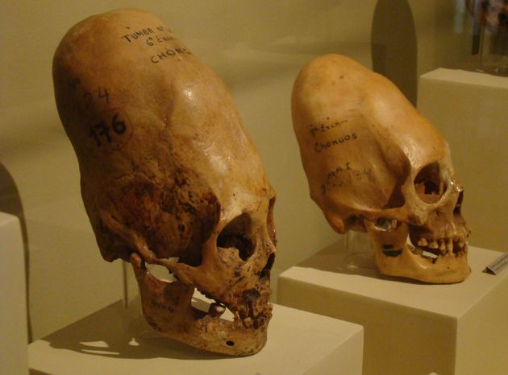

Obviously, the visible Cabal members do not display any structural abnormalities in their skulls. Interbreeding has long since obscured such differences.

However, as recently as the 1400s, the Italian noble D'Este family clearly displayed these physiological features in various depictions, such as the paintings of Pisanello.

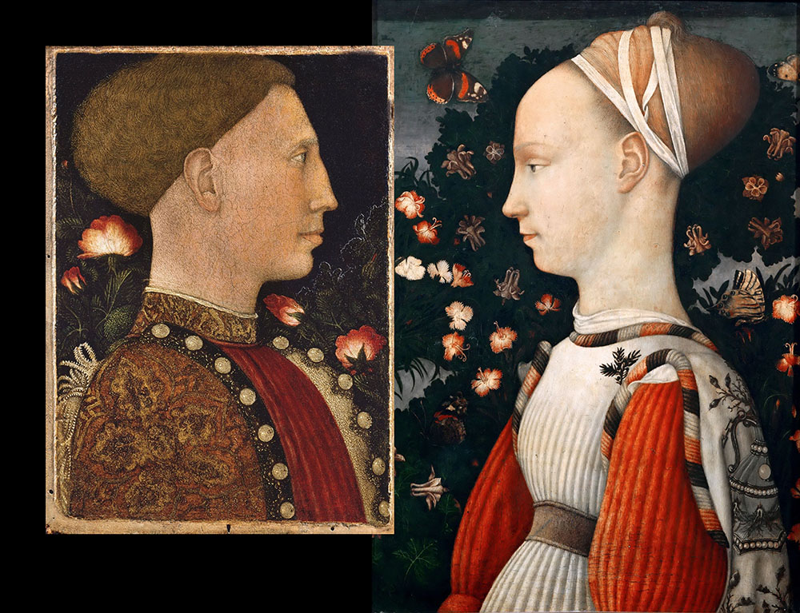

This becomes far more interesting once we realize that [a majority of European royal bloodlines have direct genetic ties to the D'Este clan.](http://familypedia.wikia.com/wiki/House_of_Este)

Furthermore, as of 2012, we found out [all American presidents except #8, Van Buren, were direct descendants of King John of England, who signed the Magna Carta in 1215.](http://www.dailymail.co.uk/news/article-2183858/All-presidents-bar-directly-descended-medieval-English-king.html)

Far from being a statistical fluke, this is one of multiple pieces of evidence that US Presidents have been part of these same hidden bloodlines.

In fact, you can genetically analyze the contestants in each election, at least up until 2016, and whoever has more of this "royal blood" will be the winner.

**FRENCH MEROVINGIAN-ERA ARISTOCRAT'S SKULL HAS ELONGATED SHAPE**

In 2013, it was also announced that an elongated skull was found in a tomb of a French noblewoman, dating back to the Merovingian era.

The Merovingian bloodline is supposedly descended from Mary Magdalene, at least in the Cabal's own tradition -- as revealed in *The Da Vinci Code*:

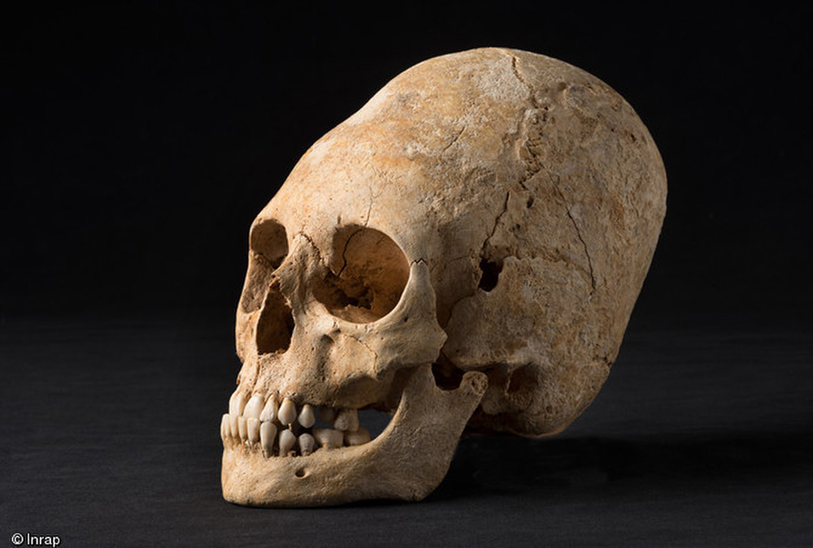

This was automatically written off as a case of "head binding" -- but it is acknowledged that multiple skulls like this have been found throughout Europe.

2013: Elite Skulls Throughout Europe Reveal Elongated, Alien-Like Features

<https://www.livescience.com/41244-deformed-skull-burial-in-france.html>

The skeleton of an ancient aristocratic woman whose head was warped into a deformed, pointy shape has been unearthed in a necropolis in France....

In those times, **the**[**deformed, alienlike skull**](https://www.livescience.com/25743-alien-like-skulls-excavated-mexico.html)**was a privilege reserved for the aristocracy.**

"In **France, Germany and eastern Europe,** these deformed skulls appear in tombs rich in objects," [archeologist Phillippe] Lefranc said.

The wealthy lady's tomb also contained gold pins, belts known as chatelaines, pearls, a comb made of a stag antler, and a bronze mirror that likely came from the Caucasus region or central Asia, he said.

**A MEDICAL NAME FOR THIS IS "DOLICHOCEPHALY"**

The elongated skull shape has been referred to as Dolichocephaly. Skulls without as much length are referred to as brachycephalic.

"Dolichos" is Greek for "elongated" and "ceph" means skull. ["Brach" means "short" in Greek.](http://wordinfo.info/unit/318/ip:21)

The French anthropologist Georges Vacher de Lapouge was very likely working on behalf of the Cabal when he wrote the racist treatise *The Aryan: His Social Role*in 1899.

Georges Vacher de Lapouge Believed People With Elongated Skulls Were Superior

<https://en.wikipedia.org/wiki/Georges_Vacher_de_Lapouge>

He wrote *L'Aryen: son Rôle Social* (1899, "The Aryan: His Social Role"), in which he opposed the [Aryan](https://en.wikipedia.org/wiki/Aryan), [dolichocephalic](https://en.wikipedia.org/wiki/Cephalic_index#Cephalic_index_in_human_anthropology) races to the [brachycephalic](https://en.wikipedia.org/wiki/Cephalic_index#Cephalic_index_in_human_anthropology) races....

[He intended to delineate] types of man, each destined to one end, in order to prevent any competition of [labour conditions](https://en.wikipedia.org/wiki/Labour_condition" \o "Labour condition).

His anthropology thus aimed at preventing [social conflict](https://en.wikipedia.org/wiki/Social_conflict) by establishing a fixed, hierarchical social order....

Lapouge had a direct influence on [Nazi](https://en.wikipedia.org/wiki/Nazi) racial and eugenic doctrine.

The Nazi concept of an "Aryan master race" was derived from Lapouge's writings, extolling the virtues of people with elongated skulls.

Most people only think of it in the typical terms of blonde hair and blue eyes -- but the elongated skull aspect is of central significance as well.

**YOU CANNOT EXPLAIN THIS AWAY WITH HEAD BINDING**

An article in Mental Floss details [ten different examples of what they see as intentional skull deformation from around the world.](http://mentalfloss.com/article/87676/10-intentionally-deformed-skulls-around-world)

It should be easy to see that if a species of existing humans already had this characteristic, and were the elites, others might seek to emulate that look.

Head binding cannot explain the features of skulls such as those found in Boskop, South Africa.

We know the brain volume is at least 25 percent greater than that of a conventional human, and can approach double the normal size in certain cases.

[Head binding cannot increase your brain volume. Nor can it boost your intelligence quotient.](http://discovermagazine.com/2009/the-brain-2/28-what-happened-to-hominids-who-were-smarter-than-us)

[In 2009, Discover Magazine clearly identified these skulls as belonging to a "now-extinct race of humans... with an average intelligence of around 150, making them geniuses among Homo Sapiens."](http://discovermagazine.com/2009/the-brain-2/28-what-happened-to-hominids-who-were-smarter-than-us)

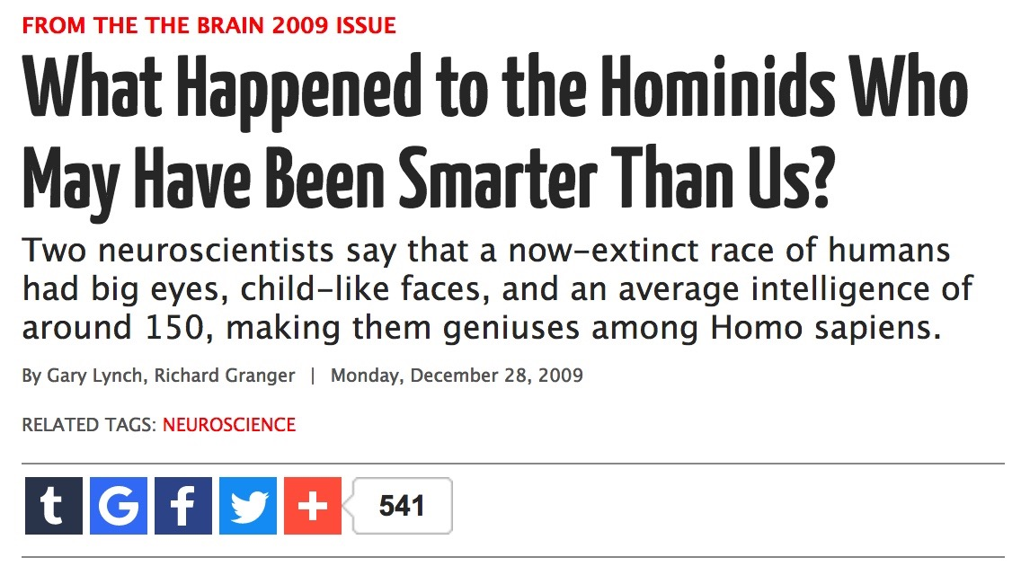

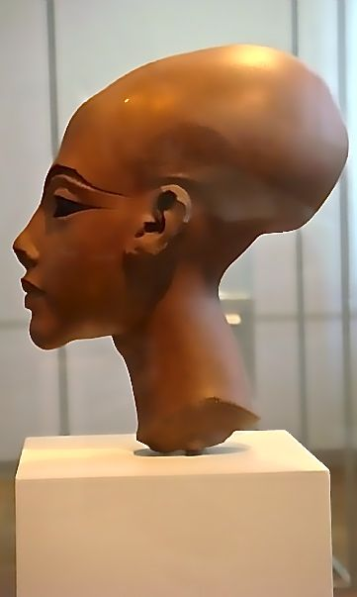

*Ancient Bust of Akenhaten and Nefertiti's Daughter, Meritaten, Showing Elongated Skull*

Discover Magazine did not say this was caused by head binding.

They very clearly and absolutely declared that this was an alternative human species, which was significantly more intelligent.

The only deficiency in their scholarship, compared to what insiders have told us, is that a small number of these people do still live on earth.

They are very secretive and keep to themselves. Their exact numbers are unknown, but there could be as many as 10 to 25,000.

That number is purely speculative. It is possible that there are even fewer of them than that here on the planet.

There are many more who believe they have a traceable genetic link to this forgotten race. This is the true nature of the Cabal.

Peterson revealed the Jesuits claim they have medical proof that they are comprised of "25 percent alien DNA."

**THERE MAY BE A WHOLE LOT OF HUMANS OUT THERE**

In light of the abundance of scientific evidence that this is a separate species of human, where might these people have come from?

One of the weirdest things we have been tracking is the idea that humans who look similar to us are far more widespread than just here on Earth.

If an alternative human species has held world power here for thousands of years, this might explain why "the authorities" have rigorously denounced the idea of ETs.

In a different world where we took it for granted that humans from various origins have come and gone, we might have discovered the secret of the Cabal a lot sooner.

Nonetheless, NASA has already announced there could be [as many as 40 billion watery, Earthlike planets in this galaxy alone.](https://www.cnet.com/news/the-milky-way-is-flush-with-habitable-planets-study-says/)

The truth is catching up with countless ancient records of human-looking ETs with advanced technology and consciousness skills contacting humanity.

**A KEY EXCERPT FROM "BIBLE REALITY CHECK" WEBSITE**

The Bible Reality Check site has done an amazing job of showing how ancient texts like the Bible have been mis-translated in certain cases.

[The last episode of my weekly Gaia show *Wisdom Teachings*covers this data. Monday's show will feature even more of this data.](http://www.gaia.com/wisdom)

You can see everything on the network for 99 cents in the first month, with no cancellation fees, before it goes up to a Netflix-type 9.99.

Your support of this work, through a [membership to Gaia with this code,](http://www.gaia.com/wisdom) provides us with vital financial support we need to keep fighting this war.

The production value of *Wisdom Teachings*has significantly increased since we rebooted it in August, which I am very happy about.

What I did not include in those episodes was this interesting quote, revealing an undeniable mass UFO sighting occurring in the time of Egypt:

<http://biblerealitycheck.com/WingsTreatise.htm>

[This is] an excerpt from Egypt's Annals of Thutmosis III, circa 1500 BC.

[It was] translated by Prince Boris de Rachewiltz from the original papyrus document found in the archives of the Egyptian Museum of the Vatican.

As in many other documents, the scribe was careful to record the exact date and time of day that the following event occurred:

“...In the year 22, of the third month of winter, sixth hour of the day, the scribes of the House of Life found that there was a **circle of fire coming from the sky...**

One rod long was its body and a rod wide, and it was noiseless.

And the hearts of the scribes became terrified and confused and they laid themselves flat on their bellies.

They reported to the Pharaoh...[and] after some days had gone by, **behold: these things became more numerous in the skies than ever.**

They shone more than the brightness of the sun and extended to the limits of the four supports of the heavens.

Dominating in the sky was the station of these fire circles. The army of Pharaoh looked on with him in their midst...

Thereupon these fire circles ascended higher in the sky towards the south...

What happened was ordered by the Pharaoh to be written in the annals of the House of Life... so that it be remembered forever.”

**INSIDERS BELIEVE THEY CRASH-LANDED IN ANTARTICA**

The apparent omnipresence of humanoid life is a mystery that has yet to be fully explained. Humans may have been seeded on multiple worlds long ago.

I have also given scientific support in my books for the idea that the genetic code is actually written into the laws of quantum mechanics itself -- universally.

We have been brainwashed by a decades-long, government-sponsored psychological operation to fear ridicule and shame if we are "believers."

Insiders have said that a particular, advanced human species did indeed crash-land here in Antarctica.

Apparently, the ruined craft and buildings are still there.

One really interesting aspect of all this is that there are three major craft, and two of them are apparently massive -- as in *miles long.*

Pete and other insiders have revealed these were full-on motherships, with many smaller craft in them that were fully operational.

Some of the smaller craft looked like various designs we see in ancient cultures -- including Tibetan stupas.



The smaller ships were all carted off to secret facilities like Wright-Patterson Air Force Base and put into storage.

They appear to be the same 'vimanas' that are so repeatedly discussed in the ancient Hindu scriptures as an everyday part of life -- at that time.

Just allow yourself to imagine that this was really true. This level of "buried treasure" is so awesome it is almost beyond our wildest imagination.

It greatly upsets me that this and so many other fascinating things have been kept completely secret from us.

Wouldn't you want to go and see this for yourself? I know I would. So have many others in the classified world. Antarctica is a very popular place on the inside.

In case you haven't seen it, [I went into far more interesting detail about this in *The Antarctic Atlantis,*which is a free video about 90 minutes long.](https://www.youtube.com/watch?v=HGcsfa-GyZk)

**DON'T FORGET ABOUT "THE ATLANTIS GENE"**

The best-selling book *The Atlantis Gene*may well have been influenced or sponsored by the Cabal. The contents are very similar to what we are talking about here.

The Cabal-driven mainstream media machine may well have been used to push the book to sell an astonishing one million copies.

Why would its "Mysterious" author take on the pseudonym "A. G. Riddle" -- as in the *Riddle of the Atlantis Gene?*

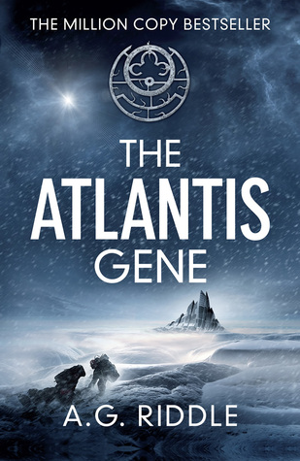

*The Atlantis Gene* is a story of a crash, discovered in Antarctica, that leads to the realization that some of humanity originated there.

Notice that the A's in the next image have the crossbars dimmed out, making them look like Masonic squares or compasses.

Notice also that the dots around the human figure again make a Templar-style cross (see next two images):

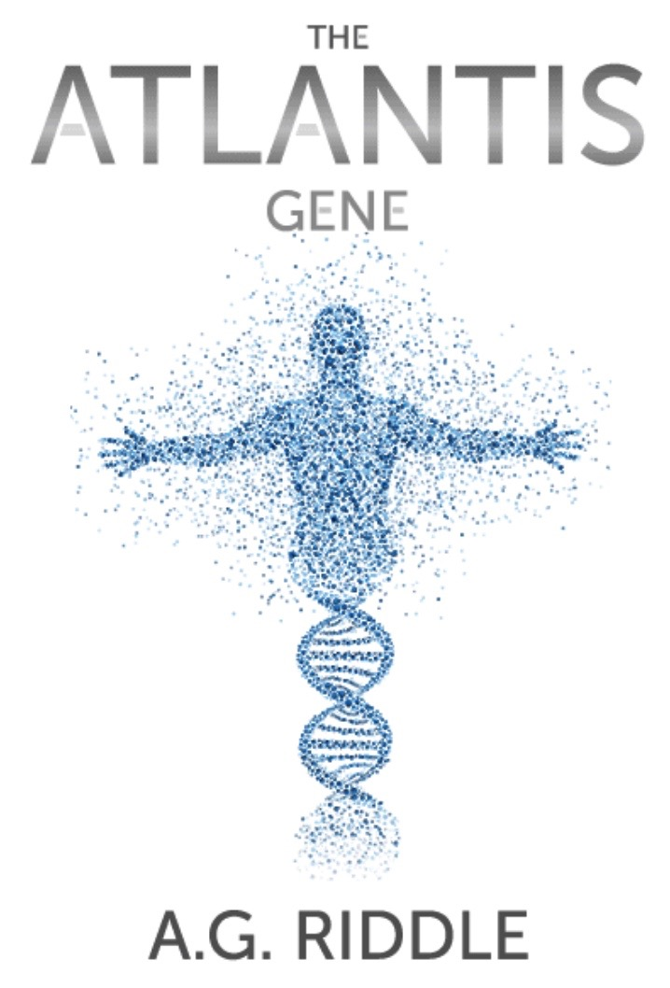

The symbol on the front cover of the book, detailed below, also has a part of the Templar "Rose Cross" in it -- another common Cabal sigil.

[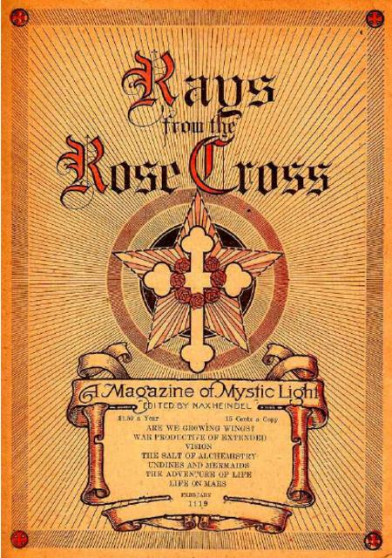](http://mattstone.blogs.com/photos/escoteric_icons/rays-of-the-rose-cross.html)

There are other encoded symbols in this sigil as well, including Templar crosses, the crescent moon, the eye-like dot in the circle, the Zodiac and five pairs of curly Baphomet-style horns:

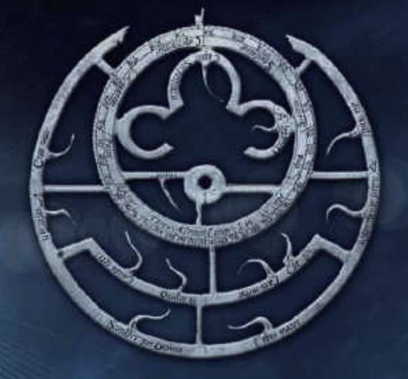

The large crescent itself, made by the outermost circle, could also be seen as a stylized pair of horns.

**CHECK OUT THE DESCRIPTION ON GOODREADS**

The secret society who initially appears to be the villain in this novel is called the*Immari.*

This has a more-than-passing similarity to the word *Illuminati,* which is the classic name this group has used for hundreds, if not thousands of years.

Some people who read the book are not happy about how it is written like a rushed treatment for a film -- which is indeed already being developed.

This writeup about the book from Goodreads should definitely get the wheels turning in your mind:

Goodreads on The Atlantis Gene

<https://www.goodreads.com/book/show/25843420-the-atlantis-gene>

The Immari are good at keeping secrets. For 2,000 years, [DW: Ever since the time of Christ,] they have hidden the truth about human evolution.

And they’ve searched for an ancient enemy — a threat that could wipe out the human race. Now the search is over.

**Off the coast of Antarctica, a research vessel has discovered a mysterious structure buried deep in an iceberg.**

**It’s been there for thousands of years, and it isn’t man made.**

The Immari think they know what it is, but they aren’t taking any chances. The time has come to execute their master plan: humanity must evolve or perish....

The Immari are close on [the heroes'] heels and will stop at nothing to find the Atlantis Gene and force the next stage of human evolution —

Even if it means killing 99.9% of the world’s population.

**THIS IS NOT SCIENCE FICTION**

I only heard about this book well after getting multiple briefings from different insiders about the secrets of Antarctica, and publishing all of it online.

There apparently was an ancient civilization that got shot down while trying to land their ship in this area. They did manage to survive, but the ship could not leave.

The smaller vimana-type ships were still able to come and go, and they ended up retro-engineering their crashed vessel into an emergency base.

The survivors cloned themselves with indigenous humans from various regions around the world to build a suitable population.

Some of these clones were giants and others remained at conventional heights.

The actual cloning facilities have now been located in various excavations, according to at least four different insiders.

In addition to giants and conventional-sized humans with elongated skulls, multiple types of human-animal chimeras were found as well.

All of this is in the process of being cleaned up, so that only the conventional-looking worker humans' bodies still remain.

It seems hard to believe, but apparently "They" really are planning on hitting us with all of this in the not-too-distant future.

**LOTS OF INTERSECTING TESTIMONY**

As strange as all of this may sound, multiple insiders I have spoken with have validated this account with remarkable precision and interconnectivity.

This included Pete Peterson personally validating his hands-on experience with these ruins -- in astonishing technical detail.

Pete was just one person involved in a very advanced scientific analysis of what must clearly be the most interesting site on earth.

Just weeks after Pete came forward with this intel on [*Cosmic Disclosure,*my other weekly show,](http://www.gaia.com/cosmic) almost everything he owned was stolen.

He survived a frightening attempt on his life before coming in for that same taping, and has insisted that we not reveal any details about it.

Honestly, it is amazing that he survived and was able to make that taping in the first place. He was angry enough to say a lot more than he ever had before.

[A fund is still underway to help him rebuild from the devastating loss of his worldly possessions. With your help he has been able to keep fighting.](https://www.gofundme.com/help-support-pete-peterson)

**UNDERGROUND ICE CAVES IN ANTARCTICA WITH LIFE**

As we have tracked in [*The Antarctic Atlantis,*](https://www.youtube.com/watch?v=HGcsfa-GyZk)now with over 1.1 million views, the Cabal has been planning a "Partial Disclosure" scenario.

This would feature the shocking discovery that ancient, megalithic stone ruins and human bodies have been found under the ice of Antarctica.

They intended to hold off on revealing the more advanced ruins for a longer time -- potentially even decades.

The hope was that an announcement of this nature could change the public's perception about them when they were on the verge of a massive defeat.

For years, insiders like Pete Peterson, the late William Tompkins and Corey Goode have told us there are habitable caverns under the ice.

Our intel was that natural volcanic activity was heating the glaciers and causing hollow caverns to form -- warm enough to walk around in a T-shirt.

This creates a wonderful haven for secret activity. German U-boats were the first to discover these amazing caves and ancient ruins in the 1930s.

Ever since they were first discovered, the whole area has been on lockdown. You can't go there. Covertly, vast teams of technicians are now working there.

Pete has also introduced me to another insider who has never come forward, and who also worked on analyzing the same, massive crash site.

**THE ANNOUNCEMENT HAS ALREADY BEEN MADE**

We were told that these caves, with temperatures sufficient to support life, would be revealed to the public before the artifacts were announced.

Stunningly, this exact announcement was made in the first week of September, by the Australian National University. Take a look:

Notice that at the very end, she says they hope to visit these caves and find "communities living beneath the ice in Antarctica."

9/8: Secret Life May Thrive in Warm Areas Under Antarctica's Glaciers

<http://www.anu.edu.au/news/all-news/secret-life-may-thrive-in-warm-caves-under-antarctica%E2%80%99s-glaciers>

"It can be really warm inside the caves - up to 25 degrees Celsius in some caves.

**You could wear a t-shirt in there and be pretty comfortable.**

There's light near the cave mouths, and light filters deeper into some caves where the overlying ice is thin."

Dr Fraser said most of the DNA found in the caves on Mount Erebus was similar to DNA from plants and animals - including mosses, algae and invertebrates - found elsewhere in Antarctica, but **not all sequences could be fully identified.**

"The results from this study give us a tantalising glimpse of what might live beneath the ice in Antarctica - **there might even be new species of animals and plants,"** she said....

Co-researcher Professor Craig Cary, from the University of Waikato in New Zealand, said previous research had found that diverse bacterial and fungal communities lived in Antartica's volcanic caves.

"The findings from this new study suggest there might be higher plants and animals as well," Professor Cary said.

**WHY WOULD WE BE RIGHT ABOUT THIS?**

I have to admit that this "sanctioned release" of information -- from a mainstream Australian university, no less -- was dazzling.

This is the first chance I've had to write about it. The above video only has 276 views at this time. It will soon be in the many tens of thousands, if not more.

We were told last December that the Cabal intended to release this exact information once they were really in trouble.

They knew they would need a huge distraction to divert the public's focus once they knew they were very close to a full exposure and defeat.

Any event this massive in scope can be very distracting -- to the point that no one will even think about whatever seemed so important before.

This type of "reveal" also puts people into a traumatized state, where they suddenly have to change everything they thought they had believed to be true.

Other insiders revealed the Cabal intended the discovery of these ruins to help trigger religious wars.

Evidence may have been planted that could lead to alternative interpretations of religion, which could be manipulated with ["false flags"](https://divinecosmos.com/start-here/davids-blog/1220-vegas-meta-analysis) to incite violence.

**HOW COULD THIS DISCOVERY CREATE MORE WARS?**

Let's say the world is shocked to see multiple ancient ruins with engraved Cabal symbols we are well familiar with -- such as the All-Seeing Eye.

Think about how all major religions are no more than about 2500 years old, tops, except for the alleged (and disputed) antiquity of Hinduism.

If we now find out that the symbols of the Cabal appear redundantly in 12,500-year-old ruins, that means they were here first.

This now becomes the oldest surviving religious tradition on earth -- and makes it far more interesting to everyone.

The idea of Atlantis instantly elevates from an interesting myth to an established, proven fact no one could ever deny.

Books like *The Atlantis Gene*may have been deliberately planted, in advance, to create movies that will orchestrate how we think about this.

This epic announcement, they hope, could help set up the idea that they are blood descendants of a more advanced race -- and therefore are gods.

**WONDER WOMAN WAS ANOTHER EXAMPLE OF SETTING THE STAGE**

The Marvel superhero franchise has been loaded with positive intel from the Alliance since at least 2013, as we will again discuss.

The DC franchise run by Warner Brothers, on the other hand, has been bursting at the seams with Cabal propaganda.

The Wonder Woman character was first introduced in *Batman vs. Superman,*which was disturbing and did not do well at the box office at all.

The strategy was modified, and thefilm *Wonder Woman*was a much more conventional and far more inspiring hero's journey story.

Despite this being a predominantly positive film, the Cabal still had to put their signatures into it.

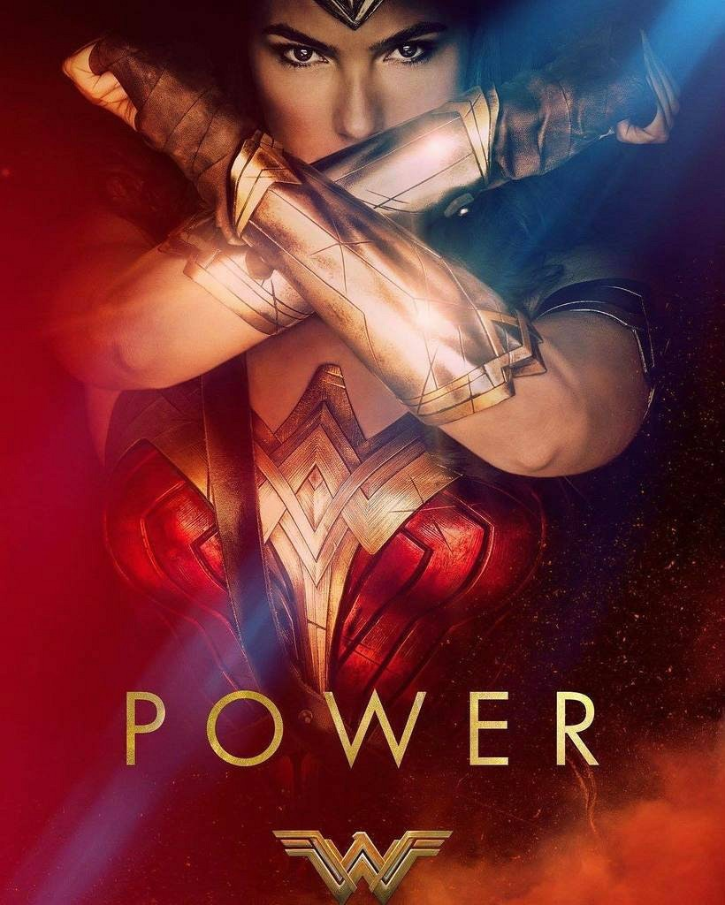

Notice the prevalence of Cabal symbols at the beginning of *Wonder Woman.*I was able to identify multiple examples just in the first few minutes.

The symbols on her headdress, breastplate and logo are all comprised of the Masonic square and compass.

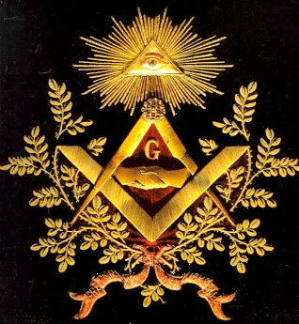

The eagle in the logo is also a Cabal symbol associated with the phoenix. It can be drawn with one or two heads.



This same ancient design appears as the United States mascot and the more stylized Nazi "Iron Eagle" as well.



This Wonder Woman logo also cleverly encodes the number 33, sideways:



The female goddesses in the movie were placed on a secret, cloaked island by Zeus, and all of them have super-powers.

Wonder Woman is the only one who actually leaves.



Most of the movie is free of this symbolism, and was obviously written by a non-Cabal screenwriter -- but they still planted multiple symbols in the beginning.

In the full context, this film could have been intended to seed those symbols in the subconscious and associate them with Godlike powers.

The real, everyday members of the Cabal have no such powers. Nor are they shapeshifters, reptilians or anything of the sort. They are fully human.

They believe they lost these powers, thanks to the meddling of an evil god -- and hope to regain them once more in the future.

This is their own unique spin on the idea of Ascension.

In their religion they believe they will be the only ones to become "Illuminated" when an anticipated solar mega-flash event occurs, as I have often discussed.

Almost every episode of [*Wisdom Teachings*](http://www.gaia.com/wisdom)since the August reboot features detailed intel on different ancient prophecies of this solar flash.

**THEY DEFINITELY HAVE A DIFFERENT RELIGION**

These people have apparently remained undercover for their own safety, even while coordinating the launch of their anticipated "New World Order."

One group with the elongated skulls survived the loss of their central homeland by living in the Americas for thousands of years.

Others prospered in Europe and Asia.

They only reconnected in the modern maritime era -- 1500s and on. There were initial power struggles before they formed an "operating agreement."

Apparently, the American and Eurasian factions of these people still have some pretty strong disagreements about certain things.

Both groups possessed secret documents and artifacts that allowed them to trace their common heritage back to "Atlantis" -- once they reunified.

The Vatican is one of the only places where anyone with an elongated skull could walk around freely, thanks to the dress code of the miter hats they wear.

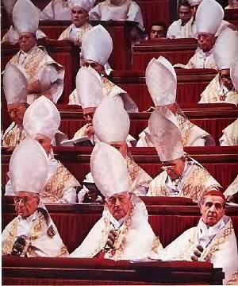

Various groups have exposed and tortured these people, including early Christians, since they have often treated us as little better than animals.

This persecution is one of the reasons they still practice a secret, alternative religion in which Lucifer is seen as good and the God most believe in is evil.

**THE FALLEN ANGELS**

Lucifer is described in conventional Bible scripture as the brightest among God's angels. The word "angel" is from the Greek *aggelos,*meaning "Messenger."

These people historically would appear among humans on earth, bearing messages -- including the tools to help establish intelligent civilization.

Lucifer questioned 'God,' organized a rebellion with other angels who felt the same way, and all of them were cast out of 'Heaven.'

Think about what this really means after you [see last week's episode of *Wisdom Teachings*on ETs in the Old Testament.](http://www.gaia.com/wisdom)

According to Bible Reality Check, "God" is originally plural and means "The Mighty Ones," and "Heaven" means "outer space" in any other text from the same period.

**LUCIFER IS NOT A MYTH IN THIS CULT**

The Cabal members really do believe that they are the descendents of the "fallen angels" that appear in the Book of Enoch.

They see Lucifer as a very tangible, flesh-and-blood being -- the leader of a small group of survivors who crash-landed in Antarctica.

The Book of Enoch was redacted from the Bible due to how much it exposes this group, but it is as valuable as the book of Genesis.

Enoch describes a race of giants who originate as "fallen angels", cannibalize humans, and are destroyed in a great flood by the Elohim for their wickedness.

With all the information we now possess, this appears to be an entirely factual account of our own suppressed ancient world history.

This is discussed in much more detail, with extensive academic references, in my latest book *The Ascension Mysteries.*

The Cabal members see themselves as direct descendants these of ETs who fell to Earth and crash-landed, losing the ability to escape.



Notice that the pilot who discovers the gorgeous "island of the gods" at the beginning of *Wonder Woman* crash-lands there in a flying craft.

This may have been another not-so-subtle nod to the Cabal's secret tradition of beliefs.

The island of goddesses has multiple Atlantis-type characteristics -- and the Cabal believes Atlantis was in Antarctica.

[There is extensive scientific evidence that the Antarctic continent was once free of ice, as I discuss in *The Antarctic Atlantis*video.](https://www.youtube.com/watch?v=HGcsfa-GyZk)

**GNOSTIC TEXTS HAVE SOME OF THEIR PHILOSOPHY**

[As we said in the previous article,](https://divinecosmos.com/start-here/davids-blog/1220-vegas-meta-analysis) the closest articulation of this Lucifer-friendly philosophy in the open world appears in Gnostic texts -- from the Nag Hammadi scrolls.

The surviving Cabal members believe the Elohim who created the disaster that shifted the Earth's axis, flooding and freezing Antarctica, had to be evil.

They then felt that the monotheistic Abrahamic religions -- Judaism, Christianity and Islam -- all represented the entrapments of this evil god.

In this view, the Universe and the Earth is said to be created by an evil "Demiurge." Everyone is hopelessly trapped until they awaken from the "spell."

The God most of humanity believes in is, to them, a wannabe impostor.

The moral and ethical codes in the monotheistic religions are believed to be keeping us enslaved, like animals in a paddock.

They also believe the "serpent in the garden of Eden" is doing its best to free us from this "monster" by giving us "the knowledge of good and evil."

**WHAT IN THE HELL....**

This seems very strange to most people. Who in the world could possibly want to support Lucifer?

However, once you understand how seriously they believe this, countless thousands of mysteries are explained.

This group has been very aggressively pushing Lucifer in our faces for some time through mass media.

They keep getting more and more audacious about it.

Religious freedom should be encouraged. If you are not hurting anyone, you can create whatever belief system you want -- and go for it.

However, once we find out that this group practices torture, rape, pedophilia and murder in ritual forms, something must be done.

**AMERICAN ELITE PEDOPHILIA MAY BE ON THE VERGE OF PUBLIC EXPOSURE**

It is an established fact that pedophilia has occurred in the Vatican and in various Catholic churches on an epidemic scale.

What is still not commonly accepted -- yet -- is that this same practice has widely occurred in the US government and in Hollywood.

The Weinstein scandal has gotten us very close to the edge of this story breaking out in a big way.

Various mainstream articles are already starting to link Weinstein's crimes to a much greater and uglier conspiracy involving pedophilia.

I did not want to be out there talking about any of this, but I know enough about it that I feel an honor and duty to inform anyone who will listen.

**IT IS NOT EASY TO ACCEPT THE TRUTH**

The biggest problem in writing about all of this is that it is so "outside the box" of mainstream, consensus thought.

Everyone knows "the government" is corrupt, but no one wants to imagine a vast, interconnecting conspiracy of this scope and magnitude.

Even if that can be accepted, it becomes much more difficult to see that these people actually do practice their own version of Luciferianism.

Yet another leap of faith must be made to consider that they could be blood descendants of humans with elongated skulls whose remains appear worldwide.

It takes even more effort to see that these people might have crash-landed here from somewhere else, and their ruins have been studied since at least the 1950s.

**WE MAY BE TOO INTIMIDATED TO CONNECT THE DOTS**

Obviously, if all these things enter into the realm of established, proven facts, we will be looking at a world that is vastly different than the one we know today.

We end up having a mega-story woven through the fabric of our lives -- a story that reads like an epic sci-fi fantasy thriller.

Once you work in the more sinister aspects of what is going on, the whole thing becomes much more like a horror movie.

Nonetheless, if you can step away from the apparent fear of ridicule and social ostracism, and consider the evidence, it keeps appearing again and again.

Ultimately you realize that the answers have been staring us in the face the entire time.

Most of us simply felt too intimidated to connect the dots.

Since the Cabal did intend to formally reveal itself, create a New World Order and be worshipped by force, they have conducted a profound marketing campaign.

**BLADE RUNNER 2049 IS JUST THE LATEST**

Derek, a commenter on our previous article, just saw the new *Blade Runner 2049*film. This same religious message is being pushed on us once again.

Jared Leto appears with a familiar-looking beard and brown hair:

[#237](https://divinecosmos.com/index.php/start-here/davids-blog/1220-vegas-meta-analysis#comment-145925) Derek 2017-10-19 05:09

I just got back from seeing the new Blade Runner movie. Anybody see this?  
  
Man....the arch-evil bad guy looks just like Jesus, makes all these biblical statements, and talks about how he "lives in heaven" and "creates angels" including "bad ones" that aren't there anymore.

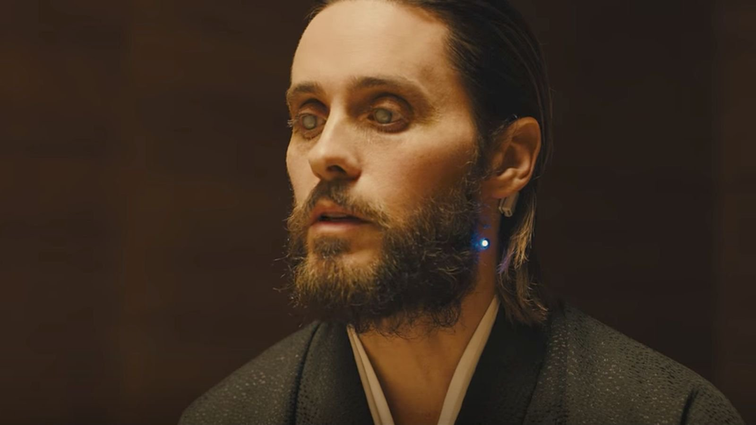

They are just getting more and more blatant with their luciferian garbage.  
  
[Moderator: Another example of how the Cabal's religion sees the God most of us believe in as an evil "Demiurge" and routinely puts this into movies.]

Notice how Jared Leto's eyes appear as if he is blind.

This is a not-so-subtle clue that they see Jesus as blind to the true "enlightenment" they possess -- a robot mind-controlled by the Demiurge.

**LET'S NOT FORGET "MALEFICENT"**

One of the most aggressive Cabal propaganda films in the recent past was Walt Disney's *Maleficent.*

For months, Angelina Jolie stared at us with devil horns and wings from billboards that were just about everywhere.

It goes without saying that Angelina had long been one of our society's most beloved celebrities, and had already largely withdrawn from the public eye when this film emerged.

Since theoretically she could take on any role she wanted, and was apparently trying to get out of the business, it was very strange that this would be her final big-studio tentpole film.

She is presented as a sympathetic character. Adults and their children are expected to emotionally bond with and root for her as the film goes on.

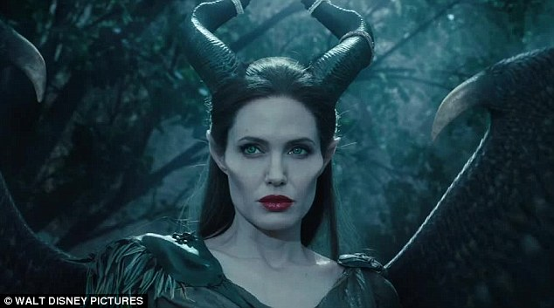

At the end of the film, she kills her adversary King Stefan, who has undeniable similarity to Jesus, minus the battle armor:

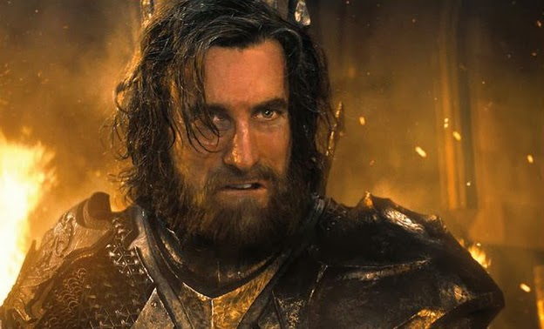

Stefan had cut off her wings earlier in the film. Angelina indicated in interviews that this was meant to symbolize rape.

The Cabal people do feel that their organization has been raped by representatives of the Demiurge and their angels, which they see as evil 'Archons.'

Much more can be written on this, and it is only one of hundreds of examples in popular films.

**THIS GROUP CALLS THEMSELVES "THE ILLUMINATI" -- AND OCCASIONALLY PLANTS DIRECT MESSAGES**

A great deal of psychological operations have been conducted to create shame and humiliation around any use of the term *Illuminati*to describe this group.

Nonetheless, this is one of the names they use.

One of the most compelling new pieces of evidence I found this year appears in a children's Disney cartoon from the 1980s, entitled *Duck Tales.*

I often watched it myself at the time, but had no idea they were implanting subconscious subliminals about the Illuminati -- by name -- into the show.

The key scene involves Scrooge Mc Duck, shirtless and nearly naked, being inspected by a doctor -- who is literally a pig, complete with the nose.

Scrooge is a wealthy tycoon who has so much gold that he swims around in his "Money Bin", which is filled with it.

In this critical scene, the pig-like doctor tries to tell the shirtless, vulnerable Scrooge that he is not wealthy or elite -- he is making it all up.

Scrooge stridently defends himself and his wealth, and ultimately storms out of the office.

**HERE IS THE KICKER**

As this scene plays out in a clip posted by various independent media outlets, we see a stylized eye chart on the wall.

The exact letters on this chart change in subtle ways as it keeps re-appearing.

The Cabal's research shows that this is a form of hypnosis. Readable words are stored in the subconscious, which understands what it is seeing.

The full message is only revealed through multiple viewings of the same chart -- as the subconscious adds it all up.

The message is also slightly veiled by deliberately misspelling some of the words. The subconscious still knows what the words mean.

The full message, without any misspellings, reads as: ASK ABOUT ILLUMINATI YOUNG BOYS.

[The first three words of the message were exposed in an excellent article on Collective Evolution from 2013, by Arjun Walia.](http://www.collective-evolution.com/2013/03/25/disneys-ducktales-exposed-ask-about-illuminati/)

See how much of it you can pick out at normal viewing speed when you watch the video -- for however long it lasts:

[I highly recommend visiting this link and downloading the video right away,](http://www.collective-evolution.com/2013/03/25/disneys-ducktales-exposed-ask-about-illuminati/) as it probably will be gone within hours otherwise.

Now that you've watched it at real-time speed, let's break this down, second by second from the video, with images.

**FRAME BY FRAME**

The first frame we see is at 0:01 in the clip. At this point we see A  SKA  BOUT  ILLUM clearly. The INATI is also visible, but less so:



This still image features a higher-resolution capture from the same moment, showing part of the message.

We also see another Disney kids' show in which "The Illuminati" is written on the chalkboard in cursive:

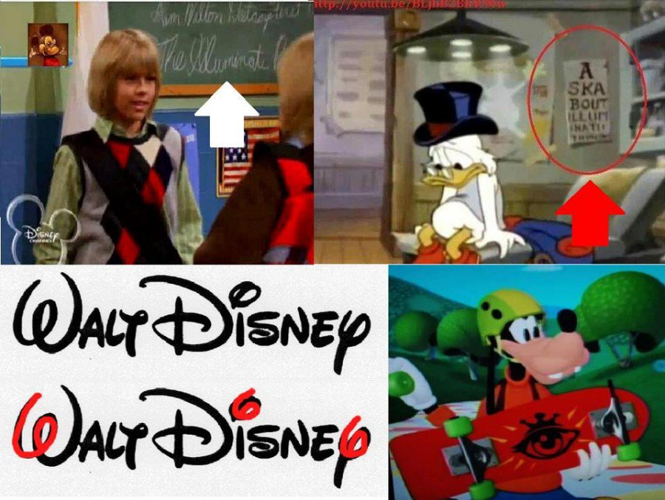

**THE MESSAGE RE-APPEARS AT 0:15**

The next time we see the eye chart, at 0:15 it has changed. The word "ABOUT" has been removed.

It now says A  SKA  ILLUM  INTAM  YOUG  BOYS:

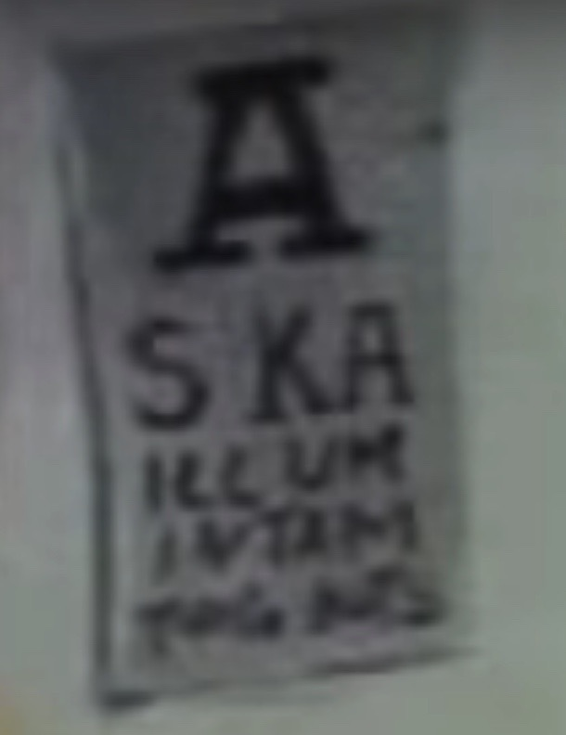

It is hard to capture YOUG BOYS precisely in a single image, but when you watch the video you can easily see it.

**IT RE-APPEARS AT 30 SECONDS**

At the 30-second mark, the chart appears with the same wording as before, slightly out of frame.

The word BOYS is now very easily visible for the subconscious minds of the viewers to capture:

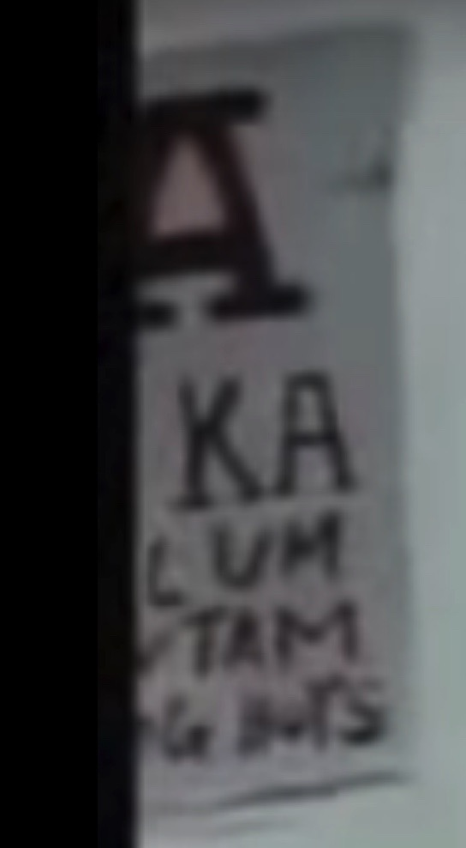

**NEXT VISIBILITY AT 1:03-06**

The chart repeatedly appears for a full three seconds at the end of the clip, from 1:03 to 1:06.

Now it says,  A  SKA  BOUT  ILLAUM  INATI !   YAUG  BOYS

Again, the misspellings are deliberate, as the subconscious still reads it but there is some degree of "plausible deniability" if this was ever discovered.

The pig-doctor's head pops over the image at times, again playing hide-and-seek and preventing it from being constantly visible to the conscious mind.

Take a look:

1:03

1:05

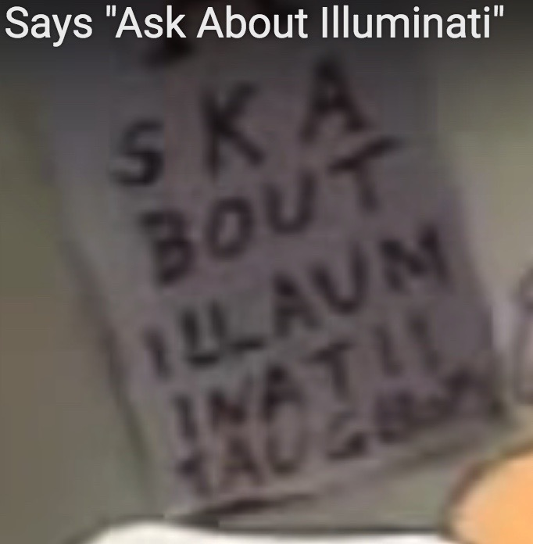

1:06

**COLLECTIVE EVOLUTION ALSO MAKES ANOTHER GOOD POINT...**

Arjun Walia, writing for Collective Evolution, also asks us to look at the primary shareholder for the Disney mega-media conglomerate.

It is none other than Fidelity Investments. They have a very (ahem) interesting logo in light of everything we are talking about:



Less obvious is the encoded Masonic square that you see where the T and the Y are joined together.

The crossing of the T and the Y forms the square, and the Y itself then forms the compass.

**WHAT IS THE NAME OF DISNEYLAND'S SECRET CLUB?**

This becomes even more interesting once we discover the name of a "secret club" that exists at Disneyland.

The club is very expensive to get into -- automatically ruling out everyone but the elite.

It has disturbing "haunted house" type of things in it, including framed pictures that change as you look at them.

Other aspects of it are clearly designed to impress children. After all, it's right in the middle of a children's theme park.

The name of the organization is -- get this -- Club 33.

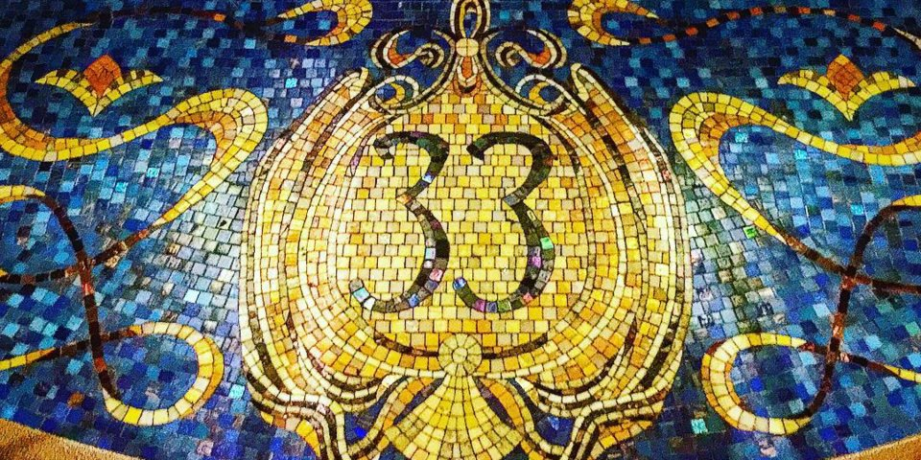

7/2016: What's It Like Inside the Secret, Members-Only Club Hidden in Disneyland

<http://www.thisisinsider.com/disneyland-exclusive-club-33-disney-2016-6>

If you're looking for the ultimate exclusive Disney experience, visiting Club 33 in Disneyland is it.

Located in the center of New Orleans Square, now at 33 Orleans Street, the club is a members-only dining experience....

The club was originally designed as a place for Walt Disney to entertain guests and business associates, but he died about five months before it was officially opened.

The **invite-only membership** has a waitlist that has been opened and closed over the years due to high demand.

According to one Club 33 member, **there is a $25,000 to $100,000 initiation fee and $12,500 to $30,000 annual fee, depending on the level of membership.**

The whole experience is super secretive, but one Club 33 member, [who runs an Instagram account dedicated to photos of the exclusive experience](https://www.instagram.com/disneyland33member/), shared some pictures with us....



This is only one of many images that have been posted. Notice the Masonc pillars on either side of the center of the bar.

We have no way of knowing if anything negative is going on in here.

However, insiders like our 4Chan informant have said there are indeed restaurants where you can choose children to have sex with from a menu.

[Cue the feverish teams scrubbing down Club 33 to [eliminate any 'maps' before the feds arrive.](https://divinecosmos.com/index.php/start-here/davids-blog/1208-endgame-pt-1)]

**WHAT MIGHT HAPPEN...**

Corey Feldman, Elijah Wood and other celebrities have said Hollywood's biggest problem is, and always has been, pedophilia.

Why would the creators of this Disney cartoon want "young boys" to "Ask About Illuminati!"

Who would be in a position to be able to answer that question in the 1980s?

What might happen to a young boy who walked up to someone "in the know" and said "Hey, mister, what is the Illuminati?"

Could such an event possibly reveal that they have found an easily hypnotizable subject?

SInce it is embedded in a Disney cartoon, what would happen if the child was at a particular theme park?

**TRAINING FILMS**

Insiders like [Svali](https://svalispeaks.wordpress.com/) and [Fritz Springmeier](https://archive.org/stream/BloodlinesOfTheIlluminatiByFritzSpringmeier/Bloodlines%20of%20the%20Illuminati%20-%20By%20Fritz%20Springmeier_djvu.txt) have revealed that some Disney films have been used as "training films" for mind-control purposes.

They may not sell very well, or even be that understandable to audiences -- but they serve a deeper agenda.

The subject will watch the film under the influence of psychedelic drugs. Electroshock trauma will be used at key points, synchronized with events in the movie.

The final element is a "trainer" who implants the key hypnotic suggestions to the subject as these scenes play out.

They will have a script that tells them exactly what to say, minute by minute, as the movie goes by -- to maximize the intended effects.

[Fritz Springmeier did a brilliant analysis of how this works in the movie Fantasia, and this site lays it all out for you with extensive images.](https://illuminatimovies.net/fantasia/)

Go take a look and save it while you can. Anything I point out to our hundreds of thousands of readers tends to quickly disappear.

I get that this is very disturbing. It may be more comfortable for you right now to think this is BS. Just hold onto this for later if that is the case.

**THERE IS NO DENYING IT**

The religious Luciferian message is so repeatedly encoded in Hollywood films that the "burden of proof" has been satisfied beyond all doubt.

Now with the Weinstein disclosure, we are seeing the sick behavior of the people who would participate in a cult like this, and use movies as propaganda.

The main thing we need to do now that all of this is breaking open is to fearlessly look at the truth on a collective level.

This involves facing our darkest fears and [dealing with a reality that is very unpleasant, but nonetheless a fact.](https://www.divinecosmos.com/index.php/start-here/davids-blog/1023-financial-tyranny)

It ultimately doesn't matter how or why this group got to be where it is today.

You don't have to believe they are the descendants of people with elongated skulls -- even though they absolutely do, at the higher levels.

The simple fact is that we need to wake up and help inform others if this problem is ever going to stop.

**LET'S NOT RUSH TO CONDEMN**

The leaders of this group really do want to kill as many of us as possible, making Hitler's crimes seem like little more than an opening band before the headliner.

However, according to top whistleblower Svali, [the majority of Cabal members would love to break free if they could get out alive.](https://www.henrymakow.com/141002.html)

Svali debuted in alternative media as of 2002 [thanks to this article from Henry Makow,](http://www.henrymakow.com/141002.html) after I personally turned him on to the story and sent a variety of links.

It had bothered me that for months at a time, not one journalist in this field would even mention the term "Illuminati" or connect the bigger dots together.

It would take years before I would be willing to personally step forward on my own and begin covering these same subjects.

A full disclosure event would apparently include revelations that multiple human groups have seeded their DNA into modern Earth humans.

For that same reason, it would be inappropriate to see the Cabal as "aliens" that are somehow different from the rest of us, and dangerous.

All of us are hybridized mixtures of different groups. Cabal members are not gods and do not possess any unique super-powers.

They are simply members of an intergenerational religious cult that sought world power without letting us know exactly who and what they are.

**IT IS IMPORTANT TO KNOW THAT THE CABAL IS BEING OPPOSED**

The group we are calling the Alliance is a series of different international factions who have agreed to work together for a common purpose.

Some of the key factions include elements that have now become a majority of the US military and intelligence community.

The Cabal still has a stranglehold on the mainstream media, and thinks nothing of killing anyone who stands in its way.

*"Well, then, David, why are you still here?"*

The answer is simple and profound. The Cabal must follow a system of immutable spiritual laws that they call "The Rules."

The main rule that concerns truth-tellers is: *You are not allowed to shoot the Red Cross workers.*

This means as long as you uphold a positive, service-to-others perspective in your life, you will not "authorize" them to take you out.

**I DON'T INTEND FOR THEM TO "AUTHORIZE" ANYTHING**

I have been made aware of many plans and efforts against me. One of the most recent ones was apparently code-named "Snow White."

It was certainly suspicious when the brakes went out in my car as of August 11th, 2017, but I am still here.

They work very diligently on someone like myself to try to offer temptations that would create sufficient karma to authorize a physical death.

For that same reason, as I have said, doing this work is akin to being an Olympic athlete in the spiritual sense -- and if you cannot compete, you're dead.

With all that being said, it is important to stay light-hearted and maintain your sense of humor.

The biggest danger you face in researching this type of darkness is from inadvertently welcoming more of it into your psyche.

If you find yourself becoming angry, irritable, jealous, vindictive, depressed, fearful, anxious, saddened, et cetera, then you need to take a break.

We have gotten along all this time right while these people have been walking among us. And now they are being very successfully opposed.

**SPIDER MAN: HOMECOMING IS THE LATEST ALLIANCE FILM**

The US military aspect of the Alliance has been using big-budget Hollywood films to counteract the Cabal's message.

I imagine there are a variety of examples that go well back in time, and the truth should be very interesting once it is revealed.

Older examples would certainly include *Eyes Wide Shut*(1999), *The Skulls*(2000), *The Manchurian Candidate*(2004), and *John Carter*(2012).

The same production value and intent that made its way into *John Carter*finally started reaching huge audiences with *Ironman 3*(2013) and *Captain America: The Winter Soldier*(2014).

These films are [incredibly blatant expose's of the Cabal -- vastly beyond any possibility of this being unintentional. Read our critical data on this subject here.](https://divinecosmos.com/start-here/davids-blog/1170-cabal-defeat?showall=&limitstart=)

In fact, the entire Marvel superhero franchise seems to have become Alliance-driven since the debut of *Ironman 3.*

The only exception has been the X-Men franchise, which stands in stark contrast as it is absolutely loaded with Cabal themes, symbols and philosophies.

The Alliance side was again demonstrated clearly in *Spider Man: Homecoming,*which you can now rent at home.



**LET'S HAVE A FEW EXAMPLES**

I only recently became aware from insiders that "smart suits" like we see with the Ironman character are indeed very real.

I know three people who claim to have used them, and their matter-of-fact statements about how cool it was were very believable.

They can regulate your body temperature, help you jump 20-30 feet at a time, move heavy objects, protect you from falls and injuries, give you a heads-up display, et cetera.

This is another example of technology that was apparently reverse-engineered from various ET crashes, perhaps as far back as Roswell.

A possible initial "leak" about some of the technology in these suits came in May: [*New Ultra-Lightweight "Fluid Armor" Can Stop a .44 Bullet.*](https://futurism.com/new-ultra-lightweight-fluid-armor-can-stop-a-44-magnum-bullet/)

*Spider Man: Homecoming*features a Peter Parker whose innate talents are enhanced by a "smart suit" that he gets from Tony Stark, the Ironman character.

In light of these recent disclosures I have gotten on smart suits, this aspect of the movie made a lot more sense to me.

**THE VILLAIN IS VERY KEY**

Michael Keaton's villain in the new Spider-Man film is a direct, symbolic reference to the Cabal.

Extraterrestrial wreckage crashed in *The Avengers*. We have a man who retrieves a power cell and other technology from it, and steals it for personal use*.*

This is similar to how the military-industrial complex came into possession of technology in the Roswell crash and reverse-engineered it.

The villain ultimately uses this alien tech to build himself into a "fallen angel," complete with wings that allow him to fly thanks to mechanical propellers.

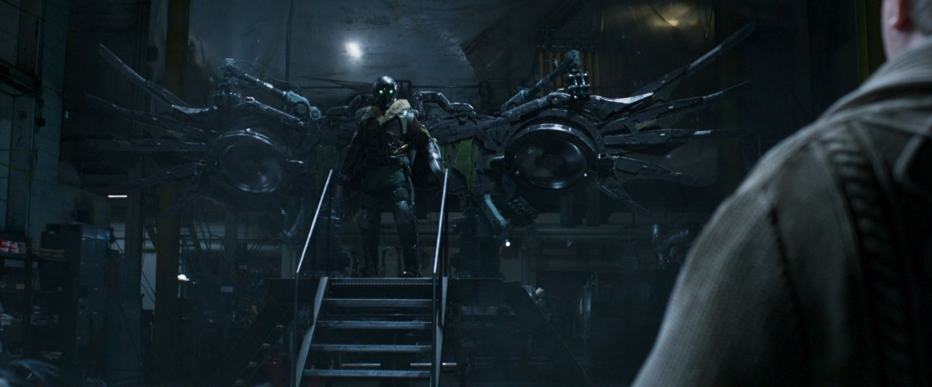

This character is called "The Vulture," and is apparently seen as too small-time for the other Avengers to bother with.

As a plot device, this obviously puts the focus on Spider-Man as the person who recognizes the threat others do not, and decides to deal with it.

Already we are seeing key elements of the Alliance message here in the structuring of this villain.

The Cabal has been feeding on us like vultures. They believe themselves to be the "Fallen Angels."

They have covertly captured extraterrestrial technology and used it to build themselves into fearsome adversaries.

**AN AMAZING DEMONSTRATION OF "MASKING"**

However, with the intel I personally have gained from Peterson, what surprised me the most about this film was the epic airplane scene.

Spider-Man ends up taking a ride on a military aircraft that uses back-projection technology to cloak itself from view.

As the plane flies along, we see apparent clouds appearing and gliding along it as it moves.

This is not as easy to see from a still image as it is when you actually watch the movie. The cloud images glide right along the body of the jet.

Many small tiles create this effect, and as the plane starts to crash, the tiles malfunction, causing it to decloak.

Given the briefings I have had, I could hardly believe it as I watched this part of the movie.

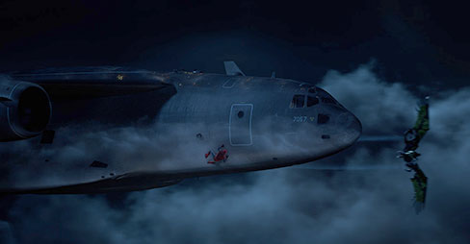

**MINOR SPOILER ALERT....**

If you prefer to see a film without any spoilers, skip this paragraph and come back once you have actually seen the movie.

One big twist in this film is that Spider Man's girlfriend ends up being the daughter of the villain.

This creates an interesting psychological dynamic between the hero and the villain.

It also leads to a final scene in which the villain refuses to betray Spider-Man's identity to a group of sinister individuals who would gladly kill him.

To me, this was a clear sign of the Alliance speaking to Cabal members, saying we are all part of the same human family.

Ultimately, even if your DNA is somewhat different, everyone deserves peace, freedom and respect.

We can learn to get along with one another instead of playing "My God is better than your God" and fighting to the death over different belief systems.

Genocide is a horrific and ridiculous crime that is absolutely unacceptable in any form.

Hundreds of thousands of people who have supported the Cabal in various ways have already defected over to the Alliance and are fighting for all of us.