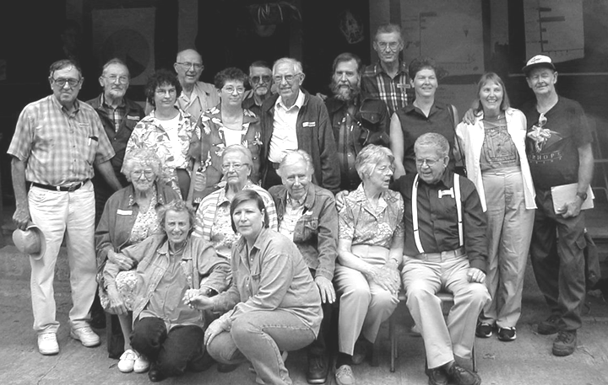
1952 - Eston Rockwell, Hubert Mendenhall, Lawrence and Donny Osborn, Wolf Guindon, Betty (Starbuck) Osborn, Lucky (Standing) Guindon, Ted Harkey, Teddy Harkey, Cecil Rockwell, Leonard Rockwell, Marvin Rockwell, Roy Butgereit, Howard Rockwell Sr., Howard Rockwell Jr., Emily Rockwell, Mary (Chamness) Rockwell, Ruth Mendenhall, Mildred (Mott) Mendenhall, Clara (Hall) Rockwell, ?, Ellen Rockwell, Dorothy Rockwell, Alberto Guindon, ?, Irma (Stanley) Rockwell, Janice (Stetzel) Harkey, Doris Rockwell, Elwood Mendenhall, Ruth (Rockwell) Mendenhall, Abner Rockwell, Doris (Stetzel) Campbell, John Rockwell, Mary Mendenhall, Phillip Mendenhall, Celia Rockwell, Paul Rockwell, Floyd Rockwell, Carol Mendenhall, Jeanette Rockwell, Ruthie Campbell, George Campbell
2001 - Roy Butgereit, Howard Rockwell, Celia (Rockwell) Geesaman, Cecil Rockwell, Kathryn (Rockwell) Hamer, Leonard Rockwell, Marvin Rockwell, George Campbell, John Rockwell, Ruth (Mendenhall) Rojas, Lucky (Standing) Guindon, Wolf Guindon, Dorothy Rockwell, Mary (Chamness) Rockwell, Doris (Stetzel) Campbell, Ruth (Campbell) Beeche, Warren Stetzel, Mildred (Mott) Mendenhall, Ted Harkey

