Monteverde Jubilee

Family Album
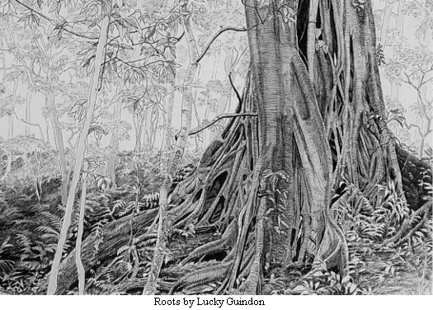
April 19, 1951
April 19, 2001
50 years growing and spreading our roots

