CHAPTER XVIII
Those Who Came, Sojourned and Departed

ELWOOD MENDENHALL
From letter by Lucky Guindon
June 24, 1958
This morning EIwood passed away and the funeral was this afternoon. It poured but a good many came to the funeral (at their house) and the cemetery. There were almost more Ticos than ourselves attending— He will be greatly missed.
++++++++++++++++++++++++++++++++++++++++

MARY K. ANDREWS
- by John Campbell
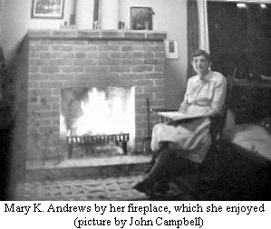
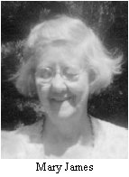
In memory of Mary K. Andrews. She left us in the springtime a few weeks before her 87th birthday—the anniversary she shared with "Julius".
For 17 years she enriched the life of the community with her youthful mind and wide ranging interests. Her sense of humor and abiding faith in the power of the universal spirit buoyed her through a life which contained more than its shares of sorrows and disappointments. Human enough to become upset by injustices, she never let herself become embittered.
She enjoyed visiting with people of all ages, perhaps sharing her remarkably clear memories of interesting events, or thoughts or passages from her voluminous reading, and, of course, inquiring "What do you know today?"
Art and nature's wonders were among her particular joys. Though always open, her mind was nevertheless very much her own.
She was a regular attender and frequent contributor in Meetings. In her writing, she frequently resorted to poetry when deeply moved. No one who was on the Family Album Committee she chaired will ever forget the fun we had assembling that edition.
Each of her friends will cherish personal memories, not easily shared, but for all she left the lesson that neither the adversities nor the infirmities that comes our way need to sour our view of life.
The following was written by Mary K. at Christmas time in 1966: "Compared with the U.S.A. the standards of living in Monteverde are in the poverty group; but there are different kinds of poverty and we are in the good kind. We know that we have all of the possessions that we need. We had some education, some travel, some interesting jobs, associates spiritually intelligent - hence merciful. Accordingly we conclude that we are able to interpret and enjoy our home amidst mountains, forests and fields in terms of wonder and beauty; our associates and neighbors in terms of beauty of heart.
Some of our neighbors with many less possessions than we have, live usefully and happily in the spirit of good-will and caring. Also, the unsatisfactory poverty of some near us is not due to small monetary income but to the lack of opportunity to enrich mind and heart.
If those of too many possessions might realize the freedom and the opportunities for abundant living that the good kind of poverty holds they would dispose of the money and things which make for a drab worriment, in order to achieve and enjoy the relations with men and nature that are worthy.
One should give ones life to be and to know, rather then to possess.
++++++++++++++++++++++++++++++++++++++++

WALTER & MARY JAMES
- by Lucille Guindon
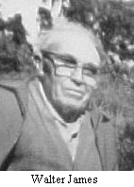
A history of Monteverde wouldn't be complete without the story of Walter and Mary James. Aunt Mary was the one who raised Wolf and his sister Sara there at Fairhope. She was a true Guindon with her wry humor and ability to do anything she set her hand to...from working at Pendle Hill in its early days to taking care of Howard and Anna Brinton's kids, and then returning home to .Fairhope to take care of her mother, and her brother's children. Later in life she married Walter James and then they adopted a son, Jerry. Uncle Walter's real talents lay in vegetable gardening or working with plants, while Aunt Mary's was in "biology, botany, and crafts. When they joined us in Monteverde, they both had talents we could use. Uncle Walter became the vegetable grower—not only for themselves and us but for the rest of the community. He was glad to give advice when asked, and kept a close record of where and when was the best place and time to plant. People soon learned to rely on him for their produce. He would often bring it to Meeting to sell on Wednesdays or at the pulpería, or sometimes take to Puntarenas to try and sell. Mostly people went to their house to buy whatever was in season. They fixed up a green-house also which added variety. Both of them liked to make do with what they had and had some imaginative inventions. Some of these Aunt Mary used in her biology class which she taught at home for several years. She always had a hands on, fresh approach to teaching, and the students learned much from her. She also taught basket weaving to several interested students. She'd go into the woods and find the right kind of vines, and process them for some of the baskets. The children were very proud of their numerous results. She didn't have a kiln but that didn't stop her from teaching pottery making. They made excursions to find good clay and made an assortment of art objects. When the dish or figure had dried enough they would varnish them, or sometimes try baking in the oven, with varying success.
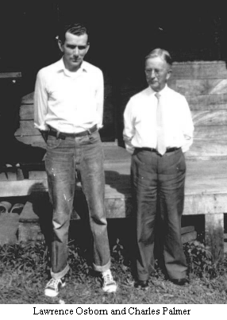
Always one to use up materials at hand, she invented a way to make foot-mats out of corn husks which were very sturdy, useful and even the children could learn how to make them. It was amazing how many things she thought up for them to do which were useful and creative. She had the biology students growing fern prothallia to sell to universities in the States and earn money for class projects.
From Aunt Mary I learned many things—how not to waste anything—use everything—try new methods—be inventive. They were both surprisingly open-minded, interested in new thoughts and scientific findings, yet grounded in their conservative Quaker upbringing. They were well-loved by all, good examples for our children to grow up with and learn from.

BOMBA
Uncle Walter did not learn Spanish easily so his vocabulary was limited. Jose Angel, who was working for him was amazed one day when he was asked to cut the chayotera. He questioned it, and Uncle Walter assured him, si si, the chayotera. So he reluctantly and slowly began cutting down these beautiful chayote vines, when here came Uncle Walter running and yelling, very agitatedly—“No, No..” He’d meant the “carretera” (road-way).

BOMBA
Walter James and Sue Trostle were leaving Dorothy Rockwell's house, where there was a large bush filled with double pink hibiscus flowers. Sue exclaimed enthusiastically that they were her favorites. Walter waited a few moments, then replied,
"Well, they're a bit too showy for me."

BOMBA
When Sue Trostle was showing Walter James some healthy spinach plants in their garden, Walter said,"Well, Sue, I think if you just let them grow, they may turn into broccoli." (They did!)

++++++++++++++++++++++++++++++++++++++++

CHARLES PALMER
In Remembrance
by Ruth A. Mendenhall
From: Family Album Vol VIII, 1963
One of the outstanding characteristics of Charles W. Palmer was his capacity for friendship. From the boys whom he had counseled many years ago, to a chance acquaintance in San José; from the milk boys who called him Mr. Ant, to College Presidents and Museum Directors; from the many pupils of his teaching years to the most important members of the Society of Friends; from the children of Monteverde to the oldest resident, all felt the warmth of his personality, and responded to it.
With heart and mind attuned to the voice of his Heavenly Father, ever ready to follow its leading, he was well qualified to minister by word and kindly deed to all with whom he came in contact.
All problems of life were lightened by his lively sense of humour, often used to illustrate a point he wished to make.
The time which he spent in Monteverde, in his later years, was a real blessing to us. We sadly miss his ministrations in so many ways, yet with a feeling of gratitude that we were privileged to have him among us. Also hope that we may long profit by his memory.
++++++++++++++++++++++++++++++++++++++++

ABNER ROCKWELL
From: Family Album Vol 7, 1962
A member of our community has written a few lines concerning Abner’s life.
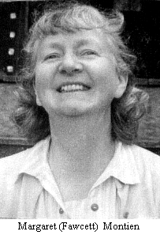
Compassion is the chief law of human existence. -- Dostoevsky --
As I knew Abner it seemed to me that he lived by this law, and when he saw it definitely broken he suffered keenly, quietly.
How beautifully he gave of himself. Week after week he came and taught our Spanish class. Morning after morning he came and led our Great Books Group, directing us into satisfying free discussions.
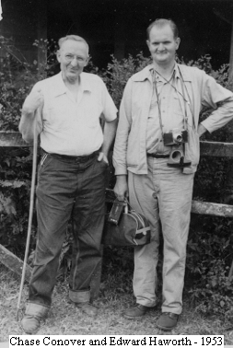
One year Abner raised gladiola bulbs for the purpose of giving them to the Costa Rican School children. Then he visited a fiesta of the Cerro Plano schools and distributed his bulbs, and joyousness reigned supreme.
As Abner has lived among us may his spirit of compassion and sharing continue as a beacon to prompt us.
++++++++++++++++++++++++++++++++++++++++

CHASE CONOVER
Chase came and lived in Monteverde for a time then bought a little house in Boca Barranca. This house was used several time by the people of Monteverde as a stop-over on the way to San José and also as a place to spend a few days and enjoy the beach.
Chase sometimes shepherded visitors to Monteverde. Edward and Rose Haworth were two of the visitors who have come to see what we are doing here.
++++++++++++++++++++++++++++++++++++++++

The Professor

By Margaret Montien
From “Family Album 1971-1991”
Margaret happens to visit Susie Newswanger at the Pensión Quetzal, but Susie has to go out and is expecting a visitor. Could Margaret please receive the person?
M. Oh Susie?
S. Yes?
M. What is this guy, anyway?
S. He’s a soology professor.
M. (to herself) What did she say, sociology? Oh well.
A knock on the door. The professor comes in. He and Margaret say hello and Margaret offers him coffee, and so begin the questions:
P. Hew long have you lived in Monteverde?
M. Nineteen years.
P. Oh, then you can surely tell me plenty about the life in this area.
M. Well, yes I expect I could.
P. Tell me now, is there still plenty of wild life around here?
M. It never was too wild. It’s true some of them do look pretty wild, but when you get acquainted with them, they are really quite nice, and harmless.
P. Oh, yes, I didn’t suppose there were any really dangerous ones, all small ones I suppose?
M. Why no, we have big ones and little ones, all sizes.
P. Oh is that so how large do they come?
M. Oh, six feet or a little over. As big as you!
P. That large and not dangerous?
M. Why no! Are you dangerous?
P. Ha! Ha! Very good! Yes I suppose size isn’t the real criterion. I understand there is quite a variety here?
M. Yes, quite a motley conglomeration to tell the truth.
P. Great! Any particularly rare specimens?
M. Some pretty rare ones alright!
P. I suppose the majority feed on fruit and vegetables. Are there any carnivores as well?
M. It’s the other way around. There are few vegetarians. The majority are carnivores, when they can get it!
P. Very interesting. I should have thought the opposite. Do they do much damage around the home? Rob the chickens or the gardens?
M. Of course not! Nor even the young ones. They are good neighbors!
P. Very unusual! A nice way of putting it! I do believe Monteverde is going to prove to be really quite a unique field of study. Do you think I could see a few examples very easily?
M. Why yes, all you have to do is walk around the area.
P. Most come out at night I suppose?
M. On the contrary, there are more in the daytime than at night.
P. How very unusual! Those that come out in the daytime, are they very shy?
M. Not especially. Some are very bold.
P. Do you think I might be able to get near enough to one of them to actually handle it?
M. Probably, but I don’t think they would like it very much!
P. Very well. But I’d like very much to study some stuffed specimens. I suppose that would not be likely?
M. You mean you could study them better if they didn’t move around so much? That is if they were stuffed.
P. Ha! Ha! That’s very good! That is exactly what I mean! Thank you Mrs. Montien. You surely have been a great help!!
M. Well, don’t mention it.
P. And now if you don’t mind I believe I’ll walk around a bit, and see what I can see. What a great thesis this will make!! Good Bye!
M. (to herself) He’s the strangest one yet!!
S. Well I’m back Margaret. What was the Zoology professor like? Seem nice?
M. Yes … The what Professor?
S. Zoology, I told you earlier, remember?
M. Oh no! I thought you said sociology! He said he wanted to see some stuffed specimens and I was going to take him to Community dinner tomorrow!!
++++++++++++++++++++++++++++++++++++++++

BECKY DAY
- by Lucille Guindon
There have been many people who have come and gone from Monteverde, interweaving their lives with the daily happenings and people of this community. One who became a part of our "extended family" was Becky Day. She first came here to teach in our school, and was a niece of Arnold and Mildred Hoge. One year blended into another and then she even took on the job of head teacher, which she also handled well. When the need for someone to direct the fledgling Monteverde Institute arose, she decided to fill that position, working with Tomas Guindon, as a team. Her ability to laugh and see humor in difficult situations was a great asset many times. She survived many challenges.
Several of her homes in Monteverde were rental houses of our children, at our end of the community, so she became one of our regular "Sunday-nighters". Then, besides that connection, while she was still teaching, she and I became co-parents of a baby howler monkey. Someone came to her with it, and knowing I had had one previously; she phoned me for advice. I said, "No, Becky, you can't raise a monkey and teach school". And she says, Well, she could take it on weekends and vacations if I could do the school-days. From former experience I knew it was a full-time job as monkey babies need to be with and on their mothers ALL the time to survive. Then, of course, the clincher-- "and this baby will just die if we don't take it!" So, we both became surrogate mothers of a month old howler monkey, named Choco. This was the famous monkey that attended Meetings for worship, and later, when I was gone to the States for a month, school with the teacher. Yes, there were lots of things Becky and I shared together besides laughter.
As Becky became more attached to living in Monteverde, she decided to buy some land with a partially torn-down house on it. She then proceeded to have it rebuilt. Soon after the house was finished and she'd had a community house warming, she returned to the States to look for more training and work, in order to finish paying for her new property. While there she became aware of strange symptoms and lack of body coordination. Eventually she was diagnosed with multiple sclerosis, which definitely threw a kink in her dreams for her future in Monteverde. She worked valiantly with educating herself on this nerve disorder and thinking positively in spite of it. But with all the medical help she could get and cooperation with experimental approaches to treat this, she became less and less mobile until just a wink of an eye was her only way to communicate. Her particular brand of MS was unrelenting, moving quickly, until her life ended at the age of 37, a loss for all of us. But it didn't really end for her influence of love, humor, and concern for others touched all those who knew her. In Waukee, Iowa, now, is a fulfilled dream of hers—a community for all people, including those with disabilities—called Lyn Circle Townhomes, under the care of a non-profit corporation, "Dream-catcher, Inc." It was Becky's dream of filling a need for others disabled, to live in a caring community, and yet be independant. This happened through the efforts of a lot of people—especially Becky's parents. It's all intertwined, a circle—Becky and her seven years in Monteverde, a caring community, then her own disability, and her dreams of helping others.
Thank you, Becky.
++++++++++++++++++++++++++++++++++++++++

MEMORIAL FOR FRANCIS AND KAY STARR
- by Martha Moss

Yesterday, the Monteverde Friends Meeting held a memorial for Kay Starr. Kay Abbott Starr had died following years of illness and according to her brother Ed Abbott and her sister-in-law Vivian, she died peacefully listening to her favorite music. Only the year before, her husband Francis Starr had also died. Both of them were in Canada at the time of death.
Kay and Francis considered themselves part-time residents of Monteverde, but as was said at the service yesterday." We all thought of them as full-time". During the years that they were with us, they both held joint memberships in Monteverde Meeting and Thousand Island Meeting in Ontario. It is not hard to imagine them sitting there together on a Meeting bench - Francis with his funny stories and Kay with her wise words.
Different people at the service described Kay as they remembered her, the following words came up: centered, strong, good sense of humor, concern for the World, unflappable, skill as a nurse, beloved grandmother and aunt. We shall miss Kay.
++++++++
Recollections of a "Part-Time" Resident
by Kay Starr
from the Family Album 1991
Our 1975 trip up the mountain, my first but Francis' fourth, was a fitting climax for our leisurely journey of some six weeks from Ontario in a VW camper. It was getting on towards evening of a rather harrowing Sunday, during which we had been relieved of our money and passports while swimming at Coco beach. Although we were arriving earlier than planned, we headed straight for the house that Francis had bought from Eston for teacher housing, a couple of years previously. When both had reconsidered the deal, they had settled for a number of years rental. As we climbed the hill past Marvin and Flory's, we were amazed to see a bright new electric sign "Soda Flormar".
That first night we spent in the camper in front of "our" house as Doris and family were occupying it in the absence of the Bill and Sylvia Powers family who had gone to Canada for the school holidays. The next day we were warmly welcomed by every one we met as we made our way to Sta. Elena to report our loss of money and passports, for the only phone to the outside was located there in a store. On the way we stopped off to say hello at the Trostles. John greeted us warmly and immediately offered to lend us money to tide us over. This was greatly appreciated as we were without money we could not have even made our phone call. John was busy making a Christmas gift for the community Christmas but said they had “just experienced a wonderful rainy season". This latter didn't seem quite right. Rainy season - wonderful?!
Although it was several days before Christmas, the Canadian Embassy told us not to bother going there regarding our passports until after January 7th! It was a joy to be here among friends and to feel the warmth and generosity of Monteverde. We were amazed to have carollers at our door on Christmas Eve. Early Christmas morning we packed cheese sandwiches and bananas and headed for the Divide. There we ate our lunch and were surprised later in the day to find that people had been looking for us to join the community festivities.
That winter on the mountain was very pleasant and I particularly remember the hospitality of Silvia and Paul Smith, Estons' and Irma and Oliver. Suddenly one evening in early February, as I was getting the evening meal, one of Eston’s children burst in saying, "The Powers are here". I said, “Where”? and got the answer, "At the pulpería and Daddy’s bringing them over"! Hard on these words Bill, Sylvia, Elizabeth and Maria arrived. Fortunately we had our camper to which to retire although Sylvia Powers assured us there was room for all in the house. Later we took our camper to the Smiths and finally Osborne and Rebecca, who were living in the Hexagon suggested we camp on the construction site of their new house where we could hook up to water and electricity. We accepted their offer and from there were able to help the ailing Oscar Montien while Margaret was away with Rene at the time of Stanley’s birth.
As we went down the mountain on our way north in the spring of 1976, I well remember saying "I feel as though I have been living in Never Never Land." The years that have followed have seen us return to this Green Mountain almost every year in the winter. Each year an active search went on for a place to build a house and to feel a more permanent part of the community. In early 1987 we applied for and were granted Joint Membership in the Monteverde Meeting., together with Thousand Island Meeting in Ontario. For many years the quest for a property was very disappointing. In the meantime we occupied many of the available houses including a stay in March 1989 with Doris in the Puffer House, as in January 1989 we were delighted to acquire the pasture opposite John and Sue's gate. In February, William started to build our house which was ready for us in November of that year. Francis has been busy planting trees to shelter and screen the house so that it fits more naturally into the Monteverde scene.
Although comparative newcomers and ones who come and go, we are happy to feel part of the community, are pleased to have been present when the Conservation League was started and to have attended the initial meetings of the Monteverde Institute. Looking back, the saying "You are always in your right place" seems to make more and more sense.
++++++++++++++++++++++++++++++++++++++++

A FEW BRIEF MOMENTS IN MONTEVERDE HISTORY
By Os Cresson
I was hitchhiking through Central America in 1972 and found Monteverde and stayed to teach science. Then my parents arrived on a visit that extended for 23 wonderful years. Rebecca cooked and gardened and did a lot of weaving. She loved to write and produced a history of Monteverde that was published as part of Friends in the Americas (Friends World Committee, 1976). She also designed a house that Bob Law and his crew built and we added two cabins. These buildings are now part of the Monteverde Institute campus. Osborne was treasurer of many committees and helped with the transition of the cheese plant to ownership by the milk producers.
Especially vivid memories of these years include walking through the forest and through the weather. The combination of Toyotas and what are called roads. Community dinners. Close contacts with so many neighbors, especially Alexis Chavarria and Esperanza Mora who adopted Rebecca and Osborne as an extra set of parents, and Enrique Hurtado and Estelita Salguera who named their first child after Rebecca. Sunday evening potlucks when we never knew if three people would show up or 30, but it was always exciting. Meetings for worship and weddings and funerals.
Anne Kriebel and how she brought people together while she was here and how her example continued to do that after she died. The birth of community institutions. The way the word Monteverde came to also refer to "La Zona," a dramatic new social unit of many people and cultures. Visits by my sister and her children as they grew up and started their own families. Our family dogs, Chula and Vishnu and Nanda and Chorotega, and the parrot Peri, and many parakeets. The day when I asked the meeting if they could put up with a Quaker with my particular views and being gently reminded, "Os, it's you we love!" Jogging with my dog for hours on end. Rebecca waiting patiently and then trying to get the runners to take something nutritious as they staggered by.
Well, time passed and Osborne lived out his 92 satisfying years (or 42% of U.S. history as he would like to put it). After he died Rebecca decided she needed a new adventure and easier access to medical care, so we moved to the Medford Leas Retirement Community outside of Philadelphia. She had a fine time for the remaining few months of her life. Having been apart from Osborne for only a few days in 60 years, she asked that her remains join those of her husband in Monteverde. So now Rebecca and Osborne rest in the heart of Monteverde, just as Monteverde rests in the hearts of those who have lived there and moved on.
++++++++++++++++++++++++++++++++++++++++

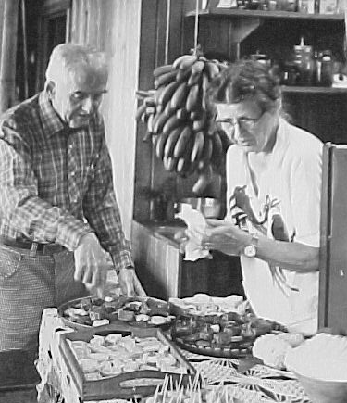
We Miss …..
- by Jan Drake-Lowther
- from Family Album 1971-1991 & updated 2001
A selection or brief encounters with those who have died in Monteverde over the past 20 years by Jan Drake-Lowther: "For now .we see through a glass darkly, but then face to face."
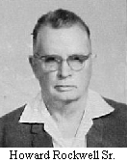
HOWARD ROCKWELL (1903.- 30 January 1972) without fail Howard always greeted us warmly at Meeting. One morning he was on the porch as we were all preparing to enter the Meeting house. David was in front of me. Howard turned and saw us coming; a huge smile crossed his face and he extended his hand. 1 don't recall the words, but his meaning was crystal clear as he conveyed to us his genuine pleasure that we had come to live in Monteverde. David and 1 never forgot that moment.

BERNI ROCKWELL (1954 - February 1972) Berni was one of the "older kids" in the Monteverde School when my children were young and just entering it as newcomers. One bright day on the schoolgrounds a child was bullying a younger child and had him pinned to the ground, Berni calmly picked the bully up by shirt and pants, removed him most effectively and insisted he stop...period.

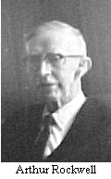
ARTHUR ROCKWELL (.1878 - 5 June 1974) While 1 was interviewing Arthur and Clara to celebrate their contribution (the first, to the proposed new library in Monteverde, Arthur reported on his past life a bit and then, in discussing his venturing forth from the United States to Costa Rica at the age of 72, he said in his gentle way "They (the younger people coming to MV) were going to need help when they got here, and I was able to give them some help."

EMILCE RODRIGUEZ de ARCE (1 July 1975) Emiice's lovely big dark eyes peered up at me from the frame of white bedding in the hospital in San Jose where I had gone to visit her after her surgery. I knew she was very ill, and my mind spun until I asked, "If we can arrange it, Emilce, would you like to go home?" The deep pools of fear in her eyes lifted with anticipation and she gave me her beautiful smile.

D1ANE REESE (1940) (?) - l4 October 1980) Up the wooden steps that led to her house and the room lined with books and a view out over the gulf. She fixed me a cup of herb tea; we talked awhile and she warmly urged me to browse through her library and borrow anything I wanted. Then she gave me the gift of silence, an unhurried silence to dip into book after book and finally make a selection.
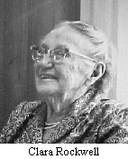
CLARA ROCKWELL (1885 - 30 December 1980) At my first "quilting bee", it was all I had imagined: women comfortable with one another chatting and working around the big frame, needles and threads spread across the panoply or colors. Clara bent to her work, a smile on her face, looking up occasionally, not missing anything; but mainly intent on those minute, perfectly spaced stitches -- four to each thrust of her needle as I recall, the needle firm in one gnarled hand above the frame, the other below to guide. Age and uncommon skill perfectly blended.

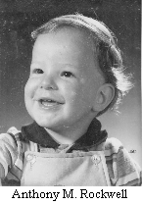
ANTHONY ROCKWELL (1979 - 29 October 1982) The sun was pouring through the windows in the Flor Mar encompassing Anthony and some colorful toys in his playpen. Although I do not remember all the various people in the room at the time, I have a vivid recollection that for a silent moment all eyes were turned toward the beautiful little human being in that pool of light. He looked up at us and smiled and the whole world stood still for me for an instant.

ANN KRE1BEL (1955 (?) - 24 November 1983) Seated at the edge of the stage in the schoolhouse with her dulcimer on her knees, Ann began a song and soon the children surrounding her were all singing. I rode horseback with her parents to San Luis when they took that same dulcimer down to give it to the people there in the valley with whom she had worked. On the long ride back up the steep hill at sunset, her presence was palpable. How many sunsets had she seen on that same ride?

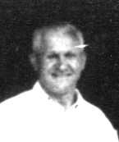
OSCAR MONTIEN (1897 - 6 January 1984) A day I always looked forward to: once each year Oscar would trudge up my lane and present me with the eagerly awaited celery plants ready to transplant into my garden. Each perfect-sized little plant was neatly wrapped in the proper-sized piece of newspaper and the neck carefully tied with old typewriter ribbon. My fingers would be smudged from removing the ribbons and covered with fresh earth from the transplanting. I don't remember ever losing a single transplant!

MARY JAMES (1902 - 21 July 1984) Frequently when a little lizard scurries across the plastic part of my roof, I am drawn back to a sunny day at Mary's when she explained how much she enjoyed the dozens of "1argartitos" that graced the green painted boards on her house. She moved among her many flowers snapping cuttings for me and telling me how to plant them, always with that certain assurance that everything is supposed to grow and prosper, and under her green thumb it did!

WALTER JAMES (1894 - 21 November 1984) To this day, my heart takes a happy turn when I think of the day I went to "pick my own" peas at Walter's. He met me at the house and led me past the citrus trees until we rounded a little turn and there spread out before us was the most glorious hillside of blooming pea vines..... row on row of healthy thriving plants in full flower on top meaning there would be gorgeous peas ready to pick below. I stood there in the sunshine with Walter reveling in that stupendous sight!

DAVID LOWTHER (1923 - 22 January 1986; Our family arrived in Monteverde in October of 1970: David 47, I was 43 and our children Julia 8, Hannah 7, and David 6. So this "Family Album" covers the period of our life here. David delighted in returning "home" to MV from frequent travel.

MILDRED HOGE (1908 - 19 October 1987 news of her death arrived in MV) Mildred's shining sense of humor and delight in the simple inevitably gave me a boost. One rare serious conversation with her changed my approach to the role of long distance telephone calls. In my experience she understood and lived the simple life, a careful spender. However, she confided she felt justified, indeed delighted, in making contact with her distant family and friends in long distance telephone calls...the money well spent. I'm improving, Mildred!

TED S1LVEY (1949 - 1987) At a "Coffee House" one evening years ago I watched a delightful transformation come over Ted's whole being when he picked up his guitar and began to play for us. He had appeared to me to be nervous, ill at ease. As he played, he became more and more alive with sheer joy in the terrific sounds he and his friends were producing, and he played, oh how he played for us!

MARGARET MONTIEN (1910 - 19 March 1988) Music -- recorder music. Thanks to Margaret, we enjoyed many an hour of making our own music, and we sometimes "entertained" others with our efforts. Her persistence in teaching herself to play the guitar was phenomenal -- to this day I can hear her delighted giggle as we struggled along.

(The following remembrances were added for this Jubilee Family Album)

OSBORNE CRESSON (1904 - 31 December l996) Perhaps everybody in Monteverde shares my memory of Osborne on his way to the dairy plant for milk in the morning, a small aluminum milk can dangling from each hand, his broad-brimmed hat trimmed by one of Becky's brilliant inkle loom belts and a dog or two in attendance. The picture is only complete, however, with his ever-ready beaming smile for every single soul who passed his way – a constant evidence that Osborne blessed all he encountered with love from the depths of his generous being.

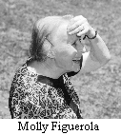
MOLLY FIGUEROLA (1905 - 30 June l997) Head bent, body tilted forward Molly walked determinedly to school, to meeting, into life. A visual memento I have is in the video of my daughter Julia's 13th birthday where Molly turns beaming to the camera as she directs a small group of recorder players, her expressive hands circling encouragingly in the air.

BECKY CRESSON (1910 - 1 February 1998) It is said that after 30 years, one can see the beauty of a soul in the face. Becky was one of the most beautiful people I have ever known. Surely heaven itself is a better place for her presence. I bask in the memory of this remarkable woman. Toward the end of her life, she walked down occasionally to my little casita, her nearest neighbor, so that we could meditate together and share a cup of tea. Sitting in silence with Becky was a privilege beyond words.

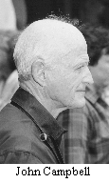
JOHN CAMPBELL (1919 - 29 July 1999) The first Christmas our family spent in Monteverde in 1970 just two months after our arrival, Julia at age 8 drew John's name in the "Christmas Draw". Much loving labor went into creating a very simple - quite crude actually - candle holder from the clay on the farm. Some weeks later when we were all invited to a delicious meal at the Campbell's, in the middle of the table with a beautiful candle burning was the Christmas gift, carefully varnished to preserve it. The glow of its light reflected in the eyes of a delighted child. Grownup Julia now writes "I remember very clearly how pleased I was that John had taken the kind of care of the candlestick that showed he truly cherished my lumpen efforts". I shall always be grateful to John for that uncommon gift of acceptance and appreciation to a young child in a very new environment.

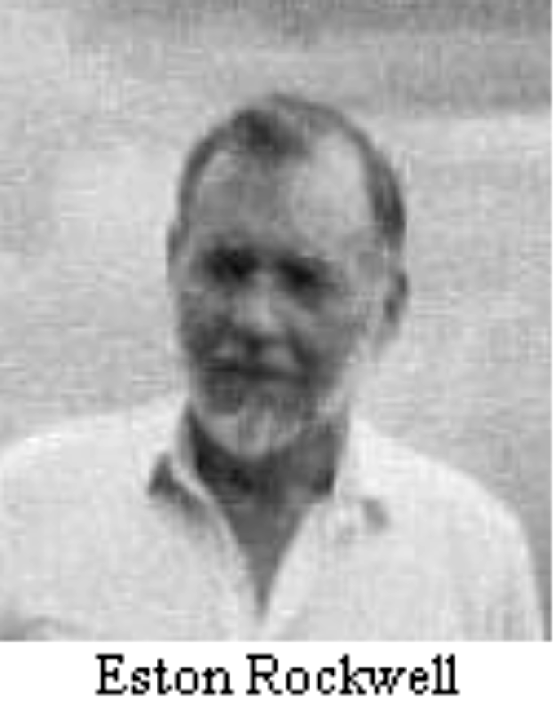
ESTON ROCKWELL (1930 - 19 September 1999) Rrrrrrrrrriiinnnggg! "Hello. This is Eston" -- and every ear was glued to the community's internal magnetic telephone system, for when Eston called, there might well be important news about the wonderful hydroelectric power we all enjoyed because of his ingenuity. Or, as was the case one Christmas Eve, managed to do without for quite a spell! After his careful explanation of just what was happening with that mysterious piece of equipment down there in Lindora attached to a long pipe that served us in such an environmentally sound manner for so many years, it was clear it was to be an "electricity-free Christmas" and someone quickly responded, "Oh, splendid - just like the old days"!

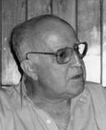
HUGO SALAS (1924 - 4 October 1999) Although I did not really know Hugo, I have a very clear sensation of his quiet arrival at Dorothy's for "Coffee" one morning following after Alicia and Susanna into the room. Someone almost immediately called his attention to a physical ailment of some sort, and for me, the man was transformed into the competent, compassionate, concerned and involved neighbor he had become in a very short time among us. I remember thinking to myself, "Please God, if every medical person could share that kind of expertise, kindliness and genuine empathy with his fellow human beings, 'twould be a better world".

God bless them all!

"For now we see through a glass darkly, but then face to face".
- 1st Corinthians 13:12
++++++++++++++++++++++++++++++++++++++++

