CHAPTER II

Getting to Costa Rica: Land Search

- from “A Brief History of Monteverde”
- by Marvin Rockwell
The four of us who had been in prison wanted to leave the United States as soon as our parole time was up on the 27th of October 1950. Most of the group packed the household goods they took in boxes and shipped, by truck to New Orleans and by ship from there to Costa Rica. On the 31st of October we took several boxes of our household goods to Mobile to ship to Costa Rica. The Howard Rockwell Sr. family bought a 1 1/2 ton Chevrolet truck which they fixed for traveling and for taking most of their household goods. A 12 by 14 tent was stretched over a frame made of pipe to enclose the truck-bed. They made the front of wood and covered with aluminum with three windows or windshields. The center one was hinged to open for ventilation and to provide a means to tap the top of the cab for communication. A doorway was made on the right front to give access to this part. There they put a mattress as a seat and two mattresses on top of the load with the ends making the back of the seat. This seat provided a wonderful view ahead. Dorothy and the girls slept on the mattresses in the truck. The rest of us slept outside on padded camp cots. They put a 35-gallon auxiliary gas tank on the truck because in Mexico there were some long distances between filling stations. We had a two burner gasoline stove which we set on a folding card table for cooking. On the 4th of November the truck and I in my brother Cecil Rockwell's Jeep and trailer started the trip to Costa Rica by land, through Mexico, Guatemala, El Salvador, Honduras and Nicaragua. Howard Sr. had to remain in Fairhope to finish the sale of their property. A cousin David Rockwell traveled with us. A friend, Roy Butgereit, whose 18th birthday was before we could leave, flew to Monterrey Mexico and we were to pick him up there. The first day of the trip we traveled 210 miles and camped in Louisiana. Next morning there was frost on our cots even though we had kept a campfire going all night.
We arrived at the U. S. - Mexico border about noon on the 7th of November. The U. S. customs officials said that I would have to have an export license to take the jeep out of the country and that it had to come from Washington D.C. Since Roy was waiting in Monterrey we decided that the truck and the rest of the "gang" should continue and I would stay in Laredo until I could get an export license. I rented a room in a motel and stayed until the export license came from Washington which took 9 days. The travelers in the truck spent that night in the "wilderness" next to the highway 39 miles south of Nuevo Laredo. Next day they got to Monterrey and found Roy at the Hotel Monterrey suffering from dysentery. They found a tourist camp on the edge of Monterrey to stay until I could catch up with them.

BOMBA (Costa Rican term for Joke or Anecdote)
None of us knew Spanish except a few words. It sometimes caused some amusing anecdotes and sometimes some difficulty. David asked the boy at the tourist court: "Como se llama?" (What is your name?). He answered: "Quien yo?" David thought he was saying his name so for the rest of the time at the camp he was called "Kenyo". It was a long time before we realized that the boy had answered "Who me?"
++++++

by Marvin Rockwell
When Hubert, Howard and Cecil had flown to Costa Rica on their exploratory trip they were taken by light aircraft over an area close to the Panamanian border called Cañas Gordas. They felt that it was a good location. Near the end of November some of the group went to see it. My father Arthur Rockwell described the trip in a letter.
+++++++
Trip to Cañas Gordas
- by Arthur Rockwell
“The six of us men left here last Thursday, a week ago today, for Cañas Gordas and returned yesterday. Clara, Lucile and Mary went with us, as Mr. Challe's guests, as far as the end of the jeep road which I believe is called Camp Three. They returned to Golfito that day and stayed over night there and came back to San José the next morning. They had horses (a mule for me) waiting at Camp Three and we rode to the farm, about five miles. It took us two hours to make the trip. I can't describe that road. Much of it was knee deep mud and some of it nearly belly deep on the horses and steep grades. The only way they move goods over the road is by pack horse or ox cart. A good yoke of oxen can take 500 pounds on the cart and move nearly one mile an hour. Our bed rolls went in by ox cart and arrived at the farm about ten o'clock. We did not get them until morning so were pretty cold under one blanket they furnished each of us that night. After that we each had our own blanket in addition to theirs.
“Some engineers and coffee experts went in the same time we did so Friday we spent walking over Challe's farm or the part which is cleared (about 70 acres). Saw his coffee, sugar cane etc. much as some of you did in the summer. Saturday the Manager, José Rojas A, and our bunch excepting me (I didn't think I was equal to it) walked from 7 A.M. until 2 P.M. to see the tract of land North of Challe's farm. From the air that tract looks like a gentle slope and rolling land the other way but from the ground the ridges are very steep and narrow. The top of the ridge just about wide enough for a trail with no land suitable for farming. On Saturday we took horses (a mule for me) rode across some of the Dr. Paralta land south of Challe's and from there we rode across the Louis Cruz tract, which is one of the tracts we had in mind to buy. We found it better than the land north of Challes but still only a small percent of it could be used for farm land. Hubert and I estimated that we saw perhaps 20 acres on which a tractor could be used in going the whole width of the tract, if we could get a tractor onto the field. There is a large waterfall on the Cruz tract which has been seen from the air and Challe wants that waterfall for power some time so he has an option on half of the tract to take either half he wants. The map we saw of the area shows the waterfall to be in the front half, the corner of which is within about one mile of the all weather road. If Challe takes the front half we see no way of getting to the back half even if we could use it. Ernesto Araya owns the land to the East of Challe, perhaps around 2500 acres more or less. He has coffee planted on about five acres near Challe's farm. The coffee had been planted one or two years and some of it not doing well. The coffee experts that came in with us were looking it over to find the trouble. Some of it was planted too deep. Jose Rojas told us he thought Araya had perhaps 100 acres cleared (which usually means the trees cut down and lying on the ground as they were in the coffee planting) and he thought Araya would sell. He also told us Araya has a store in Cañas Gordas and liquor store. His Panama customers bring their dollars to him for which he gives colones at 7 to 1. He then takes the dollars to San José and gets at yesterdays rate 8.80 to 1. We were able to get 8.90 for the first we exchanged at the street exchange office. We didn't think it worth while to try and do business with Araya because he would want more than his property was worth if we tried to do business with him. It looked to us that it would be a long time before the road to Camp 3 would be made all weather. The United Fruit Company is a poor market if you have no other as they pay just what they please when you have to sell to them as Mr. Cone has found out to his sorrow. Hubert and I both feel that we have eliminated the Cañas Gordas area in our plans.
"Hubert, Wilford and Ted have gone with Dr. Paralta to his farm in the San Carlos area. It is Northwest of San Jose through Villa Quesada up to Los Chiles by jeep, so Paralta says, then horseback to his farm near Caño Negro. Paralta was going today any way and offered to take three passengers to get a little idea what the country was like. We are afraid it is too low for us but want to see every possibility before we do anything. The Methodist missionary people in Golfito plan to establish a mission up there and want us to look it over for our use. Hubert expects to come back Saturday. Dr. Reese from Boston, who had written to Hubert, called here today and will see us again when Hubert comes back. Dr. Reese is a retired physician and has some weird tales to tell about health conditions here. We hope things are not quite as bad as he makes them out.”
++++++++++++++++++++++++++++++++++++++++
BOMBA
Clara Rockwell, Mary Rockwell and Lucille Guindon went as far as the jeep could go. Along the road, which they were traveling, they came upon a Bushmaster snake in the road, so they stopped. The women got out of the jeep to have a better look at it and the Costa Rican men were very concerned for their safety.
++++++++++++++++++++++++++++++++++++++++

THE TRIP TO CAÑAS GORDAS
- from old letters by Eston Rockwell to his parents
Yes, everybody—including Hubert, thought the land down at or near Cañas Gordas was the most likely. But that was before we were down there and tramped through the hills. Challe who had been talking the land up to Hubert really thought I guess, that the land all around him that's still in forest is the same as his farm but his farm supervisor told us and showed us that its entirely different. We walked thru the jungle for 8 hrs—walking fast too, then back and I don't believe we saw one acre of level land or anything approaching level land altogether the whole time. We saw 3 or 4 level spots big enough to build a house on but that's about all.
I can go back and tell you about some of our trips. The first one and also the longest and most interesting, was to Challe's farm down at or near Cañas Gordas. Hubert had that trip all planned for us when we first got here. There was another big party of men going at the same time to do surveying and mapping etc, so Challe chartered a special plane to take us all—about 18 altogether, from here to Golfito. The women (Clara, Mary & Lucky) weren't planning on going but when Challe decided on chartering this plane there was room and he said they could come along as his guests and go with us as far as the jeep road, then come back the next day. Of course Mary and Lucky were all excited about this and didn't need to be persuaded any to go along. Arthur, Hubert, Ted, John, Wolf, and I each rolled up a blanket to take along. Challe had the pilot fly over the land he wanted us to see. ... then we flew on to Golfito. It is a pretty little town. From the air we could see clearly how the town is built on a narrow strip of land next to the ocean and right behind it the mountains rise almost straight up.
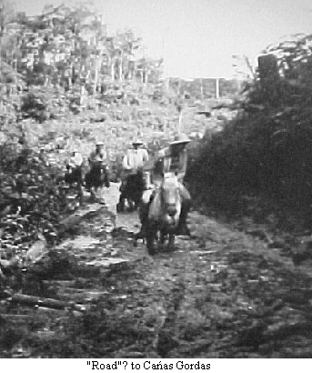
The harbor was beautiful. It was still early in the morning when we landed but the sun was shining brightly and the minute we stepped off the plane we could feel the heat hit us. The United Fruit Company had two station wagons waiting to take us down to their railroad. We had to wait about an hour, however, so we wandered around in the U.F.C.'s general store and bought ice cream cones, and since we hadn't had any breakfast, we tried to buy bananas but they thought we were mighty queer to want bananas. Finally found some in their refrigerator for flavoring ice cream. They gave them to us—wouldn't take any money. They tasted mighty good to us too. Guess people there never eat bananas unless they're starving, we found out. We also went thru their bakery and pop-bottling plant—all very nice and modern. I suppose there wouldn't be much of a town there if it weren't for the houses and buildings that they built and own. ....We got on a railroad passenger car—powered by a diesel engine and went cruising down the tracks. When we got to the end of the railroad we got in a jeep pickup truck which Challe had waiting for us and we rode to the foot of the mountains where the road started going up. The road gained 3,000 ft of altitude in the 8 miles going up. The jeep was in low gear all the time except for a few short stretches, That road was graveled—made by the US Army at a cost of 3 million dollars and was put there as a supply road for the Pan American highway before the war ended & they abandoned the project. Well, we got to the top and cruised for another mile or so on road that was up and down before coming to camp 3 where he had horses waiting for us. It was here we had to leave our wives. I climbed onto one of those wee little horses they gave us. When I rounded the turn in the road I saw why they hadn't taken the jeep further. The total width of the road from the trees on one side to the trees on the other was virtually a sea of mud. It was quite a sight. But that I found was only the beginning—it got worse. We went uphill (on horses) that seemed straight up and down —We went thru mud so deep our stirrups dragged in it if we didn't raise our feet. The ride took about 2 hrs and none of us were used to riding so were pretty sore by the time we got there. They had a guest house they put us up in. Arthur and Hubert had a trailer house to themselves. We had all the modern conveniences and meals over at the mess hall.
Jose Rojas took us on a hike thru the jungle so we could see what it looked like altho he told us before we left how it was. We started at about 7 in the morning. Altho the sun was shining up above the trees, we walked in the shade all the way. While walking on top of the ridge we could plainly see that it was only 4 to 15 ft. wide and sloped off steeply on both sides, and Jose told us that when it got to the bottom it went right back up again—there was no wide valley. We were soon to see that firsthand. At about 10 o'clock the guide opened the leather bag he was carrying on his shoulder and took out a big round block of some brown substance and started whacking off pieces of it with his machete. He passed the pieces around and told us to eat it. We did and found it was delicious. It was, we were told, what they call "dulce"—just brown sugar, nothing else. We drank a lot of water with it from the stream and went on, greatly refreshed. We got back about 3 o'clock after about 8 hours of steady walking, sliding and crawling. We were all covered with mud from above the knees down and pants were wet to the belt. The next day was Sunday so didn't do anything much. The next day we got the horses and rode over another man's farm which we found wasn't so rough but was still far from level enough to cultivate, and there wasn't enough of it either. The next morning we caught the 7:30 plane for San Jose and were there by 9 o'clock.
+++++++++++++++++++++++++++++++++++

LOOKING FOR LAND TO SETTLE ON
- from John Campbell’s Monteverde Memoirs
There was a period of about six months when different members of the group looked all over Costa Rica for some suitable land for the whole group to be able to settle on. Some places were too steep, some too windy, some too wet and some too expensive.
Howard and Dorothy with their four children and Dorothy's brother Marvin, and David Rockwell bravely set out overland from Alabama with a 1 1/2 ton Chevrolet truck, and a Willys Jeep with a 4-wheel tandem trailer. They brought most of their household goods by land. Roy Butgereit joined the overland trip in Mexico, as he had to leave the states ahead of his 18th birthday. The group split up when they arrived in Nicaragua because at that time there was no road connection between Nicaragua and Costa Rica, so Marvin, David, Howard Jr. and Leonard Rockwell stayed with the vehicles to drive them all the way down and the rest of the overland group came by plane the last part of the journey. They spent many days struggling over oxcart trails and fording rivers, some parts were so swampy that they had to use two planks 3" X 14" X 12' to get across. Some detours around parts of the road that were washed out took them through pastureland and woods. They possibly were the very first people to drive from Nicaragua to Costa Rica. They did not however drive all of the way from the states, as there was a stretch in Southern Mexico where all travelers had to load their vehicles on flat cars for a railroad trip, which terminated at Tonelá on the Guatemalan border. They arrived in San Jose on February 4th, 1951. It took three months to the day to make the trip and one of those months was spent on that 18-mile gap between Nicaragua and Costa Rica! Most of the group thought it would be easier to have their households goods shipped down by boat! These were shipped to the Atlantic Port and from there to San Jose.
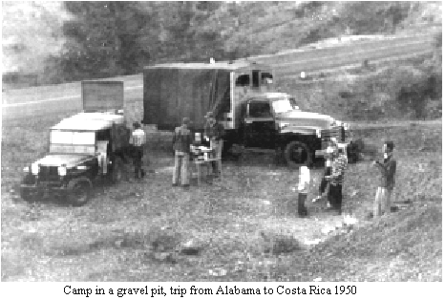
On Sunday morning, April 15th we went to the Andre Challe Beneficio outside of Heredia where part of the group was staying. As part of our contribution to the "pot luck" meal we took along a cake to help celebrate our daughter Ruth's First Birthday. This gathering came at a crucial time as an impasse had been reached in deciding where to settle. The locations with a favorable climate were in the high priced Meseta Central. More modestly priced land had been found in the General Valley, where climate and soil were less ideal. The three families who could afford it wouldn't consider settling where the climate was warmer while the less affluent majority didn't have that choice. A crisis was building. The mood was somber. The rainy season was approaching and people were growing tired of living out of suitcases. The poorer people had just had a meeting. As no alternatives were in sight, they had decided to proceed with negotiations for the purchase of the affordable, but less desirable, land. This meant that the families of a brother and sister would be located some hundred miles apart and the dream of one community would be at an end.
+++++++++++++++++++++++++++++++++++++++

- from “A Brief History of Monteverde”
- by Marvin Rockwell
We found out that Guatemala did not have a road connecting with the Mexican part of the Pan American Highway. Guatemala had a road to the Mexico-Guatemala border near the Pacific coast but Mexico did not have a road, only a railroad to Tapachula. We were told that we could put the vehicles on flatcars and ship on the narrow-gauge railroad from Arriaga to Tapachula, a distance of about 200 miles. The road from the Pan American Highway to Arriaga was very steep and rough and we thought it very bad until we encountered worse further on in the trip. We arrived in Arriaga on Saturday evening and found that the train was due to leave Sunday morning. We camped at the edge of town and were back at the station by 7 o'clock Sunday morning. They charged us 600 pesos which was equivalent to about $70.oo. Only the drivers could ride in the vehicles so the rest rode in a rickety, dirty, "1st class" coach. It took us 15 hours to travel the 200 miles arriving Monday morning. When we were ready to get off the flatcars, they wouldn't let us off until we paid an additional 320 pesos for the "freight" on the truck. The unloading ramp was at the end of the siding which was on a curve. I had to back the jeep and trailer over 7 flatcars on the curve to get to the unloading ramp and get off the train. Finally we got off the train and bought groceries, gasoline and distilled water for drinking and headed for the border. At the border the Mexican customs officials wanted us to unload everything for inspection, but they finally relented. When we entered Mexico at Laredo the officials there had listed five tires on the truck papers. We did not catch the error at the time. When we were ready to leave the country the truck had 7 tires as the wheels on the back were duals. Another hassle before they would let us go. One of the tires on the trailer had blown out along the way. Fortunately I had cut out the serial number of the tire to prove that I had not sold the tire in Mexico.
++++++
We crossed the border (between Honduras and Nicaragua) around 2 o'clock, the 20th of December 1950 and spent about half an hour on each side getting passports stamped, etc. We drove about 18 miles into Nicaragua from the border to the little town of Somoto where the Customs were. There we really hit bad problems! They said we must unload unless we had instructions from the American Ambassador at Managua to let us through without inspection. We sent a telegram to the Ambassador and prepared to camp in the corner of the custom's lot. They held our passports. Next morning At 10:00 A.M. a telegram came from Managua saying to have the load sealed uninspected. They finally sealed the loads until we got to Managua. Arrived at Managua, Nicaragua at 1:30 p.m. on the 22nd of December, had several miles of paving before getting there. We passed the airport and wondered if by any chance Cecils were aboard the plane that was just then taking off. (Just as a note of interest here - when we reached San José and were comparing notes, we found that Cecil and family were on that plane.) After the usual rigmarole of being stopped at police and guard stations to give names and license numbers, etc., we went on into the city and found the Customs building. We were expecting almost anything but after a while Howard, Howard Jr. and I came out and said we were free to go on our way. The Customs Dept. General asked first thing if we were Quakers. We had known that information was in some way traveling ahead of us that the Quakers were coming. However we never mentioned the fact that we were Quakers unless asked, as we were anxious not to try to gain favors on that account. The General wanted to do all he could to help us, and said in case we needed any kind of assistance anywhere in Nicaragua, to be sure to call on him.
December 30, 1950 -
About 6:00 A.M. we woke up and decided we might as well be up and at it again. We had pancakes, oatmeal and coffee. We broke camp and got on the road about 8:15 A.M. We drove along a little way without too much trouble. Then we came to a rather boggy place and had to put the planks down. We got across the planks alright but the mud squeezed up between the planks. After much scouting around we found a way around the place on higher ground. I got part way up the hill and had to stop to let them move a log. Then could not get traction to start on up the hill so had to back all the way down and get a run for it and made it that time. We hardly got back on the “road” again before we had to leave it again to get past another boggy dip. This time we detoured down hill a little way through tall grass. We cut small trees to put in the stream bed where we crossed it. I got the Jeep and trailer through alright but the truck stuck. I pulled the trailer on along the “road” to a level stretch and unhitched. With the Jeep hooked onto the truck with chains and some digging we got the truck out. We drove another little way along the "road" until we came to some shade and then stopped for dinner. It was twelve o'clock and we had come less than a mile. This afternoon we had some more hard going. One long stretch was in jungle and we had to cut it back. Then we came to a stream bed with rocky bottom but the hill on the other side was boggy so we cut down the brush to bypass the bog. We shoveled the bank down some and put a plank down too. I drove the Jeep and trailer through the stream bed and got pretty well up the hill before it started slipping. We were at a loss as to how to get it the rest of the way up until someone thought of putting the block and tackle on the front of the Jeep and on a tree ahead. The inch rope, which we had along, would not go through the block so we used the rope we got from the railroad trip in Mexico. David spliced some of the pieces together. After many tries we got the Jeep and trailer up the hill by the Jeep pulling the trailer and the three fellows pulling on the block and tackle. The truck stopped just about the same place on the hill. I pulled the trailer to the top of the hill and unhitched and backed down and chained the jeep to the truck and together got the truck up the hill. It was about 4 o’clock when we made camp and we had only come 1.4 miles. Ticks the size of pinheads are bothering us quite a little. We went to bed about 9.
++++++++++++++++++++++++++++++++++++++++

ARRIVAL IN COSTA RICA
- from book “Monteverde” by Mildred Mendenhall
During this six months period, "scouting trips" were made back to Costa Rica in a land search that continued even after we and eight other families had arrived in the country to stay. By Christmas we were all temporarily housed in and about the San Jose area. With the arrival of the contingent which had driven overland, the land search intensified.
The group met together twice a week for worship, potluck meals, and ongoing discussions of the various land tract possibilities. Nearly every part of the country had been explored in the hope of finding (a) terrain suited to mechanised farming practices at (b) an elevation far enough above sea level to afford a healthy climate, and (c) located in an undeveloped, less expensive area which, it was hoped, would include some uncleared forest land. Initially we all agreed that in order to maintain the health of man and beast we could not live in the lowlands where the debilitating heat, diseases and other dangers could take their toll.
However, with hope diminishing of finding what we wanted at a higher altitude, some felt we must now compromise and consider settling in a lowland valley in southern Costa Rica, surrounded by mountains and breathlessly hot at 800 meters. Others began to feel it would be wiser to purchase farmland in a locale already serviced by roads, electricity and water, that perhaps the higher initial investment would be no more costly in the final analysis.
At this point there was even some consideration being given to the group dividing, in view of differing location preferences that had developed. However, that opinion was abandoned because those more financially able had agreed to help younger members get a start. More important was the felt need to maintain our meeting for worship and the school.
++++++++++++++++++++++++++++++++++++++++

- from “Pioneering in Costa Rica”
By Cecil F. Rockwell
On November 10th my parents, Arthur & Clara Rockwell left by plane for San Jose, Costa Rica, the first of the group to complete the permanent move. Hubert Mendenhall & John Campbell went at the same time to look around some more and to return for their families. Arthur, Hubert and John made a trip to the General Valley to see a farm of Max Cone, a Northamerican with whom we had corresponded. On November 19th Ted Harkey came to join the lookers. Wilford & Lucille (Standing) Guindon (Wolf & Lucky) and Eston & Mary (Chamness) Rockwell came to Fairhope, both couples having recently been married in Iowa. Eston had also recently been paroled from prison for non-registration. The four went on to Costa Rica arriving on November 21st. On their arrival it made a group of nine who went to look some more at the Cañas Gordas property, flying to Golfito, then by train and jeep part way to Cañas Gordas. Here the women left the men and returned to Golfito where they spent the night in a Guesthouse belonging to a relative of Andre Challe, the owner of the place in Cañas Gordas, while the men continued on horseback to the Challe farm. The next morning the three women flew back to San Jose. After this trip it was decided that Cañas Gordas would not be satisfactory and we should begin to look elsewhere. My parents had rented a house in San Pedro, a suburb of San Jose. This house was large enough to make a temporary place for others to stay for a few days until they could find more permanent housing. This group then began to follow leads and investigate other locations including land in the San Carlos area, which is in the Atlantic slope and more humid and tropical. John Campbell & Ted Harkey returned to the states to prepare to bring their families and Hubert then returned to Fairhope to prepare to leave with his family.
We were finally able to sell our place on December 5th to Stanley & Rose Robberson, friends of ours. They also bought our old Plymouth car, so now we could make the final push to get ready to leave. Some of our goods that had not left with Marvin by road, and that of Father Mendenhall's were packed and ready for shipment so Corbin Williams and I took a truckload to New Orleans to go by ship to Puerto Limon and from there by rail to San Jose. With this shipment everything that could not be taken as baggage was now on the way to Costa Rica. The rest would be disposed of before leaving. Father Mendenhall's ate their last meals before leaving, at our place and Hubert's girls slept at our place too until they all left on December 19th. I took them to Mobile in Hubert's car which he still had the use of, and Walter James took their baggage in his pickup to leave at 5:30 AM. Our family left two days later on the same schedule. Art Fleming, a neighbor, took us to Mobile and Walter James again took our baggage.
From New Orleans we were on a four engine DC-4 with a stop in Merida, Mexico then on to Guatemala City. All were feeling pretty good except Paul who seemed to have a stomach flu or something. We had a stop over night in Guatemala City. That night Paul was feeling better but the rest of the children became ill. We were taking with us as baggage two collie puppies (one of ours and one of Hubert's). The next morning when we went to leave on a smaller plane, a DC-3, the box the dogs were in would not go in the door of the plane so they said they would have to be left and they would cut the box down and send them on the next day. On this leg of the flight there were stops at San Salvador, Tegucigalpa, Managua and on to San Jose. Paul seemed all right but the other three children were having some stomach trouble, so when we arrived at La Sabana Airport in San Jose we were a pretty sad looking sight. There Papa was waiting to meet us. The twin engine DC-3 was the largest plane that La Sabana Airport would accommodate at that time. We spent that night at the house in San Pedro. The next day we went to get the dogs but found they had forgotten to take them off of the plane and they had gone on to Panama and would be coming back the next day. The next day we tried again to get the dogs and found them at the airport but were told they should have been vaccinated for rabies and would have to be quarantined but they had no facilities for quarantine. Someone had written on the crate in English "FEED US, WE WON'T BITE". We finally were able to make arrangements with a Dr. Freeman, a British Veterinarian to keep the dogs for the required time. The house in San Pedro was pretty crowded with 10 people beside the maid, Berta, who had been working for the Murray's who owned the house and stayed on for a time. We all enjoyed Christmas dinner at the Murray House. Hubert's and Father & Mother Mendenhall and Mary had gone to the Tala Inn for a few days until they found apartments nearby. Hubert had bought a new Land Rover (jeep) so that made it easier to get around until my jeep arrived with the caravan coming overland. Don & Lucille Erdman, who had been corresponding with Hubert's before leaving the U.S., and 16-month-old daughter, arrived thinking they would like to be a part of the group not realizing that we were not a "cooperative community" even though it had been explained to them that we were not.
++++++++++++++++++++++++++++++++++++++++

Over land … Continued
- related by David Rockwell
January 3, 1951
"We left here about 10:30 after not being able to get horses. We crossed four little streams. We tried for two horses but after waiting for forty-five minutes we couldn't get them. We went on about a mile and went up to a shack on top of a hill and asked the man for two horses to take to La Cruz. After some dickering we made a bargain for two horses for fifteen Cordobas. He caught two horses and saddled one. After saddling one he had to go to another house on the road toward La Cruz to get a saddle for the other one. Howard riding on the saddled horse and I on the bareback, and the Costa Rican walking. We went up a steep hill to the house where the saddle was. While the Costa Rican was putting the saddle on, a lady brought out a faun to show us. Howard asked how much she wanted for it, she said she wanted twenty pesos. The fawn was about a foot high and had pretty fawn spots. With the Costa Rican leading on foot we went up a steep mountain and found that the vehicles could not make it. With that verdict we proceeded to La Cruz to send a telegram and get groceries. Upon reaching La Cruz the Costa Rican took the horses and returned to his home. After getting groceries and sending the telegram it was beginning to get dark, so we headed back for a stream to fix supper. We opened two cans of Vienna Sausages and divided a loaf of bread, while our fire was boiling water. After supper was over we went back toward La Cruz to get on top of a hill to sleep. The ticks were bad but we slept pretty good. In the morning we went back to the creek to fix breakfast. After breakfast we walked back to camp getting there just at noon."
++++++++++++++++++++++++++++++++++++++++

- from Marvin Rockwell’s journal of trip to C.R.
January 3, 1951 - Wednesday
We boiled some more water for drinking this morning. Howard and David got back from La Cruz about noon. We warmed up what was left of the Spanish Rice we had last night. I opened two cans of corn. Topped off lunch with canned cherries and tea and coffee.
We got packed up and broke camp at 2:30 P.M. We came back across the first creek with no trouble what-so-ever. We put the planks down to cross the next creek bed and got over it alright. Then we came to the last detour we made and where Howard was stuck going out. Here we filled in the holes with dirt and we came through alright but when I tried to get back on the road it was steep and the tall grass was slick and I couldn't make it. Howard drove the truck up past the jeep and trailer onto the road then we hitched the truck on to the front of the jeep with chain and pulled the jeep and trailer up onto the road. The next detour was uphill and I knew the jeep and trailer would never make it. Howard tried to take the truck over but the motor just wouldn't make it, so we hitched the jeep without the trailer onto the truck and together we made it. Then I took the jeep back and hitched onto the trailer and drove as far straight across the slough as I could then Howard backed the truck back to the slough on the other side and hitched onto the jeep with chains and rope. He pulled me right on through even though the mud came up over the wheel hubs. We drove on back to where we camped the first night across the border. We camped there about 5:30, having made as much in three hours as we made in two days going out.
++++++++++++++++++++++++++++++++++++++++

BOMBA
As the overland travellers worked their way through northem Costa Rica, they were hard at work with shovels, building road. Suddenly a loud roar sounded directly behind them and Howard whirled quickly with shovel upraised, to defend himself, only to realize it was just a howler monkey in a tree nearby.

- from account of trip by Leonard Rockwell
January 8, 1951 - Monday
We laid up a good supply of food and stuff and headed for the border for the third time. By this time our passports were beginning to look real pretty with all the stamps and fancy signatures. Our Buddies at the border (they seemed like Buddies, we had seen them so often) let us thru although they thought we were crazy and I don't blame them. Like crazy fools we got stuck in the same bog-hole that we did the first time instead of going around it like we could have done. We didn't get out that evening. We just camped there by the hole until the next morning.
January 13, 1951 - Saturday
In the lowland country there is a variety of ticks about the size of a pinhead. There were millions and millions and millions of 'em. You go thru tall grass and your pants are literally black with them. So we occupied our idle moments by scratching ticks.
Getting back to snakes, one morning we were all sitting around in the tent, all at once Rocky let out a yelp and tore out of the tent, I was wondering what was going on when Marvin did the same thing. Something is wrong here, I says. Then Gremy did likewise only he was kind enough to let me know there were snakes under my cot that I was sitting on. After a quick exit on my part Rocky got a stick and killed three boa constrictors. They were small ones -- only between five or six feet long. They get up to fifteen feet and more and are harmless to man, but me, I don't care for snakes, no matter what kind.
++++++++++++++++++++++++++++++++++++++++

- from letters by Eston Rockwell to his parents, Abner & Irma, who were planning on joining the group.
January 19, 1951 -
There was a man on the street in San Jose today selling young parrots. He wanted 5 (Colones) apiece for them—but we decided not to spend our money foolishly by buying one, although I have always wanted one, and Mary would like one too. They weren't full grown, so it would've been easy to teach them to talk, I reckon. Probably could have talked him down a little in price too.
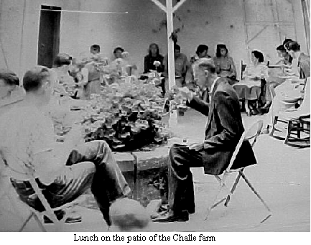
I'd better go back to our trip to San Isidro. After arriving there at 9:30 or 10:00 A.M. and immediately went to the hotel for coffee and rolls, then to the STICA agency.(county extension service) and learned about prices, farms for sale, etc. We arranged to rent horses and the others went out that P.M. Wilford and I had horses--we walked to the edge of town where a road was being built. The American foreman walked up and introduced himself, said he'd heard we were there, and seemed to know all about us—that we were Quakers, were looking for land, etc. He'd been in Costa Rica 7 or 8 years and liked it best around San Isidro—ideal climate and so forth. He told us how big the oranges & grapefruit grew, showed us their headquarters, and repair shops, their gardens (which were doing very well). I asked him about the possibilities of getting a job on the highway, and he thought the chances would be good in a couple or three weeks. The others got back from their horseback ride around 6 o'clock and hadn't been much impressed by anything they'd seen. We ate supper and went to bed after awhile (¢3 a bed). The next morning we went in Hubert's Rover to look at a dairy farm, but it didn't look like what we wanted— especially at the price of ¢500 per manzana. (1 7/10 acres) We then went down the road toward the Pacific and saw a beautiful valley, that appeared good and fertile. It was all being farmed and we saw several peons (workers) threshing beans with long poles as everybody evidently does it here in Costa Rica, and another was knocking peanuts off vines—he had a good crop of them there—good, big peanuts, too. There was corn growing there that didn't look too hot, but the STICA man said it was the wrong time of year for it and that their seed isn't good. There were several disadvantages to that land—too low altitude, no water power, no timber for lumber, and too high priced land--but it did seem pleasant to think of living there, where the days are nice and warm, with a breeze blowing perhaps, and where they have orange trees for fence posts on both sides of the road—just loaded with oranges. We did stop at one dairy farm on the way home (7 or 8 thousand feet) but almost froze to death the minute we stepped out of the Rover, so didn't figure we could enjoy living there. It was entirely too expensive anyway.
We spent the rest of the week at home-going to Arthur’s last week for Sunday dinner and meeting. We took squash pie and cooked squash (ayote). Had a very good meal. We made plans for going to Tilarán on Tuesday. Hubert had some leads on a farm or two up in that direction. It is north and west from here—the Inter-American Highway and. then northeast. We started at 4 o'clock in the morning. We had some paved road, then dirt road with streams to ford and some ruts so deep that the Rover scraped bottom. Hubert had a guard over the oil pan to protect it from the rocks in the road. There was a lot of dust part of the way. In spite of all this and a nail in one tire, we sure did enjoy the trip. After eating dinner (¢5 each) we went as far as possible in the Rover and then hired horses to look over some of the land. One farm we saw had a sugar mill where cane was pressed and the juice processed into "dulce" (hard brown sugar) which was sold in 50 lb. blocks for making rum. The owner had a sawmill and also raised beef cattle. He grossed ¢3,000 per manzana of cane. The land in this vicinity was fairly rough, although there was some that was fairly level. Near the divide it was very windy and it was raining so seemed cold. Although the altitude was only 2000 feet or so, we all nearly froze at nite with only one blanket apiece on our beds. There weren't horses enough for all of us, again, so Arthur and Don Erdman stayed behind. The land which was for sale in this territory was quite a distance from any wagon or auto road, and there was more rainfall than would be best. It was pretty well decided that the San Carlos region would be preferable to this, since it is more level. We returned to the town about dark which was near 6 o’clock, stayed there over night and started for home the next morning.
It seems like there's a bus going to every little village and hamlet in Costa Rica that has a road leading to it, and with fares so cheap, you can't see how they afford to run them.
There has been a lot of discussion as to the best kind of land to buy—whether to get high land or low, rough land or level, rainy climate or dry, cleared land or uncleared land, etc, etc. The high land where the temperature is most ideal, is apt to be rough and not very suitable except for dairying. The land at medium altitudes is used largely for coffee, and sells for from $700 to $900 per acre. None of the group from here is interested in raising coffee. Vegetables, fruits, coconuts grow best on some of the lower land where the weather is from 70° to 100° and there are more insects. Uncleared land might make possible an income from lumber if near enough a market, but cleared land would be better for immediate use for farming.
Don Erdman had been wanting to go over to Peninsula of Nicoya in the province of Puntarenas for some time as there is a farm over there for sale. He and his wife and Wilford and Lucky decided to go, but Mary and I decided we couldn't afford it. They took the train from San Jose on Tuesday morning for Puntarenas and got back yesterday (Friday). Wilford has been talking about it ever since and it seems to be quite a place. Train fare was ¢7 apiece (second class) hotel ¢10 apiece. They had a 2 hour ride by boat to the peninsula early the next morning just as it was getting light. They landed on a little strip of sand beach, mountains rising on either side of it, coconut palms waving overhead—a beautiful place, they said, and walked to the fellows house which was a mile or two away. They said they walked through a pass in the mountains, little expecting to see the valley they came to. They came out on this valley that was perfectly level, with just enough slope to the streams to make it drain well. They got horses and rode over the farm. There were several streams fed by springs, so there is always plenty of water. The owner had been experimenting with irrigation and dug a well finding water at three feet dropping to 5 or 6 feet during the dry season. Wolf said he’d never seen so much wild life anywhere else in Costa Rica—birds, monkeys, iguanas, lizards, etc. The streams are too small for fish, but they claim the ocean is full of good fish that are easy to catch. The land has been stumped, and there are no rocks. I guess timber is available not far from there. There were all kinds of fruit, and the fellow had a patch of pineapple set out, that was doing well…. There are about 2,200 acres and Wolf thought he wants 30 or 40 thousand dollars for the whole works.
Tell Glen you've got to be up off the ground when you're sleeping so you won't be in the way of snakes going through your tent. I don't think the natives sleep on the ground, though that might be softer than the beds they do sleep on If they're like the ones in the hotel at Tilarán. I haven't seen many orchids here. I don't know whether this isn't the season for them or whether they just don't grow around here.
The D4 Catterpillar is supposed to be here anytime now. It's about the last one that the dealer down here expects to get so he says its a good thing Hubert ordered it when he did. The price has gone up on them so it would be no trouble to sell it for as much or more if we decided we didn't need it. Hubert's "Pony" Massey Harris has been here waiting for him since a few days before we came down. Its a little, tractor like a "cub”. Farmall. Horses can be bought for from ¢300 on up to ¢2000 and we'll probably want horses no matter where we're at. The market for timber seems to be pretty good. We've been told that the timber you take off the land will pay for clearing it and building the road into it would depend on several things I suppose. I think it was San Carlos that I mentioned the temperature got as high as 102°. The guys said when they were there there was a breeze blowing, cool mornings and evenings, and not very hot right out in the sun during the day (that was Dec.) from what they said I gathered it was quite unusual for it to reach 100° though l imagine it'd be 90 quite frequently—just guessing. And since they have some of the highest rainfall there, I imagine It would be quite humid most of the time.
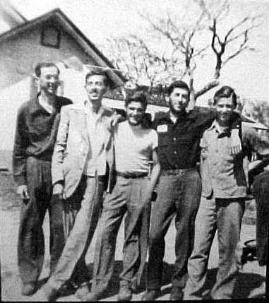
Cecil, Marvin, David, Howard and Leonard Rockwell newly arrived at the Challe farm to tell their stories.

Feb. 5, 1951 The most important news is that the truck, jeep, and trailer pulled in Sunday morning at about 3 AM. They all came here, left the truck and trailer, and Cecil took the other fellows into S.J. They all came out here after they'd had a few hours of sleep. Everybody didn't get collected until past 11 AM so we had dinner first and Meeting after. YOU should have seen the crop of beards! Marvin, Grem, and Rocky all had let their beards grow since Howard Sr. and the others left them so they had a 5 wks growth.....The vehicles came thru looking surprisingly unaffected. The jeep which had started out with a brand new set of mud grip tires had sure worn them down a lot, but the truck tires didn't show much wear...the back tires had spots where chunks of rubber had been chewed off by rocks...the trailer tires were pretty smooth.
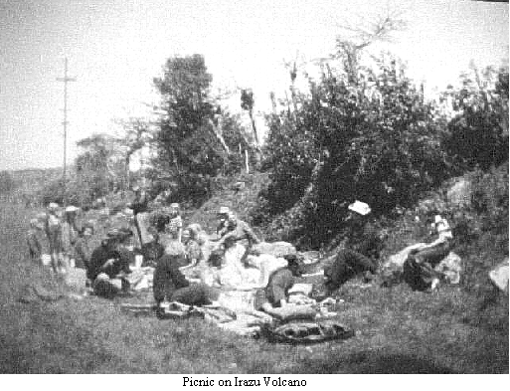
They told us all about their troubles up north near the Costa Rican border—they'd come to bog-holes where they'd sink in to the point where it looked hopeless to get out. Then they'd get out the block and tackle, the pick and shovel and start to work. They'd spent 2 nights in one bog-hole...Some of the grades were so steep the Chevy truck wouldn't pull them up in creeper so they had to unhitch the trailer from the Jeep, hook a chain from the jeep to the truck, and help it up the hill. On such hills the jeep wouldn't pull the trailer up either so they'd take a rope back down to hitch to the jeep and trailer, and pull them up with the truck. Most of the time it seemed that the jeep and the truck took turns helping each other—neither could have made it without the other. There was one stretch where the road was real slick on top … the truck nor the jeep could go up even a slight grade without assistance. In fact, a person could hardly walk up it. So they had to move almost entirely up all the grades using the block and tackle. Said if it weren't for that they wouldn't be here yet—and they almost didn't put it in before they left Fairhope.. I believe they said it was exactly three months to the day since they'd left Fairhope... The girls have been doing washing by hand here.. Dorothy now has her washing machine here but the fellows were going to clean the motor before it's used. It collected a lot of dust on the way down as did everything in the truck and trailer. The dust sifted thru even the smallest cracks.

Feb 13, 1951 Sun. Some one hatched up the plan of taking our dinner and going to the top of Volcán Irazú. I'd baked a cake Sat. to see if I could still cook—a marble cake and made a fudge icing for it and by some stroke of luck it all turned out very well. We got up at 5 Sun. morn and had a little breakfast, then threw our food, blankets etc in Howard's truck and took-off for San Jose. We were prepared for cold weather. We picked up Hubert's then out to San Pedro and got Arthurs and Uncle Elwoods. There is a nice road all the way up to the volcano—concrete though narrow. We got into the fog and mist and it sure did feel cold. There was a certain altitude where we broke thru the clouds, the sun warming us up some—but when we got near the top we drove into another layer and were surrounded by fog and mist again. The pavement came to an abrupt halt so we got out. There were no trees growing but some short little bushes here and there. We walked down the hill toward the rim of the crater and there was nothing but cinders and ashes. It sure did look desolate. Hubert told us there was a high point where on a clear day one was supposed to be able to see both oceans, and Nicaragua so some of us decided to go up there even though it wasn't a clear day. We were sure in for a climb! Right at the top it felt like we'd blow right off…seemed strange to have the wind blow right up out of the crater with such force. Wolf and I and our wives went down to the "knife edge", after we got back down...they say it drops off 500 ft on either side, but we couldn't see due to the fog. The mist got worse and we felt colder and colder so we started back down. When we were out of the fog and mist and back in the sun we pulled off beside the road, threw our blankets on the ground and got out the grub and had a regular picnic dinner beside the highway with buses of staring people going by every 5 or 10 minutes. We found everybody had a sunburned face. After we'd laid around and digested our meal, and taken pictures...we climbed back in and went back to San Jose.
+++++++

Plans were made for a trip to the General Valley, for a few days, and women had never gone along.

Mar. 25, 1951 (Mary's letter)
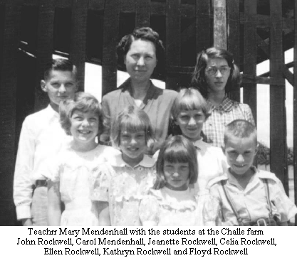
We went up to Hubert's apt. and found them in the midst of loading the jeep—when Hubert saw me he said, "Well good, we have a cook!" so—I went along. Hubert, Marvin, Gremmy (Howard Jr.), Leo, Roy Butgereit, Eston and I made up the group. We got down to the fellows place who got the option for us, at about 12:30. (Had a pretty good trip over the mt. with a stop for coffee.) Then we went on some of the most fascinating roads I ever saw. Gremmy told us the road they'd ridden horseback over were good hard red dirt, steep, but smooth ..So we started out in good faith. Hubert said that Gremmy was all correct but the only thing he forgot to state was in how many directions it was steep at the same time. Boy, we straddled & jumped ditches and rocks on a couple of wheels and all in all had quite an exciting time. All of this was the "Pan-American highway". When we got to the stream it was very nice, rocky and clear, with a pool about waist deep, which would be good for bathing... No-one lived near, so we set up camp....The guys found sleeping places to suit their desire and Eston and 1 bedded down by the fire. The moon came up and it was bright enough to read by almost. While E. and I were lying on our blanket talking, I saw a small animal that looked like a guinea pig, only bigger, run out and look at us and dash back in the underbrush, so Eston sat poised with Hubert's rifle hoping it would come out again, but he had no such luck. .... A couple of the guys went in swimming while the rest watched Hubert shoot a duck and got it... I cooked it up with rice for supper and it was delicious. ... The land was all the way from terribly rocky to no rocks, quite a bit of level land and some practically straight up and down. The soil ran all the way from real black to brown and bright yellow and red clay. All in all looked pretty decent and one of the best large pieces of land they had seen. 1 saw a wild turkey right near camp, raised a gun to shoot at him but he flew before I got the sights on him—at least I bet that's more than most of you could say! I enjoyed it immensely at camp, it was quite warm, but it didn't get above 87° F while we were there nor below 59 at night. I guess most of the group thinks it is too hot though.
++++++++++++++++++++++++++++++++++++++++

EL SEMANARIO - excerpts
(The first edition when school started)
3rd Mo 9th. 1951

"Driving to Central America is lots of fun, but there is also lots of work to it, such as practically building roads, unloading truck, and sweating it out with customs. The woman's side of it isn't easy either, planning meals, trying to keep clothes washed up, patching up holes in people and clothes. That isn't easy right there because clothes are always getting torn and people getting skinned up! We know from experience! But if you are looking for fun, and don't mind work, we won't try to stop you!"
Eston is teaching the school Spanish. We like to have him very much. Muchas gracias!

3rd Mo 30th, 1951
Guests are expected at the farm seventh day. Everyone is very excited about their arrival. The guests are: Raymond Stanley, Oliver Kirk, and Lawrence Osborn. They are being conducted on the tour by Howard Rockwell, Sr. who will be a resident here upon arrival.
A-HUNTING WE WILL GO—When the folks that went to the General Valley came back Seventh Day night we heard big tales about their hunting. Hubert had shot some kind of water bird. They said it was very good with rice. They also had another bird that Marvin shot. It was a very bright colored bird with yellow, red, green and black. It wasn't very big after they had taken off all the feathers and the big bill. Another group left well armed on a land hunting trip to Turrialba. We're hoping they'll come home loaded with wild pork or venison. We got ready for a goat barbeque at the first of the week when David went hunting, but he came back empty handed.

4th Mo. 6th, 1951
Three trips were made this week up the mountain above San Isidro to view some farms. Second-day three jeeps bumped along the roads astonishing the natives. Since the day wasn't long enough to see all they wanted, two Jeeps went again the next day to more distant places. Fourth Day the two Jeeps took all of the people who didn't go the other times.
Yesterday morning everyone got up early to see the people leaving for the General. The people that went were Cecil, Ollie, Lawrence, Howard, Raymond and Jorge. They took all sorts of paraphernalia planning to camp overnight. We are expecting them today.
++++++++++++++++++++++++++++++++++++++++
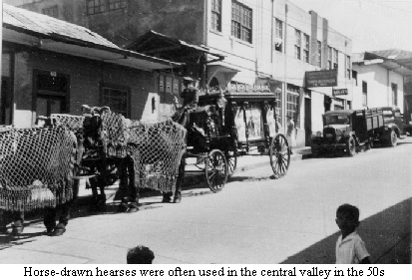
++++++++++++++++++++++++++++++++++++++++

- from letters by Eston Rockwell to his parents
Apr. 15, 1951
Guess I'd better write and let you know we're practically settled on a location so you might as well sell out, pack up and come right down. The farms we are now considering are only 4 or 5 miles from here and we drove up the hill to see them on Wednesday. We had our first rain on Tuesday when it really poured down and was darker than I can remember seeing it here during the day. We were able to make it up to the farms quite easily in the jeep but we went back yesterday (4/12) to look at 3 more farms and there was one hill that almost stopped us in jeeps as it was pretty slick and muddy. It has been raining since so I doubt if we could make it again; at least not without chains. Ray Stanley, Ollie Kirk, Lawrence Osborn and Howard Sr. came in on the plane on Saturday, 3/31/51 Wolf also came back from Turrialba the day before that, his work finished. He did get some money out of it besides his room and board. Those fellows were interested in seeing around and were taken up the 180 manzana dairy farm up the road here and thought it looked pretty nice as it's a lot like Ohio—hilly. Then Cecil took them and a few others down to the General Valley to Dr. Mezas farm so they could get an idea of what it was like there. They spent two days on that trip, camping out overnight. They came back feeling like it'd be a pretty hot place to live but otherwise thought it looked like it had several possibilities—good laying land, good lumbering prospects and so forth. It's been quite warm here in San Jose recently but since the rain started it's gotten colder so is almost uncomfortably cool. Some of us without much capital to invest felt that the General Valley would provide a better chance to get started without making such a large investment, but some of the group feels that it would be better to buy places which were higher priced but already developed, that would start producing an income immediately. There was a good deal of discussion as to whether some of the group should buy in the General Valley, and others the farms near here, but we finally decided that the group should all stay together so we sent word that we would not take advantage of our option on Dr. Meza's farm. Since then, we have found that the other people interested in that farm are not as interested as we thought or as we'd been led to believe so weren't ready to buy it the minute our option ran out—so Jorge has come back and asked what offer we would make and has seemed eager to make terms of some kind, either for a part or all of the land and would throw in the 20,000 coffee plants if we would buy a large enough portion of the farm. There still is interest in the General Valley but for the time being at least, we are not buying there, and are planning to get the land near here. We had taken soil samples from Meza's farm and found that they tested low on phosphate and below on average on nitrates and potash. The results of those tests made us wonder whether we could raise good crops there without some extra expense. The land up here is near a small town named San Josesito which means "little San Jose". That dairy farm I mentioned of 180 manzanas figures at $80 an acre more or less and is the cheapest of anything in that community. Much of it would have to be kept in pasture land. Other farms near there have good level land but would cost near $300 per acre. One man has a farm of 9 1/2 manzanas (about 16 acres) and says he makes around ¢4,000 (over $500) a year from that farm but that doesn't prove what could be done. We figured up from the figures he gave on production and price of garlic that it'd be possible to make from ¢7,500 to ¢10,000 per manzana on that crop—but there'd be a lot of work involved and then 1 manzana of garlic would probably flood the market! Hubert was figuring on what it would take to start up there— $4,000 for land $1,000 for house, $1,000 for cows and livestock.--total, $6,000. Hubert suggested to Wolf and I that the three of us might go in together on that 180 manzana farm and try starting with sheep and dairy cows and maybe put some beef cattle on it, too, to see what they would do, working together the first year since it would be too much for one person and would help us in getting a start.
He figures that place is big enough for 3 or 4 farms, with each one at about 50 acres. One disadvantage of this land is that we'd have to buy all our lumber and haul it in for building houses and so forth. The houses are pretty poor and there wouldn't be enough of them for everybody.
++++++++++++++++++++++++++++++++++++++++

Ones who came-From Nov. 1950 - Dec. 1951

Roy Butgereit 18 yrs.
John H-. Campbell, 32 yrs.
Doris (Stetzel) Campbell 32 yrs.
George Campbell 3 yrs.
Ruth Campbell 1 yr.4 m.
Wilford Guindon 20 yrs.
Lucille (Standing) Guindon 18 yrs
Alberto Guindon born in August.
Ted Harkey 23 yrs.
Janice (Stetzel) Harkey 23 yrs.
Ted, Jr. Harkey 2 yrs.
Bert Howard about 22 yrs. (left within the year)
EIwood Mendenhall 80 yrs.
Ruth (Rockwell) Mendenhall 66 yrs.
Mary Mendenhall 36 yrs.
Hubert Mendenhall 33 yrs.
Mildred (Mott) Mendenhall 30 yrs.
Carol Mendenhall 8 yrs.
Ruth Mendenhall 5 yrs.
Phillip Mendenhall 2 yrs.
Wayne Olerich about 21 yrs. (left within the year)
Marge about 21 yrs. (left within the year)
Lawrence Osborn (Standing) 18 yrs.
Betty (Starbuck) Osborn (after Aug, 51) 18 yrs.
Arthur Rockwell 72 yrs.
Clara (Hall) Rockwell 65 yrs.
Marvin Rockwell 28 yrs.
Cecil F. Rockwell 36 yrs.
EIva (Mendenhall) Rockwell 38 yrs.
Ellen Rockwell 10 yrs.
Jeanette Rockwell 8 yrs.
Floyd Rockwell 7 yrs.
Paul Rockwell 5 yrs.
Reuben Rockwell 57 yrs.
Helenbelle (Lucier) Rockwell 55 yrs.
David Rockwell 20 yrs.
Eston Rockwell 20 yrs.
Mary (Chamness) Rockwell 18 yrs.
Emily Rockwell born in December
Howard Rockwell 48 yrs.
Dorothy (Rockwell) Rockwell 45 yrs.
Howard Rockwell, Jr. 22 yrs.
Leonard Rockwell 20 yrs.
Kathryn Rockwell 15 yrs.
John Rockwell 12 yrs.
Celia Rockwell 7 yrs.

For a short time was Frank Laraway & Warren Stetzel.
In 1952, Abner Rockwell & Irma (Stanley) Rockwell & daughter, Doris Rockwell arrived.
Later, son Glen & daughter Phyllis joined them.
++++++++++++++++++++++++++++++++++++++++

Drawing by Anne Kriebel.

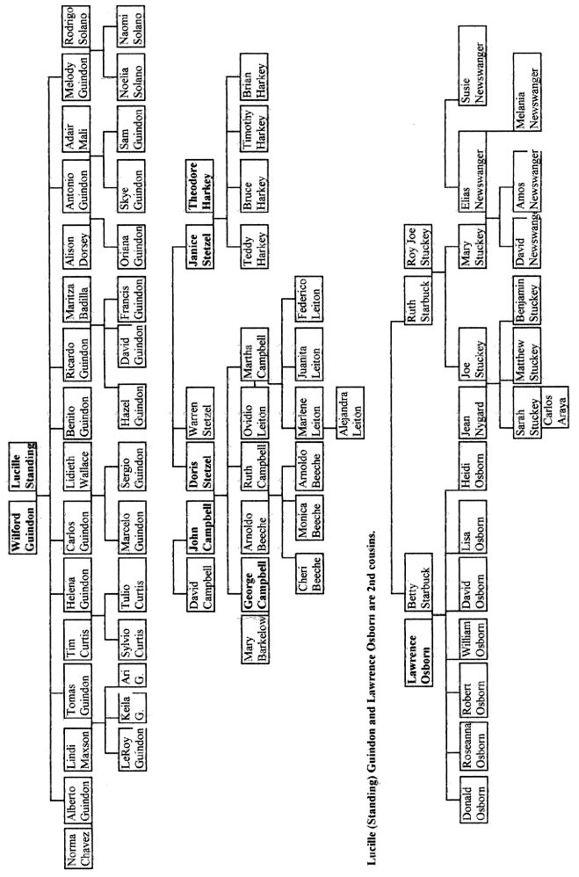
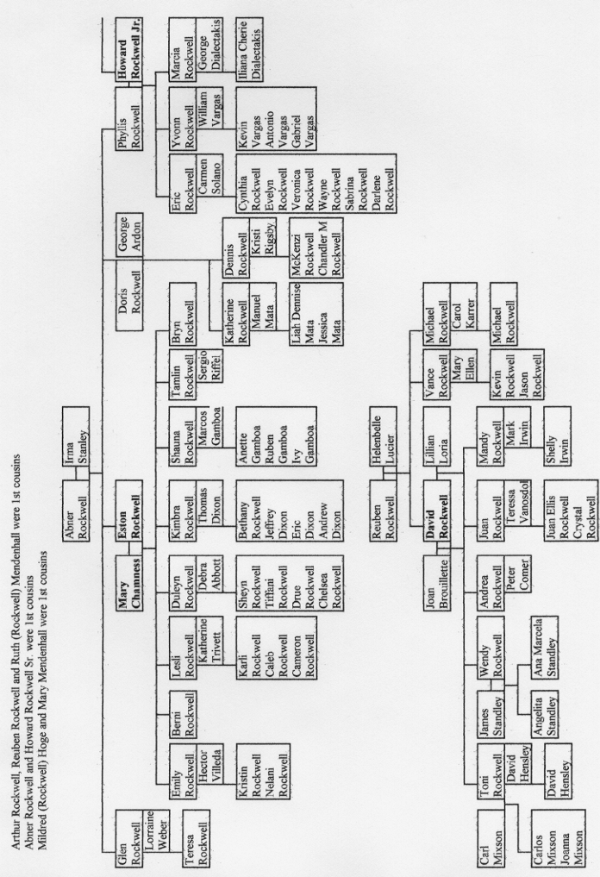
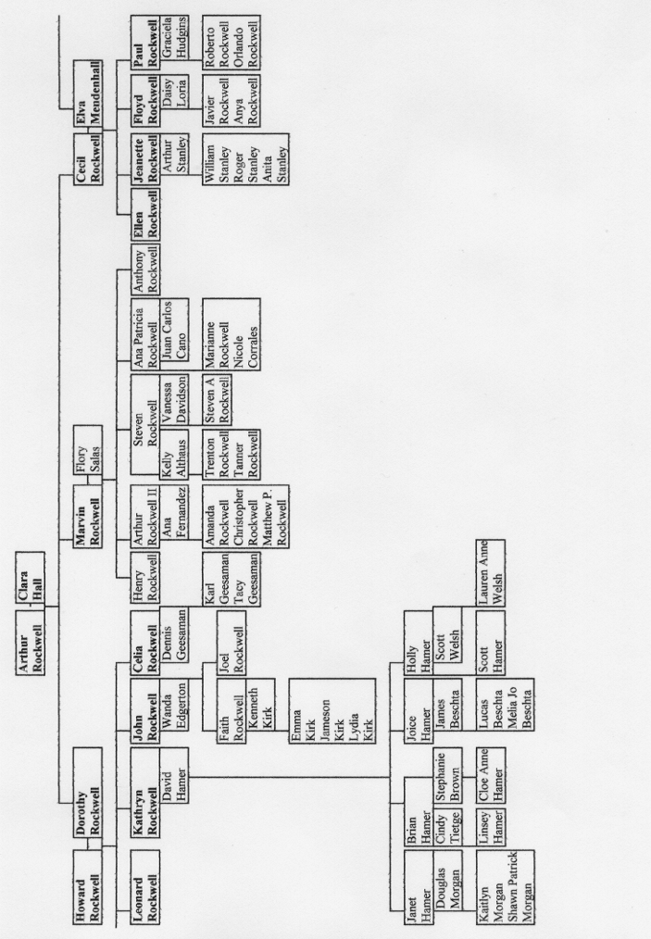
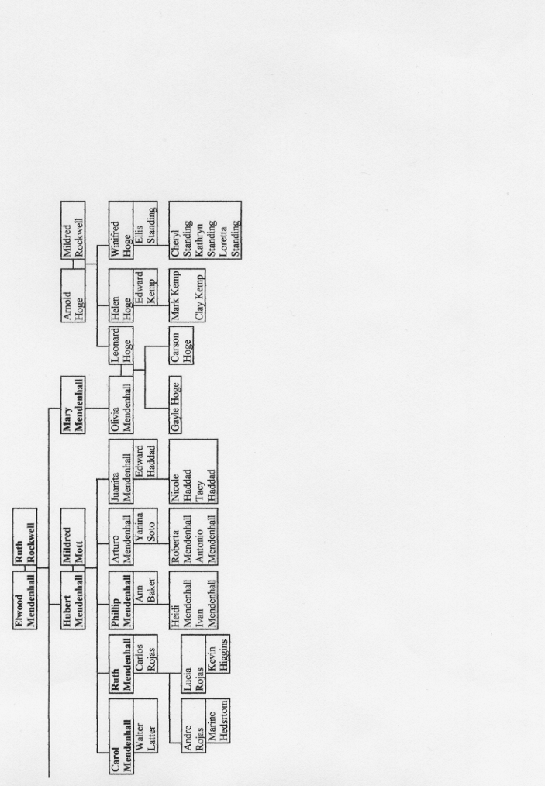

We celebrated our son George's third birthday on the 9th of June.

