Oahspe: A Kosmon Bible
http://en.wikipedia.org/wiki/Oahspe
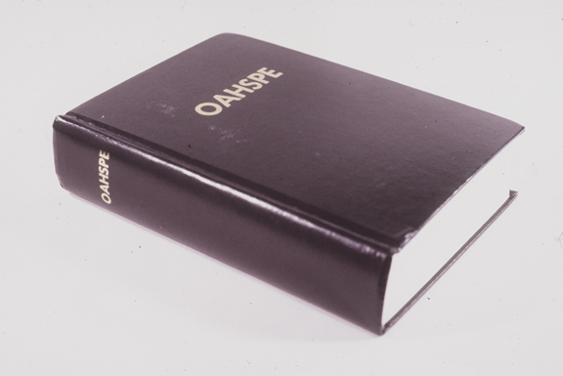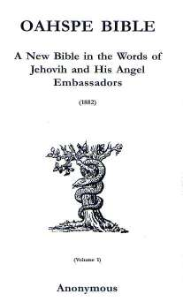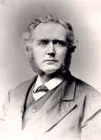
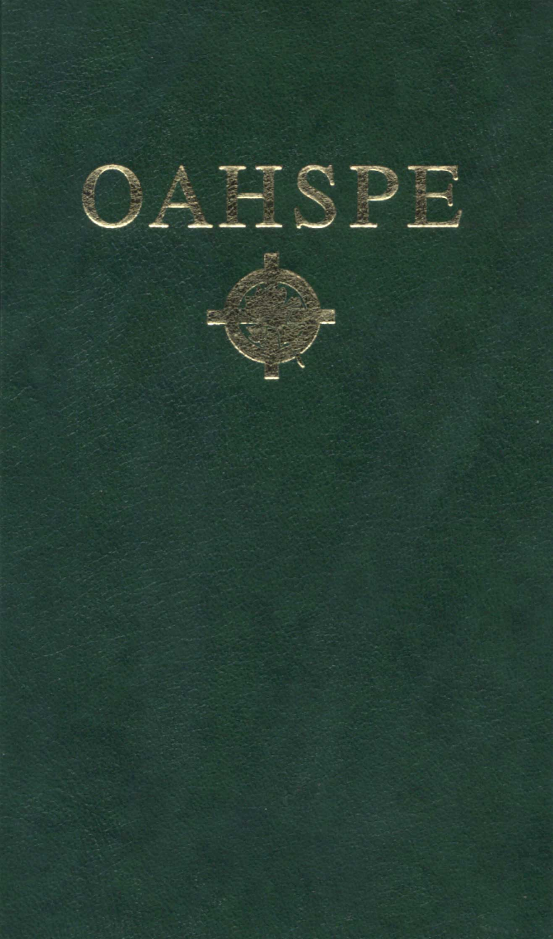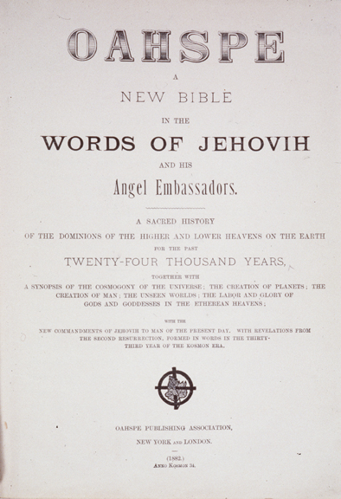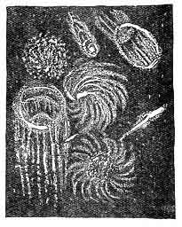
Oahspe: A Kosmon Bible in the Words of Jehovih and his Angel Embassadors (sic) is a book announcing new revelations from God, which was produced by John Ballou Newbrough (1828-1891) by automatic writing, and which was first published by Newbrough in 1882.
According to the glossary in the book, 1882 version, the meaning of the word used in the title is:
Oahspe. Sky, earth (corpor) and spirit. The all; the sum of corporeal and spiritual knowledge as at present. [1]

Contents
- 1 The revelation of Oahspe
- 2 What the Revelation says
- 3 See also
- 4 External links

The revelation of Oahspe
Newbrough was a dentist who lived in the Boston, Massachusetts area. The practice of automatic writing was well known during the period in which Oahspe was revealed, largely as a result of the technique being used in the Spiritualist movement. Newbrough believed that angels were dictating the messages that ultimately appeared in Oahspe; large portions of the manuscript were produced by Newbrough by the means of automatic writing upon the recently invented typewriter.

What the Revelation says
Oahspe's stated purpose is: "Not infallible is this Book, Oahspe; but to teach mortals how to attain to hear the Creator's voice, and see His heavens, in full consciousness, whilst still living on the earth; and to know of a truth the place and condition awaiting them after death." Oahspe Prologue, Verse 24.
The voice of Jehovih is not an audible sound but rather a subtle impression to the soul... "my voice is not a sound but comes to the soul from all sides." "I am the Creator, and am sufficient to all the living." The bulk of Oahspe contains cosmological revelations concerning the evolution of the human race and life on Earth. The text suggests that the Earth travels with the sun through various regions of space, and that each of these regions has spiritual and physical consequences for Earth and its inhabitants. These several regions are under the presidency of various spiritual beings who are designated "sons and daughters of Jehovih," and as such the text of Oahspe contains separate books like the "Book of Cpenta-Armij, Daughter of Jehovih" and even the "Book of Thor, Son of Jehovih."
One typographical peculiarity of these books is that many of them are printed on pages divided in two, top to bottom. In these, the top half of the page contains a narrative of celestial events, while the bottom half describes the corresponding events on Earth. Oahspe also contains a body of information that purports to provide explanations that cover events in the spirit worlds, pre-historical events and amendments to known historical accounts regarding the origins of all of Earth's religions.
Oahspe has many graphics which include symbols purported to be of ancient languages and an original language called Pan. And the text is written in a style that is similar to early modern/Elizabethan English, even though it was written around 1881. It also contains many unfamiliar words whose meanings and origins are not fully explained (and a few not even mentioned) in the accompanying glossary. Many of the strange words are purported to be derived from ancient mortal languages and even spirit words. A sub-book, Book of Saphah, has details of the meanings and roots of many of the unfamiliar words and symbols. Such aspects mean that Oahspe is a book that requires more than casual reading to begin to understand and digest.
A sample of the text of Oahspe will give an impression of its style:
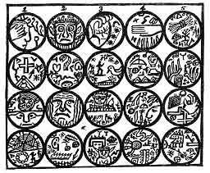
The Tablet of Fonece
1. JEHOVIH said: By virtue of My presence created I the seen and the unseen worlds. And I commanded man to name them; and man called the seen worlds Corper, and the unseen worlds Es; and the inhabitants of Corpor, man called corporeans. But the inhabitants of Es he called sometimes es'eans and sometimes spirits, and sometimes angels.
2. Jehovih said: I created the earth, and fashioned it, and placed it in the firmament; and by My presence brought man forth a living being. A corporeal body gave I him that he might learn corporeal things; and death I made that he might rise in the firmament and inherit My etherean worlds.
3. To es I gave dominion over corpor; with es I filled all place in the firmament. But corpor I made into earths and moons and stars and suns; beyond number made I them, and I caused them to float in the places I allotted to them.
4. Es I divided into two parts, and I commanded man to name them, and he called one etherea and the other atmospherea. These are the three kinds of worlds I created; but I gave different densities to atmospherean worlds, and different densities to the etherean worlds.
5. For the substance of My etherean worlds I created Ethe, the MOST RARIFIED . Out of ethe made I them. And I made ethe the most subtle of all created things, and gave to it power and place, not only by itself, but also power to penetrate and exist within all things, even in the midst of the corporeal worlds. And to ethe gave I dominion over both atmospherea and corpor.
--- From The Book of Jehovih, chapter II
Oahspe is available in a current edition printed by the Universal Faithists of Kosmon, CO. USA; and as an e-text now in the public domain. Oahspe is a text studied by an unknown number of individuals as well as a small religious denomination that now calls itself the Faithists of Kosmon; the sect still exists, though the number of its members are dwarfed by the followers of other nineteenth century alternative Scriptures.

See also
- The Urantia Book

External links
- Oahspe Quotations
- Oahspe: A Kosmon Bible in the Words of Jehovih and his Angel Embassadors, revised 1912 third edition
- Pamphlet on the Origin of Oahspe
- Shalam Colony, a utopian community founded by Oahspe believers
- Oahspe Resources
=============================================================================================
http://thenewagefiles.shadowweb.info

Oahspe
John Ballou Newbrough
1828 - 1891

Oahspe, means literally "Sky, Earth and Spirit" (O for sky, ah for earth and spe for spirit). The book is a product of automatic writing which occurred through the hands of a medium, Dr. John B. Newbrough, over the course of one year (1881) c The book states that it was written by an overshadowing of angelic beings, who are not a separate order in creation, but are actually our elder brothers and sisters, once mortals like ourselves, but now high-raised in wisdom through countless years of growth and experience.
Its purpose is to give us an understanding, while yet in mortality, of what the world of spirit is really like, what the general history of the world has been and, as a result, give us insight into our true purpose and destiny as the immortal, potentially angelic, souls that we are.
Oahspe states that we have entered a New Age, an age in which we will eventually see the maturity of humanity. It explains that this is part of the natural evolution of any inhabited planet (There are countless numbers of them throughout our vast universe, so we are not alone). We entered this New Age not long before this book was written...The eventual result will be a mature balance between material and spiritual knowledge within all of humanity.
Shalam Colony
Shalam was founded by a New York dentist and doctor named John B. Newbrough and a group of his religious followers called Faithists. Newbrough claimed to have written a new Bible, called Oahspe, while under spirit control. Contained in this Bible was "The Book of Shalam," which set forth a plan for gathering the outcast and orphaned children of the world and raising them, according to strict religious principles, to be the spiritual leaders of a new age.
Newbrough and some twenty Faithists decided to create such a place as described in "The Book of Shalam."
In 1884, Shalam Colony was finally established on the banks of the Rio Grande, one mile from the village of Dona Ana. It is generally believed that without the help of the villagers of Dona Ana, the colonists would have suffered even more than they did the first year. The villagers showed them how to cook beans and make adobe bricks, and other skills necessary to survive in this new land. Financed by a wealthy wool merchant from Boston, Andrew Howland, the colony was developed into one of the finest agricultural areas of the Southwest. Nearly a million dollars was spent to build and furnish fine buildings and maintain a herd of prize dairy cattle, build a chicken farm with heated runs, and develop a reservoir and irrigation system which was far ahead of its time.
Disaster befell the colony in 1891 when John Newbrough died of influenza. His widow, Frances Van de Water Sweet, married Andrew Howland in 1893 in an effort to put to an end malicious gossip. Together they tried valiantly to keep the colony going, but the obstacles proved overwhelming. The colony had attracted many who did not want to work; the Rio Grande flooded often and destroyed acres of crops; the financial burden was too great and the markets too few. In 1901, the children who had not been adopted were sent to orphanages in Dallas and Denver and Shalam Colony was closed.
===============================================================================================================
END

