Society for Psychical Research
http://en.wikipedia.org/wiki/Society_for_Psychical_Research
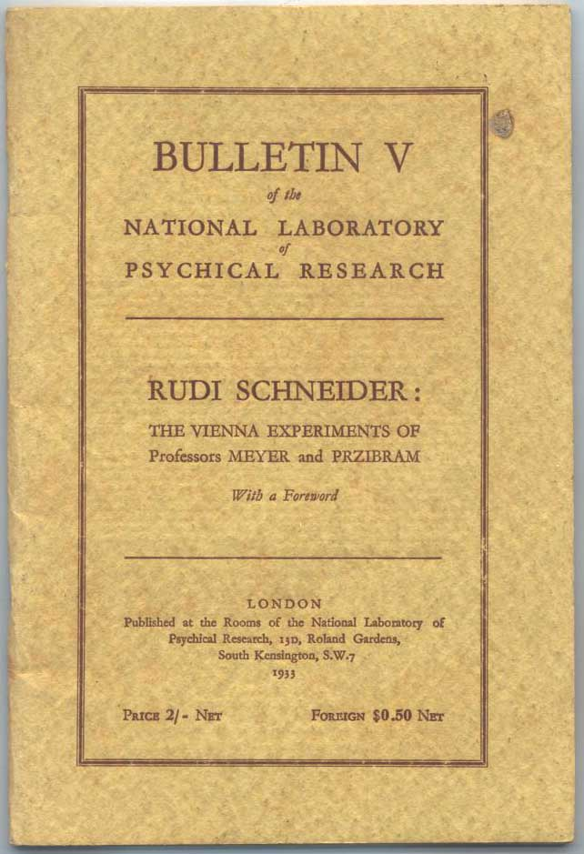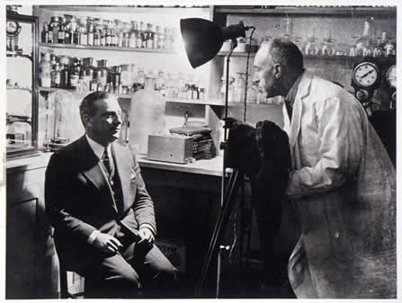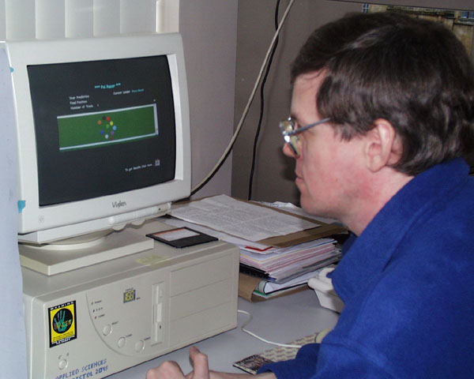

Society for Psychical Research (SPR) is a non-profit organization in the United Kingdom whose purpose is to research and investigate supernatural, magical, paranormal, and occult phenomena in a scientific and unbiased manner. It was founded in 1882 by three dons of Trinity College, Cambridge, Edmund Gurney, Frederic William Henry Myers, and Henry Sidgwick, because of their interest in spiritualism.
The Society has a membership of 5,500 and an average revenue of 5.2 million pounds per year. Its headquarters is in Marloes Road, London.
The Society holds no corporate opinions: all opinions expressed are those of the individual members. It publishes the quarterly Journal of The Society for Psychical Research (JSPR) and irregular Proceedings, and holds an annual conference.

Contents
- 1 History
- 2 Today
- 3 References
- 4 See also
- 5 External links

History
Its purpose was to encourage scientific research into psychic or paranormal phenomena in order to establish their truth. Research was initially aimed at six areas: telepathy, mesmerism and similar phenomena, mediums, apparitions, physical phenomena associated with séances and, finally, the history of all these phenomena. The Society is run by a President and a Council of twenty people. The organisation is divided between London and Cambridge, the London headquarters were initially at 14 Dean's Yard. A French branch of the Society was formed in 1885 as the Société Française pour Recherche Psychique (SFRP), which means "French Society for Psychical Research". Later, an American branch of the Society was formed as the American Society for Psychical Research (ASPR), becoming an affiliate of the original SPR in 1890. Famous supporters of the society have included Alfred Lord Tennyson, Mark Twain, Lewis Carroll, Carl Jung, J. B. Rhine and Arthur Conan Doyle (who was shamefully duped on at least one occasion by tricksters).
The Society was especially active in the thirty years after it was founded, gaining fame for the Hodgson Report in 1884. Most initial members were spiritualists but there was a core of 'professional' investigators - the Sidgwick Group, headed by Henry Sidgwick, a formation pre-dating the SPR by eight years. The Society was weakened by internal strife, a large part of the members (the Spiritists) left as early as 1887 in opposition to the non-spiritualist approach taken by most intellectuals.
The presidents of the Society for Psychical Research
1882-1884 | Henry Sidgwick (1838-1900), philosopher
1885-1887 | Balfour Stewart (1827-1887), physicist
1888-1892 | Henry Sidgwick (→ 1882)
1893 | Arthur Balfour (1848-1930), later prime minister, originator of the well known Balfour Declaration
1894-1895 | William James (1842-1910) American psychologist and philosopher
1896-1897 | Sir William Crookes (1832-1919), physicist and chemist
1900 | Frederick William Henry Myers (1843-1901), philologist and philosopher
1901-1903 | Sir Oliver Lodge (1851; †1940), physicist
1904 | Sir William Fletcher Barrett (1845-1926), physicist
1905 | Charles Robert Richet (1850; †1935), French Physiologist und Nobel Prize winner
1906-1907 | Gerald Balfour (1853-1945), politician
1908-1909 | Eleanor Sidgwick (1845-1936), parapsychologist
1910 | Henry Arthur Smith (1848-), Anwalt
1911 | Andrew Lang (1844-1912)
1912 | W. Boyd Carpenter (1841-1918), Bischof
1913 | Henri Bergson (1859-1941) French philosopher; Nobel Prize for literature 1927.
1914 | Ferdinand Canning Scott Schiller (1864-1937), philosopher
1915-1916 | George Gilbert Aime Murray (1866-1957), philologist
1917-1918 | Lawrence Pearsall Jacks (1860-1955), professor of philosophy in Oxford
1919 | John Strutt, 3rd Baron Rayleigh (1842-1919), physicist, Nobel Prize 1904
1920-1921 | William McDougall (1871-1938), psychologist
1922 | Thomas Walter Mitchell (1869; †1944), or of the British journal of medical psychology
1923 | Camille Flammarion (1842-1925), astronomer
1924-1925 | John George Piddington (1869-1952), businessman
1926-1927 | Hans Driesch (1867-1941), German biologist and natural philosopher
1928-1929 | Sir Lawrence Jones (1885-)
1930-1931 | Walter Franklin Prince (1863-1934), founded the Boston SPR in 1925
1932 | Eleanor Sidgwick (→ 1908) and Oliver Lodge (→ 1901)
1933-1934 | h Lyttelton (1865-1948), playwright
1935-1936 | Charlie Dunbar Broad (1887-1971), philosopher
1937-1938 | John Strutt, 3rd Baron Rayleigh (→ 1919)
1939-1941 | Henri Haberley Price (1899-)
1942-1944 | Robert Henry Thouless (1894-), psychologist
1945-1946 | George Tyrell (*1879; †1952), mathematician
1947-1948 | William Henry Salter (1880-), lawyer
1949 | Gardner Murphy (1895-1979), psychologist
1950-1951 | Samuel George Soal (1889-1975), mathematician
1952 | George Murray (→ 1915)
1953-1955 | Frederick Stratton (1881-), astrophysicist, professor in Cambridge
1956-1958 | Guy William Lambert (1889-), diplomat
1958-1960 | Charlie Dunbar Broad (→ 1935)
1960-1961 | Henri Habberley Price (→ 1939)
1960-1963 | Eric Robertson Dodds (1893-), professor of Greek studies in Birmingham and Oxford
1963-1965 | Donald James West (1924-), psychiatrist and criminologist
1965-1969 | Sir Alister Hardy (1896-1985), zoologist
1970 | W. A. H. Rushton (1901-1980), physiologist, professor in Cambridge
1971-1974 | Clement William Kennedy Mundle (1916-), philosopher
1974-1976 | John Beloff (1920-2006), psychologist at the University of Edinburgh
1976-1979 | Arthur J. Ellison (-2000)
1980 | Joseph Banks Rhine (1895-1980)
1980 | Louisa Ella Rhine (1891-)
1981-1983 | Arthur J. Ellison (→ 1976)
??? | ???
1992-1993 | Alan Gauld
1993-1995 | Archie Roy, professor of astronomy in Glasgow, founded the Scottish SPR in 1987
1996-1999 | David Fontana, professor of psychology at Cardiff University
1999-2004 | Bernard Carr, professor of mathematics and astronomy at London University
2004- | John Poynton, Biologist
Remark concerning the persons in italics: Eleanor Sidgwick was the wife of Henry Sidgwick and the sister of both Arthur Balfour and Gerald Balfour.

[] Today
The Society still exists and states its principal aim as "understanding events and abilities commonly described as 'psychic' or 'paranormal' by promoting and supporting important research in this area." Of its initial aims, the most successful has been the gathering of data relating to the history of the paranormal - the SPR has built up an extensive library and archive, part of which is held at the University of Cambridge. The Journal is peer reviewed and respected in the field of parapsychology.
The Society still has many well known figures among its members, including parapsychologists Susan Blackmore, Ciarán O'Keeffe, and Louie Savva. Investigators of spontaneous phenomena (hauntings, etc.) include Maurice Grosse and Guy Lyon Playfair who are best known for the Enfield Poltergeist.

[] References
- Vernon Harrison. (1997) H. P. Blavatsky and the SPR. ISBN 1-55700-119-7

[] See also
- Perrott-Warrick Fund[1]

[] External links
- SPR home page
- The Society for Psychical Research Scandal
- The Committee for the Scientific Investigation of Paranormal Claims
- The Need for Responsibility in Parapsychology: My Sixty Years in Psychical Research by Eric Dingwall, a history and evaluation
=====================================================================================================================================
END

