Reincarnation

http://en.wikipedia.org/wiki/Reincarnation

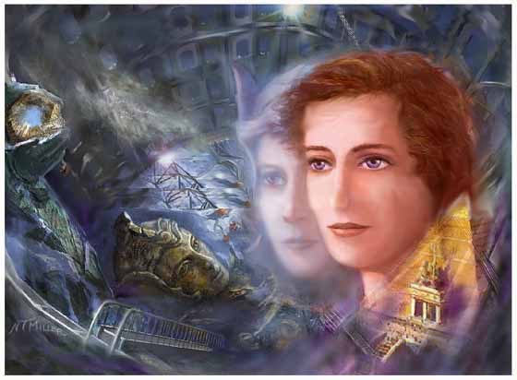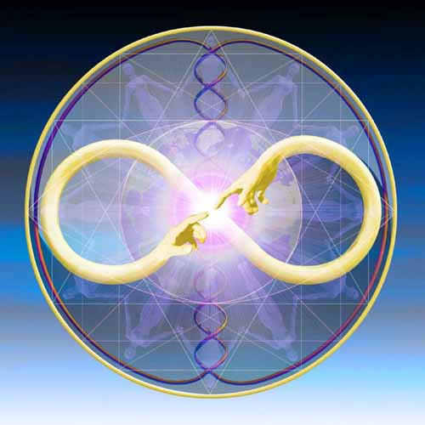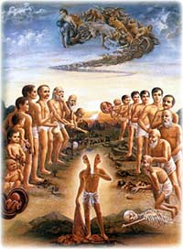

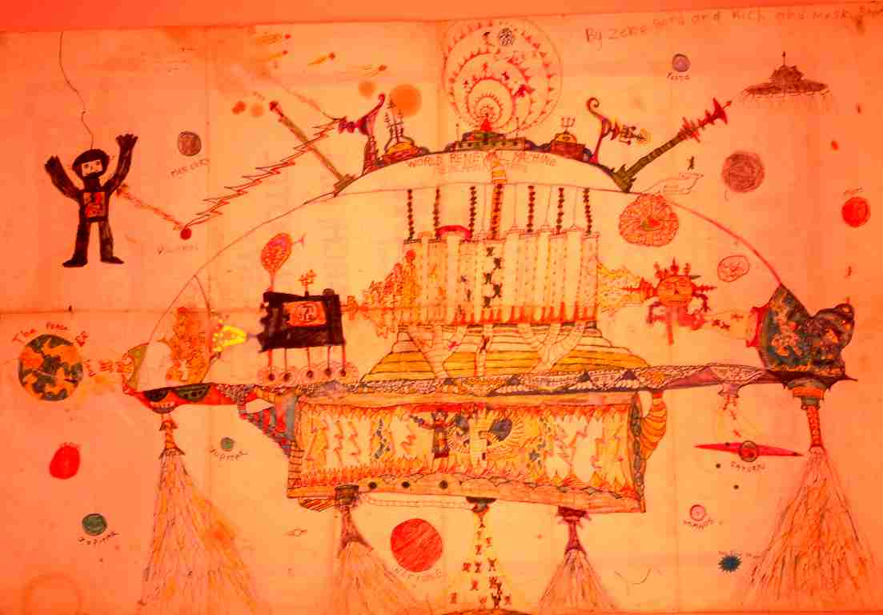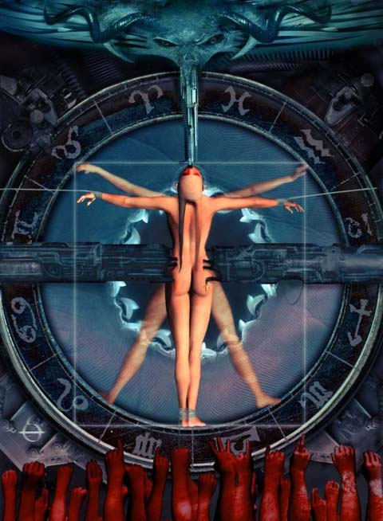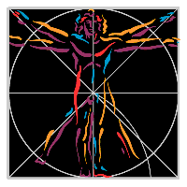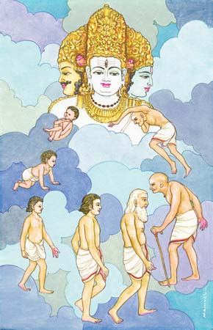

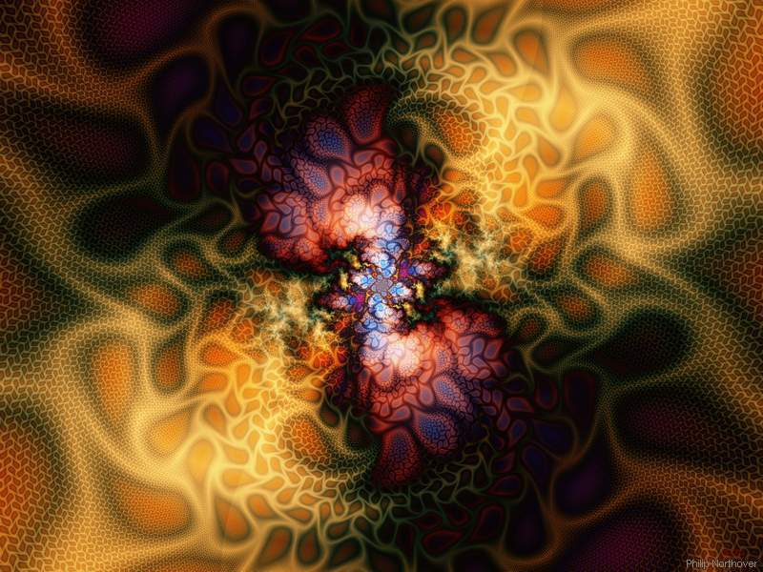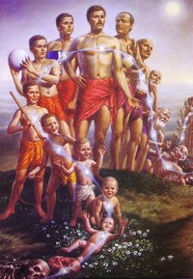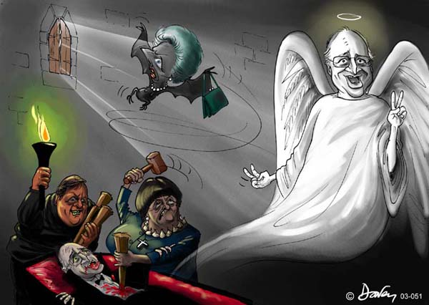

Reincarnation, literally "to be made flesh again", as a doctrine or mystical belief, holds the notion that some essential part of a living being (or in some variations, only human beings) can survive death in some form, with its integrity partly or wholly retained, to be reborn in a new body. This part is often referred to as the Spirit or Soul, the 'Higher or True Self', 'Divine Spark', 'I' or the 'Ego' (not to be confused with the ego as defined by psychology).
In such beliefs, a new personality is developed during each life in the physical world, based upon past integrated experience and new acquired experiences, but some part of the being remains constantly present throughout these successive lives as well. It is usually believed that there is interaction between predeterminism of certain experiences, or lessons intended to happen during the physical life, and the free-will action of the individual as they live that life.
This doctrine is a central tenet within the majority of Indian religious traditions such as Yoga, Vaishnavism and Shaivism (from Hinduism), and also Jainism and Sikhism. It was common belief among the Ancient Greeks and Ancient Romans^{[citation needed]}. Many modern Pagans also believe in reincarnation as do some New Age movements, along with followers of Spiritism, practitioners of certain African traditions, and students of esoteric philosophies. The Buddhist concept of Rebirth although often referred to as reincarnation differs significantly from the Vedic based traditions and New Age movements in that the "self" (or soul) does not reincarnate (see below).

Contents
[hide]
- 1 Overview
- 2 Reincarnation in various religions, traditions and philosophies
  - 2.1 Eastern religions and traditions
    - 2.1.1 Hinduism
    - 2.1.2 Buddhism
    - 2.1.3 Jainism
  - 2.2 Western religions and traditions
    - 2.2.1 Classical Greek philosophy
    - 2.2.2 Judaism
    - 2.2.3 Gnosticism
    - 2.2.4 Christianity
    - 2.2.5 Islam
    - 2.2.6 Druze
    - 2.2.7 Native American Nations
    - 2.2.8 Norse mythology
  - 2.3 Contemporary movements and thinkers
    - 2.3.1 Modern thinkers
    - 2.3.2 Spiritism
    - 2.3.3 Anthroposophy
    - 2.3.4 Theosophy
    - 2.3.5 Scientology
    - 2.3.6 Edgar Cayce
    - 2.3.7 Seth Jane Roberts
    - 2.3.8 The New Age movement
- 3 Research and debate
  - 3.1 Scientific and other research into reincarnation
  - 3.2 Objections to reincarnation
- 4 See also
- 5 References
  - 5.1 Scientific publications
  - 5.2 Literature
- 6 External links

[] Overview
Belief in reincarnation is an ancient phenomenon; in various guises humans have believed in a future life since the ancient Egyptians^{[citation needed]}, perhaps earlier, and ancient graves containing both people and possessions may testify to beliefs that a person would have need for their treasured possessions once again despite physical death.
In brief, there are several common concepts of a future life. In each of them either the person, or some essential component that defines that person (the soul or spirit) persists in continuing existence:
- Reincarnation in human form.
Successive lives on earth, usually including a belief in a passage through the spiritual world or inner planes between death and rebirth. This is the most common use of reincarnation (also called "rebirth"). In many versions, eventually there is the potential to escape the cycle, e.g. by joining God, or achieving enlightenment, some kind of self-realization, a spiritual rebirth, entering a spiritual realm, etc.
- Transmigration of the soul
Beings die, and are returned to this or another existence continually, their form upon return being of a 'higher' or 'lower' kind depending upon the virtue (moral quality) of their present life. This presupposes interchange between human and animal souls, at a minimum; plants and stone may be included, as well.
- Last Day
People live only one life. After death, they may return to the earth or be revived in some final Judgement, or at some final battle (eg the Norse Ragnarok). They may go to heaven or hell at that time, or live again and repopulate the earth. This is an apocalyptic vision of the future.
- Related to these, but no longer including a return to embodied form, are beliefs in an Afterlife
People live on this earth, and then live in some kind of afterlife for the rest of eternity - variously called heaven (paradise) or hell, or the Kingdom of the Dead, or some higher plane, or similar. They do not return to earth as such.
Beliefs in reincarnation or transmigration are widespread amongst religions and beliefs, some seeing it as part of the religion, others seeing in it an answer to many common moral and existential dilemmas, such as "why are we here" and "why do bad things sometimes appear to happen to good people." Reincarnation is therefore a claim that a person has been or will be on this earth again in a different body. It suggests that there is a connection between apparently disparate human lifetimes, and (in most cases) that there may even be covert evidence of continuity between different people's lifetimes, if looked for. Proponents claim this is indeed the case, whilst critics tend to reject the notion due to its metaphysical implications or non-acceptance by science due to other possible explanations of the phenomenon not yet eliminated from consideration. Such evidence tends to be of three kinds:
- Tradition commonly holds that certain people (such as the Dalai or Panchen Lamas in Buddhism) can be identified by looking for a child born at a specified time after their death, and by certain signs and knowledge that such a child has of their predecessor life beyond the norm. In the case of Buddhism there are well defined tests of such a child.
- In Western culture, regression or near death experience has at times provided what are claimed to be past life memories, some of which can in theory be verified, and some of which might be tested for fraudulent claims. Some aspects of these tend to be quite consistent in some ways (beings of light, messages of love and peace, etc), a factor which to some people lends credence to the idea, and to others supports that "something" is going on but without certainty what that might be.
- Last, for many people, the evidence is internal and empirical, personal belief or experience. This may not be proof as such, but to them, qualifies as sufficient evidence to believe it.

[] Reincarnation in various religions, traditions and philosophies
Philosophical and religious beliefs regarding the existence or non-existence of an enduring 'self' have a direct bearing on how reincarnation is viewed within a given tradition. There are large differences in philosophical beliefs regarding the nature of the soul (also known as the jiva or atma) amongst the Dharmic Religions such as Hinduism and Buddhism. Some schools deny the existence of a 'self', while others claim the existence of an eternal, personal self, and still others say there is neither self or no-self, as both are false. Each of these beliefs has a direct bearing on the possible nature of reincarnation, including such concepts as samsara, moksha, nirvana, and bhakti.

[] Eastern religions and traditions

[] Hinduism
Main article: Samsara
In India the concept of reincarnation is first recorded in the Upanishads (c. 800 BCE - ), which are philosophical and religious texts composed in Sanskrit. The doctrine of reincarnation is absent in the Vedas, which are generally considered the oldest of the Hindu scriptures.
According to Hinduism, the soul (atman) is immortal, while the body is subject to birth and death. The Bhagavad Gita states that:
Worn-out garments are shed by the body; Worn-out bodies are shed by the dweller within the body. New bodies are donned by the dweller, like garments.^{[1]}
The idea that the soul (of any living being - including animals, humans and plants) reincarnates is intricately linked to karma, another concept first introduced in the Upanishads. Karma (literally: action) is the sum of one's actions, and the force that determines one's next reincarnation. The cycle of death and rebirth, governed by karma, is referred to as samsara.
Hinduism teaches that the soul goes on repeatedly being born and dying. One is reborn on account of desire: a person desires to be born because he or she wants to enjoy worldly pleasures, which can be enjoyed only through a body.^{[2]} Hinduism does not teach that all worldly pleasures are sinful, but it teaches that they can never bring deep, lasting happiness or peace (ānanda). According to the Hindu sage Adi Shankaracharya - the world as we ordinarily understand it - is like a dream: fleeting and illusory. To be trapped in Samsara is a result of ignorance of the true nature of being.
After many births, every person eventually becomes dissatisfied with the limited happiness that worldly pleasures can bring. At this point, a person begins to seek higher forms of happiness, which can be attained only through spiritual experience. When, after much spiritual practice (sādhanā), a person finally realizes his or her own divine nature—ie., realizes that the true "self" is the immortal soul rather than the body or the ego—all desires for the pleasures of the world will vanish, since they will seem insipid compared to spiritual ānanda. When all desire has vanished, the person will not be reborn anymore.^{[3]}
When the cycle of rebirth thus comes to an end, a person is said to have attained moksha, or salvation.^{[4]} While all schools of thought agree that moksha implies the cessation of worldly desires and freedom from the cycle of birth and death, the exact definition of salvation depends on individual beliefs. For example, followers of the Advaita Vedanta school (often associated with jnana yoga) believe that they will spend eternity absorbed in the perfect peace and happiness that comes with the realization that all existence is One (Brahman), and that the immortal soul is part of that existence. Thus they will no longer identify themselves as individual persons, but will see the "self" as a part of the infinite ocean of divinity, described as sat-chit-ananda (existence-knowledge-bliss). The followers of full or partial Dvaita schools ("dualistic" schools, such as bhakti yoga), on the other hand, perform their worship with the goal of spending eternity in a loka, (spiritual world or heaven), in the blessed company of the Supreme being (i.e Krishna or Vishnu for the Vaishnavas, Shiva for the Shaivites). The two schools (Dvaita & Advaita) are not necessarily contradictory, however. A follower of one school may believe that both types of salvation are possible, but will simply have a personal preference to experience one or the other. Thus, it is said, the followers of Dvaita wish to "taste sugar," while the followers of Advaita wish to "become sugar."^{[5]}

[] Buddhism
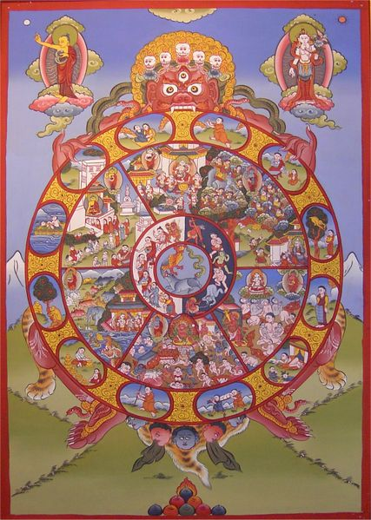
The 'Wheel of Life' as portrayed within Buddhism, showing the cycle of Samsara, or reincarnation.
photo of the painting by Henryart (who is owner of the original painting)

Main article: Rebirth (Buddhist)
Since according to Buddhism there is no permanent and unchanging self (identify) there can be no metempsychosis in the strict sense. However, the Buddha himself referred to his past-lives. Buddhism teaches that what is reborn is not the person but that one moment gives rise to another and that that momentum continues, even after death. It is a more subtle concept than the usual notion of reincarnation, reflecting the sophisticated Buddhist concept of personality existing (even within one's lifetime) without a "soul".
Buddhism never rejected samsara, the process of rebirth. Tibetan Buddhists, also believe that a new-born child may be the rebirth of some important departed lama. However what is not generally understood is that Buddhism not only points out that there is no individual self that reincarnates, but that there is no soul or essence to reincarnate in any form whatsoever. The consciousness (for want of a better term), as distinguished in Tibetan Buddhism, is not a thing, nor is it individual. As all Tibetan teachers agree, the use of the term reincarnation is one of convention, being provisional, not something to be mistaken for the Hindu idea of reincarnation as transmigration.
The Buddha has this to say on rebirth. Kutadanta continued:
"Thou believest, O Master, that beings are reborn; that they migrate in the evolution of life; and that subject to the law of karma we must reap what we sow. Yet thou teachest the non-existence of the soul! Thy disciples praise utter self-extinction as the highest bliss of Nirvana. If I am merely a combination of the sankharas, my existence will cease when I die. If I am merely a compound of sensations and ideas and desires, whither can I go at the dissolution of the body?" [7]
Said the Blessed One: "O Brahman, thou art religious and earnest. Thou art seriously concerned about thy soul. Yet is thy work in vain because thou art lacking in the one thing that is needful." [8]
"There is rebirth of character, but no transmigration of a self. Thy thought-forms reappear, but there is no egoentity transferred. The stanza uttered by a teacher is reborn in the scholar who repeats the word." [9]

[] Jainism
In Jainism, particular reference is given to how devas (gods) also reincarnate after they die. A Jainist who accumulates enough good karma may become a deva, but this is generally seen as undesirable since devas eventually die and one might then come back as a lesser being. This belief is also commonplace in a number of other schools of Hinduism.

[] Western religions and traditions

[] Classical Greek philosophy
Some ancient Greek philosophers believed in reincarnation; see for example Plato's Phaedo and The Republic. Pythagoras was probably the first Greek philosopher to advance the idea.
Main article: Metempsychosis

[] Judaism
The notion of reincarnation is not openly mentioned in the Hebrew Bible. The classical rabbinic works (midrash, Mishna and Talmud) also are silent on this topic, as are the writings of the Geonim and many of the Rishonim.
The concept appeared in an influential mystical work called the Bahir (Illumination) (claimed to be one of the most ancient books of Jewish mysticism) which is believed to have been composed by the first century mystic Nehunia ben haKana, and gained widespread recognition around 1150. After the publication of the Zohar in the late 13th century, the idea of reincarnation began to spread to most of the general Jewish community.
A classic work of the Kabbalah, Shaar ha Gilgulim ("Gate of Reincarnations") of Arizal or Isaac Luria (1534-1572 AD/CE), describes complex laws of reincarnation gilgul and impregnation ibbur of 5 different parts of the soul. Within it one can find what its author considered to be references of reincarnation in the Hebrew Bible (the Tanach).
While ancient Greek philosophers like Plato and Socrates attempted to prove the existence of reincarnation through philosophical proofs, Jewish mystics who accepted this idea did not. Rather, they offered explanations of why reincarnation would solve otherwise intractable problems of theodicy (how to reconcile the existence of evil with the premise of a good God.)
Some well-known Rabbis who accepted the idea of reincarnation include the founder of Chassidism, the Baal Shem Tov, Levi ibn Habib (the Ralbah), Nahmanides (the Ramban), Rabbenu Bahya ben Asher, Rabbi Shelomoh Alkabez and Rabbi Hayyim Vital. The argument made was that even the most righteous of Jews sometimes would suffer or be murdered unjustly. Further, children would sometimes suffer or be murdered, yet they were obviously too young for them to have committed sins for which God would presumably punish them.
Jewish supporters of reincarnation said that this idea would remove the theodicy: Good people were not suffering; rather, they were reincarnations of people who had sinned in previous lifetimes. Therefore any suffering which was observed could be assumed to be from a just God. Yitzchak Blua writes "Unlike some other areas of philosophy where the philosophic battleground revolves around the truth or falsehood of a given assertion, the gilgul debate at points focuses on the psychological needs of the people." (p.6)
Martin Buber's collection of Legend of the Baal-Shem (Die Chassidischen Bücher) includes several of the Baal Shem Tov's stories that explicitly discuss concrete cases of reincarnating souls.
Among well known Rabbis who rejected the idea of reincarnation are the Saadia Gaon(סעדיה הגאון), Hasdai Crescas, Yedayah Bedershi (early 14th century), Joseph Albo, Abraham ibn Daud and Leon de Modena. Saadia Gaon, in Emunoth ve-Deoth, concludes Section vi with a refutation of the doctrine of metempsychosis (reincarnation). While refuting reincarnation, Saadia Gaon states that Jews who hold to reincarnation have adopted non-Jewish beliefs. Crescas writes that if reincarnation was real, people should remember details of their previous lives. Bedershi offers three reasons why the entire concept is dangerous:
- There is no reason for people to try and do good in this life, if they fear that they will nonetheless be punished for some unknown sin committed in a past life.
- Some people may assume that they did not sin in their past life, and so can coast on their success; thus there is no need to try hard to live a good life. In Bedershi's view, the only psychologically tenable worldview for a healthy life is to deal with the here-and-now.
- The idea presents a conundrum for those who believe that at the end of days, God will resurrect the souls and physical bodies of the dead. If a person has lived multiple lives, which body will God resurrect?
Joseph Albo writes that in theory the idea of gilgulim is compatible with Jewish theology. However, Albo argues that there is a purpose for a soul to enter the body, creating a being with free-will. However, a return of the soul to another body, again and again, has no point. Leon De Modena thinks that the idea of reincarnation make a mockery of God's plans for humans; why does God need to send the soul back over and over? If God requires an individual to achieve some perfection or atone for some sin, then God can just extend that person's life until they have time to do what is necessary. De Modena's second argument against reincarnation is that the entire concept is absent from the entire Bible and corpus of classical rabbinic literature.
The idea of reincarnation, called gilgul, became popular in folk belief, and is found in much Yiddish literature among Ashkenazi Jews. Among a few kabbalists, it was posited that some human souls could end up being reincarnated into non-human bodies. These ideas can be found in a number of Kabbalistic works from the 1200s, and also among many mystics in the late 1500s. A distinction was made, however, between actual Transmigration and this form of reincarnation; the non-human subject had its own soul already, the human soul simply 'rode along with' the rock, or tree, or giraffe waiting to be 'elevated,' that is, to be raised to a higher level and to gradually approach the level of human again. The cow eats the grass, elevating the soul within it, the soul rides with the cow a while until a person eats the cow, and then the soul is elevated to the max'. Rabbi Chaim Vidal, when asked how he came to be the foremost disciple and sole transmitter of the teachings of his teacher, the great Issac Luria, crs, not study or mitzvot, but his diligence in blessing his food: "For this way I elevate the souls therein. These souls then become my witnesses in the Heavenly Realm, and empower me to receive even greater revelations."
"Over time however, the philosophical teaching limiting reincarnation to human bodies emerged as the dominant view. Nonetheless, the idea that one can reborn as an animal was never completely eliminated from Jewish thought, and appears centuries later in the Eastern European folk tradition". [Simcha Paull-Raphael,Jewish Views of the Afterlife, p.319]
While many Jews today do not believe in reincarnation, the belief is common amongst Orthodox Jews, particularly amongst Hasidim; some Hasidic siddurim (prayerbooks) have a prayer asking for forgiveness for one's sins that one may have committed in this gilgul or a previous one.
The greatest number of Orthodox Jews who reject the concept of reincarnation is to be found among students of Maimonides (the Rambam), among Dor Daim, and among Gaonists. One can also find Orthodox Jews who deny the compatibility of reincarnation with Judaism among segments of Modern Orthodox Judaism.

[] Gnosticism
Many Gnostic groups believed in reincarnation. For them, reincarnation was a negative concept: Gnostics believed that the material body was evil, and that they would be better off if they could eventually avoid having their 'good' souls reincarnated in 'evil' bodies.
The Gnostic Gospel of the Nazirenes - Chapter 69:
1. As Yeshua sat by the west of the temple with his disciples, behold there passed some carrying one that was dead, to burial, and a certain one said to Him, "Master, if a man die, shall he live again?"
2. He answered and said, "I am the resurrection and the life, I am the good, the beautiful, the true; if a man believe in me he shall not die, but live eternally. As in Adam all (1997 = are bound to cycles of rebirth) die, so in the Messiah shall all be made alive. Blessed are the dead who die in me, and are made perfect in my image and likeness, for they rest from their labors and their works do follow them. They have overcome evil, and are made pillars in the temple of my God, and they go out no more, for they rest in the eternal."
3. "For them that persist in evil there is no rest, but they go out and in, and suffer correction for ages, till they are made perfect. But for them that have done good and attained to perfection, there is endless rest and they go into life everlasting. They rest in the eternal."
4. "Over them the repeated death and birth have no power, for them the wheel of the eternal revolves no more, for they have attained to the center, where is eternal rest, and the center of all things is God."
Note: The text above is not from the original Gospel of the Nazirenes, which now exists only in fragments. Rather, it is the product of "channeling" and of recent origin.
The texts contains several parallels to the Gospels, which are, though, traditionally interpreted differently in their context:
"I am the resurrection and the life; he who believes in me, though he die, yet shall he live, and whoever lives and believes in me shall never die. John 11:25f RSV
Him who overcomes I will make a pillar in the temple of my God. Never again will he leave it. Revelation 3:12 (NIV)

[] Christianity
Further information: Bible and reincarnation
Almost all present official Christian denominations reject reincarnation: exceptions include the Liberal Catholic Church, Unity Church, and the Rosicrucian Fellowship. Doctrines of reincarnation were known to the early Church (before the 6th century A.D.), and believers in reincarnation claim that these doctrines were embraced or at least tolerated within the Church at that time. Two Church Fathers, Origen and Clement of Alexandria are frequently cited as supporting this. However, this cannot be confirmed from the existent writings of Origen. He was cognizant of the concept of reincarnation (metensomatosis "re-embodiment" in his words) from Greek philosophy, but he repeatedly states that this concept is no part of the Christian teaching or scripture. He writes in his Comment on the Gospel of Matthew: "In this place [when Jesus said Elijah was come and referred to John the Baptist] it does not appear to me that by Elijah the soul is spoken of, lest I fall into the doctrine of transmigration, which is foreign to the Church of God, and not handed down by the apostles, nor anywhere set forth in the scriptures" (ibid., 13:1:46–53).
Some reincarnation followers state that Origen's writings have only come down to us heavily ed 'to conform to Church doctrine', and some Origen's writings were later declared heretical by the Church (though Origen himself was not).
They also state that before the Church expurged what it considered his heretical ideas from ions of his works, other quotes of Origen were also recorded by early Church fathers that make it clear that he did indeed teach reincarnation. A discussion of Origen's relationship to reincarnation, including many more quotes, can be found at Kevin Williams' Near Death Experiences website.
Kurt Eggenstein claims that "Jerome wrote in a letter to Demetrius that among the early Christians, the doctrine of reincarnation had been passed on to the elect, as an occult tradition." He also gives a (supposed) quote from Gregory of Nyssa, saying "It is a necessity of nature that the soul becomes purified in repeated lives". The source and the translation are uncited. His book claims many more Christian authorities supported a belief in reincarnation.
In the New Testament, there are several passages that some people use to demonstrate that a belief in reincarnation was prevalent amongst those of Jesus' inner circle. He is asked if he is Elias, for example, in John 1:21; in Matthew 16:13-14 Jesus asks his disciples, ‘Who do men say that I, the Son of Man, am?’ And they said, ‘Some say that you are John the Baptist; some, Elias; and others, Jeremias, or one of the other prophets.’ According to those people, such statements are only comprehensible if Jesus' disciples believed in reincarnation - although one can argue that this merely confirms that they knew this kind of belief, or that, even if the disciples held such beliefs at that moment, that does not confirm that Christ himself endossed it. Finally, in Matthew 11:13-14, Jesus says: For all the prophets and the law prophesied until John. And if ye will receive it, this is Elias, which was for to come. This can be understood in the light of the traditional Jewish prophecy that Elijah (Elias) would return one day, bringing on the Messianic age. John however denied that he was literally Elias John 1:21. And further, Elijah was transfigured and taken up into heaven (2Kings 2:11). Since he did not die, he would have no need of reincarnation to return again as prophesied by Malachi. However, the whole descriptive image of the transfiguration does not state that Elijah did not die, just that "went up by a whirlwind into heaven", and what this process of ascending to heaven implies to the physical body is not known in the mainstream theological study. Matthew 19:28 states: "Verily I say unto you, that ye which have followed me, in the regeneration (Greek -- pale-genesia literally, rebirth) when the Son of Man shall sit in the throne of his glory, ye also shall sit upon twelve thrones, judging the twelve tribes of Israel." A more well-known passage from John 3:3 reads, "...Except a man be born again (Greek -- ano-then), he cannot see the Kingdom of God." The quote from John is sometimes translated as "born from above", and is the inspiration for the modern evangelical movement. Some readers interpret these passages to indicate reincarnation; however, Christian churches read them to refer to baptism or conversion, in a manner similar to what we know today as Born-again Christian.
In John 9:1, the disciples put the question to Jesus, regarding a man who was blind from birth, "Master, who did sin, this man, or his parents, that he was born blind?" The disciples appear to be citing two of the most plausible theories of the time: reincarnation, and sins of the parents (or, effects of parenting). This suggests that reincarnation was known to the disciples. Jesus's answer, "Neither hath this man sinned, nor his parents: but that the works of God should be made manifest in him" is open to interpretation, but it is apparent that he did not rebuke the disciples for suggesting the idea of reincarnation itself. In fact, one could interpret that he tacitly affirmed both hypotheses, while pointing to a third explanation in this particular case.
The Gnostic gospels include clear references to reincarnation, and it is clear that this early Christian (heretical) sect believed in this (see above). In the Gospel of Thomas, Nag Hammadi documents, passage #109 (Thomas O. Lambdin translation), we read: "The kingdom is like a man who had a hidden treasure in his field without knowing it. And after he died, he left it to his son. The son did not know (about the treasure). He inherited the field and sold it. And the one who bought it went plowing and found the treasure. He began to lend money at interest to whomever he wished." The "field" can be interpreted as our phenomenal world of sense experience; the "treasure" the essential Self; "inheriting" as reincarnating; and "plowing" as spiritual search and spiritual discipline.
A number of Evangelical and (in the USA) Fundamentalist Christian groups denounce any belief in reincarnation as heretical, and explain any phenomena suggestive of it as deceptions of the devil, using the Bible as source for such claims. In fact, although the Bible never mentions the word reincarnation, there are several passages through New Testament that Orthodox Christians interpret as openly rejecting reincarnation or the possibility of any return or contact with this world for the souls in Heaven or Hell (see Hb 9:27 and Luke 16:20-31)
A common reason why fundamentalist Christians reject reincarnation is that they consider the theory to defy the basic tenant of Christianity. The philosophies associated with the theory of reincarnation often focus on "working" or "learning" through various lifetimes to achieve some sort of higher understanding or state of "goodness" before salvation is granted or acquired. Basic to Christianity is the doctrine that humans can never achieve the perfection God requires and the only out is total and complete forgiveness accomplished via the sacrifice Jesus made on the cross. He died as a sacrifice for the sins of mankind. "For it is by grace you have been saved, through faith--and this not from yourselves, it is the gift of God--not by works, so that no one can boast." Eph 2:8
There are various contemporary attempts to reconcile Christianity and reincarnation. See:
- Geddes Macgregor, Reincarnation in Christianity : A New Vision of Rebirth in Christian Thought
- Rudolf Steiner, Christianity and Mystical Fact.

[] Islam
Mainstream Islam rejects the concept of reincarnation. Believing in reincarnation into this world, in such a way that it could be interpreted as a denial of resurrection may constitute apostasy in Islam.
A very few sufi groups believe in reincarnation [1] claiming that this concept is mentioned in Quran 2:28:
"How can you deny God, when you were dead and God gave you life? Then God will cause you to die, and then revive you, and then you will be returned to God." (Quran 2:28)
The mainstream Islam rejects this understanding of the verse, claiming that it refers to the worldly human life and the consequent resurrection in the hereafter.
It is claimed by some sufi groups that the mystics and poets in the Islam tradition have celebrated this belief:
"I died as mineral and became a plant,
I died as plant and rose to animal,
I died as animal and I was man.
Why should I fear?
When was I less by dying?
Yet once more I shall die as man,
To soar with angels blest;
But even from angelhood I must pass on ..."
(excerpt from Masnawi, by Hazrat)
In his Masnavi, Rumi speaks about the "seventy-two forms I have worn".
Modern Sufis who embrace the idea of reincarnation include Bawa Muhaiyadeen (see his To Die Before Death: The Sufi Way of Life) and Hazrat Inayat Khan (see The Sufi Message, vol. V, part 3).
Reincarnation has also been used to reconcile the Quran's apparent identification of Miriam, the mother of Isa as the sister of Aaron and daughter of Amran, all of whom lived well before the first century CE.
Another verse of the Qur-an that may support the theory of reincarnation is: "Thou [God] makest the night to pass into the day and Thou makest the day to pass into the night, and Thou bringest forth the living from the dead and Thou bringest forth the dead from the living, and Thou givest sustenance to whom Thou pleasest without measure." (Quran 3:27)
Some verse of Quran that seem to discount repeated lives:
- "From the (earth) did We Create you, and into it Shall We return you, And from it shall We Bring you out once again. (The Quran, 20:55)"
- " 'And Allah has produced you from the earth, Growing (gradually), And in the End He will return you Into the (earth), And raise you forth (Again at the Resurrection).' (The Quran, 71:17-18)"
- "Nor will they there Taste Death, except the first Death; and He will preserve Them from the Penalty Of the Blazing Fire. (The Quran, 44:56)"
- " 'Is it (the case) that We shall not die, except our first death, And that we Shall not be punished?' Verily this is The supreme achievement! For the like of this Let all strive, Who wish to strive. (The Quran, 37:58-61)"

[] Druze
The Druze (also known as Druse; Arabic: darazī درزي, pl. durūz دروز, Hebrew: דרוזים) are a distinct religious community based mostly in the Middle East who are an offshoot of Islam and influenced by other religions and philosophies, including Greek. Considered to be part of Islam, they believe that after death they come back as Druze again.

[] Native American Nations
Reincarnation is an intrinsic part of many Native American and Inuit traditions. Regardless of the actual religious beliefs and practices of today's Native Americans, with varying religious beliefs, the idea has survived for centuries. In the now heavily Christian Polar North (now mainly parts of Greenland and Nunavut), the concept of reincarnation is enshrined in the Inuit language. The survival of the concept of reincarnation applies across the Nations in varying degrees of integrity. The Nations are, of course, now sandwiched between Eastern [Native] and Western traditions.

[] Norse mythology
Reincarnation also appears in Norse mythology, in the Poetic Edda. The or of the Poetic Edda informs the reader that Helgi Hjörvarðsson and his mistress, the valkyrie Sváva, whose love story is told in the Helgakviða Hjörvarðssonar, were reborn as Helgi Hundingsbane and the valkyrie Sigrún. Helgi and Sigrún's love story is the matter of a part of the Völsunga saga and the lays Helgakviða Hundingsbana I and II. They were reborn a second time as Helgi Haddingjaskati and the valkyrie Kára, but unfortunately their story, Káruljóð, only survives in a probably modified form in the Hrómundar saga Gripssonar.

[] Contemporary movements and thinkers

[] Modern thinkers
In the Renaissance we find the doctrine in Giordano Bruno, and in the 17th century in the theosophist van Helmont. During the classical period of German literature metempsychosis attracted much attention: Goethe played with the idea, and it was taken up more seriously by Lessing, who borrowed it from Charles Bonnet, and by Herder. It has been mentioned with respect by Hume and by Schopenhauer.

[] Spiritism
Main article: Spiritism
Reincarnation is the core of the doctrine of Spiritism, a tolerant religious movement started in France in 1857. According to Spiritists the souls will reincarnate to perfect themselves toward communion with God. The evolution of the soul is one of the main laws of the universe; it cannot be truly stopped, only delayed. Spirits have new chances to learn and evolve by reincarnating into new bodies. Forgetfulness of the past, including previous lives, is a gift through which souls get a chance to overcome their past, paying their debts to their enemies and themselves, and acquiring newer experiences for the future.

[] Anthroposophy
Reincarnation plays an important role in the ideas of Anthroposophy, a spiritual movement founded by Rudolf Steiner. Steiner described the human soul gaining new experiences in every epoch and in a variety of races or nations. The unique personality, with its weaknesses and abilities, is not simply a reflection of the body's genetic heritage. Though Steiner described the incarnating soul as searching for and even preparing a familial lineage supportive of its future life, a person's character is also determined by his or her past lives.
Anthroposophy describes the present as being formed by a tension between the past and the future. Both influence our present destiny; there are events that occur due to our past, but there are also events that occur to prepare us rightly for the future. Between these two, there is space for human free will; we create our destiny, not only live it out, just as we build a house in which we then choose to live.
Anthroposophy has developed various spiritual exercises that are intended to develop the capacity to discern past lives and the deeper nature of the human being. In addition, Steiner investigated the karmic relationships of many historical individuals, from Karl Marx to Julian the Apostate.^{[6]}

[] Theosophy
Modern theosophy, which draws its inspiration from India, has taken metempsychosis (or rather reincarnation) as a cardinal tenet; it is, says a recent theosophical writer, "the master-key to modern problems," and among them to the problem of hery. The idea of reincarnation is also part of the New Age culture.
Today, among newer movements, belief in reincarnation is widespread in New Age and Neopagan circles. It is an important tenet of Theosophy, and central to Spiritism, founded by Allan Kardec.
Toward the Light is an example of a contemporary work originating in the western world, which very detailed accounts for reincarnation.

[] Scientology
See also the article Scientology beliefs and practices.
The Church of Scientology, founded by L. Ron Hubbard accepts past lives and holds that all beings are truly immortal, although in a variety of levels of awareness. The motto of their fraternal religious order Sea Organization is "We Come Back". Scientology does not use the word "reincarnation" to describe its beliefs, noting that "The common definition of reincarnation has been altered from its original meaning. The word has come to mean 'to be born again in different life forms' whereas its actual definition is 'to be born again into the flesh of another body.' Scientology ascribes to this latter, original definition of reincarnation." [2]
The first writings in Scientology regarding past lives date from around 1951 and slightly earlier. The controversy brought the subject to public awareness, and was followed by such cases (not related to Scientology) as Bridey Murphy in 1952. In 1960, Hubbard wrote a book on past lives entitled Have You Lived Before This Life and started a second called Where Were You Buried? that was never completed.
Much of the controversy involving Scientology arises from the logical extension of the concept of past lives to what is effectively eternity. In this context, past lives not only take place prior to Earth, but also in non-Earth civilizations, and even in universes prior to this one, where conditions and rules of existence can be different. One could even have past lives in civilizations where advanced technology was common and/or routine. Thus a person who once lived in a world destroyed by nuclear war might become upset living in a world where nuclear power has been re-discovered. Such events can also act as a template for future actions and reactions on a knowing and as well as an unknowing basis. Just as the traumas of childhood can set patterns for later in life, persons and cultures can act out unknowingly, as if in a script, the circumstances that led to unfortunate events in the past.

[] Edgar Cayce
American mystic Edgar Cayce taught reality of reincarnation and karma, but as instruments of a loving God rather than blind natural laws. Its purpose is to teach us certain spiritual lessons. Animals have undifferentiated, "group" souls rather than individuality and consciousness. Once the soul evolves through a succession of animal incarnations and achieves human status, it is not then reborn in animal form. Cayce's view arguably incorporates Theosophical teachings on spiritual evolution.

[] Seth Jane Roberts
In the series of books supposedly dictated to the medium Jane Roberts, "Seth" talks about reincarnation and life after death. Seth believed that time and space are basically illusions. Consistent with this view, Seth argues that only parts of each person incarnate (appear in physical reality). This last argument is part of Seth's view that man is a multi-dimensional entity simultaneously alive in many contexts.

[] The New Age movement
There are many people nowadays who allegedly remember their past lives and use that knowledge to help them with their current lives; this kind of occurrence is fairly central to the New Age faith. Some of the people who remember claim simply to remember without any effort on their part. They simply "see" previous times and see themselves interacting with others, occasionally even different creatures besides people themselves.

[] Research and debate

[] Scientific and other research into reincarnation
Main article: Reincarnation research
The most detailed collections of personal reports in favor of reincarnation have been published by Dr. Ian Stevenson in works such as Reincarnation and Biology: A Contribution to the Etiology of Birthmarks and Birth Defects, which documents thousands of detailed cases where claims of injuries received in past lives sometimes correlate with birthmarks or birth defects.
Stevenson has spent over 40 years devoted to the study of children who have spoken about concepts seemingly unknown to them. In each case, Dr. Stevenson methodically documents the child's statements. Then he identifies the deceased person the child allegedly identifies with, and verifies the facts of the deceased person's life that match the child's memory. He also matches birthmarks and birth defects to wounds and scars on the deceased, verified by medical records such as autopsy photographs.
Stevenson believes that his strict methods rule out all possible "normal" explanations for the child’s memories. However, it should be noted that a significant majority of Dr. Stevenson's reported cases of reincarnation originate in Eastern societies, where dominant religions often permit the concept of reincarnation. In India - where this phenomenon is common - if a child from a poor family claims to be the reincarnated person from a rich family, this can lead to the child to be adopted by that family, a motive that has led to children making fraudulent reincarnation claims.[3]
As Stevenson himself said about the 2500 cases of children, who appeared to remember past lives, which he and his associates investigated: "My conclusion so far is that reincarnation is not the only explanation for these cases, but that it is the best explanation we have for the stronger cases, by which I mean those in which a child makes a considerable number (say 20 or 30) of correct statements about another person who lives in a family that lives quite remote from his own and with which his family has had no prior contacts. When we talk about remoteness, we don't necessarily just mean physical distance. We know that two families can live only 10 kilometers apart and yet they can be very remote because they belong to different economic and social classes." See the whole interview.
There are many people who have investigated reincarnation and come to the conclusion that it is a legitimate phenomenon, such as Peter Ramster - a psychotherapist, Diandra, Dr Brian Weiss and others, but their work is generally ignored by the scientific community.

[] Objections to reincarnation
Objections to reincarnation include: that personal identity depends on memory, and most people do not remember previous incarnations.
René Guénon and others maintain that Reincarnation is both a recent concept (created in the 1800s by Spiritists and Theosophists) and distinct from both metempsychosis and transmigration - detailed in his 1923 book "The Spiritist Fallacy".
Some scientists and skeptics, such as Paul Edwards, have analyzed many of these anecdotal accounts. In every case they found that further research into the individuals involved provides sufficient background to weaken the conclusion that these cases are credible examples of reincarnation. Philosophers like Robert Almeder, having analyzed the criticisms of Edwards and others, say that the gist of these arguments can be summarized as "we all know it can't possibly be real, so therefore it isn't real" - an argument from lack of imagination.
Critics claim that a large number of mental phenomena such as memory and ability are already accounted for by physiological processes and point out moral and practical inconsistencies in the various theories of reincarnation. Without conclusive evidence showing that reincarnation exists then the theory of reincarnation cannot be considered to be a valid theory worthy of formal scientific recognition and acceptance.
Some skeptics explain the abundance of claims of evidence for reincarnation to originate from selective thinking and the psychological phenomena of false memories that often result from one's own belief system and basic fears, and thus cannot be counted as empirical evidence.
David Bishai, a researcher at Johns Hopkins School of Public Health, has studied reincarnation against the backdrop of the explosive population growth at the end of the 20th century. Although he contends that it is scientifically impossible to dismiss reincarnation out of hand due to lack of data, he shows that with a world population of 6 billion a soul will be discarnate for a period of 30 to 712 years depending on the number of souls available. This strongly argues against the notion of immediate reincarnation.

[] See also
Concepts
- Afterlife (see also Birth, Life, Death)
- False memory
- Gilgul (Kabbalah)
- Ibbur (Kabbalah)
- Karma ('Law of Karma', 'Law of Cause and Effect')
- Metempsychosis
- Xenoglossy
Themes
- Bible and reincarnation
- Life review
- Past life regression
- Planes of existence
- Silver cord
- Soul mate
- Subtle bodies
Traditions
- Anthroposophy
- Buddhism; see also Anatta, Vajrayana, Mahayana, Theravada, Rebirth (Buddhist), Tulku
- Druze
- Edgar Cayce, Edgar Cayce on Karma
- Esoteric Christianity
- Hinduism; see also Hindu philosophy, Karma in Hinduism, Atman (Hinduism) & Yoga
- Kabbalah
- Rosicrucianism
- Spiritism
- Sufism
- Theosophy
Other
- Artificial reincarnation
Fiction
- The Battlestar Galactica (2004) TV series has explored in detail a particular form of reincarnation - that of artificially constructed but sentient beings.

[] References

[] Scientific publications
- Dr. Ian Stevenson, Reincarnation and Biology: A Contribution to the Etiology of Birthmarks and Birth Defects ISBN 0-275-95283-5
- Dr. Ian Stevenson, Children Who Remember Previous Lives: A Question of Reincarnation, revised ion (This is a text aimed mainly at an undergraduate audience.) ISBN 0-7864-0913-4
- Peter Ramster, In Search of Lives Past, ISBN 0-646-00021-7
Related publications:
- Jim B. Tucker, Dr., Life Before Life: A Scientific Investigation of Children's Memories of Previous Lives ISBN 0-312-32137-6
- Paul Edwards, Reincarnation: A Critical Examination ISBN 1-57392-921-2
- Titus Rivas, published at the Journal of Scientific Exploration, U.S.A. 2003:
- Three Cases of the Reincarnation Type in the Netherlands abstract
Emily Williams Cook, Bruce Greyson, and Ian Stevenson, published at the Journal of Scientific Exploration, U.S.A. 1998:
- Do Any Near-Death Experiences Provide Evidence for the Survival of Human Personality after Death? Relevant Features and Illustrative Case Reports pdf
Pim Van Lommel, Dr., Dutchman, Cardiologist, Division of Cardiology - Hospital Rijnstate. Published 13-year study, at the world leading medical science journal "The Lancet" in 2001 (358: 2039-45), of NDEs observed in 10 different Dutch hospitals with survivors of cardiac arrest:
- Near-death experience in survivors of cardiac arrest: a prospective study in the Netherlands www pdf
- A Reply to Shermer: Medical Evidence for NDEs, 2003, www
David Fontana, Prof., Cardiff University and Liverpool John Moores University, UK, published at magazine "ParaDocs", Finland 2003:
- Does Mind Survive Physical Death? pdf
Anabela Cardoso, Dr., University of Minho, Portugal, published at magazine "ParaDocs", Finland 2003:
- ITC Voices: Contact with Another Reality? pdf
Neal Grossman, Prof., Ph.D. in The History and Philosophy of Science from Indiana University, and associate professor at the University of Illinois, Chicago, published at the Institute of Noetic Sciences (IONS) in 2002:
- Who's Afraid of Life After Death? Why NDE Evidence is Ignored www.
Journal of Conscientiology:
- Special Thematic Issue: Intermissive Period and Intermissive Courses, Journal of Conscientiology No. 26, London, UK.

[] Literature
- Acharya, Pt. Shriram Sharma, The Life Beyond Physical Death, pdf file, 1999
- Alegretti, Wagner, Retrocognitions: An Investigation into Memories of Past Lives and the Period Between Lives. ISBN 0-9702131-6-6, 2004.
- Archiati, Pietro, Reincarnation in Modern Life: Toward a new Christian Awareness. ISBN 0-904693-88-0.
- Bache, Christopher M., Ph.D., Lifecycles, Reincarnation and the Web of Life, ISBN 1-55778-645-3, 1991
- Bowman, Carol
  - Children's Past Lives, ISBN 0-553-57485-X, 1998
  - Return from Heaven, ISBN 0-06-103044-9, 2003
- Cerminara, Gina, Many Mansions: The Edgar Cayce Story on Reincarnation ISBN 0-451-03307-8, 1990
- Childs, Gilbert and Sylvia, Your Reincarnating Child: Welcoming a soul to the world. ISBN 1-85584-126-6
- Doore, Gary, What Survives? ISBN 0-87477-583-3, 1990
- Head, Joseph and Cranston, S.L., ors, Reincarnation: The Phoenix Fire Mystery ISBN 0-517-56101-8, 1994
- Heindel, Max
  - The Rosicrucian Cosmo-Conception (Part I, Chapter IV: Rebirth and the Law of Consequence), ISBN 0-911274-34-0, 1909
  - The Rosicrucian Mysteries (Chapter II: The problem of Life and its solution), ISBN 0-911274-86-3, 1911
  - The Rosicrucian Fellowship, The Light Beyond Death, pdf file, 2001
- Newton, Michael, Ph.D.
  - Life Between Lives: Hypnotherapy for Spiritual Regression, ISBN 0-73870-465-2, 2004
  - Destiny of Souls: New Case Studies of Life Between Lives, ISBN 1-56718-499-5, 2000
  - Journey of Souls: Case Studies of Life Between Lives, ISBN 1-56718-485-5, 1994
- Prophet, Elizabeth Clare, Erin L. Prophet, Reincarnation: The Missing Link in Christianity ISBN 0-922729-27-1, 1997
- Roberts, Jane
  - Seth Speaks: The Eternal Validity of the Soul, ISBN 0-553-12077-8, 1972
- Steiner, Rudolf
  - Karmic Relationships: Esoteric studies, 8 volumes. Rudolf Steiner Press. ISBN 0-85440-260-8 and others. Online version of Vol. I
  - Manifestations of Karma. ISBN 1-85584-058-8 online version
  - Reincarnation and Immortality. ISBN 0-8334-1706-1
  - Reincarnation and Karma: Two fundamental truths of existence. ISBN 0-88010-501-1
  - A Western Approach to Reincarnation and Karma : selected lectures and writings; ed. and intr. by René Querido. Hudson, NY : Anthroposophic Press, c1997 ISBN 0-88010-399-X
- Semkiw, Walter, Return of the Revolutionaries: The Case for Reincarnation and Soul Groups Reunited, ISBN 1-57174-342-1, 2003
- Vieira, Waldo, MD Our Evolution, ISBN 85-86019-42-9, 1999
- Weiss, Brian L., Dr.
  - Only Love is real: the story of soulmates reunited, ISBN 0-446-51945-6, 1996
  - Many Lives, Many Masters, ISBN 0-671-65786-0, 1988
- Yarbro, Chelsea Quinn, Messages from Michael on the nature of the evolution of the human soul, ISBN 0-872235-26-2, 1979

[] External links
- Articles, stories and books about reincarnation
- A list of FAQ's with proposed answers
- Division of Perceptual Studies, University of Virginia
- About Reincarnation (An overview, with emphasis on the Vedic viewpoint.)
- Buddhist View of Reincarnation
- The Bible and reincarnation from an anthroposophic viewpoint
- Reincarnation Forums
- Reincarnation: Fact or Fantasy? An essay that examines it.
- The Jivamala - A Buddhist practice of purification dealing with reincarnation
- The Spirit's Book, by Allan Kardec
- Past Lives
- A CSICOP review of Reincarnation: A Critical Examination
- New Age Beliefs: REINCARNATION, Islamic View by quranichealing.com
- International Scientific Research into 'the Survival after physical death'
- Reincarnation, from the skeptic's dictionary
- Reincarnation - Past Lives
- Reincarnation: Pros and Cons
- Theosophy on reincarnation
- Vijay Kumar God Creation Reincarnation
- Jewish view of reincarnation
- Christian Reincarnation Belief and Regression Therapy
- Reincarnation Stories
- About reincarnation (Buddhist site)
- Pathwork on reincarnation process
- Reincarnation Station, a somewhat silly exploration of one's personal preferences
- Spiritual Dawn - Morality and Philosophy Essay - Reincarnation
- Gesellschaft für therapeutische Hypnose und Hypnoseforschung (Germany)
- [4] The Reincarnation Cafe
- A scientific exploration of Reincarnation and Soulmates
- In Another Life reincarnation documentary project
- Do We Live More than Once? A case history of a child who "remembered a past life."
- [5] Is it possible to be a Buddhist and not believe in Reincarnation?
- Infinitesouls.com - Case histories and physical evidence of past life recall.
- Jewish Spiritual Teachings on Reincarnation from 16th Century Sefer Gilgulim by Reb Chaim Vital
====================================================================================================================================
END

