Origins of Mormonism The Mormon Book of Abraham

By Frank Zindler

http://www.atheists.org/church/mormon.html

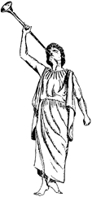

(The following article was originally was originally published in the American Atheist Magagzine, vol.27, no.1 [January 1985])
If you happen to have been born with white skin and if you have not lived all your life as a Latter-day Druid nuncio trapped in China since the 1922 reorganization of the Kuomintang, without a doubt you have been visited by pairs of bright-faced, clean-scrubbed, conservatively attired Mormon missionaries, or "elders", as the eighteen-to twenty-year old boys prefer to be called.

THE BLACK SKINNED PEOPLE
If you happen to have been born with black skin, however, you may never have the opportunity to talk with any elders -- unless, of course, you might have had the misfortune to fall on top of a couple by stumbling onto a pit-trap set for them by the Baptist or other fire-breathing Protestant groups that are out to "get the cults." If this has happened to you, and if you managed to avoid impaling yourself on the pointed sticks at the bottom of the pit, and if at least one of the missionaries avoided the sticks as well, you will have been told that Mormon church -- the Church of Jesus Christ of Latter-day Saints -- is the one of the most thriving enterprises in America today. That it is a thriving financial enterprise, you might not have been told by the youthful elder. But you will have been told that this marvelous tax shelter was founded in 1830 by a fellow named Joseph Smith, Correction, Joseph Smith Junior.

SMITH'S NEW RELIGION
Smith got his new religion going by writing a book known as The Book of Mormon. The book was much too dull to make it as a novel -- Mark Twain called the book "chloroform in print" -- so it was marketed as a new bible. Having quite a flair for publicity, Smith pretended to have translated The Book of Mormon from a pile of gold plates dug out of a glacial hill in upstate New York -- with the help of a resurrected man, no less!

ABOUT THE BOOK OF MORMON
The book purports to tell of lost tribes of Israelites and others floating to South America, some in giant barrels, others in a boat. Arriving in America, they all turned into Indians, built cities, fought wars, received a visit from Jesus Christ after he couldn't make a go of it in Palestine, and finally killed each other off in A.D. 421. Shortly before the fatal fight -- a colossal battle allegedly waged at Hill Cumorah, near Palmyra, New York -- a person appropriately name Moroni buried the plates for Smith to find.
Some day I will devote an entire column to The Book of Mormon. Here it must suffice to recount an amusing anecdote concerning the birth of the book.

THE "SEER STONE"
When young Smith claimed he had a magic "seer stone," a stone with which he could see inside hills and beneath the surface of the ground to inspect for buried treasurers and enchantments. The seer stone became transformed into the biblical "urim and thummin" with which he later claimed he could "translate" any language -- including "reformed Egyptian," the imaginary language in which his Jewish Indians supposedly had written their history. A locked box held what Smith claimed to be the gold plates bearing this reformed Egyptian Chaldee Jewish American Indian history.

TRANSLATING THE BOOK OF MORMON
Sitting in one-half of a room divided into two sections by means of a blanket hung from a rope, Smith would pretend to be translating aloud from the plates and would dictate The Book of Mormon to his secretary Martin Harris. Harris sat on the other side of the blanket, afraid to peek at the plates for fear he would be stricken with the plague, and the scab, and hemorrhoids, and the botch of Egypt. After many days of such inventive labor, 116 pages of manuscript had been written -- all of it supposedly translated by divine guidance by means of the magical seer stone.

DISASTER STRUCK
And it came to pass...disaster struck! Martin Harris' wife, Lucy, stole the manuscripture and taunted her gullible husband, "If this be a divine communication, the same being who revealed it to you can easily replace it."
The impostor Smith was trapped. He knew it was impossible for him to reproduce the story exactly, although he should have been able to do so if there had indeed been divine guidance. To redictate it would be to invite disasterous comparison. At this point, surely, a lesser man would have given up the job of bible-writing and have become a used-mule salesman or a whortleberry farmer. But not Joe Smith -- no sir! He went right back to work and dictated The Book of Mormon.

SMITH AVOIDED BEING CAUGHT
How did he get away with it? How did he avoid being checkmated by Lucy Harris' threat to compare the new inspiration with the old one? Very simple. He added a preface to the first edition of the book. The preface claimed that the 116 pages had been translated from supposed Plates of Lehi and that the devil had caused the translation to be stolen and altered from what Smith had "translated." So that even if Smith were to produce a new translation word-for-word identical with the first, it nevertheless would appear to differ from the stolen pages because of the changes which had been made in the latter by the cunning of the devil. Therefore, god had changed the writing assignment so that The Book of Mormon no longer is a translation of The Plates of Lehi!
God's exact words, according to the preface, were: "I will not suffer that Satan shall accomplish his evil design in this thing. Therefore thou shalt translate from the plates of Nephi."
As you can see, this god was still speaking King James' English even though it was now the year 1828. The preface did the trick, however, and Lucy Harris was neutralized.

SMITH WROTE OTHER SCRIPTURES
Encouraged by the success of his first bible, Joseph Smith proceeded to write other "scriptures." One of these is known as The Book of Abraham and is published today as part of a volume known as The Pearl of Great Price.

THE BOOK OF ABRAHAM
Unlike The Book of Mormon, which merely dull or silly, depending upon how much coffee one has been drinking, The Book of Abraham has a rather unpleasant side. Until recent years, it was used to justify the racist policies of the Mormon church. Blacks formerly were not allowed to hold the "priesthood." Since almost all postpubertal Mormon males are priests and since Mormon women can't amount to anything unless they marry a man who does hold the priesthood, this dogma effectively kept Blacks out of the "white and delightsome" Church of Jesus of Latter-Day Saints.
The offensive passages are to be found in Chapter I, verses 20-27. Verse 24 ends with a reference to the biblical "curse of Ham": "From Ham sprang that race which preserved the curse in the land."
Verses 26-7, referring to Pharaoh (whom Smith supposed to be a Negro), say that Noah "cursed him (Ham and his descendants) as pertaining to the priesthood. No Pharaoh being of that lineage by which he could have the right of priesthood," and so on.

IN ALL FAIRNESS
Now I must admit, in all fairness, that these passages are rather mild stuff and aren't as bad as the bible passages which were used by the Christian clergy to justify slavery. And I must inform the reader that although missionaries still do not go out in search of black converts, Blacks nowadays can hold the priesthood if they desire. The head of the Mormon church -- the "Chief Seer and Revelator" -- a few years ago got a message direct from his god to change this policy. The change came just in the nick of time, too, since civil rights legislation was making it harder for racist organizations to feed at the federal money-trough.

THE TRANSLATION OF ABRAHAM'S PAPYRI
How did Joseph Smith come to write this book?
Well, it was 1835. The Mormons had moved from New York state to Ohio. Michael Chandler, a traveling showman, came to Kirtland on July 3, 1835, exhibiting some Egyptian papyri and mummies. Smith declared the papyri contained the autographic writings of the patriarchs Abraham and Joseph of Egypt and that he could read them! The Mormons bought the mummies and the papyri.
When Josiah Quincy visited Smith later at Nauvoo, Illinois, Smith told him, "That is the handwriting of Abraham...this is the autograph of Moses, and these lines were written by his brother Aaron." In fact, the introduction to The Book of Abraham still reads, "The writings of Abraham while he was in Egypt...written by his own hand, upon papyrus.
Armed with his magic seer stone, this would-be prophet set to work and "translated" The Book of Abraham. Unique among the holy books of the world, The Book of Abraham comes equipped with three illustrations.

FACSIMILE 1

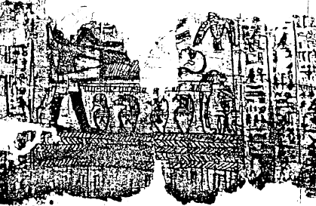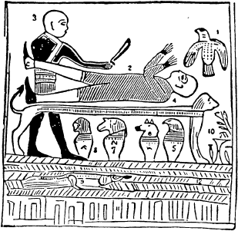

The first illustration (Fig. 1, shown above. Click either image for a closer look.) is accompanied by fantastic interpretation given by Joseph Smith. According to Smith, the "bird" in the upper right is "the angel of the Lord" and the man with the knife is an idolatrous priest trying to make a sacrifice of Abraham (the guy on the check-out counter to the left of the cash register).
Toward the end of the eighteenth century, when more and more scholars appeared who actually could read Egyptian -- even without the use of magic stones -- this interpretation was challenged. The "bird" was not an angel, but the ba or soul of a deceased person. Furthermore, it was claimed, its face had been changed. It should have a human face. The reclining figure wasn't Abraham; it was Osiris being called back to life by Anubis, the god of the dead and of embalming. The so-called priest -- it was claimed over one hundred years ago -- had been altered! He actually should have the head of a jackal and should not have a knife in his hand.

FACSIMILE 2
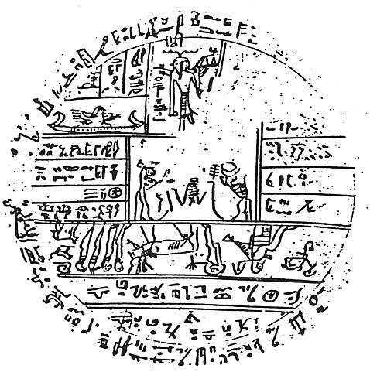
The second facsimile (Fig. 2, shown above. Click image for a closer look.) is rather different from the first, and Smith claimed it has to with astronomy. The accompanying explanation is chock-full of nonsense such as "one day to cubit," "fixed planets," and made-up words such as "Jah-oh-eh" and "Oliblish."
Although the writing in the illustration was too poorly copied for Egyptologists to make much sense out of it, it was noted a century ago that not everything was kosher. Although the writing along the top border is in hieroglyphics, starting at about one o'clock, the writing becomes cursive (hieractic), continuing to about five o'clock, where-upon it becomes hieroglyphics again! A similar peculiarity is seen in the right-central section of the figure. here each line is hieroglyphic on the left end and cursive on the right end. "Something's fishy here," said the experts.

FACSIMILE 3

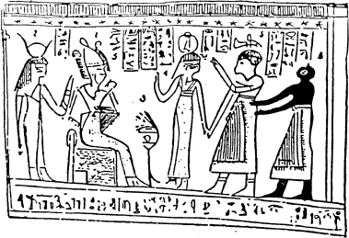 SMITH'S NOTEBOOK
The third facsimile (Fig. 3, shown above. Click image for a closer look.) Smith claimed depicts Abraham upon Pharaoh's throne discoursing on astronomy with Pharaoh behind him. The person standing in the center is a prince, flanked by the king's waiter, and the black creature on the far right is -- you guessed it! -- a slave.
Experts a hundred years ago said, "Baloney!" The scene actually depicts the judgment of a deceased person, and the characters are, from left to right, Isis (female!), Osiris on the throne, Maat (female!), the deceased, and Anubis the jackal-headed god. Today, of course, the experts still say the same thing. Unfortunately, the writing on the facsimiles was so poorly reproduced (deliberately, I would assert) that Egyptologists could not say for sure just what the writings did say, even though it was certain that Smith's interpretation was pure blarney.

THE CHANGE IN 1966
But everything changed in 1966. In that year, Jerald and Sandra Tanner, two ex-Mormons who became full-time debunkers of the faith of Brigham Young, obtained a microfilm of a document which had been hidden and suppressed by the Mormon church for over 130 years: Joseph Smith's notebook entitled "Egyptian Alphabet and Grammar". Part of the microfilm contained material in Smith's own handwriting, with his signature..1
One such page reads "Valuable discovery of hidden records that have been obtained from the ancient burying grounds of the Egyptians, (signature) Joseph Smith, Jr." Other pages are in the handwriting of several of the "prophets" secretaries.

What is the nature of this notebook? It is, I believe, a show Smith put on for the benefit of his secretaries, a pretense of actually being able to decipher Egyptian. Champollion, in France, had just succeeded in deciphering Egyptian, but in the wilds of America no one yet knew this. So Smith was free in this notebook to make up anything he wanted, confident he could get away with it. After a number of pages of absolute word-hash, we see him making up The Book of Abraham.

QUOTES FROM SMITH'S NOTEBOOK
The word-hash is so mad, however, that I cannot resist quoting a few lines. Smith's explanation of the meaning of a simple vertical stroke -- a single line -- is as follows:
"Beth-Ba-eth. This character is from the first degree. It has an arbitrary sound or signification which is Beth; and also a compound sound which is Za and comprise one simple sentence for its signification. It is only increased or lessened in it signification, or enlarges the sentence. Two connections increases its signification still: Three increases it still: Four increases still and five still, This is as far as a sentence can be carried in the first degree." (punctuation as in original)
Proceeding to the pages containing the characters from which The Book of Abraham was derived, we find Egyptian characters arrayed vertically on the left side of each page, with the verses of scripture allegedly translated from them on the right. At the top left of one such page, we find a character resembling a backward "E" --from which Smith derives the seventy-six words of verse 13 and 14 of Chapter 1!

CAN IT BE BELIEVED?
Can it be believed? Seventy-six words from one character? The idea becomes even more preposterous when we find that this character isn't even an entire Egyptian word: it's just a "determinative," a sign used to give the reader a clue as to the general meaning of the word of which it is a part. In this case, the sign signifies "water." The word of which it is a part is the Egyptian word for "pool."
The real find, however, in the "Egyptian Alphabet and Grammar" was the discovery of Smith's working version of Facsimile 2, the circular figure (Fig. 2, p 32). In exactly every place where the Egyptologists had claimed there was something fishy in the published plate in Joe's notebook we have empty spaces and called it inspiration! The critics could not have been vindicted more perfectly.

AN AMUSING ITEM
An amusing item: in the notebook version of Facsimile 2, the hieroglyphics are clear enough to be read. At about nine o'clock we can make out a hieroglyph of a bull. Reading from there towards six o'clock, we apparently can make out the phrase, "great bull who can copulate without equal..." Can this be a cryptographic prophesy of the second coming of Brigham Young -- who had how many wives?
The "Egyptian Alphabet and Grammar" would have been enough evidence to convict Joseph Smith of fraud, even if we didn't have any further evidence. But we do, we do!

THE "SMOKING PISTOL"
The "smoking pistol" itself has been found -- not in the vaults in Salt Lake City, but in the Metropolitan Museum in New York City.
The smoking pistol consists of the actual papyri Smith got from Chandler, the traveling showman -- including the papyrus from which the characters in the "Egyptian Alphabet and Grammar" had been copied, and the papyrus original of Facsimile 1. Although the papyri had been discovered in the museum in the same year in which the Tanners had published the "Grammar," it wasn't until the following year, 1967, that the papyri were given to the Mormon church by the museum.

THE DIVINE GUIDANCE
The divine guidance which is supposed to guide the "Chief Seer and Revelator" of the church apparently was vacationing on the planet Kolob in 1967, for the church authorities foolishly agreed that the papyri were authentic and were indeed the originals from which Joseph Smith translated The Book of Abraham.

THE OFFICIAL STORY
The official story -- the hope, as it were -- was that the papyri had burned up in the great Chicago fire, although there is evidence that at least some Mormon officials knew the papyri still existed and thought it best to let sleeping dogs lie. Although the plates from which The Book of Mormon had been translated had been taken back to heaven after Smith's library card expired -- conveniently making it impossible to check up on Smith's claims -- the papyri behind the Abraham opus were still on earth, and could be checked! Publication of the papyri dealt what surely must be the death-blow to The Book of Abraham.

EXAMINING FACSIMILE 1
If we examine the original of Facsimile 1, we see that the head of the so-called priest is missing. The experts said he should have the head of Anubis the jackal-god. Smith, not knowing anything about Egyptian religion, put a man's head on the figure. There is no knife in the picture either. Strike two. Smith made it up. There is no head on the ba-bird. Strike three. Smith put a bird's head on the ba -- not an unreasonable mistake if a man is uninspired and knows no Egyptology. But for the founder of a religion and a man who claims divine guidance in his interpretations, this is devastating.
But the picture wasn't the only thing "Holy Joe" filled in out of his fertile imagination. If we examine Fig. 4, a picture of the scrap of papyrus from which Smith derived the entire Book of Abraham, we may note the arrow pointing to the backward "E" discussed previously. Three lines below it, we can see some of the characters used to fill in the right-central part of Facsimile 2 (sector 14 right side of Fig. 2). Unfortunately, Smith inserted these characters upside down. How odd of god to tell Smith what all these squiggles meant, but never thought to tell him which way was up!

CONTINUING OUR EXAMINATION
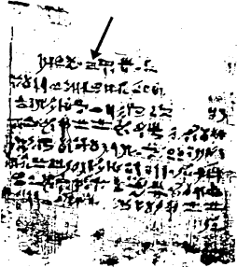
Continuing our examination of Fig. 4 (Click image above for a closer look.), we note that there is a deep, triangular cleft in the papyrus, extending from the upper right-hand corner downward to the fourth line of writing. The characters on both sides of the fissure can be found in Smith's notebook, together with the corresponding verses of The Book of Abraham.
Guess where in this papyrus Smith got the anti-Negro verses! The whole holy business about the "curse of Ham" comes from the hole! As Smith copied the characters from the papyrus into his notebook, he made up the curse-of-Ham characters to fill in the cleft in the original. Embarrassingly, he made up too many of them to fit in the space available!

EGYPTOLOGIST TRANSLATION
Egyptologists have now translated all the Joseph Smith papyri -- including the parts Joseph said could not yet be revealed -- and we can say without fear of contradiction that the materials have nothing to do with Abraham or with Blacks. They are delightfully pagan in nature, and nothing Jewish can be seen in them. They are part of the Book of Breathings -- a late abridgment of the Egyptian Book of the Dead. In fact, these papyri date from approximately the beginning of the Christian era and are about two thousand years too late to contain the autograph of Abraham!

THE MAJOR RELIGIONS
The major religions of the world began too long ago for anthropologists to be able to reconstruct accurately the complex interactions between fraud, delusion, and honest ignorance which went into their manufacture. In the case of Mormonism, however, a very scientific case can be built up to show quite unambiguously the role of chicanery in the formation of this most uniquely American religion. Joseph Smith dared to invent a new religion in the age of printing!

FIGURE 1
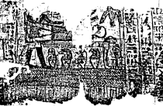
Fig. 1. Above: The original papyrus from which Smith derives "Facsimile 1" of The Book of Abraham. Faint traces of pencil line can bee seen where Smith attempted to complete the figures on the mounting paper.
Fig. 1. (cont'd) Below: Facsimile 1 appears in modern editions of The Book of Abraham, with erroneously completed details.
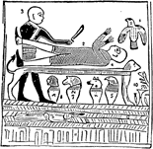

FIGURE 2
(click on images for a closer look)
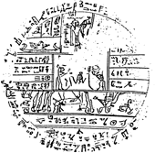
Fig. 2. Above: The working version of Facsimile 2, taken from Smith's "Egyptian Alphabet and Grammar." Note use of hieroglyphic, not cursive, characters and incompleted borders and other empty areas.
Fig 2. Below: Facsimile 2 as it appears in modern editions of The Book of Abraham, with cursive charcters taken from a different papyrus (see Fig. 4.) and inserted upside-down into the spaces and border.
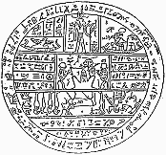

FIGURE 3
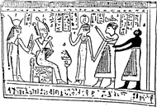
Fig. 3. Above: Facsimile 3 as it appears in modern printed editions of The Book of Abraham. The original has not yet come to light. See text for details.

FIGURE 4
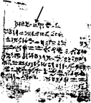
Fig. 4. Above: The scrap of papyrus from which Joseph Smith "translated" all 1,125 words of The Book of Abraham and also managed to have enough left over to fill in the blanks in Facsimile 2. Arrow points to backward "E" determinative signifying water. In Smith's "Egyptian Alphabet and Grammar," this character is made the source of seventy-six words of English "scripture!"

FREE CATALOGUE
1 Footnote: A free catalogue of suppressed Mormon documents, including the "Egyptian Alphabet and Grammar", and anti-Mormon books published by the Tanners may be obtained by writing to Utah Lighthouse Ministry, P.O. Box 1884, Salt Lake City, Utah 84110

