Lucy Mack Smith 1775 - 1856
http://en.wikipedia.org/wiki/Lucy_Mack_Smith
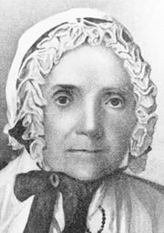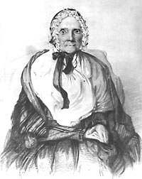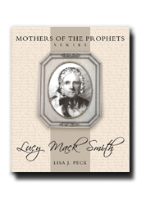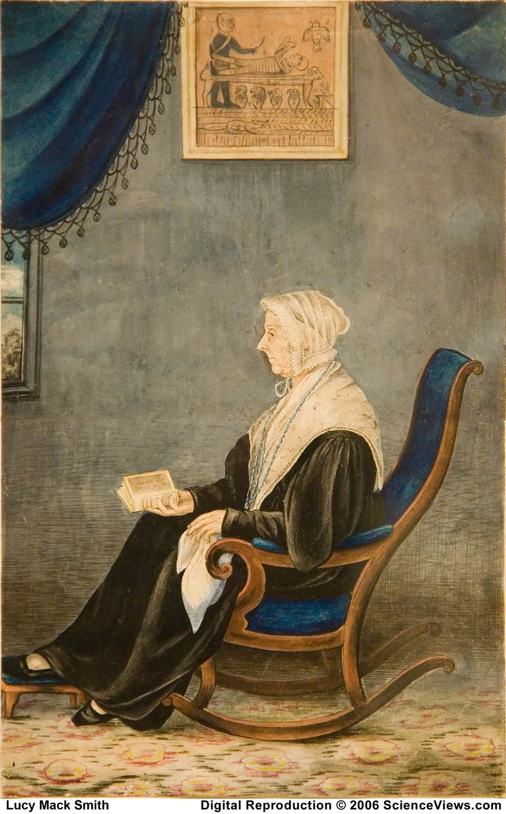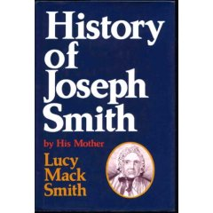

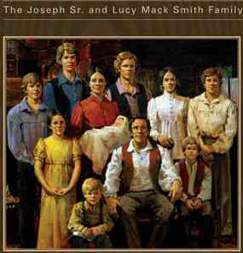
The Smith Family Homestead
Two Story Built By Joseph III
In 1860 Old Cabin c. 1803,
Is Summer Kitchen Joseph Sr.
& Lucy Lived
In Until
Their House Was Built

Lucy Mack Smith's House

Lucy Mack Smith (July 8, 1775 - May 14, 1856) was the mother of Joseph Smith, Jr., founder of the Latter Day Saint movement. She is most noted for writing an award-winning memoir: Biographical Sketches of Joseph Smith, the Prophet, and His Progenitors for Many Generations. She was a great and important leader of the movement during the life of Joseph. Lucy is a model of the early nineteenth-century republican mother, who displayed piety, dispensed values, shaped character at the domestic hearth, and brought up her sons in the paths of civic virtue preparing the way for such a restoration with an unshakable faith in her mission.

Contents
- 1 Background and early life
- 2 Marriage and children
- 3 Book of Mormon
- 4 Church leadership
- 5 Martyrdom of Hyrum and Joseph
- 6 Succession crisis
- 7 Descendants
- 8 References
- 9 External links

Background and early life
In the rural areas of northern New England where the Smiths lived, the proliferation of evangelical religious sects and the pre-Victorian emphasis on the family as a moral force were especially significant forces in Lucy's life. Migrants to this area had taken with them the revolutionary spirit of political independence. They had also encouraged the breakdown of the old order of religious domination. "The grip of colonial religious culture was broken and a new American style of religious diversity came into being." Such a setting became fertile ground for religious experimentation and the birth of indigenous religious sects, some of which "undertook to redefine social and economic order through the model of the extended family." Without stable institutional structures, the family thus became the "crucible" for forming "primary identity, socialization, and cultural norms for rural life" (Marini, 7, 56, 31). Lucy was a product of this environment.
Lucy Mack was born on July 8, 1775, in Gilsum, New Hampshire, during an era of political, economic, and social change. The second half of the eighteenth century had seen a slowly evolving shift of responsibilities within the American family. Even though the Revolutionary War would accelerate that shift, the initial impetus came from the changing economic scene. According to women's historian Linda Kerber, the growing market economy and "industrial technology reshaped the contours of domestic labor" (7). This shift toward commercialism pushed the father's work farther away from the home, with the result that the mother now took over the father's former role of final responsibility for the children's education and for their moral and religious training (Bloch, 113). Magazines and educational publications heralded mothers as "the chief transmitters of religious and moral values" (Bloch, 101). William Buchan's 1804 'Advice to Mothers', one of many such publications, described the importance of this new emphasis on mothers:
Lucy was proud of her father's involvement in the Revolutionary War. Even though Solomon Mack was not committed to any religious belief system, he certainly appreciated the diligence of his wife in attending to the spiritual and educational needs of their children. "All the flowery eloquence of the pulpit," he said, could not match the influence of his wife on their children (chap. 1). Lucy's mother, Lydia Gates Mack, was an example of the kind of "moral mother" increasingly celebrated during the last decades of the eighteenth century. Lucy's older brother, Jason, became a "seeker" and eventually formed his own religious community; her two older sisters each had a visionary confirmation that their sins were forgiven and that God called them to "witness" to others of the need for repentance. Such gestures of piety were expected in the highly charged revivalist climate of the day. As historians have noted, clergymen "encouraged people to induce 'visions'" (Buel, 11). Lucy's father, after a period of acute suffering in body and mind, underwent his own religious conversion in 1810.

Marriage and children
When Lucy married Joseph Smith, Sr., in January 1796, she brought not only the housewifely skills learned from her mother, plus a wedding gift of $1,000 from her brother, Stephen, and his business partner, John Mudget, but also the ideal of a strong, responsible, pious mother. Lydia Gates Mack was a model whom Lucy would emulate and even enlarge in her own family life. As a true republican mother, Lucy assumed the responsibility for the moral and religious guidance of her children as well as for their secular education. As a result, she emerges as a major influence in preparing them for their involvement in the charismatic movement which early Mormonism represents.
After six years of marriage, Lucy became very ill, was diagnosed with "confirmed consumption," the disease from which her sisters Lovisa and Lovina had died, and was given up by the doctors (Smith, chap. 11). Lucy did not feel prepared for death and judgment: "I knew not the ways of Christ, besides there appeared to be a dark and lonesome chasm between myself and the Saviour, which I dared not attempt to pass." By making a gigantic effort, she perceived "a faint glimmer of light." She spent the night pleading with the Lord to spare her life so she could bring up her children (Alvin and Hyrum) and "be a comfort" to her husband. She vowed that, if her life was spared, she would serve God with all her heart, whereupon she heard a voice advising her, "Seek and ye shall find; knock and it shall be opened unto you. Let your heart be comforted; ye believe in God, believe also in me." From that point on, Lucy began a long search for a religion that would teach her the way of salvation. In so doing, she was following the precepts of her culture. During this post-revolutionary period, religious speakers constantly emphasized the "cultivation" of female piety so that women might more ably fulfill their role as a "moral mother" (Bloch, 118).
Lucy also continued to educate her children in secular as well as spiritual matters. Dr. John Stafford of Palmyra, interviewed in 1880, remembered that Lucy "had a great deal of faith that their children were going to do something great" and also recalled that Lucy taught her eight children from the Bible. Stafford did not comment on the spiritual precepts they thus garnered but rather on the children's educational achievements. Joseph Jr. had been "quite illiterate," he said, but "after they began to have school at their house, he improved greatly" (Vogel 2:122). Were Lucy's ambitions for, and faith in, her children's abilities unusual for a mother of that period? Linda Kerber tells how the republican mother was to "encourage in her sons civic interest and participation. She was to educate her children and guide them in the paths of morality and virtue" (283). Nancy Woloch, notes that ministers, after "discarding predestination as an axiom, now suggested that mothers, not God, were responsible for their children's souls" (121). Lucy certainly seems to have taken such responsibilities very seriously in her own family. William Smith later affirmed that Lucy was a very pious woman and much interested in the welfare of her children, both here and hereafter, [who] made use of every means which her parental love could suggest, to get us engaged in seeking for our souls' salvation, or (as the term then was) "in getting religion." She prevailed on us to attend the meetings [the Methodist revival being preached by George Lane], and almost the whole family became interested in the matter and seekers after truth. . . . My mother continued her importunities and exertions to interest us in the importance of seeking for the salvation of our immortal souls, until almost all of the family became either converted or seriously inclined (Vogel 1:494-95).
It is quite clear that Lucy's piety and high principles were the major moral influence in her children's lives, but she also was concerned about her husband's spiritual well-being. New England ministers declared that a wife's conversion could also help her perform "her great task of bringing men back to God" (Welter, 162). Various publications of the early nineteenth century pointed out:
Religion or piety was the core of women's virtue, the source of her strength. Religion belonged to woman by divine right, a gift of God and nature. This "peculiar susceptibility" to religion was given her for a reason: "the vestal flame of piety, lighted tip by Heaven in the breast of woman" would throw its beams into the naughty world of men (Welter, 152).
According to Nancy Woloch, "Female converts outnumbered male converts three to two in the Second Great Awakening in New England. . . . By 1814, for instance, women outnumbered men in the churches and religious societies in rural Utica, and they could be relied upon to urge the conversion of family members" (121).
It was Lucy who took the initiative in trying to involve her family in seeking the "true church." In light of Joseph Sr.'s indifference, she sought consolation in earnest prayer that the gospel would be brought to her husband and was reassured by a dream that her husband would be given "the pure and undefiled Gospel of the Son of God" (56). About this time Joseph Sr. began having visionary dreams with highly symbolic content, obviously related to his ambivalence about religious faith and sometimes presaging events to come. These dreams continued after the family's move to Palmyra, New York, until he had had seven in all; Lucy remembers five well enough to quote in detail.

Book of Mormon
Lucy's efforts to find the true religion did not slacken in Palmyra. She went from sect to sect; and sometime after 1824, she and three of her children, Hyrum, Samuel, and Sophronia, joined Western Presbyterian Church, the only church with a meetinghouse in Palmyra. Although Lucy longed for her family to be united in their religious faith, she could not persuade her husband to join them. Thus, when young Joseph had his vision, followed by the coming forth of the Book of Mormon attended by other heavenly messengers, it was the means of making Lucy's dream of a family united in religious harmony come true, a dream that was part of prevailing cultural expectations.
Throughout the turmoil of the revivals, Lucy had revealed her anxiety and her determination that her family would "get religion," so she shares her joy in the eventual unity of faith which young Joseph brings to the Smith family with his vision of a "restoration." Lucy tells the story very movingly. Three years after the First Vision of young Joseph, she observes, "I presume our family presented an aspect as singular as any ever lived upon the face of the earth—all seated in a circle, father, mother, sons and daughters, and giving the most profound attention to a boy, eighteen years of age, who had never read the Bible through in his life" (chap. 19). She relates how Alvin, on his deathbed, counseled Joseph to "be faithful in receiving instruction and in keeping every commandment" (chap. 20).
While Lucy still continued attending meetings at the local Presbyterian church, young Joseph refused to attend; and when he finally obtained the promised gold plates which told of the history of the early inhabitants of the American continent, Lucy stopped going to meetings herself. She said, "We were now confirmed in the opinion that God was about to bring to light something upon which we could stay our minds, or that he would give us a more perfect knowledge of the plan of salvation and the redemption of the human family. This caused us greatly to rejoice, the sweetest union and happiness pervaded our house, and tranquility reigned in our midst" (Smith, chap. 19). Much of Lucy's consciousness during this period was that her family was to be the instrument in bringing salvation to the whole human family. It was clearly a Smith family enterprise. As Jan Shipps has pointed out, Lucy employs the pronouns we, ours, and us rather than simply referring to Joseph's particular role (Mormonism, 107).

Church leadership
When converts were baptized into the new church, Lucy expanded her motherly consciousness to include them as well. En route to Kirtland, Ohio, when the women in the group—and even the men—behaved like improvident, sulky children, Lucy used a combination of parental firmness and encouragement, took over the charge of feeding those who had come without supplies, disciplined and watched over the children of the negligent, and found housing for them as well. During a moment of grumbling, she reminded them, "Have any of you lacked? Have not I set food before you every day, and made you, who had not provided for yourselves, as welcome as my own children?" (chap. 39). It was a telling comparison, outlining as it did the role she played in the church at a time when the institution provided nothing similar. In Kirtland, Lucy shared her home with newly arrived immigrants, sometimes sleeping on the floor herself when the house was full. She also continued in her missionary work, even daring to stand up to a Presbyterian minister in defense of her faith.
When Joseph Jr. called his father as the church's first patriarch in December 1833, he emphasized the familial nature of the early Mormon movement. Likening his father to Adam, the prophet said, "So shall it be with my father; he shall be called a prince over his posterity, holding the keys of the patriarchal priesthood over the kingdom of God on earth, even the Church of the Latter Day Saints" (qtd. in Bates and Smith, 34). In this calling Father Smith was to give patriarchal blessings to the Saints; and when he attended the blessing meetings, he insisted that Lucy accompany him (chap. 44). On at least one occasion, Lucy added her blessing or confirmed what had already been received (Crosby).
During the Missouri period when Joseph and Hyrum were imprisoned in Liberty Jail, Lucy was a tower of strength to her husband and other church members. Only in Nauvoo, Illinois, with floods of converts rising like a tide over the New York stalwarts who were left and with Lucy largely isolated in caring for her dying husband did her sense of her role falter. She still felt like a mother but was less often recognized as such by her "children" in the church. Perhaps the most important meaning in Joseph Sr.'s dying blessing on Lucy was to reaffirm her role and status: "Mother, do you not know that you are the mother of as great a family as ever lived upon the earth. . . . They are raised up to do the Lord's work" (chap. 52). He was telling her that her influence, focused on her biological children, was the seedbed for a larger spiritual family.

Martyrdom of Hyrum and Joseph
Ironically, it was Joseph Jr.'s experiments with expanded family models through plural marriage that sent rifts shivering through that foundation. Even as Lucy bravely held on to her vision of the family as instruments in the hands of God, her prophet and patriarch sons were killed on June 27, 1844. When Lucy saw the bodies of her martyred sons, she cried "My God, my God, why hast thou forsaken this family?" (chap. 54).
For Lucy as a republican mother, her family had been the instrument in the hands of God in restoring Jesus Christ's true gospel to the earth in the latter days. The Second Great Awakening had seen an emphasis on restoring the primitive church of Christ; and Lucy, it appears, truly thought that her family was performing that service. Republican motherhood had bestowed on women the responsibility of teaching Jesus' pure gospel to their children and of leading their husbands back to the fold. Lucy had been successful in meeting that challenge. Joseph Smith, Jr., had become the prophet and president of Christ's church and Hyrum had been the patriarch and associate president. Lucy's whole family, including her late husband as the first patriarch, had been faithful in sustaining the church through times of persecution and great hardship. They had also served as missionaries. Lucy herself had received revelations from the Lord and had played an important role in the entire process. Lucy recalls, "I was left desolate in my distress. I had reared six sons to manhood, and of them all, one only remained, and he too far distant to speak one consoling word to me in this trying hour" (chap. 54). William, the surviving son, was on a mission in New York.

Succession crisis
It was perhaps inevitable that there would be a crisis of leadership in Nauvoo in 1844. Although it is generally assumed that the church carried on in the tradition of its founder, in reality its basic organization shifted during this period of transition. Leonard J. Arrington has noted that "the conditions under which Brigham Young and the Twelve Apostles assumed leadership assured a hierarchical structure designed along authoritarian lines. . . . The theophanous works of Joseph Smith were canonized into doctrine, and the doctrine and organizational structure became more dogmatic and inflexible" ("Intellectual,"18).
Lucy Mack Smith, it appears, was a tenuous link between these two phases of the church's history. She became a symbol of continuity, assuming greater importance at that time because of the strained relationship between Brigham Young and Joseph's widow, Emma. Hosea Stout noted in his diary on February 23, 1845, that Lucy spoke at a church meeting. All present were deeply moved as she spoke "with the most feeling and heartbroken manner" of "the trials and troubles she had passed through in establishing the Church of Christ and the persecutions and afflictions which her sons & husband had passed through" (1:23). Lucy also asked permission to speak at the October 1845 general conference. After she had recited the sufferings of her family on behalf of the church, she asked if they considered her a mother in Israel. Brigham Young made it the formal conferring of a title by saying: "All who consider Mother Smith as a mother in Israel, signify by saying 'yes.' One universal 'yes' rang throughout" (HC 7:470-47 1).
Lucy did not comment about the difficulties she encountered with church leaders during the transitional period—troubles which, without doubt, were exacerbated by her son, William—but they are suggested in the few letters and second-hand accounts that have survived (Quaife, 246-48).
James Strang published a statement allegedly signed by William Smith, Lucy Mack Smith, and three of Joseph's sisters, certifying that "the Smith family do believe in the appointment of J. J. Strang." However, Lucy Mack Smith addressed the saints at the October 1844 General Conference and stated that she hoped all her children would accompany the saints to the West, and if they did she would go. Brigham Young then said: "We have extended the helping hand to Mother Smith. She has the best carriage in the city, and, while she lives, shall ride in it when and where she pleases" (Millennial Star, Vol. VII, p. 23). Whether she shifted her support from Brigham Young to Strang in the year following that October Conference is a matter of debate; what is certain is that she never made it to Utah, staying instead with her daughter-in-law, Emma, in Nauvoo until her death in the summer of 1856.

Descendants
Further information: List of descendants of Joseph Smith, Sr. and Lucy Mack Smith

References
- Arrington, Leonard J. (1969). "The Intellectual Tradition of the Latter-day Saints". Dialogue: A Journal of Mormon Thought 4 (Spring): 13-26.
- Buchan, William (1804). Advice to Mothers on the Subject of Their Own Health and on the Means of Promoting the Health, Strength and Beauty of their Offspring. John Bioren.
- Buel, Joy Day; Richard Buel (1995). The Way of Duty: A Woman and Her Family in Revolutionary America. W. W. Norton & Company. ISBN 0-393-31210-0.
- Crosby, Caroline Barnes; Edward Lyman (2005). No Place to Call Home: The 1807-1857 Life Writings of Caroline Barnes Crosby, Chronicler of Outlying Mormon Communities (Life Writings of Frontier Women) (Life Writings Frontier Women). Utah State University Press. ISBN 0-87421-601-X.
- Kelley, William (1881). The Hill Cumorah and the Book of Mormon. Plano, Illinois: The Saints Herald.
- Marini, Stephen A. (2000). Radical Sects of Revolutionary New England. Signature Books. ISBN 1-58348-531-7.
- Shipps, Jan (1987). Mormonism: The Story of a New Religious Tradition. University of Illinois Press. ISBN 0-252-01417-0.
- Smith, Lucy Mack (1853). Biographical Sketches of Joseph Smith the Prophet, and His Progenitors for Many Generations. Liverpool: S.W. Richards.
- Smith, Lucy; Lavina Fielding Anderson and Irene M. Bates (2001). Lucy's Book: A Critical Edition of Lucy Mack Smith's Family Memoir. Signature Books. ISBN 1-56085-137-6.
- Welter, Barbara (1966). "The cult of True Womanhood: 1820-1860". American Quarterly 18 (2-1): 151-174.
- Woloch, Nany (1999). Women and the American Experience. McGraw-Hill. ISBN 0-07-229319-5.

External links
- Joseph Smith Sr The Joseph Smith Sr. & Lucy Mack Foundation
- Signature Books excerpts from Lucy's book (the Forward by Irene M. Bates)
- Strangites Testimony of Lucy Mack Smith that James J. Strang was appointed to lead the Church
Retrieved from "http://en.wikipedia.org/wiki/Lucy_Mack_Smith"
Categories: History of the Latter Day Saint movement | Latter Day Saint leaders | Latter-day Saint writers | 1775 births | 1856 deaths

===================================================================================================================================
www.lds.org/.../0,13479,4088-1-3-20-22,00.html
Lucy Mack Smith
Sutcliffe Maudsley (1809–1881)
Gouache on paper
Lucy Mack Smith (1776–1855) was the mother of Joseph and Hyrum Smith. She was an extremely devout woman and completely loyal to her son Joseph and his prophetic calling. Maudsley memorializes her loyalty and her faith by placing a copy of the Book of Mormon in her right hand and by seating her in a large rocking chair directly under a framed portion of the Egyptian papyri from which Joseph translated the Pearl of Great Price and the Book of Abraham.
Minute details in the shawl and face attest to Maudsley's keen eye and his expertise with design and patterns. The extremely fine drawing under the transparent headpiece reveals Maudsley’s skill in rendering precise details.
================================================================================================================================

United by Faith: The Joseph Sr. and Lucy Mack Smith Family
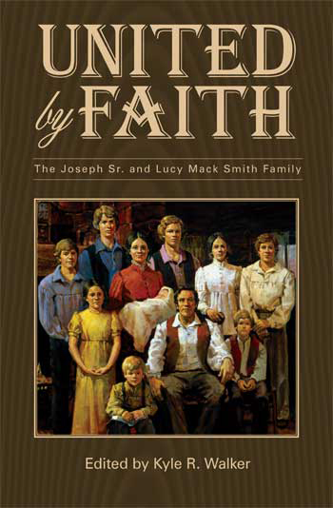
Meet the people who knew the Prophet Joseph Smith best. This intimate history quilts together the work of nine historians to take us inside Mormonism's first family. Blending meticulous research with compassionate insight, the authors present unforgettable portraits of each member of an outwardly ordinary family�the family that helped mold an extraordinary man of God.
This is a story not only of triumph against all oddds, but also a tender and moving tale of a family that, despite its flaws, remained intensely true to one of its own. The Smith family was the one constant amidst the turbulence of opposition that occurred throughout Joseph's life. They were with him from the beginning of his spiritual experiences to his martyrdom, with every living family member following him to Ohio, Missouri, and then to Illinois�a testament to their belief in his prophetic calling.
United by Faith: The Joseph Smith Sr. and Lucy Mack Smith Family offers compelling insight into this most significant family and casts penetrating new light as to why they were uniquely qualified to raise the Prophet of the Restoration.
Title: United by Faith: The Joseph Sr. and Lucy Mack Smith Family
===================================================================================================================================
http://www.signaturebooks.com/lucy.htm

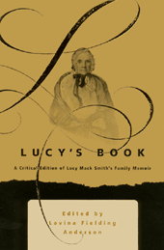

Lucy's Book
A Critical Edition of Lucy Mack Smith's Family Memoir
LAVINA FIELDING ANDERSON, EDITOR
(with an introduction by Irene M. Bates)
Hardbound. 968 Pages. / 1-56085-137-6 / $44.95
BEST BOOK AWARD, JOHN WHITMER HISTORICAL ASSOCIATION; BEST DOCUMENTARY BOOK AWARD, MORMON HISTORY ASSOCIATION
Mormonism begins with Lucy Mack, mother of the prophet Joseph Smith. In her dictated memoir, readers will detect the same seeds of religious fervor and frontier idiom that characterized her son's writings and sermons.
Although much of her original voice was lost through editing in the more formal, first published edition of her memoir—14 percent of the overall content having been discarded—Lucy's original manuscript survives and is presented here for the first time in its entirety. For comparison's sake, it is arranged in parallel columns with the first (1853) edition. Significant variants from later printings are indicated in the editor's footnotes, with prefatory chapters that provide historical background and textual genealogy.
Lucy's story is gripping and occasionally heart-breaking. As Irene Bates notes in the foreword, the memoir is given "to a new generation of [Lucy's] spiritual grandchildren" as both history and as inspiration. By restoring passages that relate Mother Smith's own, personal understanding of important events, her reactions to them, and her portrayal of Mormon women as competent and strong (a theme that was removed from later editions), editor Lavina Fielding Anderson has allowed Lucy to say what she originally intended.

"Am I indeed the mother of a prophet of the God of Heaven?" Lucy asks in the rough draft of her memoir. She answers in the affirmative. Yet her question conveys an intimacy that is absent from the polished, final version of her book. Dictated to a scribe, her spontaneity creates an ambiance that allows readers to picture her sitting in her rocking chair in Nauvoo, Illinois, reminiscing with a friend. This sense is heightened by her scribe's phonetic rendering of frontier slang. For instance, Lucy worries about "the measels and other ketchin diseases," rendered as "contagious disease" in the final version. She describes her son coming "upon a green sward under an apple tree," saying that, "Here he lay down"—flattened in the printed version, eliminating the word "sward." Where Joseph's brother says, "We must keep to work," this becomes in the published edition, "We must not slacken our hands."
But literary issues aside, Lucy's original narration carries significance due to what it says, and does not say, about Mormonism's founding, in corroborating what other family members and early converts reported. For instance, she uses the terms "dream" and "vision" interchangeably. She remembers that her son's famous first vision occurred in his bedroom at night, echoing the well established tradition of her husband's own prophetic dreams. The line dividing the physical and spiritual blurs further when Lucy tells that when her son retrieved the gold plates of the Book of Mormon, he was accosted three times by three different individuals, each of whom jumped up from behind a log, struck Joseph "a heavy blow" with a gun, and then allowed him to escape. The reader is left to wonder whether these were men or devils.
Not that such distinctions between the supernatural and material world would have mattered to Lucy, who lived comfortably in both. A popular novelist in her day, von Goethe, described a young man spending a day in the country and sensing unseen spirits that held sway over his emotions, and proclaiming that "God in His Infinity bears us aloft in perpetual joy." Lucy similarly felt that she was often "in the purview of angels," and her heart "bounded at the thought." Though "surrounded by enemies," she was "yet in extacy [sic] of happiness"; and "truly," she said, "my soul did maginify and my spirit rejoiced in God my savior." Her ability to express the reality of this spiritual world and the intensity of her emotional responses make her, among a handful of eyewitnesses, one of the most compelling chroniclers of early Mormonism.
Lavina Fielding Anderson (Ph.D., English, University of Washington) lives in Salt Lake City with her husband Paul, a museum exhibit designer at Brigham Young University. They have one son. She is the editor of the Journal of Mormon History, co-editor of the Case Reports of the Mormon Alliance, current-issues editor of the Mormon Women's Forum Quarterly, and production editor for the Review of Higher- Education. She is a past president of the Association for Mormon Letters. She has been an associate editor of Dialogue: A Journal of Mormon Thought and of the Ensign magazine. Her books include (as editor) Chesterfield: Mormon Outpost in Idaho; (co-editor) Sisters in Spirit: Mormon Women in Historical and Cultural Perspective, Tending the Garden: Essays on Mormon Literature; (contributor) On Their Own: Widows and Widowhood in the American Southwest, 1848-1939; Religion, Feminism, and Freedom of Conscience: A Mormon/Humanist Dialogue; The Wilderness of Faith: Essays on Contemporary Mormon Thought; and Women and Authority: Re-emerging Mormon Feminism. She is a recipient of the Grace Fort Arrington Award for Distinguished Service from the Mormon History Association.


===================================================================================================================================

