The Hermetic Order of the Golden Dawn Knowledge Lectures

http://www.hermetics.org/GD-articles.html

First Knowledge Lecture:
(Neophyte Degree)


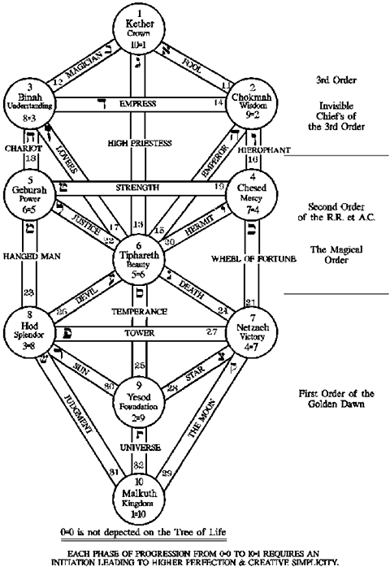

1. The Four Elements of the Ancients are duplicated conditions of:
Heat and Dryness........................ Fire 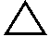
Heat and Moisture........................Air 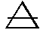
Cold and Dryness.........................Earth 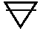
Cold and Moisture........................Water 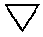

2. The Signs of the Zodiac are twelve:
1. | Aries, | The Ram | 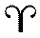
2. | Taurus, | The Bull | 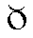
3. | Gemini, | The Twins | 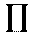
4. | Cancer, | The Crab | 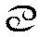
5. | Leo, | The lion | 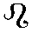
6. | Virgo, | The Virgin | 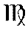
7. | Libra, | The Sclales | 
8. | Scorpio, | The Scorpion | 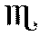
9. | Sagitarius, | The Archer | 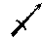
10. | Capricorn, | The goat | 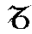
11. | Aquarius, | The Water- Bearer | 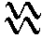
12. | Pisces, | The Fishes

These Twelve Signs are distributed among the Four Triplicites, or sets of three Signs, each being attributed to one of the Four Elements, and they represent the operation of the elements in the Zodiac.
Thus to Fire belong  Aries, Leo and Sagittarius | , ,
Thus to Earth belong  Taurus, Virgo and Capricorn | , ,
Thus to Air belong  Gemini, Libra and Aquarius | , ,
Thus to Water belong  Cancer, Scorpio and Pisces | , ,

3. To the Ancients,
six Planets were known besides the Sun, which they classed with the Planets. they also assigned certain planetary values to the North and South Nodes of the Moon--that is, the point where her orbit touches that of the Ecliptic.
These they named Caput Draconis, Head of the Dragon, 
and Cauda Draconis, Tail of the Dragon. 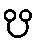
Since the discovery of two more distant Planets, Neptune and Uranus or Herschel, these two terms have been partially replaced by them.
The effect of Caput Draconis is similar to that of Neptune, 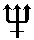.
The effect of Cauda Draconis is similar to that of Uranus, 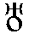.

The Old Planets are:

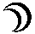 | Moon
 | Mercury
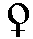 | Venus
 | Sun
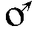 | Mars
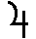 | Jupiter
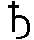 | Saturn

4. The Hebrew Alphabet
Each letter represents a number and also has a meaning.
PLATE I.- TABLE OF HEBREW AND CHALDEE LETTERS
No. | Hebrew and Chaldee Letters | Name | Significance  of Name | Sound or Power | Roman Letters Used | Numerical Value
1  2  3  4  5  6  7  8  9  10  11  12  13  14  15  16  17  18  19  20  21  22 | 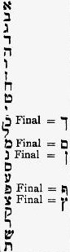 | Aleph  Beth  Gimel  Daleth  He  Vau  Zayin  Cheth  Teth  Yod  Caph  Lamed  Mem  Nun  Samekh  Ayin  Pe  Tzaddi  Qoph  Resh  Shin  Tau | Ox  House  Camel  Door  Window  Peg, Nail  Weapon, sword  Enclosure, fence  Serpent  Hand  Palm of the Hand  Ox-goad  Water  Fish  Prop, support  Eye  Mouth  Fishing-hook  Back of the head  Head  Tooth  Sign of the Cross | a (soft breathing)  b, bh (v)  g (hard), gh  d, dh (flat th)  h (rough breathing)  v,u, o  z, dz  ch, h (guttural)  t (strong)  i, y (as in yes)  k, kh  l  m  n  s  o, aa, ng (guttural)  p, ph (f)  ts, tz, j  q, qh (guttural)  r  sh, s  th, t | A  B  G  D  H  V  Z  Ch  T  I  K  K  M  N  S  O  P  Tz  Q  R  Sh  Th | 1 (Thousands are  2 denoted by a  3 larger letter; Thus  4 an Aleph larger  5 than the rest of  6 the letters  7 among which it is,  8 signifies not 1,  9 but 1000).  10  20 final = 500  30  40 final = 600  50 final = 700  60  70  80 final = 800  90 final = 900  100 (The finals are not  200 always considered as  300 bearing an increased  400 numerical value)

Five Letters
have a different shape when written at the end of a word and also have a different number.
Mem (final) Of these finals, Mem is distinguished as being the only oblong letter.
,,, The other four - Kaph, Nun, Pe, Tzaddi, have tails which should descend below the line as shown.
Hebrew and Chaldee letters are written from right to left.
The Hebrew Qabalists referred the highest and most abstract ideas to the Emanations of Deity or Sephiroth They made them ten in number. Each one is a Sephira, and when arranged in a certain manner they form the Tree of Life.
Hebrew Letters are holy symbols. They should be carefully drawn and square.
The Sephiroth are:
1. | KETHER | K - Th- R | The Crown
2. | CHOKMAH | Ch - K - M - H | Wisdom
3. | BINAH | B - İ - N - H | Understanding
4. | CHESED | Ch - S – D | Mercy
5. | GEBURAH | G - B - U - R - H | Severity
6. | TIPHARETH | Th - P - A - R - Th | Beauty
7. | NETSACH | N - TZ - Ch | Victory
8. | HOD | H - O - D | Glory
9. | YESOD | Y - S - O - D | The Foundation
10. | MALKUTH | M - L - K - U – Th | The Kingdom

MEDITATION No. 1
Let the Neophyte
consider a point as defined in mathematics--having position, but no magnitude--and let him note the ideas to which this gives rise. Concentrating his faculties on this, as a focus, let him endeavour to realize the immanence of the Divine throughout Nature in all her aspects.
Begin by finding a position, balanced, but sufficiently comfortable. Breather rhythmically until the body is still and the mind quiet. Keep this state for a few minutes at first--and for longer as you get used to preventing the mind from wandering. Think now of the subject for meditation in a general way--then choose out one thought or image and follow it to its conclusion.
The simplest rhythm for the beginner is the Fourfold Breath.
1. Empty the lungs and remain thus while counting to 4.
2. Inhale, counting to four, so that you feel filled with breath to the throat.
3. Hold this breath while counting four.
4. Exhale, counting four until the lungs are empty.
This should be practiced, counting slowly or quickly till you obtain a rhythm that suits you--one that is comfortable and stilling.
Having attained this, count the breath thus for two or three minutes, till you feel quiet, the proceed with the meditation.

THE LESSER RITUAL OF THE PENTAGRAM
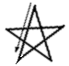
INVOKING
Take a steel dagger in the right hand. Face east.
Touching thy forehead say 'ATEH' ('Thou art' )
Touch thy breast. Say 'MALKUTH' ('The Kingdom' )
Touch thy right shoulder. Say 'VE-GEBURAH' ('The Power' )
Touch thy left shoulder. Say 'VE-GEDULAH' ('and the Glory')
Clasp thy hands before thee. Say 'LE-OLAM' ('forever')
Dagger between fingers, point up and say 'AMEN'

Make in the air towards the East the invoking Pentagram as shown and, bringing the dagger point to the center of the Pentagram, vibrate the Deity Name Yod-He-Vau-He imagining that your voice carries forward to the East of the Universe.
Holding the dagger out before you, proceed to the South, make the Pentagram, and vibrate the diety name 'Adonai'
Go to the West, make the Pentagram and vibrate 'Eheieh'.
Go to the North, make the Pentagram and vibrate 'Agla' .
Return to the East and complete your Circle by bringing the dagger point to the center of the first pentagram.
Stand with arms outstretched in the form of a cross and say:
'Before me Raphael,
Behind me Gabriel,
At my right hand Michael,
at my left hand Auriel!
Before me flames the Pentagram -
Behind me shines the six-rayed star!'
Again make the Qabalistic Cross as directed above, saying ATEH, etc.
For Banishing use the same Ritual, but reversing the direction of the lines of the Pentagram.

THE USES OF THE PENTAGRAM RITUAL
1. As a form of prayer the invoking ritual should be used in the morning and the banishing in the evening. (To banish begin at the lower left point, then up to the top, continue). The names should be pronounced inwardly in the breath vibrating it as much as possible and feeling that the whole body throbs with the sound and sends out a wave of vibration directed at the ends of the quarter.
2. As a protection against impure magnetism, the Banishing Ritual can be used to get rid of obsessing or disturbing thoughts. Give a mental image to your obsession and imagine it formulated before you. Project it out of your aura with the Saluting Sign of a Neophyte, and when it is away about three feet prevent its return with the Sign of Silence.
Now imagine the form in the East before you and do the Banishing Ritual of the Pentagram to disintegrate it, seeing it, in your mind's eye, dissolving on the further side of your ring of flame.
3. It can be used as an exercise in concentration. Seated in meditation or lying down, formulate yourself standing in robes and holding a dagger. Put your consciousness in this form and go to the East. Make yourself 'feel' there by touching the wall, opening your eyes, stomping on the floor, etc. Begin the ritual and mentally go around the room vibrating the words and trying to feel them coming from the form. Finish in the East and try to see your results in the Astral Light, then walk back and stand behind the head of your body and let yourself be reabsorbed.

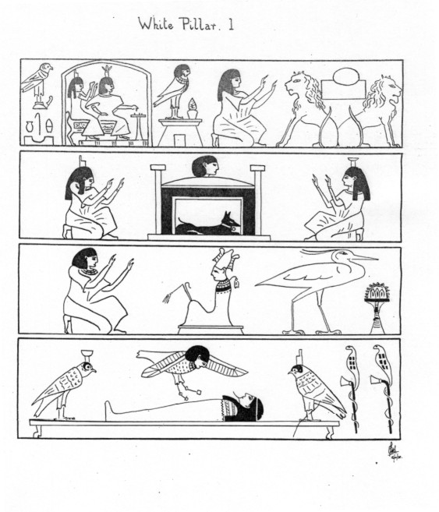

THE PILLARS
In the explanation of the Symbols of the Grade of Neophyte, your attention has been directed to the general mystic meaning of the two pillars called in the Ritual the 'Pillars of Hermes' of 'Seth' and of 'Solomon' . In the ninth chapter of the Ritual of the Dead they are referred to as the 'Pillars of Shu' , the 'Pillars of the Gods of the Dawning Light' and also as the 'North and South Columns of the Gate of the Hall of Truth'. In the 125th Chapter they are represented by the sacred gateway, the door to which the aspirant is brought when he has completed the Negative Confession. The archaic pictures on the one Pillar are painted in black upon a white background, and those on the other in white upon a black background in order to express the interchange and reconciliation of opposing forces and the eternal balance of light and darkness which gives force to visible nature.
The black cubical bases represent darkness and matter wherein the Spirit, the Ruach Elohim , begins to formulate the ineffable NAME, that name which the ancient rabbis have said 'rushes through the universe' , that name before which the darkness rushes back at the birth of time.
The flaming red triangular capitals which crown t he summit of the Pillars represent the triune manifestation of the Spirit of Life, the Three Mothers of the Sefer Yetzirah, the Three Alchemical Principals of Nature, the Sulfer, the Mercury and the Salt.
Each Pillar is surmounted by its own light-bearer veiled from the material world.
At the base of both Pillars rise the lotus flowers, symbols of regeneration and metempsychosis. The archaic illustrations are taken from vignettes of the 17th and 125th chapters of the Ritual of the Dead, the Egyptian 'Per-em-Hrw' or the 'Book of Coming Forth Into the Day' , the oldest book in the world as yet discovered. The Recension of the Priests of ON is to be found in the walls of the Pyramids of the Kings of the 5th and 6th dynasties at Sakarah, the recension of the 11th and 12th dynasties on the sarcophagi of the period, and the Theban recension of the 18th dynasty and onward is found on papyri, both plain and illuminated. No satisfactory translation of these books is available, none having been yet attempted by a scholar having the qualifications of mystic as well as Egyptologist.
The Ritual of the Dead, generally speaking, is a collection of hymns and prayers in the form of a series of ceremonial Rituals to enable the man to unite himself with Osiris the Redeemer. After this union he is no longer called the man, but Osiris with whom he is now symbolically identified. 'That they may also be One of us' , said the Christ of the New Testament. 'I am Osiris' , said the purified and justified man, his soul luminous and washed from sin in the immortal and uncreated light, united to Osiris and thereby justified, and the Son of God; purified by suffering, strengthened by opposition, regenerate through self-sacrifice. Such is the subject of the great Egyptian Ritual.
The 17th Chapter of the Theban recension consists of a very ancient text with several commentaries, also extremely old, and some prayers, none of which come into the scheme of the original text. It has, together with the 12th Chapter, been very carefully translated for the purpose of this lecture by the V.H. Frater M.W.T. and the V.H. Soror S.S.D.D. has made many valuable suggestions with regard to the interpretation. The title and preface to the 17th Chapter reads:
"Concerning the exaltation of the glorified ones, of coming and going forth in the divine domain, of the genies of the beautiful land of Amentet. Of coming forth in the light of day in any form desired, of hearing the voices of nature by being enshrined as a living Ba."
And the rubric is:
"The united with Osiris shall recite it when he has entered the Harbour. May glorious things be done thereby upon the Earth. May all the words of the Adept be fulfilled."
Owing to the complex use of symbols, the ritual translation of the chapter can only be understood by perpetual reference to the ancient Egyptian commentaries, and therefore the following paraphrase has been put together to convey to modern minds as nearly as possible the ideas conveyed by the ancient Egyptians in this glorious triumphal song of the Soul of Man made One with Osiris, the Redeemer.
"I am TUM made One with all things."
"I have become NU. I am RA in his rising ruling by right of his Power. I am the Great God self-begotten, even NU, who pronounced his Names, and thus the Circle of the Gods was created."
"I am Yesterday and know Tomorrow. I can never more be overcome. I know the secret of Osiris, whose being is perpetually revered of RA. I have finished the work which was planned at the Beginning, I am the Spirit made manifest, and armed with two vast eagle's plumes. Isis and Nephthys are their names, made One with Osiris."
"I claim my inheritance. My sins have been uprooted and my passions overcome. I am Pure White. I dwell in Time. I live through Eternity, when initiates make offerings to the Everlasting Gods. I have passed along the Pathway. I know the Northern and Southern Pillars, the two Columns at the Gateway of the Hall of Truth."
"Stretch unto me your hands, O ye dwellers in the center. For I am transformed to a God in your midst. Made One with Osiris I have filled the eye-socket in the day of the morning when Good and Evil fought together."
"I have lifted up the cloud-veil in the Sky of the Storm. Till I saw RA born again from out the Great Waters. His strength is my strength and my strength is His strength. Honour to you, Lords of Truth, Chiefs who Osiris rules. Granting release from Sin, Followers of Ma where rest is glorious. Whose throne Anubis built in the day when Osiris said:
"Lo! A man wins his way to Amentet. I come before you to drive away my faults. As ye did to the Seven Glorious Ones who follow their lord Osiris. I am that Spirit of Earth and the Sun."
"Between the Two Pillars of Flame. I am RA when he fought beneath the Ashad Tree, destroying the enemies of the Ancient of Days. I am the Dweller in the Egg. I am he who turns in the Disc. I shine forth from the Horizon as the gold from the mine. I float through the Pillars of SHU in the ether. Without a peer among the Gods. The Breath of my mouth is as a flame. I light upon the Earth in my glory. Eyes cannot gaze upon my daring beams , as they reach through the Heavens and lick up the Nile with tongues of flame. I am strong upon the Earth with the strength of RA. I have come into Harbour as Osiris made perfect. Let priestly offerings be made to me as one in the train of the Ancient of Days. I brood as the Divine Spirit. I move in the Firmness of my strength. I undulate as the Waves that vibrate through Eternity. Osiris has been claimed with acclamation, and ordained to rule among the Gods. Enthroned in their Domain of Horus where the Spirit and the Body are united in the presence of the Ancient of Days. Blotted out are the sins of his body in passion. He has passed the Eternal Gate and has received the New Years Feast with Incense, at the marriage of Earth with Heaven."
"TUM has built his Bridal Chamber. RURURET has founded his Shrine. The Procession is completed. HORUS has purified, SET has consecrated, SHU made One with Osiris has entered his heritage."
"As TUM he has entered the Kingdom to complete union with the Invisible. Thy Bride, O Osiris, is Isis, who mourned Thee when she found Thee slain. In Isis thou art born again. From Nephthys is thy nourishment. They cleansed thee in thy Heavenly Birth. Youth waits upon thee, ardour is ready at thy hand. And their arms shall uphold thee for millions of years. Initiates surround Thee and Thy enemies are cast down. The Powers of Darkness a re Destroyed. The Champions of Thy Joys are with Thee. Thy Victories in the Battle await their reward in the Pillar. The Forces of Nature obey Thee. Thy power is exceeding great. The Gods curse him that curseth Thee. Thine Aspirations are fulfilled. Thou art the Mistress of Splendour. They are destroyed who barred Thy way."
The 125th Chapter is concerned with the entry of an initiate into the Hall of the Two Columns of Justice and commenced with a most beautiful and symbolic description of Death. as a journey from the barren wilderness of Earth to the Glorious Land which lies beyond. The literal translation of the opening lines is as follows:
"I have come from afar to look upon thy beauties. My hands salute thy Name of Justice. I have come from afar, where the Acacia Tree grew not. Where the tree thick with leaves is not born. Where there come not beams from herb or grass. I have entered the Place of Mystery. I have communed with Set. Sleep came upon me, I was wrapped therein, bowing down before the hidden things. I was ushered into the House of Osiris, I saw the marvels that were there. The Princes of the Gates in their Glory"
The illustrations in this Chapter represent the Hall of Truth as seen through the open leaves of its door. The hall is presided over by a God who holds his right hand over the cage of a hawk and his left over the food of Eternity. On each side of the God is a cornice crowned by a row of alternate feathers and Uraei symbolising justice and firey power. The door leaf which completes the right hand of a stall is called 'Possessor of Truth controlling the Feet' , while that on the left is 'Possessor of strength binding the male and female animals' . The 42 judges of the dead are represented as seated in a long row, and each of them has to be named, and the Sin over which he presides has been denied.
This chapter describes the introduction of an initiate into the Hall of Truth by ANUBIS, who, having questioned the aspirant, receives from him an account of his initiation. and is satisfied by his right to enter. He states that he has been taken into the ante-chamber of the Temple and there stripped and blindfolded, he had to grope for the entrance to the Hall, and having found it he was reclothed and annointed in the presence of the Initiated. He is then asked for the Pass-words and demands that his Soul should be weighed in the Great Balance of the Hall of Truth, whereupon ANUBIS again interrogates him concerning the symbolism of the door of the Hall, and his answers being found correct, ANUBIS says, "Pass on, thou knowest it".
Among other things the initiates states that he has been purified four times, the same number of times that the Neophyte is purified and consecrated in the ceremony of the Neophyte. He then makes the long Negative Confession, stating to each judge in turn that he is innocent of that form of Sin over which he judges. Then he invokes the Judges to do him justice, and afterwards describes how he had washed in the washing place of the South, and rested in the North, in the place called 'Son of the Deliverers' and he becomes the Dweller under the Olive Tree of Peace, and how he was given a tall flame of fire and a scepter of cloud which he preserved in the salting tank in which mummies are swathed. And he found there another scepter called 'Giver of Breath' and with that he extinguished the flame and shattered the scepter of cloud, and made a lake of it. The initiate is then brought to the actual Pillars and has to name them and their parts under the symbol of the Scales of a Balance . He also has to name the Guardian of the Gateway, who prevents his passage, and when all these are propitiated the plea of the Hall cries out against his steps, saying, "Because I am silent, because I am pure." and it must know that his aspirations are pure enough and high enough for him to be allowed to tread upon it. He is then allowed to announce to Thoth that he is clean from all evil and has overcome the influence of the Planets, and THOTH says to him, "Who is He whose Pylons are of Flame, whose walls of Living Uraei, and the flames of whose House are streams of Water?" and the Initiate replies, "Osiris!"
And it is immediately proclaimed: "Thy meat shall be from the Infinite and thy drink from the Infinite. Thou art able to go forth to the sepulchural feasts on earth, for thou hast overcome."
Thus, these two chapters, which are represented by their illustrations on the Two Pillars, represent the advance and purification of the Soul and its union with Osiris the Redeemer, in the Golden Dawn of the Infinite Light, in which the Soul is transfigured, knows all, and can do all, for it is made One with the Eternal God.
KHABS AM PEKHT
KONX OM PAX
LIGHT IN EXTENSION!

Second Knowledge Lecture:
(Zelator Degree)

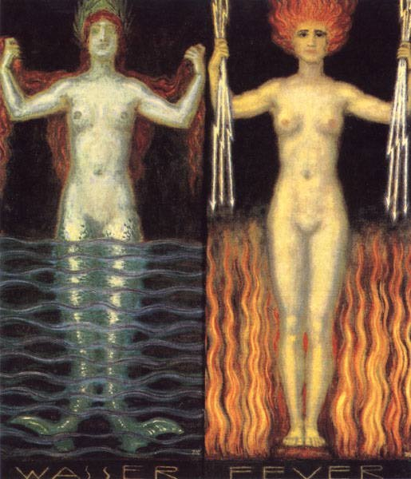
( Stuck - "Water and Fire")

The Names and Alchemical Symbols of the Three Principles of Nature are:
SULPHUR 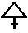
MERCURY
SALT 

The metals attributed to the Planets in Alchemy are:

LEAD | GOLD 
TIN | COPPER OR BRASS
IRON | QUICKSILVER (Mercury)
SILVER

The following terms are used in books about Alchemy. They have the meanings given below.
Sol Philosophorum
The Pure Living Alchemical Spirit of Gold--the refined essence of heat and fire

Luna Philosophorum
The Pure Living Alchemical Spirit of Silver--the refined essence of heat and moisture

The Green Lion
The Stem and Root of the Radical Essence of Metals

The Black Dragon
Death--Putrefaction--Decay.

The King
Red--The Qabalistic Microprosopus
Tiphareth-- analagous to Gold and the Sun

The Queen
White--The Qabalistic Bride of Microprosopus
Malkah--analagous to Silver and the Moon

The Four Orders of the Elements are:
1. The Spirits of the Earth: Gnomes
2. The Spirits of the Air: Sylphs
3. The Spirits of the Water: Undines
4. The Spirits of the Fire: Salamanders
These are the Essential Spiritual Beings called upon to praise God in the 'Benedicite Omnia Opera'.

The Kerubim are the Living Powers of Tetragrammaton on the Material Plane and the Presidents of the Four Elements. They operate through the Fixed or Kerubic Signs of the Zodiac and are thus symbolized and attributed:
Kerub of Air----------Man--------Aquarius
Kerub of Fire---------Lion---------Leo
Kerub of Earth--------Bull----------Taurus
Kerub of Water-------Eagle---------Scorpio

Tetragrammaton means 'Four-Lettered Name' and refers to the Unpronounceable Name of God symbolized by 'Jehovah'.
The Laver of Water of Purification refers to the waters of Binah, the Female Power reflected in the Waters of Creation.
The Altar of Burnt Offering for the sacrifice of animals symbolizes the Qlippoth, or Evil Demons of the plane coniguous to and below the Material Universe. It points out that our passions should be sacrificed.
The Qlippoth are the Evil Demons of Matter and the Shells of the Dead.
The Altar of Incense in the Tabernacle was overlaid with gold. Ours is Black to symbolize our work which is to seperate the philosophic Gold from the Black Dragon of Matter.

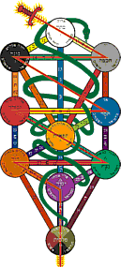
This altar diagram shows the Ten Sephiroth with all the connecting Paths numbered and lettered, and the Serpent winding over each Path. Around each Sephira are written the names of the Deity, Archangel and Angelic Host attributed to it. The Twenty-Two Paths are bound together by the Serpent of Wisdom. It unites the Paths but does not touch any of the Sephiroth, which are linked by the Flaming Sword.

The Flaming Sword is formed by the Natural Order of the Tree of Life. It resembles a Flash of Lightning.

Together the Sephiroth and the Twenty-Two Paths form the 32 Paths of the Sefer Yetzirah, or Book of Formation.

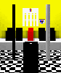
The Two Pillars on either side of the Altar represent:

Active: The White Pillar on the South Side. Male. Adam. Pillar of Light and Fire. Right Kerub. Metatron.

Passive: The Black Pillar on the North Side. Female. Eve. Pillar of Cloud. Left Kerub. Sandalphon.

THE SECOND MEDITATION
LET THE ZELATOR meditate on a straight line. Let him take a ruler or pencil and by moving it a distance equal to its length, outline a square.
Having done this, let him, after quieting his mind with the rhythmic breathing taught in the first meditation, mentally formulate a cube, and endeavour to discover the significance of this figure and its correspondences.
Let him meditate upon minerals and crystals, choosing especially a crystal of SALT, and entering into it, actually feel himself of crystalline formation.
Looking out on the Universe from this standpoint, let him identify himself with the EARTH SPIRITS in love and sympathy, recalling as far as he can their prayer as said in the closing of the Zelator Grade.
Let him meditate upon the EARTH TRIPLICITY, visualizing the symbols of a BULL--a VIRGIN--a GOAT which stand for KERUBIC EARTH--MUTABLE EARTH--CARDINAL EARTH.
For the above ideas consult a simple astrology manual. Make notes of the ideas and pictures which arise in your mind.

The Four Worlds of the Qabalah are:

1. ATZILUTH | Archetypal | Pure Diety
2. BRIAH | Creative | Archangelic
3. YETZIRAH | Formative | Angelic
4. ASSIAH | Action | Action, Man, Shells, Demons

The Ten Houses, or Heavens, of Assiah, the Material World, are:

1. Premium Mobile | Rashith ha-Gilgalim
2. Sphere of the Zodiac | Mazloth
3. Sphere of Saturn | Shabbathai
4. Sphere of Jupiter | Tzedeq
5. Sphere of Mars | Madim
6. Sphere of Sol | Shemesh
7. Sphere of Venus | Nogah
8. Sphere of Mercury | Kokab
9. Sphere of Luna | Levanah
10. Sphere of the Elements | Olam Yesodoth

THE DIVINE NAMES ATTRIBUTED TO THE SEPHIROTH

Choir of Angels (Yetzirah)
(The definitions of the Hebrew Names can only be approximate and were not given in the actual GD texts. For the most part the tables of Bill Heidrick was consulted among others)

1. Kether | Chayoth ha-Qadesh | The Holy Living Creatures
2. Chokmah | Auphanim | The Wheels / Spinning Ones
3. Binah | Aralim | The Might Ones / Thrones
4. Chesed | Chashmalim | The Shining Ones
5. Geburah | Seraphim | The Burning Ones / Exalted Ones
6. Tipharet | Melekim | Kings
7. Netzach | Elohim | Deities
8. Hod | Beni Elohim | Sons of the Gods
9. Yesod | Kerubim | Cherubs
10. Malkuth | Ashim | Fiery Spirits

Archangelic Name (Briah)

1. Kether | Metatron | "Beyond the Thrones"
2. Chokmah | Raziel | Secret of God
3. Binah | Tzaphqiel | Hidden Voice of God
4. Chesed | Tzadqiel | Righteousness of God
5. Geburah | Kamael | Longing of God
6. Tipharet | Raphael | Healing of God
7. Netzach | Haniel | Ship of God
8. Hod | Michael | Like God
9. Yesod | Gabriel | Might One of God
10. Malkuth | Sandalphon | Soul of the Redeemer

Divine Name (Atziluluth)

1. Kether | Eheieh | I am
2. Chokmah | Yah | S/he is
3. Binah | Yhvh Elohim | S/he is Male and Female Deities
4. Chesed | El | He is Mighty
5. Geburah | Elohim Gibor | The Male and Female Deities are Mighty
6. Tipharet | Yhvh Eloah ve-Daath | God (male) + Knowledge
7. Netzach | Yhvh Tzabaoth | God is Splendor
8. Hod | Elohim Tzabaoth | The Male and Female Deities are Splendor
9. Yesod | Shaddai El Chai | Almighty God Lives Forever!
10. Malkuth | Adonai ha-Aretz | Lord of the Earth

PLANETARY NAMES

Symbol | Hebrew Name of Planet | Angel | Intelligence |  | Spirit
 | Shabbathai | Cassiel | Agiel |  | Zazel
 | Tzedek | Sachiel | Iophiel |  | Hismael
 | Madim | Zamael | Graphiel |  | Bartzabel
 | Shemesh | Michael | Nakhiel |  | Sorath
 | Nogah | Hanael | Hagiel |  | Kedemel
 | Kokab | Raphael | Tiriel |  | Taphthartharath
 | Levanah | Gabriel | Malkah be Tarshisim ve-ad Ruachoth Schechalim |  | Schad Barschemoth ha-Shartathan

The traditional Tarot consists of a pack of 78 cards made up of Four Suits of 14 cards each, together with 22 Trumps, or Major Arcana, which tell the story of the Soul.
Each suit consists of ten numbered cards, as in the modern playing cards, but there are four instead of three honours: King or Knight, Queen, Prince or Emperor, Princess or Knave.
the Four Suits are:
1. Wands or Sceptres comparable to | Diamonds | ♦
2. Cups of Chalices comparable to | Hearts | ♥
3. Swords comparable to | Spades | ♠
4. Pentacles or Coins comparable to | Clubs | ♣

Third Knowledge Lecture:
(Zelator Degree)

THE SOUL is divided by the Qabalists into three Principal Parts:—
1. NESCHAMAH The Highest Part, answering to the Three Supernals.

2. RUACH The Middle Part, answering to the six Sephiroth from CHESED to YESOD, inclusive.
5. NEPHESCH The lowest, answering to MALKUTH.
NESCHAMAH answers to the higher aspirations of the Soul.
RUACH answers to the mind and reasoning powers.
NEPHESCH answers to the animal instincts.
CHIAH answers to CHOKMAH, YECHIDAH TO KETHER, while NESCHAMAH itself is referred to BINAH.
The Sepher Yetzirah divides the Hebrew Letters into
three Classes of Three, Seven, and Twelve.
Three Mothers ————————————— , ,
Seven Double Letters —————— , ,, , , ,
Twelve Single Letters ——— , , , , , , , , , , ,
The Holy Place embraces the symbolism of the 22 Letters.
The Table of Shew-Bread, the Single Letters.
The Altar of Incense the Three Mothers.
Astral Spirits are those belonging to the Astral Plane. Such are false and illusionary forms, shells of the dead, and Ghosts and Phantoms.
Elemental Spirits are those belonging to the nature of the Elements; some are good and some are evil.
An Angel is a pure and high Spirit of unmixed good in office and operation.
In the Tarot, the ten small cards of each suit refer to the Sephiroth. The four suits refer to the Letters of Tetragrammation thus:—
Sceptres or Wands to —— Yod
Cups ——————————— Heh
Swords —————————— Vau
Pentacles —————————Heh (final)
The Four Suits also refer to the Four Worlds of the Qabalists thus:—
Sceptres to ————————Atziluth
Cups ——————————— Briah
Swords —————————— Yetzirah
Pentacles —————————Assiah
The Honours of the Tarot Pack are, as it were, the Vice-gerants of the Great Name, in the Qabalistic World
to which each suit is referred. They also symbolise Father, Mother, Son, Daughter; Birth, Life, Death,
Resurrection.

THE FLYFOT CROSS  The 17 Squares out of a square of lesser squares, refer to the Sun in the twelve Signs of the Zodiac and the Four Elements: | 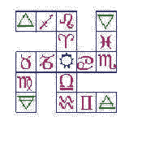
This form of the Caduceus of Hermes is that of the Three Mother Letters placed on one another thus: | 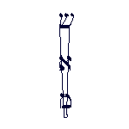
The Caduceus has another meaning on the Tree of Life. The upper part wings touch Chokmah and Binah: These are the Three Supernals.
The Seven lower Sephiroth are embraced by the twin Serpents whose heads rest upon Chesed and Geburah. | 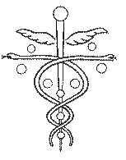

The meaning of Luna on the Tree of Life is thus:
In its increase it embraces the side of Mercy; in its decrease the side of Severity, and at the full, it reflects the Sun of Tiphareth.

MEDITATION
Let the Theoricus practise the Moon Breath, while saying mentally the word AUM: (Moon breath is through the left nostril only.)
Let him meditate upon the waxing and waning crescents, while visualising a silver crescent upon an indigo background.
Let him now call before his mind the Signs of the Airy Triplicity and enclosed in these, let him meditate upon the numbers nine and five and therewith the forms of the Pentagram and Pentangle.
Let him now rise in imagination above the mineral world into the world of trees and flowers and identify
himself in love and sympathy with the Powers of the Elements behind these.
Let him realise the mental world where mind rules over matter, and let him meditate upon the ideas of appearance and reality.

Fourth Knowledge Lecture:
(Practicus Degree)

The Figures of Geomancy

and their Zodiacal Attributes
 | Puer |  |  | Puella
 | Ammissio |  |  | Rubeus
 | Albus |  |  | Acquisitio
 | Populus |  |  | Carcer
 | Via |  |  | Tristitia
 | Fortuna Major |  |  | Laetitia
 | Fortuna Minor |  |  | Caput Draconis
 | Conjunctio |  |  | Cauda Draconis
The numbers and lineal figures appropriate to the planets are:
Saturn | 3 | Triangle
Jupiter | 4 | Square
Mars | 5 | Pentagram
Sun | 6 | Hexagram
Venus | 7 | Heptagram
Mercury | 8 | Octagram
Moon | 9 | Enneagram

THE MAGICAL SQUARES OF THE PLANETS
are formed of the squares of the number of the planet, arranged so as to yield the same number each way. The number of the sum of each column of figures and the number of the total of all the numbers of the square, are also numbers especially attached to the Planet. Thus the number of the Planet SATURN is 3, square 9, sum of all columns vertical, horizontal and diagonal 15; total sum of all numbers, 45. These numbers are then formed into Divine and Spirit Names.
[Note, the following kamea's or magical squares are not to be found in the original documents. They were placed here for clarification)

Kamea of Saturn
4 | 9 | 2
3 | 5 | 7
8 | 1 | 6
Kamea of Jupiter
4 | 14 | 15 | 1
9 | 7 | 6 | 12
5 | 11 | 10 | 8
16 | 2 | 3 | 13
Kamea of the Sun
6 | 32 | 3 | 34 | 35 | 1
7 | 11 | 27 | 28 | 8 | 30
19 | 14 | 16 | 15 | 23 | 24
18 | 20 | 22 | 21 | 17 | 13
25 | 29 | 10 | 9 | 26 | 12
36 | 5 | 33 | 4 | 2 | 31
Kamea of Venus
22 | 47 | 16 | 41 | 10 | 35 | 4
5 | 23 | 45 | 17 | 42 | 11 | 29
30 | 6 | 24 | 49 | 18 | 36 | 12
13 | 31 | 7 | 25 | 43 | 19 | 37
38 | 14 | 32 | 1 | 26 | 44 | 20
21 | 39 | 8 | 33 | 2 | 27 | 45
46 | 15 | 40 | 9 | 34 | 3 | 28
Kamea of Mercury
8 | 58 | 59 | 5 | 4 | 62 | 63 | 1
49 | 15 | 14 | 52 | 53 | 11 | 10 | 56
41 | 23 | 22 | 44 | 45 | 19 | 18 | 48
32 | 34 | 35 | 29 | 28 | 38 | 39 | 25
40 | 26 | 27 | 37 | 36 | 30 | 31 | 33
17 | 47 | 46 | 20 | 21 | 43 | 42 | 24
9 | 55 | 54 | 12 | 13 | 51 | 50 | 16
64 | 2 | 3 | 61 | 60 | 6 | 7 | 57
Kamea of the Moon
37 | 78 | 29 | 79 | 21 | 62 | 13 | 54 | 5
6 | 38 | 79 | 30 | 71 | 22 | 63 | 14 | 46
47 | 7 | 39 | 80 | 31 | 72 | 23 | 55 | 15
16 | 48 | 8 | 40 | 81 | 32 | 64 | 24 | 56
57 | 17 | 49 | 9 | 41 | 73 | 33 | 65 | 25
26 | 58 | 18 | 50 | 1 | 42 | 74 | 34 | 66
67 | 27 | 59 | 10 | 51 | 2 | 43 | 75 | 35
36 | 68 | 19 | 60 | 11 | 52 | 3 | 44 | 76
77 | 28 | 69 | 20 | 61 | 12 | 53 | 4 | 45

THE SOLID GREEK CUBICAL CROSS, the Admission Badge for the Path of tau, is composed of 22 squares, answering to the 22 letters of the Hebrew Alphabet. | 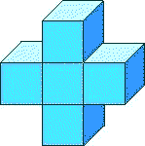
THE SOLID TRIANGLE OR TETRAHEDRON, or Pyramid of Fire,  the Admission Badge for the Path of shın, represents the Simple Fire of Nature and the Latent or Hidden Fire. | 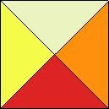
The three upper triangles refer to fıre — Solar, Volcanic and Astral, while the lowest or basal triangle represents the latent heat.
THE GREEK CROSS of 13 Squares, the Admission Badge for the Path of resh, is referred to the sun in the Twelve Signs of the Zodiac, and also in the midst of the Four Elements. | 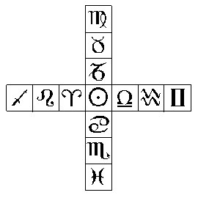
THE CUP OF STOLISTES,  the Admission Badge to the Grade of (3) =[8], is thus referred to the Tree of Life. It embraces nine of the Sephiroth, exclusive of Kether. | 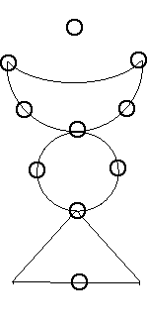
Yesod and Malkuth are referred to the triangle below, the former to the apex, the latter to the base. Like the Caduceus, it further represents the Three Elements: Water, Fire and Air. The Crescent refers to the Waters Above the Firmament, the sphere to the Firmament, and the basal triangle to the consuming Fire, which is opposed to the Fire symbolised by the upper part of the Caduceus.
THE SYMBOL of MERCURY  on the Tree of Life Embraces all but Kether. The horns spring from Daath (Knowledge) which is not, properly speaking, a Sephira, but rather a conjunction of Chokmah and Binah | 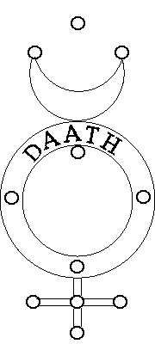

ATTRIBUTION OF THE TAROT TRUMPS

Path | Letter | No. / Tarot Trump | Symbol | Power
11 | 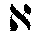 | 0 - The Foolish Man |  | Air
12 | 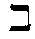 | 1 - The Juggler |  | Mercury
13 |  | 2 - The High Priestess |  | Moon
14 | 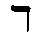 | 3 - The Empress |  | Venus
15 | 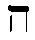 | 4 - The Emperor |  | Aries
16 |  | 5 - The Hierophant |  | Taurus
17 |  | 6 - The Lovers |  | Gemini
18 | 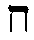 | 7 - The Chariot |  | Cancer
19 | 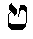 | 8 - Strength (Justice) |  | Leo
20 |  | 9 - The Hermit (Prudence) |  | Virgo
21 | 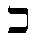 | 10 - The Wheel of Fortune |  | Jupiter
22 | 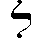 | 11 - Justice (Strength) |  | Libra
23 | 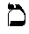 | 12 - The Hanged Man |  | Water
24 |  | 13 - Death |  | Scorpio
25 | 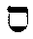 | 14 - Temperance |  | Sagittarius
26 | 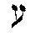 | 15 - The Devil |  | Capricorn
27 | 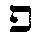 | 16 - Tower Struck by Lightning |  | Mars
28 | 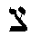 | 17 - The Star |  | Aquarius
29 | 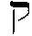 | 18 - The Moon |  | Pisces
30 | 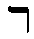 | 19 - The Sun |  | Sun
31 | 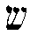 | 20 - Last Judgment |  | Fire
32 | 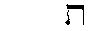 | 21 - The Universe |  | Saturn

MEDITATION

Let the Practicus meditate upon the Symbols of the Rhomboid and the Vesica.
Let him seek out their meanings and correspondences.
Let him contemplate the Symbol Mercury and the Number 8.
Let him now learn to control his emotions, on no account giving way to anger, hatred and jealousy, but to turn the force he hitherto expended in these directions towards the attainment of perfection, that the malarial marsh of his nature may become a clear and limpid lake, reflecting the Divine Nature truly and without distortion.
Let him identify himself with the Powers of Water, considering the Water Triplicity in all its aspects, with its attributions and correspondences.

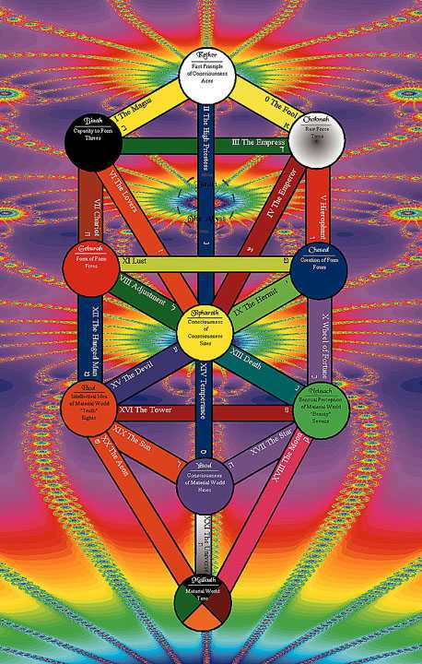

NOTES ON THE TAROT
by Frater S.R.M.D.
In the Tree of Life in the Tarot, each path forms the connecting link between two of the Sephiroth. The King and the Queen are the correlations of the Abba and the Aima in that suit; the Knight or Prince answers to Microprosopus, and the Knave or Princess which was anciently a female figure, is referred to the Bride, Kallah or Malkah.
Combining, then, the material attributions of the Sephiroth and the Path, it results that:
0. Fool =The Crown of Wisdom, the Primum Mobile, acting through the Air on the Zodiac.
1. The Juggler =The Crown of Understanding, the beginning of material production, the Primum Mobile acting through the Philosophic Mercury on Saturn.
2. High Priestess =The Crown of Beauty, the beginning of Sovereignty and Beauty, the Primum Mobile, acting through the Moon on the Sun.
3. Empress =The Wisdom of Understanding, the Union of the powers of Origination and Production; the Sphere of the Zodiac acting through Venus upon Saturn.
4. Emperor =The Wisdom of Sovereignty and Beauty, and the originator of them; the Sphere of the Zodiac acting through Aries upon the Sun, and initiating Spring.
5. Hierophant =The Wisdom and fountain of Mercy, the Sphere of the Zodiac acting through Taurus upon Jupiter.
6. The Lovers =The Understanding of Beauty and Production of Beauty and Sovereignty. Saturn acting through Gemini upon Sol.
7. Chariot = Understanding acting upon Severity. Saturn acting through Cancer upon Mars.
8. Strength = Fortitude. Mercy tempering Severity. The Glory of Strength. Jupiter acting through Leo upon Mars.
9. Hermit =The Mercy of Beauty, the Magnificence of Sovereignty, Jupiter acting through Virgo upon Sol.
10. Wheel of Fortune =The Mercy and Magnificence of Victory. Jupiter acting through Jupiter direct upon Venus.
11. Justice =The Severity of Beauty and Sovereignty. Mars acting through Libra upon Sol.
12. The Hanged Man =The Severity of Splendour. Execution of Judgment. Mars acting through Water
upon Mercury.
13. Death =The Sovereignty and result of Victory. Sol acting through Scorpio upon Venus, or Osiris under the destroying power of Typhon afflicting Isis.
14. Temperance =The Beauty of a firm Basis. The Sovereignty of Fundamental Power. Sol acting through Sagittarius upon Luna.
15. The Devil =The Sovereignty and Beauty of Material (and therefore false) splendour. Sol acting
through Capricorn upon Mercury.
16. The Tower =The Victory over Splendour. Venus acting through Mars upon Mercury. Avenging force.
17. Star =The Victory of Fundamental Strength. Venus acting through Aquarius upon Luna. Hope.
18. Moon =The Victory of the Material. Venus acting through Pisces upon the Cosmic Elements, deceptive effect of the apparent power of Material Forces.
19. Sun =The Splendour of the Material World. Mercury acting through the Sun upon the Moon.
20. Judgment =The Splendour of the Material World. Mercury acting through Fire upon the Cosmic Elements.
21. Universe =The Foundation of the Cosmic Elements and of the Material World. Luna acting through
Saturn upon the Elements.

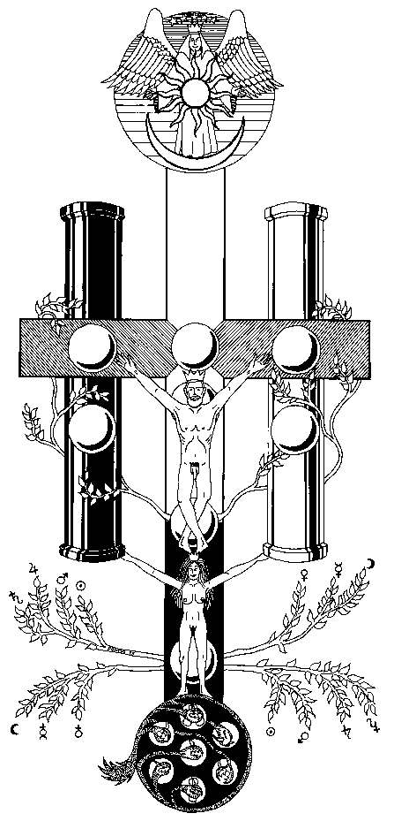

THE GARDEN OF EDEN BEFORE THE FALL
This diagram is described in the Practicus Ritual. It shows in a glyph the teaching proper to the Practicus on entering the Sephirah HOD which he has reached by the Paths of SHIN and RESH from MALKUTH and YESOD respectively.
At the summit are the THREE SUPERNAL SEPHIROTH summed up into ONE — AIMA ELOHIM, the Mother Supernal — The Woman of the Apocalypse (Chap. 12) clothed with the SUN, the MOON under her feet, and on her head the Crown of Twelve Stars.
It is written 'So the Name JEHOVAH is joined to the Name ELOHIM, for JEHOVAH planted a Garden Eastward in Eden.'
From the Three Supernals follow the other Sephiroth of THE TREE OF LIFE. Below the TREE, proceeding from MALKUTH is THE TREE OF KNOWLEDGE of GOOD AND of EVIL which is between the Tree of Life and the World or Assiah or Shells, represented by the Coiled Up DRAGON with Seven Heads and Ten Horns—being the Seven Infernal Palaces and the Ten Averse Sephiroth. (These are described in the text of the Rituals but are not read to the Candidate at his Grade. When studying this diagram, these descriptions should be looked up, but they are not required for the exam.)
The River NAHER flows forth from the Supernal Eden and in DAATH it is divided into Four Heads:—
PISON: Fire—flowing to GEBURAH where there is Gold.
GIHON: Water—the Waters of Mercy, flowing into CHESED.
HIDDIKEL: Air—flowing into TIPHARETH.
PHRATH (Euphrates): Earth—flowing into MALKUTH.
It is written "In DAATH the Depths are broken up and the Clouds drop down dew."
The word Naher has the meaning 'perennial stream' —'never failing waters' as opposed to other words meaning Torrent or Brook.
The River going out of Eden is the River of the Apocalypse, the Waters of Life, clear as crystal proceeding from the Throne, on either side of the Tree of Life, bearing all manner of Fruit.
Thus the Rivers form a Cross and on it The GREAT ADAM, the SON who is to rule the Nations, was extended from TIPHARETH and his arms stretch out to GEBURAH AND GEDULAH, and in MALKUTH is EVE, supporting with her hands the TWO PILLARS.

ON THE GENERAL GUIDANCE AND
PURIFICATION OF THE SOUL

Learn first, 0 Practicus of our Ancient Order, that true Equilibrium is the basis of the Soul. If thou thyself hast not a sure foundation, whereon wilt thou stand to direct the forces of Nature?
Know then that as Man is born into this world amidst the darkness of Nature and the strife of contending forces, so must his first endeavour be to seek the Light through their reconciliation. Thus, thou who hast trial and trouble of this life, rejoice because of them, for in them is strength, and by their means is a pathway opened unto that Light Divine.
How should it be otherwise, 0 man, whose life is but a day in Eternity a drop in the Ocean of Time? How, if thy trials were not many, couldst thou purge thy soul from the dross of Earth?
Is it but now that the higher life is beset with dangers and difficulties; hath it not been ever thus with the Sages and Hierophants of the Past? They have been persecuted and reviled, they have been tormented of men, yet through this has their glory increased. Rejoice, therefore, 0 Initiate, for the greater thy trial, the brighter thy triumph. When men shall revile thee and speak against thee falsely, hath not the Master said "Blessed art thou." Yet, 0 Practicus, let thy victories bring thee not vanity, for with increase of knowledge should come increase of wisdom. He who knows little, thinketh he knows much; but he who knoweth much hath learned his own ignorance. Seest thou a Man wise in his own conceit? There is more hope of a fool than of him.
Be not hasty to condemn other's sin. How knowest thou that in their place thou couldst have resisted the temptation? And even were it so, why shouldst thou despise one who is weaker than thyself? Be thou well sure of this, that in slander and self-righteousness is sin. Pardon therefore the sinner, but encourage not the sin. The Master condemned not the adulterous woman, but neither did he encourage her to commit the sin.
Thou therefore who desirest magical gifts, be sure that thy soul is firm and steadfast, for it is by flattering thy weakness that the Evil One will gain power over thee. Humble thyself before thy God, yet fear neither man nor spirit. Fear is failure and the forerunner of failure; and courage is the beginning of virtue. Therefore fear not the Spirits, but be firm and courteous with them, for thou hast no right either to despise or to revile them, and this too may lead thee into sin. Command and banish the Evil ones. Curse them by the Great Names of God, if need be; but neither mock nor revile them, for so assuredly thou wilt be led into error.
A man is what he maketh himself within the limits fixed by his inherited destiny; he is a part of mankind. His actions affect not himself only, but also those with whom he is brought into contact, either for good or for evil.
Neither worship nor neglect the physical body, which is thy temporary connection with the outer and material world. Therefore let thy mental equilibrium be above disturbances by material events. Restrain the animal passions and nourish the higher aspirations; the emotions are purified by suffering.
Do good unto others for God's sake, not for reward, not for gratitude from them, not for sympathy. If thou art generous, thou wilt not long for thine ears to be tickled by expressions of gratitude. Remember that unbalanced force is evil, that unbalanced severity is but cruelty and oppression, but that also unbalanced Mercy is but weakness which would allow and abet evil.
True prayer is as much action as Word; it is Will. The Gods will not do for man what his Higher Powers can do for himself, if he cultivate Will and Wisdom. Remember that this Earth is but an atom in the Universe, and thou thyself but an atom thereon. And that even couldst thou become the God of this Earth whereon thou crawlest and grovellest, thou wouldst even then be but an atom and one among many. Nevertheless, have the greatest self-respect, and to that end sin not against thyself. The sin which is unpardonable is knowingly and wilfully to reject spiritual truth, but every sin and act leaveth its effect.
To obtain magical Power, learn to control thought. Admit only true ideas which are in harmony with the end desired, and not every stray and contradictory idea that presents itself. Fixed thought is a means to an end; therefore pay attention to the power of silent thought and meditation. The material act is but the outward expression of the thought, and therefore it hath been said that "the thought of foolishness is sin." Thought therefore is the commencement of action, and if a chance thought can produce much effect, what cannot fixed thought do? Therefore, as has been already said, establish thyself firmly in the Equilibrium of Forces, in the centre of the cross of the elements, that Cross from whose centre the creative word issued in the birth of the dawning universe.
As it was said unto thee in the Grade of Theoricus: "Be thou therefore prompt and active as the Sylphs, but avoid frivolity and caprice. Be energetic and strong like the Salamanders, but avoid irritability and ferocity. Be flexible and attentive to images like the Undines, but avoid idleness and changeability. Be laborious and patient like the Gnomes, but avoid grossness and avarice." So shalt thou gradually develop the powers of thy Soul and fit thyself to command the spirits of the elements.
For wert thou to summon the Gnomes to pander to thy avarice, thou wouldst no longer command them, but they would command thee. Wouldst thou abuse the pure creatures of God's creation to fill thy coffers and to satisfy thy lust for Gold? Wouldst thou defile the Spirits of driving Fire to serve thy wrath and hatred? Wouldst thou violate the purity of the Souls of the Water to pander to thy lust and debauchery? Wouldst thou force the Spirits of the evening breeze to minister to thy folly and caprice?
Know that with such desires thou canst but attract the evil and not the good, and in that can the evil will have power over thee.
In true religion there is no sect. Therefore take heed that thou blaspheme not the name by which another knoweth his God for if thou doest this thing in Jupiter, thou wilt blaspheme YHVH; and in Osiris
YEHESHUAH.
"Ask of God and ye shall have,
Seek and ye shall find.
Knock, and it shall be opened unto you."

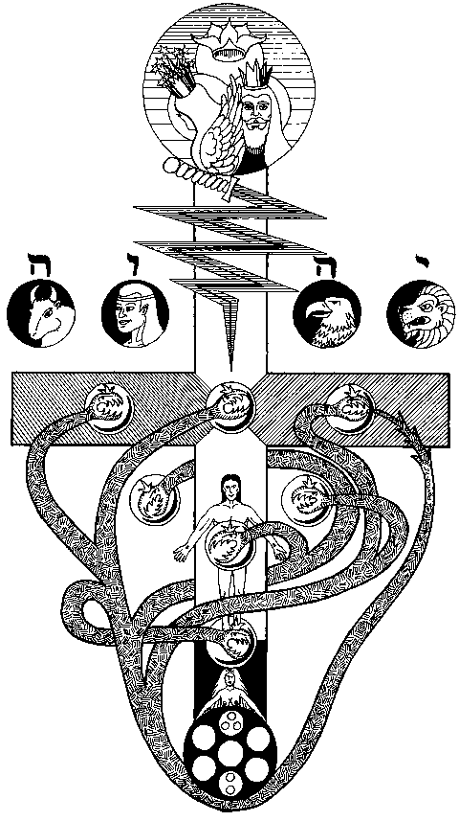

THE GARDEN OF EDEN AFTER THE FALL
This diagram is described in the Philosophus Ritual. It shows in a glyph the teaching proper to a Philosophus on entering the Sephirah NETZACH which he has reached by the Three Paths of QOPH, TZADDI, AND PEH from the SEPHIROTH—MALKUTH, YESOD and HOD respectively.
The Great Goddess EVE, being tempted by the fruits of the TREE OF KNOWLEDGE whose branches tend upwards to the seven lower Sephiroth, but also downward to the Kingdom of Shells, reached down to them and the two pillars were left unsupported.
Then the Sephirotic Tree was shattered. She fell and with her fell the Great ADAM. And the Great Red Dragon arose with his seven heads and ten horns, and EDEN was desolated—and the folds of the Dragon enclosed MALKUTH and linked it to the Kingdom of the Shells.
And the heads of the Dragon rose into the seven lower Sephiroth, even up to DAATH at the feet of Aima Elohim.
Thus were the four Rivers of EDEN desecrated and the Dragon Mouth gave forth the Infernal Waters in DAATH—and this is LEVIATHAN, The Piercing and Crooked Serpent.
But TETRAGRAMMATON ELOHIM placed the Four Letters YHVH of the NAME and the Flaming Sword of the Ten Sephiroth between the devastated Garden and the Supernal Eden, that this should not be involved in the Fall of ADAM.
And it became necessary that a Second Adam should arise to restore the System, and thus, as ADAM had been spread on the Cross of the Four Rivers, so the Second ADAM should be crucified on the Infernal Rivers of the four armed Cross of DEATH — yet to do this He must descend into the lowest, even MALKUTH the Earth, and be born of her. (Psalm 74. 'Thou breakest the Heads of Leviathan in pieces.')
And on the Dragon Heads were the names of the eight Kings of EDOM and on his horns the names of the Eleven Dukes of EDOM, for DAATH having developed in the Dragon a new Head, the Seven Headed Dragon with Ten Horns became Eight Headed and Eleven Horned. (Genesis, 36 31 to 43. Chronicles 1.43 to 54.)
NOTE: The Edomites were the descendants of Esau who sold his birthright. Their Kings came to symbolise unlawful and chaotic forces.

END

